

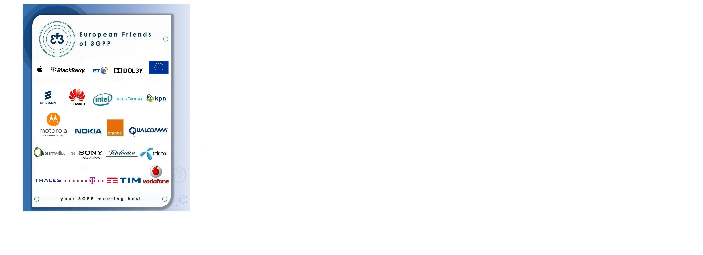

Have the pleasure of inviting you to the 3GPP SA2#138 in Dubrovnik

TITLE | TYPE | DATES | LOCATION | CTRY
3GPPSA2#138 | OR | 20 – 24 April 2020 | Dubrovnik | HR

Sophia Antipolis, 13 November 2019
3GPP SA2#138
from Monday 20 to Friday 24 April 2020 in Dubrovnik

Dear Delegate,

The European Friends of 3GPP, Apple, BlackBerry, BT, Dolby, Deutsche Telekom, EC, Ericsson, Huawei, Intel, InterDigital, KPN, Motorola, Nokia, Orange, Qualcomm, SIMAlliance, Sony, Telefonica, Telenor, Thales, TIM, Vodafone have the pleasure of inviting you to the above-mentioned meeting.

Meeting Venue

RIXOS HOTEL
Email: libertas@rixos.com Website: www.rixos.com Phone: 00385-20-200 115
Adress: Liechtensteinov put 3, 20 000 Dubrovnik

Standard room @ 125€ with B&B, VAT, leisure centre & internet included
Hotel cut-off date, 23th February 2020
Meeting Registration
Please register for the meetings online at: on-line registration
Transportation
GETTING HERE FROM THE AIRPORT
Please book your taxi at Reino Travel reinotravel777@gmail.com. The cost of the transportation could be charged to your hotel guest room.

You might find the hotel cancellation policy unreasonable. If you need to cancel your room, on a reasonable basis, please contact contact@eurofriends3.org.
A quality meeting form will be launched after the meeting.

We look forward to seeing you all in Dubrovnik.

Yours sincerely,
the European Friends of 3GPP.

Accommodation
EF3 is not responsible for reservation confirmations, cancelled or changed reservations or no-shows. Please contact the hotel directly to make any changes. Please make your own booking filling in the hotel registration form. You might find the hotel cancellation policy unreasonable. If you need to cancel your room, on a reasonable basis, please contact contact@eurofriends3.org.

WLAN: There will be a wireless LAN.

Host Contacts
For any questions about anything relating to the meeting please contact: contact@eurofriends3.org

Visa letter

****VISA LETTER****
 Delegates needing a visa in order to attend a meeting hosted by EF3 should make their hotel booking where the meeting will take place. As soon as they book their room please ask the hotel to provide you with a personal letter.
We would like to invite you to fill-in your own invitation letter which contains all your personal information. Please follow these steps:
- Please download the visa application letter template at
http://www.3gpp.org/delegates-corner#outil_sommaire
(under meeting document templates, “visa application letter template”)
- Please update the letter accordingly
- Please send your letter to contact@eurofriends3.org for signature
Deadline to apply: 23th February, 2020



Email: libertas@rixos.com Website: www.rixos.com

Phone: 00385-20-200 115
Adress: Liechtensteinov put 3, 20 000 Dubrovnik

RESERVATION AND CREDIT CARD AUTHORIZATION FORM

Group Reference: 3GPP SA2
Kindly complete this form and send via email to libertas@rixos.com by 23.2.2020
latest (or fax to 00 385 20200020). After 23rd of February 2020, reservations will be possible only on request upon hotel’s availability.

Please fill up following information:
Last Name
First Name
No. of rooms
Double-solo use room Double room
No. of Adults
Date of Arrival
Date of Departure
Accompanying Guests Information
Name 1
Comments / Requests
E-mail
Phone No.

Due to the strict rules mandated by credit card companies, we must request the following information:
Mailing Address for Credit Card Bill:
Name (as it appears on credit card)
Address:
City: State: Zip code:

Payment: directly on the reception upon the check out.
Your credit card details are only for guarantee; your credit card will be used only in case of cancellation, no show or not settled payment on the front desk.

Please read and sign below:

I hereby authorize Rixos Libertas Dubrovnik/ Croatia to use my credit card as guarantee of the booking
Card Name (American Express, Visa, MasterCard, Dinners)
Card Number
Expiration Date
Signature
Today’s date
Please enclose credit card copy.

Daily price per room in EUR:
Double room – solo use/1 person: 125,00 EUR per day
Double room – double use/2 person: 155,00 EUR per day
Tourist tax per person per day: 1,40 EUR
Breakfast and VAT is included in the price.
VAT included
Indoor pool, Turkish bath, towels, fitness area, sauna and spa area.
WIFI free of charge.

Note: Check-in time 14h / Check-out time 12h noon

Cancellation policy:
Hotel management cannot accept any cancellation made in the period shorter than 10 days prior to the date of arrival.
From 10 days up to 48 hours prior arrival – for late cancellation 3 nights will be charged.
For any later cancellation all nights will be charged.
In case of later arrival or earlier departure, the costs of the rooms will be charged for the foreseen time
of the stay unless same room is sold by the Hotel.
In case of NO SHOW the Hotel will charge the costs of the rooms for the entire foreseen period of stay.

I am aware that Hotel Libertas d.o.o processes certain personal data about me in order to fulfill my reservation and to respond to my queries, same as provide and fulfill its legal obligations. All personal data is collectedand processed by Hotel Libertas d.o.o., Liechtensteinov put 3, Dubrovnik in Croatia, which is registered at the Croatian Personal Data Protection Agency.

Signature: _______________________________

