3GPP TSG-SA1 Meeting #94e S1-211xxx
Electronic Meeting, 10-20 May 2021
CR-Form-v12.1
CHANGE REQUEST
 | 22.878 | CR | 0 | rev | - | Current version: | 18.1.0
For HELP on using this form: comprehensive instructions can be found at
http://www.3gpp.org/Change-Requests.

Proposed change affects: | UICC apps |  | ME |  | Radio Access Network |  | Core Network | x

Title: | Update of inclusive language
Source to WG: | Nokia, Nokia Shanghai Bell
Source to TSG: | SA1
Work item code: | FS_5TRS |  |  |  |  |  | Date: |  |  | 10-05-2021
Category: | A |  |  |  |  |  | Release: |  |  | 17
 | Use one of the following categories:  F (correction)  A (mirror corresponding to a change in an earlier release)  B (addition of feature),  C (functional modification of feature)  D (editorial modification)  Detailed explanations of the above categories can  be found in 3GPP TR 21.900. |  |  |  |  |  |  |  | Use one of the following releases:  Rel-8 (Release 8)  Rel-9 (Release 9)  Rel-10 (Release 10)  Rel-11 (Release 11)  …  Rel-15 (Release 15)  Rel-16 (Release 16)  Rel-17 (Release 17)  Rel-18 (Release 18)
Reason for change: |  | SA#90 decided on a 3GPP-wide action to remove all terms that can be seen as "non-inclusive" from all 3GPP TSs and TRs, starting from Rel-17.  SA1 has reviewed all the TSs and TRs under its responsibility and has provided all the CRs associated to this task. This CR is part of this series.
Summary of change: |  | Replacement of all terms that can be seen as non-inclusive by more appropriate terminology.
Consequences if not approved: |  | Non-inclusive terms will remain in this specification.
Clauses affected: |  | 4.1.2, 4.1.3
 |  | Y | N
Other specs |  |  | x | Other core specifications |  |  |  | TS/TR ... CR ...
affected: |  |  | x | Test specifications |  |  |  | TS/TR ... CR ...
(show related CRs) |  |  | x | O&M Specifications |  |  |  | TS/TR ... CR ...
Other comments:
This CR's revision history:

4.1.2 Timing Accuracy
Precise timing is key to operating the smart power grid. One area relates to controlling the frequency (50Hz/60Hz), while another area relates to providing events with timestamped measurement values, with required accuracies down to a few hundred nanoseconds [2]. Correct timing is a key enabler for communication and orchestration of technologies for accurate and optimal wide area monitoring, protection and control in the power industry [2].
In a typical smart grid architecture, centralized monitoring systems have visibility to events occurring in a distributed hierarchy of substations and distribution systems. Having very accurate timing across the endpoints allows the monitoring systems to readily detect faults, identify the source and extent of impact, and take corrective action in a manner affecting the smallest possible portion of the grid. For such event reporting, a 1ms timing accuracy is sufficient.
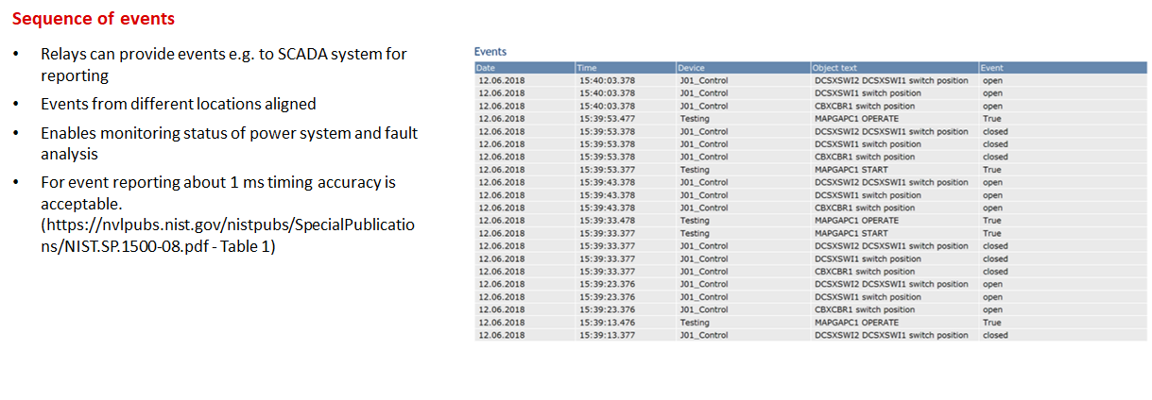
Figure 4.1.2-1: Time stamped events [5]
Timing accuracy is also needed for power system measurements for fault detection in the current phase. Recordings of the phase may be triggered at various points when a fault is detected. Running analysis on multiple time-aligned recordings can provide a clear picture of the extent of impact. For reliable analysis, 1 ms timing accuracy is typically needed across all recordings and is today limited mostly by SNTP time sync methods typically in use.
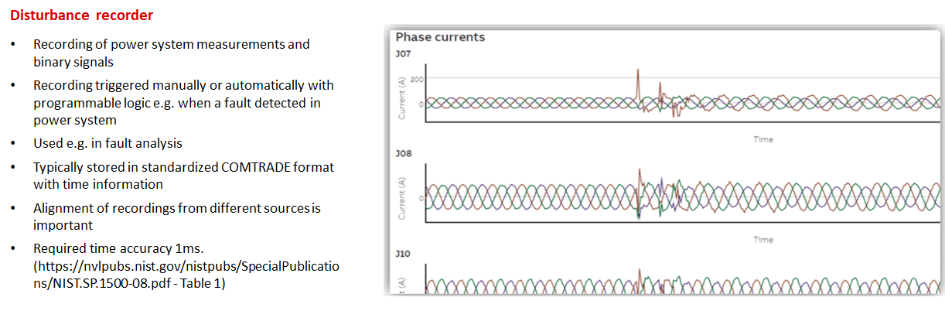
Figure 4.1.2-2: Current disturbance recoding [5]
Monitoring the power system frequency also requires timing accuracy for fault detection and resolution. In this case, accuracy between 1 µs to 10 µs is needed to provide accurate correlation of frequency.
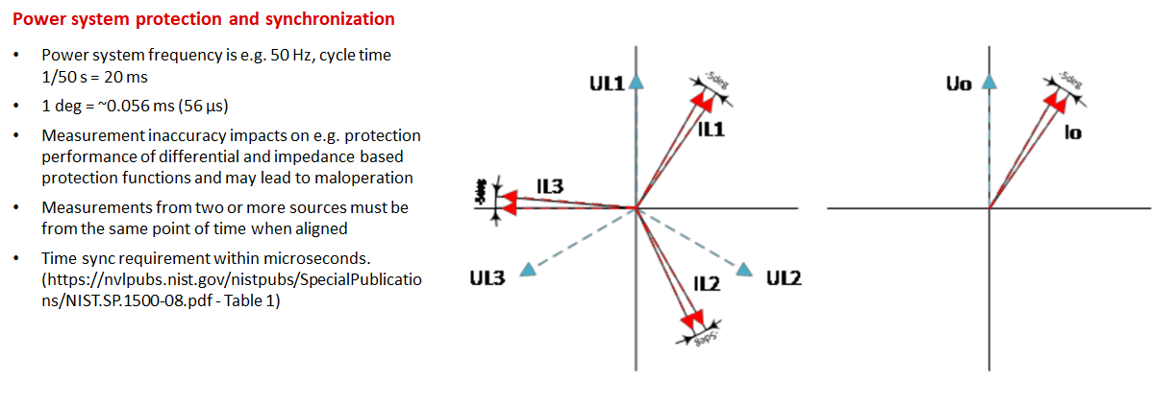
Figure 4.1.2-3: Frequency synchronization [5]
Finally, the accuracy needed depends on the timing role of the component within the power sub-system. E.g., a PTP sync device within the sub-network generally needs to fulfil the application requirements as discussed above (e.g., down to 1μs accuracy requirement) whereas a component that is a PTP Grand Master needs to be accurate to a 250 ns requirement [3], specifically, 250 ns are assumed in (section 7.2 [3]) in order to distribute synchronization over a chain of up to 15 transparent clocks while meeting the requirement of 1 µs at the end-device.

4.1.3 Timing Resiliency
A simple overview of a power sub-station is provided in Figure 4.1.3-1. In a typical deployment today, the sub-station achieves time synchronization by means of a grandmaster clock that uses the IEEE 1588 Precision Time Protocol (PTP) [4] protocol to synchronize elements inside the power sub-station via an Ethernet connection. The grandmaster clock often uses a GNSS receiver to achieve time synchronization information. To access the GNSS signal, an external GNSS antenna is typically required. The figure shows how time and communication redundancy can be achieved within substation by means defined in IEC 61850-9-3-2016 [3]. However, since the time source (GNSS) illustrated is a single point of failure (e.g. whenever satellite(s) are not available or there is interference), 5G is a candidate resiliency solution.
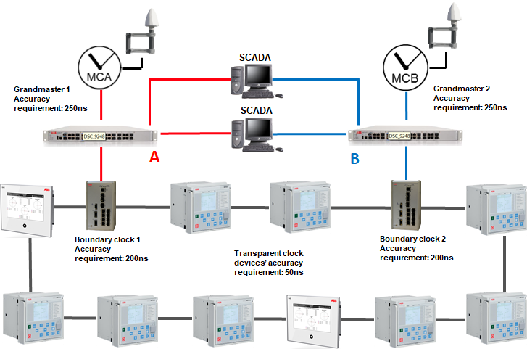
Figure 4.1.3-1: Example power sub-system setup leveraging 2x GNSS based clock grandmasters [5]
The GNSS receiver elements of the clock grandmaster installed in power-subsystems have some desirable characteristics including intrinsic multi-layer jamming and spoofing detection capabilities, e.g., autonomous disruption detection and intelligent protection and control. The timing accuracy requirement of the GNSS receiver is <250 ns according to the grandmaster requirements listed in [4]. This allows sufficient budget for synchronization distribution errors within the power sub-station versus the E2E requirements of the Smart Grid operation (e.g., where every PTP sync device needs to be synchronized to a <1 μs accuracy).
Many power sub-systems already have cellular 4G coverage. A 5G System-based timing solution offers multiple potential enhancements, including:
- As a resiliency solution to the GNSS received timing solution if GNSS fails or is compromised, e.g., integrated as alternative radio in each grandmaster clock or as an alternative grandmaster clock with 5G capability in the power sub-system.
- As an alternative to GNSS use, e.g., integrated with PTP grandmaster clock avoiding installation of external GNSS antenna and receiver at the power sub-station.
These alternatives are illustrated in Figure 4.1.3-2. In both cases, time synchronization may be provided from the 5G System to 5G sync modem by either C-Plane method (e.g., via System Information Broadcast or unicast RRC messaging) or using PTP method according to the power sub-system configuration requirements.
The latter requires also some actions from the 5G System in case time source is lost is missing, e.g., similar to IEC 61850-9-3, clockClass should be dropped when the 5G System is in holdover state. Further, PPS output has significant use-cases and is commonly used today and can be desired property of 5G sync modem.
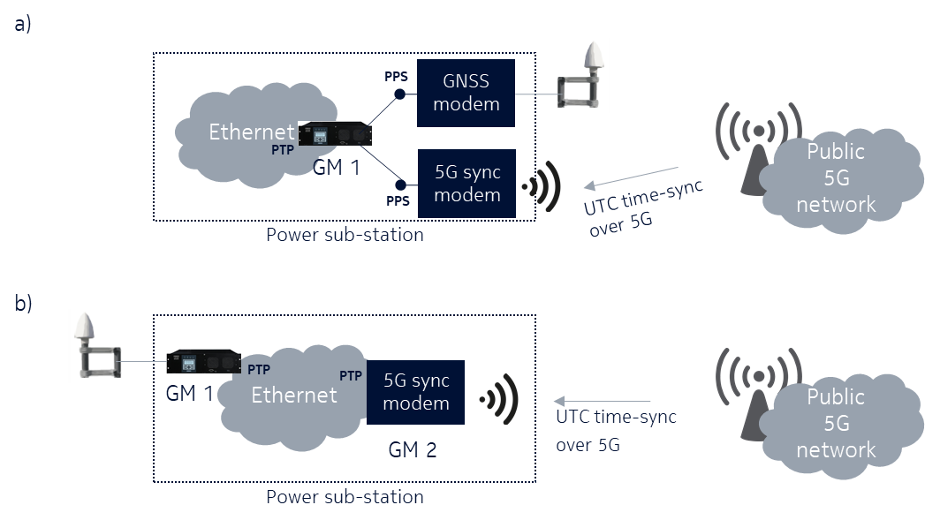
Figure 4.1.3-2: 5G integration into system – resilience and alternative mode
Another key requirement is holdover capability, the ability to continue providing accurate timing service in the event of loss of an external source (e.g., GNSS), for the 5G System. For option (a) in Figure 4.1.3-2 a 24 h holdover capability is automatically supported as this is the case for today’s distributed solution where GM1 and GNSS is always one and the same device. 5G modem functionality could be either integrated into the same device as a chip or as an input using option (b) type external modem, e.g., for this case, no specific holdover capability is required from the 5G System. With option (b), holdover capability is mainly determined by the 5G network. Here it is desirable that the 5G sync modem has a holdover capability of at least 5 s to comply with [3] and that the 5G network can support up to 24 h of holdover capability. However, as option (a) can be a solution when 24 h holdover capability is strictly needed for the power utility, this requirement could be more scalable, e.g., allow for wider range of performance of 5G networks and 5G sync modems with exploiting also hold-over capability (stability) of GM1.
High level requirements to the 5G System to support these alternatives are highlighted in Table 4.1.3-1
Table 4.1.3-1 High level requirements for 5G timing resiliency in smart grid
Area | Requirement
Time Domain | UTC, delivered from network to end-point device in power sub-station. An absolute time difference to GPS/GNSS is acceptable (can be preconfigured) as long as 5G end device provides PPS output which can be used for measuring the difference.
Deployment | Wide area support is needed to reach power sub-systems, e.g., should support full coverage requirements. Mobility is low, e.g., power sub-systems are static structures.  Public Network [5]:  - Minimum density 5 devices per km²  - Maximum density 100 devices per km²  Private Network [5]:  - Up to 1000 devices per km²
Mobility | None, synchronization devices are static and vehicles connect to grid in a static location when in need of time synchronization.
Synchronization accuracy (examples) | <250-1000 ns for synchro phasor use-cases, e.g., to supplement/replace existing GNSS receiver based solutions 1:1.  <1-10 μs for Power system protection and synchronization  <1 ms for Event reporting use-cases, Disturbance recording use-cases
Holdover capability | Up to 24h for 5G network, e.g., the 5G network needs to maintain its ability to synchronize power sub-systems even after general loss or failure of UTC time source.  >5 s for 5G sync modem [3]
Services provided by 5G System | Time resilience service provides 5G clock properties, e.g., clockClass, accuracy, etc to reflect the possible selection of clock source e.g., during GNSS unavailability.  When acting as a backup or replacement time source, the 5G System provides secure timing service to UEs and application servers.

