SA WG2 Meeting #S2-150E S2-2204037
06 - 12 April, 2022, E-Meeting
Source: NEC
Title: Solution for KI#2 Support of providing VPLMN network slice information to a roaming UE
Document for: Agreement
Agenda Item: 9.14
Work Item / Release: FS_eNS_ph3 / Rel-18
Abstract of the contribution: This paper proposes Support of providing VPLMN network slice information to a roaming UE.

Discussion
This contribution provides solution to the key issue#2 “Support of providing VPLMN network slice information to a roaming UE”.

Proposal
Add the following solution to TR 23.700-41.

* * * First Change * * * *

6.x Solution #x: “Sending rejected NSSAI to the UDM to assist the UDM to steer the UE to the PLMN supporting rejected NSSAI”

6.x.1 Introduction
The solution addresses KI#2 Support of providing VPLMN network slice information to a roaming UE.
During the registration procedure in a VPLMN, if the AMF determines that a S-NSSAI is not allowed e.g., the S-NSSAI is not supported by the VPLMN or the S-NSSAI is not available e.g. the no. of UE reached for the S-NSSAI, the AMF sends the rejected NSSAI and requested NSSAI to the UDM. When the UDM receives the rejected NSSAI and the requested NSSAI, the UDM can determine which other VPLMN can support the rejected NSSAI. The UDM will prioritize the VPLMN supporting the rejected NSSAI and initiates SoR procedure with the VPLMN supporting the prioritized VPLMN as highest priority PLMN.
when the UE receives the SoR, the UE may selects the VPLMN which supports the rejected NSSAI as this VPLMN is highest priority PLMN.

6.x.2 Procedures

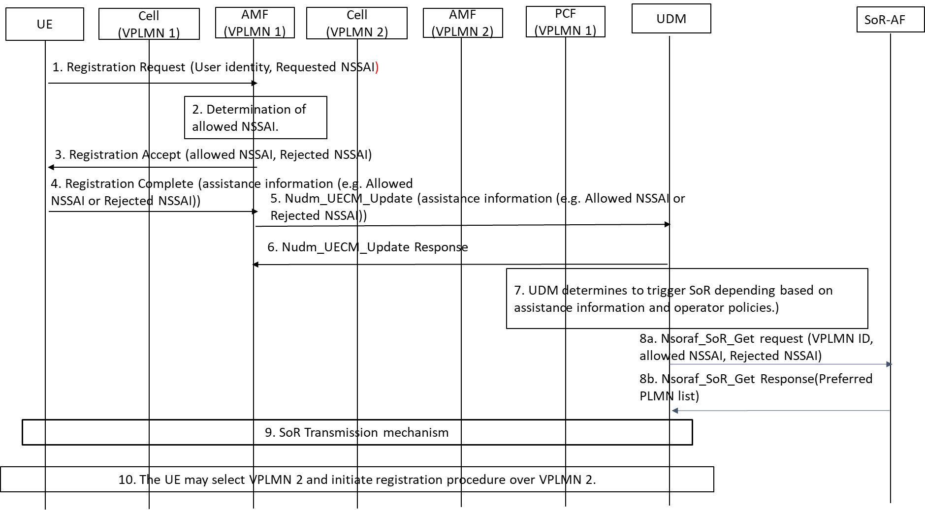

Figure 1: Steering of roaming to a VPLMN supporting the network slice which is not available in the current PLMN.

The detailed steps of the procedure are defined below:
0. The UE selects a VPLMN as defined in the 3GPP TS 23.122. The VPLMN sends configured NSSAI when it is registering to the. VPLMN for the first time.
1. The UE initiates the registration procedure (e.g. Initial Registration, mobility registration) to VPLMN 1 for the S-NSSAIs present in the requested NSSAI. The UE sends a capability that it supports Slice based SoR procedure to the AMF.
2. The AMF determines that some S-NSSAI(s) are allowed and some S-NSSAI(s) are rejected (e.g. the S-NSSAI is not supported in the TA or the PLMN). The AMF sends Registration accept message containing the allowed NSSAI and rejected NSSAI.
3-4). Upon reception of the Registration accept message, the UE sends Registration complete message. The registration complete message contains secured assistance information e.g. rejected NSSAI and allowed NSSAI which is passed transparently to the UDM via AMF. The UE may also send secured assistance information in the UL NAS TRANSPORT message e.g. Registration complete message is not required to send.
5). The AMF sends Nudm_UECM_Update containing assistance information e.g. allowed NSSAI and rejected NSSAI to the UDM.
6) The UDM sends Nudm_UECM_Update response message. When the UDM receives assistance information it will follow step 7.
7) UDM determines to trigger SoR procedure based on assistance information (e.g. the Rejected NSSAI and allowed NSSAI) as described below.
8a) The UDM sends Nsoraf_SoR_Get request (VPLMN ID, allowed NSSAI, Rejected NSSAI) to the SoR-AF.
NOTE 1: When the UDM triggers SoR is totally based on operator policies. The allowed NSSAI and rejected NSSAI is provided as assistance information to the HPLMN. For example, if the rejected NSSAI indicates a S-NSSAI is rejected with cause “S-NSSAI not available in the current PLMN” then the UDM may steer the UE to another VPLMN.
8b) The SoR-AF calculate preferred PLMN list depending on the allowed NSSAI and rejected NSSAI and sends it in the Nsoraf_SoR_Get response message (Preferred PLMN list). The preferred PLMN list consists of PLMN IDs and the S-NSSAIs supported by the PLMN in the preferred PLMN list.
9) The UDM send SoR as defined in 3GPP TS 23.122. The content of SoR can be
10) After the completion of the SoR procedure, the UE may selects the a VPLMN (e.g. VPLMN 2) according to the PLMN list received in step 9.

6.X.3 Impacts on services, entities and interfaces
AMF: Sending of allowed NSSAI and rejected NSSAI to the UDM.
UDM: determines to trigger SoR based on rejected NSSAI and allowed NSSAI.
SoR-AF: SoR AF preparing the preffered PLMN list based on the rejected NSSAI and Allowed NSSAI.

