Invitation and General information

on 3GPP RAN1#114-bis/RAN2#123-Bis/RAN3#121-Bis/RAN4#108-Bis/SA2#159/SA5#151/SA6#57/CT1#144/CT3#130/CT4#118 meetings

from Monday 9 to Friday 13 of October 2023 in Xiamen, China

Beijing, 1 August 2023

### Dear Delegate,

The Chinese Friends of 3GPP (CF3) has the pleasure of inviting you to the 3GPP RAN1#114-bis, RAN2#123-Bis, RAN3#121-Bis, RAN4#108-Bis, SA2#159, SA5#151, SA6#57, CT1#144, CT3#130 and CT4#118 meetings in Xiamen, China.

RAN1#114-bis Meeting will be held in **WuTong Fliport Hotel, Xiamen**.

RAN2#123-Bis Meeting will be held in **W Xiamen**.

RAN3#121-Bis Meeting will be held in **Conrad Hotel, Xiamen**.

RAN4#108-Bis Meeting will be held in **DoubleTree by Hilton Xiamen-Wuyuan Bay**.

SA2#159, SA5#151, SA6#57 meetings will be held in **Tianyuan Grand Hotel, Xia’Men**.

CT1#144, CT3#130 and CT4#118 meetings will be held in **InterContinental Xiamen**.

In addition, **Xiamen International Conference Center Hotel** is available as an alternative hotel for delegates.

The locations of the hotels are shown in the following map.

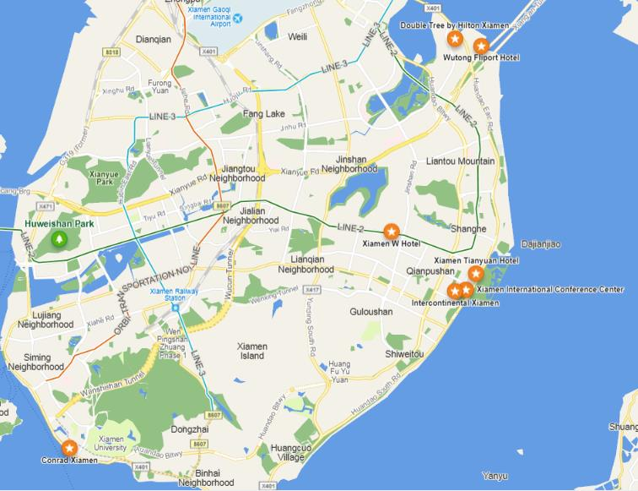

We look forward to seeing you all in Xiamen, China.

Yours sincerely,

***the Chinese Friends of 3GPP***

### **Accommodation**

CF3 is not responsible for reservation confirmations, cancelled or changed reservations or no-shows. Please contact the hotel directly to make the reservation.

|  |  |  |  |  |
| --- | --- | --- | --- | --- |
| Meeting Venue for 3GPP RAN1#114-bis   |  |  |  | | --- | --- | --- | | |  | | --- | | **WuTong Fliport Hotel, Xiamen**  NO.2496 Huangdao East Road, Huli District, Xiamen, China  Tel: +86 592 3917 777  **Group Rates:**   * Deluxe City View Room (King Bed/ 2 Double Beds): CNY 860 net per room per night with one or two daily breakfasts * Deluxe Seaview Room (King Bed/ 2 Double Beds): CNY 980 net per room per night with one or two daily breakfasts   * The above rate includes Service Charge and Estimated government taxes and fees. Broadband Internet access is complimentary in guest rooms.  * Cancellation Policy:  - You may cancel reservation for no charge before Sep15 & change before Sep 30,2023. Please note that your reservation will be hold till 18 PM on your arrival day, if your arrival time is after 18 PM please DO remark it upon reserving, otherwise your reservation will be cancelled at that time,18 PM on arrival day local time. | |  |   Hotel cut-off date, 20 September2023  [Hotel booking](http://www.fliport.com/room?hotel=XMWTF&cust_account=3GPP) | |  |   Meeting Registration  **Please register for the meetings online at:**  [**on-line registration**](https://portal.3gpp.org/#/) |

|  |  |  |  |  |
| --- | --- | --- | --- | --- |
| Meeting Venue for 3GPP RAN2#123-Bis   |  |  |  | | --- | --- | --- | | |  | | --- | | **W Xiamen**  1599 Lvling Road,Siming district Xiamen,China  Tel: +86-592-706 6666  **Group Rates:**   * Wonderful Room (King Bed/ 2 Double Beds): CNY 1,200 net per room per night with one or two daily breakfasts * Fabulous Room (King Bed/ 2 Double Beds): CNY 1,250 net per room per night with one or two daily breakfasts * Spectacular Room (King Bed/ 2 Double Beds): CNY 1,300 net per room per night with one or two daily breakfasts   * The above rate includes Service Charge and Estimated government taxes and fees. Broadband Internet access is complimentary in guest rooms.  * Cancellation Policy:  - RESERVATION IF CANCELLED LESS THAN 7 DAYS PRIOR TO ARRIVAL WILL BE SUBJECTED TO A ONE-NIGHT CHARGE. | |  |   Hotel cut-off date: 1 Oct 2023  [Hotel booking](https://www.marriott.com/event-reservations/reservation-link.mi?id=1683801797668&key=GRP&app=resvlink) | |  |   Meeting Registration  **Please register for the meetings online at:**  [**on-line registration**](https://portal.3gpp.org/#/) |

|  |  |  |  |  |
| --- | --- | --- | --- | --- |
| Meeting Venue for 3GPP RAN3#121-Bis   |  |  |  | | --- | --- | --- | | |  | | --- | | **Conrad Hotel, Xiamen**  No.186,Yanwuxi Road, Xiamen, China  Tel: +86-592-258 6666  Group Rates:   * Deluxe City Attractions View Room (King Bed/ 2 Double Beds):   CNY 1300 net per room per night with one daily breakfasts  CNY 1400 net per room per night with two daily breakfasts   * Deluxe Sea View Room (King Bed):   CNY 1500 net per room per night with one daily breakfasts  CNY 1600 net per room per night with two daily breakfasts  * The above rate includes Service Charge and Estimated government taxes and fees. Broadband Internet access is complimentary in guest rooms.  * Cancellation Policy:  - RESERVATION IF CANCELLED LESS THAN 14 DAYS PRIOR TO ARRIVAL WILL BE SUBJECTED TO A ONE-NIGHT CHARGE.  - RESERVATION IF CANCELLED LESS THAN 7 DAYS PRIOR TO ARRIVAL WILL BE SUBJECTED TO FULL STAY CHARGE.  Hotel cut-off date, 20 Sep 2023  [Hotel Booking](https://www.hilton.com/en/attend-my-event/xmncici-ggppa-3f3e7848-bb38-4134-bbdc-817710aa6611/) | |  | | |  |   Meeting Registration  **Please register for the meetings online at:**  [**on-line registration**](https://portal.3gpp.org/#/) |

|  |  |  |  |  |
| --- | --- | --- | --- | --- |
| Meeting Venue for 3GPP RAN4#108-Bis   |  |  |  | | --- | --- | --- | | |  | | --- | | **DoubleTree by Hilton Xiamen-Wuyuan Bay**  No.105 Mupu Road, Huli district,Xiamen, China  Tel: +86-592-8119888  **Group Rates:**   * King Guest Room (King Bed): CNY 700 net per room per night with one or two daily breakfasts * Guest Room with Bay View (King Bed/ Twin Beds): CNY 750net per room per night with one or two daily breakfasts * Deluxe Twin Room ( Twin Beds): CNY 750net per room per night with one or two daily breakfasts   * The above rate includes Service Charge and Estimated government taxes and fees. Standard Broadband Internet access is complimentary in guest rooms.  * Cancellation Policy:  - RESERVATION IF CANCELLED LESS THAN 15 DAYS PRIOR TO ARRIVAL WILL BE SUBJECTED TO A ONE-NIGHT CHARGE. | |  |   Hotel cut-off date, 15 September 2023  [Hotel booking](https://www.hilton.com/en/book/reservation/deeplink/?ctyhocn=XMNWBDI&groupCode=GGPPA&arrivaldate=2023-10-07&departuredate=2023-10-15&cid=OM,WW,HILTONLINK,EN,DirectLink&fromId=HILTONLINKDIRECT) | |  |   Meeting Registration  **Please register for the meetings online at:**  [**on-line registration**](https://portal.3gpp.org/#/) |

|  |  |  |  |  |
| --- | --- | --- | --- | --- |
| Meeting Venue for 3GPP SA2#159, SA5#151 and SA6#57   |  |  |  | | --- | --- | --- | | |  | | --- | | Tianyuan Grand Hotel**, Xia’Men**  No. 1813 Zijin Plaza, Huandao East Road, Siming District, Xiamen City, Fujian Province, China  Tel: +86-592-566 3999  **Group Rates:**   * Business City View Room (Large bed room/twin bed room): CNY 880 net per room per night with one or two daily breakfasts * Business Sea View Room (Large bed room/twin bed room): CNY 980 net per room per night with one or two daily breakfasts   * The above rate includes Service Charge and Estimated government taxes and fees. Broadband Internet access is complimentary in guest rooms.  * Cancellation Policy:  - RESERVATION IF CANCELLED LESS THAN 3 DAYS PRIOR TO ARRIVAL WILL BE SUBJECTED TO A ONE-NIGHT CHARGE.  Hotel cut-off date, 15 September 2023  [Hotel booking](https://forms.ebdan.net/ls/taPfF0a7?bt=yxy) | |  | | |  |   Meeting Registration  **Please register for the meetings online at:**  [**on-line registration**](https://portal.3gpp.org/#/) |

|  |  |  |  |  |
| --- | --- | --- | --- | --- |
| Meeting Venue for 3GPP CT1#144, CT3#130 and CT4#118   |  |  |  | | --- | --- | --- | | |  | | --- | | **InterContinental Xiamen**  No.19 Lingshiguan Road, Siming District, Xiamen 361008, Fujian, P.R. China  T: +86 (592) 330 9999-7157 | F: +86 (592) 330 9899  **Group Rates:**   * Classic Room 880/room/night 1 breakfast * Classic Room Sea View 980/room/night 1 breakfast * Classic Sea View High Floor 1080/room/night 1 breakfast * Classic Club Lounge Access 1180/room/night 1 breakfast * Room Rate including 1 BF fro 3GPP * Modify RMB100 to add one breakfast * * The above rate includes Service Charge and Estimated government taxes and fees. Broadband Internet access is complimentary in guest rooms.   * Cancellation Policy:  - RESERVATION IF CANCELLED LESS THAN 14 DAYS PRIOR TO ARRIVAL WILL BE SUBJECTED TO A ONE-NIGHT CHARGE.  * The above rate includes Service Charge and Estimated government taxes and fees. Broadband Internet access is complimentary in guest rooms.  * Cancellation Policy:  - RESERVATION IF CANCELLED LESS THAN 7 DAYS PRIOR TO ARRIVAL WILL BE SUBJECTED TO A ONE-NIGHT CHARGE. | |  |   Hotel cut-off date, 20 Sep 2023  [Hotel booking](https://www.intercontinental.com/redirect?path=rates&brandCode=IC&localeCode=en&regionCode=1&hotelCode=XMNLR&checkInDate=07&checkInMonthYear=092023&checkOutDate=14&checkOutMonthYear=092023&numberOfAdults=1&_PMID=99801505&GPC=S08&cn=no&viewfullsite=true) | |  |   Meeting Registration  **Please register for the meetings online at:**  [**on-line registration**](https://portal.3gpp.org/#/) |

|  |  |  |  |  |
| --- | --- | --- | --- | --- |
| For 3GPP Group Accommodation only   |  |  |  | | --- | --- | --- | | |  | | --- | | **Xiamen International Conference Center Hotel**  1697 East Huandao Road, Xiamen, China  Tel: +86-592-5958888  **Group Rates:**  **Promo/Corp. Code：160446**   * Queen room with sea view： CNY 880 net per room per night with one or two daily breakfasts * Twin room with city view：CNY 780 net per room per night with one or two daily breakfasts * Twin room with sea view ：CNY 880 net per room per night with one or two daily breakfasts   * The above rate includes Service Charge and Estimated government taxes and fees. Broadband Internet access is complimentary in guest rooms. | | * Cancellation Policy:  - RESERVATION IF CANCELLED LESS THAN 3 DAYS PRIOR TO ARRIVAL WILL BE SUBJECTED TO A ONE-NIGHT CHARGE.  - CANCELLATION COULD BE MADE By CALLING THE HOTEL AT +86-592-5958888 |   Hotel cut-off date, September 15, 2023  [Hotel booking](http://www.cndhotels.com/index.html?nodeId=130&language=en-us) | |  |   Meeting Registration  **Please register for the meetings online at:**  [**on-line registration**](https://portal.3gpp.org/#/) |

**Visa letter**

If you need an invitation letter for applying a VISA, complete the provided request form and send it to the person below no later than **15 September, 2023 (Beijing time, GMT+8).** **Late submission will not be accepted.** It is recommended for each company to designate one delegate from your company to collect all the information of your delegates who need the invitation letter and to send one request e-mail by the designated person. Please contact the Chinese Embassy at your country for further information.

For your information, from 1st Jan 2019, 144-hour visa-free transit policy for foreigners is formally implemented in Xiamen. The detailed information could be found in the following link:[144-hours visa-free Transit Policy](https://mp.weixin.qq.com/s/_IJkw2TCqAasS7dTMvFHsg) . The You can also call the National Immigration Administration service hotline at +86-12367, which is in Chinese and English.

**Contact person for invitation letter:**

Mr. Ruixiao BAI (CCSA)

E-mail: [ccsavisa@163.com](mailto:ccsavisa@163.com)

Tel: +86-15501150226

**Time Zone**

GMT +8 hours

**Voltage**

Commercial power in China is 220V. Please be sure you have the correct adapter. Voltage converters will not be provided at the meeting.



**City Profile/ Area Attractions**

[Xiamen Tours (visitxm.com)](http://english.visitxm.com/)

[Travel Guide for XM Mountains-to-Sea Trail](https://mp.weixin.qq.com/s/TWfayQ_tgN4i8VvHifm1wQ)

**Host Contact**

For any questions about anything relating to the meeting please contact:

Mr. Ruixiao BAI Mr. Xu QI

Tel.: +86- 15501150226 Tel.: +86-10-6230 4200

E-mail: [bairuixiao@ccsa.org.cn](mailto:bairuixiao@ccsa.org.cn) E-mail: [qixu@ccsa.org.cn](mailto:qixu@ccsa.org.cn)

Mr. Shizhuo ZHAO

Tel.: +86-10-6230 2645

E-mail: [zhaosz@ccsa.org.cn](mailto:zhaosz@ccsa.org.cn)

Attachment 1: Invitation letter request form for VISA

Attachment 2: Transport Information about the meeting venue**Attachment 1: Invitation letter request form for VISA**

**INVITATION LETTER REQUEST FORM**

To enter China for the meetings indicated above, you may need a letter of invitation from the Chinese host, which you will need to present to the Chinese Embassy/Consulate in your area in order to obtain your visa. In order to obtain the invitation letter, please:

1. fill out the form below
2. Send it to (please reference “Invitation letter request for 3GPP RAN X/SA X/CT X meeting” as the subject):

Mr. Ruixiao BAIChina Communications Standards Association (CCSA)

[ccsavisa@163.com](mailto:ccsavisa@163.com)

(It’s recommended to scan your passport page and email to us so that it’s discernible and can be used.)

Fax number: +86-10-6230 1849-4200 (if your passport page is photocopied and enlarged)

|  |  |  |  |  |  |
| --- | --- | --- | --- | --- | --- |
| **Company** |  | | | | |
| Applicant Information |  | | | **❒Mr ❒Ms ❒Mrs** | |
|  | | |  | |
| **Date of birth :** | | |  | |
| **Is this your first visit to China?** | | | **__ Yes ___ No** | |
| If the country in which you'll obtain your visa is different from your nationality, please indicate it here: | | | | |
| The name and the address of the Chinese Embassy/Consulate, which you are going to apply your visa.  **Name:**  **Address:** | | | | |
| **Your Address** |  | | | | |
| **Place to visit after entry** | **In this case, it is Xiamen by default.** | | | | |
| **Date of arrival at China** | |  | **Date of departure from China** | |  |

End of form

***(Please do not forget to attach a copy of your passport photograph page before sending.)***

***Your information should be sent out before 15 September, 2023.***

**Attachment 2: Transport Information about Meeting Venue**

**WuTong Fliport Hotel, Xiamen** is about 8 km and 15 mins by car from Xiamen Gaoqi International Airport.

**Taxi (15 mins)**

The fare for taxi from the Airport to the hotel is around CNY **25** per way. (Please take the taxi which can provide the invoice for your trip)

In case of taking a taxi, please print the following note which shows taxi driver the address of WuTong Fliport Hotel, Xiamen, in both English and Chinese.

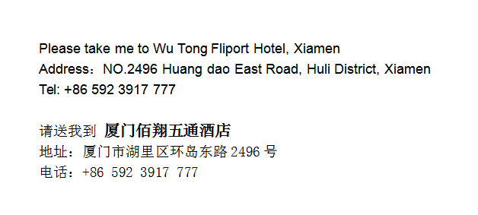

**W Xiamen** is about 9 km and 25 mins by car from Xiamen Gaoqi International Airport..

**Taxi (25 mins)**

The fare for taxi from the Airport to the hotel is around CNY 30per way. (Please take the taxi which can provide the invoice for your trip)

In case of taking a taxi, please print the following note which shows taxi driver the address of W Xiamen in both English and Chinese.

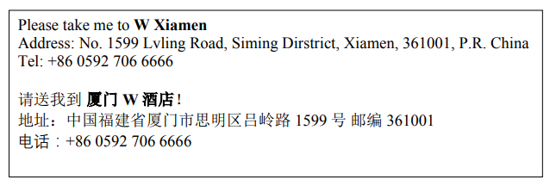

Please take me to **Shangri-La Hotel, Xi’an**.

Address: 38B Keji Road, Xi’an, China

Tel: +86-29-8875 8888

请送我到**西安香格里拉大酒店**

地址：中国西安市科技路38号乙

电话：+86-29-8875 8888

Please take me to **Shangri-La Hotel, Xi’an**.

Address: 38B Keji Road, Xi’an, China

Tel: +86-29-8875 8888

请送我到**西安香格里拉大酒店**

地址：中国西安市科技路38号乙

电话：+86-29-8875 8888

Please take me to **Shangri-La Hotel, Xi’an**.

Address: 38B Keji Road, Xi’an, China

Tel: +86-29-8875 8888

请送我到**西安香格里拉大酒店**

地址：中国西安市科技路38号乙

电话：+86-29-8875 8888

Please take me to **Shangri-La Hotel, Xi’an**.

Address: 38B Keji Road, Xi’an, China

Tel: +86-29-8875 8888

请送我到**西安香格里拉大酒店**

地址：中国西安市科技路38号乙

电话：+86-29-8875 8888

**Conrad Hotel, Xiamen** is about 15 km and 25 mins by car from Xiamen Gaoqi International Airport.

**Taxi (25 mins)**

The fare for taxi from the Airport to the hotel is around CNY **40** per way. (Please take the taxi which can provide the invoice for your trip)

In case of taking a taxi, please print the following note which shows taxi driver the address of Conrad Hotel, Xiamen in both English and Chinese.

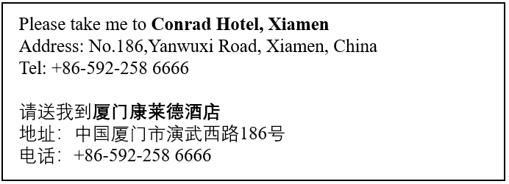

**DoubleTree by Hilton Xiamen-Wuyuan Bay** is about 7km and 15 mins by car from Xiamen Gaoqi International Airport.

**Taxi (15 mins)**

The fare for taxi from the Airport to the hotel is around CNY **25** per way. (Please take the taxi which can provide the invoice for your trip)

In case of taking a taxi, please print the following note which shows taxi driver the address of DoubleTree by Hilton Xiamen-Wuyuan Bay in both English and Chinese.

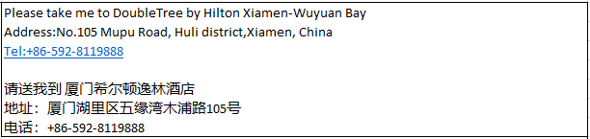

**Tianyuan Grand Hotel, Xia’Men** It is about 14 km and 25 minutes’ drive from Xiamen Gaoqi International Airport.

**Taxi (25 Minutes)**

The taxi fee from the airport to the hotel is about RMB 39 yuan each way. (Please take the taxi which can provide the invoice for your trip)

In case of taking a taxi, please print the following note which shows taxi driver the address of Tianyuan Grand Hotel**, Xia’Men**  in both English and Chinese.

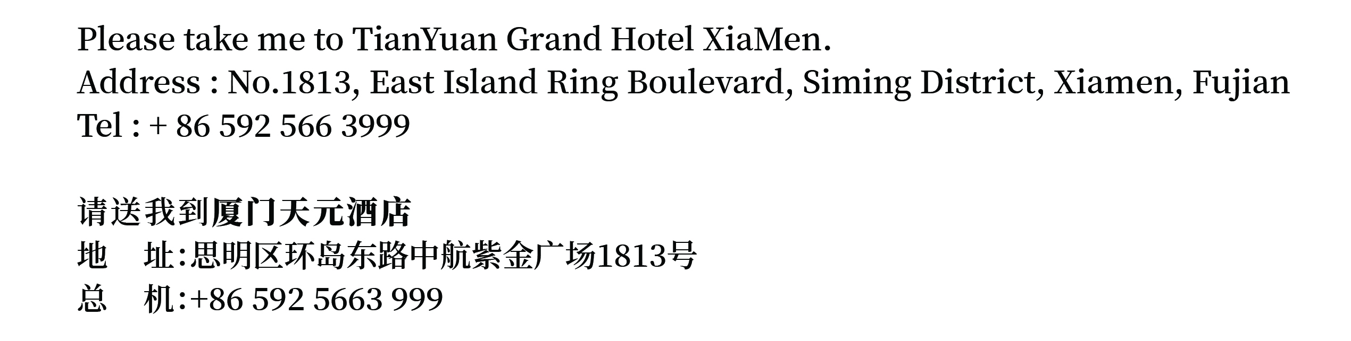

**InterContinental Xiamen** is about 10.5 km and 25 mins by car from Xiamen Gaoqi International Airport.

**Taxi (25 mins)**

The fare for taxi from the Airport to the hotel is around CNY **30** per way. (Please take the taxi which can provide the invoice for your trip)

In case of taking a taxi, please print the following note which shows taxi driver the address of InterContinental Xiamen Hotel in both English and Chinese.

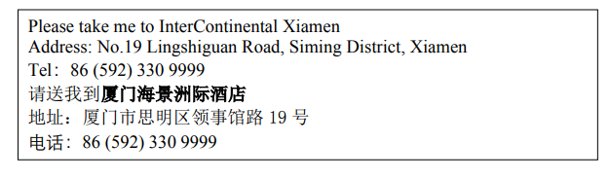

**Xiamen International Conference Center Hotel** is about 14 km and 25 minutes' drive from Xiamen Gaoqi International Airport.

.

**Taxi (25mins)**

The fare for taxi from the Airport to the hotel is around CNY 27per way. (Please take the taxi which can provide the invoice for your trip)

In case of taking a taxi, please print the following note which shows taxi driver the address of Xiamen International Conference Center Hotel in both English and Chinese.

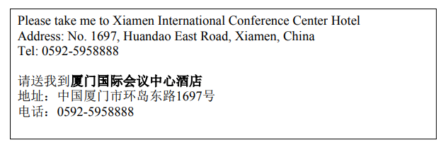

* Apple Computer Trading Co., Ltd.
* BEIJING SAMSUNG TELECOM R&D CENTER
* China Academy of Information and Communications Technology
* China Academy of Telecommunication Technology
* China Mobile Communications Corporation
* China Telecommunications Corporation
* China Unicom
* Guangdong OPPO Mobile Telecommunications Corp., Ltd.
* Huawei Technologies Co., Ltd.
* Nanjing Ericsson Panda Com Ltd.
* Qualcomm Wireless Communication Technologies (China) Limited.
* vivo Mobile Communication Co., Ltd.
* ZTE Corporation

***Have a successful meeting and enjoy your stay in Xiamen!***