3GPP TSG-SA WG6 Meeting #50-e meeting S6-222400
22nd – 31st August 2022, Online

Source: vivo
Title: Solution update for multiple PEMCs in PIN create
Spec: 3GPP TR 23.700-78
Agenda item: 9.1
Document for: Approval
Contact: Huazhang Lv (Huazhang.lv@vivo.com)

1. Introduction
This pCR proposes to put forward a solution update for solution 2.
2. Reason for Change
For a certain PIN, it may have the multiple PEMCs for this PIN.
Just like at home or office, there can be multiple managers. For example, at home, the role of managers can be the parents. And at office, the different leaders or maintainers can have the role of PEMC.
Also, if one PEMC is out of touch or switched off, and the PIN may not be able to update by other PINEs. So, the multiple PEMCs are reasonable for a certain PIN.
It is not convenient, in a PIN it limits that there is only one PEMC.
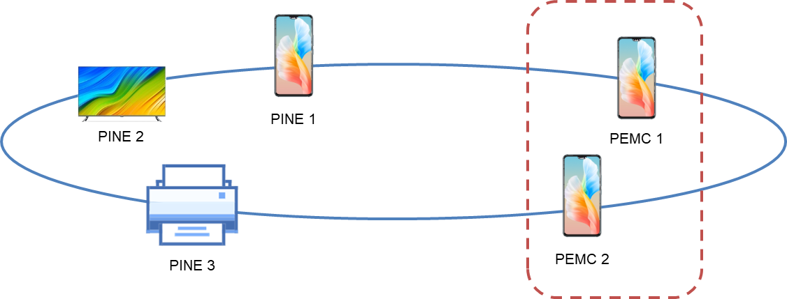
Figure 2-1: Multiple PEMCs in a certain PIN
3. Conclusions
N/A
4. Proposal
It is proposed to agree the following changes to 3GPP TR 23.700-78 v 0.4.0.

* * * First Change, all new text * * * *

7.3.2.2 Procedures of Creation of PIN
This procedure presents a high-level overview of Solution #X.
Figure 7.3.2.2.2.-1 illustrates PIN creation procedure based on request/response model.
Pre-conditions:
1. The UE (PINAPP) has been pre-configured or has discovered the address (e.g. IP address, FQDN, URI) of the PIN server;
2. The UE Identifier or PIN client Identifier is available;
3. The PINAPP has been authorized to communicate with the PIN server;
4. The UE or PINAPP has already received the role of PEMC from PIN server;

Figure 7.3.2.2.2-1: Creation of PIN
1. The UE or PINAPP which is the role of PEMC sends a PIN creation request to the PIN server to request to create a PIN. The PIN creation request includes the security credentials of the UE or PINAPP received during PINAPP authorization procedure and may include the UE identifier such as GPSI, PIN client ID, UE location and PINAPP profile(s) information. The PEMC can also indicate the PIN service that the PIN can provide to PIN server.
The PEMC can request to create a PIN that including other PIN elements that has already communicated with PINAPP (PEMC). If so, the PEMC sends the PIN creation request including the PIN elements information for example, UE identifier such as GPSI, PIN client ID, UE location and PINAPP profile(s) information.
If there are no other PIN elements in the request, the PEMC requests to create a PIN that including only one element that the PEMC.
NOTE: In order to save the procedure of several PEMCs to be involved into the certain PIN as individual PEMC, the PEMC can have the additional PEMC GPSIs in the PIN create request, to indicate additional PEMCs that are allowed to manage the PIN. This procedure doesn’t have conflict with that other PEMC requests to join the certain PIN and becomes PEMC separately.
NOTE: For a certain PIN, only one PEMC at a time can be set active.
Editor’s note: Whether those PEMC list provided by the PEMC during modification/creation automatically become the PIN members without explicitly joining the PINE is FFS.
Editor’s note: How to guarantee there is only on active PEMC at a time and determine the currently active PEMC is FFS.

2. Upon receiving the request, the PIN server performs an authorization check to verify whether the PINAPP (PEMC) has authorization to perform the operation.

Editor's Note: Whether and how the 5GC involved in the PIN creation is FFS.

3. The PIN server sends a successful response to PINAPP (PEMC), which includes a newly assigned PIN ID to indicate the PIN. If the PIN creation request fails, the PIN server should give the failure response to indicates that indicates the cause of PIN creation request failure.
If there are no other PIN elements in the PIN creation request and the PIN creation is successful, the PEMC indicates the PINAPP (PEMC) to be the PEGC. The PINAPP who has already had the role of PEMC can also has the role of PEGC.
If the PEGC is indicated, the PIN server sends PIN client ID (that represents the PEGC), assigned IP address or port number in successful response to PINAPP (PEMC). And, the PIN Server also sends the PEGC information about access control in the response, including:
- Access control information includes: user name, account, SSID, BSSID. All the information is used by PIN elements (PINAPP) in PIN to access 5G or access other application outside of PIN;
NOTE 1: How to PIN server receives or derive PEGC information about access control is in the scope of SA2.
After the procedure above, the PINAPP (PEMC) creates a PIN with PINAPP(PEGC) and other accepted PIN elements in PIN.

* * * End of Change * * * *

