3GPP TSG-SA WG6 Meeting #49-e S6-221031

E-Meeting, 16th – 25th May 2022

Title: LS on the applicability of hold and forward function in DS-TT ports for
5G-native systems

Response to: -

Release: Release 17

Work Item: eSEAL

Source: SA6
To: SA2
Cc: -

Contact Person:

Name: Aron Szabo

E-mail Address: aron.szabo@ericsson.com

Send any reply LS to: 3GPP Liaisons Coordinator, mailto:3GPPLiaison@etsi.org

Attachments: None

1. Overall Description:
The implementation of the hold and forward function in DS-TTs for 5G-native systems is discussed in SA6. The investigated setup is a specific case of UE-to-UE time-sensitive and deterministic communication.

The architecture of a 5G system integrated as a TSN Bridge in TS 23.501 [1] is shown in Figure 1. This architecture serves as a basis of the proposed implementation which is shown in Figure 2. With the addition of a second TSN end system to the device side of the architecture, two separate TSN end systems communicate with each other while no TSN data transfer exists on the N6 / NW-TT side.

In the proposed implementation the same architecture and mechanisms are exploited as those defined for the integration of a 5GS with an external TSN system shown in Figure 1. In the proposed implementation, only DS-TT ports of the architecture are used.

According to subclause 5.27.4 of TS 23.501, DS-TT ports and NW-TT ports support a hold and forward mechanism to schedule traffic if a 5G system participates transparently as a bridge in a TSN network with TSN data transfer both on DS-TT ports and on the NW-TT port.

TS 23.501 does not specify the support of hold and forward function in DS-TT ports and in NW-TT ports for another implementations of the TSN-integrated 5GS architecture in Figure 1, in particular does not specify for the case with two communicating TSN end systems on the device side and no TSN data transfer on the N6 side of the TSN Bridge as demonstrated in Figure 2, for a use case of having a local switch in UPF.

Therefore, SA6 has the following questions for SA2:

Question1: Is UE-to-UE communication supported on the device side and no TSN data transfer on the N6 side for the TSN-integrated 5GS architecture as it is demonstrated in Figure 2 with the following clarifications to "System architecture view with 5GS appearing as TSN bridge” in Figure 4.4.8.2-1 of TS 23.501:
- Two communicating TSN end systems are on the device side instead of a single TSN system and these two TSN end systems communicate with each other.
- No TSN data transfer exists on the N6 / NW-TT side.

Question 2: If UE-to-UE communication is supported on the device side and no TSN data transfer on the N6 side, is the hold and forward function supported in DS-TT ports for TSN-integrated 5G systems?
The proposed implementation is demonstrated in Figure 2.

2. Actions:
To SA2 group.
ACTION: SA6 kindly requests SA2 to consider the above question and kindly inform SA6 on the decision or recommendation.

3. Dates of Next SA6 Meetings:
3GPP TSG SA6#49-bis-e 06/2022 E-Meeting
3GPP TSG SA6#50 08/2022 Meeting (Wroclaw, PL)

Appendix – list of figures:

Figure 1: Architecture from TS 23.501 [1], Figure 4.4.8.2-1 "System architecture view with 5GS appearing as TSN bridge”

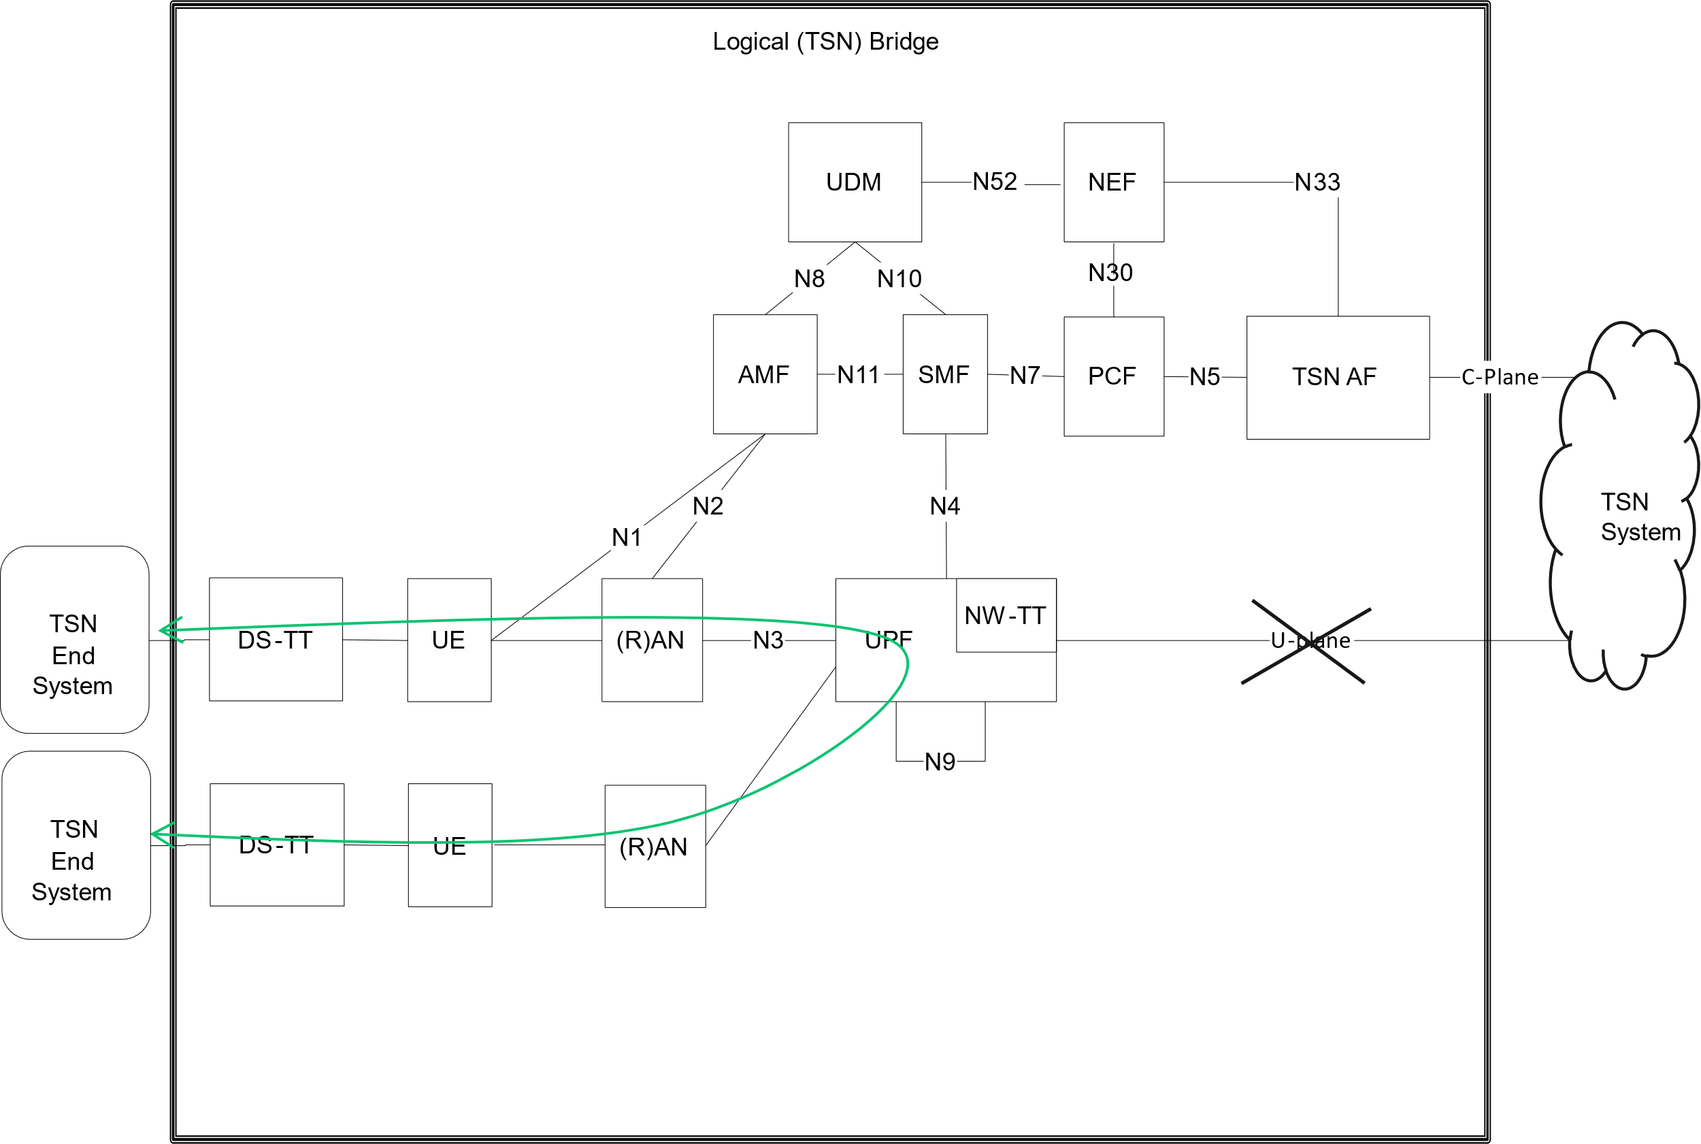
Figure 2: UE-to-UE time-sensitive and deterministic communication, based on Figure 1

