3GPP TSG-SA WG6 Meeting #48-e S6-220714
e-meeting, 5th – 14th April 2022 (revision of S6-220250)

Source: Huawei, Hisilicon
Title: Update to SEALDD architecture for traffic flow description
Spec: 3GPP TR 23.700-34 v0.3.0
Agenda item: 9.10
Document for: Approval
Contact: Yaxin (wangyaxin11@huawei.com), Niranth (namogh@huawei.com)

1. Introduction
This pCR proposes to update the SEALDD architecture for traffic flow description.
2. Reason for Change
As an example of generic APP server functions shown in Fig 2.1, APP server mainly includes 4 parts: communication part, data storage part, signalling and data distribution part, application service logic part. Communication part, signalling and data distribution part, and data storage part are generic for different applications. While the application service logic function is different for different kinds of applications.
Communication part, signalling and data distribution part and storage part can be implemented in SEALDD server. The application server just focuses on the service logic processing and consumes the SEALDD services to transmit/store data. In this case, application traffic transfer (including signalling traffic transfer and data traffic transfer) and data storage can be optional SEALDD services provided to application server. If the application server uses all the SEALDD services for signalling transmission and data transmission, all the application traffic is transmitted through SEALDD layer and the VAL client does not maintain a direct connection with the VAL server for application traffic transmission. The VAL server can also maintain a direct connection with the VAL server for application traffic transmission and only use the SEALDD service for part of the application traffic transmission.
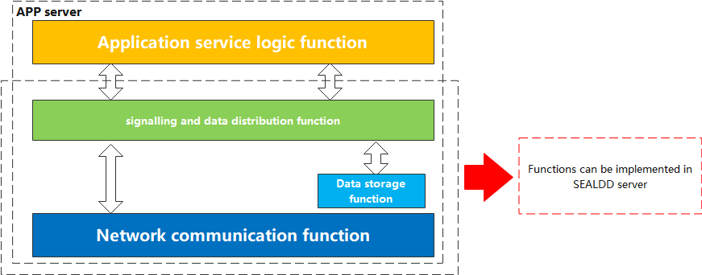
Fig 2.1 Example of generic APP server functions
In addition, as proposed in the architecture description of TR 23.700-34 v0.3.0:
VAL client sends application data traffic to SEALDD client for SEALDD service over SEALDD-C. After data plane packet processing by SEALDD client, the application data traffic is converted to SEALDD data traffic and transferred to SEALDD server over SEALDD-UU. The SEALDD server restores the application data traffic and sends it to VAL server over SEALDD-S.
Only uplink traffic is described while downlink traffic transferring procedure is not described. A new figure should also be added to clearly show the roles of the functions in data delivery procedure.
3. Proposal
It is proposed to agree the following changes to 3GPP TR 23.700-34 v0.3.0.

* * * First Change * * * *

6 Solutions

6.1 Solution #1: Data delivery enabler service architecture

6.1.1 Solution description

6.1.1.1 Functional architecture description
This clause describes the architecture for enabling SEAL Data Delivery applications in the following representations:
- A service-based representation as specified in 3GPP TS 23.434 [5], where the SEAL Data Delivery Enabler Layer functions (e.g. SEALDD server) enable other authorized Vertical Application Layer functions (e.g. VAL server) to access their services.
- A service-based representation as specified in 3GPP TS 23.501 [6], where the Network Functions (e.g. NEF) enable authorized SEAL Data Delivery Layer functions (e.g. SEALDD server) i.e. Application Functions, to access their services;
- A service-based representation, where the Core Network Northbound APIs as specified in 3GPP TS 23.501 [6] and 3GPP TS 23.502 [7], are utilized by authorized SEAL Data Delivery Enabler Layer functions via CAPIF core function specified in 3GPP TS 23.222 [3]; and
- A reference point representation, where existing interactions between any two functions (e.g. SEALDD client and SEALDD server) is shown by an appropriate point-to-point reference point (e.g. SEALDD-UU).
SEAL Data Delivery Enabler Layer functions shown in the service-based representation of the SEAL Data Delivery architecture shall only use service-based interfaces for their interactions.
Figure 6.1.1-1 illustrates the service based representation of SEAL Data Delivery function in the overall SEAL service-based representation which is specified in clause 15 of 3GPP TS 23.434 [5].
Figure 6.1.1-1 SEALDD representation in SEAL generic functional model representation using service-based interfaces
The SEALDD function exhibits service-based interfaces which are used for providing and consuming SEALDD services. The service-based interface for SEALDD function is representation as Sdd.
NOTE: Not all entities represented in this diagram will interact with the Sdd interface.
Figure 6.1.1-2 illustrates the service-based representation for utilization of the 5GS network services based on the 5GS SBA specified in 3GPP TS 23.501 [6].
Figure 6.1.1-2: Utilization of 5GS network services based on the 5GS SBA – service based representation
The SEALDD server acts as AF for consuming network services from the 3GPP 5G Core Network entities over the Service Based Architecture specified in 3GPP TS 23.501 [6].
Figure 6.1.1-3 illustrates the service-based representation for utilization of the Core Network (5GC, EPC) northbound APIs via CAPIF.
Figure 6.1.1-3: Utilization of Core Network Northbound APIs via CAPIF – service based representation
The SEALDD server acts as authorized API invoker to consume services from the Core Network (5GC, EPC) northbound API entities like SCEF, NEF, SCEF+NEF which act as API Exposing Function as specified in 3GPP TS 23.222 [3].
The mechanism for northbound APIs discovery using the service-based interfaces depicted in figure 6.1.1-3 is as specified in 3GPP TS 23.222 [3].
Figure 6.1.1-4 illustrates the architecture for SEAL Data Delivery enabler service.
Figure 6.1.1-4 Architecture for SEAL Data Delivery Service
For uplink traffic, VAL client sends application data traffic to SEALDD client for SEALDD service over SEALDD-C. After data plane packet processing by SEALDD client, the application data traffic is converted to SEALDD data traffic and transferred to SEALDD server over SEALDD-UU. The SEALDD server restores the application data traffic and sends it to VAL server over SEALDD-S. For downlink traffic, VAL server sends application data traffic to SEALDD server for SEALDD service over SEALDD-S. After data plane packet processing by SEALDD server, the application data traffic is converted to SEALDD data traffic and transferred to SEALDD client over SEALDD-UU. The SEALDD client restores the application data traffic and sends it to VAL client over SEALDD-C. Optionally, VAL deployments may choose to route application signalling traffic and application data traffic for some or all functions it offers using SEALDD service and figure 6.1.1-5 illustrates the architecture for achieving this. In this case the VAL client and VAL server may choose not to maintain application connection by themselves and transfer all the application traffic over SEALDD connections for those functions.
NOTE: SEALDD capabilities are provided as APIs to the VAL Layer, VAL layer can choose one or more services (e.g. application signalling traffic transfer, application data traffic transfer, etc.) according to its requeirements.
Figure 6.1.1-5 Architecture for application traffic transfer
The SEAL Data Delivery client interacts with the SEAL data delivery server to establish application layer data transport path.
Through this path, the SEALDD server and client provides data transport service capabilities such as data plane packet processing (e.g. packet duplication, elimination or transport coordination), data forwarding, data caching, background data transfer, etc. to support the VAL server and client.

