3GPP TSG-SA WG6 Meeting #48-e S6-220618
e-meeting, 05th – 14th April 2022 (revision of S6-22xxxx)

CR-Form-v12.1
CHANGE REQUEST
 | 23.434 | CR | 0095 | rev | - | Current version: | 17.5.0
For HELP on using this form: comprehensive instructions can be found at
http://www.3gpp.org/Change-Requests.

Proposed change affects: | UICC apps |  | ME | X | Radio Access Network |  | Core Network

Title: | Removal of Gate Control EN
Source to WG: | Ericsson
Source to TSG: | S6
Work item code: | eSEAL |  |  |  |  |  | Date: |  |  | 2022-03-30
Category: | F |  |  |  |  |  | Release: |  |  | Rel-17
 | Use one of the following categories:  F (correction)  A (mirror corresponding to a change in an earlier release)  B (addition of feature),  C (functional modification of feature)  D (editorial modification)  Detailed explanations of the above categories can  be found in 3GPP TR 21.900. |  |  |  |  |  |  |  | Use one of the following releases:  Rel-8 (Release 8)  Rel-9 (Release 9)  Rel-10 (Release 10)  Rel-11 (Release 11)  …  Rel-15 (Release 15)  Rel-16 (Release 16)  Rel-17 (Release 17)  Rel-18 (Release 18)
Reason for change: |  | Inclusion and justification of hold and forward function in TSN-integrated 5G systems, in accordance with Qualcomm’s observation, see “Additional discussion” below. Removal of related Editor’s note.
Summary of change: |  | - Necessary clarification and justification of including the hold and forward function in TSN-integrated 5G systems is provided in “Additional discussion”.  - “TSCTSF” is replaced with “TSN AF” in 14.2.2.3 and in 14.3.7.3.  - “Nxx” is changed to “N5” in 14.2.2.3 including Figure 14.2.2.3-1 and in 14.3.7.3.  - “TSC Assistance Information” is replaced with “TSC Assistance Container” in 14.3.7.3 and reference is added.  - Details on the configuration and gate control list sent over N5 for the hold and forward buffering are added to 14.3.7.3.  - Removed Editor’s note from 14.3.7.3.
Consequences if not approved: |  | Time-sensitive and deterministic operation will not be feasible for Ethernet PDU sessions in 5G TSC UE-to-UE communication.
Clauses affected: |  | 14.2.2.3, v
 |  | Y | N
Other specs |  |  | X | Other core specifications |  |  |  | TS/TR ... CR ...
affected: |  |  | X | Test specifications |  |  |  | TS/TR ... CR ...
(show related CRs) |  |  | X | O&M Specifications |  |  |  | TS/TR ... CR ...
Other comments:
This CR's revision history:

Additional discussion:
We acknowledge Qualcomm’s objection that the proposed inclusion of hold and forward functionality is applicable only if the 5GS is integrated transparently as a bridge in a TSN network.
In this CR we clarify that the proposed inclusion of hold and forward function along with the other proposed changes are for TSN-integrated 5G systems.
The proposed case of implementation is shown in Fig. 1., where two separate TSN end systems communicate with each other and no data transfer is present between the external TSN System and the TSN Bridge on the C-Plane and on the U-Plane.
The functional architecture of the proposed implementation is demonstrated in Fig. 2 where no external TSN System is present. Please note that the architectures in Fig. 1 and Fig. 2 are equivalent, highlighting the implementation in Fig. 1 and the functionality in Fig. 2.
With the lack of the external TSN system, C-plane and U-plane, the proposed modification is indeed under the umbrella of TSC, however, the proposed schema is a 5G native case where DS-TTs are synched with TSN End Systems. This is achieved by the TSN-integration of a 5G system. We changed TSCTSF to TSN AF in 14.2.2.3 in order to indicate that this is a TSN case.
The proposed changes are in line with 3GPP SA6 specs and the presence of the VAL Server and the SEAL NRM Server including CNC are indicated in Fig. 2 accordingly.
In the present CR we argue the relevance of de-jittering downstream TSC traffic by the hold and forward functionality in DS-TTs. This functionality is available for deterministic 5G-TSN streams in TS 23.501 [1].
The proposed functionality is crucial for Ethernet PDU sessions in 5G TSC UE-to-UE time-sensitive and deterministic communication. To achieve this, 5G TSC must provide de-jittering at the DS-TT egress for UE-to-UPF and UPF-to-UE traffic.

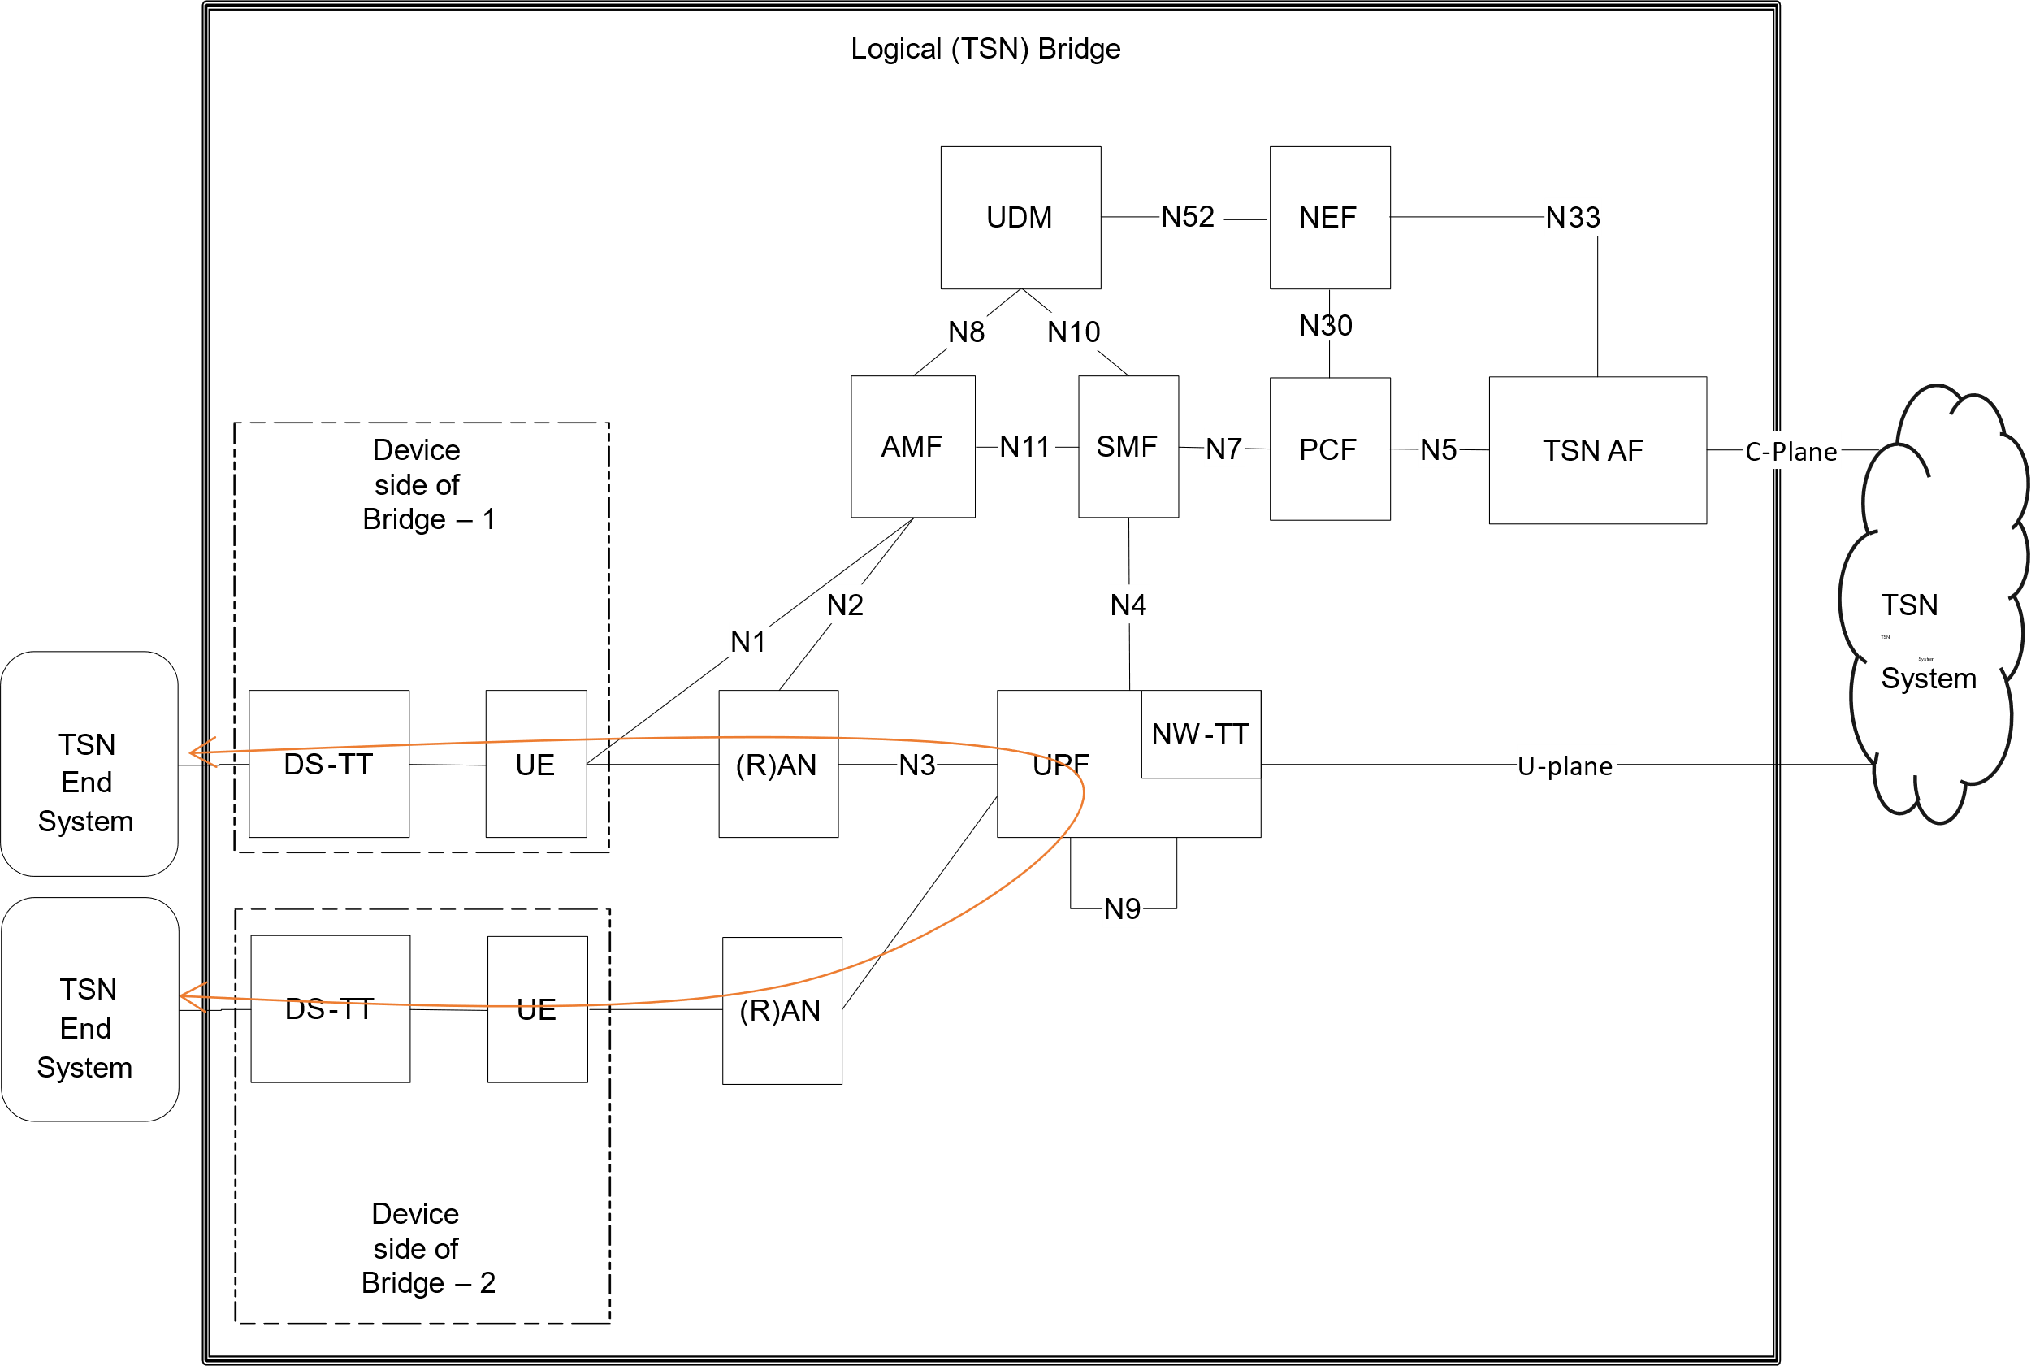
Fig. 1: Planned implementation of the proposed functionality, based on “Figure 4.4.8.2-1: System architecture view with 5GS appearing as TSN bridge” in TS 23.501 [1]

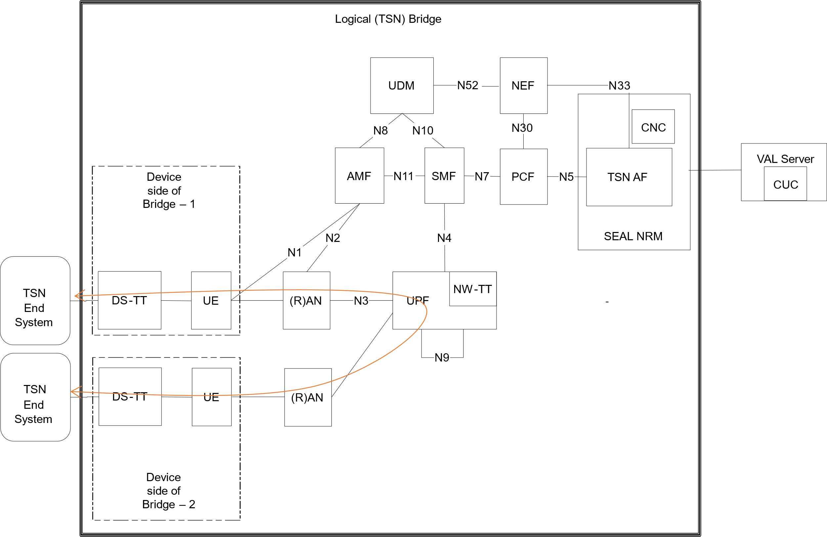
Fig. 2: Functional diagram of the proposed implementation equivalent to Fig. 1; figure based on “Figure 4.4.8.2-1: System architecture view with 5GS appearing as TSN bridge” in TS 23.501 [1]
References
[1] 3GPP TS 23.501: "Technical Specification Group Services and System Aspects; System architecture for the 5G System (5GS)"
[2] 3GPP TS 23.502: "Technical Specification Group Services and System Aspects; Procedures for the 5G System (5GS)”

* * * First Change * * * *

14.2.2.3 On-network functional model for network resource management for 5G TSC
5G TSC refers to time sensitive communication service offered within the 5G system (i.e., without integration with a TSN system) by the 5GS for the UEs connected to the 5GS. The architecture for the 5G TSC is depicted in Figure 14.2.2.3-1. The SEAL NRM server acts as an AF towards the 5G Core Network and performs coordination of QoS flows to fulfill the end-to-end QoS requirements for the UEs involved in the TSC communication. It combines the roles of TSN AF and TSC CNC (similar to the TSN CNC in the TSN integration case), which means that it controls the allocation of resources of TSC communication within the boundaries of the 5G domain.
Upon request from a VAL server via the NRM-S reference point it configures the TSC end-to-end QoS flows in the 5GS. In line with other SEAL service enablers the SEAL NRM server provides a RESTful interface on the NRM-S reference point. As a TSN AF the SEAL NRM server interacts with the 5GS PCF over the N5 reference point to configure the 5G QoS and TSCAI parameters in the 5GS.

Figure 14.2.2.3-1: On-network functional model for network resource management for 5G TSC

* * * Next Change * * * *

14.3.7.3 TSC stream creation procedure
This procedure allows the VAL server to create a TSC stream. The TSC stream creation procedure enables the VAL server to establish TSC connectivity with the required QoS between the UEs connected to the 5GS after the stream discovery procedure.
Pre-conditions:
1. Each UE has an established Ethernet PDU session for its DS-TT port MAC address.
2. Connectivity between the DS-TTs has been validated by the TSC stream availability discovery procedure.
3. NRM server maintains mapping from the traffic class to TSC QoS.
Figure 14.3.7.3-1: TSC stream creation procedure
1. NRM server receives a TSC stream creation request from a VAL server to create a TSC stream identified by a VAL Stream ID, between DS-TT ports in the stream specification and for the traffic class in the traffic specification.
2. NRM server calculates the schedule for the VAL Stream ID based on the information collected earlier from the 5GS via N5. It provides per-stream filtering and policing parameters (e.g. as defined in IEEE 802.1Q [IEEE8021Q]) used to derive the TSC QoS information and related flow information. NRM server also provides the forwarding rule (e.g. as defined in IEEE 802.1Q [IEEE8021Q]) used to identify the DS-TT MAC address of the corresponding PDU session. Based on the 5GS bridge delay information it determines the TSC QoS information and TSC Assistance information for the stream.
3. As a TSN AF, the NRM server triggers via N5 the Npcf_policy_Authorization_Create service operation as described in 3GPP TS 23.502 [2] for the TSC stream for both UL QoS flow (sender UE to UPF/bridge) and DL QoS flow (UPF/bridge to receiver UE). The AF request includes the DS-TT port MAC address, TSC QoS information, TSC Assistance Container- (3GPP TS 23.501 [1], cl.5.27.2.3), flow bit rate, priority, Service Data Flow Filter containing flow description including Ethernet Packet Filters. The QoS flow will be assigned for the PDU session for the source MAC address for the UL direction and for the PDU session for the destination MAC address for the DL direction. The configuration sent over N5 also includes the gate control list (including AdminControlList, AdminBaseTime, AdminCycleTime and Tick Granularity) for the traffic specification. The gate control parameters are for the hold and forward buffering by the UE-TSC for the respective TSC flow. This information is delivered to the DS-TT by the 5GS. The NRM server can use the gate control parameters for hold and forward buffering in the same way as in the case of TSN integration.

4. NRM server sends TSC stream creation response to the VAL server with the result of TSC stream creation for the VAL Stream ID.
* * * End of Changes * * * *

