3GPP TSG-SA WG6 Meeting #44 S6-212668r2
e-meeting, 12th – 20th July 2021 (revision of S6-21xxxx)
CR-Form-v12.1
CHANGE REQUEST
 | 23.255 | CR | 0023 | rev | - | Current version: | 17.1.0
For HELP on using this form: comprehensive instructions can be found at
http://www.3gpp.org/Change-Requests.

Proposed change affects: | UICC apps |  | ME | X | Radio Access Network |  | Core Network | X

Title: | Removal of Editor’s Notes in clause 7.3
Source to WG: | InterDigitial
Source to TSG: | S6
Work item code: | UASAPP |  |  |  |  |  | Date: |  |  | 2021-11-10
Category: | F |  |  |  |  |  | Release: |  |  | Rel-17
 | Use one of the following categories:  F (correction)  A (mirror corresponding to a change in an earlier release)  B (addition of feature),  C (functional modification of feature)  D (editorial modification)  Detailed explanations of the above categories can  be found in 3GPP TR 21.900. |  |  |  |  |  |  |  | Use one of the following releases:  Rel-8 (Release 8)  Rel-9 (Release 9)  Rel-10 (Release 10)  Rel-11 (Release 11)  …  Rel-15 (Release 15)  Rel-16 (Release 16)  Rel-17 (Release 17)  Rel-18 (Release 18)
Reason for change: |  | The TS has five Editor’s Notes in clause 7.3.
Summary of change: |  | The Editor’s Notes are proposed removed. It has not been any work on these ENs for meetings. Due to this, it is assumed that these ENs are outdated and can be removed.  It can also be noted that one of the Editor’s Notes indicates that the mechanism in question is out of scope of the current release.
Consequences if not approved: |  | Editor’s Notes indicating open points remain.
Clauses affected: |  | 7.3.2.1,7.3.2.2, 7.3.2.3
 |  | Y | N
Other specs |  |  | X | Other core specifications |  |  |  | TS/TR ... CR ...
affected: |  |  | X | Test specifications |  |  |  | TS/TR ... CR ...
(show related CRs) |  |  | X | O&M Specifications |  |  |  | TS/TR ... CR ...
Other comments:
This CR's revision history:

* * * * First Change * * * *

7.3.2.1 Procedure for group creation for one pair of UAV and UAV-C
Figure 7.3.2.1-1 illustrates a high-level procedure for group creation.
Pre-conditions:
- Both UAV-C and UAV have successfully registered and connected to the UAE server.
- A CAA-level UAV ID is already assigned to the UAV-C and UAV.
Figure 7.3.2.1-1: Procedure for group creation for one pair of UAV and UAV-C
1. The UAE server recognizes a unique pair of UAV and UAV-C either by 3GPP UE ID or CAA-level UAV ID.
NOTE: The mechanisms for how the UAE server recognizes a pair of UAV-C and UAV is out of scope of the present document.

2. The UAE server sends a group creation request to the SEAL GM server, if there is no pre-assigned group ID, by using the GM-S reference link as specified in 3GPP TS 23.434 [5] using the procedure defined in clause 10.3. The SEAL GM server creates one group ID for one pair of UAV and UAV-C as specified in 3GPP TS 23.434 [5].
3. The UAE server uses the returned group ID for UAS for QoS management.

7.3.2.2 Procedure for group-based approach for C2 QoS provisioning
Figure 7.3.2.2-1 illustrates a high-level workflow of group-based C2 QoS provisioning.

Pre-conditions:
- Both UAV and UAV-C have registered to 3GPP 5G network respectively. C2 communication is established.
- The procedure specified in clause 7.3.2.1 is performed and the group ID for the UAS group is available at the UAE server.
Figure 7.3.2.2-1: Procedure of group-based approach for C2 QoS provisioning.
1. The UAE server monitors the QoS for the UAS group (which includes a UAV and UAV-C) by SEAL NRM as specified in 3GPP TS 23.434 [5].

2. In cases where the network condition for C2 communication does not satisfy the pre-defined QoS requirement, the UAE server may choose to send QoS adaptation request to the SEAL NRM server using the NRM-S reference point as specified in 3GPP TS 23.434 [5]. The QoS adaptation request needs to be sent per group ID for a pair of UAV and UAV-C created in the procedure specified in clause 7.3.2.1. The subsequent network resource adaptation procedure is triggered by the UAE server as specified in clause 14.3.3.3.1 of 3GPP TS 23.434 [5].
3. The UAE client and UAE server established communication based on new QoS requirements as specified in clause 14.3.3.2.1.2 of 3GPP TS 23.434 [5].
4. UAS application layer adapts the updated QoS assignment.
NOTE: The mechanisms for how the UAS application layer is adapting newly assigned QoS is out of scope of the present document.

7.3.2.3 Procedure for group update
Figure 7.3.2.3-1 illustrates the group membership update when UAV-2 is used to replace UAV-1.
Pre-conditions:
- The UAV-C, UAV-1, and UAV-2 are all previously successfully subscribed with 3GPP Core Network and UAS application specific server (e.g. USS/UTM) and have received a 3GPP UE ID (e.g. GPSI) and a CAA-level UAV ID.
- The UAV-1 and UAV-C have been grouped by a group ID by SEAL GMS as specified in clause 7.3.2.1.
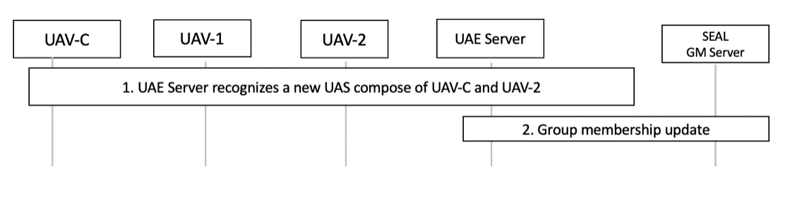
Figure 7.3.2.3-1: Procedure for group update
1. The UAE server recognizes a new pair of UAV-2 and UAV-C by the new CAA-level UAV ID.
NOTE: The mechanisms for how the UAE server recognizes a new pair of UAV-C and UAV is out of scope of the present document.

2. The UAE server sends a group membership update request to the SEAL GM server using the procedure specified in clause 10.3.2.6 of 3GPP TS 23.434 [5]. The SEAL GM server sends a group membership update response as specified in clause 10.3.2.7 of 3GPP TS 23.434 [5].
* * * * End of Changes * * * *

