3GPP TSG-SA WG6 Meeting #42-e S6-210554
e-meeting, 1st – 9th March 2021 (revision of S6-21xxxx)

CR-Form-v12.1
CHANGE REQUEST
 | 23.379 | CR | 0291 | rev | - | Current version: | 17.5.0
For HELP on using this form: comprehensive instructions can be found at
http://www.3gpp.org/Change-Requests.

Proposed change affects: | UICC apps |  | ME | X | Radio Access Network |  | Core Network | X

Title: | Update to the temporary group call
Source to WG: | Huawei, Hisilicon
Source to TSG: | S6
Work item code: | enh3MCPTT |  |  |  |  |  | Date: |  |  | 2021-02-23
Category: | C |  |  |  |  |  | Release: |  |  | 17
 | Use one of the following categories:  F (correction)  A (mirror corresponding to a change in an earlier release)  B (addition of feature),  C (functional modification of feature)  D (editorial modification)  Detailed explanations of the above categories can  be found in 3GPP TR 21.900. |  |  |  |  |  |  |  | Use one of the following releases:  Rel-8 (Release 8)  Rel-9 (Release 9)  Rel-10 (Release 10)  Rel-11 (Release 11)  …  Rel-15 (Release 15)  Rel-16 (Release 16)  Rel-17 (Release 17)  Rel-18 (Release 18)
Reason for change: |  | (1) The NOTEs in clause 10.6.2.5.3 and 10.6.2.8 are not valid now as R17 is still ongoing and SA3 is working on the R17 security solutions.  “NOTE: This procedure has no security solution in 3GPP TS 33.180 [19].”  (2) The information flow to support clause 10.6.2.5.3 and 10.6.2.8 is missing.  (3) How the list of group/user is formed into a temporary group at the MCPTT server is not well described in clause 10.6.2.5.3 and 10.6.2.8.
Summary of change: |  | (1) Change the NOTE in clause 10.6.2.5.3 and 10.6.2.8 to Editor’s Note;  (2) Update the group call request to support clause 10.6.2.5.3 and 10.6.2.8;  (3) Using the pre-configured group to form the temporary group at the MCPTT server.
Consequences if not approved: |  | The lack of information flows and temporary group formation details will impact the implementation by stage-3 groups.
Clauses affected: |  | 10.6.2.2.7, 10.6.2.2.8, 10.6.2.2.9, 10.6.2.5.3, 10.6.2.8.1, 10.6.2.8.2
 |  | Y | N
Other specs |  |  | X | Other core specifications |  |  |  | TS/TR ... CR ...
affected: |  |  | X | Test specifications |  |  |  | TS/TR ... CR ...
(show related CRs) |  |  | X | O&M Specifications |  |  |  | TS/TR ... CR ...
Other comments:
This CR's revision history:

/************************** 1st of change ****************************/

10.6.2.2.7 Group call request (MCPTT client – MCPTT server)
Table 10.6.2.2.7-1 describes the information flow group call request from the MCPTT client to the MCPTT server.
Table 10.6.2.2.7-1 Group call request information elements
Information Element | Status | Description
MCPTT ID | M | The MCPTT ID of the calling party
Functional alias | O | The functional alias of the calling party
MCPTT group ID (NOTE 1) | M | The MCPTT group ID of the group on which the call is requested
MCPTT group ID | O (NOTE 2) | MCPTT group ID of the MCPTT group from which configuration is to be taken
MCPTT group ID list | O (NOTE 2) | The list of MCPTT group ID of the groups which the call is requested
SDP offer | M | Media parameters of MCPTT clients
Implicit floor request | O | When originating client requests the floor, this element shall be included
Broadcast indicator | O | Indicates that the group call request is for a broadcast group call
MCPTT ID list | O | The MCPTT ID of users being invited to the temporary group call - user regroup
Temporary group indicator | O | Indicates that the group call request is for a temporary group call
Location information | O | Location of the calling party.
Requested priority | O | Application priority level requested for this call
NOTE 1: The MCPTT group ID indicates identity of the temporary regroup group when the temporary group indicator is present.
NOTE 2: Only presents when temporary group indicator is set.

10.6.2.2.8 Group call request (MCPTT server – MCPTT server)
Table 10.6.2.2.8-1 describes the information flow group call request between the MCPTT servers.
Table 10.6.2.2.8-1 Group call request information elements
Information Element | Status | Description
MCPTT ID | M | The MCPTT ID of the calling party
Functional alias | O | The functional alias of the calling party
MCPTT group ID | M (NOTE 1) | The MCPTT group ID of the group on which the call is initiated
MCPTT group ID | O (NOTE 2) | MCPTT group ID of the MCPTT group from which configuration is to be taken
Temporary group indicator | O | Indicates that the group call request is for a temporary group call
MCPTT group ID list | O (NOTE 2) | The list of MCPTT group ID of the groups which the call is requested
SDP offer | M | Media parameters of MCPTT server
Broadcast indicator | O | Indicates that the group call request is for a broadcast group call
Implicit floor request (NOTE 3) | O | Indicates that the originating client requests the floor.
Requested priority | O | Priority level requested for the call.
Location information | O | Location of the calling party
NOTE 1: The MCPTT group ID indicates the identity of the temporary regroup group when the temporary group indicator is present.
NOTE 2: Only presents when temporary group indicator is set.
NOTE 3: This element shall be included only when the originating client requests the floor.

10.6.2.2.9 Group call request (MCPTT server – MCPTT client)
Table 10.6.2.2.9-1 describes the information flow group call request from the MCPTT server to the MCPTT client.
Table 10.6.2.2.9-1 Group call request information elements
Information Element | Status | Description
MCPTT ID | M | The MCPTT ID of the calling party
Functional alias | O | The functional alias of the calling party
MCPTT group ID | M | The MCPTT group ID of the group on which the call is initiated
MCPTT group ID(NOTE 1) | O (NOTE 2) | MCPTT group ID of the MCPTT group from which configuration is to be taken
MCPTT group ID list | O (NOTE 2) | The list of MCPTT group ID of the groups which the call is requested
SDP offer | M | Media parameters of MCPTT server
Broadcast indicator | O | Indicates that the group call request is for a broadcast group call
Temporary group indicator | O | Indicates that the group call request is for a temporary group call
NOTE 1: The MCPTT group ID indicates the identity of the temporary regroup group when the temporary group indicator is present.
NOTE 2: Only presents when temporary group indicator is set.

/************************** Next of change ****************************/

10.6.2.5.3 Temporary group – broadcast group call procedure
NOTE: This procedure has no security solution in 3GPP TS 33.180 [19].
Figure 10.6.2.5.3-1 illustrates the procedure for temporary group-broadcast group call procedure. The protocol used may be SIP. In this procedure, the members affiliated to the group involved in the call is automaticalled affiliated the temporary group formed at the MCPTT server.
Pre-conditions:
1. The security aspects of sharing the user information between primary and partner MCPTT systems shall be governed as per the service provider agreement between them. In this case, we consider the partner MCPTT system does not share their users' information to the primary MCPTT system.
2. The authorized MCPTT user/dispatcher belongs to the primary MCPTT system.
3. The MCPTT server of the primary MCPTT system is where the authorized MCPTT user/dispatcher created the temporary group.
4. Other groups in the temporary group – broadcast group may belong to partner MCPTT systems.
5. The MCPTT group identity and group configuration for the regroup MCPTT group have been preconfigured in MCPTT client and other group members who are involved and have received the relevant security related information to allow them to communicate in the regroup MCPTT group.
6. The call initiating MCPTT client is aware of a suitable preconfigured regroup group whose configuration has been preconfigured in the MCPTT UEs of the group members who will be regrouped.
7. In order to be aware whether the group is regrouped, the MCPTT server is subscribed to the group configuration in GMS.

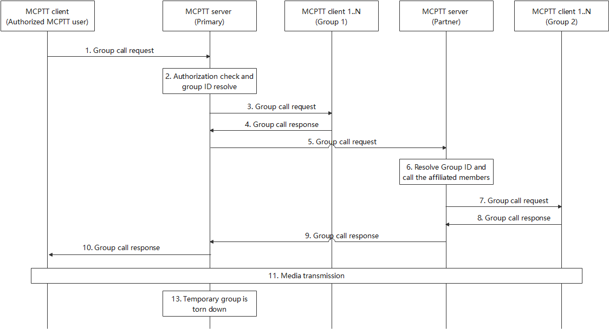
Figure 10.6.2.5.3-1: Temporary group – broadcast group call
1. The MCPTT client of authorized user initiates a group call with multiple groups from primary and partner MCPTT systems. A group call request message with the MCPTT group IDs (group1's MCPTT group ID, group2's MCPTT group ID) is routed to the MCPTT server of the primary MCPTT system, which is where the authorized MCPTT user/dispatcher created the temporary group.
2. The MCPTT server also checks that none of the MCPTT groups that are requested for regrouping are already regrouped. The MCPTT server of the primary MCPTT system forms the temporary group by using the configuration of the preconfigured MCPTT group and the groups' information received. It resolves the MCPTT group IDs and identifies the appropriate MCPTT server responsible for the groups. It further triggers a temporary group – broadcast group call via a group call request message to the affiliated group members of group1's MCPTT group ID of the MCPTT server of the primary MCPTT system.
NOTE 1: The temporary group information is not notified to the group members of the constituent groups.
NOTE 2: The list of groups included in the regroup is held in dynamic data in the MCPTT server, and is not used to update group configuration information in the group management server.
3. The MCPTT server of the primary MCPTT system sends the group call requet to the affiliated group members of the group1.
4. The affiliated group members of the group 1 respond with the group call response.
5. A group call request message is further initiated with the MCPTT server of the partner MCPTT system for group2's MCPTT group ID.
6. Upon receiving the group call request message from the MCPTT server of the primary MCPTT system, the MCPTT server of the partner MCPTT system resolves the group id and initiates a call invitation to their affiliated group members. Alternatively, the MCPTT server of the partner MCPTT system notifies the group members via a notification message containing the group call session identity information. Upon receipt of the notification message, the group members may perform a late call entry.
7. The MCPTT server of the partner MCPTT system sends the group call request to the affiliated group members of the group 2.
8. The group members upon receipt of the invitation may accept or reject the call, and respond with the group call response.
9. The MCPTT server of the partner MCPTT system provides a group call response message to the MCPTT server of the primary MCPTT system with success or failure result and/or detailed reason information in case of failure.
10. The MCPTT server of the primary MCPTT system provides a group call response message to the MCPTT client of the authorized MCPTT user upon receiving response to the corresponding group call request with the MCPTT server of the partner MCPTT system. The group call response will consist of the success or failure result and/or detailed reason information in case of failure.
NOTE 3: The group call response message is triggered depending on the conditions to proceed with the call.
11. Upon successful group call setup, a group call is established amongst the multiple group members from primary and partner MCPTT systems. The call originating MCPTT user starts transmitting media to other group call participants.
NOTE 4: Only the call originating MCPTT user is allowed to transmit media on broadcast group call.
NOTE 5: A broadcast group call transmitted on a temporary group-broadcast group has priority over group calls on its subordinate groups.
12. At the completion of the media transmission, the broadcast group call is released, and the temporary group – broadcast group is torn down.

/************************** Next of change ****************************/

10.6.2.9 Group regroup with preconfigured group

10.6.2.9.1 General
NOTE: This procedure has no security solution in 3GPP TS 33.180 [19].
A group regroup may be achieved by regrouping MCPTT groups into a new MCPTT regroup group which uses the configuration of a separate preconfigured MCPTT group. The MCPTT regroup group configuration needs to be provided to the relevant MCPTT group members of the MCPTT groups that will be regrouped in advance of the regrouping operation.
NOTE 1: A preconfigured group which is intended only to provide configuration for the preconfigured regroup process is identified by a parameter in the group configuration described in 3GPP TS 23.280 [16].
NOTE 2: The configuration may alternatively be taken from any MCPTT group that has been configured in the user profile of all the relevant MCPTT users who will be regrouped.
NOTE 3: Regroup groups may be defined according to the organizational structure of a mission critical organization, or by some other means which allows the MCPTT client of an authorized user to be aware of an appropriate regroup group for sets of MCPTT groups that will be regrouped together.
The preconfigured MCPTT group that provides the configuration is not used as the MCPTT regroup group itself, it only provides configuration for one or more MCPTT regroup groups. The MCPTT group ID of the regroup group is provided by the authorized user when the preconfigured regrouping is carried out.
The MCPTT regroup group can be specified to be a broadcast or non-broadcast type according to the configuration of the MCPTT group whose configuration is specified by the regroup request. The broadcast type of regroup is used for one-way communication where only an authorized MCX user is allowed to transmit and all other regroup members are only allowed to receive the communication (e.g. a call from a dispatcher to all regroup members). The non-broadcast type is used for two-way communication where all regroup members can transmit and receive (i.e, the regroup group call behaves like a normal non-broadcast group call).
These procedures provide a regrouping service for MCPTT only and are independent of group regrouping procedures specified in 3GPP TS 23.280 [16]. If the MCPTT server has been notified by the group management server that one of the MCPTT groups that has been requested for regrouping by means of this procedure has already been regrouped by the group regrouping procedure specified in 3GPP TS 23.280 [16], the MCPTT server shall reject the request for regrouping described in the following procedure.
Editor's note: These procedures provide a regrouping service for MCPTT only; any issues arising from conflicts with similar regrouping operations for MCVideo and MCData are FFS.

/************************** Next of change ****************************/

10.6.2.10 User regroup using group creation procedure

10.6.2.10.1 General
NOTE: This procedure has no security solution in 3GPP TS 33.180 [19].
User regroup using the group creation procedure can be initiated by an authorized user creating a temporary group with a list of MCPTT users. The group ID for this temporary group can be provided at the time of group creation. The temporary group can be used by all MCPTT users in the list for two-way (non-broadcast) communication until deleted by an authorized user. Optionally, the group can be used for one-way (broadcast ) communication where the creator of the temporary group can make a broadcast group call, but the other MCPTT users can only listen to the group call and cannot respond.

/************************** End of change ****************************/

