3GPP TSG-SA WG6 Meeting #41-e S6-210910
e-meeting, 18th – 26th January 2021 (revision of S6-21xxxx)

Source: Huawei, Hisilicon, CBN
Title: New solution to key issue#3 on use of multicast and broadcast MBS session
Spec: 3GPP TR 23.783 v1.2.0
Agenda item: 8.1
Document for: Approval
Contact: Cuili – Ge <gecuili@huawei.com>

1. Introduction
This pCR is proposed to introduce a new solution to key issue #3 on use of multicast and broadcast MBS session.
2. Reason for Change
Based on the TS 23.247 and the key issue, it is proposed to introduce the solution how the MC service can utilize the multicast and broadcast session to request the MBS delivery resource for the group communication and send service announcement to the group mmebers.
3. Conclusions
4. Proposal
It is proposed to agree the following changes to 3GPP TR 23.783 v1.2.0.

* * * First Change * * * *

6.x Solution x: use of multicast/broadcast MBS session

6.x.1 Description
This solution is to address the key issue #3 on use of multicast/broadcast MBS session for group communication. This solution allows the MC service server to request the MBS session (multicast MBS session or broadcast MBS session) before the group call is setup (pre-established MBS QoS flow) or during the group call (dynamic-established MBS QoS flow).
In this solution, for a specific group call, the selection of multicast or broadcast can be determined by the MC service server based on the MC service operator’s policy or configuration, e.g., based on group size, service type. Duing the group call lifetime, the MC service server will not dynamically switch between multicast and broadcast. The group communication may be switched between unicast and the selection MBS delivery method (i.e., either multicast or broadcast).
Editor’s note : The policy and configuration for the MC service server to determine to use multicast or broadcast is FFS.

6.x.1.1 Use of pre-established MBS QoS flow

6.x.1.1.1 General
In this scenario, the MC service server pre-establishes MBS QoS flow in certain pre-configured areas or for specific group before the initiation of the group communication session. When a user originates a request for a group communication session for one of these areas or the specific group, the pre-established MBS QoS flow is used for the DL media transmission.
The following steps needs to be performed prior the start of the MC group communication session over pre-established MBS QoS flow:
- MBS QoS flow in the multicast MBS session or broadcast MBS session is Pre-established;
- Announce the pre-established MBS QoS flow to the MC service clients;
- MC service UE joins the multicast MBS session if the multicast MBS session is used.
When these preparation steps have been done the MC group communication session using MBS QoS flow can start.
Both the media packets as well as the application level control signalling (e.g. floor control messages) to the receiving MC service clients are sent on the MBS QoS flow. Optionally a separate MBS QoS flow could be used for the application level control messages, due to different QoS characteristic requirements.

6.x.1.1.2 Pre-established Multicast MBS QoS flow procedure
The procedure figure 6.x.1.1.2-1 shows only one of the receiving MC service clients receiving the multicast QoS flow. There might also be MC service clients in the same MC group communication session that receive the communication on unicast QoS flow.
Pre-conditions:
- The participating users are already affiliated.

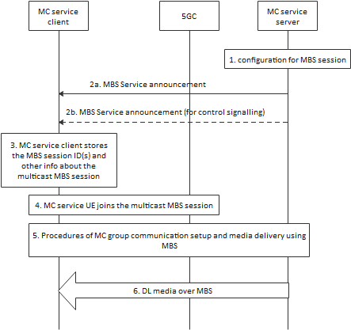
Figure 6.x.1.1.2-1: Use of pre-established multicast QoS flow
1. The MC service server determine to activate the multicast MBS session to establish the multicast QoS flow. The MC service configures the multicast MBS session as specified in 3GPP TS 23.247[x]. This multicast QoS flow will be used for the MC communication media.
2a. The MC service server passes the multicast MBS session info for the service description associated with the pre-established multicast QoS flow to the MC service client. The MC service client obtains the MBS session ID(s) from the service description.
2b. The MC service server may pass the multicast MBS session info for the service description associated with the pre-established floor control multicast QoS flow to the MC service client. The MC service client obtains the MBS session ID(s) from the service description.
NOTE 2: Step 2a and Step 2b can be done in one MBS service announcement message.
3. The MC service client stores the MBS session ID(s).
4. The MC service client joins the multicast MBS session with the received MBS session ID(s) as specified in 3GPP TS 23.247[x].
5. An MC service group communication session is established.
6. As the MC service server transmits the media over the multicast QoS flow, the media packets are detected and delivered to the MC service client.

6.x.1.1.3 Pre-established Broadcast MBS QoS flow procedure
The procedure figure 6.x.1.1.3-1 shows only one of the receiving MC service clients using an MBS QoS flow. There might also be MC service clients in the same MC group communication session that receive the communication on unicast QoS flows.
Pre-conditions:
- The participating users are already affiliated.
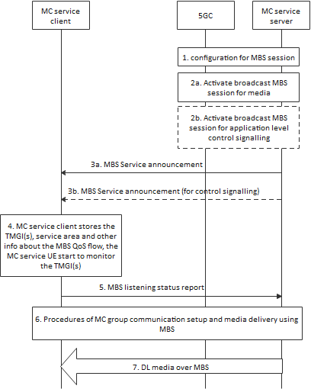
Figure 6.x.1.1.3-1: Use of pre-established broadcast QoS flow
1. The MC service server determines to use the broadcast or the group communication. The MC service configures the broadcast MBS session as specified in 3GPP TS 23.247[x].
2a. The MC service server determines to activate broadcast MBS session to establish the broadcast QoS flow. The activation of the broadcast QoS flow is done on the N29 reference point and according to 3GPP TS 23.247 [x]. This broadcast QoS flow will be used for the MC communication media.
2b. Optionally, the MC service server may also activate a broadcast QoS flow dedicated for application level control signalling. The activation of the broadcast MBS session is done on N29 reference point and according to 3GPP TS 23.247 [x].
NOTE 1: The procedure to determine the activation of broadcast QoS flow is implementation specific.
3a. The MC service server passes the broadcast MBS session info for the service description associated with the pre-established broadcast QoS flow to the MC service client. The MC service client obtains the TMGI, identifying the broadcast QoS flow, from the service description.
3b. The MC service server may pass the broadcast MBS session info for the service description associated with the pre-established floor control broadcast QoS flow to the MC service client. The MC service client obtains the TMGI, identifying the broadcast QoS flow, from the service description.
NOTE 2: Step 3a and Step 3b can be done in one MBS service announcement message.
4. The MC service client stores the information associated with the TMGI(s). The MC service client uses the TMGI and other related information to activate the monitoring of the broadcast QoS flow by the MC service UE.
5. The MC service client that enters or is in the service area of at least one announced TMGI indicates to the MC service server that the MC service client is able to receive media over the broadcast QoS flow, whereby the MC service server may decide to use the broadcast QoS flow instead of unicast QoS flow for MC communication sessions.
NOTE 3: Step 5 is optional for the MC service UE on subsequent MBS service announcements.
6. An MC service group communication session is established.
7. As the MC service server transmits the media over the broadcast QoS flow, the media packets are detected and delivered to the MC service client.

6.x.1.2 Use of dynamic-established MBS QoS flow

6.x.1.2.1 General
In this scenario, the group communication session is already started and the MC service server uses a unicast QoS flow for communication with the UE on the DL at the start of the group communication session. When the MC service server decides to use an MBS QoS flow for the DL media transmission, the MC service server establishes an MBS QoS flow using the procedures defined in 3GPP TS 23.247 [x]. The MC service server provides MBS service description information associated with MBS QoS flow(s) obtained from the MB-SMF, to the UE. The UE starts using the MBS QoS flow(s) to receive DL media and stops using the unicast QoS flow for the DL media transmission.
NOTE 1: The MC service server logic for determining when to establish the new MBS delivery is implementation specific. For example, the MC service server could decide to establish the broadcast MBS delivery based on the location of the UE's that are a part of the group communication session.

6.x.1.2.2 Dynamic-established Multicast QoS flow procedure
The procedure figure 6.x.1.2.2-1 shows only one of the receiving MC service clients receiving the multicast QoS flow. There might also be MC service clients in the same MC group communication session that receive the communication on unicast QoS flow.

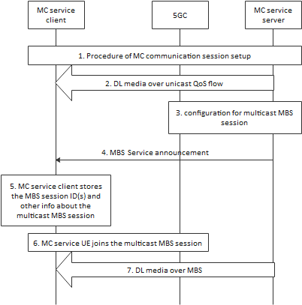
Figure 6.x.1.2.2-1: Use of dynamic-established multicast QoS flow
1. An MC service group communication session is established.
2. The downlink data is sent by unicast delivery.
3. The MC service server configures the multicast MBS session to establish the multicast QoS flow(s) for the group communication session according to the procedures defined in 3GPP TS 23.247 [x]. Service description associated with the multicast MBS session is returned from the MB-SMF.
4. The MC service server provides service description information associated with the multicast MBS session to the UE. The MC service UE obtains the MBS session ID(s) from the announcement message. This message may be sent on an application level control signalling MBS QoS flow.
5. The MC service client stores the MBS session ID(s).
6. The MC service client joins the multicast MBS session with the received MBS session ID(s) as specified in 3GPP TS 23.247[x].
7. MC service server sends the downlink media for the group communication session over the multicast delivery.

6.x.1.2.3 Dynamic-established Broadcast QoS flow procedure
The procedure figure 6.x.1.2.3-1 shows only one of the receiving MC service clients receiving the broadcast QoS flow. There might also be MC service clients in the same MC group communication session that receive the communication on unicast QoS flow.
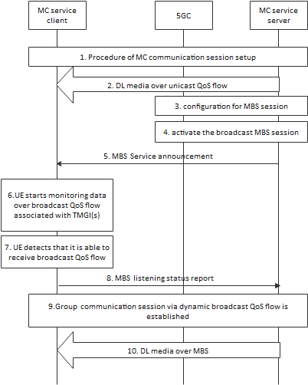
Figure 6.x.1.2.3-1: Use of dynamic broadcast QoS flow establishment
1. An MC service group communication session is established.
2. The downlink data is sent by unicast delivery.
3. The MC service server configures the broadcast MBS session.
4. The MC service server activates broadcast MBS session to establish the broadcast QoS flow for the group communication session according to the procedures defined in 3GPP TS 23.247 [x]. Service description associated with the broadcast QoS flow(s) is returned from the MB-SMF.
5. The MC service server provides service description information associated with the broadcast QoS flow to the UE. The MC service UE obtains the TMGI from the announcement message. This message may be sent on an application level control signalling MBS QoS flow.
6. The MC service UE starts monitoring data over broadcast QoS flow associated with the TMGI, while in the service area associated with the TMGI.
7. The MC service UE detects that it is able to receive data over broadcast QoS flow associated with the TMGI.
8. The MC service client notifies the MC service server the MBS listening status associated to the monitored TMGI, (e.g. that it is successfully receiving the TMGI). The MC service client may also notify the reception quality level of the TMGI. MC service server stops sending media data over unicast way to the MC service client.
NOTE 1: The broadcast QoS flow reception quality level may be used by the MC service server to make an efficient decision to switch again to a unicast transmission or to take measures to prepare such a switch (e.g. when the quality level indicates that the reception quality of the broadcast QoS flow is decreasing or reaching an insufficient quality level for the reception of MC services).
9. An MC service group communication session via dynamic broadcast QoS flow(s) is established.
NOTE 2: Step 9 can occur before step 8.
10. MC service server sends the downlink media for the group communication session over the broadcast delivery.

6.x.1.3 MBS service announcement

6.x.1.3.1 Description
The MBS service announcement may be done on either a unicast QoS flow or a MBS QoS flow. Using a unicast QoS flow for MBS service announcement provides an interactive way of doing announcement. The MC service server will send the MBS service announcement message to the MC service client regardless if there is an MBS QoS flow active or the MC service client can receive the data on the MBS QoS flow with sufficient quality. The benefit of the announcement over unicast QoS flow is that it gives a secure way to inform the MC service client about the MBS session information and how to retrieve the data on the MBS QoS flow.
When there is more than one MBS QoS flow active for MC service, there are not the same reasons to use unicast QoS flow for additional MBS QoS flow announcement. Instead a MBS QoS flow for application level control signalling can be used to announce additional MBS QoS flows.
The MBS service announcement messages are sent on an MBS QoS flow used for application control messages. This MBS QoS flow will have a different QoS setting compared to an MBS QoS flow used for media, since application signalling messages are more sensitive to packet loss.

6.x.1.3.2 MBS service announcement over MBS QoS flow procedure
The procedure defined below enables the MC service to announcement a new MBS QoS flow.
Pre-conditions:
- An MBS QoS flow used for MC service application control messages must have been pre-established and announced to the MC service client.
- Additional MBS QoS flow information may have already been announced to the client.

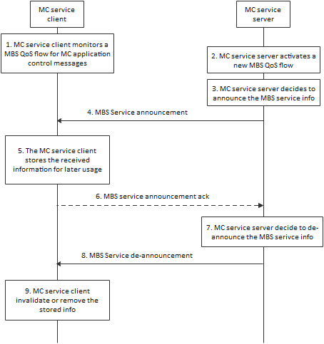
Figure 6.x.1.3.2-1: MBS service announcement over an MBS QoS flow used for application control messages
1. The MC service client monitors an MBS QoS flow that is used for MC service application signalling messages, such as MBS service announcement messages.
2. The MC service server activates a new MBS QoS flow which is either multicast QoS flow or broadcast QoS flow.
3. The MC service server announce the associated MBS service infomation to the MC service client. The MBS QoS flow may have just been activated or may have already been running for some time. The step may be repeated as needed.
4. The MC service server sends a MBS service announcement on the MBS QoS flow used for MC application control messages. The MBS service announcement contains the identity of the MBS serssion (i.e. the TMGI or the source specific IP multicast address) and may optionally include additional information about the newly announced MBS QoS flow. Required and optional MBS service announcement details may have already been provided. In this case the MBS session ID could be used as a key for such MBS QoS flow details.
5. The MC service clients stores the received MBS service information for later usage.
6. If requested by the MC service server, the MC service client sends an acknowledgement of the MBS service announcement to the MC service server.
7. The MC service server de-announce the MBS QoS flow.
8. The MC service server sends a MBS service de-announcement message that contains the MBS session ID.
9. The MC service client invalidates or remove the stored MBS service information.
The same procedure can also be used to modify existing MBS service announcement information. Example of such modification could be addition of UDP ports or modification of codec in the SDP.

6.x.1.4 Information flows for MBS transmission

6.x.1.4.1 MBS service announcement
Table 6.x.1.4.1-1 describes the information flow MBS service announcement from the MC service server to the MC service client.
Table 6.x.1.4.1-1: MBS service announcement
Information element | Status | Description
MBS session ID | M (NOTE 1) | The identity of the MBS session used for media delivery, it is either the TMGI source specific IP multicast address
List of service area identifier | O | A list of service area identifier for the applicable broadcast area.
Frequency | O | Identification of frequency if multi carrier support is provided
SDP information | M | SDP with media and floor control information applicable to groups that can use this MBS QoS flow (e.g. codec, protocol id, FEC information)
Monitoring state | O | The monitoring state is used to control if the client is actively monitoring the broadcast QoS flow quality or not.
Announcement acknowledgment | O | Indicate if an acknowledgement of the MBS service announcement is required
Unicast status | O | An indication that the listening status of the unicast QoS flow is requested.
ROHC information | O | Indicate the usage of ROHC and provide the parameters of the ROHC channel to signal to the ROHC decoder.
NOTE: When MBS service announcement is done on a MBS QoS flow all attributes above are optional except the TMGI.

6.x.1.4.2 MBS listening status report
Table 6.x.1.4.2-1 describes the information flow for the MBS listening status report from MC service client to MC service server. The information is used for the decision on the switching from broadcast delivery to unicast delivery or vice versa.
Table 6.x.1.4.2-1: MBS listening status report
Information element | Status | Description
MC service ID | M | The identity of the MC service user who wants to report the MBS listening status.
TMGI(s) | M | TMGI(s) information.
MBS listening status(s) | M | The MBS listening status per TMGI.
MBS reception quality level | O | The reception quality level per TMGI (see NOTE)
Unicast listening status | O | The unicast listening status.
NOTE: The set of quality levels helps service continuity in MBS scenarios. A reception quality level may help to make an efficient switching decision to another QoS flow. How these levels are used is implementation specific.

6.x.2 Impacts on existing nodes and functionality

MC service server functionality impact is supporting the 5G MBS related functionalities by acting the AF in the 5G MBS architecture including:
- configuring the 5GS MBS session;
- activating the 5G broadcast MBS session;
- supporting MBS session ID in service announcement;
- sending media/floor control message via the 5G MBS delivery to the MB-UPF..

6.x.3 Solution evaluation

This solution is derived from the MBMS mechanism in 3GPP TS 23.280 and the MC service server interacts with the 5GC and send the service anouncement to the UE.
For the broadcast delivery, the mechanism for MC over LTE MBMS can be reused with term and reference update.
For the multicast deliver, the mechanism for the MC over LTE MBMS can be reused by reducing the steps (e.g., listening report) which is not applicable, and also the term, reference update.

