3GPP TSG-SA WG6 Meeting #39-e S6-202052
e-meeting, 31st August – 8th September 2020 (revision of S6-201xxx)

Source: Tencent
Title: Solution to Key issue #5.8: UAS Identification usage in application layer architecture
Spec: 3GPP TR 23.755 v0.11.0
Agenda item: 8.5
Document for: Approval
Contact: Shuai Zhao (Shuaiizhao AT Tencent DOT com)

1. Introduction
This contribution provides a proposal for a solution to key issue #5.8: UAS Identification usage in application layer architecture
2. Reason for Change
Application identification plays an important role across all VAL layers. The SEAL user ID for most of the services is provided for VAL users including location, group, key, configuration management. Therefore, the SEAL needs to have the most updated UAV id to guarantee uninterrupted services for the UAE application layer.
A UAS may connect to a USS/UTM using a 3GPP network, WIFI, internet, or other means of networking approach. Whichever way the connection happens, a USS/UTM may only use one identifier for communicating with the UAS. In 3GPP’s perspective, such RID is called a CAA-level UAV ID. There are currently more than a few CAA-level id considerations that may be associated with one UAS, such as a CAA assigned registration number, ANSI/CTA-2063-A manufacture assigned number, UUID, or an IETF DRIP id. and also, a 3GPP UAV UE ID after connected (e.g. GPSI).
However, there are situations where a UAV may be replaced. The below assumptions are made in the SA2 architecture TR 23.754.
- “A UAV can be replaced by another from a UAS.”
- “A UAV Controller can be removed from a UAS and replaced with another UAV Controller or a TPAE.”
- “The USS/UTM accesses 3GPP services (e.g. location services) for a UAV corresponding to the CAA-level UAV Identity by using the 3GPP UAV Identity (i.e. the GPSI).”
NOTE: the assignment of either CAA-Level ID or 3GPP UAV ID is outside of SA6’s scope.
Also, a 3GPP connected UAV must register with a USS/UTM per certain regulations with a pre- or dynamically assigned CAA-level UAV id as mentioned above. Whatever the case is, after being replaced, a new registration between a UAS and 3GPP network or a UAV to USS/UTM may be needed, which may have an impact on how SEAL provides specific services to a UAS.
The proposed solution described below addresses this issue.
3. Proposal
It is proposed to include into the 3GPP TR 23.755 v0.11.0 the following solution on the support for UAS identification usage in application layer architecture as possible solution for addressing the key issue #5.

* * * First Change * * * *

8.X Solution #x – Support for UAS identification usage in application layer architecture.

8.x.1 Solution description
This solution describes a possible solution for the Key Issue #5.8 defined in Clause 5.8 with preconditions defined below. It focuses on CAA-level ID update due to UAV replacement and describes the interactions between the UAE server and SEAL as well as how to use SEAL for group membership update when there is a UAV replacement.
The pre-conditions for the considered solution space are as follows:
- The UAV-C, UAV-1 and UAV-2 are all previously successfully subscribed with 3GPP and USS/UTM and received a 3GPP UE ID (ex. GPSI) and a CAA-level ID.
- The UAV-2 (a replacement) is also successfully subscribed with 3GPP and USS/UTM also received a CAA-level ID.
- The UAV-1 and UAV-C has previous given a group id by SEAL GM.
The following figure 8.x.1-1 illustrates the group membership update when UAV-2 is used to replace UAV-1
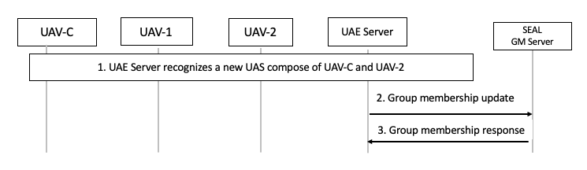
Figure 8.x.1-1: Procedue of group membership update after UAV replacement
- The UAE server recognizes a new pair of UAV-2 and UAV-C by the new CAA-level UAV ID.
- The UAE server sends a group membership update request to SEAL GM server using the procedure specified in Clause 10.3.2.6 of TS 23.434 [4].
- The SEAL GM server sends a group membership update response as specificed in clause 10.3.2.7 of TS 23.434[9].
Post-conditions:
The UAE server may use the newly assigned group ID to manage QoS monitoring and adjustment for UAV-C and UAV-2, as specificed in procudure 8.5.1-2.

8.x.2 Solution evaluation
Editor's Note: This subclause will evaluate the solution.

