3GPP TSG-SA WG6 Meeting #39-bis-e S6-201881 rev1
e-meeting, 12th – 20th October 2020 (revision of S6-20xxxx)

Source: Convida Wireless LLC
Title: Support of multiple delivery mechanisms
Spec: 3GPP TR 23.700-24 v1.0.0
Agenda item: 8.6
Document for: Approval
Contact: Mladin.Catalina@convidawireless.com

1. Introduction
The MSGin5G Service has been specified in TS 22.262 to use “enhancements and optimizations on the 3GPP network capabilities to facilitate IoT applications including device triggering, small data transfer, and Non IP Data Delivery (NIDD) etc.”.
In addition, specific requirements address the need to interwork with legacy message delivery mechanisms such as SMS and to support broadcast. In this contribution we provide a solution showing how the MSGin5G service provides value-add to applications by enabling access to multiple delivery mechanisms, while not exposing the corresponding network APIs. The delivery mechanisms exemplified include device triggering and NIDD, two of the IoT mechanisms called out by TS 22.262. IP-based delivery is also included as a mechanism underlying the delivery of the service data.
While providing some of the details of how each of the mechanisms is to be supported (e.g. by indicating the T8 APIs that can be used for device triggering), the intent of the contribution is to provide first high-level TR description of how the MSGin5G service may manage multiple mechanisms. Each mechanism (e.g. IP-based delivery) may then be more fully described in a separate solution/section. Finally, it is the expectation that normative stage 2 and stage 3 will follow providing all the necessary implementation details down to protocol level.
The contribution also addresses the following comments on this topic received for the related S6-201629 at SA5#39-e:
5GMARCH develops MSGin5G service to deliver MSGin5G messages among MIoT service endpoints (supporting UEs). It is a typical client server service that all the messages will be delivered by the new GSMin5G server. The new protocols and procedures on application layer are developed for MSGin5G service to exchange MSGin5G messages between the 5GMSGS client (in the 5GMSGS UE) and MSGin5G server and always be used. The application layer message routing is always based on the service ID independent of whatever the transport protocol to deliver it which is not is SA6 scope. The MSGin5G message delivery to non 5GMSGS UE (i.e. not 5GMSGS client but such as a SMS/NIDD client) is covered in 6.X through a Message Gate.
[response] Using service ID for routing in MSGin5G is a proposed solution which needs to be agreed and specified in the normative phase. It has not yet been shown to cover all cases in work scope.

2. Reason for Change
Introduce high-level solution for the Key Issue on exposure of multiple delivery mechanisms
3. Proposal
It is proposed to agree the following changes to 3GPP TR 23.700-24 v1.0.0.

* * * First Change * * * *

2 References
The following documents contain provisions which, through reference in this text, constitute provisions of the present document.
- References are either specific (identified by date of publication, edition number, version number, etc.) or non-specific.
- For a specific reference, subsequent revisions do not apply.
- For a non-specific reference, the latest version applies. In the case of a reference to a 3GPP document (including a GSM document), a non-specific reference implicitly refers to the latest version of that document in the same Release as the present document.
[1] 3GPP TR 21.905: "Vocabulary for 3GPP Specifications".
[2] 3GPP TS 22.262: "Message Service within the 5G System".
[3] 3GPP TS 23.682: "Architecture enhancements to facilitate communications with packet data networks and applications".
[4] GSMA PRD RCC.07: "RCC.07 Rich Communication Suite 9.0 Advanced Communications Services and Client Specification v10.0".
[5] OMA OMA-ERELD-LightweightM2M-V1_1-20180612-C: "Enabler Release Definition for LightweightM2M".
[6] 3GPP TS 23.041: "Technical realization of Cell Broadcast Service (CBS)".
[7] 3GPP TS 23.038: "Alphabets and language-specific information".
[8] 3GPP TS 38.331: "NR; Radio Resource Control (RRC); protocol specification".
[9] 3GPP TS 23.434: "Service Enabler Architecture Layer for Verticals".
[10] 3GPP TS 23.502: "Procedures for the 5G System".
[11] 3GPP TS 23.040: "Technical realization of the Short Message Service (SMS)".
[12] ATIS-0700008.v002: "Cell Broadcast Entity (CBE)-to-Cell Broadcast Center (CBC) Interface Specification".
[13] 3GPP TS 23.222: "Functional architecture and information flows to support Common API Framework for 3GPP Northbound APIs; Stage 2".
[14] 3GPP TS 23.501: "System Architecture for the 5G System (5GS); Stage 2".
[yy] 3GPP TS 29.122: "T8 reference point for northbound Application Programming Interfaces (APIs)".
[zz] 3GPP TS 29.522: "5G System; Network Exposure Function Northbound APIs; Stage 3".

* * * Second Change * * * *

6.X Solution X: Support of multiple MTC delivery mechanisms for legacy 3GPP UEs

6.X.1 Description
This clause addresses identified gaps about message delivery to Legacy 3GPP UEs when multiple MTC delivery mechanisms are supported.

6.X.2 Overview of message delivery to Legacy 3GPP UE
Pre-condition:
- The MSGin5G server received an MSGin5G message request, the target of this MSGin5G message includes a Legacy 3GPP UE.
- The MSGin5G server is able to determine whether a terminating UE is a Legacy 3GPP UE, and which MTC message delivery mechanisms are available.
Editor’s Note. How the MSGin5G server determines whether a terminating UE is a Legacy 3GPP UE is FFS
- The Legacy 3GPP Message Gateway is provided by the MSGin5G Server with information on service IDs to maintain mappings to the IDs used in the legacy network
Editor’s Note. How the Legacy 3GPP Message Gateway is provided with information to maintain ID mapping information is FFS
Figure 6.X.2-1 shows message delivery from MSGin5G Server to the Legacy 3GPP UE.
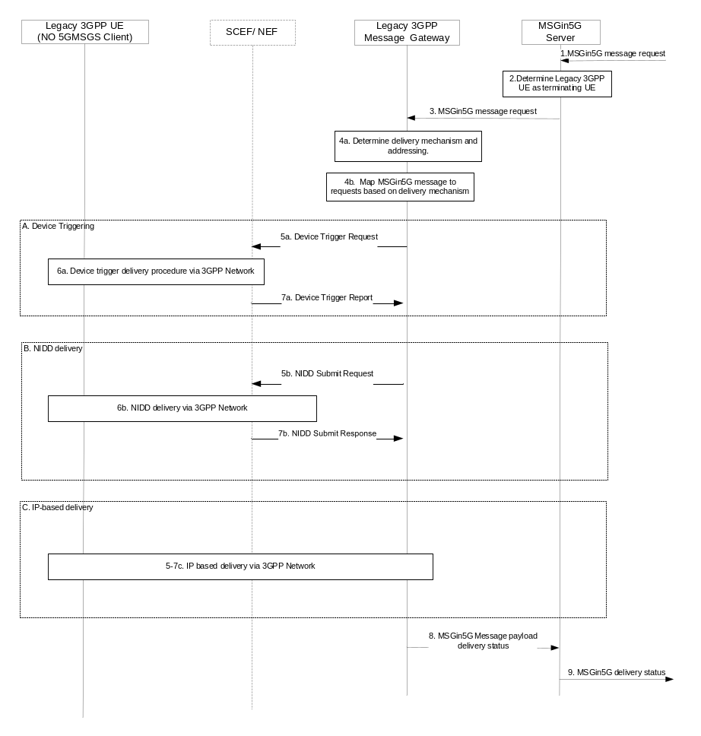
Figure 6.X.2-1: Message delivery from MSGin5G server to Legacy 3GPP UE
- The MSGin5G server receives an MSGin5G message request
- The MSGin5G server identifies that the target UE is a Legacy 3GPP UE e.g. based on MSGin5G service ID.
- The MSGin5G server sends the MSGin5G message to the Legacy 3GPP Message Gateway.
- a. The Legacy 3GPP Message Gateway maps the service ID to the corresponding identifier based on Legacy 3GPP UE capability, the UE communication status, the MSGin5G service configuration, etc. For example (the following is not an exhaustive list):
  - For the Device triggering delivery mechanism, it maps the service ID to MSISDN and Application port ID
  - For NIDD delivery mechanism it maps the service ID to External Identifier or MSISDN.
  - For IP delivery via an established IP connection, it maps the service ID to the UE IP address.
Editor’s Note: The role of the Legacy 3GPP Message Gateway in IP delivery, as well as the IP delivery mechanism for this case are FFS.
NOTE: How the choice of delivery mechanism is made is FFS. The examples above show how the Legacy 3GPP Message Gateway can enable the MSGin5G message delivery via a variety of available MTC mechanisms. Implementation and configuration choices may limit the delivery mechanisms available.
b. The Legacy 3GPP Message Gateway maps MSGin5G message Information Elements and payload depending on delivery mechanism.
5-7) The Legacy 3GPP Message Gateway sends the payload of the MSGin5G message to the terminating Legacy 3GPP UE using the determined delivery mechanism. For example:
- For Device triggering delivery mechanism, the Legacy 3GPP Message Gateway interacts with the SCEF/NEF and maps the payload of the MSGin5G message to one or more Device Triggering requests. The SCEF/NEF interacts with SMS-SC for delivery to the UE and to receive the Message Delivery Report (see TS 23.682 [3] clause 5.2, TS 29.122[yy] clause 4.4.6, TS 29.522 [zz] clause 4.4.3)
- For NIDD delivery mechanism, the Legacy 3GPP Message Gateway interacts with the SCEF/NEF and maps the payload of the MSGin5G message to one or more NIDD submit request messages. The Reliable Data Service Configuration, Maximum Latency, Priority, PDN Connection Establishment Option settings are based on pre-configurations (see TS 23.682 [3] clause 3.13, TS 29.122 [yy] clause 4.4.5.3, TS 29.522 [zz] clause 4.4.12.3).
- For IP delivery it initiates IP-based delivery to the UE of the payload of the MSGin5G message.
Editor’s Note: The role of the Legacy 3GPP Message Gateway in IP delivery, as well as the IP delivery mechanism for this case are FFS.
The Legacy 3GPP UE receives the payload of the MSGin5G message and the mapped Information Elements and interprets them depending on the receiving client.
8) The MSGin5G Legacy 3GPP Message Gateway sends MSGin5G delivery status to the MSGin5G Server.
9) The MSGin5G Server sends MSGin5G delivery status to the Application Server.

6.X.3 Overview of message delivery from Legacy 3GPP UE
Editor’s Note: Clause TBD

6.Y Solution Y: Support of multiple MTC delivery mechanisms for 5GMSGS UEs

6.Y.1 Description
This solution addresses identified gaps about message delivery to 5GMSGS UEs.

6.Y.2 Overview of message delivery to 5GMSGS UE
Pre-condition:
- The MSGin5G server received an MSGin5G message request, the target of this MSGin5G message is a 5GMSGS UE.
- The MSGin5G server is pre-configured to be able to determine whether a terminating UE is a 5GMSGS UE, and which MTC message delivery mechanisms are available.
Editor’s Note. How the MSGin5G server determines whether a terminating UE is a 5GMSGS UE is FFS
Figure 6.X.2-1 shows message delivery from MSGin5G Server to the 5GMSGS UE.
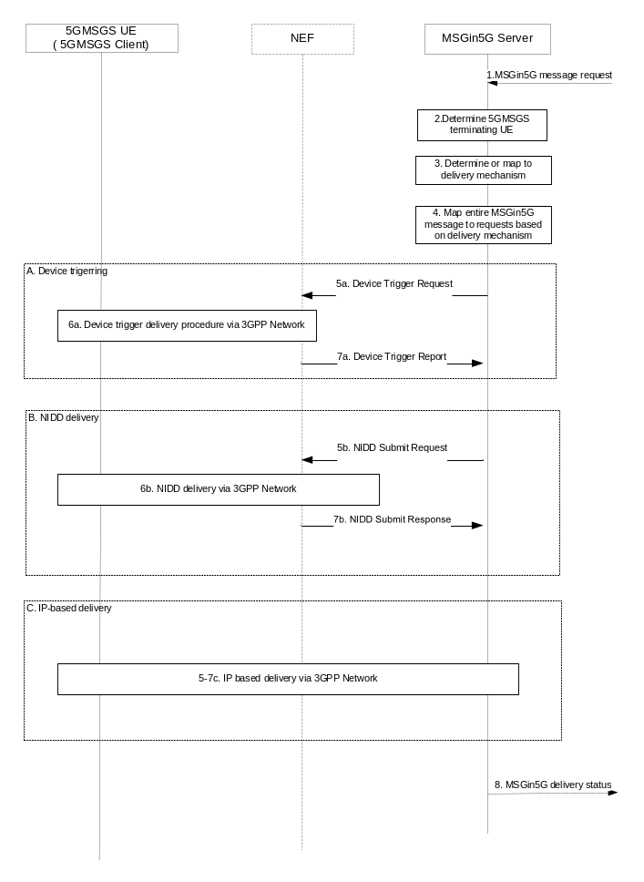
Figure 6.Y.2-1: Message delivery from MSGin5G server to 5GMSGS UE
- The MSGin5G Server receives an MSGin5G message request
- The MSGin5G Server identifies that the target UE is a 5GMSGS UE e.g. based on MSGin5G service ID.
- The MSGin5G Server maps the service ID to the corresponding identifier based on 5GMSGS UE capability, the UE communication status, the MSGin5G service configuration, etc. For example (the following is not an exhaustive list):
  - For Device triggering delivery mechanism, it maps the service ID to MSISDN and 5GMSGS Client port ID
  - For NIDD delivery mechanism it maps the service ID to External Identifier or MSISDN
  - For IP delivery via an established IP connection, it maps the service ID to the IP address.
NOTE: How the choice of delivery mechanism is made is FFS. The examples above show how the MSGin5G Server can enable the MSGin5G message delivery via a variety of mechanisms.
- The MSGin5G Server maps the entire MSGin5G message into requests, depending on the delivery mechanism, e.g. the entire MSGin5G message may be mapped into several NIDD messages.
NOTE: How the choice of delivery mechanism is made is FFS. The examples above show how the MSGin5G server can enable the MSGin5G message delivery via a variety of mechanisms. Implementation and configuration choices may limit the delivery mechanisms available.
- The MSGin5G Server maps MSGin5G message Information Elements and payload depending on delivery mechanism.
5-7) The MSGin5G Server sends the entire MSGin5G message to the 5GMSGS Client on the terminating UE using the determined delivery mechanism. For example:
- For Device triggering delivery mechanism, the MSGin5G Server interacts with the NEF and maps the MSGin5G message to one or more Device Triggering requests. The NEF interacts with SMS-SC to receive the Message Delivery Report) (see TS 23.682 [3] clause 5.2, TS 29.522 [zz] clause 4.4.3)
- For NIDD delivery mechanism, the MSGin5G interacts with the NEF and maps the MSGin5G message to one or more NIDD submit request messages. The Reliable Data Service Configuration, Maximum Latency, Priority, PDN Connection Establishment Option settings are based on pre-configurations (see TS 23.682[3] clause 3.13, TS 29.122 [yy] clause 4.4.5.3, TS 29.522 [zz] clause 4.4.12.3).
- For IP delivery it initiates IP-based delivery to the UE.
The 5GMGS Client receives the data and interprets it as MSGin5G message (i.e. both the header and the payload).
8) The MSGin5G Server sends MSGin5G delivery status to the Application Server.

6.Y.3 Overview of message delivery from 5GMSGS UE
Editor’s Note: Clause TBD

