3GPP TSG-SA WG6 Meeting #22 S6-180723
Newport Beach, US, 16th – 20th April 2018 (revision of S6-180683)
CR-Form-v11.2
CHANGE REQUEST
 | 23.283 | CR | 0005 | rev | 3 | Current version: | 15.0.0
For HELP on using this form: comprehensive instructions can be found at
http://www.3gpp.org/Change-Requests.

Proposed change affects: | UICC apps |  | ME | X | Radio Access Network |  | Core Network | x

Title: | Corrections to chat group call procedures and information flows
Source to WG: | Airbus
Source to TSG: | S6
Work item code: | MCCI |  |  |  |  |  |  | Date: |  | 2018-04-17
Category: | F |  |  |  |  |  |  | Release: |  | Rel-15
 | Use one of the following categories:  F (correction)  A (mirror corresponding to a change in an earlier release)  B (addition of feature),  C (functional modification of feature)  D (editorial modification)  Detailed explanations of the above categories can  be found in 3GPP TR 21.900. |  |  |  |  |  |  |  | Use one of the following releases:  Rel-8 (Release 8)  Rel-9 (Release 9)  Rel-10 (Release 10)  Rel-11 (Release 11)  Rel-12 (Release 12)  Rel-13 (Release 13)  Rel-14 (Release 14)  Rel-15 (Release 15)  Rel-16 (Release 16)
Reason for change: |  | Several corrections required for the Chat group call subclause  Group join request information flow is missing "implicit floor request" IE.  Error in subclause 10.3.5.2: group is defined in LMR system, but authorization check is done in the MCPTT server.  Titles of subclauses 10.3.5.2 and 10.3.5.3 are ambiguous.  Subclauses 10.3.5.6 and 10.3.5.7 should be common for pre-arranged and chat group calls, now they are under chat group call only.
Summary of change: |  | 10.3.2.8 IWF group join request  -"Implicit floor request" IE added  10.3.5.2  -title changed to describe better the actual procedure  Figure 10.3.5.2-1  -error corrected – MCPTT server does not make authorization check for groups defined in the LMR system  10.3.5.3  -title changed to describe better the actual procedure  -clarification to the figure and corrections to the description of the steps (the order of actions was incorrect)  10.3.5.5 Release chat group call defined in the MCPTT system  -clarification to the text  Subclauses 10.3.5.6 and 10.3.5.7 are common to chat and pre-arranged group calls. They are marked as void and the content moved into a new sub-clause 10.3.6.  Editorial correction in Table 10.3.2.8-1: "NOTE1" →"See NOTE1" →.
Consequences if not approved: |  | Incorrect and/or ambiguous sublcause titles, procedure descriptions and information flow.
Clauses affected: |  | 10.3.2.8, 10.3.5.2, 10.3.5.3, 10.3.5.4, 10.3.5.5, 10.3.5.6, 10.3.5.7, 10.3.6 (new), 10.3.6.1 (new), 10.3.6.2 (new), 10.3.6.3 (new)
 |  | Y | N
Other specs |  |  | x | Other core specifications |  |  | TS/TR ... CR ...
affected: |  |  | x | Test specifications |  |  | TS/TR ... CR ...
(show related CRs) |  |  | x | O&M Specifications |  |  | TS/TR ... CR ...
Other comments:

* * * First change * * * *

10.3.2.8 IWF group join request
Table 10.3.2.8-1 describes the information flow IWF group join request from the IWF to the MCPTT server and from the MCPTT server to the IWF.
Table 10.3.2.8-1: IWF group join request information elements
Information Element | Status | Description
MCPTT ID | M | The MCPTT ID of the originator of the request. (see NOTE 1)
MCPTT group ID | M | The MCPTT group ID of the group to which the group communication is requested
SDP offer | M | Media parameters of originator
Implicit floor request (see NOTE 2) | O | Indicates that the originating client requests the floor.
NOTE 1: The IWF is configured with an MCPTT ID for use when the IWF is affiliating itself to the group on behalf of the LMR system.
NOTE 2: This element is included only when the originating client requests the floor.

* * * Second change * * * *

10.3.5.2 MCPTT user initiated chat group call in an interworking group defined in LMR system
In this procedure, an MCPTT user initiates a chat group call in an interworking group defined in the LMR system. The signalling procedure is described in figure 10.3.5.2-1.

Pre-conditions:
1. The interworking group information is known at the MCPTT server and the IWF by configuration or group creation. The interworking group has been defined in the LMR system.
2. The mapping relationship of group and user identities between the MCPTT system and the LMR system has been configured at the IWF.
NOTE: For all the signalling messages passing through the IWF between the MCPTT system and the LMR system, the IWF performs the identity conversion and protocol translation.

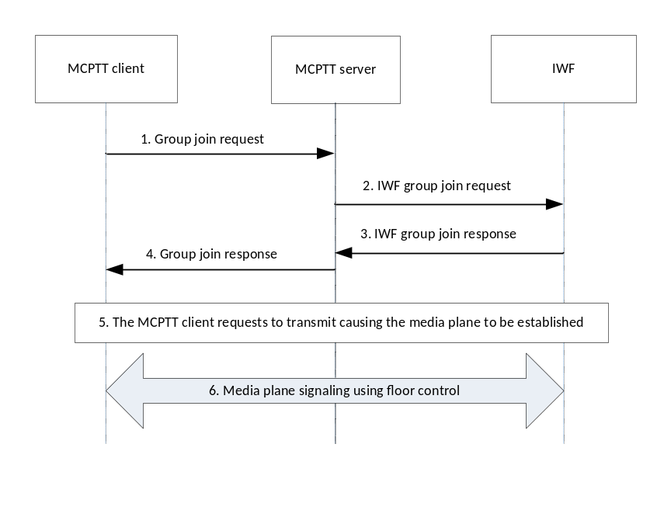
Figure 10.3.5.2-1: MCPTT user initiated chat group call in an interworking group defined in the LMR system
1. MCPTT user of the MCPTT client indicates to join the group communication for the group. This may include a request to transmit.The MCPTT client joins the group by sending a group join request to the MCPTT server. If there is a request to transmit, then the group join request contains an indication of an implicit floor request.
2. The MCPTT server notices that the interworking group is defined in the LMR system and forwards the group join request as an IWF group join request to the IWF.

3. The IWF replies with an IWF group join response indicating the acceptance of the group join request and also returns the IWF selected media parameters for the chat group call in the IWF group join response.
4. The MCPTT server forwards the IWF group join response to the MCPTT client as a group join response.
5. If the MCPTT client requests to transmit, the MCPTT server establishes the media plane (if not already established) for the call.
6. Floor control will continue to be used by the floor participants associated with the MCPTT client and the IWF for the duration of the call. Media plane signalling using floor control will be used for subsequent calls for the group as long as one or more users are affiliated.

10.3.5.3 LMR user initiated chat group call in an interworking group defined in MCPTT system
In this procedure, an LMR user initiates a chat group call in an interworking group defined in the MCPTT system. The signalling procedure is described in figure 10.3.5.3-1.

Pre-conditions:
1. The interworking group information is known at the IWF by configuration. The interworking group has been defined in the MCPTT system.
2. MCPTT user 1 and MCPTT user 2 have previously joined (affiliated) to the group.
3. The mapping relationship of group and user identities between the MCPTT system and the LMR system has been configured at the IWF.
4. LMR user initiates a join to the group.
NOTE: For all the signalling messages passing through the IWF between the MCPTT system and the LMR system, the IWF performs the identity conversion and protocol translation.

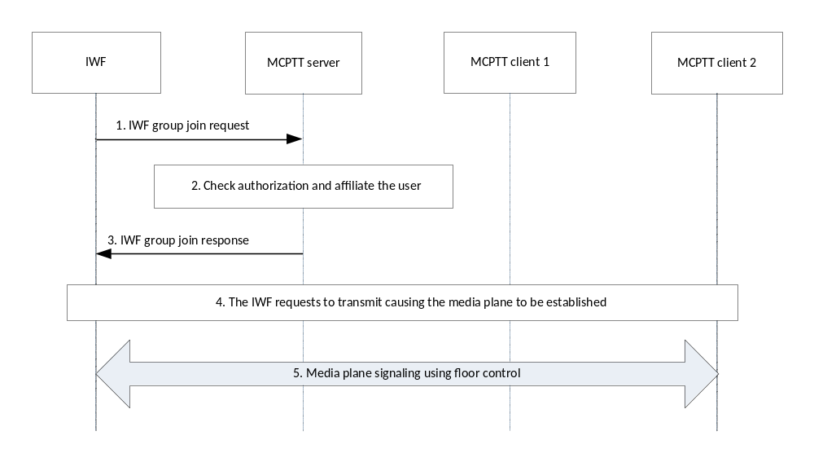
Figure 10.3.5.3-1: LMR user initiated chat group call in an interworking group defined in the MCPTT system
1. The IWF sends an IWF group join request to the MCPTT server. If there is a request to transmit, then the IWF group join request contains an indication of an implicit floor request.
2. The MCPTT server checks whether the MCPTT ID is authorized to affiliate to the group. MCPTT server generates an implicit affiliation if the MCPTT ID is not already affiliated to the group.
3. The MCPTT server replies with a group join response indicating the acceptance of the group join request and also returns the MCPTT server selected media parameters for the chat group call in the IWF group join response.
4. If the IWF requests to transmit, the MCPTT server establishes the media plane (if not already established) for the call.
5. Floor control will continue to be used by the floor participants associated with MCPTT client 1, MCPTT client 2 and the IWF for the duration of the call. Media plane signalling using floor control will be used for subsequent calls for the group as long as one or more users are affiliated.

10.3.5.4 Release chat group call on an interworking group defined in the LMR system
This procedure describes the case where the LMR system releases an ongoing MCPTT chat group call on an interworking group defined in the LMR system, for all the participants of that group call. The signalling procedure is described in figure 10.3.5.4-1.

Pre-conditions:
1. A chat group call is ongoing involving an MCPTT client and the IWF.
2. The LMR system initiates release of the chat group call.
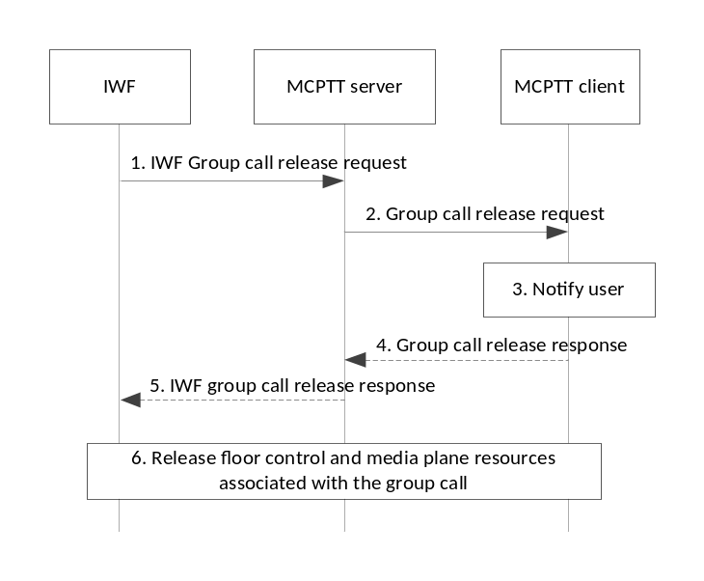
Figure 10.3.5.4-1: Release chat group call on an interworking group defined in the LMR system
1. The IWF sends an IWF group call release request to the MCPTT server. An individual IWF group call release request is sent for each MCPTT user in the call.
2. MCPTT server forwards the release request(s) to the group's MCPTT users, as described in 3GPP TS 23.379 [7].
3. MCPTT users are notified about the release of the group call.
4. Optionally, the MCPTT client confirms the group call release request received in step 2 with a group call release response to the MCPTT server.
5. The MCPTT server forwards the group call release response to the IWF as an IWF group call release response.
6. The MCPTT client and the IWF release the floor control and media plane resources associated with the chat group call that is released. Successful release of the chat group call does not affect the status of affiliation of any of the clients.

10.3.5.5 Release chat group call on an interworking group defined in the MCPTT system
This procedure describes the case where the MCPTT server releases an ongoing MCPTT chat group call, on an interworking group defined in the MCPTT system, for all the participants of that group call, since at least one of the conditions for release are met e.g. due to hang time expiry, last participant leaving, second last participant leaving, initiator leaving, the number of affiliated MCPTT group members is below the minimum number permitted.
The signalling procedure is described in figure 10.3.5.5-1.
Pre-conditions:
1. A chat group call is ongoing involving MCPTT clients 1, 2 and the IWF.
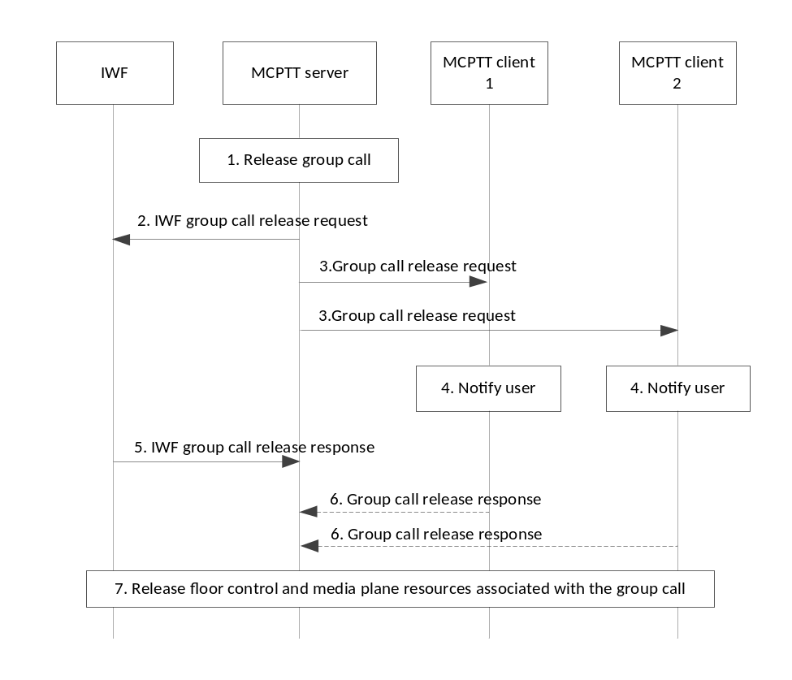
Figure 10.3.5.5-1: Release chat group call on an interworking group defined in the MCPTT system
1. The MCPTT server decides to release the MCPTT chat group call which is ongoing e.g., due to hang time expiry, last participant leaving, second last participant leaving, initiator leaving, or minimum number of affiliated MCPTT group members are not present.
2. The MCPTT server sends an IWF group call release request to the IWF to release the ongoing session. If the IWF has joined itself to this group on behalf of all the group's LMR users, only one IWF group call release request message is sent to the IWF. If the MCPTT server has received individual joins from the group's LMR users, an individual IWF group call release request is sent to the IWF for each joined LMR user.
3. The MCPTT server sends a group call release request towards each MCPTT participant of the ongoing group call.
4. The MCPTT users are notified about the release of the group call.
5. The IWF confirms the IWF group call release request(s) received in step 2 by IWF group call release response(s) to the MCPTT server.
6. Optionally, the MCPTT client(s) receiving a group call release request may send a group call release response to the MCPTT server.
7. MCPTT client 1, client 2 and the IWF release the floor control and media plane resources associated with the chat group call that is released. Successful release of the chat group call does not affect the status of affiliation of any of the clients.

10.3.5.6 void

10.3.5.7 void

* * * Third change * * * *

10.3.6 Exiting group call due to de-affiliation

10.3.6.1 General
The following procedures are applicable both for the pre-arranged and chat group calls.

10.3.6.2 Exiting group call defined in the LMR system due to de-affiliation
Procedures in figure 10.3.6.2-1 are the signalling control plane procedures for the IWF requesting a newly de-affiliated MCPTT user to leave an ongoing MCPTT group call.
Pre-conditions:
1. The MCPTT group is previously defined on the IWF with MCPTT users affiliated to that group. At least one user is an LMR user represented by an MCPTT ID.
2. An MCPTT user on the MCPTT client and an LMR user via the IWF, are on an ongoing call.
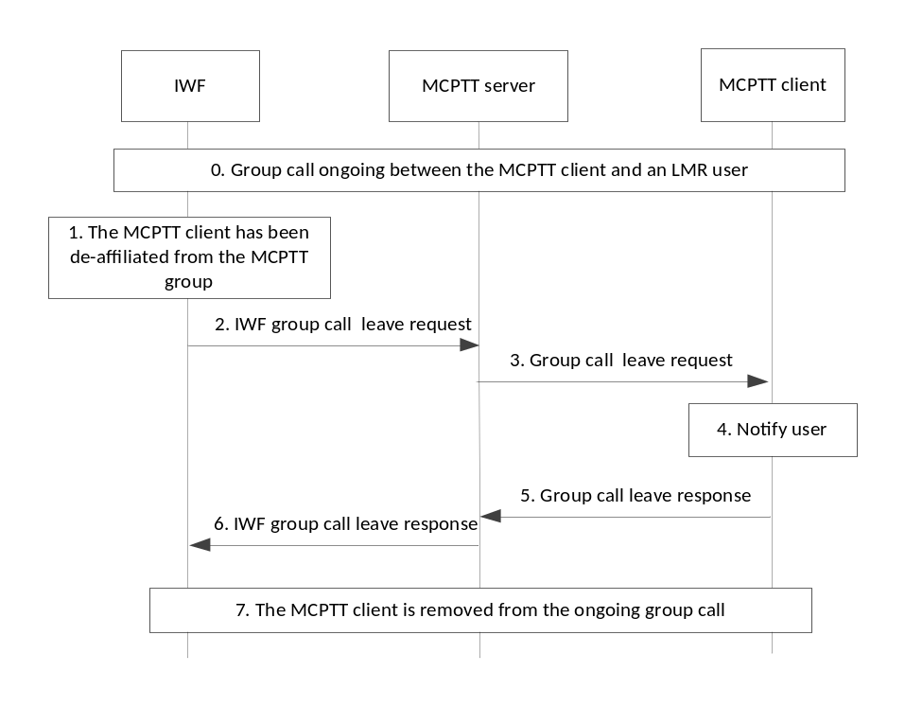
Figure 10.3.6.2-1: Exiting MCPTT group call due to de-affiliation
1. The MCPTT client is de-affiliated.
2. The IWF sends an IWF group call leave request to the MCPTT client via the MCPTT server.
3. The MCPTT server forwards the IWF group call leave request as a group call leave request to the MCPTT client.
4. The MCPTT user at the MCPTT client is notified about leaving the group call.
5. The MCPTT client sends the group call leave response to the MCPTT server and leaves the group call.
6. The MCPTT server forwards the group call leave response to the IWF as an IWF group call leave response.
7. The MCPTT client is now removed from the ongoing group call.

10.3.6.3 Exiting group call defined in the MCPTT system due to de-affiliation
Procedures in figure 10.3.6.3-1 are the signalling control plane procedures for the MCPTT server requesting a newly de-affiliated LMR user to leave an ongoing MCPTT group call.
Pre-conditions:
1. The MCPTT group is previously defined on the group management server with MCPTT users affiliated to that group. At least one user is an LMR user represented by an MCPTT ID.
2. An MCPTT user on the MCPTT client and an LMR user via the IWF, are on an ongoing call.
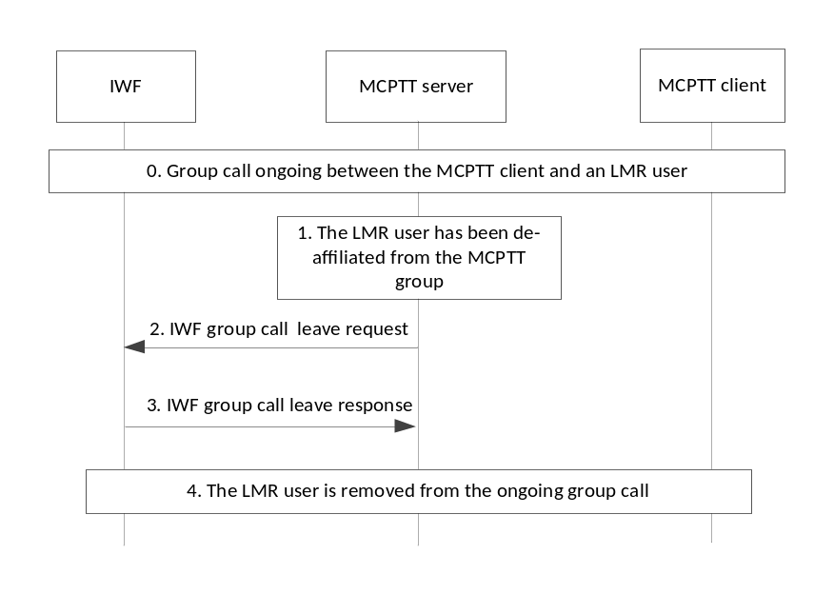
Figure 10.3.6.3-1: Exiting MCPTT group call due to de-affiliation
1. The LMR user represented by the IWF has been de-affiliated.
2. The MCPTT server sends an IWF group call leave request to the LMR user via the IWF.
3. The IWF sends an IWF group call leave response to the MCPTT server and leaves the group call.
4. The LMR user represented by the IWF is now removed from the ongoing group call.

* * * End of changes * * * *

