3GPP TSG-SA WG6 Meeting #52-bis-e S6-22xxxx
e-meeting, 11th – 20th January 2023 (revision of S6-22xxxx)

Source: China Mobile
Title: Deployment model
Spec: 3GPP TS 23.435
Agenda item: 8.10
Document for: Approval
Contact: Shaowen Zheng, zhengshaowen@chinamobile.com

1. Introduction
This contribution adds the deployment model of the NSCALE.
2. Reason for Change
There are two ENs about the edge NSCE need to be solved, and the deployment model in the Annex is needed.
4. Proposal
It is proposed to agree the following changes to TS 23.435.

* * * First Change * * * *

Annex A (informative):
Deployment models

A.1 Deployment scenarios

A.1.1 General
In addition to SA2 and SA5 network slicing capabilities, the NSCE service provides application layer enablement to support the network slice management and control in the granularity of slice which is identified by S-NSSAI.
A network slice can have only one owner and one NSCE service provider. NSCE service provider and slice owner can be different. For example the slice owner is VAL server, but the NSCE service provider is MNO.
This clause describes examples of deployment models with respect to different deployment scenarios as follows.

A.1.2 Centralized NSCE deployment
Figure A.1.2 shows a fundamental deployment of NSCE server whose service area covering the whole PLMN. It is also possible slice coverage area to be smaller than the NSCE service area.
The network slice capability enablement service is provided with the view of whole PLMN in this scenario.
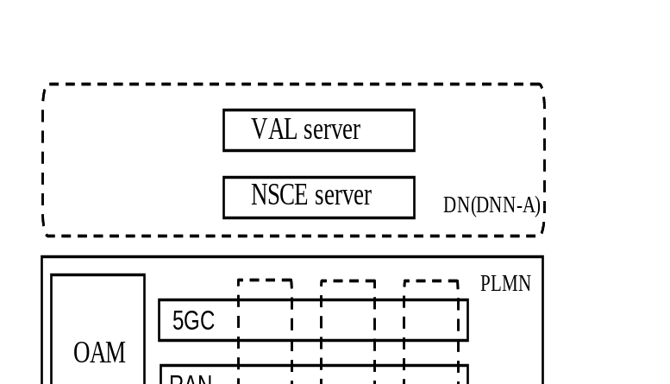
Figure A.1.2: Illustration of centralized NSCE deployment

A.1.3 Distributed NSCE deployment
The distributed deployment refers to the deployment model in which the service area only covers some specific areas as shown below (based on geographical coordinates or TA list(s)).
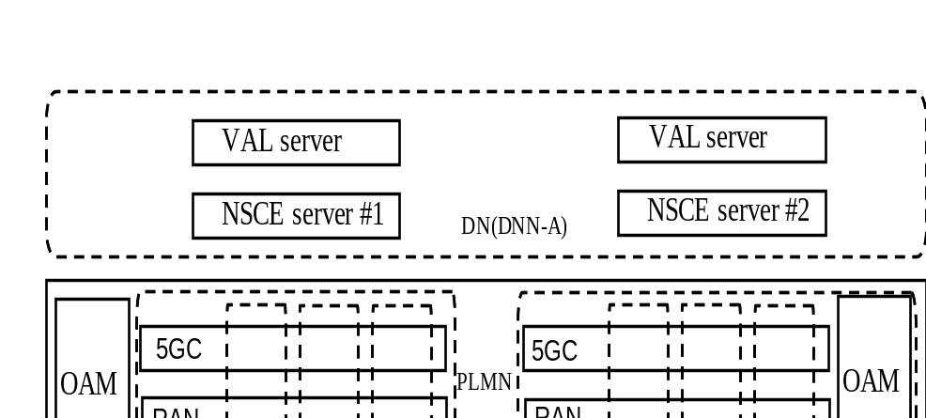
Figure A.1.3: Illustration of distributed NSCE deployment

When there are multiple NSCE servers managed by same provider, NSCE server(s) may be subscribed for providing the network slice statistics to another NSCE server to provide a global view.
There can be two use cases to provide the NSCE service in the distributed deployment:
One use case is that the distributed deployed NSCE is about a slice service area which is equivalent to the edge/NPN area. For this scenario, if the distributed deployed NSCE wants to access the NEF/NWDAF/NSACF services or to receive policies from OAM, it needs to interact to the global NSCE.
A further use case could be that some NSCE services (e.g. MnS discovery) are locally provided to VAL servers (for example as a micro-service), whereas other capabilities are provided for the whole PLMN area. So, the distributed NSCE includes a subset of capabilities which are edge native. The local deployment of such capabilities can allow for more efficient services to the VAL servers (e.g. for QoS verification, the edge deployed NSCE can receive more timely KQI/QoE measurements and can process them locally before triggering an event).

A.1.3.1 NPN NSCE deployment
Figure A.1.3.1 shows the NPN NSCE server deployment. This case is valid if a geographical match between slice coverage area, NPN coverage area and NSCE service area is pre-configured. The matching may be pre-configured by network operator based on the TA list. The service area of the NSCE server equals to the area of the NPN in this case. The slice(s) coverage area may equals to the area of the NPN, but it is also possible slice coverage area to be smaller than the NPN service area.
The NSCE server is deployed in Non-public network to provide the network slice capabilities exposure application service based on the interaction with NPN-5GC and NPN-OAM.
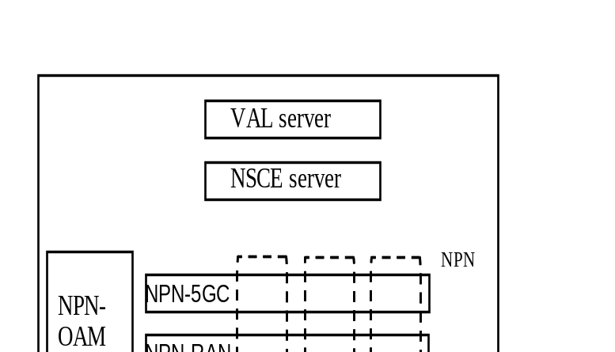
Figure A.1.3.1: Illustration of NPN NSCE deployment

A.1.3.2 Edge NSCE deployment
Figure A.1.3.2 shows the edge NSCE deployment cases when the NSCE server is deployed in the EDN using LADNs as described in Annex A.2.4 of TS 23.558[x]. This case is valid if a geographical match between slice coverage area, LADN service area (which is EDN service area) and NSCE service area is pre-configured. The matching can based on the TA list or geographical coordinates. The service area of the NSCE server equals to the area of the LADN in this case. The slice(s) coverage area may equals to the area of the LADN(EDN), but it is also possible slice coverage area to be smaller than the LADN(EDN) service area.
The NSCE server is deployed in EDN to provide the network slice capabilities exposure application service based on the interaction with EDN-5GC and EDN-OAM.
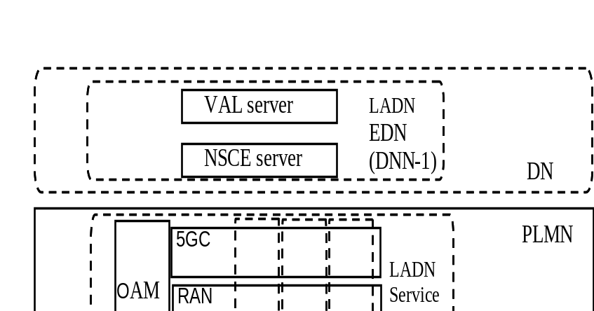
Figure A.1.3.2: Illustration of edge NSCE deployment

A.2 Deployment of NSCE server(s) in relation to VAL server and 3GPP system
To support the centralized/distributed deployment, the NSCE server(s) will have different deployment models and different relation with VAL server and 3GPP system. This clause describes examples of deployment models of NSCE server(s) in relation to VAL server and 3GPP system.
Figure A.2-1 illustrates the centralized NSCE deployment. The NSCE server can be deployed in PLMN domain by MNO, or deployed in VAL service provider domain by vertical.
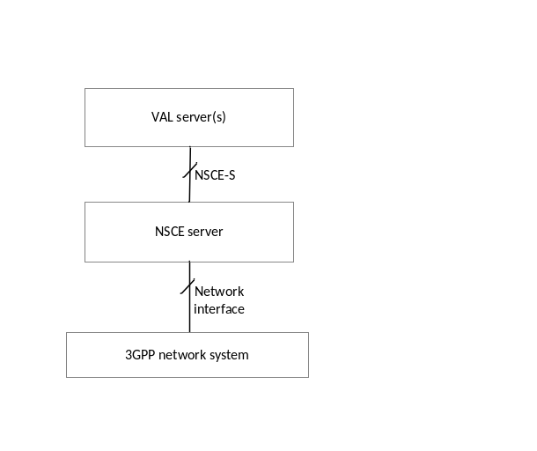
Figure A.2-1: Illustration of centralized NSCE deployment
Figure A.2-2 illustrates the distributed NSCE deployment. The NSCE servers can be deployed in PLMN domain by MNO, deployed in VAL service provider domain by vertical, or deployed in 3rd party domain by3rd party. The VAL server can communicate with multiple NSCE servers via NSCE-S as long as other NSCE servers are discovered and accessible. Or, the VAL server can communicate with other NSCE servers via NSCE-E if needed.
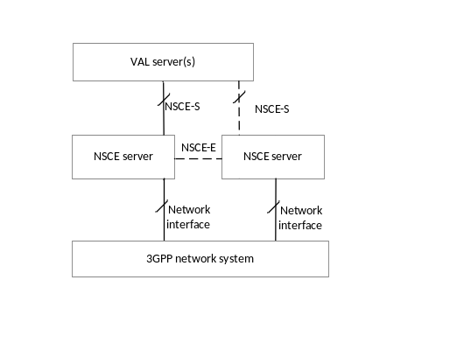
Figure A.2-2: Illustration of distributed NSCE deployment

* * * Next Change * * * *

9.8 Information collection from NSCE server(s)

9.8.1 General
The collected information by NSCE server could be exposed to other NSCE server(s) to optimize network resource allocation, based on the agreement among the NSCE servers. Then the NSCE server providing network slice related information acts as the producer, while the NSCE server obtaining network slice related information is the consumer.

9.8.2 Procedure

9.8.2.1 Information collection from NSCE server(s) subscribe request and response
Pre-condition:
1. The producer NSCE server #2 has agreement with consumer NSCE server #1 to provide the collected slice information.
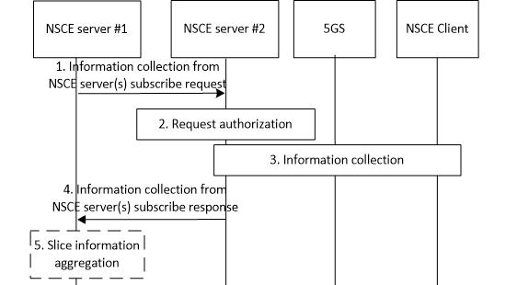

Figure 9.8.2.1-1: Information collection from NSCE server(s) subscribe request and response
1. The NSCE server#1 sends out the information collection subscribe request with expected period and interested slice ID, e.g., List of SNSSAI. This step could be done by pre-configuration.
2. The NSCE server #2 shall check if the NSCE server #1 is authorized to get the network slice information.
3. After authentication, the NSCE server #2 collects slice information.
If the NSCE#2 is an edge NSCE server with the connection of the edge OAM or NEF, then the slice information could be collected from the edge OAM or NEF. Otherwise, the collected slice information is what from the NSCE client.
Editor's note: The service Network slice related performance and analytics monitoring could be re-utilized to collected slice information. While the details and reference of Network slice related performance and analytics monitoring is FFS.

4. The NSCE server #2 sends collected slice information to NSCE server #1.
5. The NSCE server #1 may process the collected slice information (such as information aggregation), if needed.

