3GPP TSG-SA WG6 Meeting #49-e S6-220xxxx
E-meeting, 16th – 25th May 2022 (revision of S6-22xxxx)

Source: CATT
Title: Discussion on Fused Location Server Architecture
Agenda Item: 9.7
Contact: Chunshan Xiong, chunshan.xiong@cictmobile.com

1. Discussion
This discussion aims at following major issues:
- To further refine the architecture for Fused Location Server.
- To further refine the interfaces for the Fused Location Server
- To clarify the main differences between FLS and SEAL LM.
- To define and clarify the interaction modes between FLS and SEAL LM.

1.1 The Fused Location Fuction and the Core Location Services
In the current standalone architecture discussed in solution#1 (as illustrated in Figure 1), the Fused Location Fuction(FLF) is within the positioning and location fusion realm, basically this function provides the basic positioning functions. Based on the requested Location QoS and other request parameters, the Fused Location Fuction provides the requested location information towards the application server and the interface to UE - only to the target UE for location and positioning functions.
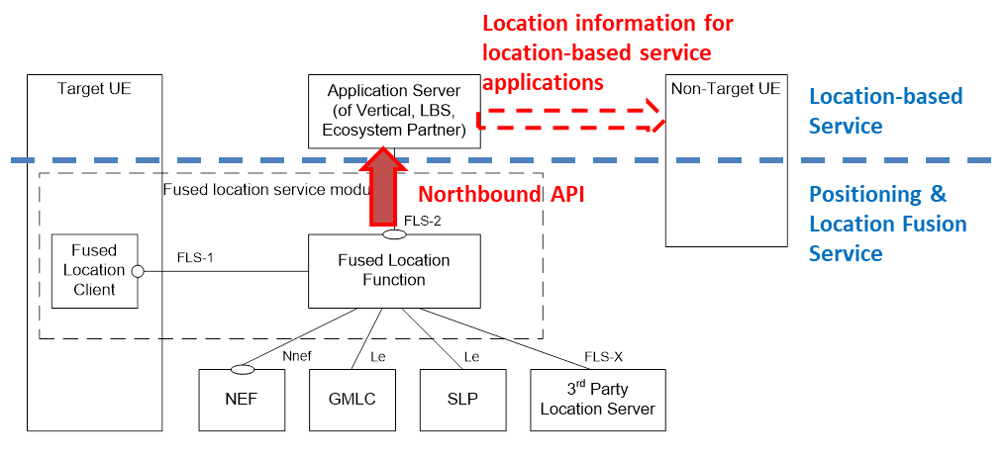
Figure 1. The current Fused Location Function in the TR
It should be addressed that the Fused Location Fuction does not interface with non-target UE directly for providing location for location-based service purpose, i.e. does not process the external user’s request of location-based service, since the Fused Location Fuction (positioning layer) does not have user information. The potential location retrieval by other users (of non-target UEs) will depend on the location-based service level mechanisms and authorizations.
The Fused Location Fuction firstly needs to produce the fused location data from multiple sources based on the the rquested location QoS (e.g. the requirements of the positionting accuracy, reliability and latency). Based on the requested location QoS, the FLF needs to select one or more access types, one or more location methods (as described in TS 29.572) and related CP/UP(SUPL) methods based on the requested location QoS (not exhausted):
- 2G/3G/4G/5G/NR satellite access
- Non-3GPP access connected to 5GC
- GNSS (e.g. GPS, Galilieo, BeiDou etc.)
- Barometric Pressure
- WLAN
- Bluetooth
- Terrestrial Beacon System (TBS) positioning based on MBS signals
- Motion Sensor
- RFID
- Radio finger-print
- Celll ID
- ECID
- OTDOA
- DL_TDOA
- DL_AOD
- Multi-RTT
- NR_ECID
- UL_TDOA
- UL_AOA
- Ultra Wide Band (UWB)
- Fingerprint
Furthermore, and the most important, the Fused Location Server(FLS) needs to include the additional Core Service Functions in order to provide core location services, the core location services are the basic location service used by a lot of mobile internet and industrial applications. A mobile internet and industrial application using the location service normally uses one or more these core location services. The core location services includes (not exhausted)
- Location format mapping
- Location Event Trigger provision, invoke, revoke
- Periodic and or event Triggered location reporting
- Real time location information Pushing
- Geofencing
- (Indoor) Map provision
- Location Alerting
- Real time Tracing request or playback (continuous locations in a map)
- History Trace request or playback
- Time information of the first entering and the last leaveing an area (e.g. working campus)
- The length of time to stay in an area
- The times to re-enter and re-leave an area
- Location information analysis
- Heatmap
- Speed
- Heading Direction
The FLS may needs retrieve location data from the database and/or location contextual information from the target UE. In the Use Case of Accurate positioning to support AR in 3GPP TR 22.872, the contextual information relating to the user’s position and motion is needed, and this contextual information can be acquired from the UE e.g. by sensors. In the Use Case of Flow management in large transportation hubs, the contextual information (e.g. local map, radio finger-print) is needed and can be acquired from the relevant database.
The FLS may need to store the target UE's location information and associated time information stored in a database. And the FLS can suport the query of the first time to enter and the last time to leave an area (e.g. the working campus) , this function are widely used by a lot of companies to check the (per-day and per-month) working time of the employees.
As illustrated in the diagram below, Fused Location Server architecture should include two layers functions: the first layer function is the Fused Location Function(produces the precise location information) and the second layer funcgitons is the Core Service Functions (as list above) as well. The Core Service Functions can be provided as dedicated APIs (through FLS-2 interface) towards the verticals, and are independent with each other.
Figure 2. The updated Fused Location Server Architecture

1.2 FLS and Non-3GPP defined Accesses
The FLS can get location information via the 3GPP access as defined in TS29.527 and also can get location information via the non-3GPP defined access as described in figure 2.
The key differences between the FLS and SEAL LM are that the FLS can get location information from the non-3GPP defined accesses, while the SEAL LM only support to get the location informaton via the 3GPP defined accesses as described in TS 29.527.

1.3 Target UE Interaction and Interface with the tareget UE
There are five types of interaction defined in TS23.273 between the 5GC and target UE. The first type of interaction is to get the location information from the target UE as described in clause 6.11 of TS 23.273. The second type of interaction is to provide the location notification to the target UE and to get the grantation from the target UE to allow/block the location information as described in clause as described in clause 6.1.2 of TS 23.273.The third type of interaction is for the mobile terminated deferred location service to install the (periodic or triggered) location event to the target UE as described in clause 6.3.1, the target UE can (e.g. periodically) enter the CMM-Connected state based on the events to support the location information retrieving. The fourth interaction is to provide the Location Privacy Indication from the target UE as described in clause 6.12. The fifth interaction is to provide the Network Assistance Data and the cipering keys to deciper the Network Assistance Data as described in clause 6.14.
For the non-3GPP defined accesses, the FLS also needs to support the five types of interaction to get the location information from the non-3GPP defined accesses:
- Get the UE location information;
- Provide location notification to the target UE and get grantation to get location information from the target UE;
- Install location event triggers in the target UE to support the target UE terminated deferred location information;
- Get the location privacy indication udpated by the target UE;
- Provide the location assistant data and ciphering key to the target UE;

1.4 Reference point with Database
There is a VAL-UDB reference point between the SEAL server interacts and the VAL user database for storing and retrieving user profile as described in the figure 6.2-4 of TS 23.434.
There is also a reference point between the FLS and a database for storing and retrieving location information for the target UE and user profile for the target UE.

1.5 FLS and multiple PLMNs
FLS can support the target UE with multiple PLMN accesses. E.g. the target UE has a 3GPP access in PLMN-A and a non-3GPP defined access in PLMN-B (or with no PLMN belongs), or has 3GPP access in both PLMN-A with 3GPP RAN and PLMN-B with non-3GPP access. In such case, FLS can get location information from multiple PLMN and the location server (e.g. SEAL LM or FLS ) within the PLMN-B can be consider as a 3rd party location server for the FLS and the FLS supports the interfaces to different location servers of the different PLMNs.

1.6 Key differences between FLS and SEAL LM
- FLS supports the Non-3GPP defined access while SEAL LM does not supportthe non-3GPP deinfed accesses.
- FLS supports a lot of core loation services.
- FLS supports to interface to multiple PLMNs.
The SEAL Location Management architecture is originally part of the Mission Critical Service architecture which was defined from the perspective of vertical user layer:
- SEAL LM is responsible for transfer the location but not judge locations;
- SEAL LM is aware of the vertical user level information and process the user request (e.g. the SEAL LM can directly process the user’s request to obtain another user’s location, which is totally vertical layer service);
- SEAL-LM has two location exposure interfaces (for VAL server and for LMC respectively);
- SEAL LM is not visible to the underlying positioning network.
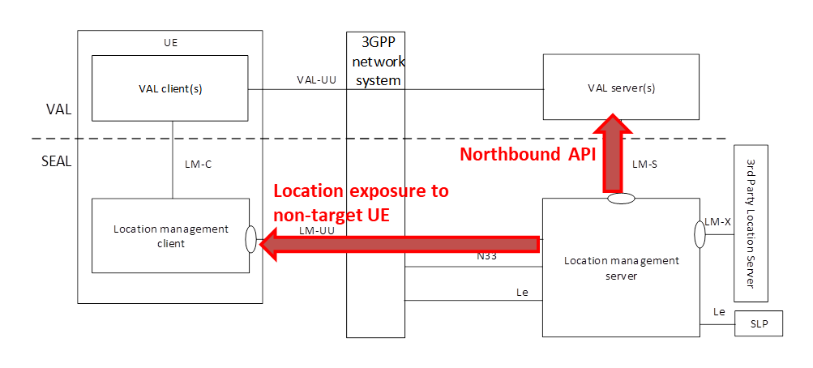
Figure 3. Illustrative diagram for SEAL location management architecture
The standalone Fused location service architecture is differnt in:
- FLS needs to determine and fuse location results from multiple sources;
- FLS does not process the VAL service level user’s request and is not aware of the user information;
- Single location exposures towards VAL applications (server);
- FLS needs to configure and dynamically manage the positioning source (network).

1.7 Two interaction modes with SEAL LM as the location source to the FLS
FLS fuses different location information from multiple resources and provide a better location service/information to the Application Server via its northbound API. And the SEAL LM can be one of its location source as described in figure 4a and figure 4b.
Since the SEAL LM does not support to get location information from the non-3GPP defined access, the FLS needs to have the interface FLS-1 to get location information from the non-3GPP defined access. And the FLS-1 interface provides the five types of fucntions related to the location information as described in the clause 1.3 of this paper.
There are some differences between the figure 4a and figure 4b. In the figure 4a, the current SEAL LM does not upgraded at all, and the FLS can directly use the service API and other interface to get location information, and SEAL LM is just a location information source. In the figure 4b, the SEAL LM is upgraded with supporting the Le interface to get target UE location information, and the FLS directly uses the service API of the upgraded SEAL LM to support the Le interface and to get the location information of the target UE from the 3GPP network.
Since the FLS needs to get the location information from other PLMNs if the target UE is with multiple PLMN accesses , in such cased, the FLS-4 referece point is to provide such location information from different PLMNs.
The FLS-3 reference point is described in the clause of 1.4 of this paper and is defined for storing and retrieving location information for the target UE and user profile for the target UE.

Figure 4a. SEAL LM as location source for Fused Location Server

Figure 4b. Upgraded SEAL LM as location source for Fused Location Server

The FLS has the two layer functions (i.e. Fused Location Function and Core Location Service). In the figure 4a, a lot of new interfaces are introduced. While in the figure 4b. the FLS still can have the two layer functions (i.e. Fused Location Function and Core Location Service), but in the deployment cases, the Fused Location Functions in the FLS can be merged with the SEAL LM, and the FLS can only has the Core Location Service, in such case, the whole architecure of the figure 4b is further simplied. Also the interfaces in the figure 4b is much less than the figure 4a.

1.8 SEAL LM gets location informatio from the FLS
In the SA6#48e meetig, the similar archiecture as described in the figure 5 is proposed. During the offline discussion, it is pointed out that the FLS clones a lot of functions and interfaces of the SEAL LM, and it seems that this architecture is not supported by the proposer.
Figure 5. SEAL LM relays location request to Fused Location Server

2. Conclusion
Based on discussions above, two potential directions are considered:
- To keep standalone Fused Location Server in the deployment scenarios if the vertical application (e.g. the mobile internet) wants a lightweight location server.
- The figure 4b can be selected as the architecture to merge the Fused Location Server and SEAL LM and SEAL LM needs to upgrade to support Le interface.
- The location information from the Non-3GPP defined access is only supported in the Fused Location Server.
- The interface between the FLS and target UE for the non-3GPP defined access interaction is needed.
- The Fused Location Server can get different location sources (e.g. SEAL LMs) from multiple PLMNs.
- The Core Location Service are defined in the Fused Location Server.

3. Proposal
Based on the conclusion, it is proposed to keep standalone FLS and SEAL LM architectures as two options in the TR, and the merged architecture based on the figure 4b can be further developed in the normative work .

