3GPP TS 23.554 V17.0.1 (2021-09)
Technical Specification
3rd Generation Partnership Project;
Technical Specification Group Services and System Aspects;
Application architecture for MSGin5G Service; Stage 2;
(Release 17)



The present document has been developed within the 3rd Generation Partnership Project (3GPP TM) and may be further elaborated for the purposes of 3GPP..
The present document has not been subject to any approval process by the 3GPP Organizational Partners and shall not be implemented.
This Specification is provided for future development work within 3GPP only. The Organizational Partners accept no liability for any use of this Specification.
Specifications and Reports for implementation of the 3GPP TM system should be obtained via the 3GPP Organizational Partners' Publications Offices.

Keywords

3GPP
Postal address

3GPP support office address
650 Route des Lucioles - Sophia Antipolis
Valbonne - FRANCE
Tel.: +33 4 92 94 42 00 Fax: +33 4 93 65 47 16
Internet
http://www.3gpp.org
Copyright Notification
No part may be reproduced except as authorized by written permission.
The copyright and the foregoing restriction extend to reproduction in all media.

© 2021, 3GPP Organizational Partners (ARIB, ATIS, CCSA, ETSI, TSDSI, TTA, TTC).
All rights reserved.

UMTS™ is a Trade Mark of ETSI registered for the benefit of its members
3GPP™ is a Trade Mark of ETSI registered for the benefit of its Members and of the 3GPP Organizational Partners
LTE™ is a Trade Mark of ETSI registered for the benefit of its Members and of the 3GPP Organizational Partners
GSM® and the GSM logo are registered and owned by the GSM Association

Contents
Foreword 7
Introduction 7
1 Scope 8
2 References 8
3 Definitions, symbols and abbreviations 9
3.1 Definitions 9
3.2 Symbols 10
3.3 Abbreviations 10
4 Architectural requirements 10
4.1 General 10
4.1.1 Description 10
4.1.2 Requirements 10
4.2 UE types 10
4.2.1 Description 10
4.2.2 Requirements 11
4.3 Communication models 11
4.3.1 Description 11
4.3.2 Requirements 11
5 Application layer architecture 11
5.1 General 11
5.2 Application Architecture 12
5.3 Functional entities 13
5.3.1 General 13
5.3.2 MSGin5G Server 13
5.3.2.1 General functionalities 13
5.3.2.2 Target resolution 14
5.3.3 MSGin5G Client 14
5.3.4 Message Gateway 14
5.3.4.1 General Description of Message Gateway 14
5.3.4.2 Legacy 3GPP Message Gateway 15
5.3.4.3 Non-3GPP Message Gateway 15
5.3.5 Application Client 15
5.3.6 Application Server 15
5.3.7 Legacy 3GPP Message Client 15
5.3.8 Non-3GPP Message Client 16
5.3.9 SEAL Client 16
5.3.10 SEAL Server 16
5.4 Reference Points 16
5.4.1 General 16
5.4.2 MSGin5G-1 16
5.4.3 MSGin5G-2 16
5.4.4 MSGin5G-3 16
5.4.5 MSGin5G-4 17
5.4.6 MSGin5G-5 17
5.4.7 MSGin5G-6 17
5.4.8 SEAL-C 17
5.4.9 SEAL-S 17
5.4.10 SEAL-UU 17
5.5 Capability exposure for enabling MSGin5G Service 17
5.5.1 MSGin5G application enabler layer adaptation to CAPIF 17
5.6 Service-based interface representation for MSGin5G Service 18
5.6.1 General 18
5.6.2 Service-based architecture 18
5.6.3 Service-based interfaces 19
6 Identities 19
6.1 Identities for MSGin5G service endpoints 19
6.1.1 General 19
6.1.2 MSGin5G UE Service Identity (UE Service ID) 19
6.1.3 Application Server Service Identity (AS Service ID) 20
6.1.4 Message Gateway Service Identity (MGW Service ID) 20
6.2 MSGin5G Group Service Identity (Group Service ID) 20
6.3 Broadcast Area Service Identity (Broadcast Area ID) 20
6.4 MSGin5G UE Identity (MSGin5G UE ID) 20
6.5 Non-MSGin5G UE identity (Non-MSGin5G UE UE ID) 20
6.6 Application Identity (Application ID) 20
7 Generic description of the MSGin5G Service (informative) 20
7.1 General 21
7.2 Service flow 22
8 Procedures and information flows 23
8.1 Configuration 23
8.1.1 General 23
8.1.2 MSGin5G UE Configuration 23
8.1.3 Non-MSGin5G UE Configuration 24
8.2 Registration 25
8.2.1 MSGin5G UE Registration 25
8.2.2 MSGin5G UE De-Registration 27
8.2.3 Non-MSGin5G UE Registration 28
8.2.4 Non-MSGin5G UE De-registration 30
8.3 Message delivery procedures into and from MSGin5G Server 32
8.3.1 General 32
8.3.2 MSGin5G inbound messages into the MSGin5G Server 32
8.3.3 MSGin5G outbound messages from the MSGin5G Server 38
8.3.4 MSGin5G message delivery status report into the MSGin5G Server 41
8.3.5 MSGin5G message delivery status report from the MSGin5G Server 43
8.4 Message Aggregation 45
8.4.1 General 45
8.4.2 Message Aggregation at MSGin5G Client 46
8.4.3 Message Aggregation at MSGin5G Server 48
8.5 MSGin5G Message Segmentation and Reassembly 49
8.5.1 General 49
8.5.2 Application-to-Point Segmentation and Reassembly 49
8.5.3 Point-to-Application Message Segmentation and Reassembly 51
8.5.4 Point-to-Point Message Segmentation and Reassembly 53
8.5.5 Group Message Segmentation and Reassembly 55
8.5.6 MSGin5G Message Segment Recovery 55
8.6 MSGin5G messaging procedure on Message Gateway 56
8.6.1 General MSGin5G messaging procedure on Message Gateway 56
8.6.2 Non-MSGin5G UE receives message from group 58
8.6.2.1 Legacy 3GPP UE receives message from group 58
8.6.2.2 Non-3GPP message client receives message from group 58
8.7 E2E Message delivery procedures 59
8.7.1 Point-to-Point Message delivery procedures 60
8.7.1.1 From MSGin5G UE to MSGin5G UE 60
8.7.1.2 From MSGin5G UE to Legacy 3GPP UE 60
8.7.1.3 From MSGin5G UE to Non-3GPP UE 62
8.7.1.4 From Legacy 3GPP UE to MSGin5G UE 63
8.7.1.5 From Non-3GPP UE to MSGin5G UE 64
8.7.2 Application-to-Point Message delivery procedures 66
8.7.2.1 From Application Server to MSGin5G UE 66
8.7.2.2 From Application Server to Legacy 3GPP UE 67
8.7.2.3 From Application Server to Non-3GPP UE 68
8.7.3 Point-to-Application Message delivery procedures 69
8.7.3.1 From MSGin5G UE to Application Server 69
8.7.3.2 From Legacy 3GPP UE to Application Server 70
8.7.3.3 From Non-3GPP UE to Application Server 71
8.7.4 MSGin5G Group messaging 72
8.7.4.1 General 72
8.7.4.2 Message delivery from UE to group 72
8.7.4.3 Message delivery procedure from Application Server to group 73
8.7.5 Message delivery between MSGin5G UEs in different PLMNs 74
8.7.5.1 General 74
8.7.5.2 Inter-PLMN message exchange procedure 74
8.8 Other MSGin5G messaging related procedures 75
8.8.1 Messaging Topic Subscription 75
8.9.1 General 77
8.9.2 UE reachability status monitoring 77
8.9.2.1 General 77
8.9.2.2 Procedures 78
8.9.2.2.1 Request-response 78
8.9.2.2.2 Subscribe 79
8.9.2.2.3 Notify 79
8.9.2.2.4 Unsubscribe 80
8.9.2.3 Flows 81
8.9.3 MSGin5G device triggering 81
8.9.3.1 General 81
8.9.3.2 Procedure 82
8.9.3.3 Flows 83
8.10.1 General 84
8.10.2 Configuration management service 84
8.10.2.1 General 84
8.10.2.2 Information flows 84
8.10.2.3 Procedures 85
8.10.3 Group management service 85
8.10.3.1 General 85
8.10.3.2 Information flows 85
8.10.3.3 Procedures 85
8.10.3.4 APIs 85
8.11 Constrained devices in MSGin5G service 85
8.11.1 General 85
8.11.2 Constrained device registration to use gateway UE 86
8.11.3 Constrained device Deregistration from using gateway UE 87
8.11.4 Constrained device sending message using Gateway UE 88
8.11.5 Constrained device receiving message via Gateway UE 89
9 APIs and related information flows 91
9.1 APIs provided by MSGin5G Server 91
9.1.1 Mm5s APIs 91
9.1.1.1 M5S_AS_Originating_Message_Delivery API 91
9.1.1.1.1 General 91
9.1.1.1.2 Send_MSGin5G_Message operation 91
9.1.1.2 M5S_UE_Originating_Message_Delivery API 91
9.1.1.2.1 General 91
9.1.1.2.2 Send_ MSGin5G_Message operation 91
9.1.1.3 M5S_AS_Originating_Delivery_Status_Report API 91
9.1.1.3.1 General 91
9.1.1.3.2 Report_Message_Delivery_Status operation 91
9.1.1.4 M5S_UE_Originating_Delivery_Status_Report API 92
9.1.1.4.1 General 92
9.1.1.4.2 Report_Message_Delivery_Status operation 92
9.1.1.5 M5S_AS_Registration API 92
9.1.1.5.1 General 92
9.1.1.5.2 Registration operation 92
9.1.1.5.3 Deregistration operation 92
9.1.2 Mm5s Information flows 93
9.1.2.1 M5S Application Server originating message send request 93
9.1.2.2 M5S Application Server originating message delivery status report request 93
9.1.2.3 M5S Application Server registration request 93
9.1.2.4 M5S Application Server registration response 94
9.1.2.5 M5S Application Server de-registration request 94
9.1.2.6 M5S Application Server de-registration response 94
9.2 APIs provided by Message Gateway 94
9.2.1 Ml3g APIs 94
9.2.1.1 L3G_Message_Delivery API 94
9.2.1.1.1 General 94
9.2.1.1.2 Send_Message operation 94
9.2.1.2 L3G_Delivery_Status_Report API 95
9.2.1.3.1 General 95
9.2.1.3.2 Report_Message_Delivery_Status operation 95
9.2.2 Mn3g APIs 95
9.2.2.1 N3G_Message_Delivery API 95
9.2.2.1.1 General 95
9.2.2.1.2 Send_Message operation 95
9.2.2.2 N3G_Delivery_Status_Report API 95
9.2.2.2.1 General 95
9.2.2.2.2 Report_Message_Delivery_Status operation 95
10 Information Elements 96
10.1 Payload 96
10.2 Application ID 96
10.3 Messaging Topic 96
10.4 Recipient Broadcast Area ID 96
10.5 Message ID 96
10.6 Failure Cause 97
Annex A (informative): Change history 97

Foreword
This Technical Specification has been produced by the 3rd Generation Partnership Project (3GPP).
The contents of the present document are subject to continuing work within the TSG and may change following formal TSG approval. Should the TSG modify the contents of the present document, it will be re-released by the TSG with an identifying change of release date and an increase in version number as follows:
Version x.y.z
where:
x the first digit:
1 presented to TSG for information;
2 presented to TSG for approval;
3 or greater indicates TSG approved document under change control.
y the second digit is incremented for all changes of substance, i.e. technical enhancements, corrections, updates, etc.
z the third digit is incremented when editorial only changes have been incorporated in the document.

Introduction

1 Scope
The present document specifies the functional architecture, procedures, information flows and APIs for MSGin5G Service. MSGin5G Service provides messaging communication capability in 5GS especially for Massive Internet of Things (MIoT).
MSGin5G Service includes the following message communication models:
- Point-to-Point message;
- Application-to-Point message/ Point-to-Application message;
- Group message;
- Broadcast message.
The corresponding service requirements are defined in 3GPP TS 22.262 [2].

2 References
The following documents contain provisions which, through reference in this text, constitute provisions of the present document.
- References are either specific (identified by date of publication, edition number, version number, etc.) or non-specific.
- For a specific reference, subsequent revisions do not apply.
- For a non-specific reference, the latest version applies. In the case of a reference to a 3GPP document (including a GSM document), a non-specific reference implicitly refers to the latest version of that document in the same Release as the present document.
[1] 3GPP TR 21.905: "Vocabulary for 3GPP Specifications".
[2] 3GPP TS 22.262: "Message Service within the 5G System".
[3] GSMA PRD RCC.07: "RCC.07 Rich Communication Suite 9.0 Advanced Communications Services and Client Specification".
[4] OMA OMA-ERELD-LightweightM2M-V1_1-20180612-C: "Enabler Release Definition for LightweightM2M".
[5] 3GPP TS 23.434: "Service Enabler Architecture Layer for Verticals".
[6] 3GPP TS 23.222: "Functional architecture and information flows to support Common API Framework for 3GPP Northbound APIs; Stage 2".
[7] 3GPP TS 23.502: "Procedures for the 5G System".
[8] 3GPP TS 23.682: "Architecture enhancements to facilitate communications with packet data networks and applications".
[9] 3GPP TS 29.122: "T8 reference point for northbound Application Programming Interfaces (APIs)".
[10] 3GPP TS 29.522: "5G System; Network Exposure Function Northbound APIs; Stage 3".
[11] 3GPP TS 23.401: "General Packet Radio Service (GPRS) enhancements for Evolved Universal Terrestrial Radio Access Network (E-UTRAN) access".
[12] 3GPP TS 23.501: "System Architecture for the 5G System (5GS); Stage 2".
[13] 3GPP TS 23.204: "Support of Short Message Service (SMS) over generic 3GPP Internet Protocol (IP) access; Stage 2".
[14] 3GPP TS 23.041: "Technical realization of Cell Broadcast Service (CBS)".
[15] 3GPP TS 23.040: "Technical realization of the Short Message Service (SMS)".

3 Definitions, symbols and abbreviations

3.1 Definitions
For the purposes of the present document, the terms and definitions given in 3GPP TR 21.905 [1] and the following apply. A term defined in the present document takes precedence over the definition of the same term, if any, in 3GPP TR 21.905 [1].
Application-to-Point messaging: An MSGin5G message delivery that is originated at an Application Server in the network and terminated at a UE.
Broadcast Area: an area consisting of one or more cells where the broadcast message is delivered.
Broadcast messaging: An MSGin5G message delivery that is delivered to UEs in a Broadcast Area.
Group messaging: message delivery that is originated at a UE or an Application Server and is terminated at all members of the group (a group member can be of type UE, Legacy 3GPP UE or Non-3GPP UE).
Legacy 3GPP Message Gateway: the entity in MSGin5G Service to support interworking with Legacy 3GPP UEs.
Legacy 3GPP UE: the UE that supports legacy 3GPP message sending and receiving (e.g. SMS, NIDD, etc) in MSGin5G Service.
MSGin5G Client: the client that enables MSGin5G message sending and receiving.
Message Gateway: general terminology for Legacy 3GPP Message Gateway or Non-3GPP Message Gateway.
MSGin5G Group: the group of UEs which members may be MSGin5G UE, Legacy 3GPP UE and Non-3GPP UE.
MSGin5G message: the message defined in the present specification that is exchanged between the MSGin5G Service endpoints under the MSGin5G Service.
MSGin5G Server: A server in MSGin5G Service that receives and delivers MSGin5G messages among MSGin5G Service endpoints.
MSGin5G Service: an MNO message service using the 5G System that enables Point- to-Point, Application-to-Point, Point-to-Application, Group and Broadcast message delivery for thing-to-thing communication and person-to-thing communication.
Messaging Topic: an identifier for a topic to which a UE or an Application Server can subscribe to in order to receive messages that are characterized by a Message Topic.
MSGin5G UE: the UE that uses MSGin5G Client in MSGin5G Service.
Non-3GPP Message Gateway: the entity in MSGin5G Service to support interworking with Non-3GPP UEs.
Non-3GPP UE: the UE that supports non-3GPP message sending and receiving (e.g. RCS message as specified in GSMA PRD RCC.07 [3], OMA LWM2M message as specified in OMA OMA-ERELD-LightweightM2M [4]) in MSGin5G Service.
NOTE: The MSGin5G UE utilizes MSGin5G Client in MSGin5G Service. The Legacy 3GPP UE and Non-3GPP UE does not utilize MSGin5G Client in MSGin5G Service.
Non-MSGin5G UE: general terminology for Legacy 3GPP UE or Non-3GPP UE.
Point-to-Application messaging: A MSGin5G message delivery that is originated at a UE and terminated at an Application Server.
Point-to-Point messaging: An MSGin5G message delivery that originates at a UE and terminates at a UE, where at least one of the end points is a MSGin5G UE.

3.2 Symbols
For the purposes of the present document, the following symbols apply:
<symbol> <Explanation>

3.3 Abbreviations
For the purposes of the present document, the abbreviations given in 3GPP TR 21.905 [1] and the following apply. An abbreviation defined in the present document takes precedence over the definition of the same abbreviation, if any, in 3GPP TR 21.905 [1].
5GS 5G System
CAPIF Common API Framework for northbound APIs
NIDD Non IP Data Delivery
SCEF Service Capability Exposure Function
SEAL Service Enabler Architecture Layer for Verticals
SMSC Short Message Service Center
VAL Vertical Application Layer
CoAP Constrained Application Protocol
SCS Service Capability Server

4 Architectural requirements

4.1 General

4.1.1 Description
This subclause specifies the general architecture requirements for MSGin5G Service.

4.1.2 Requirements
[AR-4.1.2-a] The MSGin5G Client shall support one or more applications which need to use the MSGin5G message exchanging capabilities.
[AR-4.1.2-b] The MSGin5G Server shall support one or more Applications Servers which support the MSGin5G message exchanging capabilities.
[AR-4.1.2-c] The MSGin5G messaging related capabilities (e.g. registration, Point-to-Point messaging, Group messaging, message delivery status, etc.) should be exposed as APIs to the Applications Server(s).
[AR-4.1.2-d] The application architecture shall enable the communication between the UEs in different PLMNs. The UEs support MSGin5G Service.

4.2 UE types

4.2.1 Description
This subclause specifies the requirements for UE types supported by MSGin5G Service.
Editor’s note: It is FFS whether the MSGin5G Server and the Message Gateway require understanding of the UE type of the UEs served.

4.2.2 Requirements
[AR-4.2.2-a] The application architecture shall support the message exchanging between the following UE types:
1. MSGin5G UE:
1) light weight constrained devices (e.g. sensors, actuators) and
2) unconstrained devices with advanced capabilities (e.g. washing machine, micro-ovens)
2. Legacy 3GPP UE
3. Non-3GPP UE
[AR-4.2.2-b] The application architecture shall enable the unconstrained devices to act as a UE Message Gateway to constrained devices to communicate with MSGin5G Server.

4.3 Communication models

4.3.1 Description
This subclause specifies the requirements for MSGin5G communication models.

4.3.2 Requirements
[AR-4.3.2-a] The application architecture shall support the following message communication models:
1 Point-to-Point message;
2 Application-to-Point message/ Point-to-Application message;
3 Group message;
4 Broadcast message.
[AR-4.3.2-b] The application architecture shall support the interconnecting between MSGin5G and other different messaging delivery mechanisms, e.g. SMS specified in 3GPP TS23.040 [15], or RCS message as specified in GSMA PRD RCC.07 [3]).

5 Application layer architecture

5.1 General
The following aspects of MSGin5G Service are described in this clause:
- application architecture;
- functional entities;
- reference points; and
- capability exposure for enabling MSGin5G Service.

5.2 Application Architecture
Figure 5.2-1 shows the application architecture of the MSGin5G Service. The MSGin5G Service shall fulfil the service requirements which are enumerated in 3GPP TS 22.262 [2] and the architecture requirements enumerated in clause 4.
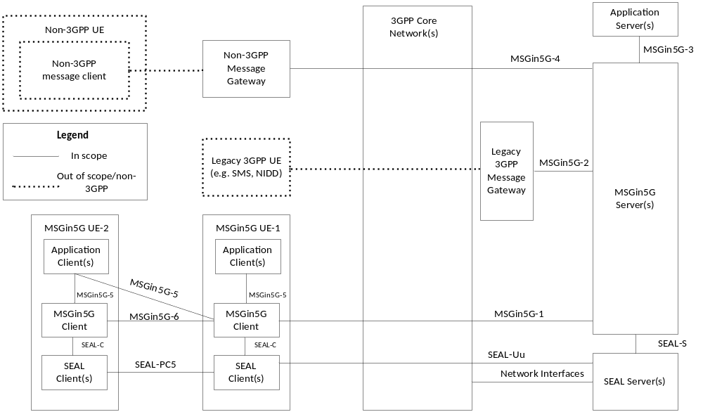
Figure 5.2-1: Application Architecture of the MSGin5G Service
The MSGin5G Client(s) interacts with SEAL Clients over the SEAL-C reference point specified for each SEAL service as specified in 3GPP TS 23.434 [5]. The Legacy 3GPP Message Gateway and Non-3GPP Message Gateway may interact with SEAL Clients over the SEAL-C reference point specified for each SEAL service. The MSGin5G Server(s) interacts with SEAL Servers over the SEAL-S reference point specified for each SEAL service as specified in 3GPP TS 23.434 [5]. The interaction between a SEAL Client and the corresponding SEAL Server is supported by SEAL-UU reference point specified for each SEAL service as specified in 3GPP TS 23.434 [5].
NOTE2: For simplicity, the SEAL Clients' interaction with Legacy 3GPP Message Gateway and Non-3GPP Message Gateway, and the SEAL-UU interface between Legacy 3GPP Message Gateway and Non-3GPP Message Gateway and SEAL Servers are not shown in Figure 5.2-1.
The MSGinUE-1 may be constrained devices and unconstrained devices with advanced capabilities, and can communicate with MSGin5G Server over MSGin5G-1 reference point. The MSGin5G UE-2 is a constrained device which does not have enough capability to communicate with MSGin5G Server. If allowed by configuration, the MSGin5G UE-1 may act as a UE Message Gateway to MSGin5G UE-2.
The Legacy 3GPP Message Gateway interacts with MSGin5G Server over MSGin5G-2 reference point on behalf of Legacy 3GPP UE (e.g., SMS, NIDD).
The Non-3GPP Message Gateway interacts with MSGin5G Server over MSGin5G-4 reference point on behalf of Non-3GPP UE.
NOTE 3: A SEAL Group Management Server and a SEAL Configuration Management Server (both specified in 3GPP TS 23.434 [5]) may be collocated in the MSGin5G Server. A SEAL Configuration Management Client specified in 3GPP TS 23.434 [5] may be collocated in the MSGin5G Client, Legacy 3GPP Message Gateway and Non-3GPP Message Gateway. The implementation of such deployment option is out of this specification.
NOTE 4: In certain deployment options, the MSGin5G UE-2 may not contain MSGin5G Client. In such scenario, the Application Client in MSGin5G UE-2 will interact with MSGin5G Client in MSGin5G UE-1 to send and receive messages.
NOTE 5: When both MSGin5G UE-1 and MSGin5G UE-2 support MSGin5G Client, MSGin5G Client in MSGin5G UE-1 acts as a relay for the MSGin5G Client in MSGin5G UE-2 to receive MSGin5G Service. When MSGin5G UE-2 does not support an MSGin5G Client and only MSGin5G UE-1 supports an MSGin5G Client, MSGin5G Client in MSGin5G UE-1 acts as a gateway for the Application Client in MSGin5G UE-2 to receive MSGin5G Service.
NOTE 6: Depending on the non-3GPP message service, the interaction between Non-3GPP message client and Non-3GPP Message Gateway may involve 3GPP Core Network.
NOTE 7: 3GPP Core Network may not be involved for the interaction between the Non-3GPP Message Gateway and the MSGin5G Server.
Editor’s note: Specifying details of MSGin5G Client interaction towards Application Client is FFS.

5.3 Functional entities
Editor’s note: The three logical Client types: MSGin5G Client, Legacy 3GPP Client, Non-3GPP Client

5.3.1 General
The functional entities of the application architecture for the MSGin5G Service are described in this clause.

5.3.2 MSGin5G Server

5.3.2.1 General functionalities
An MSGin5G Server provides server-side functionality to assist MSGin5G Clients with the sending and receiving of messages via the MSGin5G Service to/from Application Servers and/or other MSGin5G Service endpoints on other UEs.
Functionalities of MSGin5G Server:
- To resolve message delivery mechanism for the MSGin5G Service endpoint based on the terminating MSGin5G Service ID to determine if the message is to be delivered to a MSGin5G UE, an Application Server or a Message Gateway for final delivery;
- To resolve the MSGin5G Group Service ID to determine the members of the Group specified in 3GPP TS 23.434[5];
- Interworking with non 3GPP messaging service through the Non-3GPP Message Gateway;
- Interworking with legacy 3GPP messaging service through the Legacy 3GPP Message Gateway;
- Exchanging MSGin5G messages with application servers, MSGin5G Clients, Legacy 3GPP Message Gateway and Non-3GPP Message Gateway;
- Supporting MSGin5G message segmentation according to service provider's policy;
- Supporting UE configuration procedures as specified in TS 23.434 [5] or communicating with the SEAL Configuration Management Server to provide MSGin5G configuration data on a UE to be ready for the MSGin5G Service; and
- Managing information related to the MSGin5G Service, such as MSGin5G Client availability, Legacy 3GPP Message Gateway and Non-3GPP Message Gateway.
Editor’s note: What MSGin5G Client information related to the MSGin5G Service will be managed by the MSGin5G Server is FFS.

5.3.2.2 Target resolution
Upon receiving the MSGin5G message request to deliver the message to the target UE (which could be any of the MSGin5G UE, Legacy 3GPP UE, Non-3GPP UE) on the terminating side, the MSGin5G Service performs certain actions in order to ensure message delivery to the right target UE and in appropriate format. The actions include determining the service supported by the target UE and the need for translation the MSGin5G message request to a format understood by the target UE.
Upon receiving the MSGin5G message request, the MSGin5G Server checks the MSGin5G UE registration repository (created at the time of each MSGin5G UE registration to MSGin5G Server) for the target end point identifier, i.e. UE Service ID/AS Service ID. The MSGin5G Server will attempt for delivery MSGin5G message request towards recipient UE based on the UE Service ID/AS Service ID. If the recipient UE is Non-MSGin5G UE, the Message Gateway that the Non-MSGin5G UE is registered with will receive the MSGin5G message request on behalf of the Non-MSGin5G UE, and then delivers the message to the Non-MSGin5G UE via the Non-MSGin5G message delivery mechanism.
Editor’s note: It is FFS that whether Message Gateway selection based on UE type is needed.

5.3.3 MSGin5G Client
A MSGin5G Client provides client-side functionality for UE Application Clients with the sending and receiving of messages via the MSGin5G Service to/from Application Servers and/or other MSGin5G Service endpoints; i.e. UEs.
Functionalities of MSGin5G Client:
- Exposing MSGin5G APIs to enable Application Clients to use an MSGin5G Service;
- Supporting registration of a MSGin5G Client to a MSGin5G Server to use a MSGin5G Service; and
- Supporting configuration of an MSGin5G Client required to use MSGin5G Service;
- Construct MSGin5G message when requested by a native application or Application Client;
- Deliver MSGin5G message payload to the targeted native application or Application Client; and
- Exchanging MSGin5G messages via a MSGin5G Server to/from Application Servers and/or other MSGin5G Service endpoints; i.e. UEs.
NOTE: A native application on an MSGin5G UE is the application logic built within the MSGin5G Client.

5.3.4 Message Gateway

5.3.4.1 General Description of Message Gateway
A Message Gateway in MSGin5G application architecture provides functionality to deliver MSGin5G messages to Non-MSGin5G UEs.
A Message Gateway performs the role of interconnecting two different messaging delivery mechanisms and assures the message integrity between different message delivery mechanisms. A message delivery mechanism comprises the specific set of protocols, procedures and rules.
Functionalities of Message Gateway:
- Enables seamless delivery of an MSGin5G message between different message delivery mechanisms with integrity;
- Communicates with the MSGin5G Server using either an MSGin5G Client functionality or similar functions to enable sending and receiving MSGin5G messages;
- Delivers payload of an MSGin5G message to the Non-MSGin5G UE using the specific message delivery mechanism available to that Non-MSGin5G UE and vice versa;
- Performs message sender and receiver addresses conversion according to the two connected message delivery mechanisms and maintain the mapping of the address pair used for a response message delivery;
- Perform registration and de-registration with the MSGin5G Server on behalf of the Non-MSGin5G UEs;
- Act as a service endpoint to perform message segmentation and reassembly for the Non-MSGin5G UEs when needed; and
- Performs protocol conversion according to the service supported by the target UE;
- Supports the MSGin5G message delivery status report
1. If application level message delivery status report is not supported by the Non-MSGin5G message delivery mechanisms, based on the information (e.g. response to the message delivery request, transport level information, etc) obtained from the Non-MSGin5G message delivery mechanisms, the Message Gateway fetches the delivery status from the above information and uses it to create a MSGin5G message delivery status report on behalf of Non-MSGin5G UE. If the delivery status is failure, also fetch the suitable failure reason from the above information and use it as reason of failure in the MSGin5G message delivery status report.
2. If application level message delivery status report is supported by the Non-MSGin5G message delivery mechanisms (e.g. RCS specified in GSMA PRD RCC.07 [3]), translates the application level message delivery status report in the Non-MSGin5G message delivery mechanisms to MSGin5G message delivery status report.
There are two types of Message Gateways used to deliver MSGin5G messages to different UE types: the Legacy 3GPP Message Gateway and the non-3GPP Message Gateway
NOTE: Implementation of the Message Gateway and the MSGin5G Server together is deployment option that is out of this specification.

5.3.4.2 Legacy 3GPP Message Gateway
The Legacy 3GPP Message Gateway is used to deliver MSGin5G message to Legacy 3GPP UEs, using their 3GPP supported message delivery mechanisms.

5.3.4.3 Non-3GPP Message Gateway
The Non-3GPP Message Gateway is used to deliver MSGin5G message to Non-MSGin5G UEs, using their (non-3GPP) supported message delivery mechanisms.

5.3.5 Application Client
The Application Client is an entity in the application layer to implement and perform the application service logic for its own service.
The Application Client interacts with MSGin5G Client for sending and receiving MSGin5G messages. The Application Client provides needed information for the MSGin5G Client to perform MSGin5G Service with other endpoints.

5.3.6 Application Server
The Application Server is an entity in the application layer to implement and perform the application service logic.
The Application Server supports sending and receiving messages with MSGin5G Service layer protocols and procedures.

5.3.7 Legacy 3GPP Message Client
The Legacy 3GPP Message Client provides client-side functionality
for a Legacy 3GPP messaging service (e.g. SMS, NIDD).
NOTE: The details of the Legacy 3GPP Message Client are out of scope of the present document.

5.3.8 Non-3GPP Message Client
The Non-3GPP Message Client provides client-side functionality for a Non-3GPP messaging service.
NOTE: The details of the Non-3GPP message client are out of scope of the present document.

5.3.9 SEAL Client
The following SEAL Clients for MSGin5G Service are supported:
- Group management client as specified in 3GPP TS 23.434 [5];
- Configuration management client as specified in 3GPP TS 23.434 [5].

5.3.10 SEAL Server
The following SEAL Servers for MSGin5G Service are supported:
- Group management server as specified in 3GPP TS 23.434 [5];
- Configuration management server as specified in 3GPP TS 23.434 [5].
Editor’s note: Usage of other SEAL services (e.g. location) from 3GPP TS 23.434 [5] for MSGin5G Service is FFS.

5.4 Reference Points

5.4.1 General
The reference points of the service architecture for the MSGin5G Service are described in this clause.

5.4.2 MSGin5G-1
The interactions related to enabling MSGin5G message exchange between a MSGin5G Client and an MSGin5G Server are supported by the MSGin5G-1 reference point. This reference point supports:
- Registration of a MSGin5G Client to a MSGin5G Server when not using IMS based solution; and
- The exchange of MSGin5G messages.

5.4.3 MSGin5G-2
The interactions related to enabling MSGin5G message exchange between an MSGin5G Server and the Legacy 3GPP Message Gateway are supported by the MSGin5G-2 reference point. This reference point supports:
- The exchange of MSGin5G messages between MSGin5G Server and the Legacy 3GPP Message Gateway; and
- Perform registration /de-registration on behalf of the Legacy 3GPP UEs that the Message Gateway connects with the MSGin5G Server.
NOTE: Indicating the delivery mechanism on the MSGin5G-2 reference point is out of scope of current functionality.

5.4.4 MSGin5G-3
The interactions related to enabling MSGin5G message exchange between an Application Server and an MSGin5G Server are supported by the MSGin5G-3 reference point. This reference point supports:
- Access to MSGin5G Server and APIs to enable sending and receiving of MSGin5G messages; and
- Adherence to CAPIF as specified in 3GPP TS 23.222 [6].

5.4.5 MSGin5G-4
The interactions related to enabling MSGin5G message exchange between a Non-3GPP Message Gateway and an MSGin5G Server are supported by the MSGin5G-4 reference point. This reference point supports:
- The exchange of MSGin5G messages between MSGin5G Server and the Non-3GPP Message Gateway; and
- Perform registration/de-registration on behalf of the Non-3GPP UEs that the Message Gateway connects with the MSGin5G Server

5.4.6 MSGin5G-5
The interactions related to enabling MSGin5G message related information exchange between an Application Client and an MSGin5G Client are supported by the MSGin5G-5 reference point. This reference point supports:
- Providing information from Application Clients required to enable the MSGin5G Client to construct an MSGin5G message to be delivered to other MSGin5G Service endpoints.
- Configuring application clients with information required to enable the MSGin5G Client and MSGin5G Server to exchange and route MSGin5G messages to other MSGin5G Service endpoints.
- Sending notifications and information in the incoming MSGin5G messages received by the MSGin5G Client to the Application Clients from other MSGin5G Service endpoints.

5.4.7 MSGin5G-6
The MSGin5G Client of MSGin5G UE-2 communicates with MSGin5G Client of MSGin5G UE-1 over MSGin5G-6 reference point. The interface is based on NR PC5.

5.4.8 SEAL-C
The following SEAL-C reference points for MSGin5G Service are supported:
- GM-C reference point for group management as specified in 3GPP TS 23.434 [5];
- CM-C reference point for configuration management as specified in 3GPP TS 23.434 [5].

5.4.9 SEAL-S
The following SEAL-S reference points for MSGin5G Service are supported:
- GM-S reference point for group management as specified in 3GPP TS 23.434 [5];
- CM-S reference point for configuration management as specified in 3GPP TS 23.434 [5].

5.4.10 SEAL-UU
The following SEAL-UU reference points for MSGin5G Service are supported:
- GM-UU reference point for group management as specified in 3GPP TS 23.434 [5];
- CM-UU reference point for configuration management as specified in 3GPP TS 23.434 [5].

5.5 Capability exposure for enabling MSGin5G Service

5.5.1 MSGin5G application enabler layer adaptation to CAPIF
The MSGin5G Server and Application Server may support CAPIF. When CAPIF is supported:
- The MSGin5G Server shall support the CAPIF API provider domain functions (i.e. CAPIF-2/2e, CAPIF-3/3e, CAPIF-4/4e and CAPIF-5/5e as specified in 3GPP TS 23.222 [6]) as shown in Figure 5.5.1-1;
- The Application Server shall act as API invoker and support the API invoker functions (i.e. CAPIF-1/1e and CAPIF-2/2e as specified in 3GPP TS 23.222 [6]) as shown in Figure 5.5.1-1.
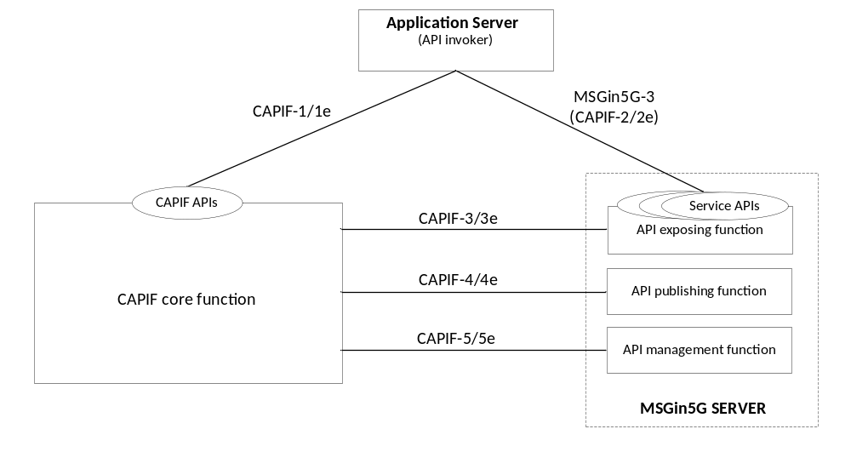
Figure 5.5.1-1: MSGin5G adaptation to the CAPIF architecture

5.6 Service based interface representation for MSGin5G Service

5.6.1 General
The Service based architecture for MSGin5G Service is represented using functional entities and reference points between the functional entities as specified in subclause 5.

5.6.2 Service based architecture
Figure 5.6.2-1 is the Service based Architecture for MSGin5G Service.
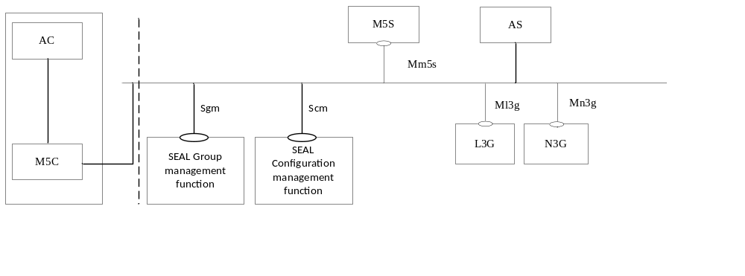
Figure 5.6.2-1: Service based MSGin5G Architecture
NOTE: The AS, L3G and N3G in this Service based MSGin5G Architecture are in the same trust domain.
The M5S function is a service based function exhibited by MSGin5G Server.
The M5C function is the MSGin5G Client.
The AC is the application client.
The L3G function is a service based function exhibited by Legacy 3GPP Message Gateway.
The N3G function is a service based function exhibited by Non-3GPP Message Gateway.
The M5S manages the distribution of the messages it has received from MSGin5G UE, from Application Server, or from N3G (on behalf of Non-3GPP UE) or from L3G (on behalf of Legacy 3GPP UE).
The M5S invokes services provided by L3G/N3G to send MSGin5G Messages towards Legacy 3GPP UE or Non-3GPP UE.
The AS/L3G/N3G invokes services provided by M5S to send MSGin5G Messages to M5S on behalf of Legacy 3GPP UE or Non-3GPP UE.
The M5S invokes services provided by SEAL Group management function to do MSGin5G Group management.
The M5S/L3G/N3G invokes services provided by SEAL Configuration management function to do service configuration (including UE service ID provisioning).

5.6.3 Service based interfaces
Table 5.6.3-1 specifies the service based interfaces supported by MSGin5G Service.
Table 5.6.3-1: Service based interfaces supported by MSGin5G Service
Service based interface | Application function entity | Mapping server entity | APIs offered
Mm5s | MSGin5G Server function | MSGin5G Server | Specified in 9.1
Ml3g | Legacy 3GPP Message Gateway function | Legacy 3GPP Message Gateway | Specified in 9.2.1
Mn3g | Non-3GPP Message Gateway function | Non-3GPP Message Gateway | Specified in 9.2.2

6 Identities

6.1 Identities for MSGin5G service endpoints

6.1.1 General
MSGin5G service endpoints shall be identified by unique identifiers within the MSGin5G service domain. For each MSGin5G service endpoint the identifier shall be a unique URI that can be used to identify the MSGin5G service endpoint's home service domain.
The following clauses describe different types if MSGin5G service endpoint identifiers.

6.1.2 UE Service Identity (UE Service ID)
UE Service ID is the identifier of a UE (i.e. MSGin5G UEs, Legacy 3GPP UEs and Non-3GPP UEs).
For an MSGin5G UE, the assigned UE Service ID is used by the MSGin5G Client to register with the MSGin5G Server and to send and receive MSGin5G messages. It is used by the MSGin5G Server to authenticate and authorize the associated UE to the MSGin5G Service at the application layer.
For a Legacy 3GPP UE or a Non-3GPP UE, the assigned UE Service ID is used by the Message Gateway to register with the MSGin5G Server, to map into the Service ID in their defined message delivery mechanisms for interworking, and to send/receive MSGin5G messages to/from MSGin5G Server on behalf of Legacy 3GPP UE or Non-3GPP UE.

6.1.3 Application Server Service Identity (AS Service ID)
AS Service ID is the identifier of an Application Server. It is used to perform mutual authentication with the MSGin5G Server for establishing a secured service connection, and it is used to send/receive MSGin5G messages to/from other MSGin5G service endpoints via MSGin5G Server.

6.1.4 Message Gateway Service Identity (MGW Service ID)
MGW Service ID is the identifier of Message Gateway. It is used to perform mutual authentication with the MSGin5G Server for establishing a secured service connection, and it is used to send/receive MSGin5G messages to/from MSGin5G Server on behalf of Legacy 3GPP UE or Non-3GPP UE.

6.2 MSGin5G Group Service Identity (Group Service ID)
The Group Service ID is a unique identifier within the MSGin5G Service that represents a pre-defined MSGin5G Group. A pre-defined MSGin5G Group is established before the MSGin5G Group messages are sent to it, and is assigned a unique and permanent Group Service ID when it is established. This Group Service ID shall be communicated to all members of the group. A service endpoint (UE or Application Server) shall use this Group Service ID to send a message to all members of the group.
The Group Service ID shall be a unique URI that can be used to identify where the group is hosted.

6.3 Broadcast Area Service Identity (Broadcast Area ID)
The Broadcast Area ID is the identity of the Service Area where the broadcast message is delivered.

6.4 MSGin5G UE Identity (MSGin5G UE ID)
The MSGin5G UE ID is a unique identifier that represents the MSGin5G UE (i.e. the device identifier of the MSGin5G UE). The MSGin5G UE ID may be pre-configured to the MSGin5G UE by its vendor.

6.5 Non-MSGin5G UE identity (Non-MSGin5G UE ID)
The Non-MSGin5G UE ID is a unique identifier that represents the Non-MSGin5G UE in the Non-MSGin5G Service. A Non-MSGin5G UE ID is associated with a specific Non-MSGin5G UE. It is used by the Message Gateway in the MSGin5G Service to record the Non-MSGin5G UE. It is also used by the Message Gateway as a part of VAL UE ID when the Message Gateway executes the Non-MSGin5G UE configuration procedure on behalf of a Non-MSGin5G UE. The format of Non-MSGin5G UE ID may differ among different VALs. The non-MSGin5G ID may be pre-configured to the Non-MSGin5G UE by its vendor.

6.6 Application Identity (Application ID)
Application ID is an identifier that represents the application for which the payload of message is intended. The content of Application ID is outside the scope of this document.

7 Generic description of the MSGin5G Service (informative)
Editor’s note: The text in this clause needs to be aligned with the procedures specified below.

7.1 General
Massive Internet of Things (MIoT) is one of key market segments of 5G. The typical IoT device communication is sending and receiving small data which can be delivered just in a message. The MSGin5G Service is designed and optimized for massive IoT device communication including thing-to-thing communication and person-to-thing communication.
The MSGin5G Service is a message enabler for applications. An Application Client in a UE utilizes MSGin5G Service to send a message to another UE, to multiple UEs or to the Application Server, or the Application Server utilizes the MSGin5G Service to send a message to a UE or to multiple UEs. All messages will be routed via the MSGin5G Server in the 5G system. The MSGin5G Service flow is shown in figure 7.1-1.
If the UE supports a legacy 3GPP message service (e.g. SMS, NIDD, or CB) and does not support the MSGin5G Service (i.e. UE has no MSGin5G Client), the message will be translated to the appropriate message delivery mechanism by the Legacy 3GPP Message Gateway. A UE that does not support any 3GPP message service can connect to the MSGin5G Service via Non-3GPP Message Gateway that facilitates the translation between the MSGin5G Service and non-3GPP message delivery mechanism. The connection between such UE and the gateway can be via 3GPP access or non 3GPP access (e.g. WLAN) and is out of scope of the present specification.
An Application Server resides outside the 3GPP domain and connects to the MSGin5G Server via a CAPIF-aware reference point.
The message communication models include:
- Point-to-Point messaging: message that is originated at a UE (UE A) and terminated at another UE (UE B, a Legacy 3GPP UE or a Non-3GPP UE).
- Application-to-Point messaging: message that is originated at an Application Sever and terminated at a UE.
- Point-to-Application messaging: message that is originated at a UE and terminated at an Application Sever
- Group Messaging: message that is originated at a UE or an Application Server and is terminated at a group of UEs (a group member can be of type UE A, Legacy 3GPP UE or Non-3GPP UE).
- Broadcast Messaging: message that is originated at an Application Sever or an MSGin5G UE and broadcasted to all the UEs in a specific Broadcast Area within coverage of a cell or of multiple cells, existing broadcast function (e.g. CB) specified in 3GPP TS 23.041 [14] is reused in broadcast messaging of MSGin5G Service.
Editor’s note: How to send the broadcast message from MSGin5G Server to the MSGin5G UE, Legacy 3GPP UE and Non-3GPP UE is FFS.
- Topic Messaging: message that is originated at an Application Sever or a UE and is delivered to all UEs and Application Server(s) that have subscribed to the topic.

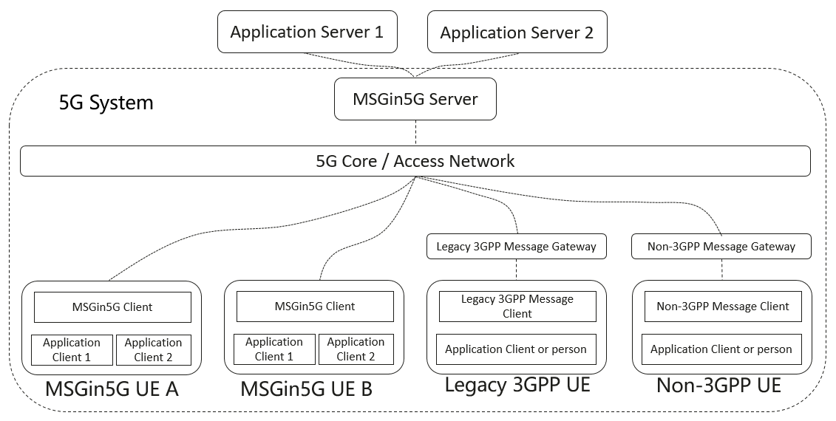
Figure 7.1-1: The MSGin5G Service overview

7.2 Service flow
Before a UE or an Application Server can use the MSGin5G Service it needs to register with the MSGin5G Server.
A UE registers with its identity, its security credentials, the capabilities that it supports, and its availability. The MSGin5G Server will use the availability registration and de-registration to determine if the UE is available for message delivery. If a UE is unavailable for message delivery, the MSGin5G Server will store the message and deliver it once the UE becomes available again.
When a UE or an Application Server sends a MSGin5G message to a recipient UE then such message will be sent to the MSGin5G Server and this server will deliver the message to the UE based on the capabilities of the recipient UE (MSGin5G UE, Legacy 3GPP UE or Non-3GPP UE). If the recipient UE is a Legacy 3GPP UE then the MSGin5G Server will forward the message to the Legacy 3GPP Message Gateway and this gateway will convert the message to a message that is supported by the recipient UE (e.g. SMS, NIDD or CB). If the recipient UE is a Non-3GPP UE then the MSGin5G Server will forward the message to the Non-3GPP Message Gateway and this gateway will convert the message to a message that is supported by the recipient UE.
A Legacy 3GPP UE sends the application payload to the Legacy 3GPP Message Gateway and this gateway will forward the application payload in a MSGin5G message to the MSGin5G Server, which will deliver the message to the recipient UE(s). A Non-3GPP UE sends the application payload to the Non-3GPP Message Gateway and this gateway will forward the application payload in a MSGin5G message to the MSGin5G Server, which will deliver the message to the recipient UE(s).
NOTE: Conversion by a Message Gateway is out of scope of the present specification.
If a UE or an Application Server sends a MSGin5G message to a group of UEs, the MSGin5G Server will deliver the message to all group members taking into account if such a UE is a MSGin5G UE, a Legacy 3GPP UE or a Non-MSGin5G UE and if such UE is available for delivery.
If a UE or an Application Server sends a MSGin5G message containing a Messaging Topic to the MSGin5G Server, the MSGin5G Server will distribute the message to all UEs and Application Servers that have subscribed to that topic.
If a UE or an Application Server sends a broadcast message to a Broadcast Area, the MSGin5G Server forwards the message to the Legacy 3GPP Message Gateway and this gateway will forward the message to the broadcast function.
Editor’s note: For broadcast messaging, whether the Legacy 3GPP Message Gateway is enough and technically right for broadcasting message to all UEs is FFS.
An originating UE or Application Server may request the recipient UE(s) to acknowledge reception of the message. If such a request is made, a message delivery status report shall be sent by the recipient MSGin5G UE or the Message Gateway (on behalf of the Non-MSGin5G UE) as a point-to-point message back to the originating UE or Application Server. The acknolwedgement information is included in the payload and the format of this information is out of scope of the present specification.
The Non-MSGin5G UE may respond to an incoming MSGin5G message; it is subject to the Message Gateway implementation to maintain the transaction of the incoming MSGin5G message and reply to it to the sender, with the response it receives from the Non-MSGin5G UE.

8 Procedures and information flows

8.1 Configuration

8.1.1 General
The configuration procedure is used to get the MSGin5G Service configuration information (e.g. UE Service ID). The configuration procedure is used by the MSGin5G UE or used by Message Gateway on behalf of the Non-MSGin5G UE. The MSGin5G Service configuration information is used in the future messaging communication.
The VAL UE configuration data specified in TS 23.434 [5] is used in this configuration procedure. After the configuration procedure, the MSGin5G UE, or the Message Gateway on behalf of the Non-MSGin5G UE can register to MSGin5G Server.
NOTE 1: The configuration on the Message Gateway to support the Non-MSGin5G UE for MSGin5G Service can also be done without using the SEAL configuration procedures and is implementation specific.
NOTE 2: The MSGin5G Service configuration information can also be pre-configured to the MSGin5G UE/Non-MSGin5G UE and is implementation specific.

8.1.2 MSGin5G UE Configuration
In the MSGin5G UE configuration procedure, the MSGin5G UE acts as Configuration management client specified in 3GPP TS 23.434 [5].
The following steps of configuration management service apply for the MSGin5G UE:
- Send the Get VAL UE configuration request specified in clause 11.3.2.1 of 3GPP TS 23.434 [5];
- Receive the related Get VAL UE configuration response specified in clause 11.3.2.2 of 3GPP TS 23.434 [5];
The usage of the above information flows is clarified as below:
- The MSGin5G UE ID works as VAL UE ID which is mandatory in the Get VAL UE configuration request;
- The UE Service ID works as VAL user ID;
- The service identifier of MSGin5G Service works as VAL service ID;
Besides the IEs specified in clause 11.3.2.1 of 3GPP TS 23.434 [5], the information in table 8.1.2-1 is also included in the Get VAL UE configuration request.
Table 8.1.2-1: Additional Information in the Get VAL UE configuration request
Information element | Status | Description
MSGin5G UE information | O | Other information needed by the configuration procedure. (NOTE 1)

NOTE 1: The information can be the device type, device vendor, etc. It is specified by application provider or MSGin5G service provider and is out of scope of this document. The MSGin5G service provider can configure the MSGin5G UE with different configuration data based on this IE. E.g. all sensors can be configured to a same MSGin5G Server.
The information in table 8.1.2-2 is included in the Get VAL UE configuration response as a part of VAL UE configuration data.
Table 8.1.2-2: Information in the Get VAL UE configuration response
Information element | Status | Description
UE Service ID | M | UE Service ID assigned to the requesting MSGin5G UE.
MSGin5G Server address | M | The MSGin5G Server which serves this MSGin5G UE.
MSGin5G Service specific information | O | The specific information of the MSGin5G Service specified by the MSGin5G service provider. (NOTE 2)

Editor’s note 1: The definition of MSGin5G Server address is needed to be added.
NOTE 2: E.g. the segment size of MSGin5G message in this service provider. The detailed definition is out of scope of this document.
Besides the functionalities of Configuration Management Server specified in 3GPP TS 23.434 [5], the MSGin5G Configuration Function should also checks whether the MSGin5G UE ID (i.e. VAL UE ID) is included in a former Get VAL UE configuration request.
- If so, the MSGin5G Configuration Function included the UE Service ID assigned to the MSGin5G UE in the former configuration procedure as a part of VAL UE configuration data,
- Otherwise, a new UE Service ID is assigned to the MSGin5G UE and included in the VAL UE configuration data.
Then the MSGin5G Configuration Function processes the configuration request according to the service policy.

8.1.3 Non-MSGin5G UE Configuration
When a Non-MSGin5G UE interacts to the Message Gateway first time (e.g. a Non-MSGin5G UE sends a message to an MSGin5G UE/Application Server or vice versa), the Message Gateway records the Non-MSGin5G UE ID and performs the configuration procedure on behalf of the Non-MSGin5G UE to get the MSGin5G Service configuration information (e.g. UE Service ID).
NOTE 1: All the necessary service information (including the UE Service ID) of a Non-MSGin5G UE can be pre-configured with the Message Gateway before the Non-MSGin5G UE first uses the MSGin5G Service. This configuration procedure is outside the scope of the current specification.
In the Non-MSGin5G UE configuration procedure, the Message Gateway acts as Configuration management client specified in 3GPP TS 23.434 [5] on behalf of each Non- MSGin5G UE.
The following steps of configuration management service may apply for the Message Gateway:
- Send the Get VAL UE configuration request specified in clause 11.3.2.1 of 3GPP TS 23.434 [5];
- Receive the related Get VAL UE configuration response specified in clause 11.3.2.2 of 3GPP TS 23.434 [5];
The usage of the above information flows is clarified as below:
- An Information Element contains both Non-MSGin5G UE ID and GW Service ID works as VAL UE ID which is mandatory in the Get VAL UE configuration request;
NOTE 2: The Non-MSGin5G UE ID may differ among different VALs and may not unique among different Gateways. It is not enough to use only Non-MSGin5G UE ID as VAL UE ID.
- The UE Service ID works as VAL user ID;
- The service identifier of MSGin5G Service works as VAL service ID;
Besides the IEs specified in clause 11.3.2.1 of 3GPP TS 23.434 [5], the information in table 8.1.3-1 is also included in the Get VAL UE configuration request.
Table 8.1.3-1: Additional Information in the Get VAL UE configuration request
Information element | Status | Description
Non-MSGin5G UE information | O | Other information needed by the configuration procedure. (NOTE 3)

NOTE 3: The information can be the device type, device Vendor, etc. It is specified by application provider or MSGin5G service provider and is out of scope of this document. The MSGin5G service provider can configure the Non-MSGin5G UE with different configuration data based on this IE. E.g. all sensors can be configured to a same MSGin5G Server.
The information in table 8.1.3-2 is included in the Get VAL UE configuration response as a part of VAL UE configuration data.
Table 8.1.3-2: Information in the Get VAL UE configuration response
Information element | Status | Description
UE Service ID | M | UE service ID assigned to the requesting Non-MSGin5G UE.
MSGin5G Server address | M | The MSGin5G Server which serves this MSGin5G UE.
MSGin5G Service specific information | O | The specific information of the MSGin5G Service specified by the MSGin5G service provider. (NOTE 4)

Editor’s note 1: The definition of MSGin5G Server address is needed to be added.
NOTE 4: E.g. the segment size of MSGin5G message in this service provider, the detailed definition is out of scope of this document.
Besides the functionalities of Configuration Management Server specified in 3GPP TS 23.434 [5], the MSGin5G Configuration Function should also checks whether the MSGin5G UE ID (i.e. VAL UE ID) is included in a former Get VAL UE configuration request.
- If so, the MSGin5G Configuration Function included the UE Service ID assigned to the MSGin5G UE in the former configuration procedure as a part of VAL UE configuration data,
- Otherwise, a new UE Service ID is assigned to the MSGin5G UE and included in the VAL UE configuration data.
Then the MSGin5G Configuration Function processes the configuration request according to the service policy.

8.2 Registration

8.2.1 MSGin5G UE Registration
The signalling flow for MSGin5G UE registration is illustrated in figure 8.2.1-1. The procedure assumes that the MSGin5G UE is responsible for initiating registration to the MSGin5G Server in order to establish association with the MSGin5G Server to receive MSGin5G Service.
Pre-conditions:
1. The MSGin5G UE has connected to the serving network successfully.
2. A UE Service ID has been provisioned on the MSGin5G UE.
3. The MSGin5G Server address has been provisioned on the MSGin5G UE.
4. Both the MSGin5G UE and MSGin5G Server have been configured with the necessary credentials to enable authenticating one another.
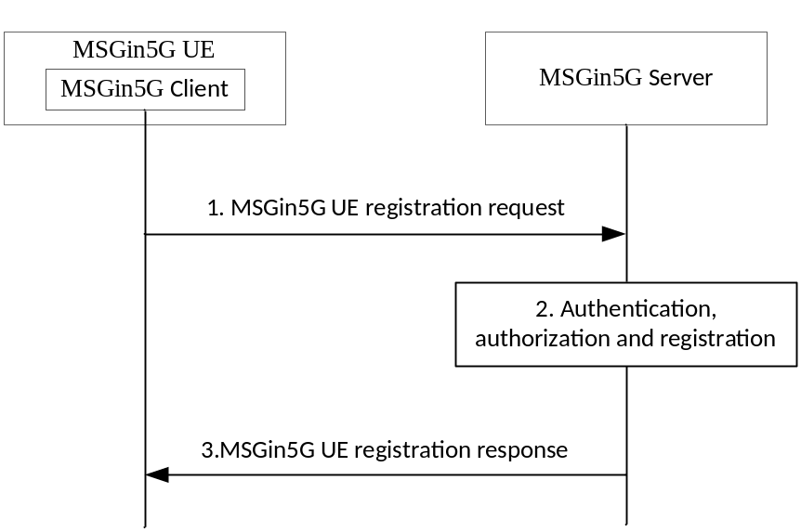
Figure 8.2.1-1: MSGin5G Client registration
1. The MSGin5G UE sends an MSGin5G UE registration request to the MSGin5G Server. The request includes security credentials required for the MSGin5G Client to register to the MSGin5G Server. The request includes the UE Service ID and MSGin5G Client Profile information as detailed in Table 8.2.1-1.
Table 8.2.1-1: MSGin5G UE registration request
Information element | Status | Description
UE Service ID | M | UE service identifier assigned to the requesting MSGin5G UE.
UE credential information | M | The information needed to authenticate the UE. It is SA3 responsibility to define the detail of the needed credential information.
MSGin5G Client Profile | O | Set of parameters describing the MSGin5G Client
>MSGin5G Client Triggering Information | O | UE Identifier (i.e., MSISDN, external ID), port number(s) and associated protocol (e.g., SMS, NIDD, etc.) for device triggering. The MSGin5G Server uses the information in step 5 of clause 8.8.3. See Table 8.2.1-2.
>MSGin5G Client Communication Availability | O | Communication availability information for the MSGin5G Client to receive MSGin5G messages. This IE informs the MSGin5G Server if the client has a specific application-level schedule/periodicity to its MSGin5G communications, which may be used in conjunction with UE reachability monitoring to determine whether and when MSGin5G communications are attempted. See Table 8.2.1-3.

Table 8.2.1-2: MSGin5G Client Triggering Information
Information element | Status | Description
MSGin5G UE ID | M | Identity of the UE hosting the MSGin5G Client (e.g., the External Identifier defined in TS 23.682 [19], or an MSISDN)
MSGin5G Client Ports | M | List of port numbers that the MSGin5G Client listens on for device triggers from the MSGin5G Server. Also included with each port number is an associated protocol (e.g., SMS, NIDD, etc.).

Table 8.2.1-3: MSGin5G Client and Non-MSGin5G UE Communication Availability
Information element | Status | Description
Scheduled communication time | M | Time when the UE becomes available for communication.
Communication duration time | M | Duration time of periodic communication.
Periodic communication indicator | O | Identifies whether the client communicates periodically or not, e.g., on demand.
Periodic communication interval | O | Interval Time of periodic communication. This IE is mandatory if the Periodic communication indicator indicates periodic communications.
Data size indication | O | Indicates the expected data size to be exchanged during the communication duration.
Store and forward option | O | Indicates opting out of store and forward services for incoming MSGin5G requests.

Editor’s note: Whether MSGin5G client capabilities are needed is FFS.
2. Upon receiving the request, the MSGin5G Server validates the registration request and verifies the security credentials.
3. The MSGin5G Server sends an MSGin5G UE registration response to the MSGin5G UE. If the registration is successful, the MSGin5G Server stores the MSGin5G Client Profile information.
Table 8.2.1-4: MSGin5G UE registration response
Information element | Status | Description
UE Service ID | M | UE service identifier assigned to the requesting MSGin5G UE.
Registration result | M | Indication if the registration is success or failure

8.2.2 MSGin5G UE De-Registration
By de-registering, the MSGin5G UE informs the MSGin5G Server that it wishes to terminate its association with the MSGin5G Server.
NOTE: De-registration implies that Client Triggering Information and the Client Communication Availability Information are no longer valid.
The procedure assumes that the MSGin5G UE is responsible for initiating the de-registration from the MSGin5G Server. The signalling flow for MSGin5G UE de-registration is illustrated in figure 8.2.2-1.
Pre-conditions:
1. The MSGin5G UE is registered to the MSGin5G Server.
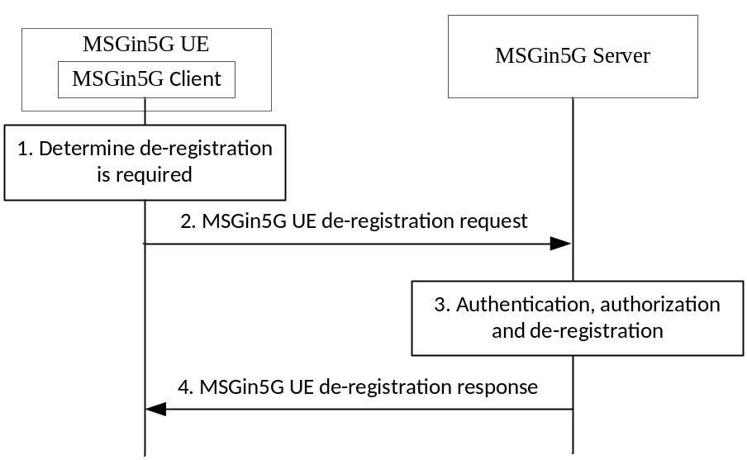
Figure 8.2.2-1: MSGin5G UE de-registration
1. The MSGin5G UE determines to de-register from the MSGin5G Server.
2. The MSGin5G UE sends an MSGin5G UE de-registration request to the MSGin5G Server that includes the UE Service ID, as detailed in Table 8.2.2-1.
Table 8.2.2-1: MSGin5G UE de-registration request
Information element | Status | Description
UE Service ID | M | UE service identifier assigned to the Non-MSGin5G UE.
UE credential information | M | The information needed to authenticate the UE. It is SA3 responsibility to define the detail of the needed credential information.

3. The MSGin5G Server validates the MSGin5G UE de-registration request and verifies the security credentials. The MSGin5G Server deletes any applicable MSGin5G Client Profile information that it has stored.
4. The MSGin5G Server an MSGin5G UE de-registration response as detailed in Table 8.2.2-2 to the MSGin5G UE.
Table 8.2.2-2: MSGin5G UE de-registration response
Information element | Status | Description
UE Service ID | M | UE service identifier assigned to the non-SGin5G UE.
De-registration result | M | Indication if the de-registration is success or failure

8.2.3 Non-MSGin5G UE Registration
Non-MSGin5G UEs (i.e., Legacy 3GPP UEs or Non-3GPP UEs) are connected to the MSGin5G Server through a Message Gateway. The Message Gateway performs registration with the MSGin5G Server on behalf of the Non-3GPP UEs, based on the registration request from the Non-3GPP UE or on pre-provisioned information. After the procedure is complete, the Message Gateway may communicate the result to the UE to enable MSGin5G Service at the Non-3GPP UEs.
The signalling flow is illustrated in figure 8.2.3-1.
Pre-conditions:
1. The Message Gateway has been pre-provisioned with the MSGin5G Server address and UE Service ID for a Non-3GPP UE.
2. Both the Non-3GPP UE and Message Gateway have been configured with the necessary credentials to enable authentication and Non-3GPP UE registration at the Message Gateway.
3. A secured connection has been established between the Message Gateway and the MSGin5G Server.

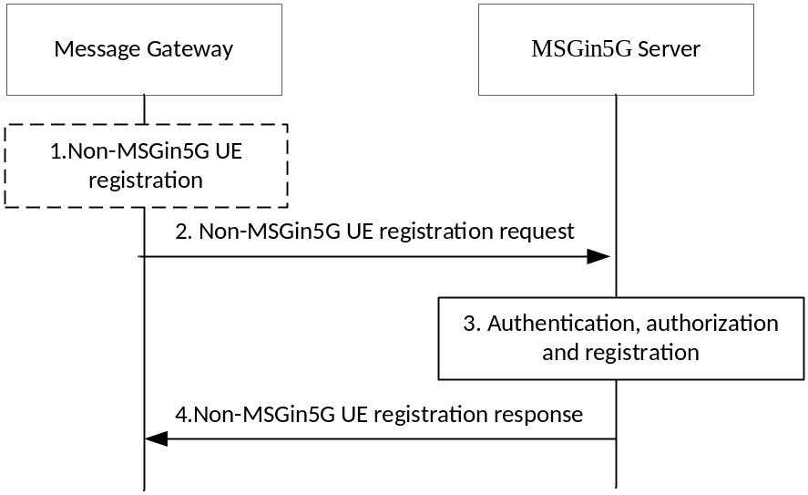
Figure 8.2.3-1: Non-MSGin5G UE registration
1. The Non-MSGin5G UE registers at the Message Gateway. Alternatively, the Non-MSGin5G UE registration information is configured at the Message Gateway. The Message Gateway, based on the registration request and pre-provisioned information, registers the UE with the MSGin5G Server, a corresponding UE Service ID and, if available, a Non-MSGin5G UE profile.
Table 8.2.3-1: Non-MSGin5G UE registration request
Information element | Status | Description
UE Service ID | M | UE service identifier assigned to the requesting Non-MSGin5G UE.
GW Service ID | M | GW service identifier of the Message Gateway performing registration on behalf of a Non-MSGin5G UE
UE credential information | M | The information needed to authenticate the UE. It is SA3 responsibility to define the detail of the needed credential information.
Non-MSGin5G UE Profile | O | Set of parameters describing the Non-MSGin5G UE
>Non-MSGin5G UE Communication Availability | O | Communication availability information for the Non-MSGin5G UE to receive messages. This IE informs the MSGin5G Server if the UE has a specific application-level schedule/periodicity to its MSGin5G communications, which may be used to determine whether and when MSGin5G communications are attempted. See Table 8.2.1-3.

2. The Message Gateway sends the Non-MSGin5G UE registration request to the MSGin5G Server. The request includes the information detailed in Table 8.2.3-1.
3. The MSGin5G Server authenticates the Message Gateway and authorises the Non-MSGin5G UE to receive the MSGin5G Service. The MSGin5G Server records the UE's availability for MSGin5G Service.
4. The MSGin5G Server returns the result of the registration in the Non-MSGin5G UE registration response message with the information detailed in table 8.2.2-2.

8.2.4 Non-MSGin5G UE De-registration
The Message Gateway performs de-registration with the MSGin5G Server on behalf of the Non-MSGin5G UEs, in order to terminate services from the MSGin5G Server. After the procedure is complete, the Message Gateway communicates the result to the requesting UE.
The procedure assumes that the Non-MSGin5G UE is responsible for initiating the de-registration from the MSGin5G Server. The signaling flow for Non-MSGin5G UE de-registration is illustrated in figure 8.2.4-1.
Pre-conditions:
1. The Message Gateway successfully performed registration with the MSGin5G Server on behalf of the Non-MSGin5G UE.
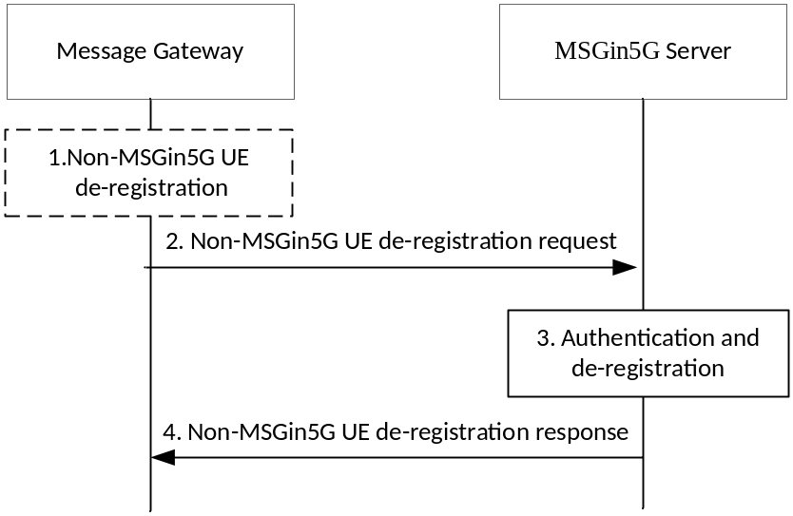
Figure 8.2.4-1 : Non-MSGin5G UE de-registration
1. The Message Gateway determines to de-register the Non-MSGin5G UE with the MSGin5G Server.
2. The Message Gateway sends a Non-MSGin5G UE de-registration request to the MSGin5G Server that includes the UE Service ID associated with the Non-MSGin5G UE, as shown in Table 8.2.4-1.
Table 8.2.4-1: Non-MSGin5G UE de-registration request
Information element | Status | Description
UE Service ID | M | UE service identifier assigned to the Non-MSGin5G UE.
UE credential information | M | The information needed to authenticate the UE. It is SA3 responsibility to define the detail of the needed credential information.

3. The MSGin5G Server validates the Non-MSGin5G UE de-degistration request and verifies the security credentials. The MSGin5G Server deletes any applicable MSGin5G Client Profile information that it has stored.
4. The MSGin5G Server deletes any applicable information that it has stored and replies with a Non-MSGin5G UE de-registration response as shown in table 8.2.4-2.
Table 8.2.4-2: Non-MSGin5G UE De-registration response
Information element | Status | Description
UE Service ID | M | UE service identifier assigned to the Non-MSGin5G UE.
De-registration result | M | Indication if the de-registration is success or failure

Editor’s note: Support for bulk registration and de-registration of Non-MSGin5G UE s (i.e., registering more than one UE Service ID at the same time) is FFS.

8.2.5 Application Server Registration
The signalling flow for Application Server registration is illustrated in figure 8.2.5-1. Application Server may use the procedure in this clause to do registration. The procedure assumes that the Application Server is responsible for triggering registration to the MSGin5G Server in order to establish association with the MSGin5G Server to receive MSGin5G Service.
NOTE: The procedure in this clause is optional for Application Server registration.
Pre-conditions:
1. The Application Server has connected to the serving network successfully.
2. An AS Service ID has been provisioned.
3. The MSGin5G Server address has been provisioned on the Application Server.
4. Both the Application Server and MSGin5G Server have been configured with the necessary credentials to enable authenticating one another.
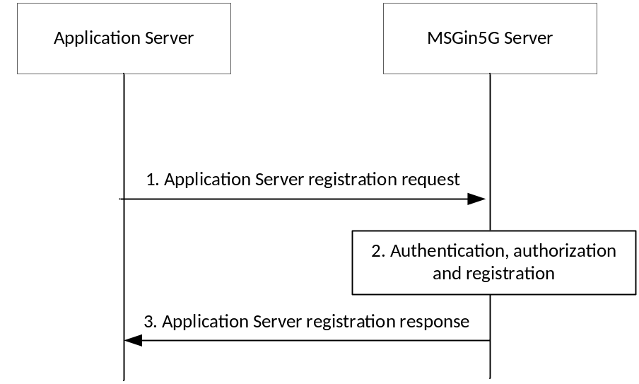
Figure 8.2.5-1: Application Server registration
1. The Application Server sends an Application Server registration request to the MSGin5G Server. The request includes security credentials required for the Application Server to register to the MSGin5G Server. The request includes the AS Service ID and Application Server Profile information as detailed in Table 9.1.2.3-1.
2. Upon receiving the request, the MSGin5G Server validates the Application Server registration request and verifies the security credentials.
3. The MSGin5G Server sends an Application Server registration response to the Application Server, the response includes the information elements as specified in Table 9.1.2.4-1. If the registration is successful, the MSGin5G Server stores the AS Profile information as detailed in Table 9.1.2.3-1.

8.2.6 Application Server De-registration
By de-registering, the Application Server informs the MSGin5G Server that it wishes to terminate its association with the MSGin5G Server.
The procedure assumes that the Application Server is responsible for triggering the de-registration from the MSGin5G Server. The signalling flow for Application Server de-registration is illustrated in figure 8.2.6-1.
Pre-conditions:
1. The Application Server is registered to the MSGin5G Server.

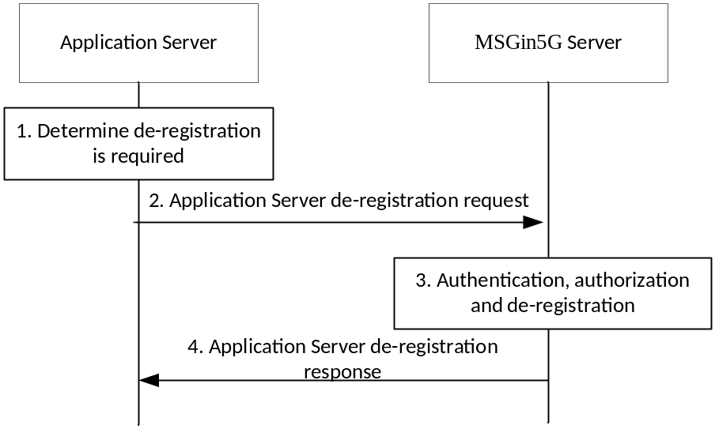
Figure 8.2.6-1: Application Server de-registration
1. The Application Server determines to de-register from the MSGin5G Server.
2. The Application Server sends an Application Server de-registration request to the MSGin5G Server that includes the AS Service ID, as detailed in Table 9.1.2.5-1.
3. The MSGin5G Server validates the Application Server de-registration request and verifies the security credentials. The MSGin5G Server deletes any applicable AS Profile information that it has stored.
4. The MSGin5G Server replies an Application Server de-registration response as detailed in Table 9.1.2.6-1.

8.3 Message delivery procedures into and from MSGin5G Server

8.3.1 General
All MSGin5G message traffic is routed via the MSGin5G Server. The present clause specifies all MSGin5G message traffic towards and from the MSGin5G Server.
Editor’s note: Alignment of this solution with the architecture and the conclusions from the study is FFS.

8.3.2 MSGin5G inbound messages into the MSGin5G Server
Figure 8.3.2-1 shows the procedure for an MSGin5G UE that initiates an MSGin5G message request.
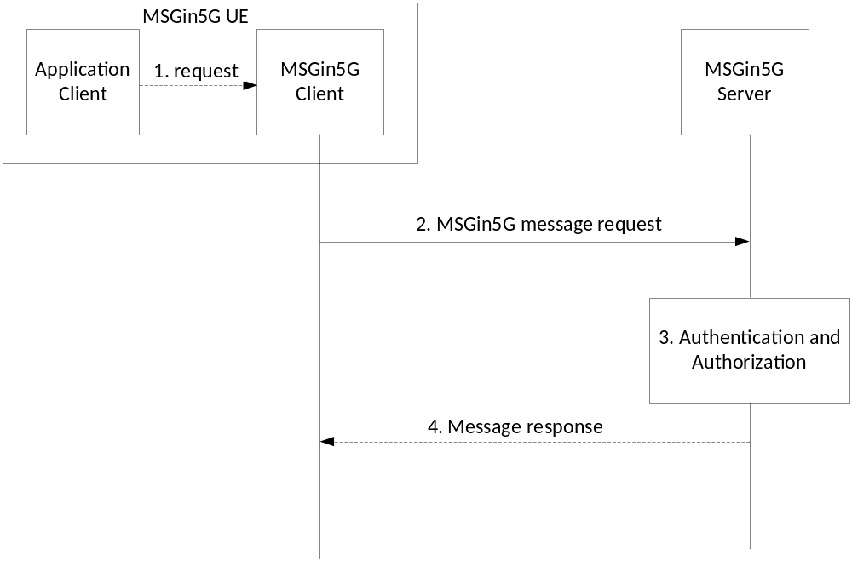
Figure 8.3.2-1: New MSGin5G message request from UE
Figure 8.3.2-2 shows the procedure for an Application Server that initiates an API request for sending an MSGin5G message to UE.
Editor’s note: The APIs provided by MSGin5G Server to Application Server are to be specified in another clause of the TS.

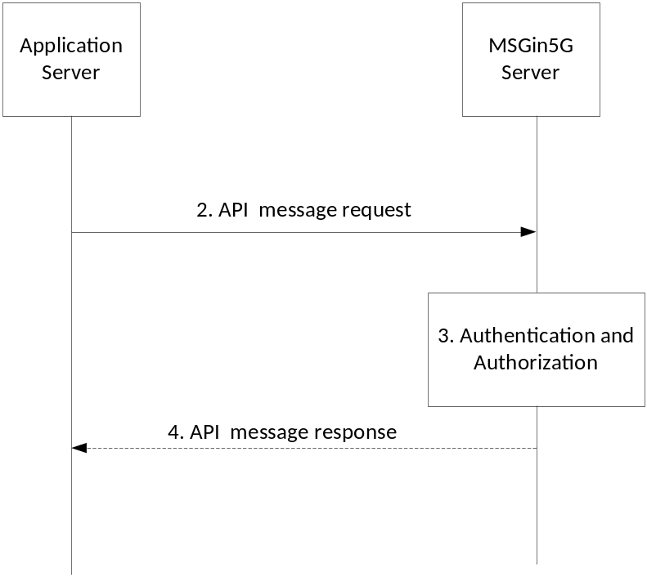
Figure 8.3.2-2: Application Server initiates a request for sending an MSGin5G message
Figure 8.3.2-3 shows the procedure for a Legacy 3GPP Message Gateway or a non-3GPP Message Gateway that sends a new MSGin5G message request to the MSGin5G Server on behalf of a Legacy 3GPP UE or Non-3GPP UE.
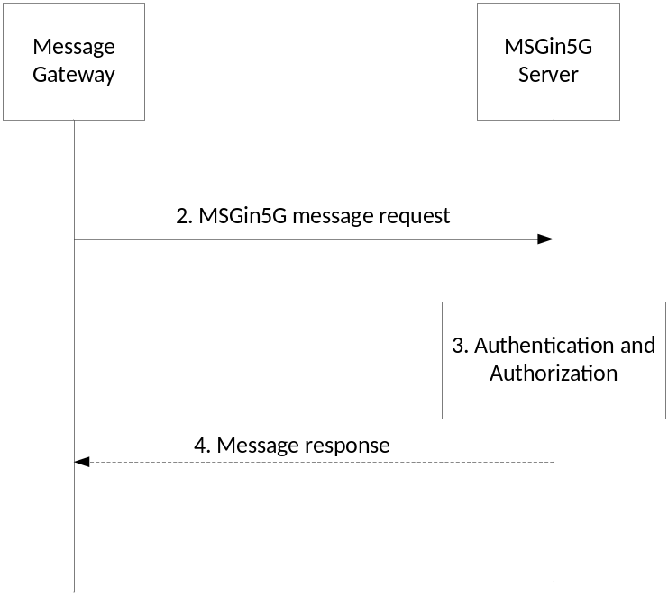
Figure 8.3.2-3: New MSGin5G message request sending from Message Gateway
The following procedure applies to the above figures 8.3.2-1, 8.3.2-2 and 8.3.2-3 with the exception that step 1 only applies to figure 8.3.2-1.
1. The Application Client in the UE sends a request to the MSGin5G Client for invoking the MSGin5G Client to send a new MSGin5G message to a recipient or to multiple recipients.
Editor’s note: Whether the APIs provided by the MSGin5G Client to the Application Client is to be specified in another clause of the TS is FFS.
2. As shown in figure 8.3.2-1 or 8.3.2-3, the MSGin5G Client or Message Gateway sends the MSGin5G message request to the MSGin5G Server and includes the IEs as listed in table 8.3.2-1 in the request; or as shown in figure 8.3.2-2, the Application Server sends an API request to the MSGin5G Server for sending a MSGin5G message, the API request includes the IEs as listed in table 8.3.2-1.
NOTE: If the value of the Store and forward flag IE in the MSGin5G message request indicates that store and forward services are requested by the sender, the procedure in 8.3.x. applies instead.
Table 8.3.2-1: Request to MSGin5G Server for sending MSGin5G message
Information element | Status | Description
Originating UE Service ID/AS Service ID | M | The service identity of the sending MSGin5G Client, Legacy 3GPP UE, Non-3GPP UE or the sending Application Server.
Recipient UE Service ID/AS Service ID  (see NOTE 1, NOTE 2) | O | The service identity of the receiving MSGin5G Client, Legacy 3GPP UE, Non-3GPP UE or the receiving Application Server.  This IE is mandatory for Point-to-Point messaging, Application-to-Point messaging, AOMT messaging and MOAT messaging and is not present in other message scenarios.
Group Service ID  (see NOTE 1) | O | The service identifier of the target MSGin5G Group.  This IE is mandatory for a Group Message and is not present in other message scenarios.
Broadcast Area ID  (see NOTE 1) | O | The service identifier of the Broadcast Service Area where the message needs to be broadcast.  This IE is mandatory in the Broadcast Message and is not present in other message scenarios.
Messaging Topic (see NOTE 1) | O | Indicates which Messaging Topic this message is related to.  This IE is mandatory for a message distribution based on topic and is not present in other message scenarios.
Application ID | O | Identifies the application(s) for which the payload is intended.  This list of Application IDs IE is required when the message is sent to one or multiple Application Clients served by same MSGin5G Client.  This list of Application IDs IE may be included when the message is sent to an Application Server or to an Application Client.  MSGin5G Server is unaware of the content.
Message ID | M | Unique identifier of this message.
Security credentials | O | Security information required by the MSGin5G Server.  This is a placeholder for SA3 security information.
Delivery status required | O | Indicates if delivery acknowledgement from the recipient is requested.
Payload | O | Payload of the message.  MSGin5G Server/Client is unaware of the content.  If the request is sent from MSGin5G Client or Message Gateway to the MSGin5G Server, the maximum size of this IE is a configurable value that shall not exceed 2048 octets.
Priority type | O | Application priority level requested for this message.
Message is segmented | O | Indicates this message is part of a segmented message.
Segmentation set identifier | O | All segmented messages associated within the same set of segmented messages (i.e. associated with the same MSGin5G message) are assigned the same unique identifier.  Mandatory IE to be present in every segmented message.
Total number of message segments | O | Indicates the total number of segments for the message.  The Total Segments needs to be included only in the first segment of the message.
Message segment number | O | An incrementing message segment number that indicates segmented message number of each segmented message within a set of segmented messages
Last segment flag | O | An indicator of whether this segmented message is the last segment in the set of segmented messages or not.  The Last Segment Flag needs to be included only in the last segment of the message. Message segment number of the segment with "Last Segment Flag" set can be considered as total segments.
Store and forward flag | M | An indicator of whether store and forward services are requested for this message. If the value indicates that store and forward services are requested by the sender, the store and forward procedure in clause X applies.
Store and forward parameters | O | Parameters used by MSGin5G Server for providing store and forward services, as detailed in table 8.3.2-2. This IE shall be included only if the value of the Store and forward flag IE indicates that store and forward services are requested. The MSGin5G store and forward procedure is detailed in clause X.
NOTE 1: Only one of these IEs shall be included to represent the type of message request.
NOTE 2: When the originator is an Application Server, (i.e. Originating AS Service ID is present), this IE shall be a UE Service ID.

Editor’s note: The store and forward procedure in clause X listed in table 8.3.2-1 is FFS.
Table 8.3.2-2: Store and forward parameters
Value | Status | Description
Message expiration time | O | Indicates message expiration time used for providing store and forward services if the destination is not available for communications, The MSGin5G Server attempts delivery at or before the message expiration time, or when the recipient becomes available.
Application specific store and forward information | O | Application specific information about store and forward handling, e.g. a delivery time/date.

3. The MSGin5G Server authenticates the message and verifies that the sender is authorized to send the message.
4. The MSGin5G Server may send a Message response to the originating entity if the message is rejected or stored and includes the IEs as listed in table 8.3.2-3 in the response.
Table 8.3.2-3: Message Response
Information element | Status | Description
Originating UE Service ID/AS Service ID | M | The identity of the MSGin5G Client, Legacy 3GPP UE, Non-3GPP UE or the identity of the Application Server that initiated the previous Request.
Message ID | M | Identifier of the initiating Request.
Delivery Status | O | Indicates if delivery is a failure, or if the message is stored for deferred delivery.
Failure Cause | O | The reason for failure

8.3.3 MSGin5G outbound messages from the MSGin5G Server
Figure 8.3.3-1 shows the procedure for the MSGin5G Server that forwards an MSGin5G message.

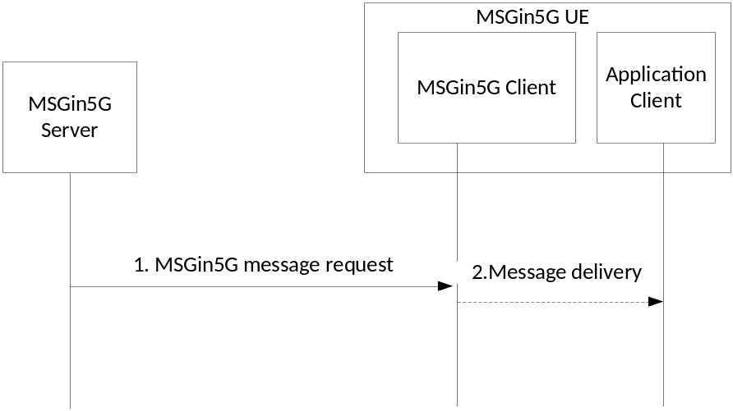
Figure 8.3.3-1: MSGin5G message towards UE
Figure 8.3.3-2 shows the same procedure (step 1 only), however for the MSGin5G Server that sends the message to an Application Server by application request.
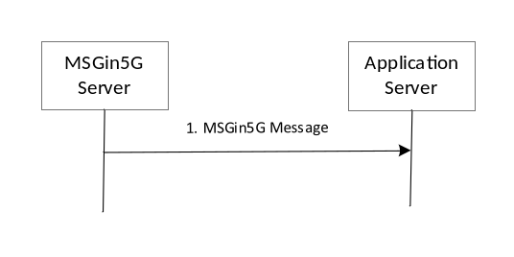
Figure 8.3.3-2: message towards an Application Server
Figure 8.3.3-3 shows the procedure for the MSGin5G Server that sends an MSGin5G message to a Legacy 3GPP Message Gateway or a Non-3GPP Message Gateway.

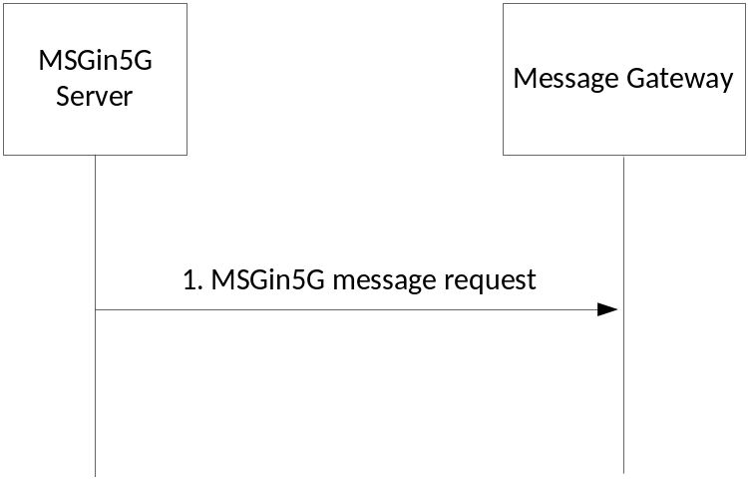
Figure 8.3.3-3: MSGin5G message towards a Message Gateway
The following procedure applies to the above figures 8.3.3-1, 8.3.3-2 and 8.3.3-3 with the exception that step 2 only applies to figure 8.3.3-1.
1. The MSGin5G Server sends the MSGin5G message request and includes the IEs as listed in table 8.3.3-1.
Table 8.3.3-1: MSGin5G message request from MSGin5G Server
Information element | Status | Description
Originating UE Service ID/AS Service ID | M | The service identity of the originating MSGin5G Client, Legacy 3GPP UE, Non-3GPP UE or the originating Application Server.  This IE is copied from the associated inbound message.
Recipient UE Service ID/AS Service ID  (see NOTE1, NOTE 2) | O | The service identity of the receiving entity.  This IE is mandatory for  Point-to-Point messaging, Application-to-Point messaging, AOMT messaging and MOAT messaging and is not present in other message scenarios.  This IE is copied from the associated inbound message.
Broadcast Area ID  (see NOTE 1) | O | The identifier of the Service Area where the message needs to be broadcast.  This IE is mandatory in the Broadcast Message and is not present in other message scenarios.  This IE is copied from the associated inbound message.
Application ID | O | Identifies the application for which the payload is intended.  This list of Application ID(s) IE is required when the message is sent to one or multiple Application Clients served by same MSGin5G Client.  This list of Application ID(s) IE may be included when the message is sent to an Application Server or to an Application Client.  This list of IEs is copied from the associated inbound message.
Message ID | M | Unique identifier of this message.  This IE is copied from the associated inbound message request.
Delivery status required | O | Indicates if delivery acknowledgement from the recipient is requested.  This IE is copied from the associated inbound message.
Payload | O | Payload of the message.  This IE is copied from the associated inbound message.
Message is segmented | O | Indicates this message is part of a segmented message.
Group Service ID | O | The service identifier of a Group.  This IE is included if message delivery is based on Group messaging.  This IE is copied from the Recipient Group Service ID IE in the associated inbound message.
Messaging Topic | O | Indicates which Messaging Topic this message is related to.  This IE is included if message delivery is based on a Messaging Topic subscription.  This IE is copied from the Messaging Topic IE in the associated inbound message.
Segmentation Set Identifier | O | All segmented messages associated within the same set of segmented messages (i.e. associated with the same MSGin5G message) are assigned the same unique identifier.  Mandatory IE to be present in every segmented message.
Total number of message segments | O | Indicates the total number of segments for the message.  The Total Segments needs to be included only in the first segment of the message.
Message segment number | O | An incrementing message segment number that indicates segmented message number of each segmented message within a set of segmented messages.
Last Segment Flag | O | An indicator of whether this segmented message is the last segment in the set of segmented messages or not.  The Last Segment Flag needs to be included only in the last segment of the message. Message segment number of the segment with "Last Segment Flag" set can be considered as total segments.
NOTE 1: Only one of these IEs shall be included to represent the type of message request.
NOTE 2: When the originator is an Application Server, (i.e. Originating AS Service ID is present), this IE shall be a UE Service ID.

If the received MSGin5G message request is for Group Message, the MSGin5G Server shall replace the Recipient Group Service ID IE with the Recipient UE Service ID of each individual group member, excluding the message originator.
If the received MSGin5G message request is for a Topic Message, the MSGin5G Server shall replace the Messaging Topic IE with the Recipient UE Service ID/AS Service ID of each individual Topic subscriber, excluding the message originator.

8.3.4 MSGin5G message delivery status report into the MSGin5G Server
Figure 8.3.4-1 shows the procedure for an MSGin5G UE that initiates a MSGin5G message delivery status report.
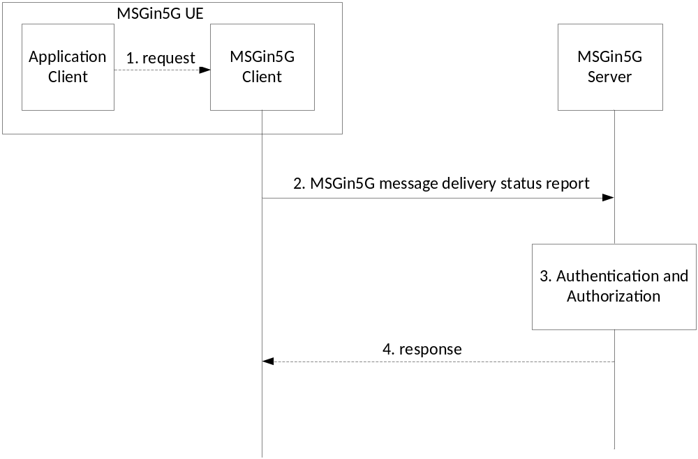
Figure 8.3.4-1: message delivery status report from MSGin5G UE

Figure 8.3.4-2 shows the procedure for an Application Server that initiates an API request for MSGin5G message delivery status report to UE.

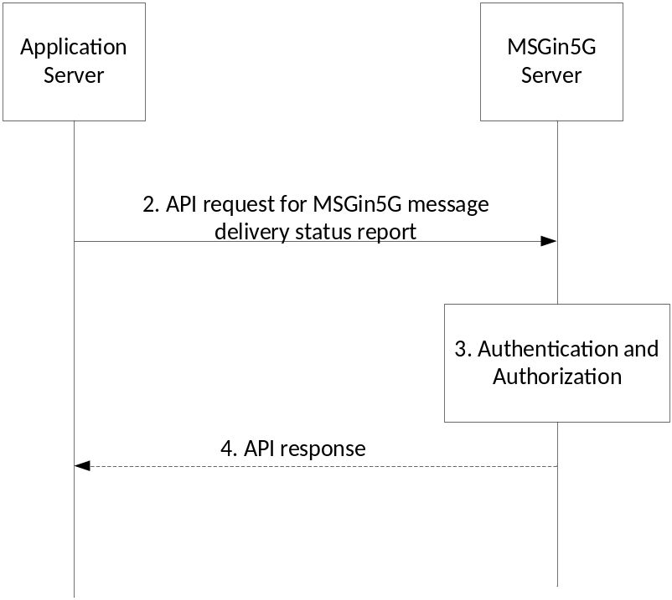
Figure 8.3.4-2: message delivery status report from Application Server
Figure 8.3.2-3 shows the procedure for a Legacy 3GPP Message Gateway or a Non-3GPP Message Gateway that sends an MSGin5G message delivery status report to the MSGin5G Server on behalf of a Legacy 3GPP UE or Non-3GPP UE.
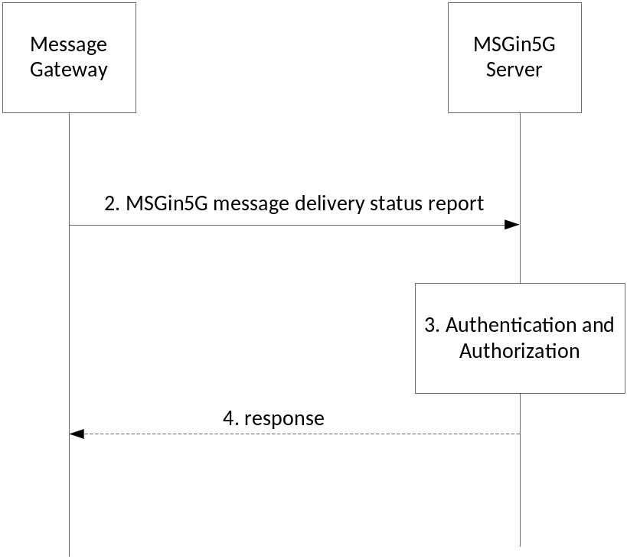
Figure 8.3.4-3: message delivery status report from Message Gateway (on behalf of Non-MSGin5G UE)
Pre-conditions:
1. The sender of an MSGin5G message has asked for a message delivery status report.
Procedures:
The following procedure applies to the above figures 8.3.4-1, 8.3.4-2 and 8.3.4-3 with the exception that step 1 only applies to figure 8.3.4-1.
1. The Application Client in the MSGin5G UE sends a request to the MSGin5G Client for invoking the MSGin5G Client to send an MSGin5G message delivery status report to a recipient.
Editor’s note: Whether the APIs provided by the MSGin5G Client to the Application Client is to be specified in another clause of the TS is FFS.
2. As shown in figure 8.3.4-1 or 8.3.4-3, the MSGin5G Client or Message Gateway sends the MSGin5G message delivery status report to the MSGin5G Server and includes the IEs as listed in table 8.3.4-1, or as shown in figure 8.3.4-2, the Application Server sends an API request to the MSGin5G Server for sending a MSGin5G message, the API request includes the IEs as listed in table 8.3.4-1.
Table 8.3.4-1: message delivery status report to MSGin5G Server
Information element | Status | Description
Originating UE Service ID/AS Service ID | M | The service identity of the sending MSGin5G Client, Legacy 3GPP UE, Non-3GPP UE or the sending Application Server.
Recipient UE Service ID/AS Service ID (NOTE) | M | The service identity of the receiving MSGin5G Client, Legacy 3GPP UE, Non-3GPP UE or the receiving Application Server.  This is the sender of the message that this message delivery status report is for.
Message ID | M | Unique identifier of message delivery status report.  The message ID of the MSGin5G message that is being acknowledged is included in this IE.
Security Credentials | O | Security information required by the MSGin5G Server.  This is a placeholder for SA3 security information.
Failure Cause | O | The Failure Cause indicates the failure reason, if applicable.
Delivery Status | M | The delivery status description, including success or failure in delivery
NOTE: When the originator is an Application Server, (i.e. Originating AS Service ID is present), this IE shall be a UE Service ID.

3. The MSGin5G Server verifies that the sender is authorized to send the message delivery status report.
4. The MSGin5G Server may send a response to the originating entity if the message delivery status report is rejected and includes the IEs as listed in table 8.3.2-3 in the response.

8.3.5 MSGin5G message delivery status report from the MSGin5G Server
Figure 8.3.5-1 shows the procedure for the MSGin5G Server that forwards an MSGin5G message delivery status report to a MSGin5G UE.

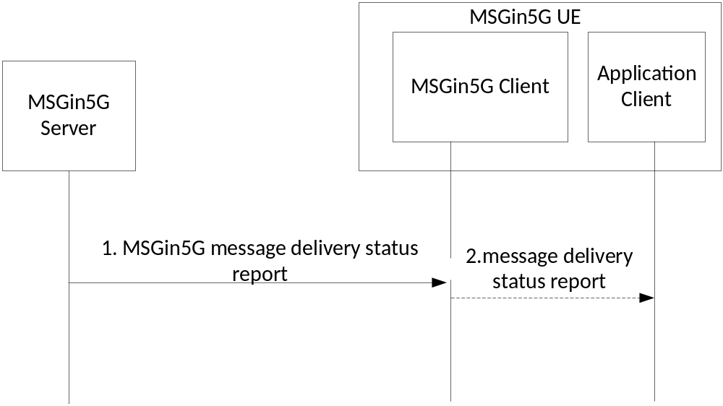
Figure 8.3.5-1: message delivery status report towards a MSGin5G UE
Figure 8.3.5-2 shows the procedure for the MSGin5G Server that forwards an MSGin5G message delivery status report to an Application Server.
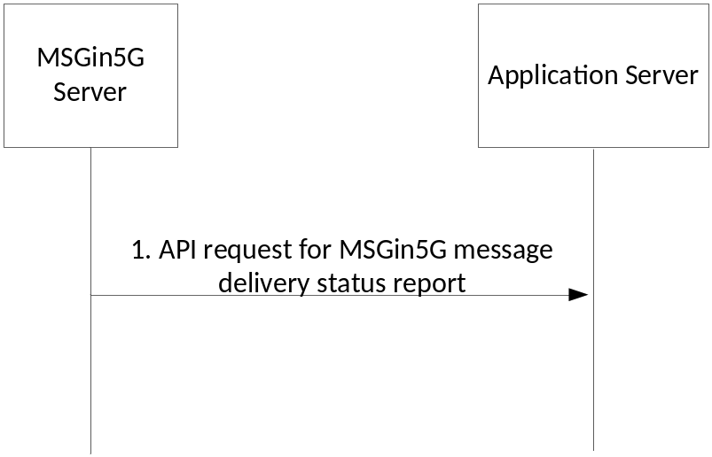
Figure 8.3.5-2: message delivery status report towards an Application Server
Figure 8.3.5-3 shows the procedure for the MSGin5G Server that forwards an MSGin5G message delivery status report to a Legacy 3GPP Message Gateway or a Non-3GPP Message Gateway.

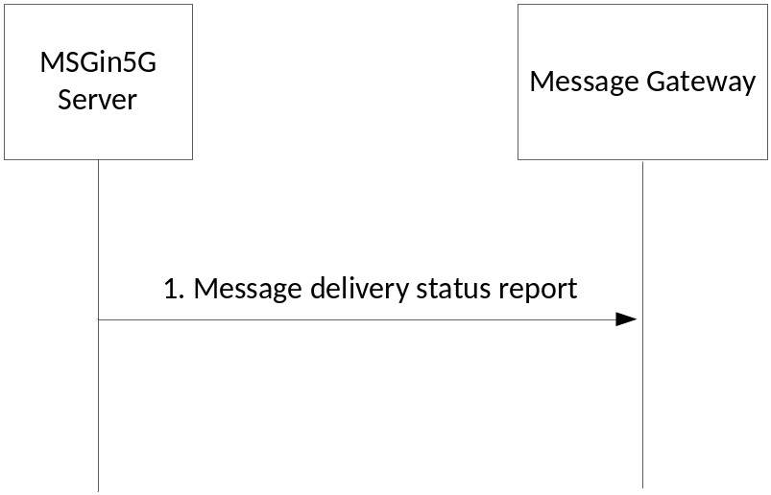
Figure 8.3.5-3: message delivery status report towards a Message Gateway
The following procedure applies to the above figures 8.3.5-1, 8.3.5-2 and 8.3.5-3 with the exception that step 2 only applies to figure 8.3.5-1.
1. the MSGin5G Server sends the MSGin5G message delivery status report to the MSGin5G UE or Message Gateway and includes the IEs as listed in table 8.3.5-1, or as shown in figure 8.3.5-2 and figure 8.3.5-3, the MSGin5G Server sends an API request to the Application Server for sending a MSGin5G message, the API request includes the IEs as listed in table 8.3.5-1.
Table 8.3.5-1: message delivery status report to MSGin5G Server
Information element | Status | Description
Originating UE Service ID/AS Service ID | M | The service identity of the sending MSGin5G Client, Legacy 3GPP UE, Non-3GPP UE or the sending Application Server.
Recipient UE Service ID/AS Service ID (see NOTE) | M | The service identity of the receiving MSGin5G Client, Legacy 3GPP UE, Non-3GPP UE or the receiving Application Server.  This is the sender of the message that this message delivery status report is for.
Message ID | M | Unique identifier of message delivery status report.  The message ID of the MSGin5G message that is being acknowledged is included in this IE.
Failure Cause | O | The Failure Cause indicates the failure reason, if applicable.
Delivery Status | M | The delivery status description, including success or failure in delivery.
NOTE: When the originator is an Application Server, (i.e. Originating AS Service ID is present), this IE shall be a UE Service ID.

2. The MSGin5G Client sends the MSGin5G message delivery status report to Application Client.

8.4 Message Aggregation

8.4.1 General
Based on maximum segment size allowed to transmit over available transport, the MSGin5G Service can optimize communications by aggregating one or more messages towards the target.
The following pre-conditions apply for message aggregation:
1. The recipient UE(s) support an MSGin5G Client or the (Legacy-3GPP and non-3GPP) Message Gateway supports the MSGin5G Client capability.
2. The MSGin5G Client 1 and MSGin5G Client 2 are registered with the MSGin5G Server.

8.4.2 Message Aggregation at MSGin5G Client
Figure 8.4.2-1 shows the procedure for an MSGin5G Client aggregating Point-to-Point messages and group messages each carrying small amounts of data.
NOTE 1: Aggregation of multiple messages can also be done with the Application Client; in this case it is implementation specific and out of the scope of the current specification.

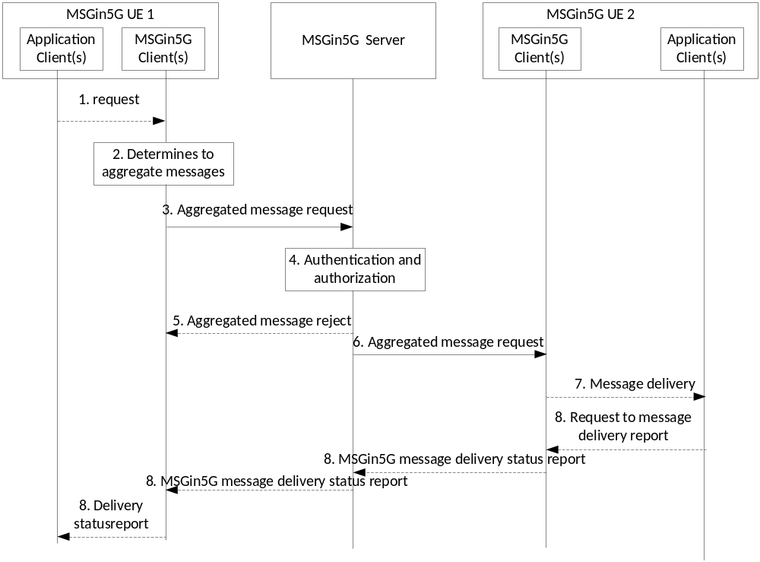
Figure 8.4.2-1: MSGin5G Client aggregates messages towards target end point
1. Application Client(s) on UE 1 initiates a request to the MSGin5G Client 1 to send a message to another target or to send a group message.
2. The MSGin5G Client 1 checks if aggregation is allowed for this message, checks the message data size and the priority level to determine if the received message can be aggregated. For example, MSGin5G Client 1 finds that the messages have small payload size when compared to the maximum segment size that can be transmitted over available transport and are not high priority messages, which could be sent as per scheduling policy towards a selected target.
NOTE 2: MSGin5G Client 1 decides to continue aggregating messages until optimal use of segment size before sending message towards MSGin5G Server.
NOTE 3: How the MSGin5G Client 1 uses individual message priority, maximum time to wait, etc for aggregating and sending is out of scope of the present document.
3. The MSGin5G Client 1 aggregates multiple MSGin5G message requests intended for a selected target and sends the Aggregated message request as defined in Table 8.3.2-1 and Table 8.3.2-3 according to scheduling policy towards MSGin5G Server.
Table 8.4.2-1: Aggregated message request (MSGin5G Client to MSGin5G Server)
Information element | Status | Description
Originator UE Service ID | M | The service identity of the sending MSGin5G Client.
Recipient UE Service ID | M | The service identity of the receiving MSGin5G Client.
Message ID | M | Unique identifier of the aggregated message
Number of individual messages | M | Indicates total number of messages which are aggregated into single message
List of individual messages | M | Each element in this list contains information as specified in Table 8.3.2-1.

Table 8.4.2-2: Individual message data
Information element | Status | Description
Individual Message ID | M | Unique identifier of this individual message
Application ID | O | Identifies the application for which the payload is intended
Disposition Type | O | Indicates the disposition type expected from the receiver (i.e. message delivery status report)
Payload | M | Payload of the message
Priority type | O | Application priority level requested for this message.

NOTE 4: Total size of Aggregated message request is less than or equal to maximum segment size allowed to be transmitted over available transport.
4. MSGin5G Server checks whether the MSGin5G Client 1 is authenticated and authorized to send Aggregated message request. If authenticated and authorized, the MSGin5G Server skips step 5.
5. If MSGin5G Client 1 is not authorized to send Aggregated message request or the Aggregated message request is not valid, the MSGin5G Server sends Aggregated message reject to the MSGin5G Client 1. The information elements defined in Table 8.4.2-3 are included in the request.
Table 8.4.2-3: Aggregated message reject (MSGin5G Server to MSGin5G Client)
Information element | Status | Description
Destination MSGin5G Client ID | M | The identity of the MSGin5G Client sending the original message.
Message ID | M | Unique identifier of this message
Reject Reason | O | This IE contains the failure reason, e.g. the originator is not authorized to send a message request or one of the multiple messages aggregated has an issue, may be included in this IE.

Editor’s note: If the Application ID should be in table 8.4.2-3 instead of table 8.3.2-3 is FFS.
6. If MSGin5G Client 1 is authorized to send Aggregated message request, the MSGin5G Server sends Aggregated message request towards the selected target MSGin5G Client(s) 2.
7. The MSGin5G Client 2 splits the received Aggregated message request into multiple individual MSGin5G message requests per application and sends them towards Application Client(s).
8. The Application Client(s) may initiate sending a message delivery status report, if requested in the original message that is received as in Step 7. MSGin5G Client 2 sends the message delivery status report towards the Application Client(s) on UE 1 via MSGin5G Server and MSGin5G Client 1.
NOTE 5: The message delivery status reports can also be aggregated into a single message.

8.4.3 Message Aggregation at MSGin5G Server
Figure 8.4.3-1 shows the procedure for MSGin5G Server aggregating Application-to-Point messages each carrying small data targeted towards the target UE.
NOTE 1: Aggregation of multiple messages can also be done at the Application Server; in this case it is implementation specific and out of the scope of the current specification.

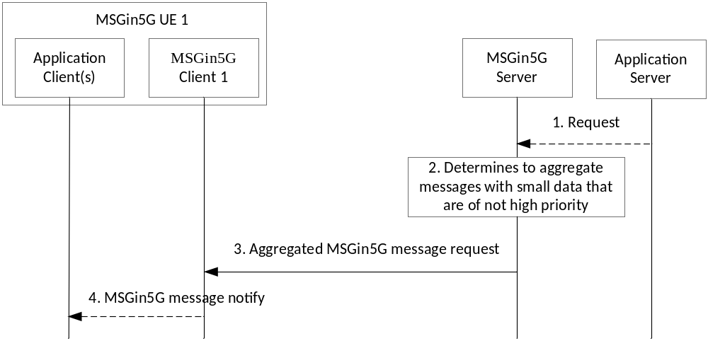
Figure 8.4.3-1: MSGin5G Client aggregates messages towards target end point
1. The Application Server initiates to send Application-to-Point message or a group message towards target UE(s) 1 and sends the request to MSGin5G Server and includes an indication that message aggregation is allowed for this message.
2. The MSGin5G Server checks the message data size and the priority level to determine if the received message can be aggregated. For example, MSGin5G Server finds that the messages have small payload size when compared to the maximum segment size that can be transmitted over available transport and are not high priority messages, which could be sent as per scheduling policy towards a selected target.
NOTE 2: MSGin5G Server decides to continue aggregating messages until optimal use of segment size before sending message towards MSGin5G Client 1.
3. The MSGin5G Server aggregates multiple MSGin5G message requests intended for the target UE and sends the Aggregated message request as defined in Table 8.3.3-1 and Table 8.4.3-1 according to scheduling policy towards the MSGin5G Client 1.
Table 8.4.3-1: Aggregated message request (MSGin5G Server to MSGin5G Client)
Information element | Status | Description
Recipient UE Service ID | M | The service identity of the receiving MSGin5G Client.
Message ID | M | Unique identifier of this message
Number of individual messages | M | Indicates total number of messages which are aggregated into single message
List of Individual messages | M | Each element in this list contains information as specified in Table 8.3.3-1

Editor’s note: Table 8.4.3-1 is identical to table 8.3.3-1 but lacks the Originator AS Service ID. It is FFS if only table 8.3.3-1 is sufficient.
NOTE 3: Total size of Aggregated message request is less than or equal to maximum segment size allowed to transmit over available transport.
4. The MSGin5G Client 1 splits the received Aggregated message request into multiple individual MSGin5G message requests per application and sends towards Application Client(s) as notifications.
NOTE 4: The MSGin5G Server may aggregate messages towards the target UE if it receives message from multiple MSGin5G UEs (instead of application server).

8.5 MSGin5G Message Segmentation and Reassembly

8.5.1 General
This clause introduces MSGin5G message segmentation and reassembly functionality to the MSGin5G Service.
Segmentation and reassembly operations are performed either by the MSGin5G Server or by the MSGin5G Client, depending on the communication models. For Application-to-Point use case, the MSGin5G Server performs MSGin5G message segmentation while the MSGin5G Client performs MSGin5G message reassembly. For Point-to-Application use case, the MSGin5G Client performs MSGin5G message segmentation while the MSGin5G Server performs MSGin5G message reassembly.
The maximum segmentation size of MSGin5G message is 2048 bytes and can be configurable.

8.5.2 Application-to-Point Segmentation and Reassembly
Figure 8.5.2-1 shows the MSGin5G message segmentation and reassembly procedure for Application-to-Point MSGin5G message use cases (e.g. AOMT).
NOTE 1: Segmentation can also be done by the Application Server, in this case the Application Server will create a segmented message and send it as a regular MSGin5G message. In this case it is implementation specific and out of the scope of the current specification.
Pre-conditions:
1. A UE hosts an MSGin5G Client and an Application Client.
2. The MSGin5G Client registers with the MSGin5G Server.
3. An Application Server needs to deliver application data to the Application Client on the UE and the size of the application data exceeds the maximum allowed packet size (e.g. due to limitation by the UE's access network transport).

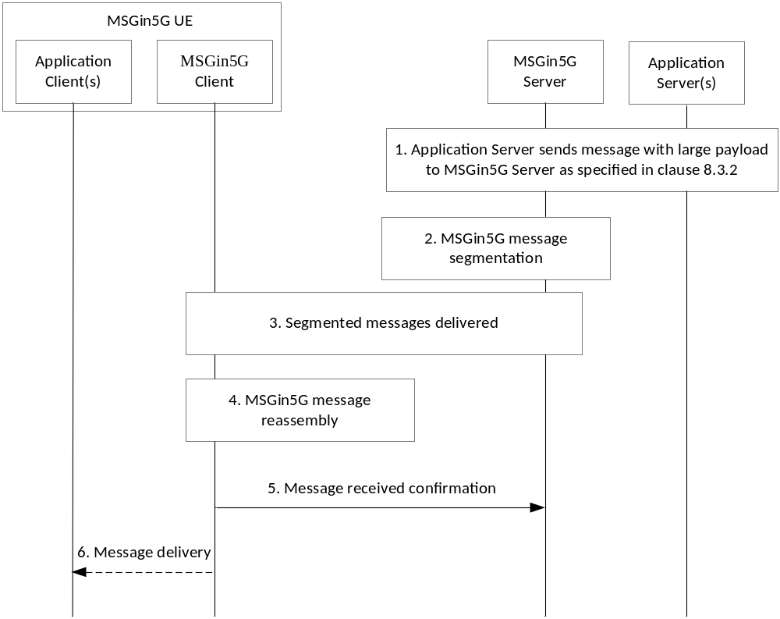
Figure 8.5.2-1: Application-to-Point MSGin5G Message Segmentation and Reassembly
1. An Application Server sends a message to an MSGin5G Server that targets an Application Client on a UE.
2. The MSGin5G Server compares the size of the received message to the maximum allowed packet size and detects that the size exceeds the limit. As a result, the MSGin5G Sever segments the received message into a set of segmented messages. Within each segmented message, the information elements defined in Table 8.3.3-1 are included to enable the MSGin5G Client on the targeted UE to reassemble the segmented messages, with following clarifications.
a) The MSGin5G message request includes following information elements from Table 8.3.3-1:
i) Originating AS Service ID, Recipient UE Service ID, Message ID, Segmentation Set Identifier and Message segment number in each segmented message
ii) Delivery status required and Total number of message segments, only if it is the first segment of the message
iii) Last Segment Flag, only if it is the last segment of the message.
3. The MSGin5G Server sends each segmented message to the targeted UE. If any segment is not received within the expected time (based on configuration) then proceed to step 4.
4. If MSGin5G Client has received all segments (determined based on First segment and Last Segment), the MSGin5G Client reassembles all the segmented messages into a single MSGin5G message based on the information elements mentioned in step 2. If not all segments are received within expected time, then the MSGin5G Client recovers the segments as described in clause 8.5.6 MSGin5G message segment recovery procedure, before continuing with rest of the steps.
NOTE 2: When no further segments received within expected time and if both first segment and last segment are missing, recovery can be initiated as described in clause 8.5.6 MSGin5G message segment recovery procedure for recovering the first segment and then for remaining segments.
Editor’s note: For Application-to-Point messages to UEs without MSGin5G Clients, reassembly and the responsibility of the Message Gateway in this procedure are FFS.
5. The MSGin5G Client sends Message status request to the MSGin5G Server. The information elements defined in Table 8.5.2-2 are included in the request. The result information element will contain "success" if the reassembly of the segments is success. Otherwise, the result information element will contain "failure".
Table 8.5.2-2: Message Received Confirmation Request Information Elements
Information element | Status | Description
Segmentation Set Identifier | M | The Segmentation Set Identifier as received in segments.
Result | M | Indicates the "success" or "failure"

NOTE 3: The MSGin5G Server may send acknowledge back to MSGin5G Client based on application requirement.
Editor’s note: Whether table 8.5.2-2 can be replaced with the existing Table 8.3.2-3 is FFS.
6. If reassembly of segments is success, the MSGin5G Client delivers the contents of the MSGin5G message to the targeted Application Client. If MSGin5G Client has not received all messages (even after recovery procedure) or reassembly of segments failed for any reason (e.g. corrupt data) then the MSGin5G Client will notify receiving of failed message to Application Client.

8.5.3 Point-to-Application Message Segmentation and Reassembly
Figure 8.5.3-1 shows the MSGin5G message segmentation and reassembly procedure for Point-to-Application MSGin5G message use cases (e.g. MOAT).
Pre-conditions:
1. A UE hosts an MSGin5G Client and an Application Client.
2. The MSGin5G Client registers with the MSGin5G Server.
3. An Application Client on the UE needs to deliver application data to an Application Server and the size of the application data exceeds the maximum allowed packet size (e.g. due to limitation by the UE's access network transport).
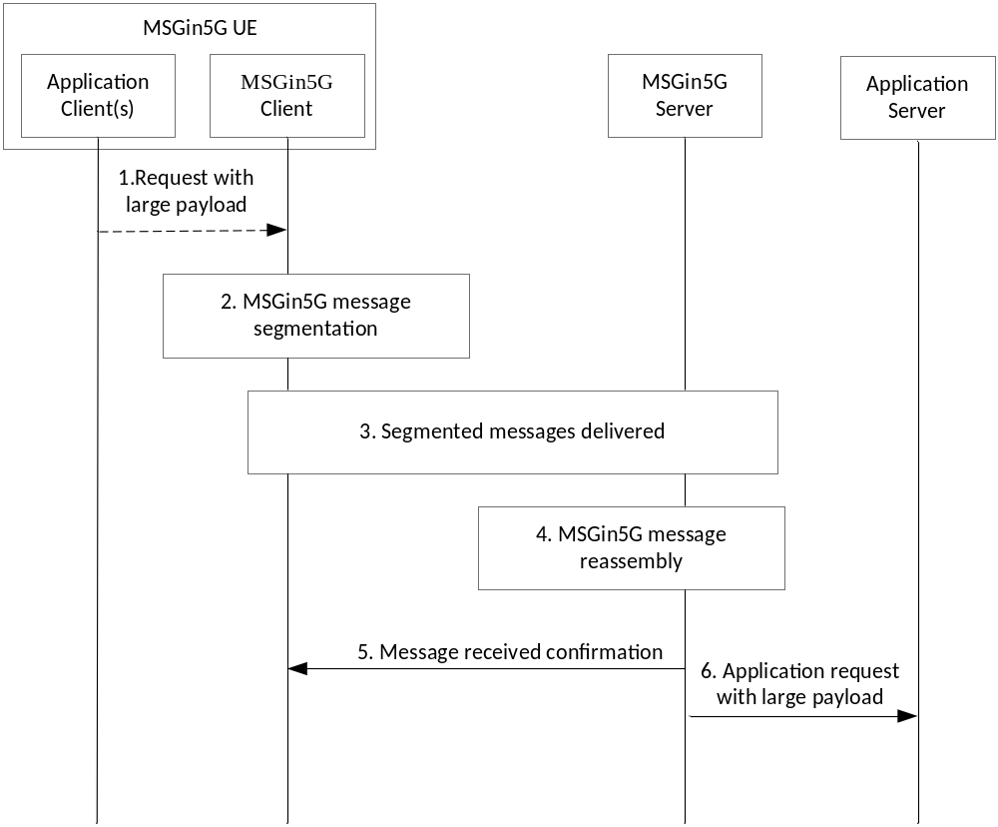
Figure 8.5.3-1: Point-to-Application MSGin5G Message Segmentation and Reassembly
1. An Application Client on a UE sends a message to an MSGin5G Client that targets an Application Server and that has a size that exceeds the maximum allowed packet size.
2. The MSGin5G Client compares the size of the received message to the maximum allowed packet size and detects that the size exceeds the limit. As a result, the MSGin5G Client segments the received message into a set of segmented messages such that each segmented message can fit within the maximum allowed packet size. Within each segmented message, the information elements defined in Table 8.3.2-1 are included to enable the MSGin5G Server to reassemble the segmented messages, with following clarifications.
a) The MSGin5G message request includes following information elements from Table 8.3.2-1:
i) Originating UE Service ID, Recipient AS Service ID, Message ID, Segmentation set identifier and Message segment number in each segmented message
ii) Delivery status required and Total number of message segments, only if it is the first segment of the message
iii) Last segment flag, only if it is the last segment of the message.
Editor’s note: For UEs without MSGin5G Clients, the segmentation of Point-to-Application messages and the responsibility of the Message Gateway in this procedure are FFS.
3. The MSGin5G Client sends each segmented message to the MSGin5G Server. If any segment is not received within the expected time (based on configuration) then proceed to step 4.
4. If MSGin5G Server has received all segments (determined based on first segment and last Segment), the MSGin5G Server reassembles all the segmented messages into a single MSGin5G message based on the information elements mentioned in step 2. If not all segments are received within expected time, then the MSGin5G Server recovers the segments as described in clause 8.5.6 MSGin5G message segment recovery procedure, before continuing with rest of the steps.
NOTE 1: When no further segments received within expected time and if both first segment and last segment are missing, recovery can be initiated as described in clause 8.5.6 MSGin5G message segment recovery procedure for recovering the first segment and then for remaining segments.
5. The MSGin5G Server sends message received confirmation to the MSGin5G Client. The information elements defined in Table 8.5.2-2 are included in the request. The result information element will contain "success" if the reassembly of the segments is success. Otherwise, the result information element will contain "failure".
NOTE 2: The MSGin5G Client may send acknowledge back to MSGin5G Server based on application requirement.
6. If reassembly of segments is success, the MSGin5G Server delivers the contents of the MSGin5G message to the targeted Application Server. If MSGin5G Server has not received all messages (even after recovery procedure) or reassembly of segments failed for any reason (e.g. corrupt data) then the MSGin5G Server will notify receiving of failed message to application server.
Editor’s note: MSGin5G message segmentation and reassembly for Broadcast messages is FFS.

8.5.4 Point-to-Point Message Segmentation and Reassembly
Figure 8.5.4-1 shows the MSGin5G message segmentation and reassembly procedure for Point-to-Point MSGin5G message use cases (e.g. MOMT).
This procedure assumes that a UE is only aware of the maximum payload size of the delivery mechanism it is currently using, and it is not aware of the maximum payload size of the recipient UE.
Pre-conditions:
1. Both UEs host an MSGin5G Client and an Application Client.
2. The MSGin5G Clients register with the MSGin5G Server.
3. An Application Client on the UE needs to deliver application data to an Application Client on another UE and the size of the application data exceeds the allowed maximum packet size (e.g. due to limitation by the UE's access network transport).

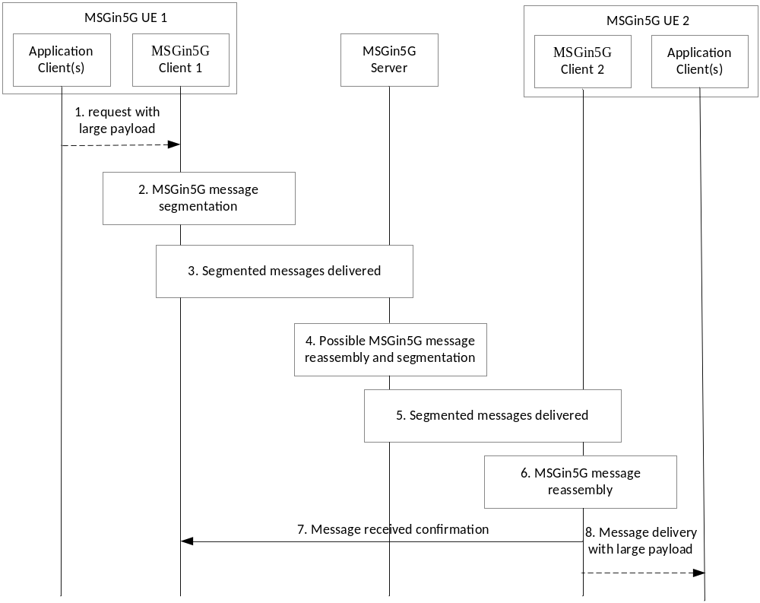
Figure 8.5.4-1: Point-to-Point MSGin5G Message Segmentation and Reassembly
1. An Application Client on a UE sends a message to an MSGin5G Client that targets an Application Client on another UE.
2. The MSGin5G Client compares the size of the received message to the maximum allowed packet size and detects that the size exceeds the limit of the originating UE. As a result, the MSGin5G Client segments the received message into a set of segmented messages such that each segmented message can fit within the maximum allowed packet size. Within each segmented message, the information elements defined in Table 8.51.2-1 are included to enable reassembly of the segmented messages, with following clarifications.
a) The MSGin5G message request includes following information elements from Table 8.3.2-1:
i) Originating UE Service ID, Recipient UE Service ID, Message ID, Segmentation set identifier and Message segment number in each segmented message
ii) Delivery status required and Total number of message segments, only if it is the first segment of the message
iii) Last segment flag, only if it is the last segment of the message.
3. The MSGin5G Client sends each segmented message to the MSGin5G Server. If any segment is not received within the expected time (based on configuration) then proceed to step 4.
4. The MSGin5G Server checks if each segment does not exceed the configured maximum packet size of the targeted UE. If the maximum packet size is not exceeded, then the MSGin5G Server proceeds with step 5.
If the maximum packet size is exceeded, then the MSGin5G Server reassembles subsequent segmented messages, until the Last segment flag indication is received, into a single MSGin5G message. The re-assembled message is then segmented such that each segment is smaller than the maximum allowed packet size of the targeted UE. Within each segmented message, the information elements as mentioned in step 2 are included to enable reassembly at the target.
5. If MSGin5G Client in UE 2 has received all segments (determined based on First segment and Last Segment), the MSGin5G Server delivers the contents of the MSGin5G message to the targeted MSGin5G Client. If any segment as a separate message is not received within the expected time (based on configuration) then proceed to step 7.
6. The 5GMSG Client reassembles all the segmented messages into a single MSGin5G message based on the information elements defined mentioned in step 2.
7. The MSGin5G Server sends Message received confirmation to the MSGin5G Client. The information elements defined in Table 8.5.2-2 are included in the request. The result information element will contain "success" if the reassembly of the segments is success. Otherwise, the result information element will contain "failure".
NOTE: The MSGin5G Client may send acknowledge back to MSGin5G Server based on application requirement.
8. The MSGin5G Client delivers the contents of the MSGin5G message to the targeted Application Client. If MSGin5G Client has not received all messages (even after recovery procedure) or reassembly of segments failed for any reason (e.g. corrupt data) then the MSGin5G Client will notify receiving of failed message to Application Client.

8.5.5 Group Message Segmentation and Reassembly
A Group Message is sent from the MSGin5G Server to a group of recipient UEs. The MSGin5G Server sends the message to each individual recipient taking into account the maximum packet size that is supported by the recipient and segments the message as described in clause 8.5.4.
Editor’s note: For group member UEs without MSGin5G Client, how the segmentation is carried out and the responsibility of the Message Gateway in this procedure are FFS

8.5.6 MSGin5G Message Segment Recovery
Figure 8.5.6-1 illustrates an MSGin5G message segmentation recovery procedure. The procedure is applicable to Application-to-Point messages, Point-to-Application messages and Group messages.
Pre-conditions:
1. The Message sender has delivered segmented messages to Message receiver.
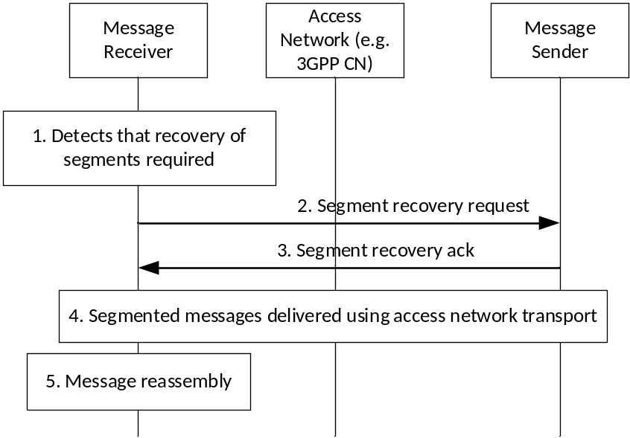
Figure 8.5.6-1: MSGin5G Message Segmentation and Reassembly
1. The Message Receiver detects that few segments are missing to reassemble complete message.
2. The Message receiver sends Segment recovery request to Message sender. The information elements defined in Table 8.5.6-1 are included in the request message.
Table 8.5.6-1: Segment Recovery Request Information Elements
Information element | Status | Description
Segmentation Set Identifier | M | The Segmentation Set Identifier as received in segments.
List of Segment range | M | List of Segment range which the client wants to recover, each segment range consist of start and end sequence number of missing segments e.g. (5-7, 10-10, 15-19)

3. The Message sender sends Segment recovery acknowledgement to the MSGin5G Client.
4. The Message sender sends each segmented message to the Message receiver within an individual access network transport packet. If the next segment is not received within the expected time (based on configuration) then the Message receiver may consider as recovery failed or may initiate the procedure again with updated list of segment range.
NOTE: The MSGin5G message segment recovery procedure may repeat based on the configuration.

8.6 MSGin5G messaging procedure on Message Gateway

8.6.1 General MSGin5G messaging procedure on Message Gateway
Figure 8.6.1-1 shows the MSGin5G message delivery procedure on Message Gateway for Non-MSGin5G UEs.
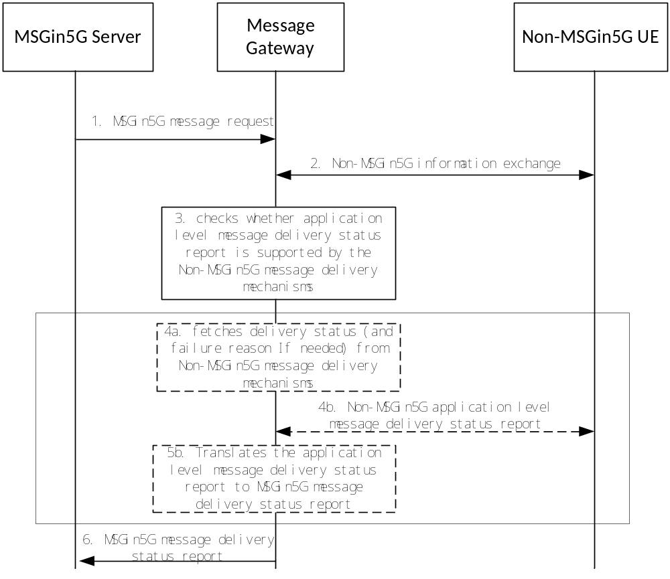
Figure8.6.1-1: MSGin5G messaging procedure on Message Gateway.
1. The MSGin5G Server determines to send the MSGin5G message request to a Non-MSGin5G UE and forwards it to the Message Gateway for delivery. A Delivery status required IE may be included in the MSGin5G message request.
2. The Message Gateway records if a message delivery status report is requested in the message. Then it translates the MSGin5G message to Non-MSGin5G message (e.g. SMS, RCS message as specified in GSMA PRD RCC.07 [3]) with message delivery status report requested and finishes the information exchange procedure with Non-MSGin5G UE (e.g. sends the non-MSGin5G message to the Non-MSGin5G UE and receives the needed response).
NOTE 1: The information exchange procedure between Message Gateway and Non-MSGin5G UE is out of scope of this specification.
3. The Message Gateway checks if application level message delivery status report is supported by the Non-MSGin5G message delivery mechanisms. If not supported, step 4a will be used and steps 4b and 5b will be skipped; otherwise step 4b-5b will be used and step 4a will be skipped.
4a. Based on the information (e.g. response to the non-MSGin5G message delivery request, transport level information, etc) obtained from the non-MSGin5G message delivery mechanisms, the Message Gateway fetches the delivery status from the above information and uses it to create a MSGin5G message delivery status report. If the delivery status is failure, also fetch the suitable failure reason from the above information and use it as reason of failure in the MSGin5G message delivery status report. The Information Elements listed in table 8.3.4-1 are included in the MSGin5G message delivery status report.
4b. A non-MSGin5G application-level message delivery status report is received by the Message Gateway.
NOTE 2: The procedure of non-MSGin5G application level message delivery status report is out of scope of this specification.
5b. The Message Gateway translates the non-MSGin5G application level message delivery status report to MSGin5G message delivery status report as specified in clause 8.3.4. The Information Elements listed in table8.3.4-1 are also included in this MSGin5G message delivery status report, but the Delivery Status and Failure Cause IEs are fetched from the non-MSGin5G application level message delivery status report.
6. The Message Gateway sends the MSGin5G message delivery status report to the MSGin5G Server on behalf of the Non-MSGin5G UE as specified in clause 8.3.4 in a point-to-point message.

8.6.2 Non-MSGin5G UE receives message from group

8.6.2.1 Legacy 3GPP UE receives message from group
Figure 8.6.2.1-1 shows the procedure for Legacy 3GPP UE to receive message from group.
Pre-conditions:
1. The MSGin5G Server has received the message to send to target UE.
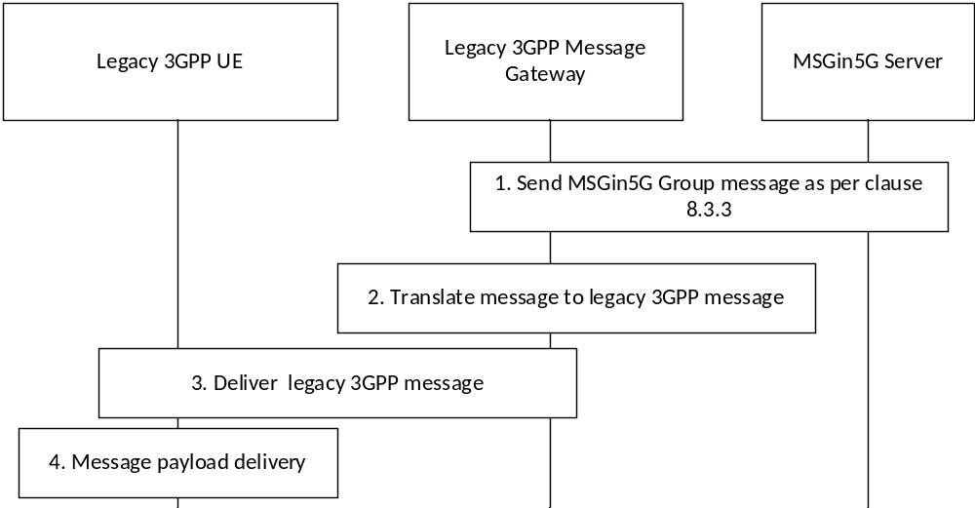
Figure 8.6.2.1-1: Legacy 3GPP UE receives a message from the group
1. The MSGin5G Server sends the MSGin5G message request to the recipient based on the UE Service ID. The Legacy 3GPP Message Gateway receives the MSGin5G message request on behalf of the Non-GPP UE as defined in clause 8.3.3 with following clarifications:
a) The MSGin5G message request includes Originating UE Service ID, Recipient Group Service ID, Recipient UE Service ID, Message ID, Payload information elements from Table 8.3.3-1. The MSGin5G message request may include Delivery status required, Application ID and Priority type information elements from Table 8.3.3-1.
2. The Legacy 3GPP Message Gateway translates the MSGin5G message request to Legacy 3GPP message (e.g. SMS).
3. The Legacy 3GPP message gateway sends Legacy 3GPP message (e.g. SMS) to Legacy 3GPP UE.
4. The Legacy 3GPP UE delivers the payload of the legacy 3GPP message (e.g. SMS) to the targeted Application Client on the Legacy 3GPP UE.

8.6.2.2 Non-3GPP message client receives message from group
Figure 8.6.2.2-1 shows the procedure for Non-3GPP message client to receive message from group.
Pre-conditions:
1. The MSGin5G Server has received the message to send to target UE.

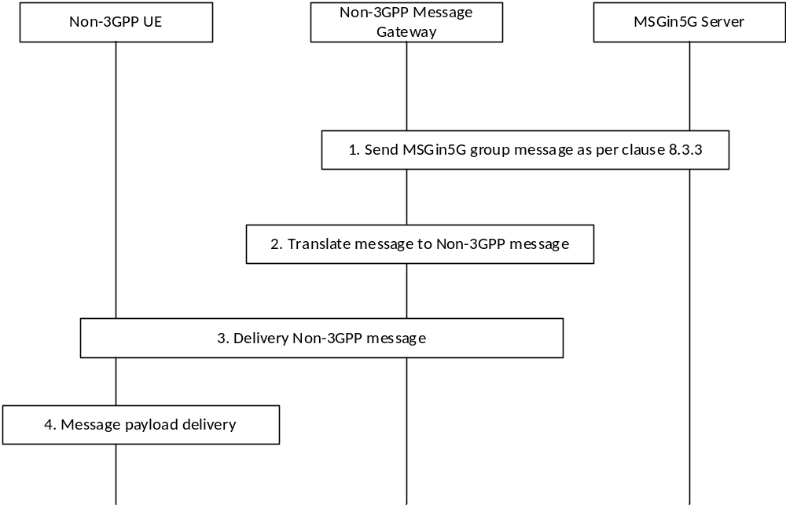
Figure 8.6.2.2-1: Non-3GPP message client receives a message from the group
1. The MSGin5G Server sends the MSGin5G message request to the recipient based on the UE Service ID. The MSGin5G Gateway receives the MSGin5G message request on behalf of the Non-GPP UE as defined in clause 8.3.3 with following clarifications:
a) The MSGin5G message request includes Originating UE Service ID, Recipient Group Service ID, Recipient UE Service ID, Message ID, Payload information elements from Table 8.3.3-1. The MSGin5G message request may include Delivery status required, Application ID and Priority type information elements from Table 8.3.3-1.
2. The Non-3GPP Message Gateway translates the MSGin5G message to Non-3GPP message.
3. The Non-3GPP Message Gateway sends message to Non-3GPP Message Client.
4) The Non-3GPP UE delivers the payload of the non-3GPP message (e.g. RCS) to the targeted Application Client on the Non-3GPP UE.
NOTE: The procedure to translate MSGin5G message to Non-3GPP message and to send Non-3GPP message from Non-3GPP Message Gateway to Non-3GPP Message Client are out of scope of 3GPP.

8.7 E2E Message delivery procedures
Editor’s note: It is also FFS how endpoints are provided with the Service IDs of the counterparts with which the E2E message delivery procedures are used.
Editor’s note: Generalizing MSISDN to Legacy 3GPP identifier in pre-conditions is FFS.

8.7.1 Point-to-Point Message delivery procedures

8.7.1.1 From MSGin5G UE to MSGin5G UE
Figure 8.7.1.1-1 shows the message delivery procedure from MSGin5G UE 1 to MSGin5G UE 2.
Pre-conditions:
1. Both MSGin5G Client 1 in MSGin5G UE 1 and MSGin5G Client 2 in MSGin5G UE 2 have registered with the MSGin5G Server.

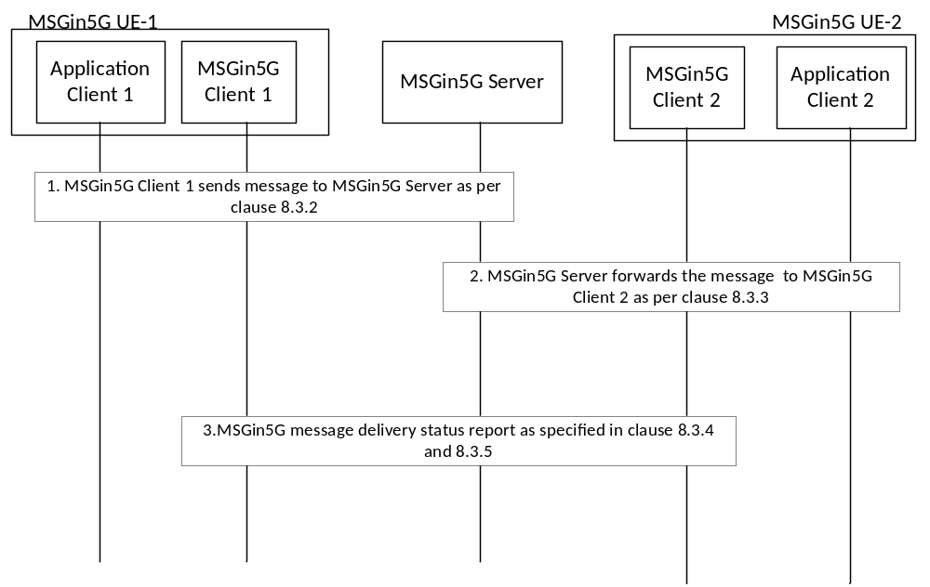
Figure 8.7.1.1-1 Message delivery between MSGin5G UEs
1. The MSGin5G Client 1 sends an MSGin5G message request to MSGin5G Server as specified in clause 8.3.2 with following clarifications:
a) The MSGin5G message request includes Originating UE Service ID, Recipient UE Service ID and Message ID information elements in Table 8.3.2-1, and may include Delivery status required, Application ID, Payload, Priority type information elements from Table 8.3.2-1.
b) Upon receiving the MSGin5G message request, the MSGin5G Server determines that the MSGin5G Client 1 is authorized to send message to MSGin5G Client 2.
2. The MSGin5G Server forwards the MSGin5G message request to MSGin5G Client 2 as specified in clause 8.3.3.
3. If Delivery status required is included in the MSGin5G message request, MSGin5G Client 2 sends MSGin5G message delivery status report to the MSGinG Server as specified in clause 8.3.4 and then the MSGin5G Server sends MSGin5G message delivery status report to MSGin5G Client 1 as specified in clause 8.3.5.

8.7.1.2 From MSGin5G UE to Legacy 3GPP UE
Figure 8.7.1.2-1 shows the message delivery procedure from MSGin5G UE to Legacy 3GPP UE.
Pre-conditions:
1. MSGin5G Client in MSGin5G UE has registered with the MSGin5G Server and the Legacy 3GPP Message Client in Legacy 3GPP UE has registered with the MSGin5G Server via the Legacy 3GPP Message Gateway.
2. Legacy 3GPP Message Gateway is aware of the UE Service ID of Legacy 3GPP UE and maintains the mapping to IDs used in the legacy network.

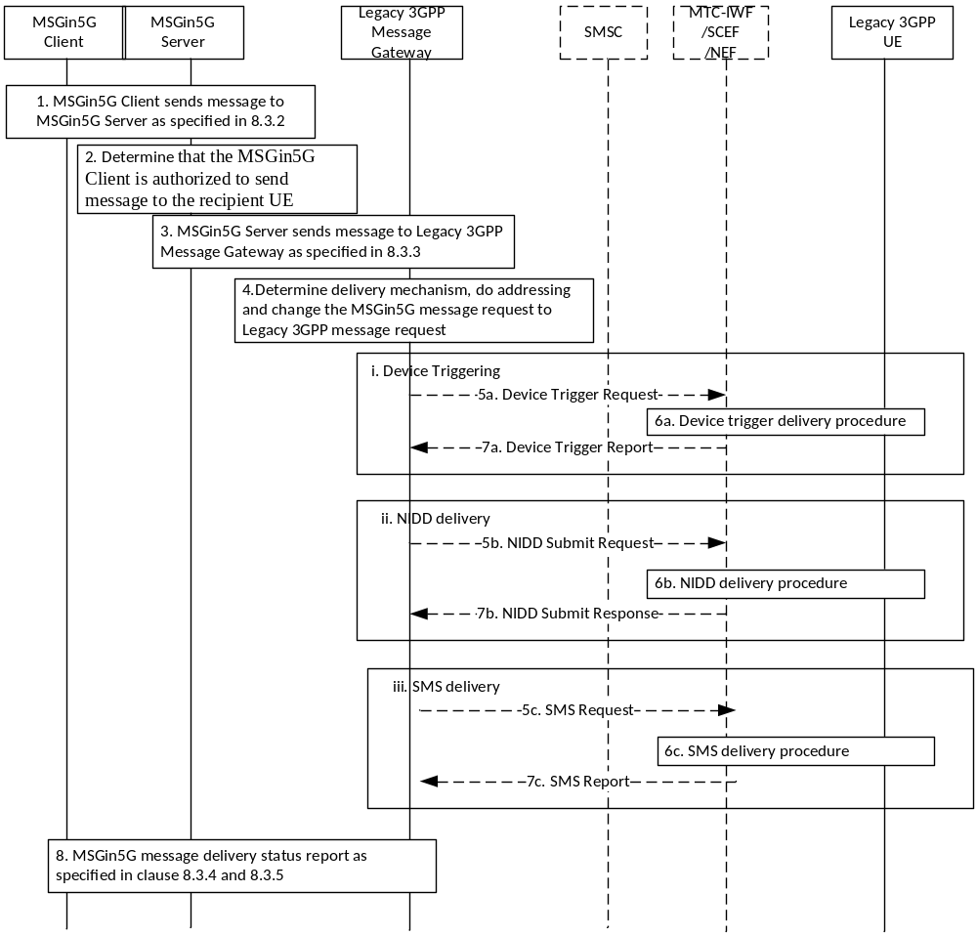
Figure 8.7.1.2-1 Message delivery from MSGin5G UE to Legacy 3GPP UE
1. The MSGin5G Client sends an MSGin5G message request to MSGin5G Server as specified in clause 8.3.2 with following clarifications:
a) The MSGin5G message request includes Originating UE Service ID, Recipient UE Service ID and Message ID information elements in Table 8.3.2-1, and may include Delivery status required, Application ID, Payload, Priority type information elements from Table 8.3.2-1.
2. Upon receiving the MSGin5G message request, the MSGin5G Server determines that the MSGin5G Client is authorized to send message to the recipient UE.
3. The MSGin5G Server forwards the MSGin5G message request to the recipient based on the UE Service ID. The Legacy 3GPP Gateway receives the MSGin5G message request on behalf of the Legacy 3GPP UE as specified in 8.3.3.
4. The Legacy 3GPP Message Gateway determines which legacy 3GPP message delivery mechanism (e.g. SMS, NIDD, Device triggering, etc.) will be used based on Legacy 3GPP UE capability, the UE communication status, the MSGin5G service configuration, etc. When selected, the Legacy 3GPP Message Gateway maps the UE Service ID to the corresponding identifier. For example (not an exhaustive list):
a) if the Legacy 3GPP Message Gateway selected the device triggering delivery mechanism, it maps the UE Service ID to MSISDN and Application port ID
b) if the Legacy 3GPP Message Gateway selected the NIDD delivery mechanism, it maps the UE Service ID to External Identifier or MSISDN.
c) if the Legacy 3GPP Message Gateway selected the SMS delivery mechanismm, it maps the UE Service ID to MSISDN.
5-7. The Legacy 3GPP Message Gateway sends the payload of the MSGin5G message to the terminating Legacy 3GPP UE using the determined delivery mechanism. For example:
a) For Device triggering delivery mechanism, the Legacy 3GPP Message Gateway interacts with the MTC-IWF/SCEF/NEF and maps the payload of the MSGin5G message to one or more Device Triggering requests. The MTC-IWF/SCEF/NEF interacts with SMS-SC for delivery to the UE and to receive the message delivery status report (see TS 23.682 [8] clause 5.2, TS 29.122 [9] clause 4.4.6 and TS 29.522 [10] clause 4.4.3)
b) For NIDD delivery mechanism, the Legacy 3GPP Message Gateway may interact with the SCEF/NEF and maps the payload of the MSGin5G message to one or more NIDD submit request messages. The Reliable Data Service Configuration, Maximum Latency, Priority, PDN Connection Establishment Option settings are based on pre-configurations (see TS 23.682 [8] clause 5.13, TS 29.122 [9] clause 4.4.5.3 and TS 29.522 [10] clause 4.4.12.3). Alternatively, if tunnel parameters are provisioned in the Legacy 3GPP Message Gateway and UPF/P-GW the payload could be tunnelled via the UPF/P-GW (see TS 23.401 [11] (clause 4.3.17.8.3.3) , TS 23.501[12] clause 5.6.10.3, TS 23.502 [7] clause 4.24);
c) For SMS delivery mechanism, the Legacy 3GPP Message Gateway sends SMS to the Legacy 3GPP UE through the SMSC according the procedure in TS 23.204 [13] or the procedure in clause 4.13.3 of TS 23.502 [7].
8. If Delivery status required is included in the MSGin5G message request, the Legacy 3GPP Message Gateway sends MSGin5G message delivery status report to the MSGin5G Server as specified in clause 8.3.4 and then the MSGin5G Server sends the message delivery status report to the MSGin5G Client as specified in clause 8.3.5.

8.7.1.3 From MSGin5G UE to Non-3GPP UE
Figure 8.7.1.3-1 shows the message delivery procedure from MSGin5G UE to Non-3GPP UE.
Pre-conditions:
1. MSGin5G Client in MSGin5G UE has registered with the MSGin5G Server and the Non-3GPP Message Client in Non-3GPP UE has registered with the MSGin5G Server via the Non-3GPP Message Gateway.
2. Non-3GPP Message Gateway is aware of the non-3GPP message client in Non-3GPP UE and provides the mapping to UE Service ID.
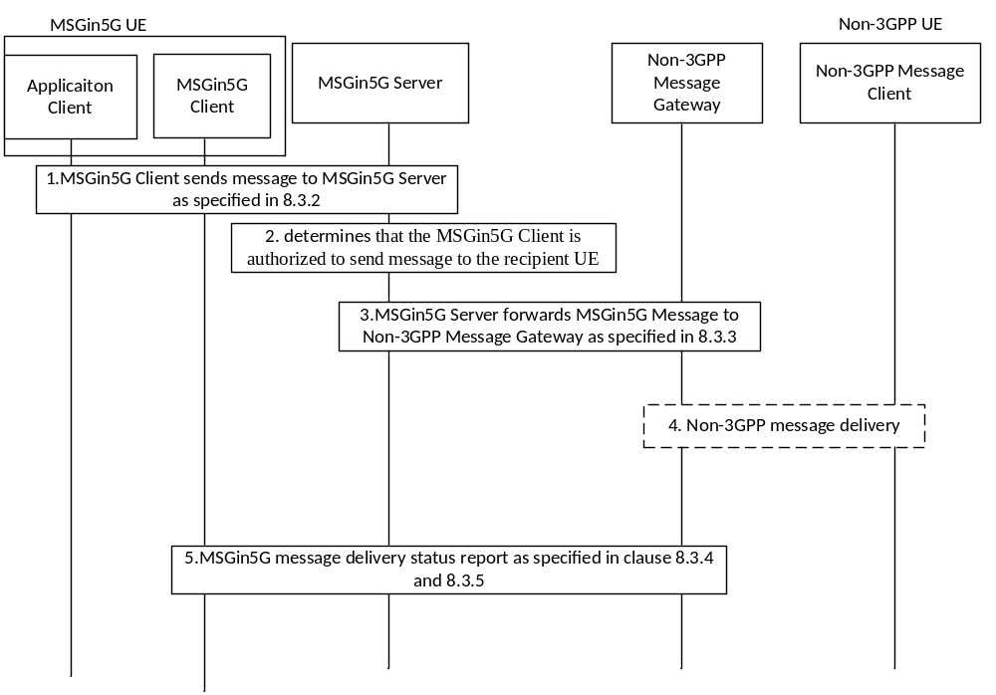
Figure 8.7.1.3-1 Message Delivery from MSGin5G UE to Non-3GPP UE
1. The MSGin5G Client sends an MSGin5G message request to the MSGin5G Server as specified in 8.3.2 with following clarifications:
a) The MSGin5G message request includes Originating UE Service ID, Recipient UE Service ID and Message ID information elements in Table 8.3.2-1, and may include Delivery status required, Application ID, Payload, Priority type information elements from Table 8.3.2-1.
2. The MSGin5G Server determines that the MSGin5G Client is authorized to send message to the recipient UE.
3. The MSGin5G Server forwards the MSGin5G message request to the recipient based on the UE Service ID. The Non-3GPP Message Gateway receives the MSGin5G message request on behalf of the Non-3GPP UE as specified in clause 8.6.1.
4. The Non-3GPP Message Gateway translates the MSGin5G message to the Non-3GPP message with message delivery status report requested and sends it to the Non-3GPP Message Client. This step is outside the scope of the current specification.
5. If message delivery status report is requested, the Non-3GPP Message Gateway sends the MSGin5G message delivery status report to the MSGin5G Server as specified in clause 8.3.4, the MSGin5G Server forwards the MSGin5G message delivery status report to the MSGin5G Client as specified in clause 8.3.5.

8.7.1.4 From Legacy 3GPP UE to MSGin5G UE
This procedure is used for message reply from Legacy 3GPP UE (e.g. SMS UE) to MSGin5G UE.
Figure 8.7.1.4-1 shows the message delivery procedure from Legacy 3GPP UE (e.g. SMS UE) to MSGin5G UE.
Pre-conditions:
1. MSGin5G Client in MSGin5G UE has registered with the MSGin5G Server and the Legacy 3GPP Message Client in Legacy 3GPP UE has registered with the MSGin5G Server via the Legacy 3GPP Message Gateway.
2. The Legacy 3GPP UE received a message from the MSGin5G UE.
3. The Legacy 3GPP Message Gateway is aware of the Legacy 3GPP UE and provides the mapping to UE Service ID.
4 The Legacy 3GPP Message Gateway assigns a routable Legacy 3GPP identifier, e.g. MSISDN or External Identifier, to the MSGin5G UE when it sent MSGin5G message to Legacy 3GPP UE. The Legacy 3GPP Message Gateway keeps the mapping between the UE Service ID of the MSGin5G UE and the MSISDN assigned to it.
5. The Legacy 3GPP UE replies to the MSGin5G UE upon receiving the message from the MSGin5G UE.

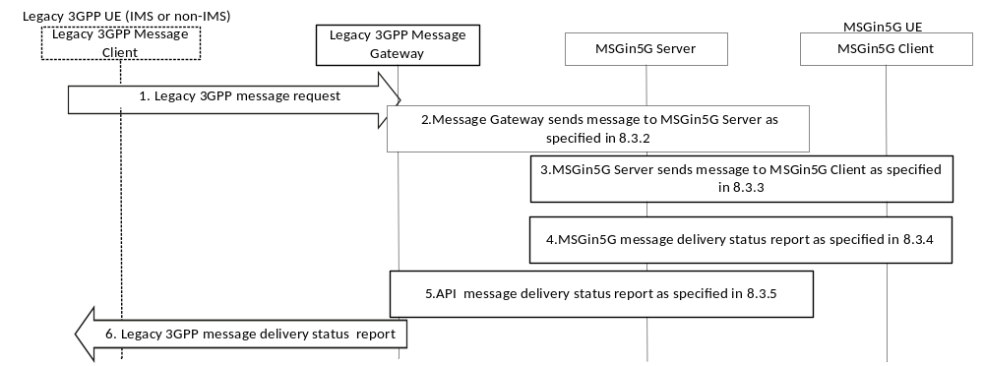
Figure 8.7.1.4-1: Legacy 3GPPs UE replies to MSGin5G UE
1. The Legacy 3GPP UE sends a Legacy 3GPPmessage request to the Legacy 3GPP Message Gateway (e.g. through SMSC if SMS is used according the procedure in 3GPP TS 23.204 [13] or the procedure in clause 4.13.3 of TS 23.502 [7]).
2. The Legacy 3GPP Message Gateway translates the SMS message to MSGin5G message and sends an MSGin5G message request to the MSGin5G Server as specified in 8.3.2 with the following clarifications:
a) The MSGin5G message request includes Originating UE Service ID, Recipient UE Service ID and Message ID information elements in Table 8.3.2-1, and may include Delivery status required, Application ID, Payload, Priority type information elements from Table 8.3.2-1.
b) Upon receiving the MSGin5G message request, the MSGin5G Server determines that the Legacy 3GPP UE with its UE Service ID is allowed to reply message to the MSGin5G UE.
3. The MSGin5G Server forwards the MSGin5G message request to the target MSGin5G Client as specified in 8.3.3.
4-6. If the message delivery status report is requested by the with its UE Service ID UE, the MSGin5G Client in MSGin5G UE sends an MSGin5G message delivery status report to the MSGin5G Server as specified in clause 8.3.4, the MSGin5G Server sends the MSGin5G message delivery status report to the Legacy 3GPP Message Gateway specified in clause 8.3.5, the Legacy 3GPP Message Gateway translates the MSGin5G message delivery status report to a Legacy 3GPP message delivery status report and sends it to the Legacy 3GPP UE.

8.7.1.5 From Non-3GPP UE to MSGin5G UE
This procedure is used for message reply from Non-3GPP UE to MSGin5G UE.
Figure 8.7.1.5-1 shows the message delivery procedure from Non-3GPP UE to MSGin5G UE.
Pre-conditions:
1. MSGin5G Client in MSGin5G UE has registered with the MSGin5G Server and the Non-3GPP Message Client in Non-3GPP UE has registered with the MSGin5G Server via the Non-3GPP Message Gateway.
2. The Non-3GPP UE received a message from the MSGin5G UE.
3. The Non-3GPP Message Gateway is aware of the Non-3GPP message client on the Non-3GPP UE and provides the mapping to UE Service ID.
4 The Non-3GPP Message Gateway assigns a routable Non-3GPP identifier to the MSGin5G UE when it sent MSGin5G message to Non-3GPP UE. The Non-3GPP Message Gateway keep the mapping between the UE Service ID of the MSGin5G UE and the MSISDN assigned to it.
5. The Non-3GPP UE replies to the MSGin5G UE upon receiving the message from the MSGin5G UE.

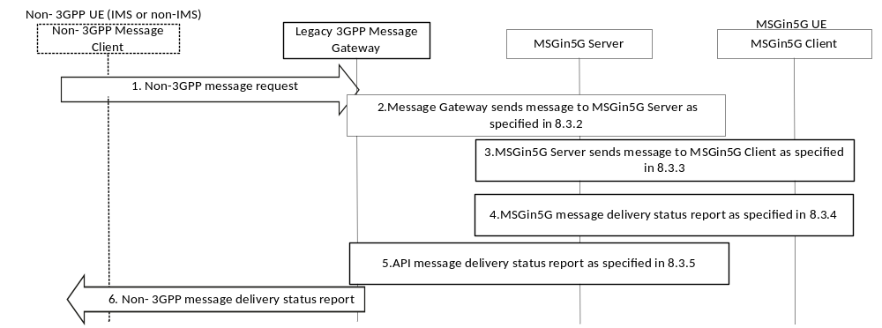
Figure 8.7.1.5-1: Non-3GPP UE replies to MSGin5G UE
1. The Non-3GPP UE sends a Non-3GPP message request to the Non-3GPP Message Gateway.
2. The Non-3GPP Message Gateway translates the Non-3GPP message to MSGin5G message with message delivery status report requested and sends an MSGin5G message request to the MSGin5G Server as specified in clause 8.3.2 with the following clarifications:
a) The MSGin5G message request includes Originating UE Service ID, Recipient UE Service ID and Message ID information elements in Table 8.3.2-1, and may include Delivery status required, Application ID, Payload, Priority type information elements from Table 8.3.2-1.
b) Upon receiving the MSGin5G message request, the MSGin5G Server determines that the Non-3GPP UE with its UE Service ID is allowed to reply message to the MSGin5G UE.
3. The MSGin5G Server forwards the MSGin5G message request to the target MSGin5G Client as specified in clause 8.3.3.
4. If the message delivery status report is request by the Non-3GPP UE, the MSGin5G Client in MSGin5G UE sends an MSGin5G message delivery status report to the MSGin5G Server specified in clause 8.3.4, the MSGin5G Server sends the MSGin5G message delivery status report to the Non-3GPP Message Gateway specified in clause 8.3.5, the Non-3GPP Message Gateway translates the MSGin5G message delivery status report to a Non-3GPP message delivery status report and sends it to the Non-3GPP UE.

8.7.2 Application-to-Point Message delivery procedures

8.7.2.1 From Application Server to MSGin5G UE
Editor’s note: It is FFS whether and how NIDD can be chosen as alternative delivery mechanism in application -to-Point message delivery to MSGin5G UEs.
Figure 8.7.2.1-1 shows the message delivery procedure from Application Server to MSGin5G UE.
Pre-conditions:
1. The MSGin5G Client is registered with the MSGin5G Server.
2. The Application Server has established a secured communication with the MSGin5G Server

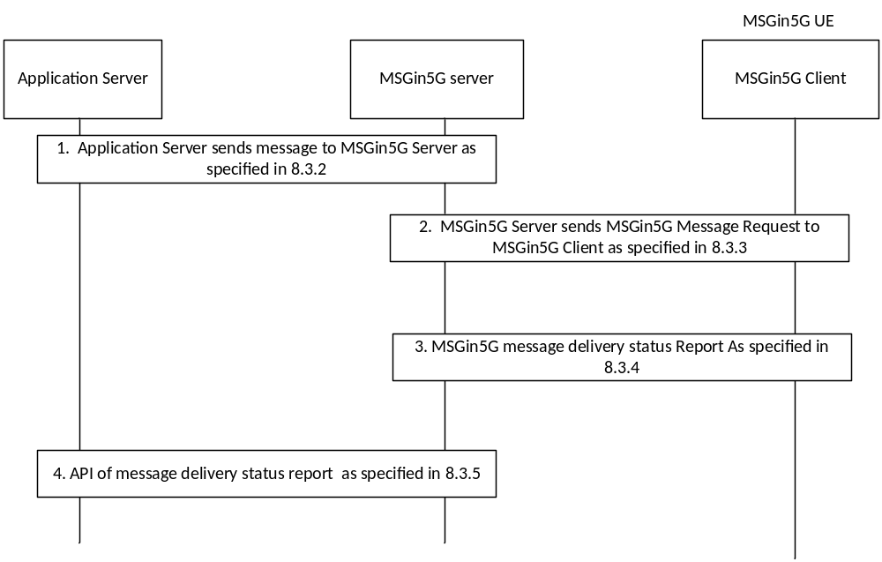
Figure 8.7.2.1-1 Message delivery from Application Server to MSGin5G UE
1. The Application Server sends API Request to MSGin5G Server for sending MSGin5G message as specified in clause 8.3.2 with the following clarifications:
a) The API request includes Originating AS Service ID, Recipient UE Service ID and Message ID information elements in Table 8.3.2-1, and may include Delivery status required, Application ID, Payload, Priority type information elements from Table 8.3.2-1.
b) Upon receiving the API Request for MSGin5G message delivery, the MSGin5G Server determines that the Application Server is allowed to send message to the MSGin5G UE.
2. The MSGin5G Server sends MSGin5G message request to MSGin5G Client as specified in clause 8.3.3.
3. If Delivery status required is included in the MSGin5G message request, MSGin5G Client 2 sends message delivery status report to the MSGin5G Server specified in clause 8.3.4.
4. The MSGin5G Server sends the message delivery status report to the Application Server as specified in clause 8.3.5

8.7.2.2 From Application Server to Legacy 3GPP UE
Figure 8.7.2.2-1 shows the message delivery procedure from Application Server to Legacy 3GPP UE.
Pre-conditions:
1. The Application server has established a secured communication with the MSGin5G Server
2. The Legacy 3GPP Message Client in Legacy 3GPP UE has registered with the MSGin5G Server via the Legacy 3GPP Message Gateway.
3. Legacy 3GPP Message Gateway is aware of the legacy 3GPP message client (i.e. SMS client) in Legacy 3GPP UE and provides the mapping to UE Service ID.

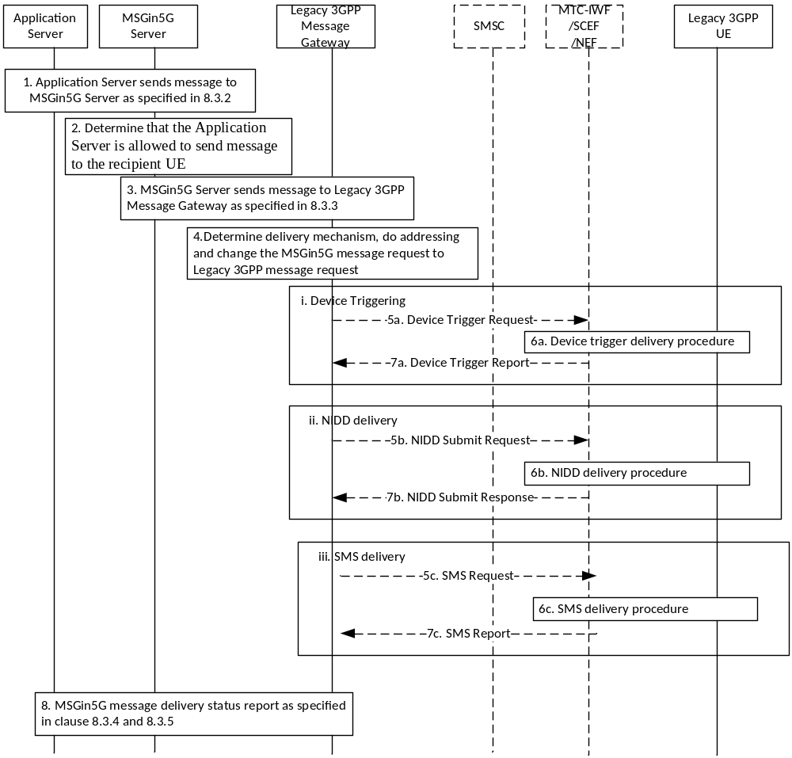
Figure 8.7.2.2-1Application Server to Legacy 3GPP UE messaging
1. The Application Server sends an API Request to MSGin5G Server for sending MSGin5G message as specified in clause 8.3.2 with the following clarifications:
a) The API Request includes Originating AS Service ID, Recipient UE Service ID and Message ID information elements in Table 8.3.2-1, and may include Delivery status required, Application ID, Payload, Priority type information elements from Table 8.3.2-1.
2. Upon receiving the API Request for MSGin5G message delivery, the MSGin5G Server determines that the Application Server is allowed to send message to the recipient UE
3. The MSGin5G Server sends MSGin5G message request to the recipient based on the UE Service ID. The Legacy 3GPP Gateway receives the MSGin5G message request on behalf of the Legacy 3GPP UE as specified in clause 8.3.3.
4-7. Same with step 4-7 in clause 8.7.1.2
8. The Legacy 3GPP Message Gateway sends the MSGin5G message delivery status report to the MSGin5G Server as specified in clause 8.3.4.

8.7.2.3 From Application Server to Non-3GPP UE
Figure 8.7.2.3-1 shows the message delivery procedure from Application Server to Non-3GPP UE.
Pre-conditions:
1. The Application Server has established a secured communication with the MSGin5G Server
2. The Non-3GPP Message Client in Non-3GPP UE has registered with the MSGin5G Server via the Non-3GPP Message Gateway.
3. Non-3GPP Message Gateway is aware of the non-3GPP message client in Non-3GPP UE and provides the mapping to UE Service ID.

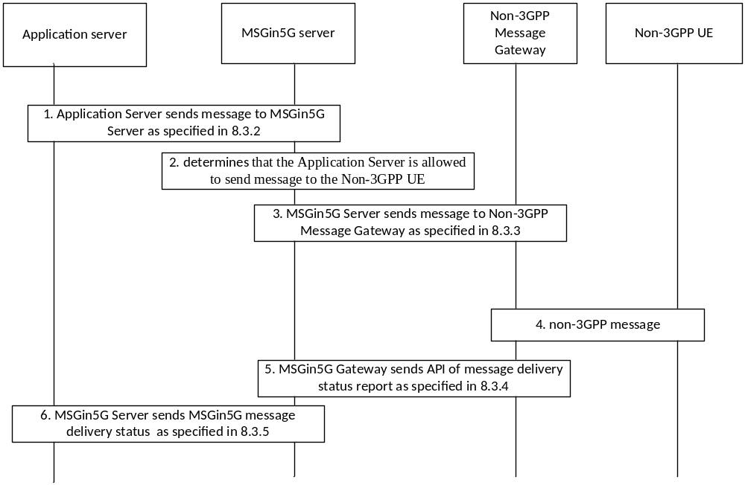
Figure 8.7.2.3-1 Application Server to Non-3GPP UE messaging
1. The Application Serve sends an API Request to MSGin5G Server for sending MSGin5G message as specified in 8.3.2 with the following clarifications:
a) The API Request includes Originating AS Service ID, Recipient UE Service ID and Message ID information elements in Table 8.3.2-1, and may include Delivery status required, Application ID, Payload, Priority type information elements from Table 8.3.2-1.
2. Upon receiving the API Request for MSGin5G message delivery, the MSGin5G Server determines that the Application Server is allowed to send message to the Non-3GPP UE.
3. The MSGin5G Server sends MSGin5G message request to the recipient based on the UE Service ID. The Non-3GPP Message Gateway receives the MSGin5G message request on behalf of the Non-3GPP UE as specified in clause 8.3.3.
4. The Non-3GPP Message Gateway translates the MSGin5G message to the Non-3GPP message and sends it to the Non-3GPP UE. This step is outside the scope of the current specification.
5-6. If message delivery status report is required, the Non-3GPP Message Gateway sends the MSGin5G message delivery status report to the MSGin5G Server as specified in clause 8.3.4, the MSGin5G Server sends the message delivery status report to the Application Server as specified in clause 8.3.5.

8.7.3 Point-to-Application Message delivery procedures

8.7.3.1 From MSGin5G UE to Application Server
Figure 8.7.3.1-1 shows the message delivery procedure from MSGin5G UE to Application Server.
Pre-conditions:
1) The Application Server and MSGin5G Client in MSGin5G UE have registered with the MSGin5G Server.

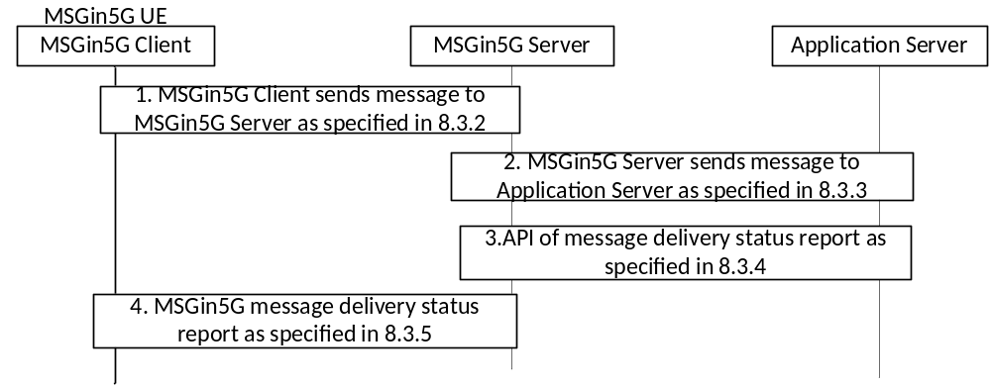
Figure 8.7.3.1-1: Message delivery from MSGin5G UE to Application Server
1. The MSGin5G Client sends an MSGin5G message request to MSGin5G Server as specified in clause 8.3.2 with the following clarifications:
a) The MSGin5G message request includes Originating UE Service ID, Recipient AS Service ID and Message ID information elements in Table 8.3.2-1, and may include Delivery status required, Application ID, Payload, Priority type information elements from Table 8.3.2-1.
b) Upon receiving the MSGin5G message request, the MSGin5G Server determines the recipient is an Application Server and the MSGin5G Client is allowed to send message to Application Server.
2. The MSGin5G Server forwards the MSGin5G message request to Application Server as specified in clause 8.3.3.
3-4. If Delivery status required is included in the MSGin5G message request, Application Server sends message delivery status report to the MSGin5G Server as specified in clause 8.3.4, the MSGin5G Server sends the delivery status to MSGin5G Client as specified in clause 8.3.5.

8.7.3.2 From Legacy 3GPP UE to Application Server
This procedure is used for message reply from Non-3GPP UE to Application Server.
Figure 8.7.3.2-1 shows the message delivery procedure from Legacy 3GPP UE to Application Server.
Pre-conditions:
1. The Application server has established a secured communication with the MSGin5G Server.
2. The Legacy 3GPP Message Client in Legacy 3GPP UE has registered with the MSGin5G Server via the Legacy 3GPP Message Gateway.
3 The Legacy 3GPP UE received a message from the Application Server.
4. The Legacy 3GPP Message Gateway is aware of the Legacy 3GPP Message Client on the Legacy 3GPP UE and provides the mapping between its identifiers and UE Service ID.
5. The Legacy 3GPP Message Gateway assigns a routable Legacy 3GPP identifier, e.g. MSISDN or External Identifier, to the Application Server when it sent MSGin5G message to Legacy 3GPP UE. The Legacy 3GPP Message Gateway keeps the mapping between the AS Service ID of the Application Server and the MSISDN assigned to it

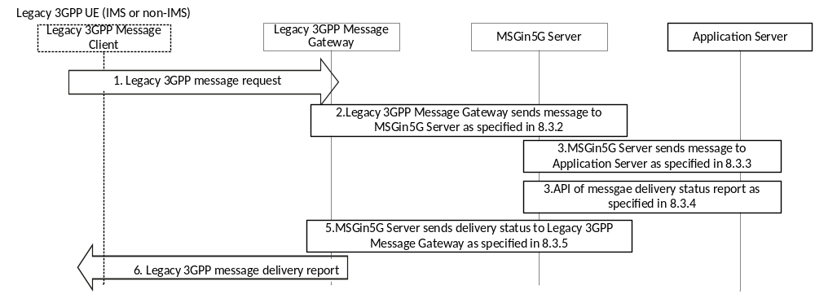
Figure 8.7.3.2-1: Legacy 3GPP UE replies to Application Server
1. The Legacy 3GPP UE sends an Legacy 3GPP message request to the Legacy 3GPP Message Gateway (e.g. through SMSC if SMS is used according the procedure in 3GPP TS 23.204 [13] or the procedure in clause 4.13.3 of TS 23.502 [7]).
2. The Legacy 3GPP Message Gateway translates the Legacy 3GPP message to MSGin5G message, and may include message delivery status report requested in the MSGin5G message. The Legacy 3GPP Message Gateway sends the MSGin5G message request to the MSGin5G Server as specified in clause 8.3.2 with the following clarifications:
a) The MSGin5G message request includes Originating UE Service ID, Recipient AS Service ID and Message ID information elements in Table 8.3.2-1, and may include Delivery status required, and may include Application ID, Payload and Priority type information elements from Table 8.3.2-1.
b) Upon receiving the MSGin5G message request, the MSGin5G Server determines that the Legacy 3GPP UE with its UE Service ID is allowed to reply message to the Application Server.
3. The MSGin5G Server forwards the MSGin5G message in API request to Application Server as specified in clause 8.3.3.
4-6. If message delivery status report is requested, the Application Server sends message delivery status report by API request to MSGin5G Server as specified in clause 8.3.4, the MSGin5G Server forwards the message delivery status report to the Legacy 3GPP Message Gateway as specified in clause 8.3.5, the Legacy 3GPP Message Gateway translates the MSGin5G message delivery status report to a Legacy 3GPP message delivery status report and sends it to the Legacy 3GPP UE.

8.7.3.3 From Non-3GPP UE to Application Server
This procedure is used for message reply from Legacy 3GPP UE to Application Server.
Figure 8.7.3.3-1 shows the message delivery procedure from Non-3GPP UE to Application Server.
Pre-conditions:
1. The Application server has established a secured communication with the MSGin5G Server
2. The Non-3GPP Message Client in Non-3GPP UE has registered with the MSGin5G Server via the Non-3GPP Message Gateway.
2. The Non-3GPP UE received a message from the Application Server.
3. The Non-3GPP Message Gateway is aware of the Non-3GPP message client on the Non-3GPP UE and provides the mapping between its identifiers and UE Service ID.
4. The Non-3GPP Message Gateway assigns a routable Non-3GPP identifier to the Application Server when it sent MSGin5G message to Non-3GPP UE. The Non-3GPP Message Gateway keep the mapping between the AS Service ID of the Application Server and the MSISDN assigned to it

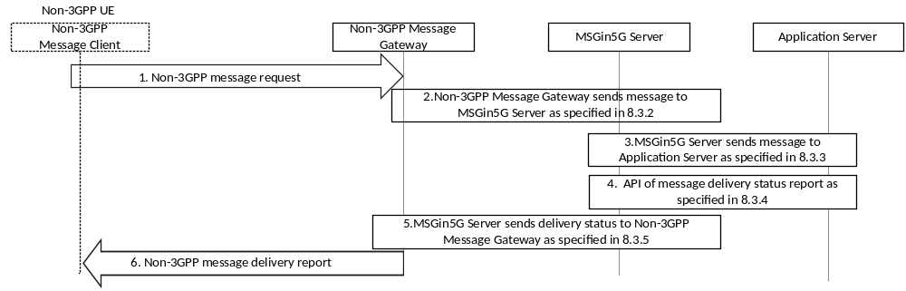
Figure 8.7.3.3-1: Non-3GPP UE replies to Application Server
1. The Non-3GPP UE sends a Non-3GPP message request to the Non-3GPP Message Gateway.
2. The Non-3GPP Message Gateway translates the Non-3GPP Message to MSGin5G message and may include MSGin5G message delivery status report requested in the MSGin5G message. The Non-3GPP Message Gateway sends an MSGin5G message request to the MSGin5G Server as specified in clause 8.3.2 with the following clarifications:
a) The MSGin5G message request includes Originating UE Service ID, Recipient AS Service ID and Message ID information elements in Table 8.3.2-1, and may include Delivery status required, Application ID, Payload, Priority type information elements from Table 8.3.2-1.
b) Upon receiving the MSGin5G message request, the MSGin5G Server determines that the Non-3GPP UE with its UE Service ID is allowed to reply message to the Application Server.
3. The MSGin5G Server forwards the MSGin5G message in API request to Application Server as specified in clause 8.3.3.
4-6. If the delivery status is required, the Application Server sends message delivery status report by API request to MSGin5G Server as specified in clause 8.3.4, the MSGin5G Server sends the message delivery status report to the Non-3GPP Message Gateway as specified in clause 8.3.5, the Non-3GPP Message Gateway translates the MSGin5G message delivery status report to a Non-3GPP message delivery status report and sends it to the Non-3GPP UE.

8.7.4 MSGin5G Group messaging

8.7.4.1 General
This clause introduces a group messaging procedure for MSGin5G Client and MSGin5G Server to send and receive Group message after a group is created. In this procedure, the group creation and membership management are handled by group management function specified in 3GPP TS 23.434 [5].

8.7.4.2 Message delivery from UE to group
Figure 8.7.4.2-1 shows the MSGin5G Group messaging procedure in which MSGin5G Client (both IMS and non-IMS UE) sends a message to a group.
Editor’s note: Solution for the group hosted on the legacy side where MSGin5G Client is one of the group members is FFS.
Pre-conditions:
1. A MSGin5G Group is created by following group management SEAL service procedures as specified in 3GPP TS 23.434 [5].
2. All participants in the MSGin5G Group may get the Group information i.e. the Group Service ID.
3. The group consists of different types of UEs i.e. MSGin5G UE, Legacy 3GPP UE and Non-3GPP UE.
4. The MSGin5G Server has a copy of the group profile with all the group members by using Group information query specified in 3GPP TS 23.434 [5].
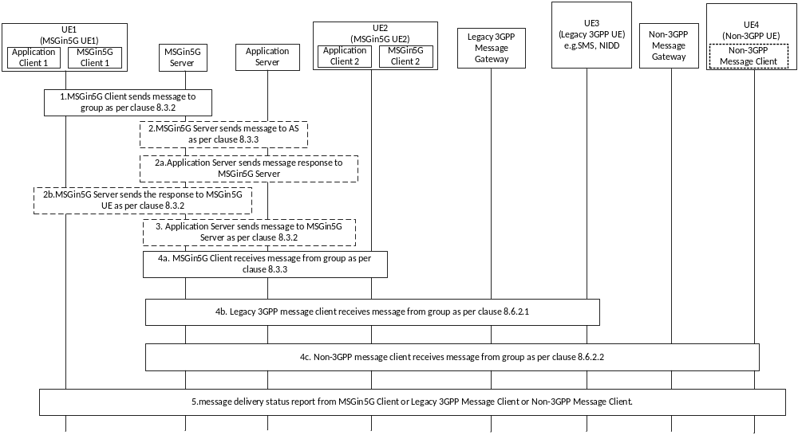
Figure 8.7.4.2-1: Group messaging in MSGin5G Service
1. The MSGin5G Client 1 sends a message to a group as specified in clause 8.3.2 with following clarifications:
a) The MSGin5mG Message request includes Originating UE Service ID, Recipient Group Service ID and Message ID information elements from Table 8.3.2-1. The MSGin5G message request may include Delivery status required, Application ID, Payload and Priority type information elements from Table 8.3.2-1.
NOTE: If the originating UE is member of the group, the originating UE is not included as recipient of the group message.
2. Upon receiving the MSGin5G message request to send the group message, the MSGin5G Server may send the message to the Application Server based on service ID present in the received MSGin5G message request (e.g. to log application specific message or for analytics). Otherwise go to step 4.
a) Upon receiving the MSGin5G message request, the Application Server validates the message and if the message is not valid, the Application Server sends MSGin5G message response with delivery status set as Reject to the MSGin5G Server. Otherwise, go to step 3.
b) The MSGin5G Server sends the MSGin5G message response with delivery status set as reject to the MSGin5G Client 1. The information elements defined in Table 8.3.2-3 are included in the response. Following procedures will be skipped.
3. The Application Server initiates to send message to all group members and sends the MSGin5G message request to the MSGin5G Server.
Editor’s note: Whether to keep or correct step 2 or 3 is FFS.
4 Upon receiving the MSGin5G message request, if the MSGin5G Server determines the MSGin5G Client-1 is authorized to send the group message, the MSGin5G server resolves the group ID to determine the members of that group, based on the information from the group management server as specified in 3GPP TS 23.434 [5].
5. The MSGin5G Server sends the message to all participants of the group by their UE Service ID. The MSGin5G message request includes Originating UE Service ID, Recipient Group ID, Recipient UE Service ID, Message ID, Payload information elements from Table 8.3.3-1. The MSGin5G message request may include Delivery status required, Application ID and Priority type information elements from Table 8.3.3-1. The MSGin5G Server routes, using the procedures in clause 8.3.3, the message to:
a) the MSGin5G UE,
b) the Legacy 3GPP UE,
c) the Non-3GPP UE.
NOTE: Steps 5 a), 5 b) and 5 c) can happen in parallel and in any order.
5. Upon receiving the group message, if message delivery status report is requested and if supported by target message client, the MSGin5G Client or Legacy 3GPP UE or Non-3GPP message client sends the message delivery status report to originator MSGin5G Client 1 as specified in clause 8.2.4 and 8.3.5.

8.7.4.3 Message delivery procedure from Application Server to group
Figure 8.6.4.3-1 shows the MSGin5G Group messaging procedure in which Application Server sends a message to a group.
Pre-conditions:
1. A MSGin5G Group is created by following group management SEAL service procedures as specified in 3GPP TS 23.434 [5].
2. The group consists of different types of UEs i.e. MSGin5G UE, Legacy 3GPP UE and Non-3GPP UE, they may receive group message from one Application Server.
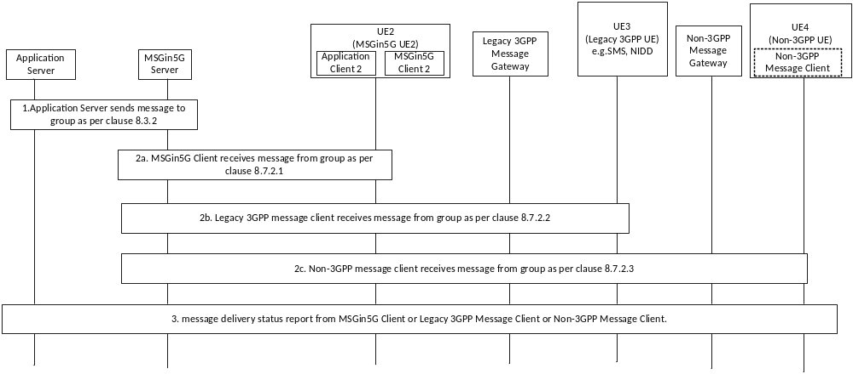
Figure 8.7.4.3-1: Group messaging in MSGin5G Service
1. The Application Server sends a message to a group as specified in clause 8.3.2.
2 Upon receiving the MSGin5G message request, if the AS is authorized to send the group message, the MSGin5G server resolves the group ID to determine the members of that group, based on the information from the group management server specified in 3GPP TS 23.434 [5].
3. The MSGin5G Server sends the message to all participants of the group based on UE Service ID. The MSGin5G Message Request includes Originating AS Service ID, Recipient Group ID, Recipient UE Service ID, Message ID, Payload information elements from Table 8.3.3-1. The MSGin5G Message Request may include Delivery Status Required, Application ID and Priority Type information elements from Table 8.3.3-1. The MSGin5G Server routes, using the procedures in clause 8.7.2, the message to:
a) the MSGin5G UE,
b) the Legacy 3GPP UE,
c) the Non-3GPP UE.
NOTE: Steps 3 a), 3 b) and 3 c) can happen in parallel and in any order.
4. Upon receiving the group message, if message delivery status report is requested and if supported by target message client, the MSGin5G Client or Legacy 3GPP UE or Non-3GPP message client sends the message delivery status report to originator Application Server as specified in clause 8.3.4 and 8.3.5.

8.7.5 Message delivery between MSGin5G UEs in different PLMNs

8.7.5.1 General
MSGin5G message may be delivered between MSGin5G UEs in different PLMNs.
The procedure applies to point-to-point and group message delivery only.

8.7.5.2 Inter-PLMN message exchange procedure
Pre-condition:
1. MSGin5G UE 1 (MSGin5G Client 1) registered to the MSGin5G Server 1 in one PLMN.
2. MSGin5G UE 2 (MSGin5G Client 2) registered to the MSGin5G Server 2 in another PLMN.
3. MSGin5G Server 1 and MSGin5G Server 2 have established a secured connection.
Figure 8.7.5-1 shows message delivery between MSGin5G UEs in different PLMNs, where MSGin5G UE 1 is registered in MSGin5G Server 1 and MSGin5G UE2 is registered in MSGin5G Server 2.
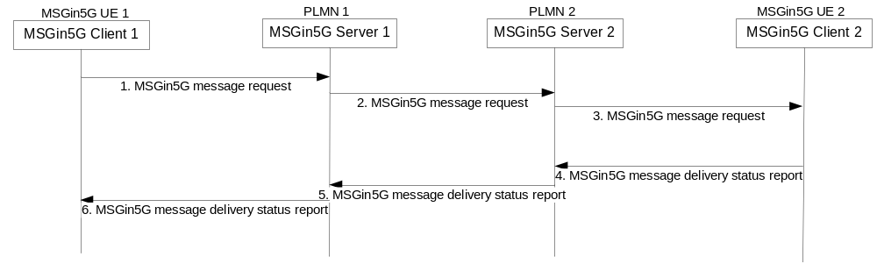
Figure 8.7.5-1: Message delivery between MSGin5G UEs in different PLMNs
1. The MSGin5G Client 1 in MSGin5G UE 1 sends an MSGin5G message request to MSGin5G Server 1 in PLMN 1.
2. The MSGin5G Server 1 analyses the target UE Service ID and determines that the message is to the MSGin5G UE 2 in PLMN 2, authenticates that the MSGin5G UE 1 is allowed to send a message to the MSGin5G UE 2, and then the MSGin5G Server 1 forwards the MSGin5G message request to MSGin5G Server 2 in PLMN 2.
3. MSGin5G Server 2 forwards the MSGin5G message request to the MSGin5G Client 2 in MSGin5G UE 2.
4-6. If the message delivery status report is requested, the MSGin5G Client 2 sends a point-to-point MSGin5G message, with the message delivery status report to MSGin5G Client 1 as per procedure specified in the present clause.

8.8 Other MSGin5G messaging related procedures

8.8.1 Messaging Topic Subscription
An MSGin5G Client or an Application Server can subscribe one or more Messaging Topic(s) on the MSGin5G Server. The Messaging Topic IE will be populated by the Application Client or the Application Server and the content of this IE is out of scope.
When an MSGin5G Client or an Application Server is subscribed to a Messaging Topic then then MSGin5G Server will forward messages that contain that same Messaging Topic to the subscriber.
Figure 8.8.1-1 shows the MSGin5G Client/Application Server subscribing to Messaging Topic(s) on the MSGin5G Server.
Pre-conditions:
1. The MSGin5G Client or Application Server has registered to the MSGin5G Server.
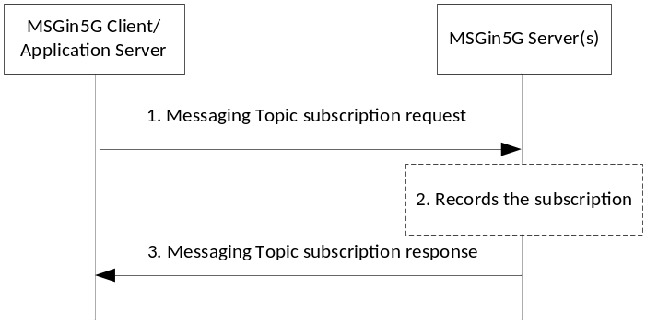
Figure 8.8.1-1: MSGin5G Service endpoint subscribes to Messaging topic(s)
1. The MSGin5G Client or Application Server sends a Messaging Topic subscription request to the MSGin5G Server. The request includes the information listed in Table 8.8.1-1.
Table 8.8.1-1: Messaging Topic subscription request
Information element | Status | Description
Originating UE Service ID/AS Service ID | M | The service identity of the sending MSGin5G Client or the sending Application Server.
Messaging Topic | M | A list of one or more Messaging Topic IEs that identify the topic that is to be subscribed to.
Expiration | O | The date and time when the subscription expires.  If this IE is included and the value is 0, the subscription is to be deleted from the MSGin5G Server.  If this IE is not included the expiration time is subject to operator policy.
NOTE: The content of the Messaging Topic is out of scope of the present document.

2. The MSGin5G Server validates the Messaging Topic subscription request and checks the local stored Messaging Topic(s).
a) If the subscribed Messaging Topic has already been created, the MSGin5G Server checks whether the UE Service ID/AS Service ID of the subscriber is already included in this Messaging Topic.
1. If not, the MSGin5G Server adds the UE Service ID/AS Service ID of the subscriber to this Messaging Topic. The MSGin5G Server sets the validity time of this subscription to the value of the Expire IE or to a default value according to the service policy.
2. Else,
a. the MSGin5G Server updates the validity time of this subscription, or
b. if the Expire IE is set to 0, the MSGin5G Server removes the subscription.
b) If the subscribed Messaging Topic has not been already created, the MSGin5G Server creates this Messaging Topic, and adds the UE Service ID/AS Service ID of the subscriber to this Messaging Topic. The MSGin5G Server sets the validity time of this subscription to the value of the Expire IE or to a default value according to the service policy.
3. The MSGin5G Server sends a Messaging Topic Subscription response to the originator of the request. The response includes the information listed in Table 8.8.1-2.
Table 8.8.1-2: Messaging Topic Subscription response
Information element | Status | Description
Subscription status | M | Indicates whether the subscription was successfully added or deleted on the MSGin5G Server
Expiration | O | The validity date and time of this subscription set by the MSGin5G Server.

8.8.2 Message delivery based on Messaging Topic
An MSGin5G Client or an Application Server can subscribe one or more Messaging Topic(s) on the MSGin5G Server. The Messaging Topic IE will be populated by the Application Client or the Application Server and the content of this IE is out of scope.
When a MSGin5G Client or an Application Server have a subscription to a Messaging Topic, then then MSGin5G Server forwards messages that contain the Messaging Topic to the subscriber.
Figure 8.8.2-1 shows the Message delivery to a subscribing service endpoint based on Messaging Topic.
Pre-conditions:
1. The MSGin5G Client or Application Server subscribed to a Messaging Topic with the MSGin5G Server. A Messaging Topic with the UE Service ID/AS Service ID of the subscriber has been created.
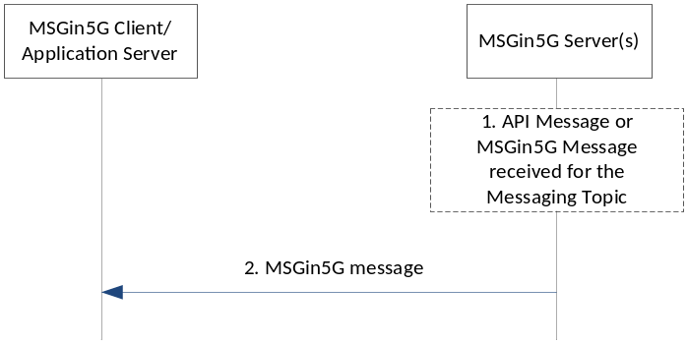
Figure 8.8.2-1: Message delivery to subscribing service endpoint based on Messaging Topic
1. The MSGin5G Server receives an MSGin5G message request corresponding to step 2 in figures 8.3.2-1 or 8.3.2-2 which includes the IEs as listed in table 8.3.2-1. The MSGin5G message request contains a Messaging Topic IE corresponding to the Messaging Topic for which the subscription exists.
2. The MSGin5G Server uses the procedure described in clause 8.3.3 to forward a copy of the received message to the UE Service ID/AS Service ID of the subscriber to this Messaging Topic.

8.9 Usage of Network Capabilities

8.9.1 General
The present clause specifies the functionality leveraged by the MSGin5G Service via Core Network exposure.

8.9.2 UE reachability status monitoring

8.9.2.1 General
UE reachability status leverages the 3GPP network monitoring functionality exposed via T8/N33 reference point. How the MSGin5G Server determines whether and how (e.g., via request/response or subscription) to monitor the UE reachability using the 3GPP Network capabilities is implementation dependent.
NOTE 1: Use of the UE reachability status monitoring procedure in the application layer has no impact to how the Core Network delivers the message to the UE.
NOTE 2: MSGin5G service provider policies may indicate whether the UE reachability status monitoring feature is enabled or not.
Editor’s note: The use of UE reachability monitoring in conjunction with other features (e.g., device triggering, store and forward) is to be further described after the individual, stand-alone functions have a basic definition in the specification.

8.9.2.2 Procedures

8.9.2.2.1 Request-response
Figure 8.9.2.2.1-1 shows the procedure which may be used by the MSGin5G Server to make a request for UE reachability status information.
Pre-conditions:
1. A UE hosts a MSGin5G Client.
2. The MSGin5G Client registers with the MSGin5G Server and shares UE contact information.
3. The MSGin5G Server determines to subscribe for monitoring of UE reachability events in the Core Network, e.g., that the UE is a sleepy node.
NOTE: How the MSGin5G Server determines to subscribe for monitoring of UE reachability events in the Core Network is implementation dependent.

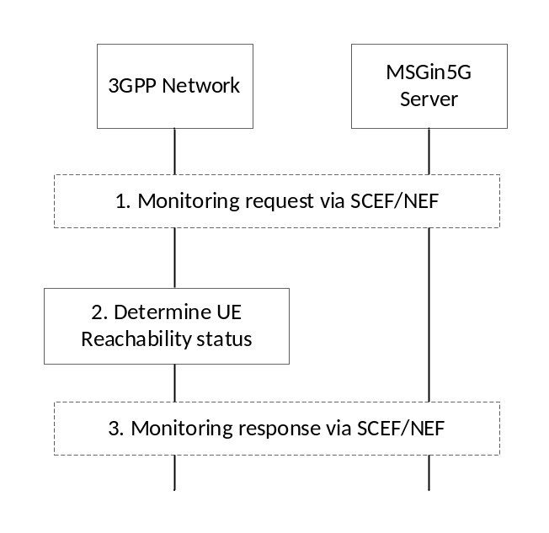
Figure 8.9.2.2.1-1: MSGin5G reachability status request-response.

1. The MSGin5G Server sends a one-time Monitoring Request to the 3GPP Network using SCEF/NEF capabilities.
The one-time Monitoring Request includes monitoring type set to UE_REACHABILITY, Maximum Number of Reports of 1 and does not include the Monitoring Duration IE.
2. The 3GPP network processes the monitoring request and determines the reachability status of the UE(s), as described in 3GPP TS 29.122 [9].
3. If the Monitoring Request is successfully processed, a monitoring response providing the UE(s) reachability status is sent to the MSGin5G Server. The response may include idle mode information e.g., active time granted to the UE, eDRX cycle length, periodic RAU/TAU timer, etc., depending on the parameters indicated in the request.

8.9.2.2.2 Subscribe
Figure 8.9.2.2.2-1 shows the procedure which may be used by the MSGin5G Server to subscribe for monitoring of UE reachability.
Pre-conditions:
1. A UE hosts an MSGin5G Client.
2. The MSGin5G Client registers with the MSGin5G Server and shares UE contact information.
3. The MSGin5G Server determines to subscribe for monitoring of UE reachability events in the Core Network, e.g., that the UE is a sleepy node.
NOTE: How the MSGin5G Server determines to subscribe for monitoring of UE reachability events in the Core Network is implementation dependent.
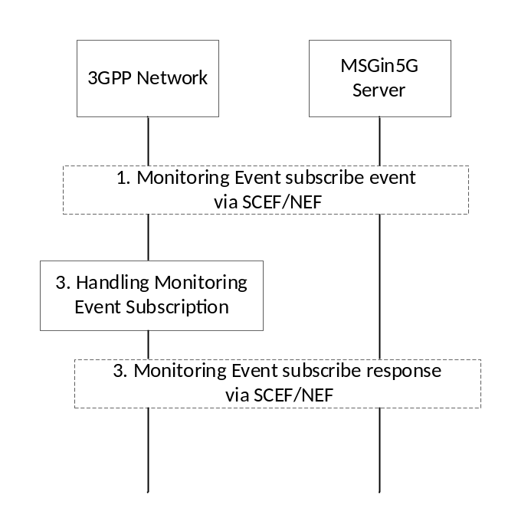
Figure 8.9.2.2.2-1: MSGin5G reachability status subscribe.
1. The MSGin5G Server sends a Monitoring Event Subscribe request to the 3GPP Network using existing SCEF/NEF capabilities.
The Monitoring Event Subscribe is a Monitoring Request with monitoring type set to UE_REACHABILITY , and either the Maximum Number of Reports greater than 1 or the Monitoring Duration IE are included.
3. The 3GPP network processes the Monitoring Event Subscribe request as described in 3GPP TS 29.122 [9].
4. If the Monitoring Event Subscribe Request is successfully processed, a response indicating the request was accepted is sent to the MSGin5G Server.

8.9.2.2.3 Notify
Figure 8.9.2.2.3-1 shows the procedure which may be for updating MSGin5G reachability status.
Pre-conditions:
1. The MSGin5G Server has subscribed for reachability status monitoring for a UE or group of UEs.
2. The monitored UE(s) transitions to Connected Mode, Idle Mode or eDRX paging occasion and the 3GPP Network Entities detects the change in UE reachability status.

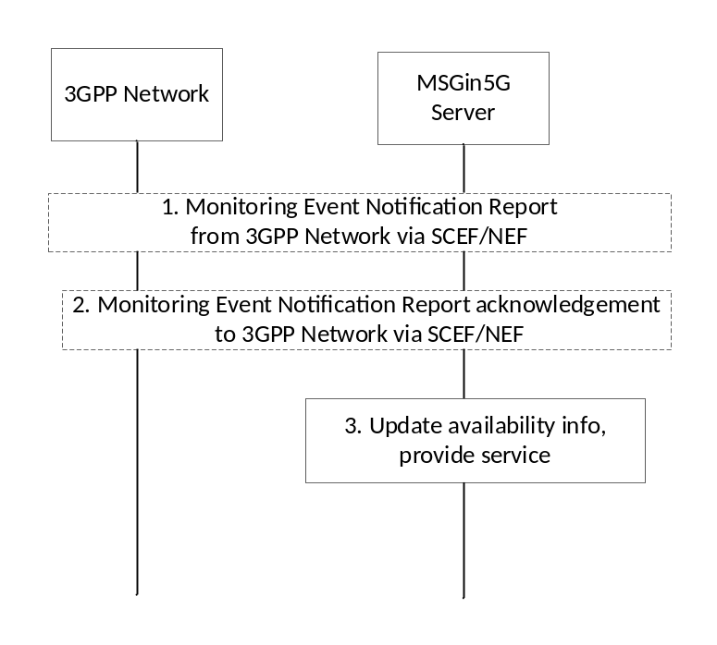
Figure 8.9.2.2.3-1: MSGin5G reachability status notify.
1. Based on the reachability status change of a monitored UE(s), the 3GPP Network sends a Monitoring Notification message for UE reachability to the MSGin5G Server as specified in 3GPP TS 29.122 [9].
The notification may include idle mode information e.g., active time granted to the UE, eDRX cycle length, periodic RAU/TAU timer, etc., depending on the subscription.
2. After receiving a UE Reachability monitoring notification, the MSGin5G Server responds with an acknowledgement of the notification via SCEF/NEF.
3. The MSGin5G Server uses the information provided in the UE reachability monitoring event report to update its information on the UE's availability, e.g., MSGin5G Client Availability information. The MSGin5G Server may provide additional services based on reachability information, e.g., forward a stored message, etc.

8.9.2.2.4 Unsubscribe
Figure 8.9.2.2.4-1 shows the procedure which may be used by the MSGin5G Server to unsubscribe from monitoring of UE reachability.
Pre-conditions:
1. The MSGin5G Server has subscribed for reachability status monitoring for a UE or group of UEs.
2. Later, the MSGin5G Server determines to unsubscribe for monitoring of UE reachability events in the Core Network,
NOTE 1: How the MSGin5G Server determines to subscribe or unsubscribe for monitoring of UE reachability events in the Core Network is implementation dependent.
NOTE 2: If the initial MSGin5G Server subscription for reachability status monitoring reaches the Maximum Number of Reports or Monitoring Duration indicated in the request, the 3GPP Network automatically deletes the subscription and an explicit MSGin5G reachability status unsubscribe is not necessary.

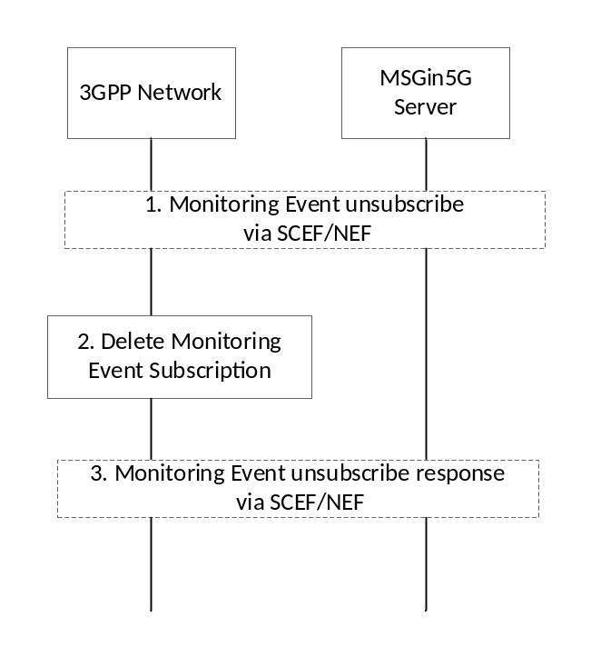
Figure 8.9.2.2.4-1: MSGin5G reachability status unsubscribe.
1. The MSGin5G Server sends a Monitoring event unsubscribe request to the 3GPP Network using existing SCEF/NEF capabilities.
2. The 3GPP network processes the Monitoring event unsubscribe request and deletes the subscription, as described in 3GPP TS 29.122 [9].
3. If the Monitoring event unsubscribe request is successfully processed, a response indicating the subscription was deleted is sent to the MSGin5G Server via SCEF/NEF.

8.9.2.3 Flows
The following information flows are specified for UE reachability status monitoring:
- UE Reachability monitoring request and response;
- UE Reachability monitoring subscribe and unsubscribe
- UE Reachability monitoring notify
All UE reachability monitoring interactions from MSGin5G Server (acting as SCS/AS) to SCEFNEF occur over T8/N33 reference points capabilities detailed in 3GPP TS 23.502 [7] and TS 29.522[10]. As specified in TS 29.522[10] clause 4.4.2, all UE Reachability monitoring procedures use APIs specified in TS 23.682 [8] clause 5.6.1.4 and 3GPP TS 29.122 [9] clause 4.4.2.2.

8.9.3 MSGin5G device triggering

8.9.3.1 General
MSGin5G device triggering is the means by which an Application Server sends an MSGin5G message and the 3GPP network device triggering capabilities exposed via T8 /N33 reference point are leveraged. For example, when an Application Server initiates an MSGin5G message request, but the target UE is not reachable, the MSGin5G Server may use the 3GPP network device triggering mechanism to wake up the device and provide the payload to the destination.

8.9.3.2 Procedure
Figure8.9.3.2-1 shows the MSGin5G device triggering procedure.
Pre-conditions:
1. A UE hosts an MSGin5G Client and/or Application Client which are supported by the MSGin5G Service.
2. The MSGin5G Client registers with the MSGin5G Server.
3. At a later time, the UE becomes unreachable by the MSGin5G Server.
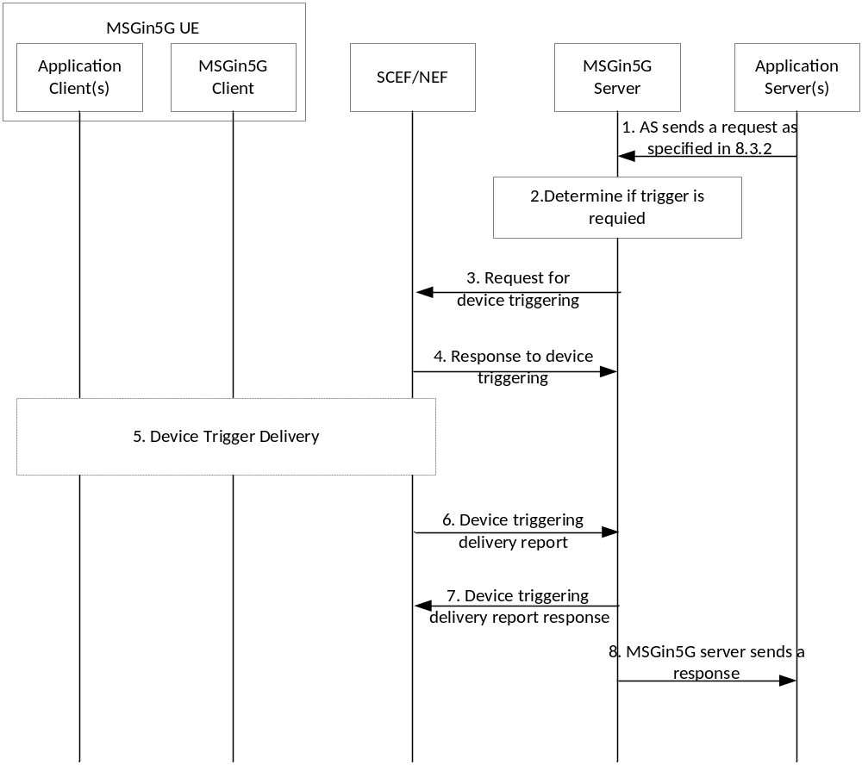
Figure 8.9.3.2-1: MSGin5G Triggering Procedure
1. The Application Server sends an API request to the MSGin5G Server for sending an MSGin5G message, the API request includes the IEs as detailed in clause 9.1.2.1.
2. If the MSGin5G Server determines that the recipient MSGin5G Client is not reachable, it initiates a device trigger request via the SCEF/NEF as a result of the step 1 request.
To determine the reachability of the target UE, the MSGin5G Server may use the UE reachability status monitoring procedure in clause 8.9.2. The MSGin5G Server may also use availability information provided by the MSGin5G Client at registration in the MSGin5G Client Communication Availability IE, as detailed in Table 8.2.1-1.
NOTE 1: How the MSGin5G Server uses the MSGin5G Client Communication Availability IE, the UE reachability status monitoring procedure, or a combination thereof to make this determination is implementation specific.
NOTE 2: If the recipient MSGin5G Client is reachable then the trigger request is not required, the MSGin5G Server sends the MSGin5G message as detailed in clause 8.3.3 and the rest of the steps in this procedure are skipped.
3. The MSGin5G Server sends a request for Device Triggering via SCEF/NEF and determines the flow as detailed in clause 8.9.3.3.2. The Device Triggering request uses the UE Identifier, port number(s) and associated protocol information provided by the MSGin5G Client at registration in the MSGin5G Client Triggering Information IE.
The MSGin5G Server may use MSGin5G Client Communication Availability and/or pre-configured information to determine the timing of the Device Triggering request, e.g. the trigger may be sent to ensure that the target UE is reachable prior to resuming MSGin5G communications.
4. The MSGin5G Server receives a response from SCEF/NEF indicating the success or failure status of the request, as detailed in clause 8.9.3.3.
5. The device trigger is delivered to the target via SCEF/NEF and the Core Network. The targeted MSGin5G Client or Application Client receives the device trigger request. The targeted MSGin5G Client or Application Client parses the payload of the trigger request and determines the device trigger purpose. The target UE becomes reachable, and the MSGin5G Client or Application Client becomes available for further MSGin5G communications.
6. The MSGin5G Server receives a Device Triggering delivery status report from SCEF/NEF indicating the success of the delivery, as detailed in clause 8.9.3.3.
7. The MSGin5G Server send a Device Triggering delivery status report response to SCEF/NEF to acknowledge the delivery status report, as detailed in clause 8.9.3.3.
8. The MSGin5G Server responds to the request received in step 1.
Based on the trigger purpose derived from the payload, the targeted MSGin5G Client or Application Client performs the corresponding actions (e.g. establish access network connectivity, contact the Application Server etc).

8.9.3.3 Flows
The following information flows are specified for MSGin5G triggering:
1. request for device triggering;
2. response to device triggering;
3. device triggering delivery report; and
4. device triggering delivery report response.
All device triggering interactions from MSGin5G Server (acting as SCS/AS) to SCEF/NEF occur over T8/N33 reference points, using capabilities detailed in 3GPP TS 23.502 [7] and TS 29.522[10]. As specified in TS 29.522[10] clause 4.4.3, all device triggering flows use APIs specified in TS 23.682 [8] clause 5.17.1 and 3GPP TS 29.122 [9] clause 4.4.6.

8.10 Usage of SEAL

8.10.1 General
The MSGin5G service functional entities MSGin5G Client and MSGin5G Server utilize the SEAL services. All SEAL services specified in 3GPP TS 23.434 [5] are available to MSGin5G Service. In this clause, only the details of the information flows, procedures and APIs whose utilization by MSGin5G Service are well-known are described.

8.10.2 Configuration management service

8.10.2.1 General
The MSGin5G Service functional entities MSGin5G Client and MSGin5G Server utilize configuration management service procedures of SEAL to support MSGin5G Service.

8.10.2.2 Information flows
The following information flows of Configuration Management service are applicable for the MSGin5G Service:
- Get VAL UE configuration request specified in subclause 11.3.2.1 of 3GPP TS 23.434 [5];
- Besides the IEs specified in subclause 11.3.2.1 of 3GPP TS 23.434 [5], the information in table 8.10.2.2-1 is also included in the Get VAL UE configuration request.
Table 8.10.2.2-1: Additional information in the Get VAL UE configuration request
Information element | Status | Description
MSGin5G UE information | O | Other information needed by the configuration procedure.(NOTE)
NOTE: The information can be the device type, device Vendor, etc. It is specified by application provider or MSGin5G service provider and is out of scope of this document. The MSGin5G service provider can configure the MSGin5G UE with different configuration data based on this IE. E.g. all sensors can be configured to a same MSGin5G Server.

- Get VAL UE configuration response specified in subclause 11.3.2.2 of 3GPP TS 23.434 [5];
- Besides the IEs specified in subclause 11.3.2.2 of 3GPP TS 23.434 [5], the information in table 8.10.2.2-2 is also included in the Get VAL UE configuration response.
Table 8.10.2.2-2: Additional information in the Get VAL UE configuration response
Information element | Status | Description
UE service ID | M | MSGin5G service ID assigned to the requesting MSGin5G UE.
MSGin5G Server address | M | The MSGin5G Server which serves this MSGin5G UE.
MSGin5G service specified information | O | The specific information of the MSGin5G Service specified by the MSGin5G service provider. (NOTE)
NOTE: E.g. the segment size of MSGin5G message in this service provider, the detailed definition is out of scope of this document.

The usage of the above information flows are clarified as below:
- The VAL UE ID is the MSGin5G UE ID;
- VAL service ID is the service identifier of the MSGin5G Service; and
- VAL UE configuration data is the MSGin5G UE configuration data.

8.10.2.3 Procedures
The following procedures of configuration management service are applicable for the MSGin5G Service:
- VAL UE configuration data specified in subclause 11.3.3 of 3GPP TS 23.434 [5].

8.10.3 Group management service

8.10.3.1 General
The MSGin5G service functional entities MSGin5G Client and MSGin5G Server utilize SEAL Client and SEAL Server for the group management service (e.g. creation, join, leave) on the group configuration information (e.g. group join policy, group leader) provided by the MSGin5G Server. The decisions and corresponding triggers (e.g. group creation, join, leave) for group management are responsibility of the application leveraging MSGin5G Service. The group management service of SEAL provides support for creating group for MSGin5G Service for applications leveraging MSGin5G Service.

8.10.3.2 Information flows
Editor’s note: The reference to information flows of group management procedures as specified in 3GPP TS 23.434 [5] are FFS.

8.10.3.3 Procedures
The following procedures of group management service of SEAL as specified in 3GPP TS 23.434 [5] are applicable for the MSGin5G Service:
- Group creation specified in clause 10.3.3;
-- Subsequent to Step 3, when the identity list with the list of VAL user IDs or VAL UE IDs that are part of the created group contain the list of VAL user IDs or VAL UE IDs which does not have group management client on the UE (e.g. Legacy 3GPP UEs or Non-3GPP UEs), it is responsibility of the VAL server (MSGin5G Server) to initiate the group creation notification towards those UEs.
- Group configuration management specified in clause 10.3.6;
- Group membership update specified in clause 10.3.5.2.
Editor’s note: Adding new Group deletion procedure to TS 23.434 and adding any other SEAL procedure references to this specification is FFS.
Editor’s note: Whether MSGin5G service endpoints can dynamically join and leave group is FFS.

8.10.3.4 APIs
The following APIs of group management service of SEAL as specified in 3GPP TS 23.434 [5] are applicable for the MSGin5G Service:
- SS_GroupManagement API specified in clause 10.4.2;
- SS_Group_Management_Event API specified in clause 10.4.5.

8.11 Constrained devices in MSGin5G Service

8.11.1 General
This clause specifies the procedures for the constrained device UE-2 to perform registration to use MSGin5G UE-1 as gateway UE and to send messages and receive messages using MSGin5G UE-1 which is acting as a gateway UE for the MSGin5G UE-2.
NOTE: The procedure in this clause is also applicable to MSGin5G UE that is out of network coverage.
Editor’s note: The API definition for the procedures defined in this clause is FFS.
Editor’s note: Whether the procedures in this clause are applicable to Application Client within MSGin5G UE-1 is FFS.

8.11.2 Constrained device registration to use gateway UE
The signalling flow for registration of Application Client-2 on the UE-2 (which is a constrained device) with MSGin5G Client-1 to use it as a gateway UE is illustrated in figure 8.11.2-1.
Pre-conditions:
1. The MSGin5G UE-1 is configured with information to recognize and authorize UE-2.
2. The UE-2 is a constrained device and does not have access network connection to connect with the MSGin5G Server.
3. The UE-2 has discovered MSGin5G UE-1 is having connectivity to the MSGin5G Server and offers gateway UE functionality.
4. The UE-2 is using NR-PC5 to communicate with MSGin5G UE-1.
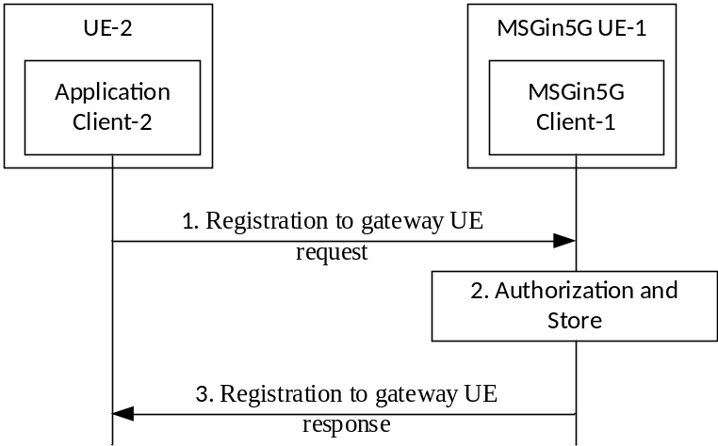
Figure 8.11.2-1: Registration of application client on UE-2 with MSGin5G Client-1 to use gateway UE functionality
1) An Application Client-2 on the UE-2 registers with MSGin5G Client-1 in MSGin5G UE-1 to request MSGin5G Client-1 to act as a gateway UE. The request message includes information elements as specified in Table 8.11.2-1.
Table 8.11.2-1: Information elements for Registration to gateway UE request
Information element | Status | Description
Layer-2 ID | M | Layer-2 identity of UE-2
Application ID | M | Application ID of the application client on MSGinG UE-2
Credential information | M | UE-2 credential information

Editor’s note: The security parameters to include in the message between UE-2 and MSGin5G UE-1 are FFS.
2) Upon receiving the request from the Application Client-2, the MSGin5G Client-1 authorizes the Application Client-2 on UE-2 to use gateway functionality and MSGin5G Client-1 stores the mapping between Application ID and Layer-2 ID of the UE-2.
NOTE 1: The MSGin5G Client-1 may reject the request for registration to use gateway UE functionality based on local condition (like available power or connectivity to access network or any other reason outside the scope of 3GPP).
3) The MSGin5G Client-1 sends response to the Application Client-2. The response message includes information elements as specified in Table 8.11.2-2.
Table 8.11.2-2: Information elements for Registration to gateway UE response
Information element | Status | Description
Result | M | Indicates success or failure of the request
Registration ID | O | Identifies registration. This IE is included only if Result IE is set to success.
Failure reason | O | Indicates failure reason. This IE is included only if Result IE is set to failure.

NOTE 2: If MSGin5G Client-1 decided to reject the request for registration to use gateway UE functionality or if authorization fails as in step 2), the MSGin5G Client-1 sends a failure response to the Application Client-2. Otherwise, the MSGin5G Client-1 sends a success response to the Application Client-2.
NOTE 3: The MSGin5G Client-1 may act as Gateway UE for multiple constrained devices, at the same time.

8.11.3 Constrained device Deregistration from using gateway UE
The signalling flow for deregistration of Application Client-2 on the UE-2 (which is a constrained device) with MSGin5G Client-1 to discontinue use of gateway UE functionality is illustrated in figure 8.11.3-1.
Pre-conditions:
1. The UE-2 is a constrained device and is successfully registered with MSGin5G UE-1 acting as a gateway UE.
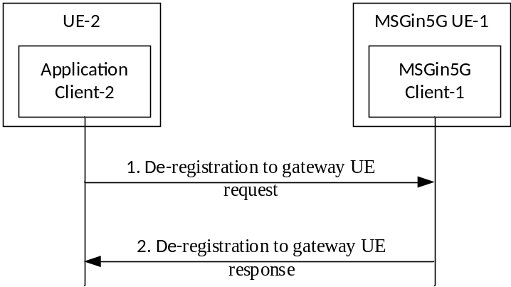
Figure 8.11.3-1: Deregistration of Application Client on UE-2 with MSGin5G Client-1 on MSGin5G UE-1 to discontinue use of gateway UE functionality
1) An Application Client-2 on the UE-2 deregisters with MSGin5G Client-1 in MSGin5G UE-1 to discontinue usage of gateway UE functionality of MSGin5G UE-1. The request message includes information elements as specified in Table 8.11.3-1.
Table 8.11.3-1: Information elements for De-registration to gateway UE request
Information element | Status | Description
Registration ID | M | Identifies the registration

2) Upon receiving the request from the Application Client-2, the MSGin5G Client-1 removes the mapping between Application ID and Layer-2 ID of the UE-2. The MSGin5G Client-1 sends response to the Application Client-2 on UE-2. The response message includes information elements as specified in Table 8.11.2-2.

8.11.4 Constrained device sending message using Gateway UE
The signalling flow for the Application Client-2 on the UE-2 (which is a constrained device) to send message using gateway UE functionality on MSGin5G UE-1 is illustrated in figure 8.11.4-1.
Pre-conditions:
1. The MSGin5G UE-1 is connected to an access network that provides connectivity to the MSGin5G Server.
2. The UE-2 is constrained device and is successfully registered with MSGin5G UE-1 acting as a gateway UE.

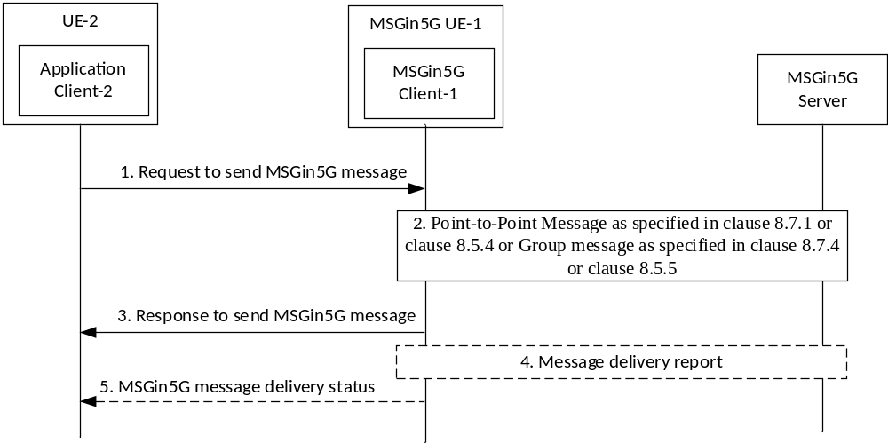
Figure 8.11.4-1: Application Client-2 on UE-2 sends message using gateway UE functionality on MSGin5G UE-1
1) An Application Client-2 on the UE-2 sends a request to send MSGin5G message to the MSGin5G Client-1. The information elements defined in Table 8.11.4-1 are included in the message.
Table 8.11.4-1: Information elements for Request to send MSGin5G message
Information element | Status | Description
Recipient address | O | Indicates details of the recipient. This IE is mandatory to initiate Point-to-Point messaging.
Recipient Group ID | O | Indicates target group.  This IE is mandatory to initiate Group Message.
Application ID | O | Identifies the application(s) for which the payload is intended.
Payload | M | Payload of the message.  MSGin5G Server/Client is unaware of the content.
Delivery status required | O | Indicates whether delivery status is required or not

Editor’s note: If Priority type needs to be communicated from application clients is FFS.
2) Upon receiving the request from the Application Client-2 in UE-2,
a) if the size of the received message exceeds the maximum allowed packet size, if Recipient Group Service ID is included, the MSGin5G Client-1 sends the group message as specified in clause 8.7.4. Otherwise, the MSGin5G Client-1 sends point to point message as specified in clause 8.5.4;
b) If the size of the received message does not exceed the maximum allowed packet size, if Recipient Group Service ID is included, the MSGin5G Client-1 sends the group message as specified in clause 8.5.5. Otherwise, the MSGin5G Client-1 sends point to point message as specified in clause 8.7.1.
The MSGin5G Client-1 uses the information elements received in the request from UE-2 to send the MSGin5G message request;
NOTE 1: The MSGin5G Client-1 may also reject the request to send MSGin5G message based on local condition (like available power or connectivity to access network or any other reason outside the scope of 3GPP).
3) The MSGin5G Client-1 sends response to send MSGin5G message to Application Client-2 on UE-2. The response message includes information elements as specified in Table 8.11.4-2.
Table 8.11.4-2: Information elements for Response to send MSGin5G message
Information element | Status | Description
Result | M | Indicates success or failure of the request
Failure reason | O | Indicates failure reason. This IE is included only if Result IE is set to failure.

NOTE 2: If the MSGin5G Client-1 has decided to reject the request to send the message or the MSGin5G Client-1 received reject response from MSGin5G Server in step 2, the MSGin5G Client-1 sends failure response to the Application Client-2 and stops performing further steps.
4) If delivery status is requested while sending the message in step 1, the MSGin5G Client-1 may receive message delivery status report from the MSGin5G Server.
5) Upon receiving the message delivery status report, the MSGin5G Client-1 sends the delivery status to the Application Client-2 on UE-2. The message includes information elements as specified in Table 8.11.4-3.
Table 8.11.4-3: Information elements for MSGin5G message delivery status
Information element | Status | Description
Delivery status | M | Indicates delivery status

8.11.5 Constrained device receiving message via Gateway UE
The signalling flow for Application Client-2 on the UE-2 (which is constrained device) to receive message (group message, point-to-point message or point-to-application message) using gateway UE functionality on MSGin5G UE-1 is illustrated in figure 8.11.5-1.
Pre-conditions:
1. The MSGin5G UE-1 is connected to an access network that provides connectivity to the MSGin5G Server.
2. The UE-2 is constrained device and is successfully registered with MSGin5G UE-1 acting as a gateway UE.
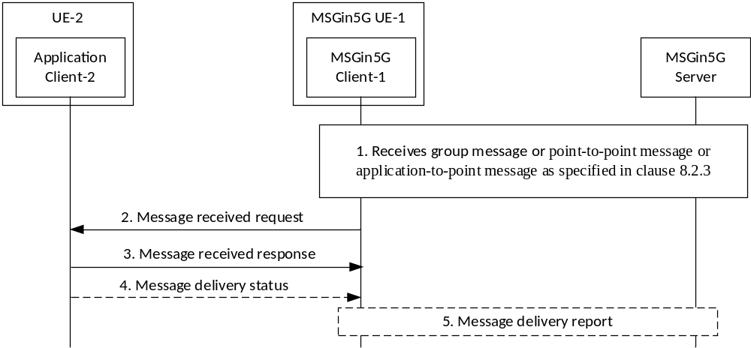
Figure 8.11.5-1: UE-2 receives message using gateway UE functionality on MSGin5G UE-1
1) The MSGin5G Client-1 receives either a group message or a point-to-point message or application-to-point message as specified in clause 8.2.3 for the Application Client-2 on UE-2 for which the MSGin5G Client-1 is acting as Gateway UE. The MSGin5G Client-1 performs reassembly if the received message is segmented. The MSGin5G Client-1 may also perform segment recovery procedure as specified in clause 8.4.6 to recover missing segments.
2) Upon successfully receiving a message for the Application Client-2 on UE-2, the MSGin5G Client-1 sends message received request to Application Client-2 based on Application ID on the UE-2. The request includes information elements as specified in Table 8.11.5-1.
Table 8.11.5-1: Information elements for Message received request
Information element | Status | Description
Originator address | O | Indicates details of the originator. This IE is mandatory for Point-to-Point messaging.
Group Service ID | O | Indicates group for which the message is received.  This IE is mandatory for Group Message.
Payload | M | Payload of the message.  MSGin5G Server/Client is unaware of the content.
Delivery status required | O | Indicates whether delivery status is required or not
Priority type | O | Application priority level requested for this message.

3) Upon successfully receiving the message, the Application Client-2 on UE-2 sends the message received response to the MSGin5G Client-1.
4) If delivery status is requested in the received message, the Application client-2 on UE-2 sends message delivery status to the MSGin5G Client-1.
5) Upon receiving the delivery status, the MSGin5G Client-1 sends message delivery status report to the MSGin5G Server.

9 APIs and related information flows

9.1 APIs provided by MSGin5G Server

9.1.1 Mm5s APIs

9.1.1.1 M5S_AS_Originating_Message_Delivery API

9.1.1.1.1 General
API description: This API enables the Application Server to send MSGin5G message to the MSGin5G Server.

9.1.1.1.2 Send_MSGin5G_Message operation
API operation name: Send_MSGin5G_Message
Description: Send a MSGin5G message to MSGin5G Server.
Known Consumers: Application Server
Inputs: Refer subclause 9.1.2.1
Outputs: Refer subclause 8.3.2
See subclause 8.3.2 for the details of usage of this API operation.

9.1.1.2 M5S_UE_Originating_Message_Delivery API

9.1.1.2.1 General
API description: This API enables the Message Gateway or other 5GS Function to delivery MSGin5G message to the MSGin5G Server.

9.1.1.2.2 Send_ MSGin5G_Message operation
API operation name: Send_MSGin5G_Message
Description: Send a MSGin5G Message to MSGin5G Server.
Known Consumers: L3G, N3G.
Inputs: Refer subclause 8.3.2
Outputs: Refer subclause 8.3.2
See subclause 8.3.2 for the details of usage of this API operation.

9.1.1.3 M5S_AS_Originating_Delivery_Status_Report API

9.1.1.3.1 General
API description: This API enables the Application Server to delivery MSGin5G message delivery status report to the MSGin5G Server.

9.1.1.3.2 Report_Message_Delivery_Status operation
API operation name: Report_Message_Delivery_Status
Description: Send a MSGin5G message delivery status report to MSGin5G Server.
Known Consumers: Application Server
Inputs: Refer subclause 9.1.2.2
Outputs: Refer subclause 8.3.4
See subclause 8.3.4 for the details of usage of this API operation.

9.1.1.4 M5S_UE_Originating_Delivery_Status_Report API

9.1.1.4.1 General
API description: This API enables the Message Gateway or other 5GS Function to deliver MSGin5G message delivery status report to theMSGin5G Server.

9.1.1.4.2 Report_Message_Delivery_Status operation
API operation name: Report_Message_Delivery_Status
Description: Send an MSGin5G message delivery status report to MSGin5G Server.
Known Consumers: L3G, N3G.
Inputs: Refer subclause 8.3.4
Outputs: Refer subclause 8.3.4
See subclause 8.3.4 for the details of usage of this API operation.

9.1.1.5 M5S_AS_Registration API

9.1.1.5.1 General
API description: This API enables the Application Server to register to MSGin5G Server.

9.1.1.5.2 Registration operation
API operation name: Registration
Description: Do registration or update registration to an MSGin5G Server, by using this API, the Application Server provides/updates its information, including the URL used for the message delivery from MSGin5G Server to Application Server.
Known Consumers: Application Server
Inputs: Refer subclause 9.1.2.3
Outputs: Refer subclause 9.1.2.4

9.1.1.5.3 Deregistration operation
API operation name: Send_MSGin5G_Message
Description: Do deregistration with a MSGin5G Server.
Known Consumers: Application Server
Inputs: Refer subclause 9.1.2.5
Outputs: Refer subclause 9.1.2.6

9.1.2 Mm5s Information flows

9.1.2.1 M5S Application Server originating message send request
The information flows from the Application Server to the MSGin5G Server for message delivery includes the IEs in table 8.3.2-1. Additionally, the following information in table 9.1.2.1-2 elements needs to be included:
Table 9.1.2.1-2: M5S Northbound Message Delivery Send request
Information element | Status | Description
Latency | O | The latency requirement for the message.
Authorization Information | O | The authorization information used to determine whether the Application Server is allowed to send the message
Store and forward indicator | O | Whether this message may be store for further delivery when the target UE is unavailable.

9.1.2.2 M5S Application Server originating message delivery status report request
The information flows from the Application Server to the MSGin5G Server for message delivery status report includes the IE in table 8.3.4-1, and the following information in table 9.1.2.2-1 elements needs to be included:
Table 9.1.2.2-1: M5S Northbound Message Delivery Send request
Information element | Status | Description
Authorization Information | O | The authorization information used to determine whether the Application Server is allowed to send the message

9.1.2.3 M5S Application Server registration request
The information flows from the Application Server to the MSGin5G Server for registration request includes the information elements in Table 9.1.2.3-1.
Table 9.1.2.3-1: Application Server Registration request
Information element | Status | Description
AS service ID | M | The MSGin5G identifier of the Application Server.  This ID is configured before registration.
Application ID | O | The identifier of the application specified by the application provider.
Authorization Information | O | The authorization information used to determine whether the Application Server is allowed to send the message
Security Credentials | O | Security information required for the Application Server to register to the MSGin5G Server.
Notification target URI | O | The URL for receiving message, message delivery status report, etc. The MSGin5G Server uses this URL to interact to Application Server.
Application Profile (NOTE) | O | The elements in Application Profile include the information of the Application Server, e.g. application name, application provider, application scenario description, application category, etc.  This IE is used by MSGin5G Server to compare with application client information.
NOTE: The detailed definition of Application Profile is out of scope of this document.

9.1.2.4 M5S Application Server registration response
The information flows from the MSGin5G Server to the Application Server for registration response includes the information elements in Table 9.1.2.4-1.
Table 9.1.2.4-1: Application Server registration response
Information element | Status | Description
AS service ID | M | The MSGin5G identifier of the Application Server.
Registration result | M | Indication if the registration is success or failure

Editor’s note: Whether other information may be included in the Application Server registration response is FFS.

9.1.2.5 M5S Application Server de-registration request
The information flows from the Application Server to the MSGin5G Server for de-registration request includes the information elements in Table 9.1.2.5-1.
Table 9.1.2.5-1: Application Server de-registration request
Information element | Status | Description
AS service ID | M | The MSGin5G identifier of the Application Server.

9.1.2.6 M5S Application Server de-registration response
The information flows from the MSGin5G Server to the Application Server for de-registration response includes the information elements in Table 9.1.2.6-1.
Table 9.1.2.6-1: Application Server de-registration response
Information element | Status | Description
AS service ID | M | The MSGin5G identifier of the Application Server.
De-registration result | M | Indication if the de-registration is success or failure

9.2 APIs provided by Message Gateway

9.2.1 Ml3g APIs

9.2.1.1 L3G_Message_Delivery API

9.2.1.1.1 General
API description: This API enables the MSGin5G Server to delivery MSGin5G Message to the Legacy 3GPP Message Gateway.

9.2.1.1.2 Send_Message operation
API operation name: Send_MSGin5G_Message
Description: Send a MSGin5G Message to Legacy 3GPP Message Gateway.
Known Consumers: M5S.
Inputs: Refer subclause 8.3.3
Outputs: Refer subclause 8.3.3
See subclause 8.3.3 for the details of usage of this API operation.

9.2.1.2 L3G_Delivery_Status_Report API

9.2.1.3.1 General
API description: This API enables the MSGin5G Server to delivery MSGin5G Message to the Legacy 3GPP Message Gateway.

9.2.1.3.2 Report_Message_Delivery_Status operation
API operation name: Report_Message_Delivery_Status
Description: Send an MSGin5G message delivery status report to Legacy 3GPP Message Gateway.
Known Consumers: M5S.
Inputs: Refer subclause 8.3.5
Outputs: Refer subclause 8.3.5
See subclause 8.3.5 for the details of usage of this API operation.

9.2.2 Mn3g APIs

9.2.2.1 N3G_Message_Delivery API

9.2.2.1.1 General
API description: This API enables the MSGin5G Server to delivery MSGin5G message to the Non-3GPP Message Gateway.

9.2.2.1.2 Send_Message operation
API operation name: Create_MSGin5G_Message
Description: Send an MSGin5G message to Non-3GPP Message Gateway.
Known Consumers: M5S.
Inputs: Refer subclause 8.3.3
Outputs: Refer subclause 8.3.3
See subclause 8.3.3 for the details of usage of this API operation.

9.2.2.2 N3G_Delivery_Status_Report API

9.2.2.2.1 General
API description: This API enables the MSGin5G Server to delivery MSGin5G message to the Non-3GPP Message Gateway.

9.2.2.2.2 Report_Message_Delivery_Status operation
API operation name: Report_Message_Delivery_Status
Description: Send an MSGin5G message delivery status report to Non-3GPP Message Gateway.
Known Consumers: M5S.
Inputs: Refer subclause 8.3.5
Outputs: Refer subclause 8.3.5
See subclause 8.3.5 for the details of usage of this API operation.

10 Information Elements

10.1 Payload
The Payload Information Element carries the application payload that is transferred by the MSGin5G Service, of which the content is transparent to the MSGin5G Service.
If the message originates from a MSGin5G UE, the Payload IE is a string of maximum length that can be transported without segmentation but not more than 2048 octets.

10.2 Application ID
The Application ID Information Element identifies the Application Client on the UE or in the Application Server.
The Application ID is a string, which shall allow identifying 65535 different Application Clients. The Application ID is configured or provisoned in the Application Client or the Application Server.
Editor’s note: The number "65535" may be revisited in Stage 3.

10.3 Messaging Topic
The Messaging Topic Information Element indicates the topic of the message, which an interested UE or Application Server can subscribe to.
1. The Messaging Topic IE is a string, which shall allow identiying 65535 different Messaging Topics. Allocating and populating the Messaging Topic IE is done by the Application Client or the Application Server.
Editor’s note: The number "65535" may be revisited in Stage 3.

10.4 Recipient Broadcast Area ID
The Recipient Broadcast Area ID Information Element identifies the service area where the Broadcast Message will be delivered.
The Recipient Broadcast Area ID IE is a string, which shall allow identiying 65535 different Broadcast Areas. The Recipient Broadcast Area ID is provisoned on the Application Client or the Application Server and is mapped by the Legacy 3GPP Message Gateway onto the Broadcast Area as used by the broadcast service in the 5GC.
Editor’s note: The number "65535" may be revisited in Stage 3.

10.5 Message ID
The Message ID Information Element uniquely identifies a specific MSGin5G message in the MSGin5G Service. If message delivery status report is requested by a MSGin5G message, the Message ID IE in this MSGin5G message is used by the sender of the MSGin5G message to match the message delivery status report with the original MSGin5G message. It is also used by the MSGin5G Server in aggregating the message delivery status report message delivery status reports.
The Message ID is globally unique within the MSGin5G Service and is generated by the sender of a new message.

10.6 Failure Cause
The Failure Cause Information Element indicates the the failure reason of a MSGin5G message, if this MSGin5G message can not be delivered successfully.
The Failure Cause IE is a string, which shall allow identiying 65535 different failure reasons.
Editor’s note: The number "65535" may be revisited in Stage 3.

Annex A (informative):
Change history
Change history
Date | Meeting | TDoc | CR | Rev | Cat | Subject/Comment | New version
2020-11 | SA6#40-e |  |  |  |  | TR skeleton agreed in SA6#40: S6-202295 | 0.0.0
2021-01 | SA6#41-e |  |  |  |  | Implemented pCRs approved in SA6#41-e: S6-210363  Editorial changes by the rapporteur | 0.1.0
2021-03 | SA6#42-e |  |  |  |  | Implemented pCRs approved in SA6#42-e: S6-210615, S6-210588, S6-210597, S6-210720  Editorial changes by the rapporteur | 0.2.0
2021-04 | SA6#42 BIS-e |  |  |  |  | Implemented pCRs approved in SA6#42 BIS-e: S6-210827, S6-211087, S6-211088, S6-210989, S6-211089, S6-211090, S6-211091, S6-211092, S6-211093, S6-211094, S6-211095, S6-210988, S6-210969, S6-211071, S6-211096, S6-210822, S6-211042, S6-211043, S6-211097, S6-211098  Editorial changes by the rapporteur | 0.3.0
2021-06 | SA6#43 -e |  |  |  |  | Implemented pCRs approved in SA6#43-e: S6-211135, S6-211136, S6-211367, S6-211337, S6-211232, S6-211338, S6-211230, S6-211342, S6-211339, S6-211340, S6-211341, S6-211399, S6-211400, S6-211349, S6-211490, S6-211169, S6-211343, S6-211344, S6-211430, S6-211355  Editorial changes by the rapporteur | 0.4.0
2021-06 | SA#92 -e | SP-210474 |  |  |  | Presentation for information at SA#92-e | 1.0.0
2021-07 | SA6#44-e |  |  |  |  | Implemented pCRs approved in SA6#44-e: S6-211527, S6-211722, S6-211723, S6-211726, S6-211727, S6-211724, S6-211841, S6-211774, S6-211775, S6-211776, S6-211777, S6-211780, S6-211779, S6-211781, S6-211592, S6-211842, S6-211628, S6-211629, S6-211843, S6-211844, S6-211713  Editorial changes by the rapporteur | 1.1.0
2021-09 | SA6#45-e |  |  |  |  | Implemented pCRs approved in SA6#45-e: S6-212164, S6-212153, S6-212084, S6-212089, S6-211944, S6-212154, S6-212105, S6-211954, S6-211955, S6-212155, S6-211957, S6-211959, S6-212156, S6-212177  Editorial changes by the rapporteur | 1.2.0
2021-09 | SA#93-e | SP-210947 |  |  |  | Presentation for approval at SA#93-e | 2.0.0
2021-09 | SA#93-e | SP-210947 |  |  |  | MCC Editorial update for publication after TSG SA approval (SA#93) | 17.0.0
2021-09 |  |  |  |  |  | Editorial changes by the rapporteur | 17.0.1

