3GPP TS 32.111-2 V10.2.0 (2011-06)
Technical Specification
3rd Generation Partnership Project;
Technical Specification Group Services and System Aspects;
Telecommunication management;
Fault Management;
Part 2: Alarm Integration Reference Point (IRP):
Information Service (IS)
(Release 10)


The present document has been developed within the 3rd Generation Partnership Project (3GPP TM) and may be further elaborated for the purposes of 3GPP.
The present document has not been subject to any approval process by the 3GPP Organizational Partners and shall not be implemented.
This Specification is provided for future development work within 3GPP only. The Organizational Partners accept no liability for any use of this Specification.
Specifications and reports for implementation of the 3GPP TM system should be obtained via the 3GPP Organizational Partners' Publications Offices.

Keywords
UMTS, management, alarm
3GPP
Postal address

3GPP support office address
650 Route des Lucioles - Sophia Antipolis
Valbonne - FRANCE
Tel.: +33 4 92 94 42 00 Fax: +33 4 93 65 47 16
Internet
http://www.3gpp.org
Copyright Notification
No part may be reproduced except as authorized by written permission.
The copyright and the foregoing restriction extend to reproduction in all media.

© 2011, 3GPP Organizational Partners (ARIB, ATIS, CCSA, ETSI, TTA, TTC).
All rights reserved.
UMTS™ is a Trade Mark of ETSI registered for the benefit of its members
3GPP™ is a Trade Mark of ETSI registered for the benefit of its Members and of the 3GPP Organizational Partners
LTE™ is a Trade Mark of ETSI currently being registered for the benefit of its Members and of the 3GPP Organizational Partners
GSM® and the GSM logo are registered and owned by the GSM Association
Contents
Foreword 7
Introduction 7
1 Scope 9
2 References 9
3 Definitions and abbreviations 10
3.1 Definitions 10
3.2 Abbreviations 10
4 Basic aspects 10
4.1 Void 10
4.2 System Context 10
5 Information Object Classes 12
5.1 Information entities imported and local label 12
5.2 Class diagram 12
5.2.1 Attributes and relationships 12
5.2.2 Inheritance 13
5.3 Information Object Class Definitions 13
5.3.1 AlarmInformation 13
5.3.1.1 Definition 13
5.3.1.2 Attribute 14
5.3.1.3 State diagram 14
5.3.2 AlarmList 16
5.3.2.1 Definition 16
5.3.2.2 Attribute 16
5.3.3 AlarmIRP 17
5.3.3.1 Definition 17
5.3.3.2 Attribute 17
5.3.3.3 Notification Table 17
5.3.4 Comment 17
5.3.4.1 Definition 17
5.3.4.2 Attribute 17
5.3.5 CorrelatedNotification 17
5.3.5.1 Definition 17
5.3.5.2 Attribute 17
5.3.6 MonitoredEntity 18
5.3.6.1 Definition 18
5.3.6.2 Attribute 18
5.4 Information relationships definition 19
5.4.1 relation-AlarmIRP-AlarmList (M) 19
5.4.1.1 Definition 19
5.4.1.2 Role 19
5.4.1.3 Constraint 19
5.4.2 relation-AlarmList-AlarmInformation (M) 19
5.4.2.1 Definition 19
5.4.2.2 Role 19
5.4.2.3 Constraint 19
5.4.3 relation-AlarmInformation-Comment (M) 19
5.4.3.1 Definition 19
5.4.3.2 Role 20
5.4.3.3 Constraint 20
5.4.4 relation-AlarmInformation-CorrelatedNotification (M) 20
5.4.4.1 Definition 20
5.4.4.2 Role 20
5.4.4.3 Constraint 20
5.4.5 relation-AlarmedObject-AlarmInformation (M) 20
5.4.5.1 Definition 20
5.4.5.2 Role 20
5.4.5.3 Constraint 21
5.4.6 relation-backUpObject-AlarmInformation (O) 21
5.4.6.1 Definition 21
5.4.6.2 Role 21
5.4.6.3 Constraint 21
5.5 Information attribute definition 22
5.5.1 Definition and legal values 22
5.5.2 Constraints 24
6 Interface Definition 25
6.1 Class diagram 25
6.2 Generic rules 27
6.3 Interface AlarmIRPOperations_1 (M) 27
6.3.1 acknowledgeAlarms (M) 27
6.3.1.1 Definition 27
6.3.1.2 Input Parameters 27
6.3.1.3 Output Parameters 28
6.3.1.4 Pre-condition 28
6.3.1.5 Post-condition 28
6.3.1.6 Exceptions 29
6.3.2 getAlarmList (M) 29
6.3.2.1 Definition 29
6.3.2.2 Input Parameters 30
6.3.2.3 Output Parameters 31
6.3.2.4 Pre-condition 34
6.3.2.5 Post-condition 34
6.3.2.6 Exceptions 34
6.4 Interface AlarmIRPOperation_2 (O) 35
6.4.1 getAlarmCount (M) 35
6.4.1.1 Definition 35
6.4.1.2 Input Parameters 35
6.4.1.3 Output Parameters 36
6.4.1.4 Pre-condition 36
6.4.1.5 Post-condition 36
6.4.1.6 Exceptions 37
6.5 Interface AlarmIRPOperation_3 (O) 37
6.5.1 unacknowledgeAlarms (M) 37
6.5.1.1 Definition 37
6.5.1.2 Input Parameters 37
6.5.1.3 Output Parameters 37
6.5.1.4 Pre-condition 38
6.5.1.5 Post-condition 38
6.5.1.6 Exceptions 38
6.6 Interface AlarmIRPOperation_4 (O) 38
6.6.1 setComment (M) 38
6.6.1.1 Definition 38
6.6.1.2 Input Parameters 39
6.6.1.3 Output Parameter 39
6.6.1.4 Pre-condition 39
6.6.1.5 Post-condition 40
6.6.1.6 Exceptions 40
6.7 Interface AlarmIRPOperation_5 (O) 40
6.7.1 clearAlarms (M) 40
6.7.1.1 Definition 40
6.7.1.2 Input Parameter 40
6.7.1.3 Output Parameter 41
6.7.1.4 Pre-condition 41
6.7.1.5 Post-condition 41
6.7.1.6 Exceptions 41
6.8 Notification AlarmIRPNotifications_1 (M) 42
6.8.1 notifyNewAlarm (M) 42
6.8.1.1 Definition 42
6.8.1.2 Input Parameters 43
6.8.1.3 Input Parameters for notification related to security alarm 44
6.8.1.4 Triggering Event 44
6.8.1.4.1 From-state 44
6.8.1.4.2 To-state 45
6.8.2 notifyAckStateChanged (M) 45
6.8.2.1 Definition 45
6.8.2.2 Input Parameters 46
6.8.2.3 Triggering Event 46
6.8.2.3.1 From-state 46
6.8.2.3.2 To-state 46
6.8.3 notifyClearedAlarm (M) 47
6.8.3.1 Definition 47
6.8.3.2 Input Parameters 47
6.8.3.3 Triggering Event 47
6.8.3.3.1 From-state 47
6.8.3.3.2 To-state 48
6.8.4 notifyAlarmListRebuilt (M) 48
6.8.4.1 Definition 48
6.8.4.2 Input Parameters 48
6.8.4.3 Triggering Event 50
6.8.4.3.1 From-state 50
6.8.4.3.2 To-state 50
6.9 Notification AlarmIRPNotification_2 (O) 50
6.9.1 notifyChangedAlarm (M) 50
6.9.1.1 Definition 50
6.9.1.2 Input Parameters 51
6.9.1.3 Triggering Event 51
6.9.1.3.1 From-state 51
6.9.1.3.2 To-state 51
6.10 Notification AlarmIRPNotification_3 (O) 52
6.10.1 notifyComments (M) 52
6.10.1.1 Definition 52
6.10.1.2 Input Parameters 52
6.10.1.3 Triggering Events 52
6.10.1.3.1 From-state 52
6.10.1.3.2 To-state 53
6.11 Notification AlarmIRPNotification_4 (O) 53
6.11.1 notifyPotentialFaultyAlarmList (M) 53
6.11.1.1 Definition 53
6.11.1.2 Input Parameters 54
6.11.1.3 Triggering Event 54
6.11.1.3.1 From-state 54
6.11.1.3.2 To-state 54
6.12 Notification AlarmIRPNotification_5 (O) 55
6.12.1 notifyCorrelatedNotificationChanged (M) 55
6.12.1.1 Definition 55
6.12.1.2 Input Parameters 55
6.12.1.3 Triggering Events 55
6.12.1.3.1 From-state 55
6.12.1.3.2 To-state 56
Annex A (normative): Event Types 57
Annex B (normative): Probable Causes 58
Annex C (informative): Examples of using notifyChangedAlarm 64
Annex D (informative): Examples of using correlatedNotification 66
Annex E (informative): Change history 67

Foreword
This Technical Specification has been produced by the 3rd Generation Partnership Project (3GPP).
The contents of the present document are subject to continuing work within the TSG and may change following formal TSG approval. Should the TSG modify the contents of the present document, it will be re-released by the TSG with an identifying change of release date and an increase in version number as follows:
Version x.y.z
where:
x the first digit:
1 presented to TSG for information;
2 presented to TSG for approval;
3 or greater indicates TSG approved document under change control.
y the second digit is incremented for all changes of substance, i.e. technical enhancements, corrections, updates, etc.
z the third digit is incremented when editorial only changes have been incorporated in the document.

Introduction
The present document is part of a TS-family covering the 3rd Generation Partnership Project: Technical Specification Group Services and System Aspects; Telecommunication management; as identified below:
32.111-1 "Fault Management; Part 1: 3G fault management requirements".
32.111-2 "Fault Management; Part 2: Alarm Integration Reference Point (IRP): Information Service (IS)".
32.111-3 "Fault Management; Part 3: Alarm Integration Reference Point (IRP): Common Object Request Broker Architecture (CORBA) Solution Set (SS)".
32.111-5 "Fault Management; Alarm Integration Reference Point (IRP): eXtensible Markup Language (XML) definitions".
32.111-7 "Fault Management; Alarm Integration Reference Point (IRP): SOAP Solution Set (SS)".
The present document is part of a set of TSs which describes the requirements and information model necessary for the Telecommunication Management (TM) of 3G systems. The TM principles and TM architecture are specified in 3GPP TS 32.101 [6] and 3GPP TS 32.102 [7].
A 3G system is composed of a multitude of Network Elements (NE) of various types and, typically, different vendors inter-operate in a co-ordinated manner in order to satisfy the network users' communication requirements.
The occurrence of failures in a NE may cause a deterioration of this NE's function and/or service quality and will, in severe cases, lead to the complete unavailability of the NE. In order to minimize the effects of such failures on the Quality of Service (QoS) as perceived by the network users it is necessary to:
- detect failures in the network as soon as they occur and alert the operating personnel as fast as possible;
isolate the failures (autonomously or through operator intervention), i.e. switch off faulty units and, if applicable, limit the effect of the failure as much as possible by reconfiguration of the faulty NE/adjacent NEs;
- if necessary, determine the cause of the failure using diagnosis and test routines; and,
- repair/eliminate failures in due time through the application of maintenance procedures.
This aspect of the management environment is termed "Fault Management" (FM). The purpose of FM is to detect failures as soon as they occur and to limit their effects on the network QoS as far as possible.
The latter is achieved by bringing additional/redundant equipment into operation, reconfiguring existing equipment/NEs, or by repairing/eliminating the cause of the failure.
Fault Management (FM) encompasses all of the above functionalities except commissioning/decommissioning of NEs and potential operator triggered reconfiguration (these are a matter of Configuration Management).
FM also includes associated features in the Operations System (OS), such as the administration of alarm list, the presentation of operational state information of physical and logical devices/resources/functions, and the provision and analysis of the alarm and state history of the network.

1 Scope
The present document defines the Alarm Integration Reference Point (IRP) Information Service (IS), which addresses the alarm surveillance aspects of Fault Management (FM), applied to the N Interface.
The purpose of the AlarmIRP is to define an interface through which a "system" (typically a Network Element Manager or a Network Element) can communicate alarm information for its managed objects to one or several Manager Systems (typically Network Management Systems).
The Alarm IRP IS defines the semantics of alarms and the interactions visible across the reference point in a protocol neutral way. It defines the semantics of the operations and notifications visible in the IRP. It does not define the syntax or encoding of the operations, notifications and their parameters.

2 References
The following documents contain provisions which, through reference in this text, constitute provisions of the present document.
References are either specific (identified by date of publication, edition number, version number, etc.) or non-specific.
For a specific reference, subsequent revisions do not apply.
For a non-specific reference, the latest version applies. In the case of a reference to a 3GPP document (including a GSM document), a non-specific reference implicitly refers to the latest version of that document in the same Release as the present document.
[1] 3GPP TS 32.150: "Telecommunication management; Integration Reference Point (IRP) Concept and definitions".
[2] ITU-T Recommendation X.733 (02/92): "Information technology - Open Systems Interconnection - Systems Management: Alarm reporting function".
[3] ITU-T Recommendation X.721: "Information Technology - Open Systems Interconnection -Structure of management information: Definition of management information".
[4] 3GPP TS 32.401 "Telecommunication management; Performance Management (PM); Concept and requirements".
[5] 3GPP TS 32.302: "Telecommunication management; Configuration Management (CM); Notification Integration Reference Point (IRP): Information Service (IS)".
[6] 3GPP TS 32.101: "Telecommunication management; Principles and high level requirements".
[7] 3GPP TS 32.102: "Telecommunication management; Architecture".
[8] Void.
[9] 3GPP TS 32.111-1: "Telecommunication management; Fault Management; Part 1: 3G fault management requirements".
[10] 3GPP TS 32.622: "Telecommunication management; Configuration Management (CM); Generic network resources Integration Reference Point (IRP): Network Resource Model (NRM)".
[11] ITU-T Recommendation M.3100 (07/95): "Generic network information model".
[12] Void.
[13] Void.
[14] 3GPP TS 32.312: "Telecommunication management; Generic Integration Reference Point (IRP) management; Information Service (IS)".
[15] ITU-T Recommendation X.736: "Information technology - Open Systems Interconnection - Systems Management: Security alarm reporting function".

3 Definitions and abbreviations

3.1 Definitions
For the purposes of the present document, the terms and definitions given in TS 32.111-1 [9] and the following apply:
active alarm: an alarm that has not been cleared ( i.e. an alarm whose perceivedSeverity is not Cleared).
Event: occurrence that is of significance to network operators, the NEs under surveillance and Network Management applications. Events do not have state.
IRPAgent: See 3GPP TS 32.150 [1].
IRPManager: See 3GPP TS 32.150 [1].
IRP document version number string (IRPVersion): See 3GPP TS 32.312 [14].
Matching-Criteria-Attributes: which identifies a set of ITU-T Recommendation X.733 [2] defined attributes.
Notifications carrying identical values for these attributes are considered to be carrying alarm information related to (a) the same network resource and (b) the same alarmed condition. The matching-criteria-attributes are: objectInstance, eventType, probableCause and specificProblem, if present.
Notification: which refers to the transport of events from IRPAgent to IRPManager.
In this IRP, notifications are used to carry alarm information from IRPAgent to IRPManager.

3.2 Abbreviations
For the purposes of the present document, the following abbreviations apply:
DN Distinguished Name
EM Element Manager
FM Fault Management
IOC Information Object Class
IRP Integration Reference Point
IS Information Service
NE Network Element
NM Network Manager
OS Operations System
QoS Quality of Service
SS Solution Set
SupportIOC Support Information Object Class
TM Telecommunication Management
UML Unified Modelling Language

4 Basic aspects

4.1 Void

4.2 System Context
The general definition of the System Context for the present IRP is found in 3GPP TS 32.150 [1] subclause 4.7.
In addition, the set of related IRP(s) relevant to the present IRP is shown in the two diagrams below.
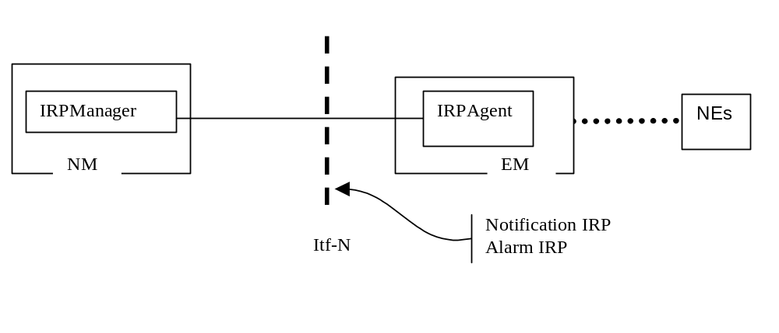
Figure 1: System Context A
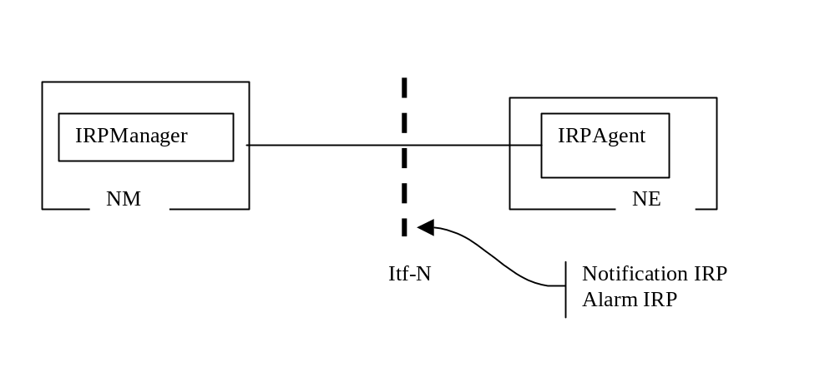
Figure 2: System Context B

5 Information Object Classes

5.1 Information entities imported and local label
Label reference | Local label
32.302 [5], information object class, NotificationIRP | NotificationIRP
32.302 [5], interface, notificationIRPNotification | NotificationIRPNotification
32.622 [10], information object class, IRPAgent | IRPAgent
32.312 [14], information object class, ManagedGenericIRP | ManagedGenericIRP

5.2 Class diagram
This clause introduces the set of classes (i.e. IOCs, SupportIOCs) that encapsulate information within the AlarmIRP. The intent is to identify the information required for the AlarmIRP implementation of its operations and notification emission. This clause provides the overview of all support object classes in UML. Subsequent clauses provide more detailed specification of various aspects of these support object classes.

5.2.1 Attributes and relationships
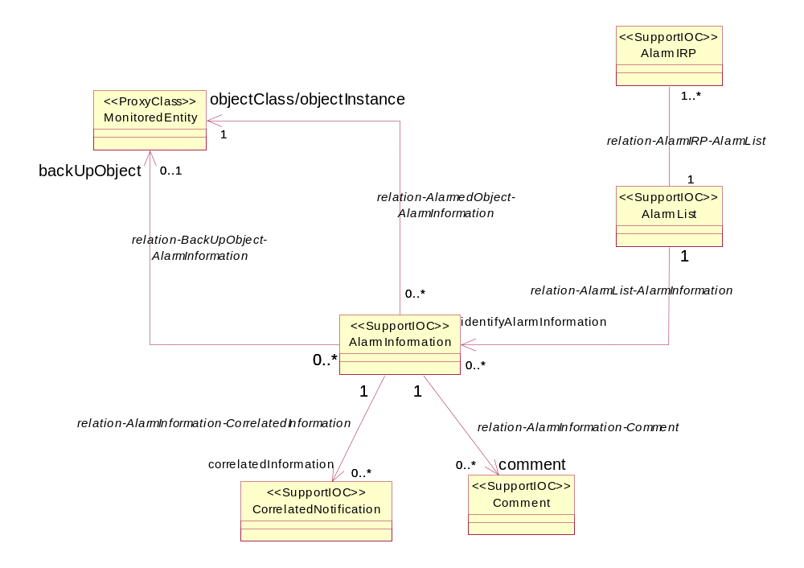

5.2.2 Inheritance
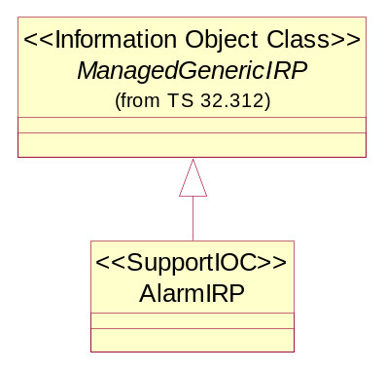

5.3 Information Object Class Definitions

5.3.1 AlarmInformation

5.3.1.1 Definition
AlarmInformation contains information about alarm condition of an alarmed MonitoredEntity.
One AlarmIRP is related to at most one AlarmList. The IRPAgent or its related AlarmIRP or the related AlarmList assigns an identifier, called alarmId, to each AlarmInformation in the AlarmList. An alarmId unambiguously identifies one AlarmInformation in the AlarmList.

5.3.1.2 Attribute
Attribute name | Support Qualifier
alarmId | M
notificationId (note 1) | M
alarmRaisedTime | M
alarmClearedTime | M
alarmChangedTime | O
eventType | M
probableCause | M
perceivedSeverity | M
rootCauseIndicator | O
specificProblem | O
backedUpStatus | O
trendIndication | O
thresholdInfo | O
stateChangeDefinition | O
monitoredAttributes | O
proposedRepairActions | O
additionalText | O
additionalInformation | O(see note 4)
ackTime | M
ackUserId | M
ackSystemId | O
ackState | M
clearUserId | O (see note 2)
clearSystemId | O (see note 2)
serviceUser | O (see note 3)
serviceProvider | O (see note 3)
securityAlarmDetector | O (see note 3)
NOTE 1: This attribute may be "retired/removed" in Release 5 when Log IRP is introduced. Its removal implies that information carried in this attribute is no longer made accessible to IRPManager via the getAlarmList().
NOTE 2: These attributes and qualifiers are applicable only if the IRPAgent supports clearAlarms() (they are absent if clearAlarms() is not supported).
NOTE 3: These attributes must be supported if the IRPAgent emits notifyNewAlarm that carries security alarm information.
NOTE 4: This attribute is optionally populated whenever vendor specific attributes are needed.
A specific condition for this optional population is when an alarm presented by the EM (e.g. EM user interface) has different values of perceived severity, and / or alarm type, compared with the values presented to the Itf-N.

5.3.1.3 State diagram
Alarms have states. The alarm state information is captured in AlarmInformation in AlarmList.
The solid circle icon represents the Start State. The double circle icon represents the End State. In this state, the alarm is Cleared and acknowledged. The AlarmInformation shall not be accessible via the IRP and is removed from the AlarmList.
Note the state diagram uses " X / Y ^ Z " to label the arc that indicates state transition. The meanings of X, Y and Z are:
- X identifies the triggering event
- Y identifies the action of AlarmIRP because of the triggering event
- Z is the notification to be emitted by AlarmIRP because of the triggering event
Note that acknowledgeAlarm^notifyAckStateChanged and the unacknowledgeAlarm^notifyAckStateChange refer to cases when the request of the IRPManager is successful for the AlarmInformation concerned. They do not refer to the cases when the request is a failure since in the failure cases, no state transition would occur.
Note that, to reduce cluttering to the diagram, the setComment^notifyComment is not included in the figure. One transition should be applied from unack&unclear to itself. Similarly, another transition should be applied from ack&unclear to itself. Another one is from unack&clear to itself.
"PS" used in the state diagram stands for "perceived severity".
Figure A is used if it supports ^notifyChangedAlarm and Figure B is used if it does not support ^notifyChangedAlarm.
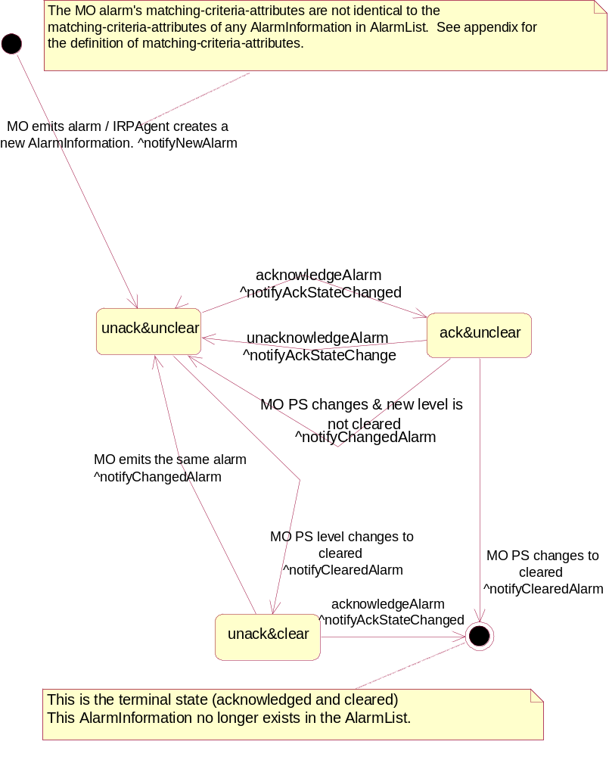

Figure A. ^notifyChangedAlarm supported
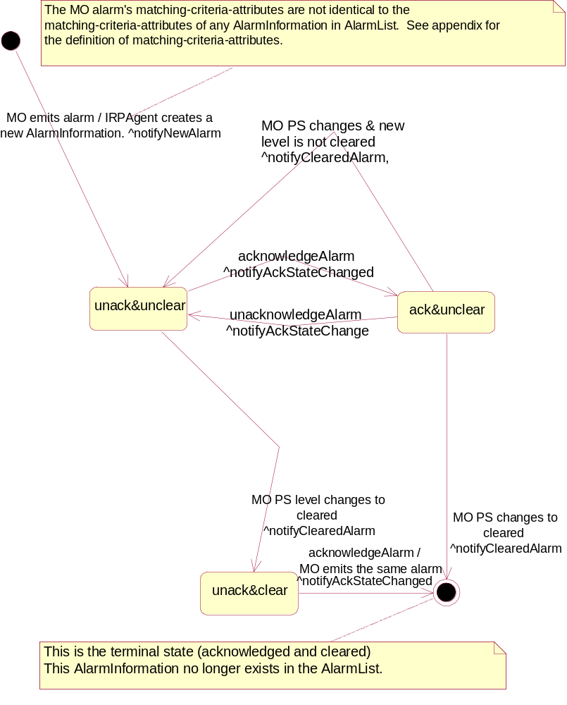

Figure B. ^notifyChangedAlarm not supported

5.3.2 AlarmList

5.3.2.1 Definition
AlarmIRP maintains an AlarmList that contains currently active alarms (i.e. AlarmInformation whose perceivedSeverity is not Cleared) and alarms that are Cleared but not yet acknowledged.

5.3.2.2 Attribute
There is no additional attribute defined for this class besides those inherited.

5.3.3 AlarmIRP

5.3.3.1 Definition
AlarmIRP is the representation of the alarm management capabilities specified by the present document. This class inherits from ManagedGenericIRP class specified in 3GPP TS 32.312 [14].

5.3.3.2 Attribute
There is no additional attribute defined for this class besides those inherited.

5.3.3.3 Notification Table
Name | Qualifier | Notes
notifyAlarmListRebuilt | M | See 6.8.4.
notifyPotentialFaultyAlarmList | O | See 6.11.1.

5.3.4 Comment

5.3.4.1 Definition
Comment contains commentary and associated information such as the time when the commentary is made.

5.3.4.2 Attribute
Attribute Name | Support Qualifier
commentTime | M
commentText | M
commentUserId | M
commentSystemId | O

5.3.5 CorrelatedNotification

5.3.5.1 Definition
It identifies one MonitoredEntity. For that MonitoredEntity identified, a set of notification identifiers is also identified. One or more CorrelatedNotification instances can be related to an AlarmInformation. In this case, the information of the AlarmInformation is said to be correlated to information carried in the notifications identified by the CorrelatedNotification instances. See further definition of correlated notification in ITU-T Recommendation X.733 [2], clause 8.1.2.9.
The meaning of correlation is dependent on the type of notification itself. See the comment column of the correlatedNotification input parameter for each type of notification, such as notifyNewAlarm.
Notification carries AlarmInformation. The AlarmInformation instances referred to by the correlatedNotification may or may not exist in the AlarmList. For example, the AlarmInformation carried by the identified notification may have been acknowledged and Cleared and therefore, no longer exist in the AlarmList.

5.3.5.2 Attribute
Attribute Name | Support Qualifier
source | M
notificationIdSet | M

5.3.6 MonitoredEntity

5.3.6.1 Definition
It represents classes that can have an alarmed state. The types of classes that can have alarmed state are:
a) All classes whose Notification Tables include alarm notifications.
b) VSE subclass of 3GPP defined classes and VSE defined classes that can have alarmed state.
The objectClass and objectInstance of this class identifies an instance of this class. The AlarmInformation uses this information in two places. In one place, the information is used to identify the instance that is in alarmed state. In another place, the information is used to identify an instance that can be used as the back up network resource for the instance that is in alarmed state.

5.3.6.2 Attribute
There is no attribute for this class.

5.4 Information relationships definition

5.4.1 relation-AlarmIRP-AlarmList (M)

5.4.1.1 Definition
This represents the relationship between AlarmIRP and AlarmList.

5.4.1.2 Role
There is no role defined for this relationship.

5.4.1.3 Constraint
There is no constraint for this relationship.

5.4.2 relation-AlarmList-AlarmInformation (M)

5.4.2.1 Definition
This represents the relationship between AlarmList and AlarmInformation.

5.4.2.2 Role
Name | Definition
identifyAlarmInformation | It represents a capability to obtain the information contained in AlarmInformation.

5.4.2.3 Constraint
Name | Definition
inv_ hasAlarmInformation1 | No AlarmInformation playing the role of theAlarmInformation shall have its perceivedSeverity = "cleared" and its ackState = "acknowledged".
inv_ hasAlarmInformation2 | The alarmId of all AlarmInformation instances playing the role of theAlarmInformation are distinct.

5.4.3 relation-AlarmInformation-Comment (M)

5.4.3.1 Definition
This represents the relationship between AlarmInformation and Comment.

5.4.3.2 Role
Name | Definition
comment | It represents a capability to obtain the information contained in Comment.

5.4.3.3 Constraint
There is no constraint.

5.4.4 relation-AlarmInformation-CorrelatedNotification (M)

5.4.4.1 Definition
This represents the relationship between AlarmInformation and CorrelatedNotification.

5.4.4.2 Role
Name | Definition
correlatedNotification | It represents a capability to obtain the information contained in CorrelatedNotification.

5.4.4.3 Constraint
There is no constraint.

5.4.5 relation-AlarmedObject-AlarmInformation (M)

5.4.5.1 Definition
This represents the relationship between MonitoredEntity and AlarmInformation.

5.4.5.2 Role
Name | Definition
objectClass/objectInstance | It represents the capability to obtain the identification, in terms of objectClass and objectInstance, of alarmed network resource.

5.4.5.3 Constraint
Name | Definition
inv_relation-AI-ME | All AlarmInformation involved in this relationship with the same MonitoredEntity shall have at least one different value in the following attributes: eventType, probableCause and specificProblem.

5.4.6 relation-backUpObject-AlarmInformation (O)

5.4.6.1 Definition
The relationship represents the relationship between AlarmInformation and the backUpObject.

5.4.6.2 Role
Name | Definition
backUpObject | It represents a capability to obtain the identification, in terms of objectClass and objectInstance, of the backUpObject.

5.4.6.3 Constraint
Name | Definition
inv_identifyBackUpObject | This relationship is present if and only if the AlarmInformation.backedUpStatus attribute is present and is indicating true.

5.5 Information attribute definition

5.5.1 Definition and legal values
Name | Definition | Legal Values
alarmId | It identifies one AlarmInformation in the AlarmList.
notificationId | It identifies the notification that carries the AlarmInformation.
alarmRaisedTime | It indicates the date and time when the alarm is first raised by the alarmed resource. | All values indicating valid time.
alarmChangedTime | It indicates the last date and time when the AlarmInformation is changed by the alarmed resource. Changes to AlarmInformation caused by invocations of the IRPManager would not change this date and time. | All values indicating valid time.
alarmClearedTime | It indicates the date and time when the alarm is Cleared. | All values indicating valid time.
eventType | It indicates the type of event. See Annex A for information on event type. | See Annex A.
probableCause | It qualifies alarm and provides further information than eventType. See Annex B for a complete listing. | See Annex B.
perceivedSeverity | It indicates the relative level of urgency for operator attention. | Critical, Major, Minor, Warning, Indeterminate, Cleared: see ITU-T Recommendation X.733 [2]. This IRP does not recommend the use of indeterminate.
specificProblem | It provides further qualification on the alarm than probableCause. This attribute value shall be single-value and of simple type such as integer or string. See definition in ITU-T Recommendation X.733 [2] clause 8.1.2.2. | Provided by vendor.
backedUpStatus | It indicates if an object (the MonitoredEntity) has a back up. See definition in ITU-T Recommendation X.733 [2] clause 8.1.2.4. | All values that carry the semantics of backedUpStatus defined by ITU-T X.733 [2] clause 8.1.2.4.
trendIndication | It indicates if some observed condition is getting better, worse, or not changing. | "Less severe", "no change", "more severe": see definition in ITU-T Recommendation X.733 [2] clause 8.1.2.6.
thresholdInfo | It indicates the crossed threshold information such as:  - The identifier of the monitored attribute whose value has crossed a threshold,  - The threshold settings,  - The observed value that have crossed a threshold, etc.  See definition in ITU-T Recommendation X.733 [2] clause 8.1.2.7. See also for information in TS 32.401 [4] subclause 5.6.
stateChangeDefinition | It indicates MO attribute value changes. See definition in ITU-T Recommendation X.733 [2] clause 8.1.2.10.
monitoredAttributes | It indicates MO attributes whose value changes are being monitored. See definition in ITU-T Recommendation X.733 [2] clause 8.1.2.11.
proposedRepairActions | It indicates proposed repair actions. See definition in ITU-T Recommendation X.733 [2] clause 8.1.2.12.
additionalText | It carries semantics that is outside the scope of this IRP specification. It may provide the identity of the NE (e.g. RNC, Node-B) from which the alarm has been originated. It corresponds to the "user label" attribute of the object class representing the NE in the Generic Network Resource Model [10].  It can contain further information on the alarm. | N/A
additionalInformation | This attribute when present allows the inclusion of a set of vendor specific alarm information in the alarm.  A specific condition for this optional population is when an alarm presented by the EM (e.g. EM user interface) has different values of perceived severity, and / or alarm type, compared with the values presented to the Itf-N.  Any other uses of additional information on the alarm and its semantics is outside the scope of this IRP. | The additional information field is a list of one or more information parts.  This specification allows the support of two such information parts to carry  - vendor defined perceived severity  - vendor defined alarm type  using defined identification.  Other vendor specific information parts are allowed by using vendor specific identifications.
ackTime | It identifies the time when the alarm has been acknowledged or unacknowledged the last time, i.e. it registers the time when ackState changes. | All values that indicate valid time that are later than that carried in alarmRaisedTime.
ackUserId | It identifies the last user who has changed the Acknowledgement State. | It can be used to identify the human operator such as "John Smith" or it can identify a group, such as "Team Six", or it can contain no information such as "".
ackSystemId | It identifies the system (EM or NM) that last changed the ackState of an alarm, i.e. acknowledged or unacknowledged the alarm. | It can be used to identify the system, such as "system 6" or it can contain no information such as "".
ackState | It identifies the Acknowledgement State of the alarm. | Acknowledged: the alarm has been acknowledged.  Unacknowledged: the alarm has been unacknowledged or the alarm has never been acknowledged.
commentTime | It carries the time when the comment has been added to the alarm.
commentText | It carries the textual comment.
commentUserId | It carries the identification of the user who made the comment.
commentSystemId | It carries the identification of the system (EM or NM) from which the comment is made. That system supports the user that made the comment.
rootCauseIndicator | It indicates that this AlarmInformation is the root cause of the events captured by the notifications whose identifiers are in the related CorrelatedNotification instances. | “Yes”, “No”
source | It identifies one MonitoredEntity. | All values that carry the semantics of DN.
notificationIdSet | It carries one or more notification identifiers.
clearUserId | It carries the identity of the user who invokes the clearAlarms operation. | It can be used to identify the human operator such as "John Smith" or it can identify a group, such as "Team Six", or it can contain no information such as "".
clearSystemId | It carries the identity of the system in which the IRPManager runs. That IRPManager supports the user who invokes the clearAlarms(). | It can be used to identify the system, such as "system 6" or it can contain no information such as "".
serviceUser | It identifies the service-user whose request for service provided by the serviceProvider led to the generation of the security alarm. | This attribute may carry no information if the server user is not identifiable.
serviceProvider | It identifies the service-provider whose service is requested by the serviceUser and the service request provokes the generation of the security alarm.
securityAlarmDetector | It carries the identity of the detector of the security alarm. | This attribute may carry no information if the security alarm detector is not identifiable.

5.5.2 Constraints
Name | Definition
inv_alarmChangedTime | Time indicated shall be later than that carried in alarmRaisedTime.
inv_alarmClearedTime | Time indicated shall be later than that carried in alarmRaisedTime.
inv_ackTime | Time indicated shall be later than that carried in alarmRaisedTime.
inv_notificationId | NotificationIds shall be chosen to be unique across all notifications of a particular Managed Object (representing the NE) throughout the time that alarm correlation is significant. The algorithm by which alarm correlation is accomplished is outside the scope of this IRP.

6 Interface Definition

6.1 Class diagram
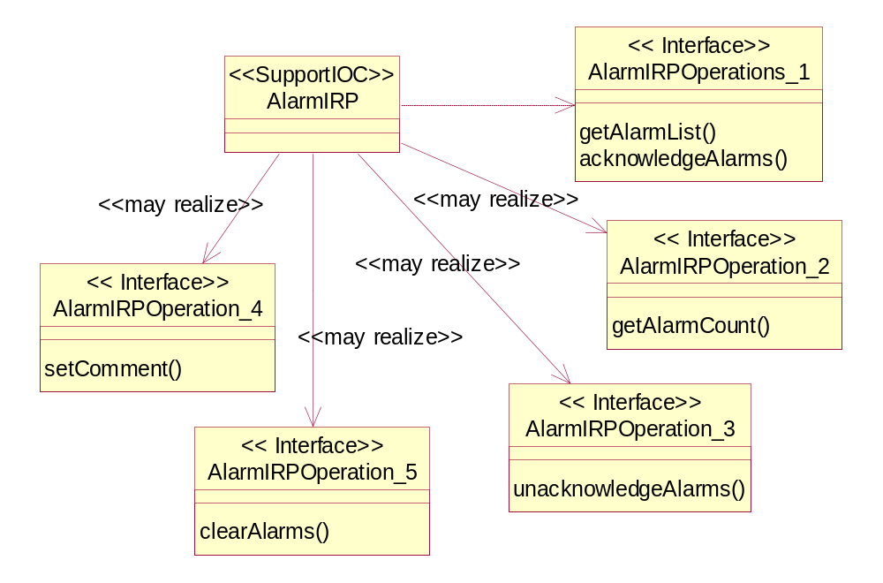
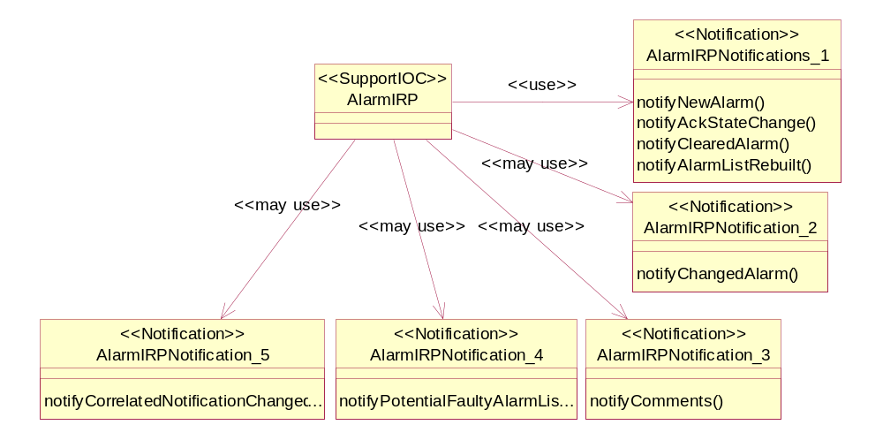

6.2 Generic rules
Rule 1: each operation with at least one input parameter supports a pre-condition valid_input_parameter which indicates that all input parameters shall be valid with regards to their information type. Additionally, each such operation supports an exception operation_failed_invalid_input_parameter which is raised when pre-condition valid_input_parameter is false. The exception has the same entry and exit state.
Rule 2: Each operation with at least one optional input parameter supports a set of pre-conditions supported_optional_input_parameter_xxx where "xxx" is the name of the optional input parameter and the pre-condition indicates that the operation supports the named optional input parameter. Additionally, each such operation supports an exception operation_failed_unsupported_optional_input_parameter_xxx which is raised when (a) the pre-condition supported_optional_input_parameter_xxx is false and (b) the named optional input parameter is carrying information. The exception has the same entry and exit state.
Rule 3: each operation shall support a generic exception operation_failed_internal_problem that is raised when an internal problem occurs and that the operation cannot be completed. The exception has the same entry and exit state.

6.3 Interface AlarmIRPOperations_1 (M)

6.3.1 acknowledgeAlarms (M)

6.3.1.1 Definition
The IRPManager invokes this operation to acknowledge one or more alarms.

6.3.1.2 Input Parameters
Name | Qualifier | Information Type | Comment
alarmInformationAndSeverityReferenceList | M | List of AlarmInformation.alarmId and AlarmInformation.perceivedSeverity | It carries one or more identifiers identifying AlarmInformation instances in AlarmList, including optionally the perceivedSeverity of the AlarmInformation instance that is going to be acknowledged.  alarm InformationAndSeverity ReferenceList  { alarmId - Mandatory;  perceivedSeverity - Optional  }
ackUserId | M | AlarmInformation.ackUserId | It identities the user acknowledging the alarm.
ackSystemId | O | AlarmInformation.ackSystemId | It identifies the processing system on which the subject IRPManager runs. It may be absent implying that IRPManager does not wish this information be kept in AlarmInformation in AlarmList.

6.3.1.3 Output Parameters
Name | Qualifier | Matching Information | Comment
badAlarm Information ReferenceList | M | List of pair of AlarmInformation.alarmId, ENUM (UnknownAlarmId, AcknowledgmentFailed, WrongPerceivedSeverity) and additional failure reason. | If allAlarmsAcknowledged is true, it contains no information.  If someAlarmAcknowledged is true, then it contains identifications of AlarmInformation that are (a) present in input parameter AlarmInformationReferenceList but are absent in the AlarmList = UnknownAlarmId; or  (b) present in input parameter AlarmInformationReferenceList and are present in the AlarmList but the Acknowledgement Information (see note below table) has not changed, in contrast to IRPManager's request = AcknowledgmentFailed; or  (c) present in input parameter AlarmInformationReferenceList and are present in the AlarmList but the perceivedSeverity to be acknowledged has changed and/or is different within the Alarm List = WrongPerceivedSeverity (applicable only if perceivedSeverity was provided).
status | M | ENUM (OperationSucceeded, OperationFailed, OperationPartiallySucceeded) | If someAlarmAcknowledged is true, status = OperationPartiallySuceeded.  If allAlarmsAcknowledged is true, status = OperationSucceeded.  If operation_failed is true, status = OperationFailed.

NOTE: Acknowledgement Information is defined as the information contained in AlarmInformation.ackTime, AlarmInformation.ackUserId, AlarmInformaton.ackSystemId, AlarmInformation.ackState.

6.3.1.4 Pre-condition
atLeastOneValidId.
Assertion Name | Definition
atLeastOneValidId | The AlarmInformationReferenceList contains at least one identifier that identifies one AlarmInformation in AlarmList and that this identified AlarmInformation shall have its ackState indicating "unacknowledged" and, if provided, an equal perceivedSeverity.

6.3.1.5 Post-condition
someAlarmAcknowledged OR allAlarmsAcknowledged.
Assertion Name | Definition
someAlarmAcknowledged | At least one but not all AlarmInformation identified in input parameter AlarmInformationReferenceList has been acknowledged. Acknowledgement of an AlarmInformation means that the ackState attribute has been set to "acknowledged", that ackUserId, ackSystemId attributes of this AlarmInformation have been set to the values provided as input parameter and that the time of acknowledgeAlarms operation has been registered in ackTime attribute.
allAlarmsAcknowledged | All AlarmInformation identified in input parameter have been acknowledged. Acknowledgement of an AlarmInformation means that the ackState attribute has been set to "acknowledged", that ackUserId, ackSystemId attributes of this AlarmInformation have been set to the values provided as input parameter and that the time of acknowledgeAlarms operation has been registered in ackTime attribute.

6.3.1.6 Exceptions
Name | Definition
operation_failed | Condition: Pre-condition is false or post-condition is false.  Returned Information: The output parameter status.  Exit state: Entry state.

6.3.2 getAlarmList (M)

6.3.2.1 Definition
The IRPManager invokes this operation to request the AlarmIRP to provide either the complete list of AlarmInformation instances in the AlarmList or only a part of this list (partial alarm alignment).
The parameters baseObjectClass and baseObjectInstance are used to identify the part of the alarm list to be returned. If they are absent, then the complete alarm list shall be provided (full alarm alignment). If they identify a particular class instance, then only a) the AlarmInformation instances related to this class instance and b) the AlarmInformation instances related to the subordinate class instances of this class instance shall be provided (partial alarm alignment). An instance-a is said to be subordinate to instance-b if the DN of the latter is part of the DN of the former.
There are two modes of operation. One mode is synchronous. In this mode, the list of AlarmInformation instances in AlarmList is returned synchronously with the operation. The other mode is asynchronous. In this mode, the list of AlarmInformation instances is returned via notifications. In asynchronous mode of operation, the only information returned synchronously is the status of the operation. A method allowing to abort an ongoing alarm alignment process shall be available in the asynchronous mode. The mode of operation to be used is determined by means outside the scope of specification. To use asynchronous mode, the IRPManager must have established a subscription with the NotificationIRP via the subscribe operation specified in 3GPP TS 32.302 [5].

6.3.2.2 Input Parameters
Name | Qualifier | Information Type | Comment
alarmAckState | O | ENUM (all alarms, all active alarms, all active and acknowledged alarms, all active and unacknowledged, all Cleared and unacknowledged alarms, all unacknowledged) | It carries a constraint. The AlarmIRP shall apply it on AlarmInformation instances in AlarmList when constructing its output parameter AlarmInformationList.
baseObjectClass | O, see note 1 | This parameter is either absent or carries the object class of a certain class. | See how this attribute is used to support full alarm alignment and partial alarm alignment in 6.3.2.1.  See note 2.
baseObjectInstance | O, see note 1 | This parameter is either absent or carries the DN of a certain class instance. | See how this attribute is used to support full alarm alignment and partial alarm alignment in 6.3.2.1.  See note 2.
filter | O | N/A | It carries a filter constraint.  If the filter is present, the AlarmIRP shall apply it on AlarmInformation instances in AlarmList when constructing its output parameter AlarmInformationList.  If the filter is not present, all of the AlarmInformation instances included by the scope are selected.
NOTE 1: If the notification notifyAlarmListRebuilt supports indicating that only a part of the alarm list has been rebuilt then the operation getAlarmList shall support partial alarm alignment.

NOTE 2: The legal values of the parameters baseObjectClass and baseObjectInstance are restricted to those carried by the parameters baseObjectClass and baseObjectInstance in the recent notifyAlarmListRebuilt notifications. The timeline for “recent” is vendor-specific.

6.3.2.3 Output Parameters
Name | Qualifier | Matching Information | Comment
alarmInformationList | M  For the Qualifier of the parameters in each list entry see the following table | List of AlarmInformation. | It carries the requested AlarmInformation instances.  Case when synchronous mode of operation is used:  (a) The AlarmIRP shall apply the constraints expressed in alarmAckState and filter to AlarmInformation instances when constructing this output parameter.  Case when asynchronous mode of operation is used (i.e. this output parameter is conveyed via notifications):  (a) If the filter parameter is present, the IRPAgent shall apply the constraint when constructing this output parameter. Furthermore, if the alarmAckState constraint is present, the IRPAgent shall apply that constraint as well. The filter constraint, if any, that is currently active in the notification channel is not used for the construction of this output parameter.  (b) If the filter parameter is absent, the IRPAgent shall apply the filter constraint currently active in the notification channel when constructing this output parameter. If the alarmAckState constraint is present, the IRPAgent shall apply that constraint as well.
status | M | ENUM (OperationSucceeded, OperationFailed) | If allAlarmInformationReturned is true, status = OperationSucceeded.  If operation_failed is true, status = OperationFailed.

The following table lists the set of sub-elements of the alarmInformationList attribute, and alarmInformationList forms a list of such sets.

Name | Qualifier | Matching Information | Comment
notificationType | M | "notifyNewAlarm"  or  “notifyChangedAlarm”  or  “notifyClearedAlarm” | The parameter carries  - notifyNewAlarm in case the alarm has not yet changed and has not yet been cleared.  - notifyChangedAlarm in case the alarm has changed but has not yet been cleared.  - notifyClearedAlarm in case the alarm has been cleared but not yet acknowledged.
alarmType | M | AlarmInformation.eventType | This parameter indicates "Communications Alarm", "Processing Error Alarm", "Environmental Alarm". "Quality Of Service Alarm" or "Equipment Alarm" for non-security-related alarms.  It indicates "Integrity Violation", "Operational Violation", "Physical Violation", "Security Service or Mechanism Violation" or "Time Domain Violation” for security alarms.
objectClass, objectInstance | M | MonitoredEntity.objectClass where the MonitoredEntity is identified by the relation-AlarmedObject-AlarmInformation of the new AlarmInformation.  MonitoredEntity.objectInstance where the MonitoredEntity is identified by the relation-AlarmedObject-AlarmInformation of the new AlarmInformation.
notificationId | M | This carries the semantics of notification identifier.
eventTime | O | AlarmInformation.alarmRaisedTime or  AlarmInformation.alarmChangedTime or  AlarmInformation.alarmClearedTime | The parameter carries the  - alarmRaisedTime in case notificationType carries notifyNewAlarm  - alarmChangedTime in case notificationType carries notifyChangedAlarm  - alarmClearedTime in case notificationType carries notifyClearedAlarm  The availability and accuracy of time carried by the time parameters in individual entries of the list (i.e. eventTime, alarmRaisedTime, alarmClearedTime and ackTime) shall be "best effort".  Reason: An EMS is not required to persistently store these times or other alarm information (as in case of synchronization information may be provided by the NE), while also some NE's do not keep these times (and a later attempt to retrieve the alarm data from the NEs will not deliver these time data).
systemDN | C | See usage of this attribute in Notification header - see [5]. | Presence dependent on solution set.  See usage of this attribute in Notification header - see [5].
alarmId | M | AlarmInformation.alarmId
alarmRaisedTime | M | AlarmInformation.alarmRaisedTime | The availability and accuracy of time carried by the time parameters in individual entries of the list (i.e. eventTime, alarmRaisedTime, alarmClearedTime and ackTime) shall be "best effort".  Reason: An EMS is not required to persistently store these times or other alarm information (as in case of synchronization information may be provided by the NE), while also some NE's do not keep these times (and a later attempt to retrieve the alarm data from the NEs will not deliver these time data).
alarmChangedTime | O | AlarmInformation.alarmChangedTime | not applicable if the severity of related alarm was not changed  The availability and accuracy of time carried by the time parameters in individual entries of the list (i.e. eventTime, alarmRaisedTime, alarmChangedTime, alarmClearedTime and ackTime) shall be "best effort".  Reason: An EMS is not required to persistently store these times or other alarm information (as in case of synchronization information may be provided by the NE), while also some NE's do not keep these times (and a later attempt to retrieve the alarm data from the NEs will not deliver these time data).
alarmClearedTime | M | AlarmInformation.alarmClearedTime | not applicable if related alarm was not cleared  The availability and accuracy of time carried by the time parameters in individual entries of the list (i.e. eventTime, alarmRaisedTime, alarmClearedTime and ackTime) shall be "best effort".  Reason: An EMS is not required to persistently store these times or other alarm information (as in case of synchronization information may be provided by the NE), while also some NE's do not keep these times (and a later attempt to retrieve the alarm data from the NEs will not deliver these time data).
probableCause | M | AlarmInformation.probableCause
perceivedSeverity | M | AlarmInformation.perceivedSeverity
specificProblem | O | AlarmInformation.specificProblem
backedUpStatus | O | AlarmInformation.backedUpStatus | not applicable if related alarm is a security alarm
trendIndication | O | AlarmInformation.trendIndication | not applicable if related alarm is a security alarm
thresholdInfo | O | AlarmInformation.thresholdInfo | not applicable if related alarm is a security alarm
stateChangeDefinition | O | AlarmInformation.stateChange | not applicable if related alarm is a security alarm
monitoredAttributes | O | AlarmInformation.monitoredAttributes | not applicable if related alarm is a security alarm
proposedRepairActions | O | AlarmInformaton.proposedRepairActions | not applicable if related alarm is a security alarm
additionalText | O | AlarmInformation.additionalText
additionalInformation | O | AlarmInformation.additionalInformation
ackTime | M | AlarmInformation.ackTime | not applicable if related alarm was not acknowledged nor unacknowledged  The availability and accuracy of time carried by the time parameters in individual entries of the list (i.e. eventTime, alarmRaisedTime, alarmClearedTime and ackTime) shall be "best effort".  Reason: An EMS is not required to persistently store these times or other alarm information (as in case of synchronization information may be provided by the NE), while also some NE's do not keep these times (and a later attempt to retrieve the alarm data from the NEs will not deliver these time data).
ackUserId | M | AlarmInformation.ackUserId | not applicable if related alarm was not acknowledged nor unacknowledged
ackSystemId | O | AlarmInformation.ackSystemId | not applicable if related alarm was not acknowledged nor unacknowledged
ackState | M | AlarmInformation.ackState | not applicable if related alarm was not acknowledged nor unacknowledged
clearUserId | O | AlarmInformation.clearUserId | not applicable if related alarm was not cleared
clearSystemId | O | AlarmInformation.clearSystemId | not applicable if related alarm was not cleared
backUpObject | O | MonitoredEntity.objectInstance where the MonitoredEntity is identified by relation-BackUpObject-AlarmInformation of the new AlarmInformation. | not applicable if related alarm is a security alarm
correlatedNotifications | O | The set of CorrelatedNotification related to this AlarmInformation.
comments | M | The set of Comment instances involved in a relationship with this AlarmInformation. | not applicable if the related alarm has no appended comments
serviceUser | M | AlarmInformation.serviceUser | not applicable if related alarm is not a security alarm
serviceProvider | M | AlarmInformation.serviceProvider | not applicable if related alarm is not a security alarm
securityAlarmDetector | M | AlarmInformation.securityAlarmDetector | not applicable if related alarm is not a security alarm

6.3.2.4 Pre-condition
baseObjectExists
Assertion Name | Definition
baseObjectExists | If the parameters baseObjectClass and baseObjectInstance are provided the object identified by them has to exist.  If they are not provided this pre-condition is not applicable.

6.3.2.5 Post-condition
allAlarmInformationReturned.
Assertion Name | Definition
allAlarmInformationReturned | All AlarmInformation that satisfy the constraints expressed in input parameters filter and alarmAckState and are present in the AlarmList at the moment of this operation invocation are returned. All AlarmInformation in AlarmList remains unchanged as the result of this operation.

6.3.2.6 Exceptions
Assertion Name | Definition
operation_failed | Condition: At least one input parameter is invalid or the pre-condition is false or the post-condition is not true.  Returned Information: The output parameter status.  Exit state: Entry state.
filter_complexity_limit | Condition: Operation not performed because the filter parameter was too complex.  Returned Information: The output parameter status.  Exit state: Entry state.

6.4 Interface AlarmIRPOperation_2 (O)

6.4.1 getAlarmCount (M)

6.4.1.1 Definition
An IRPManager wishes to know the amount of AlarmInformation kept in the AlarmList. The IRPManager requests the counts via this operation. Possible usage is for IRPManager to find out the number of AlarmInformation in AlarmList before invoking getAlarmList operation.

6.4.1.2 Input Parameters
Name | Qualifier | Information Type | Comment
filter | O | N/A | It carries a filter constraint. The operation shall apply it when counting the AlarmInformation instances in AlarmList.  Case when synchronous mode of operation is used for getAlarmList:  (a) If this parameter is present, the operation shall count the AlarmInformation instances which satisfy both (a) this filter constraint and (b) the condition set by input parameter alarmAckState.  (b) If this parameter is absent, the operation shall count all AlarmInformation instances that satisfy the condition set by input parameter alarmAckState.  Case when asynchronous mode of operation is used for getAlarmList:  (a) If this parameter is present, the operation shall count all AlarmInformation instances that satisfy this filter constraint and the condition set by input parameter alarmAckState.  (b) If this parameter is absent, the operation shall count AlarmInformation instances that satisfy (a) the filter constraint currently active in the notification channel established between the IRPManager and the IRPAgent that is equipped with NotificationIRP capabilities and (b) the condition set by input parameter alarmAckState.
alarmAckState | O | ENUM (all alarms, all active alarms, all active and acknowledged alarms, all active and unacknowledged, all cleared and unacknowledged alarms, all unacknowledged) | It carries a constraint. The operation shall apply it on AlarmInformation instances in AlarmList when counting.

6.4.1.3 Output Parameters
Name | Qualifier | Matching Information | Comment
criticalCount, majorCount, minorCount, warningCount, indeterminateCount, clearedCount | M | N/A | They carry the number of AlarmInformation in AlarmList that has the following properties.  Case when synchronous mode of operation is used:  (a) The operation shall apply the constraints expressed in alarmAckState and filter to AlarmInformation instances when counting.  Case when asynchronous mode of operation is used (i.e. this output parameter is conveyed via notifications):  (a) If the filter parameter is present, the operation shall apply the constraint when counting. Furthermore, if the alarmAckState constraint is present, the operation shall apply that constraint as well. The filter constraint, if any, that is currently active in the notification channel is not used for the counting.  (b) If the filter parameter is absent, the operation shall apply the filter constraint currently active in the notification channel when counting. If the alarmAckState constraint is present, the operation shall apply that constraint as well.
status | M | ENUM (OperationSucceeded, OperationFailed) | If allAlarmInformationCounted is true, status = OperationSucceeded.  If operation_failed is true, status = OperationFailed.

6.4.1.4 Pre-condition
There are no pre-conditions.

6.4.1.5 Post-condition
allAlarmInformationCounted.
Assertion Name | Definition
allAlarmInformationCounted | All AlarmInformation that satisfy the constraints expressed in input parameters filter and alarmAckState and are present in the AlarmList at the moment of this operation invocation are counted and the result returned.  All AlarmInformation in AlarmList remains unchanged as the result of this operation.

6.4.1.6 Exceptions
Name | Definition
operation_failed | Condition: the pre-condition is false or the post-condition is true.  Returned Information: The output parameter status.  Exit state: Entry state.
filter_complexity_limit | Condition: Operation not performed because the filter parameter is too complex.  Returned Information: The output parameter status.  Exit state: Entry state.

6.5 Interface AlarmIRPOperation_3 (O)

6.5.1 unacknowledgeAlarms (M)

6.5.1.1 Definition
IRPManager invokes this operation to remove acknowledgement information kept in one or more AlarmInformation instances.

6.5.1.2 Input Parameters
Name | Qualifier | Information Type | Comment
alarmInformationReferenceList | M | List of AlarmInformation.alarmId | It carries one or more identifiers identifying AlarmInformation in AlarmList.
ackUserId | M | AlarmInformation.ackUserId | It identities the user that invokes this operation.
ackSystemId | O | AlarmInformation.ackSystemId | It identifies the processing system on which the subject IRPManager runs.

6.5.1.3 Output Parameters
Name | Qualifier | Matching Information | Comment
badAlarmInformationReferenceList | M | List of pair of AlarmInformation.alarmId and the failure reason. | If allAlarmsUnacknowledged is true, it contains no information.  If someAlarmUnacknowledged is true, then it contains identifications of AlarmInformation that are  (a) present in input parameter AlarmInformationReferenceList but are absent in the AlarmList; or  (b) present in input parameter AlarmInformationReferenceList and are present in the AlarmList but the Acknowledgement Information (see note below table) has not changed, in contrast to IRPManager's request.
status | M | ENUM (OperationSucceeded, OperationFailed, OperationPartiallySucceeded) | If someAlarmUnacknowledged is true, status = OperationPartiallySucceeded.  If allAlarmsUnacknowledged is true, status = OperationSucceeded.  If operation_failed is true, status = OperationFailed.

NOTE: Acknowledgement Information is defined as the information contained in AlarmInformation.ackTime, AlarmInformation.ackUserId, AlarmInformaton.ackSystemId and AlarmInformation.ackState.

6.5.1.4 Pre-condition
atLeastOneValidId AND validUserId&SystemId.
Assertion Name | Definition
atLeastOneValidId | The AlarmInformationReferenceList contains at least one identifier that identifies one AlarmInformation in AlarmList and that this identified AlarmInformation shall have its ackState indicating "acknowledged".
validUserId&SystemId | The values of ackUserId and ackSystemId attributes of the AlarmInformation must be the same as the ones provided as input parameters. The AlarmInformation is identified by the input parameter AlarmInformationReferenceList.

6.5.1.5 Post-condition
someAlarmUnacknowledged OR allAlarmsUnacknowledged.
Assertion Name | Definition
someAlarmUnacknowledged | At least one but not all AlarmInformation identified in input parameter alarmListReferenceList has been unacknowledged. This means that the ackState attribute has been set to "unacknowledged", that ackTime, ackUserId, ackSystemId attributes of this AlarmInformation have been set to containing no information.
allAlarmsUnacknowledged | All AlarmInformation identified in input parameter have been unacknowledged. This means that the ackState attribute has been set to "unacknowledged", that ackTime, ackUserId, ackSystemId attributes of this AlarmInformation have been set to contain no information.

6.5.1.6 Exceptions
Name | Definition
operation_failed | Condition: Pre-condition is false or post-condition is false.  Returned Information: The output parameter status.  Exit state: Entry state.

6.6 Interface AlarmIRPOperation_4 (O)

6.6.1 setComment (M)

6.6.1.1 Definition
The IRPManager invokes this operation to record a comment in one or more AlarmInformation instances in AlarmList.

6.6.1.2 Input Parameters
Name | Qualifier | Information Type | Comment
alarmInformation ReferenceList | M | List of AlarmInformation.alarmId | It carries one or more identifiers identifying AlarmInformation instances in the AlarmList.
commentUserId | M | The Comment.commentUserId where Comment is involved in relation-AlarmInformation-Comment with an AlarmInformation.
commentSystemId | O | The Comment.commentSystemId where Comment is involved in relation-AlarmInformation-Comment with an AlarmInformation.
commentText | M | The comment.commentText where Comment is involved in relation-AlarmInformation-Comment with an AlarmInformation.

6.6.1.3 Output Parameter
Name | Qualifier | Matching Information | Comment
badAlarm Information ReferenceList | M | List of pair of AlarmInformation.alarmId and the failure reason. | If allUpdated is true, it contains no information.  If someUpdated is true, then it contains identifications of AlarmInformation that are not present in AlarmList or that they are present, but AlarmInformation.comments has not changed, in contrast to IRPManager's request.
Status | M | ENUM(  Operation succeeded,  Operation failed,  Operation partially failed) | If allUpdated is true, then status = OperationSucceeded.  If someUpdated is true, then status = OperationPartiallyFailed.  If exception operationFailed is raised, then status = OperationFailed.

6.6.1.4 Pre-condition
atLeastOneValidId.
Assertion Name | Properties
atLeastOneValidId | The AlarmInformationReferenceList contains at least one identifier that identifies one AlarmInformation in AlarmList.

6.6.1.5 Post-condition
allUpdated OR someUpdated.
Assertion Name | Properties
allUpdated | The AlarmInformation.comment of all alarms identified by the input parameter AlarmInformationReferenceList has been updated.  The input parameter commentText, commentUserId and commentSystemId are added to the AlarmInformation.comment. The time of the operation invocation is captured in the AlarmInformation.comment as well.  To make it possible to add the new comment, the IRPAgent may remove one or more old comment previously held by AlarmInformation.comments.
someUpdated | The AlarmInformation.comment attribute of at least one but not all alarms identified by the input parameter AlarmInformationReferenceList has been updated.  The input parameter commentText, commentUserId and commentSystemId are added to the AlarmInformation.comment. The time of the operation invocation is captured in the AlarmInformation.comment as well.  To add a new Comment, it may be necessary to remove one or more old Comment instances being held. The commentTime of the removed Comment instances shall be older than that of the remaining Comment instances.

6.6.1.6 Exceptions
Name | Properties
operation_failed | Condition: the pre-condition is false or the post-condition is false.  Returned Information: The output parameter status.  Exit state: Entry state.

6.7 Interface AlarmIRPOperation_5 (O)

6.7.1 clearAlarms (M)

6.7.1.1 Definition
The IRPManager invokes this operation to clear one or more AlarmInformation instances in AlarmList. For example, this operation can be used to support the manual clearing of the ADMC (automatic detection and manual clearing, see also 3GPP TS 32.111-1 [9]) alarms.

6.7.1.2 Input Parameter
Name | Qualifier | Information Type | Comment
alarmInformation ReferenceList | M | List of AlarmInformation.alarmId | It carries one or more identifiers identifying AlarmInformation instances in the AlarmList.
clearUserId | M | AlarmInformation.clearUserId | It identities the user clearing the alarm.
clearSystemId | O | AlarmInformation.clearSystemId | It identifies the processing system on which the subject IRPManager runs. It may be absent implying that IRPManager does not wish this information be known to the IRPAgent.

6.7.1.3 Output Parameter
Name | Qualifier | Matching Information | Comment
badAlarmInformation ReferenceList | M | List of pair of AlarmInformation.alarmId and the failure reason. | If allCleared is true, it contains no information.  If someCleared is true, then it contains identifications of AlarmInformation that are not present in AlarmList or that are present in AlarmList but remain unchanged, in contrast to IRPManager's request.
status | M | ENUM(  OperationSucceeded,  OperationFailed,  OperationPartiallySucceeded) | If allCleared is true, then status = OperationSucceeded.  If someCleared is true, then status = OperationPartiallySucceeded.  If exception operationFailed is raised, then status = OperationFailed.

6.7.1.4 Pre-condition
atLeastOneValidId.
Assertion Name | Properties
atLeastOneValidId | The input parameter alarmInformationReferenceList contains at least one identifier that identifies one AlarmInformation in AlarmList.

6.7.1.5 Post-condition
allCleared OR someCleared.
Assertion Name | Properties
allCleared | The AlarmInformation.perceivedSeverity of all instances identified by the input parameter alarmInformationReferenceList are set to 'cleared'. The AlarmInformation.clearUserId and AlarmInformation.clearSystemId of all instances identified are set with values carried by input parameters clearUserId and clearSystemId respectively.
someCleared | It has the same properties as allCleared except that it is applicable to one or more but not all instances identified by the input parameter alarmInformationReferenceList.

6.7.1.6 Exceptions
Name | Properties
operation_failed | Condition: the pre-condition is false or the post-condition is false.  Returned Information: The output parameter status.  Exit state: Entry state.

6.8 Notification AlarmIRPNotifications_1 (M)
The present document does not specify methods for IRPManager to detect alarm loss. The use of alarmId to detect alarm loss is an arrangement made between IRPAgent and IRPManager. The use of such arrangement is outside the scope of the present document. For example, IRPAgent may use integer sequence (e.g. 1, 2, 3, 4, 5, …) as alarmId instances for its alarms. Based on this knowledge, IRPManager can detect alarm loss. This kind of arrangement may not be possible for all SS.
The present document does not specify how IRPAgent can determine if IRPManager has received alarms correctly. Not all SSs provide such capability.
The present document does not specify methods for IRPManager and IRPAgent to recover alarm loss. The only mechanism recommended to deal with alarm loss is the use of getAlarmList operation. The present document does not specify conditions under which IRPManager should invoke this operation.
The filter qualifiers in tables listing input parameters of notifications only refer to applying a filter constraint to that notification. In other words: The filter qualifiers Y(es)/N(o) specify if the input parameter can be used or not when constructing the input parameter filter of operations subscribe or changeSubscriptionFilter defined in 3GPP TS 32.302 [5].

6.8.1 notifyNewAlarm (M)

6.8.1.1 Definition
A new AlarmInformation has been added in the AlarmList. The subscribed IRPManager instances are notified of this fact if the added AlarmInformation satisfies the current filter constraint of their subscription.
There are two tables for Input Parameters. If alarmType parameter indicates "Communications Alarm", "Processing Error Alarm", "Environmental Alarm". "Quality Of Service Alarm" or "Equipment Alarm", the first table (see clause 6.8.1.2) shall be applicable for this notifyNewAlarm. If alarmType parameter indicates "Integrity Violation", "Operational Violation", "Physical Violation", "Security Service or Mechanism Violation" or "Time Domain Violation", the second table (see clause 6.8.1.3) shall be applicable.

6.8.1.2 Input Parameters
Parameter Name | Qualifier | Matching Information | Comment
objectClass | M,Y | MonitoredEntity.objectClass | Notification header - see [5]. It shall carry the MonitoredEntity class name. The MonitoredEntity is identified by the relation-AlarmedObject-AlarmInformation of the new AlarmInformation.
objectInstance | M,Y | MonitoredEntity.objectInstance | Notification header - see [5]. It shall carry the DN of the MonitoredEntity. The MonitoredEntity is identified by the relation-AlarmedObject-AlarmInformation of the new AlarmInformation.
notificationId | M,N | -- | Notification header - see [5].
eventTime | M,Y | AlarmInformation.alarmRaisedTime | Notification header - see [5].
systemDN | C,Y | -- | Notification header - see [5].
notificationType | M,Y | "notifyNewAlarm".
probableCause | M,Y | AlarmInformation.probableCause
perceivedSeverity | M,Y | AlarmInformation.perceivedSeverity
alarmType | M,Y | AlarmInformation.eventType | The notification structure defined by this table is applicable if this parameter indicates "Communications Alarm", "Processing Error Alarm", "Environmental Alarm". "Quality Of Service Alarm" or "Equipment Alarm".
specificProblem | O,N | AlarmInformation.specificProblem
correlatedNotifications | O,N |  | The set of CorrelatedNotification related to this AlarmInformation.
backedUpStatus | O,N | AlarmInformation.backedUpStatus
backUpObject | O,N | MonitoredEntity.objectInstance | It carries the DN of the back up object. The object is identified by relation-BackUpObject-AlarmInformation of the new AlarmInformation.
trendIndication | O,N | AlarmInformation.trendIndication
thresholdInfo | O,N | AlarmInformation.thresholdInfo
stateChangeDefinition | O,N | AlarmInformation.stateChange
monitoredAttributes | O,N | AlarmInformation.monitoredAttributes
proposedRepairActions | O,N | AlarmInformaton.proposedRepairActions
additionalText | O,N | AlarmInformation.additionalText
additionalInformation | O,N | AlarmInformation.additionalInformation
alarmId | M,N | AlarmInformation.alarmId

6.8.1.3 Input Parameters for notification related to security alarm
Parameter Name | Qualifier | Matching Information | Comment
objectClass | M,Y | MonitoredEntity.objectClass | See Table 6.8.1.2.
objectInstance | M,Y | MonitoredEntity.objectInstance | See Table 6.8.1.2.
notificationId | M,N | -- | See Table 6.8.1.2.
eventTime | M,Y | AlarmInformation.alarmRaisedTime | See Table 6.8.1.2.
systemDN | C,Y | -- | See Table 6.8.1.2.
notificationType | M,Y | "notifyNewAlarm".
probableCause | M,Y | AlarmInformation.probableCause
perceivedSeverity | M,Y | AlarmInformation.perceivedSeverity
alarmType | M,Y | AlarmInformation.eventType | The notification structure of this table is applicable if this parameter indicates "Integrity Violation", "Operational Violation", "Physical Violation", "Security Service or Mechanism Violation", "Time Domain Violation".
correlatedNotifications | O,N | The set of CorrelatedNotification related to this AlarmInformation.
additionalText | O,N | AlarmInformation.additionalText
additionalInformation | O,N | AlarmInformation.additionalInformation
serviceUser | M,N | AlarmInformation.serviceUser | This may contain no information if the identify of the service-user (requesting the service) is not known.
serviceProvider | M,N | AlarmInformation.serviceProvider | This shall always identify the service-provider receiving a service request, from serviceUser, that provokes the security alarm.
securityAlarmDetector | M,N | AlarmInformation.securityAlarmDetector | This may contain no information if the detector of the security alarm is the serviceProvider.
alarmId | M,N | AlarmInformation.alarmId

6.8.1.4 Triggering Event

6.8.1.4.1 From-state
noMatchedAlarm.
Assertion Name | Definition
noMatchedAlarm | AlarmList does not contain an AlarmInformation that has the following properties:  Its matching-criteria-attributes values are identical to that of the newly generated network alarm and it is involved in relation-AlarmObject-AlarmInformation with the same MonitoredEntity as the one identified by the newly generated network alarm.

6.8.1.4.2 To-state
newAlarmInAlarmList.
Assertion Name | Definition
newAlarmInAlarmList | AlarmList contains an AlarmInformation holding information conveyed by the newly generated network alarm. This AlarmInformation is involved in relation-AlarmObject-AlarmInformation with the same MonitoredEntity as the one identified by the newly generated network alarm.  The following attributes of the AlarmInformation shall be populated with information in the newly generated alarm.  alarmId, notificationId, alarmRaisedTime, eventType, probableCause, perceivedSeverity.  The following attributes of the same AlarmInformation shall be populated with information in the newly generated alarm if the information is present (in the newly generated alarm) and if the attribute is supported:  specificProblem, backedUpStatus, trendIndication, thresholdInfo, stateChangeDefinition, monitoredAttributes, proposedRepairActions, additionalText, additionalInformation.

6.8.2 notifyAckStateChanged (M)

6.8.2.1 Definition
The subscribed IRPManager instances are notified regarding changes in alarm Acknowledgement State. The AlarmInformation carried in the notification shall satisfy the current filter constraint of the subscription.
The notification shall contain all parameters that are filterable and are present in the original (related) notifyNewAlarm notification.
The IRPManager and the EM can acknowledge and unacknowledge alarms as defined by 3GPP TS 32.111-1 [9]. Specifically, the AlarmIRP itself can acknowledge alarms.
The capability that IRPAgent itself acknowledges alarms is optional. The trigger, of such capability, is vendor defined. For example, it runs once a day, once every 4 hours, or always. The algorithm for determining which cleared alarm should be acknowledged is vendor specific. For example: acknowledge alarm records that have been cleared more than 24 hours or acknowledge alarm records whose highest perceived severity level has been MINOR. When acknowledged, the alarm ackState changes and the AlarmIRP shall emit the corresponding notifyAckStateChanged.

6.8.2.2 Input Parameters
Parameter Name | Qualifier | Matching Information | Comment
objectClass | M,Y | MonitoredEntity.objectClass | See Table 6.8.1.2.
objectInstance | M,Y | MonitoredEntity.objectInstance | See Table 6.8.1.2.
notificationId | M,N | -- | See Table 6.8.1.2.
eventTime | M,Y | AlarmInformation.ackTime | See Table 6.8.1.2.
systemDN | C,Y | -- | See Table 6.8.1.2.
notificationType | M,Y | "notifyAckStateChanged"
probableCause | M,Y | AlarmInformation.probableCause
perceived Severity | M,Y | AlarmInformation.perceivedSeverity
alarmType | M,Y | AlarmInformation.eventType
alarmId | M,N | AlarmInformation.alarmId
ackState | M,N | AlarmInformation.ackState
ackUserId | M,N | AlarmInformation.ackUserId | If this AlarmInformation has been acknowledged by a human operator, than this parameter contains the operator identifier. If it has been acknowledged by a System (EM or NM), than this parameter contains the identifier of the System.
ackSystemId | O,N | AlarmInformation.ackSystemId | This parameter always contains the identifier of the System (EM or NM) where the acknowledgement request was originated.

6.8.2.3 Triggering Event

6.8.2.3.1 From-state
ackedByIRPManager OR ackedByIRPAgent AND alarmInformationExists.
Assertion Name | Definition
ackedByIRPManager | Reception of a acknowledgeAlarms operation and a subsequent operation success return.
ackedByIRPAgent | Reception of a local (non-standard) acknowlegeAlarms equivalent operation and a subsequent operation success return.
alarmInformationExists | The AlarmInformation exists in AlarmList.

6.8.2.3.2 To-state
alarmAckStateHasChanged.
Assertion Name | Definition
alarmAckStateHasChanged | The AlarmInformation.ackState of the AlarmInformation identified by from-state assertion alarmInformationExists have been updated. Specifically, the following attributes of the subject AlarmInformation are updated:  -- notificationId, ackTime, ackUserId, ackState, ackSystemId.

6.8.3 notifyClearedAlarm (M)

6.8.3.1 Definition
IRPAgent notifies the subscribed IRPManager of alarm clearing if the subject AlarmInformation satisfies the optional filter constraint expressed in the subscribe operation.
The notification shall contain all parameters that are filterable and are present in the original (related) notifyNewAlarm notification.

6.8.3.2 Input Parameters
Parameter Name | Qualifier | Matching Information | Comment
objectClass | M,Y | MonitoredEntity.objectClass | See Table 6.8.1.2.
objectInstance | M,Y | MonitoredEntity.objectInstance | See Table 6.8.1.2.
notificationId | M,Y | -- | See Table 6.8.1.2.
eventTime | M,Y | AlarmInformation.alarmClearedTime | See Table 6.8.1.2.
systemDN | C,Y | -- | See Table 6.8.1.2.
notificationType | M,Y | "notifyClearedAlarm"
probableCause | M,Y | AlarmInformation.probableCause
perceivedSeverity | M,Y | AlarmInformation.perceivedSeverity | Its value shall indicate Cleared.
alarmType | M,Y | AlarmInformation.eventType
correlated Notifications | O,N | The set of CorrelatedNotification related to this AlarmInformation. | It contains references to other AlarmInformation instances whose perceivedSeverity levels are Cleared as well. In this way, perceivedSeverity level of multiple AlarmInformation instances can be Cleared by one notification.
clearUserId | O,N | AlarmInformation.clearUserId | It is present if the AlarmInformation is cleared by the IRPManager using clearAlarms.
clearSystemId | O,N | AlarmInformation.clearSystemId | It is present if clearUserId is present and if AlarmInformation.clearSystemId contains information.
alarmId | M,N | AlarmInformation.alarmId

6.8.3.3 Triggering Event

6.8.3.3.1 From-state
alarmMatchedAndCleared OR clearedByIRPManager.
Assertion Name | Definition
alarmMatchedAndCleared | The matching-criteria-attributes of the newly generated network alarm have values that are identical (matched) with ones in one AlarmInformation in AlarmList and the perceivedSeverity of the matched AlarmInformation is not Cleared  AND  The perceivedSeverity of the newly generated network alarm is cleared.
clearedByIRPManager | Reception of a valid clearAlarms operation that identifies the subject AlarmInformation instances. This triggering event shall occur regardless of the perceivedSeverity state of the identified AlarmInformation instances.

6.8.3.3.2 To-state
alarmInformationCleared_1 OR alarmInformationCleared_2.
Assertion Name | Definition
alarmInformationCleared_1 | Case if From-state is alarmMatchedAndCleared:  The following attributes of the subject AlarmInformation are updated:  notificationId, perceivedSeverity (updated to Cleared), alarmClearedTime.
alarmInformationCleared_2 | Case if From-state is clearedByIRPManager:  The following attributes of the subject AlarmInformation are updated:  notificationId, perceivedSeverity (updated to Cleared), alarmClearedTime, alarmClearedUserId, alarmClearedSystemId.

6.8.4 notifyAlarmListRebuilt (M)

6.8.4.1 Definition
The IRPAgent or its related AlarmIRP maintains an AlarmList. They can lose confidence in the integrity of its AlarmList. Under this condition, IRPAgent or its related AlarmIRP shall invoke notifyAlarmListRebuilt notification after the AlarmList has been rebuilt.
The AlarmIRP can also invoke notifyAlarmListRebuilt notification indicating that part of the AlarmList has been rebuilt. In this case, the notification carries the class instance indicating that the AlarmList only have been rebuilt for alarms concerning this class instance and its subordinate class instances. Furthermore, this notification indicates that there is no rebuilt going on for superior class instances of this class instance.

6.8.4.2 Input Parameters

Parameter Name | Qualifier | Matching Information | Comment
objectClass | M,Y | It identifies  - the class of the instance identified by systemDN or  - the class of MonitoredEntity. | Notification header - see [5].  If it identifies the class of the instance identified in systemDN, then all AlarmInformation instances in the AlarmList may have been rebuilt.  If it identifies the class of MonitoredEntity, then some or all AlarmInformation instances in the AlarmList may have been rebuilt. See next parameter for the identification of the set of AlarmInformation that have been rebuilt.
objectInstance | M,Y | It identifies  - the instance identified by systemDN or  - an instance of MonitoredEntity. | Notification header - see [5].  If it identifies the instance identified by systemDN, then all AlarmInformation instances in the AlarmList may have been rebuilt.  If it identifies an instance of MonitoredENtity, then the AlarmList only have been rebuilt for AlarmInformation of this instance and AlarmInformation of its subordinate instances.
notificationId | M,N | -- | See Table 6.8.1.2.
eventTime | M,Y | -- | Notification header - see [5]. It carries the time when the AlarmList is rebuilt.
systemDN | C,Y | -- | See Table 6.8.1.2.
notificationType | M,Y | "notifyAlarmListRebuilt".
reason | M,N | "Agent-NE communication error", "Agent restarts", "indeterminate". Other values can be added. | It carries the reason why the IRPAgent has rebuilt the AlarmList. This may carry different reasons than that carried by the immediate previous notifyPotentialFaultyAlarmList.
alarmListAlignmentRequirement | O(note),N | ENUM (alignmentRequired, alignmentNotRequired) | It carries an enumeration of "alignmentRequired" and "alignmentNotRequired".  IRPAgent uses alignmentRequired to indicate that IRPAgent current AL is not identical to the one that could have been built using (a) IRPAgent AL information at the time it emits the immediate previous notifyPotentialFaultyAlarmList() and (b) the notifications (carrying alarm information) emitted after the previously identified notification and before the subject notification.  Otherwise, the IRPAgent uses alignmentNotRequired.  When this parameter is absent, it implies alignmentRequired.

NOTE: If IRPAgent supports notifyPotentialFaultyAlarmList() notification, it shall support this parameter. If IRPAgent does not support notifyPotentialFaultyAlarmList() notification, it shall not support this parameter.

6.8.4.3 Triggering Event

6.8.4.3.1 From-state
alarmListRebuilt_0 OR alarmListRebuilt_1.
Assertion Name | Definition
alarmListRebuilt_0 | IRPAgent has cold-started, initialized, re-initialized or rebooted and it has initiated procedure to rebuild its AlarmList.
alarmListRebuilt_1 | IRPAgent loses confidence in part or whole of its AlarmList. IRPAgent has initiated procedure to repair its AlarmList.

6.8.4.3.2 To-state
alarmListRebuilt_2.
Assertion Name | Definition
alarmListRebuilt_2 | IRPAgent rebuilt the whole or part of AlarmList.

6.9 Notification AlarmIRPNotification_2 (O)

6.9.1 notifyChangedAlarm (M)

6.9.1.1 Definition
The subscribed IRPManager instances are notified regarding changes in AlarmInformation in AlarmList. This notification is only triggered by a change in perceivedSeverity attribute value (except to the value "Cleared"). The AlarmInformation carried in the notification shall satisfy the current filter constraint of the subscription.
The notification shall contain all parameters that are filterable and are present in the original (related) notifyNewAlarm notification.

6.9.1.2 Input Parameters
Parameter Name | Qualifier | Matching Information | Comment
objectClass | M,Y | MonitoredEntity.objectClass | See Table 6.8.1.2.
objectInstance | M,Y | MonitoredEntity.objectInstance | See Table 6.8.1.2.
notificationId | M,N | -- | See Table 6.8.1.2.
eventTime | M,Y | AlarmInformation.alarmChangedTime | See Table 6.8.1.2.
systemDN | C,Y | -- | See Table 6.8.1.2.
notificationType | M,Y | "notifyChangedAlarm"
probableCause | M,Y | AlarmInformation.probableCause
perceivedSeverity | M,Y | AlarmInformation.perceivedSeverity
alarmType | M,Y | AlarmInformation.eventType
alarmId | M,N | AlarmInformation.alarmId

6.9.1.3 Triggering Event

6.9.1.3.1 From-state
alarmMatched AND alarmNotCleared AND alarmChanged.
Assertion Name | Definition
alarmMatched | The matching-criteria-attributes of the newly generated network alarm has values that are identical (matches) with ones in one AlarmInformation in AlarmList.
alarmNotCleared | The perceivedSeverity of the newly generated network alarm is not Cleared.
alarmChanged | The perceivedSeverity of the newly generated network alarm and of the matched AlarmInformation are different.

6.9.1.3.2 To-state
informationUpdate.
Assertion Name | Definition
informationUpdate | - The AlarmInformation identified in alarmMatched in from-state has been updated according to the following rules: perceivedSeverity is updated;  - notificationId is updated;  - alarmChangedTime is updated;  - ackTime, ackUserId and ackSystemId are updated to contain no information;  - ackState is updated to "unacknowledged";

6.10 Notification AlarmIRPNotification_3 (O)

6.10.1 notifyComments (M)

6.10.1.1 Definition
The subscribed IRPManager instances are notified regarding to the addition of a Comment instance to an AlarmInformation instance in the AlarmList. The AlarmInformation carried in the notification shall satisfy the current filter constraint of the subscription.
The notification shall contain all parameters that are filterable and are present in the original (related) notifyNewAlarm notification.
The IRPManager and the IRPAgent can add comments to instances of AlarmInformation as described in 3GPP TS 32.111-1 [9].
IRPAgent shall support this notification if it supports the operation setComment.

6.10.1.2 Input Parameters
Parameter Name | Qualifier | Matching Information | Comment
objectClass | M,Y | MonitoredEntity.objectClass | See Table 6.8.1.2.
objectInstance | M,Y | MonitoredEntity.objectInstance | See Table 6.8.1.2.
notificationId | M,N | -- | See Table 6.8.1.2.
eventTime | M,Y | Comment.commentTime | Notification header - see [5]. It carries the time when the last Comment is added.
systemDN | C,Y | -- | Notification header - see [5].
notificationType | M,Y | "notifyComments"
alarmType | M,Y | AlarmInformation.eventType
probableCause | M,Y | AlarmInformation.probableCause
perceived Severity | M,Y | AlarmInformation.perceivedSeverity
comments | M,N | The set of Comment instances involved in a relationship with this AlarmInformation.
alarmId | M,N | AlarmInformation.alarmId

6.10.1.3 Triggering Events

6.10.1.3.1 From-state
commentedByIRPManager OR commentedByIRPAgent AND alarmInformationExists.
Assertion Name | Definition
commentedByIRPManager | Reception of a setComment operation and a subsequent operation success return.
commentedByIRPAgent | Reception of a local (non-standard) setComment equivalent operation and a subsequent operation success return.
alarmInformationExists | The AlarmInformation is in AlarmList.

6.10.1.3.2 To-state
commentInserted.
Assertion Name | Definition
commentInserted | One Comment has been created and it is involved in a relationship with the AlarmInformation identified by from-state assertion alarmInformationExists. The following attributes of the newly created Comment instance shall be populated:  commentTime, commentText, commentUserId and commentSystemId.

6.11 Notification AlarmIRPNotification_4 (O)

6.11.1 notifyPotentialFaultyAlarmList (M)

6.11.1.1 Definition
The IRPAgent or its related AlarmIRP maintains an AlarmList. They can lose confidence in the integrity of its AlarmList. Under this condition, IRPAgent or its related AlarmIRP or the related AlarmList shall invoke notifyPotentialFaultyAlarmList. They then can begin to rebuild the faulty AlarmList, if found necessary. After the successful rebuilt or the discovery that rebuilt is not necessary, they shall invoke notifyAlarmListRebuilt notification.
This notification can identify a set of AlarmInformation that is potentially faulty or unreliable. This identification is done in the following way. If the MOI of an AlarmInformation is the same or is a subordinate to the MOI carried in the notification, then the AlarmInformation may be faulty or unreliable.
This notification can identify all the AlarmInformation instances of the AlarmList that are potentially faulty or unreliable. In this case, the notification shall carry a MOI identifying the IRPAgent.
The IRPManager behaviour, on reception of this notifyPotentialFaultyAlarmList notification, is not specified. The IRPManager behaviour is considered not essential for the specification of the interface itself. However, the following are recommended actions the IRPManager should take, in case it receives this notification.
1) The IRPManager should not perform any task requiring the integrity of the AlarmInformation identified as faulty or unreliable by the subject notification.
2) The IRPManager should not invoke operations that require integrity of the AlarmList such as getAlarmList., acknolwedgeAlarms operations.

6.11.1.2 Input Parameters
Parameter Name | Qualifier | Matching Information | Comment
objectClass | M,Y | It identifies  - the class of the instance identified by systemDN or  - the class of MonitoredEntity. | Notification header - see [5].  If it identifies the class of the instance identified in systemDN, then all AlarmInformation instances in the AlarmList may not be reliable.  If it identifies the class of MonitoredEntity, then some or all AlarmInformation instances in the AlarmList may not be reliable. See next parameter for the identification of the set of AlarmInformation that may not be reliable.
objectInstance | M,Y | It identifies  - the instance identified by systemDN or  - an instance of MonitoredEntity. | Notification header - see [5].  If it identifies the instance identified by systemDN, then all AlarmInformation instances in the AlarmList may not be reliable.  If it identifies an instance of MonitoredENtity, then AlarmInformation of this instance and AlarmInformation of its subordinate instances may not be reliable.
notificationId | M,N | -- | Notification header - see [5].
eventTime | M,Y | -- | Notification header - see [5]. It carries the time when the objectInstance has lost confidence of its AlarmList content.
systemDN | C,Y | -- | See Table 6.8.1.2.
notificationType | M,Y | "notifyPotentialFaultyAlarmList".
reason | M,N | "Agent-NE communication error", "Agent restarts", "indeterminate". Other values can be added. | It carries the reason why the IRPAgent has to rebuild its AlarmList.

6.11.1.3 Triggering Event

6.11.1.3.1 From-state
faultyAlarmListDetected.
Assertion Name | Definition
faultyAlarmListDetected | IRPAgent detects faults in part or whole of its AlarmList.

6.11.1.3.2 To-state
faultyAlarmList
Assertion Name | Definition
faultyAlarmList | IRPAgent initiates the AlarmList rebuild process.

6.12 Notification AlarmIRPNotification_5 (O)

6.12.1 notifyCorrelatedNotificationChanged (M)

6.12.1.1 Definition
The set of SupportIOC CorrelatedNotification instances has been created, updated or removed. The subscribed IRPManager instances are notified of this fact if the changes satisfy the current filter constraint of their subscription.

6.12.1.2 Input Parameters
Parameter Name | Qualifier | Matching Information | Comment
objectClass | M,Y | MonitoredEntity.objectClass | See Table 6.8.1.2.
objectInstance | M,Y | MonitoredEntity.objectInstance | See Table 6.8.1.2.
notificationId | M,N | -- | See Table 6.8.1.2.
eventTime | M,Y | -- | Notification header - see [5]. It carries the time when the CorrelatedNotification is added.
systemDN | C,Y | -- | Notification header - see [5].
notificationType | M,Y | "notifyCorrelatedNotificationChanged"
correlatedNotifications | M,N |  | The set of CorrelatedNotification related to this AlarmInformation.
alarmId | M,N | AlarmInformation.alarmId
rootCauseIndicator | O,N | AlarmInformation.rootCauseIndicator

6.12.1.3 Triggering Events

6.12.1.3.1 From-state
newAlarmCorrelationInfoIsAvailable AND alarmInformationExists.
Assertion Name | Definition
newAlarmCorrelationInfoIsAvailable | New alarm correlation information is available but not yet conveyed to any IRPManager.
alarmInformationExists | The AlarmInformation is in AlarmList.

6.12.1.3.2 To-state
alarmCorrelatedInfoUpdated.
Assertion Name | Definition
alarmCorrelatedInfoUpdated | The set of SupportIOC CorrelatedNotification instances has been created, updated or removed.

Annex A (normative):
Event Types
This annex lists and explains event types used by the present document.
The table below lists the event types referred to in the present document.
Notification IRP: Information Service in 3GPP TS 32.302 [5] defines a parameter called notificationType that shall be present in all notification. The present document defines a parameter called alarmType that shall be present in all notifications carrying alarm information. Examples of the notificationType are "notification of new alarm", "notification of AlarmList rebuilt", "notification of alarm cleared", etc. Examples of the alarmType are the event types defined in table below.
The present document also defines an attribute of AlarmInformation called eventType. The mapping of this eventType (internal attribute and not visible to IRPManager) to notificationType or alarmType (both visible to IRPManager) is defined in relevant sections of the present document. The choice of using "eventType" is to keep the list of attributes of AlarmList unchanged (compared to Release 99). One can replace this eventType with two attributes, called notificationType and alarmType so that mapping of these two attributes to the externally visible parameters of the same name will be straight-forward.
It is noted that the mapping of the IS notificationType and alarmType to CORBA event_name or other fields are specified in the respective Solution Set.
Table A.1: Event Types
Event Types | Explanation
Communications Alarm | An alarm of this type is associated with the procedure and/or process required conveying information from one point to another (ITU-T Recommendation X.733 [2]).
Processing Error Alarm | An alarm of this type is associated with a software or processing fault (ITU-T Recommendation X.733 [2]).
Environmental Alarm | An alarm of this type is associated with a condition related to an enclosure in which the equipment resides (ITU-T Recommendation X.733 [2]).
Quality of Service Alarm | An alarm of this type is associated with degradation in the quality of a service (ITU-T Recommendation X.733 [2]).
Equipment Alarm | An alarm of this type is associated with an equipment fault (ITU-T Recommendation X.733 [2]).
Integrity Violation | An indication that information may have been illegally modified, inserted or deleted.
Operational Violation | An indication that the provision of the requested service was not possible due to the unavailability, malfunction or incorrect invocation of the service.
Physical Violation | An indication that a physical resource has been violated in a way that suggests a security attack.
Security Service or Mechanism Violation | An indication that a security attack has been detected by a security service or mechanism.
Time Domain Violation | An indication that an event has occurred at an unexpected or prohibited time.

Annex B (normative):
Probable Causes
This annex lists probable causes and their corresponding event types.
Sources of these probable causes are ITU-T Recommendation M.3100 [11], ITU-T Recommendation X.721 [3], ITU-T Recommendation X.733 [2], and ITU-T Recommendation X.736 [15]. In addition, probable causes for 2G and 3G wireless systems are listed.
Table B.1: Probable Causes from ITU-T Recommendation M.3100 [11]
M.3100 Probable cause | Event type
Indeterminate | Unknown
Alarm Indication Signal (AIS) | Communications
Broadcast Channel Failure | Communications
Call Setup Failure | Communications
Communications Receive Failure | Communications
Communications Transmit Failure | Communications
Connection Establishment Error | Communications
Degraded Signal | Communications
Demodulation Failure | Communications
Far End Receiver Failure (FERF) | Communications
Framing Error | Communications
Invalid Message Received | Communications
Local Node Transmission Error | Communications
Loss Of Frame (LOF) | Communications
Loss Of Pointer (LOP) | Communications
Loss Of Signal (LOS) | Communications
Modulation Failure | Communications
Payload Type Mismatch | Communications
Transmission Error | Communications
Remote Alarm Interface | Communications
Remote Node Transmission Error | Communications
Routing Failure | Communications
Excessive Bit Error Rate (EBER) | Communications
Path Trace Mismatch | Communications
Unavailable | Communications
Signal Label Mismatch | Communications
Loss Of Multi Frame | Communications
Antenna Failure | Equipment
Back Plane Failure | Equipment
Battery Charging Failure | Equipment
Data Set Problem | Equipment
Disk Failure | Equipment
Equipment Identifier Duplication | Equipment
External IF Device Problem | Equipment
Frequency Hopping Failure | Equipment
IO Device Error | Equipment
Line Card Problem | Equipment
Loss Of Redundancy | Equipment
Loss Of Synchronization | Equipment
Multiplexer Problem | Equipment
NE Identifier Duplication | Equipment
Power Problem | Equipment
Power Supply Failure | Equipment
Processor Problem | Equipment
Protection Path Failure | Equipment
Protecting Resource Failure | Equipment
Protection Mechanism Failure | Equipment
Real Time Clock Failure | Equipment
Receiver Failure | Equipment
Replaceable Unit Missing | Equipment
Replaceable Unit Type Mismatch | Equipment
Signal Quality Evaluation Failure | Equipment
Synchronization Source Mismatch | Equipment
Terminal Problem | Equipment
Timing Problem | Equipment
Transceiver Failure | Equipment
Transmitter Failure | Equipment
Trunk Card Problem | Equipment
Replaceable Unit Problem | Equipment
Air Compressor Failure | Environmental
Air Conditioning Failure | Environmental
Air Dryer Failure | Environmental
Battery Discharging | Environmental
Battery Failure | Environmental
Commercial Power Failure | Environmental
Cooling Fan Failure | Environmental
Cooling System Failure | Environmental
Engine Failure | Environmental
Fire Detector Failure | Environmental
Fuse Failure | Environmental
Generator Failure | Environmental
Low Battery Threshold | Environmental
Pump Failure | Environmental
Rectifier Failure | Environmental
Rectifier High Voltage | Environmental
Rectifier Low F Voltage | Environmental
Ventilation System Failure | Environmental
Enclosure Door Open | Environmental
Explosive Gas | Environmental
External Equipment Failure | Environmental
External Point Failure | Environmental
Fire | Environmental
Flood | Environmental
High Humidity | Environmental
High Temperature | Environmental
High Wind | Environmental
Ice Build Up | Environmental
Intrusion Detection | Environmental
Low Fuel | Environmental
Low Humidity | Environmental
Low Cable Pressure | Environmental
Low Temperature | Environmental
Low Water | Environmental
Smoke | Environmental
Toxic Gas | Environmental
Application Subsystem Failure | Processing Error
Configuration Or Customisation Error | Processing Error
Database Inconsistency | Processing Error
File Error | Processing Error
Storage Capacity Problem | Processing Error
Memory Mismatch | Processing Error
Corrupt Data | Processing Error
Loss of Real Time | Processing Error
Out Of CPU Cycles | Processing Error
Out Of Memory | Processing Error
Reinitialized | Processing Error
Software Environment Problem | Processing Error
Software Error | Processing Error
Software Download Failure | Processing Error
Timeout Expired | Processing Error
Underlaying Resources Unavailable | Processing Error
Version Mismatch | Processing Error
Bandwidth Reduced | Quality of service
Congestion | Quality of service
Excessive Error Rate | Quality of service
Excessive Response Time | Quality of service
Excessive Retransmission Rate | Quality of service
Reduced Logging Capability | Quality of service
System Resources Overload | Quality of service

Table B.2: Probable Causes from ITU-T Recommendation X.721 [3], X.733 [2], X.736 [15]
X.721/X.733/X.736 Probable Cause | Event type
Adapter Error | Equipment
Application Subsystem Failure | Processing error
Authentication Failure | Security Service or Mechanism Violation
Bandwidth Reduction | Quality of service
Breach of Confidentiality | Security Service or Mechanism Violation
Cable Tamper | Physical Violation
Call Establishment Error | Communications
Communication Protocol Error | Communications
Communication Subsystem Failure | Communications
Configuration or Customizing Error | Processing error
Congestion | Quality of service
Corrupt Data | Processing error
CPU Cycles Limit Exceeded | Processing error
Data Set or Modem Error | Equipment
Degraded Signal | Communications
Delayed Information | Time Domain Violation
Denial of Service | Operational Violation
DTE-DCE Interface Error | Communications
Duplicate Information | Integrity Violation
Enclosure Door Open | Environmental
Equipment Malfunction | Equipment
Excessive Vibration | Environmental
File Error | Processing error
Fire Detected | Environmental
Flood Detected | Environmental
Framing Error | Communications
Heating or Ventilation or Cooling System Problem | Environmental
Humidity Unacceptable | Environmental
Information Missing | Integrity Violation
Information Modification detected | Integrity Violation
Information out of Sequence | Integrity Violation
Input/Output Device Error | Equipment
Input Device Error | Equipment
Intrusion Detection | Physical Violation
Key Expired | Time Domain Violation
LAN Error | Communications
Leak Detection | Environmental
Local Node Transmission Error | Communications
Loss of Frame | Communications
Loss of Signal | Communications
Material Supply Exhausted | Environmental
Multiplexer Problem | Equipment
Non-Repudiation Failure | Security Service or Mechanism Violation
Out of Hours Activity | Time Domain Violation
Out of Memory | Processing error
Out of Service | Operational Violation
Output Device Error | Equipment
Performance Degraded | Quality of service
Power Problem | Equipment
Pressure Unacceptable | Environmental
Procedural Error | Operational Violation
Processor Problem | Equipment
Pump Failure | Environmental
Queue Size Exceeded | Quality of service
Receive Failure | Equipment
Receiver Failure | Equipment
Remote Node Transmission Error | Communications
Resource at or Nearing Capacity | Quality of service
Response Time Excessive | Quality of service
Re-transmission Rate Excessive | Quality of service
Software Error | Processing error
Software Program Abnormally Terminated | Processing error
Software Program Error | Processing error
Storage Capacity Problem | Processing error
Temperature Unacceptable | Environmental
Threshold Crossed | Quality of service
Timing Problem | Equipment
Toxic Leak Detected | Environmental
Transmit Failure | Equipment
Transmitter Failure | Equipment
Unauthorised Access Attempt | Security Service or Mechanism Violation
Underlying Resource Unavailable | Processing error
Unexpected Information | Integrity Violation
Unspecified Reason | Operational Violation
Unspecified Reason | Physical Violation
Unspecified Reason | Security Service or Mechanism Violation
Version Mismatch | Processing error

Table B.3: Probable Causes for 2G & 3G Wireless Systems
2G & 3G Wireless Systems | Event Type
A-bis to BTS interface failure | Equipment
A-bis to TRX interface failure | Equipment
Antenna problem | Equipment
Battery breakdown | Equipment
Battery charging fault | Equipment
Clock synchronization problem | Equipment
Combiner problem | Equipment
Disk problem | Equipment
Equipment failure | Equipment
Excessive receiver temperature | Equipment
Excessive transmitter output power | Equipment
Excessive transmitter temperature | Equipment
Frequency hopping degraded | Equipment
Frequency hopping failure | Equipment
Frequency redefinition failed | Equipment
Line interface failure | Equipment
Link failure | Equipment
Loss of synchronization | Equipment
Lost redundancy | Equipment
Mains breakdown with battery back-up | Equipment
Mains breakdown without battery back-up | Equipment
Power supply failure | Equipment
Receiver antenna fault | Equipment
Receiver Failure | Equipment
Receiver multicoupler failure | Equipment
Reduced transmitter output power | Equipment
Signal quality evaluation fault | Equipment
Timeslot hardware failure | Equipment
Transceiver problem | Equipment
Transcoder problem | Equipment
Transcoder or rate adapter problem | Equipment
Transmitter antenna failure | Equipment
Transmitter antenna not adjusted | Equipment
Transmitter failure | Equipment
Transmitter low voltage or current | Equipment
Transmitter off frequency | Equipment
Database inconsistency | Processing error
File system call unsuccessful | Processing error
Input parameter out of range | Processing error
Invalid parameter | Processing error
Invalid pointer | Processing error
Message not expected | Processing error
Message not initialized | Processing error
Message out of sequence | Processing error
System call unsuccessful | Processing error
Timeout expired | Processing error
Variable out of range | Processing error
Watch dog timer expired | Processing error
Cooling system failure | Environmental
External equipment failure | Environmental
External power supply failure | Environmental
External transmission device failure | Environmental
Fan failure | Environmental
High humidity | Environmental
High temperature | Environmental
Intrusion detected | Environmental
Low humidity | Environmental
Low temperature | Environmental
Smoke detected | Environmental
Excessive Error Rate | Quality of service
Reduced alarm reporting | Quality of service
Reduced event reporting | Quality of service
Reduced logging capability | Quality of service
System resources overload | Quality of service
Broadcast channel failure | Communications
Connection establishment error | Communications
Invalid message received | Communications
Invalid MSU received | Communications
LAPD link protocol failure | Communications
Local alarm indication | Communications
Remote alarm indication | Communications
Routing failure | Communications
SS7 protocol failure | Communications
Transmission error | Communications

Table B.4 identifies probable causes that are defined by more than one standard. This is for information only.
Table B.4: Duplicated Probable Causes
Duplicated Probable Cause | 2G & 3G | X.721 X.733 | X.736 | M.3100 | Event Type
Broadcast Channel Failure | X |  |  | X | Communications
Call Establishment Error (X.721/X.733)  Call Setup Failure (M.3100) |  | X |  | X | Communications
Connection Establishment Error | X |  |  | X | Communications
Degraded Signal |  | X |  | X | Communications
Framing Error |  | X |  | X | Communications
Invalid Message Received | X |  |  | X | Communications
Local Node Transmission Error |  | X |  | X | Communications
Loss of Frame |  | X |  | X | Communications
Loss of Signal |  | X |  | X | Communications
Remote Node Transmission Error |  | X |  | X | Communications
Routing Failure | X |  |  | X | Communications
Antenna Failure (M.3100)  Antenna Problem (2G & 3G) | X |  |  | X | Equipment
Battery Charging Failure (M.3100)  Battery Charging Fault (2G & 3G) | X |  |  | X | Equipment
Disk Failure (M.3100)  Disk Problem (2G & 3G) | X |  |  | X | Equipment
Equipment Failure (2G & 3G)  Equipment Malfunction (X.721/X.733) | X | X |  |  | Equipment
Frequency Hopping Failure | X |  |  | X | Equipment
IO Device Error (M.3100)  Input/Output Device Error (X.721/X.733) |  | X |  | X | Equipment
Loss Of Redundancy (M.3100)  Lost Redundancy (2G & 3G) | X |  |  | X | Equipment
Loss Of Synchronization | X |  |  | X | Equipment
Multiplexer Problem |  | X |  | X | Equipment
Power Problem |  | X |  | X | Equipment
Power Supply Failure | X |  |  | X | Equipment
Processor Problem |  | X |  | X | Equipment
Receiver Failure | X | X |  | X | Equipment
Signal Quality Evaluation Failure (M.3100)  Signal Quality Evaluation Fault (2G & 3G) | X |  |  | X | Equipment
Timing Problem |  | X |  | X | Equipment
Transceiver Failure (M.3100)  Transceiver Problem (2G & 3G) | X |  |  | X | Equipment
Transmitter Failure | X | X |  | X | Equipment
Cooling System Failure | X |  |  | X | Environmental
External Equipment Failure | X |  |  | X | Environmental
Enclosure Door Open |  | X |  | X | Environmental
Fan Failure (2G & 3G)  Cooling Fan Failure (M.3100) | X |  |  | X | Environmental
Fire Detected (X.721/X.733)  Fire (M.3100) |  | X |  | X | Environmental
Flood Detected (X.721/X.733)  Flood (M.3100) |  | X |  | X | Environmental
High Humidity | X |  |  | X | Environmental
High Temperature | X |  |  | X | Environmental
Intrusion Detected (2G & 3G)  Intrusion Detection (X.736/M.3100) | X |  | X | X | Environmental (2G & 3G);  Physical Violation (X.736/M.3100)
Low Humidity | X |  |  | X | Environmental
Low Temperature | X |  |  | X | Environmental
Pump Failure |  | X |  | X | Environmental
Smoke Detected (2G & 3G)  Smoke (M.3100) | X |  |  | X | Environmental
Application Subsystem Failure |  | X |  | X | Processing Error
Bandwidth Reduced  Bandwidth Reduction (X.721/X.733) |  | X |  | X | Quality of Service
Configuration or Customization Error (M.3100)  Configuration or Customizing Error (X.721/X.733) |  | X |  | X | Processing Error
Database Inconsistency | X |  |  | X | Processing Error
File Error |  | X |  | X | Processing Error
Storage Capacity Problem |  | X |  | X | Processing Error
Excessive Bit Error Rate (M.3100)  Excessive Error Rate (2G & 3G)  Excessive Error Rate | X |  |  | X | Communications (M.3100)  Quality of Service (GSM 12.11/M.3100)
Corrupt Data |  | X |  | X | Processing Error
Out Of Memory |  | X |  | X | Processing Error
Software Error |  | X |  | X | Processing Error
Timeout Expired | X |  |  | X | Processing Error
Underlaying Resource Unavailable (M.3100)  Underlying Resource Unavailable (X.721/X.733) |  | X |  | X | Processing Error
Version Mismatch |  | X |  | X | Processing Error
Congestion |  | X |  | X | Quality of Service
Reduced Logging Capability | X |  |  | X | Quality of Service
System Resources Overload | X |  |  | X | Quality of Service
Excessive Response Time (M.3100)  Response Time Excessive (X.721/X.733) |  | X |  | X | Quality of Service
Excessive Retransmission Rate (M.3100)  Re-Transmission Rate Excessive (X.721/X,733) |  | X |  | X | Quality of Service
Transmission Error | X |  |  | X | Communications

Annex C (informative):
Examples of using notifyChangedAlarm
This annex describes a number of valid and invalid interactions governing the case when IRPAgent is reporting a specific fault of a particular network resource whose alarm severity level changes from, e.g. "Critical" to "Minor" and then to "Cleared".
In the following examples:
ni is notificationId,
moc is managedObjectClass,
moi is managedObjectInstance,
et is eventType,
pc is probableCause,
sp is specificProblem,
ps is perceivedSeverity and
ai is alarmId.
EXAMPLE 1: Valid sequence of a hypothetical case:
- NotifyNewAlarm
(ni=1, ai=X, moc=A, moi=B, et=C, pc=D, sp=E, ps=Critical)
- NotifyChangedAlarm
(ni=2, ai=X, moc=A, moi=B, et=C, pc=D, sp=E, ps=Minor)
- NotifyClearedAlarm
(ni=3, ai=X, moc=A, moi=B, et=C, pc=D, sp=E, ps=Cleared)
EXAMPLE 2: Valid sequence of a hypothetical case (assuming that the alarm with "ai=X" is acknowledged after either (1) or (2), but before (3)):
- NotifyNewAlarm
(ni=1, ai=X, moc=A, moi=B, et=C, pc=D, sp=E, ps=Critical)
- NotifyClearedAlarm
(ni=2, ai=X, moc=A, moi=B, et=C, pc=D, sp=E, ps=Cleared)
- NotifyNewAlarm
(ni=3, ai=Y, moc=A, moi=B, et=C, pc=D, sp=E, ps=Minor)
- NotifyClearedAlarm
(ni=4, ai=Y, moc=A, moi=B, et=C, pc=D, sp=E, ps=Cleared)

EXAMPLE 3: Invalid sequence of a hypothetical case:
- NotifyNewAlarm
(ni=1, ai=X, moc=A, moi=B, et=C, pc=D, sp=E, ps=Critical)
- NotifyChangedAlarm
(ni=2, ai=Y, moc=A, moi=B, et=C, pc=D, sp=E, ps=Minor)
- NotifyClearedAlarm
(ni=3, ai=Y, moc=A, moi=B, et=C, pc=D, sp=E, ps=Cleared)
Interaction (2) is illegal since it uses a different ai for the same alarm. It should use ai=X as in interaction (1).
EXAMPLE 4: Invalid sequenceof a hypothetical case:
- NotifyNewAlarm
(ni=1, ai=X, moc=A, moi=B, et=C, pc=D, sp=E, ps=Critical)
- NotifyNewAlarm
(ni=2, ai=X, moc=A, moi=B, et=C, pc=D, sp=E, ps=Minor)
Interaction (2) is illegal since it invokes notifyNewAlarm using same ai value. It should use notifyChangedAlarm with the same ai value.

Annex D (informative):
Examples of using correlatedNotification
This annex describes a number of examples of when the IRPAgent is indicating that several alarms are correlated.
EXAMPLE 1: Alarms X and Y are correlated, but the root cause is unknown.
Information of AlarmInformation X has been captured in a notification whose identifier is ”x”.
AlarmInformation X holds a relation to a CorrelatedNotification instance which has the following attribute values
source=”ABC”
notificationIdSet carries the identifier ”y”
X.rootCauseIndicator=”No”
Information of AlarmInformation Y has been captured in a notification whose identifier is ”y”.
Optionally, AlarmInformation Y may hold a relation to a correlatedNotification instance which has the following attribute values
source=”DEF”
notificationIdSet carries the identifier ”x”
Y.rootCauseIndicator=”No”
EXAMPLE 2: Alarms X and Y are correlated, where Alarm X is the root cause of Alarm Y.
Information of AlarmInformation X has been captured in a notification whose identifier is ”x”.
AlarmInformation X holds a relation to a correlatedNotification instance which has the following attribute values
source=”ABC”
notificationIdSet carries the identifier ”y”
X.rootCauseIndicator=”Yes”
Information of AlarmInformation Y has been captured in a notification whose identifier is ”y”.
Optionally, AlarmInformation Y may hold a relation to a correlatedNotification instance which has the following attribute values
source=”DEF”
notificationIdSet carries the identifier ”x”
Y.rootCauseIndicator=”No”

Annex E (informative):
Change history
Change history
Date | TSG # | TSG Doc. | CR | Rev | Subject/Comment | Old | New
Sep 2006 | SA_33 | SP-060527 | 0057 | -- | Add missing Notification Table in Alarm IRP IS | 6.8.0 | 6.9.0
Dec 2006 | SA_34 | SP-060722 | 0058 | -- | Add filter complexity limitation parameter | 6.9.0 | 7.0.0
Mar 2007 | SA_35 | SP-070046 | 0059 | -- | Correct the references of IRPAgent and IRPManager | 7.0.0 | 7.1.0
Mar 2007 | -- | -- | -- | -- | Deleted reference to CMIP SS, discontinued from R7 onwards | 7.0.0 | 7.1.0
Dec 2008 | SA_42 | SP-080846 | 0060 | -- | Spelling and naming corrections | 7.1.0 | 8.0.0
Mar 2009 | SA_43 | SP-090207 | 0061 | -- | Include reference to SOAP Solution Set specification | 8.0.0 | 8.1.0
Dec 2009 | SA_46 | -- | -- | -- | Upgrade to Release 9 | 8.1.0 | 9.0.0
Mar 2010 | SA_47 | SP-100035 | 0062 | -- | Correct the description of the alarm list rebuilt handling capabilities. Align spec to follow recommendations of latest Repertoire and Templates. | 9.0.0 | 9.1.0
Dec 2010 | SA_50 | SP-100833 | 0063 | 2 | Add alarmChangedTime to the output parameters of getAlarmList operation. | 9.1.0 | 10.0.0
Mar 2011 | SA_51 | SP-110095 | 0064 | -- | Correct the qualifier of clearUserId in AlarmInformation | 10.0.0 | 10.1.0
May 2011 | SA_52 | SP-110285 | 0065 | 1 | Improvements to description of examples | 10.1.0 | 10.2.0
May 2011 | SA_52 | SP-110289 | 0066 | 1 | Add indication for root cause of alarm | 10.1.0 | 10.2.0
May 2011 | SA_52 | SP-110289 | 0067 | 1 | Add notification for change of alarm correlation data | 10.1.0 | 10.2.0

