3GPP TSG-SA5 (Telecom Management) S5e100034
Meeting SA5#71, 10-14 May 2010, Montreal, Canada revision of S5-1000019
CR-Form-v9.6
CHANGE REQUEST
 | 32.593 | CR | 0034 |  rev | - |  Current version: | 9.0.0 | 
For HELP on using this form look at the pop-up text over the  symbols. Comprehensive instructions on how to use this form can be found at http://www.3gpp.org/specs/CR.htm.

Proposed change affects:  | UICC apps |  | ME |  | Radio Access Network | X | Core Network

Title:  | Modify errors in abbreviations and misspelled SSL/TTL in 5.1.2.3.
Source to WG:  | ETRI
Source to TSG:  | SA5
Work item code:  | OAM10 |  |  |  |  |  |  | Date:  |  | 14/05/2010
Category:  | D |  |  |  |  |  |  | Release:  |  | Rel-10
 | Use one of the following categories:  F (correction)  A (corresponds to a correction in an earlier release)  B (addition of feature),  C (functional modification of feature)  D (editorial modification)  Detailed explanations of the above categories can  be found in 3GPP TR 21.900. |  |  |  |  |  |  |  | Use one of the following releases:  R99 (Release 1999)  Rel-4 (Release 4)  Rel-5 (Release 5)  Rel-6 (Release 6)  Rel-7 (Release 7)  Rel-8 (Release 8)  Rel-9 (Release 9)  Rel-10 (Release 10)
Reason for change:  |  | 1. Wrong word in abbreviations  2. Misspelled SSL/TTL in clause 5.1.2.3.
Summary of change:  |  | 1. Correct wrong words in abbreviations  2. Replace SSL/TTL with SSL/TLS in clause 5.1.2.3.
Consequences if   not approved: |  | Wrong abbreviation and misspelled SSL/TTL may cause incorrect understanding  of spec and wrong implementation.
Clauses affected:  |  | 3.2, 5.1.2.3
 |  | Y | N
Other specs  |  |  | X | Other core specifications 
affected: |  |  | X | Test specifications
 |  |  | X | O&M Specifications
Other comments: 

1st modifications

3.2 Abbreviations
For the purposes of the present document, the following abbreviations apply:

CM Configuration Management
DNS Domain Name Server
EPC Evolved Packet Core
FM Fault Management
FQDN Fully Qualified Domain Name
FTP File Transfer Protocol
HMS Home NodeB Management System
HeMS Home eNodeB Management System
HNB Home NodeB
HeNB Home eNodeB
HeNB-GW HeNB Gateway
HTTP Hyper Text Transfer Protocol
HTTPS Hyper Text Transfer Protocol Secure
IP Internet Protocol
LAN Local Area Network
MME Mobility Management Entity
MNO Mobile Network Operator
OAM Operation, Administration, Maintenance
PM Performance Management
RPC Remote Procedure Call
SeGW Security Gateway
SSL Secure Socket Layer
SFTP Secure File Transfer Protocol
TLS Transport Layer Security

Next modifications

5.1.2.3 Serving HeMS discovery via Initial HeMS accessible on the public internet (Conditional Mandatory)
This procedure applies for deployments where Initial HeMS is accessible on the public internet. In this case the HeNB is factory programmed with Initial HeMS’ FQDN, which the operator needs to publish in a public DNS. For such deployments, the support for this procedure by HeNB is mandatory. Otherwise, the support for this procedure is not mandatory.
The procedure for Serving HeMS discovery via Initial HeMS accessible on the public internet is described next and illustrated in Figure ‎5-1.

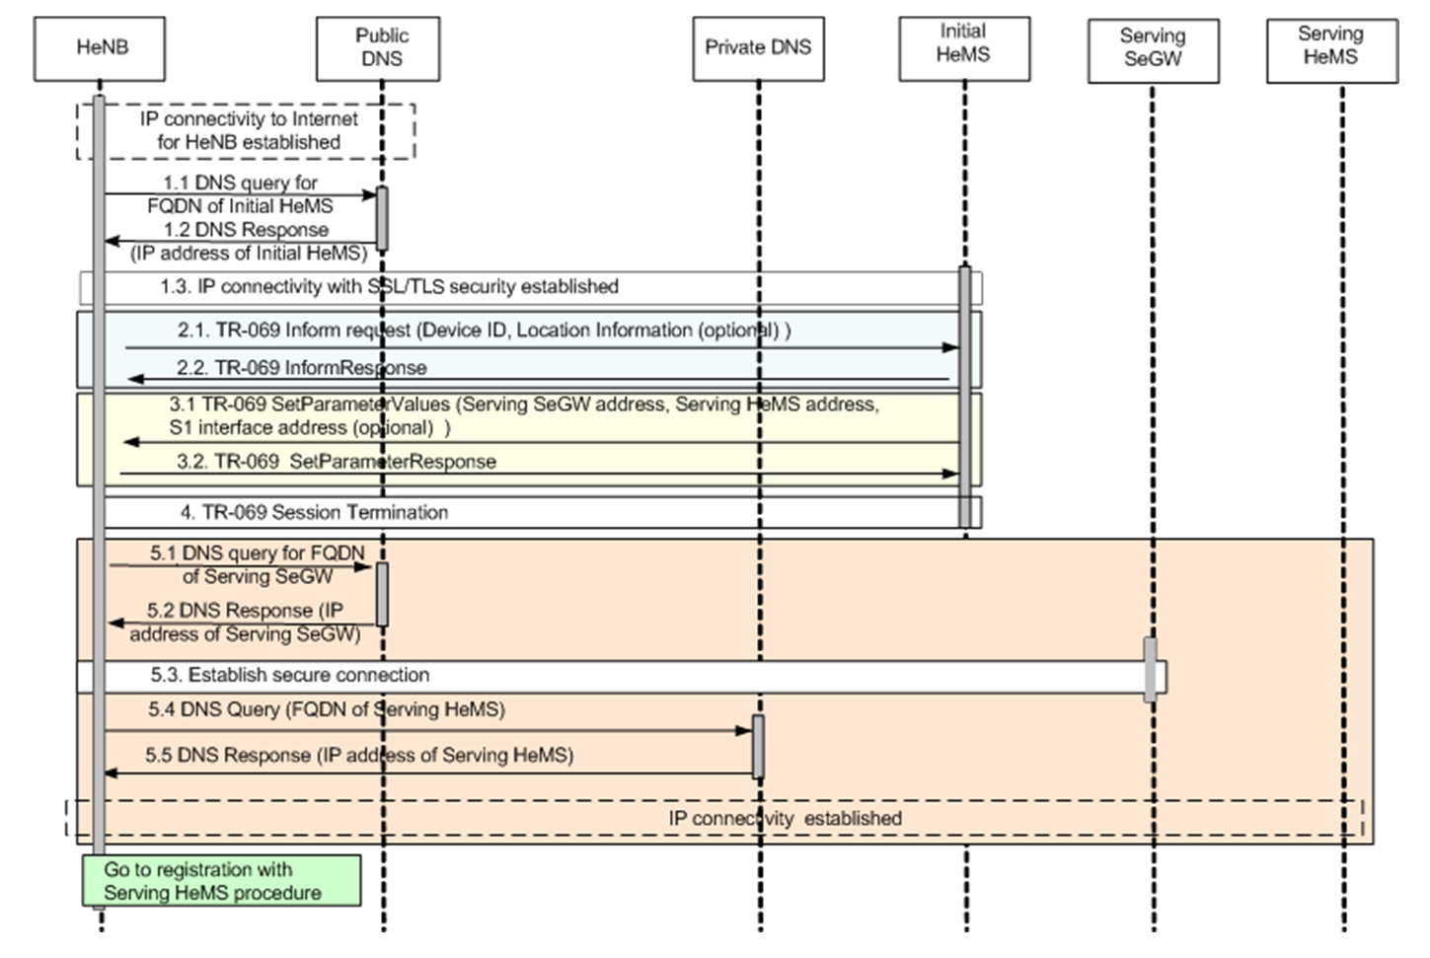
Figure ‎5-1 Serving HeMS Discovery via Initial HeMS accessible on the public internet
As a pre-condition, the HeNB establishes IP connectivity to the Internet when it is initially powered up.
1. In steps 1.1-1.3 HeNB establish IP connectivity with the Intial HeMS using SSL/TLS security. The HeNB must have a reference to the IP address of the Initial HeMS pre-programmed. The HeNB performs DNS query to a public DNS for the IP address corresponding to the FQDN of the Initial HeMS if needed.
Steps 2 to 4 are identical to steps 2 to 4 in the procedure for Serving HeMS discovery via Initial HeMS accessible inside operator’s private secure network domain (Section Error: Reference source not found). Steps 5.1 to 5.5 are identical to steps 6.1 to 6.5 in the procedure for Serving HeMS discovery via Initial HeMS accessible inside operator’s private secure network domain (Section Error: Reference source not found).
Next, the HeNB performs registration with the Serving HeMS (section Error: Reference source not found)

End of modifications

