3GPP TSG-SA5 (Telecom Management) S5-101502
Meeting SA5#71, 10– 14 May 2010, Montreal, Canada revision of S5-101497

CR-Form-v9.6
CHANGE REQUEST
 | 32.505 | CR | 0010 |  rev | - |  Current version: | 9.1.0 | 
For HELP on using this form look at the pop-up text over the  symbols. Comprehensive instructions on how to use this form can be found at http://www.3gpp.org/specs/CR.htm.

Proposed change affects:  | UICC apps |  | ME |  | Radio Access Network | X | Core Network

Title:  | Alignment of XML with TS 32.502 for ARCF
Source to WG:  | Nokia Siemens Networks
Source to TSG:  | SA5
Work item code:  | OAM9 |  |  |  |  |  |  | Date:  |  | 14/05/2010
Category:  | B |  |  |  |  |  |  | Release:  |  | Rel-9
 | Use one of the following categories:  F (correction)  A (corresponds to a correction in an earlier release)  B (addition of feature),  C (functional modification of feature)  D (editorial modification)  Detailed explanations of the above categories can  be found in 3GPP TR 21.900. |  |  |  |  |  |  |  | Use one of the following releases:  R99 (Release 1999)  Rel-4 (Release 4)  Rel-5 (Release 5)  Rel-6 (Release 6)  Rel-7 (Release 7)  Rel-8 (Release 8)  Rel-9 (Release 9)  Rel-10 (Release 10)
Reason for change:  |  | XML definitions do net yet support definitions for ARCF.
Summary of change:  |  | XML definitions for ARCF added.
Consequences if   not approved: |  | No XML support for ARCF
Clauses affected:  |  | 4.1, 4.2, 4.3, 4.4, new clauses 4.5, 4.6
 |  | Y | N
Other specs  |  |  | X | Other core specifications 
affected: |  |  | X | Test specifications
 |  |  | X | O&M Specifications
Other comments: 

1st Modifications

4.1 Self Configuration notifications XML definition structure
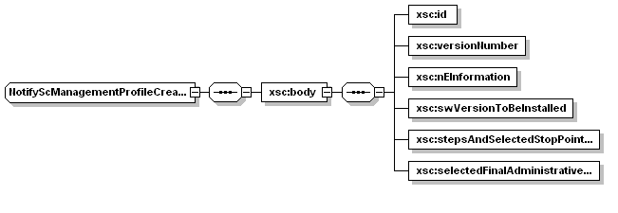
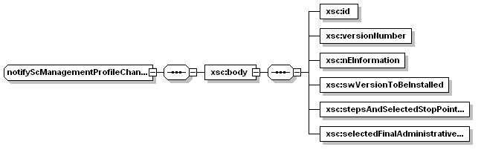
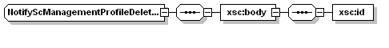
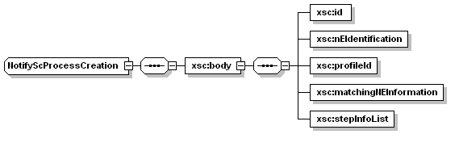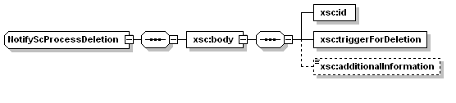
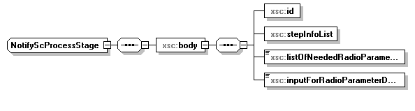
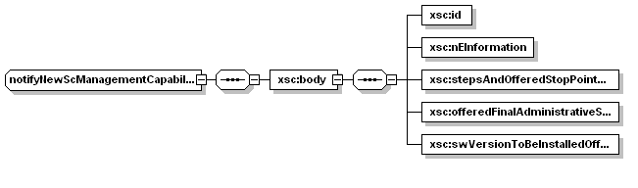

4.2 Self Configuration IRP XML Schema for notifications (file name “scIRPNotif.xsd”)
<?xml version="1.0" encoding="UTF-8"?>
<!--
3GPP TS 32.505 SCIRP Notification XML Schema
sCIRPNotif.xsd
-->
<schema targetNamespace="http://www.3gpp.org/ftp/specs/archive/32_series/32.505#scnIRPNotif" xmlns:xsc="http://www.3gpp.org/ftp/specs/archive/32_series/32.505#scnIRPNotif" xmlns:swm="http://www.3gpp.org/ftp/specs/archive/32_series/32.535#swManagementIRPNotif" xmlns:xe="http://www.3gpp.org/ftp/specs/archive/32_series/32.305#notification" xmlns="http://www.w3.org/2001/XMLSchema" elementFormDefault="qualified" attributeFormDefault="unqualified">
<import namespace="xe:Notification" schemaLocation="notification.xsd"/>
<simpleType name="NeededRadioParameter">
<restriction base="string"/>
</simpleType>
<simpleType name="SingleInputForRadioParameterDetermination">
<restriction base="string"/>
</simpleType>
<complexType name="NotifyScManagementProfileCreation">
<complexContent>
<extension base="xe:Notification">
<sequence>
<element name="body">
<complexType>
<sequence>
<element name="id" type="swm:Id"/>
<element name="versionNumber" type="swm:VersionNumber"/>
<element name="nEInformation" type="swm:NEInformation"/>
<element name="swVersionToBeInstalled" type="swm:SwVersionToBeInstalledConditional"/>
<element name="stepsAndSelectedStopPointList" type="swm:StepsAndSelectedStopPointList"/>
<element name="selectedFinalAdministrativeState" type="swm:FinalAdministrativeStateValue"/>
</sequence>
</complexType>
</element>
</sequence>
</extension>
</complexContent>
</complexType>
<complexType name="NotifyScManagementProfileDeletion">
<complexContent>
<extension base="xe:Notification">
<sequence>
<element name="body">
<complexType>
<sequence>
<element name="id" type="swm:Id"/>
</sequence>
</complexType>
</element>
</sequence>
</extension>
</complexContent>
</complexType>
<complexType name="NotifyScProcessCreation">
<complexContent>
<extension base="xe:Notification">
<sequence>
<element name="body">
<complexType>
<sequence>
<element name="id" type="swm:Id"/>
<element name="nEIdentification" type="swm:Id"/>
<element name="profileId" type="swm:ProfileId"/>
<element name="matchingNEInformation" type="swm:NEInformation"/>
<element name="stepInfoList" type="swm:StepInfoList"/>
</sequence>
</complexType>
</element>
</sequence>
</extension>
</complexContent>
</complexType>
<complexType name="NotifyScProcessStage">
<complexContent>
<extension base="xe:Notification">
<sequence>
<element name="body">
<complexType>
<sequence>
<element name="id" type="swm:Id"/>
<element name="stepInfoList" type="swm:StepInfoList"/>
<element name="listOfNeededRadioParameters" type="xsc:NeededRadioParameter"/>
<element name="inputForRadioParameterDetermination" type="xsc:SingleInputForRadioParameterDetermination"/>
</sequence>
</complexType>
</element>
</sequence>
</extension>
</complexContent>
</complexType>
<complexType name="NotifyScProcessDeletion">
<complexContent>
<extension base="xe:Notification">
<sequence>
<element name="body">
<complexType>
<sequence>
<element name="id" type="swm:Id"/>
<element name="triggerForDeletion" type="swm:TriggerForDeletion"/>
<element name="additionalInformation" type="string" minOccurs="0"/>
</sequence>
</complexType>
</element>
</sequence>
</extension>
</complexContent>
</complexType>
<complexType name="notifyNewScManagementCapabilityAvailability">
<complexContent>
<extension base="xe:Notification">
<sequence>
<element name="body">
<complexType>
<sequence>
<element name="id" type="swm:Id"/>
<element name="nEInformation" type="swm:NEInformation"/>
<element name="stepsAndOfferedStopPointList" type="swm:StepsAndOfferedStopPointList"/>
<element name="offeredFinalAdministrativeStateInformation" type="swm:OfferedFinalAdministrativeStateInformation"/>
<element name="swVersionToBeInstalledOfferList" type="swm:swVersionToBeInstalledOfferList"/>
</sequence>
</complexType>
</element>
</sequence>
</extension>
</complexContent>
</complexType>
<complexType name="notifyScManagementProfileChange">
<complexContent>
<extension base="xe:Notification">
<sequence>
<element name="body">
<complexType>
<sequence>
<element name="id" type="swm:Id"/>
<element name="versionNumber" type="swm:VersionNumber"/>
<element name="nEInformation" type="swm:NEInformation"/>
<element name="swVersionToBeInstalled" type="swm:SwVersionToBeInstalledConditional"/>
<element name="stepsAndSelectedStopPointList" type="swm:StepsAndSelectedStopPointList"/>
<element name="selectedFinalAdministrativeState" type="swm:FinalAdministrativeStateValue"/>
</sequence>
</complexType>
</element>
</sequence>
</extension>
</complexContent>
</complexType>
<element name="notifyScManagementProfileCreation" type="swm:NotifyScManagementProfileCreation"/>
<element name="notifyScManagementProfileDeletion" type="swm:NotifyScManagementProfileDeletion"/>
<element name="notifyScManagementProcessCreation" type="swm:NotifyScManagementProcessCreation"/>
<element name="notifyScProcessStage" type="swm:NotifyScProcessStage"/>
<element name="notifyScManagementProcessDeletion" type="swm:NotifyScManagementProcessDeletion"/>
<element name="notifyNewScManagementCapabilityAvailability" type="swm:notifyNewScManagementCapabilityAvailability"/>
<element name="notifyScManagementProfileChange" type="swm:NotifyScManagementProfileChange"/>
</schema>

Next modifications

4.3 Self Configuration XML Schema for IOCs (file name “scIRPIOCs.xsd”)
<?xml version="1.0" encoding="UTF-8"?>
<!--
3GPP TS 32.505 Self Configuration IRP IOC XML Schema
scIRPIOCs.xsd
-->
<schema xmlns="http://www.w3.org/2001/XMLSchema" xmlns:xsci="http://www.3gpp.org/ftp/specs/archive/32_series/32.505#scIRPIOCs"
xmlns:xn="http://www.3gpp.org/ftp/specs/archive/32_series/32.535#swManagementIRPIOCs" xmlns:ns1="http://www.3gpp.org/ftp/specs/archive/32_series/32.535#swManagementIRPIOCs " targetNamespace="http://www.3gpp.org/ftp/specs/archive/32_series/32.505#scIRPIOCs" elementFormDefault="qualified" attributeFormDefault="unqualified">
<import namespace="http://www.3gpp.org/ftp/specs/archive/32_series/32.535#swManagementIRPIOCs " schemaLocation=" swManagementIRPIOCs.xsd"/>
<simpleType name="id">
<restriction/>
</simpleType>
<simpleType name="neInformation">
<restriction/>
</simpleType>
<simpleType name="radioParameterName">
<restriction base="string"/>
</simpleType>
<simpleType name="radioParameterValue">
<restriction/>
</simpleType>
<simpleType name="FileLocation">
<restriction base="string"/>
</simpleType>
<simpleType name="validationErrorInfo">
<restriction base="string">
<enumeration value="ParameterNotSupported"/>
<enumeration value="InvalidParameter"/>
<enumeration value="ValueNotSupported"/>
<enumeration value="MissingParameterValue"/>
<enumeration value="ConflictingParamterValue"/>
<enumeration value="SemanticsError"/>
<enumeration value="OtherError "/>
</restriction>
</simpleType>
<simpleType name="VersionNumber">
<restriction base="unsignedShort"/>
</simpleType>
<complexType name="ProfileId">
<sequence>
<element name="id" type="xsci:Id"/>
<element name="versionNumber" type="xsci:VersionNumber"/>
</sequence>
</complexType>
<simpleType name="FinalAdministrativeStateValue">
<restriction base="string">
<enumeration value="LOCKED"/>
<enumeration value="UNLOCKED"/>
<enumeration value="DETERMINED_BY_CONFIGURATION_DATA"/>
</restriction>
</simpleType>
<complexType name="listOfNeededRadioParameters ">
<sequence>
<element name="radioParameterName" type="xsci:radioParameterName"/>
<element name="radioParameterValue" type="xsci:radioParameterValue"/>
</sequence>
</complexType>
<complexType name="valuesOfNeededRadioParameter">
<sequence>
<element name="listOfNeededRadioParameters" type="xsci:listOfNeededRadioParameters"/>
</sequence>
</complexType>
<complexType name="OfferedFinalAdministrativeStateInformation">
<sequence>
<element name="OfferedFinalAdministrativeStateValue" type="xsci:FinalAdministrativeStateValue"/>
</sequence>
</complexType>
<complexType name="StepsAndOfferedStopPointListEntry">
<sequence>
<element name="nameOfStep" type="xsci:NameOfStep"/>
<element name="sequenceNumberInProcess" type="xsci:SequenceNumberInProcess"/>
<element name="stopPointCanBeSetBeforeThisStep" type="xsci:StopPointCanBeSetBeforeThisStep"/>
</sequence>
</complexType>
<complexType name="StepsAndOfferedStopPointList">
<sequence>
<element name="stepsAndOfferedStopPointListEntry" type="xsci:StepsAndOfferedStopPointListEntry" maxOccurs="unbounded"/>
</sequence>
</complexType>
<simpleType name="StopPointCanBeSetBeforeThisStep">
<restriction base="boolean"/>
</simpleType>
<complexType name="StepsAndSelectedStopPointListEntry">
<sequence>
<element name="nameOfStep" type="xsci:NameOfStep"/>
<element name="sequenceNumberInProcess" type="xsci:SequenceNumberInProcess"/>
<element name="stopPointSetIndication" type="xsci:StopPointSetIndication"/>
</sequence>
</complexType>
<complexType name="StepsAndSelectedStopPointList">
<sequence>
<element name="stepsAndSelectedStopPointListEntry" type="xsci:StepsAndSelectedStopPointListEntry" maxOccurs="unbounded"/>
</sequence>
</complexType>
<simpleType name="StopPointSetIndication">
<restriction base="string">
<enumeration value="STOP_POINT_IS_SET_BEFORE_THIS_STEP"/>
<enumeration value="STOP_POINT_IS_NOT_SET"/>
</restriction>
</simpleType>
<simpleType name="SequenceNumberInProcess">
<restriction base="unsignedShort"/>
</simpleType>
<simpleType name="NameOfStep">
<restriction base="string">
<enumeration value="SW_DOWNLOAD"/>
<enumeration value="SW_INSTALLATION"/>
<enumeration value="SW_ACTIVATION"/>
<enumeration value="PREPARE_BASIC_CONFIGURATION_AND_OAMLINK"/>
<enumeration value="RETRIEVE_CONFIGURATION_DATA"/>
<enumeration value="SETUP_PRECONFIGURED_SIGNALLING_LINKS"/>
<enumeration value="SET_FINAL_STATE_OF_NE "/>
</restriction>
</simpleType>
<simpleType name="StepProgress">
<restriction base="string">
<enumeration value="NOT_YET_STARTED"/>
<enumeration value="RUNNING"/>
<enumeration value="COMPLETED"/>
<enumeration value="AWAITING_RESUME"/>
<enumeration value="FAILURE"/>
<enumeration value="TERMINATED"/>
</restriction>
</simpleType>
<complexType name="StepInfoListEntry">
<sequence>
<element name="nameOfStep" type="xsci:NameOfStep"/>
<element name="sequenceNumberInProcess" type="xsci:SequenceNumberInProcess"/>
<element name="stopPointSetIndication" type="xsci:StopPointSetIndication"/>
<element name="stepProgress" type="xsci:StepProgress"/>
</sequence>
</complexType>
<complexType name="StepInfoList">
<sequence>
<element name="stepInfoListEntry" type="xsci:StepInfoListEntry" maxOccurs="unbounded"/>
</sequence>
</complexType>
<complexType name="scManagementCapabilityIOC">
<sequence>
<element name="id" type="xsci:Id"/>
<element name="neInformation" type="xsci:NEInformation"/>
<element name="stepsAndOfferedStopPointList" type="xsci:StepsAndOfferedStopPointList"/>
<element name="offeredFinalAdministrativeStateInformation" type="xsci:OfferedFinalAdministrativeStateInformation"/>
</sequence>
</complexType>
<complexType name="scManagementProfileIOC">
<sequence>
<element name="id" type="xsci:Id"/>
<element name="versionNumber" type="xsci:VersionNumber"/>
<element name="neInformation" type="xsci:NEInformation"/>
<element name="stepsAndSelectedStopPointList" type="xsci:StepsAndSelectedStopPointList"/>
<element name="selectedFinalAdministrativeState" type="xsci:FinalAdministrativeStateValue"/>
</sequence>
</complexType>
<complexType name="scProcessIOC">
<sequence>
<element name="id" type="xsci:Id"/>
<element name="nEIdentification" type="xsci:NEInformation"/>
<element name="profileId" type="xsci:ProfileId"/>
<element name="stepInfoList" type="xsci:StepInfoList"/>
</sequence>
</complexType>
</schema>
Next modifications

4.4 Self Configuration IRP IOC XML definition structure
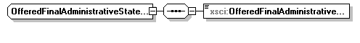
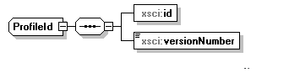
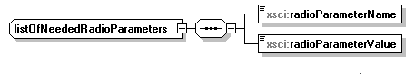
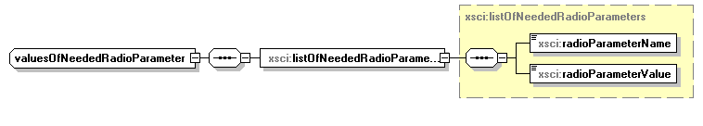

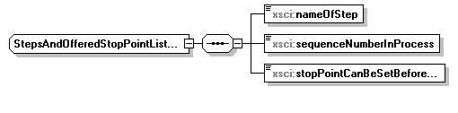
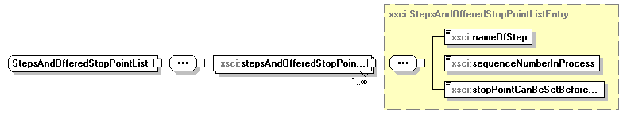
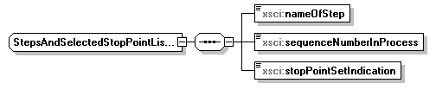
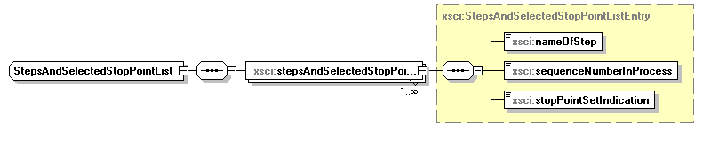
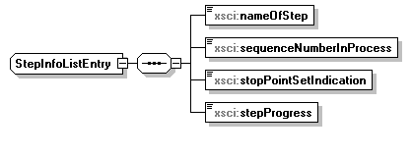
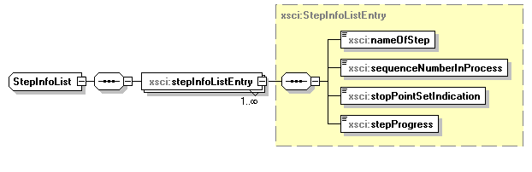
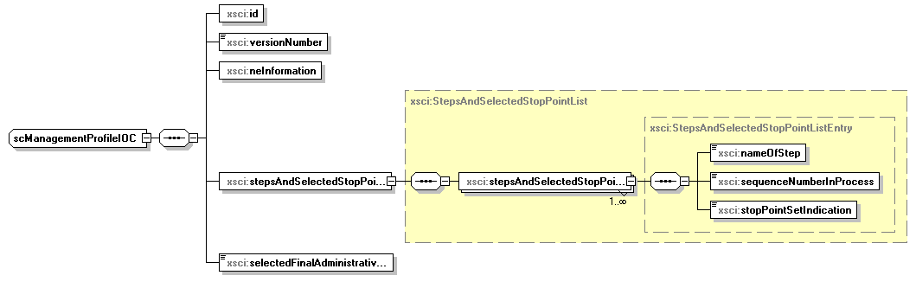
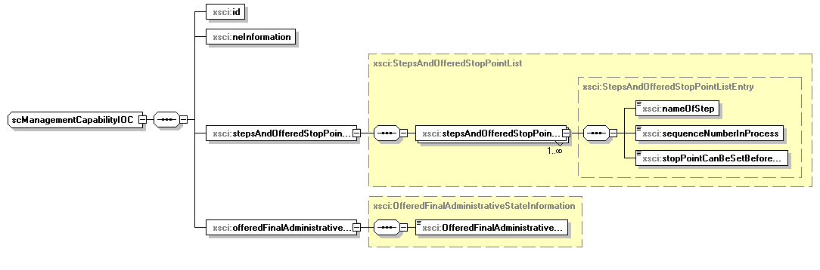

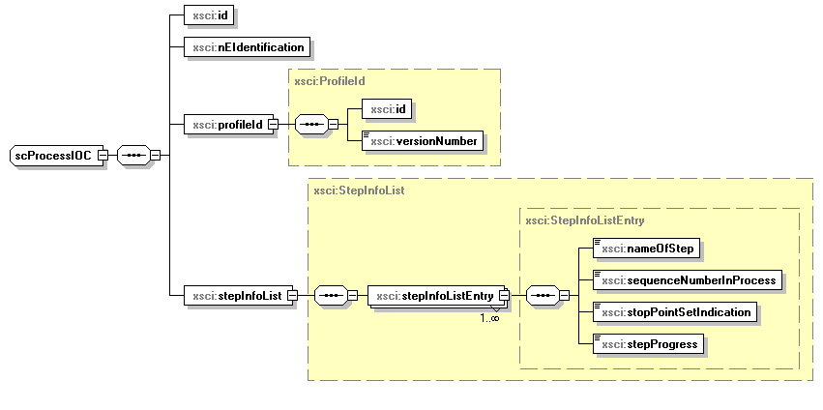

Next modifications: New section

ARCF NRM XML definition structure
Remark: These definitions are to be used only embedded into SOAP operations defined by Self-Configuration IRP SOAP solution set or by Bulk CM IRP or FT IRP during self-configuration,

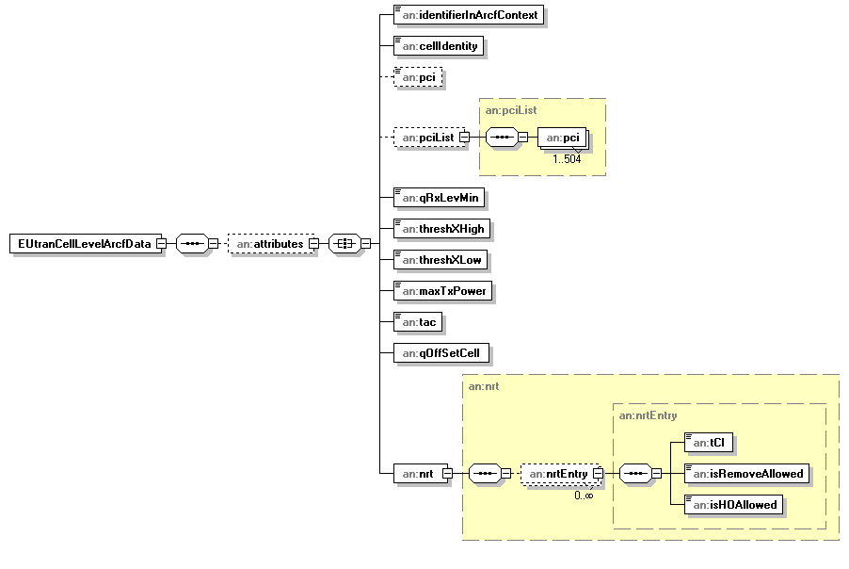

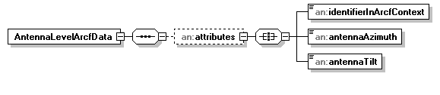

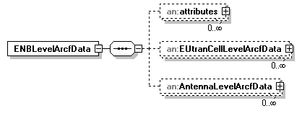

The same definition structure applies for ENBLevelArcfData2, EUtranCellLevelArcfData2 and AntennaLevelArcfData2.

ARCF XML Schemas for IOCs

ARCF XML Schema for operation resumeScProcessWithArcfData and usage of FT IRP (file name “arcfNrm.xsd”)
<?xml version="1.0" encoding="UTF-8"?>
<!--
3GPP TS 32.505 ARCF Network Resource Model IRP
XML schema definition
arcfNrm.xsd
-->
<schema xmlns="http://www.w3.org/2001/XMLSchema" xmlns:xn="http://www.3gpp.org/ftp/specs/archive/32_series/32.625#genericNrm" xmlns:en="http://www.3gpp.org/ftp/specs/archive/32_series/32.765#eutranNrm" xmlns:an="http://www.3gpp.org/ftp/specs/archive/32_series/32.505#arcfNrm" targetNamespace="http://www.3gpp.org/ftp/specs/archive/32_series/32.505#arcfNrm" elementFormDefault="qualified">
<import namespace="http://www.3gpp.org/ftp/specs/archive/32_series/32.625#genericNrm"/>
<import namespace="http://www.3gpp.org/ftp/specs/archive/32_series/32.765#eutranNrm"/>
<simpleType name="identifierInArcfContext">
<restriction base="string"/>
</simpleType>
<simpleType name="cellIdentity">
<restriction base="en:cellIdentity"/>
</simpleType>
<simpleType name="pci">
<restriction base="en:pci">
<maxInclusive value="503"/>
<!-- Minimum value is 0, maximum value is 3x167+2=503 -->
</restriction>
</simpleType>
<complexType name="pciList">
<sequence>
<element name="pci" type="en:Pci" maxOccurs="504"/>
</sequence>
</complexType>
<simpleType name="qRxLevMin">
<restriction base="short">
<minInclusive value="-70"/>
<maxInclusive value="-22"/>
</restriction>
</simpleType>
<simpleType name="threshXHigh">
<restriction base="short"/>
</simpleType>
<simpleType name="threshXLow">
<restriction base="short"/>
</simpleType>
<simpleType name="maxTxPower">
<restriction base="short"/>
</simpleType>
<simpleType name="tac">
<restriction base="short"/>
</simpleType>
<simpleType name="antennaAzimuth">
<restriction base="short"/>
</simpleType>
<simpleType name="antennaTilt">
<restriction base="short"/>
</simpleType>
<simpleType name="qOffSetCell">
<restriction base="string">
<enumeration value="dB-24"/>
<enumeration value="dB-22"/>
<enumeration value="dB-20"/>
<enumeration value="dB-18"/>
<enumeration value="dB-16"/>
<enumeration value="dB-14"/>
<enumeration value="dB-12"/>
<enumeration value="dB-10"/>
<enumeration value="dB-8"/>
<enumeration value="dB-6"/>
<enumeration value="dB-5"/>
<enumeration value="dB-4"/>
<enumeration value="dB-3"/>
<enumeration value="dB-2"/>
<enumeration value="dB-1"/>
<enumeration value="dB-0"/>
<enumeration value="dB1"/>
<enumeration value="dB2"/>
<enumeration value="dB3"/>
<enumeration value="dB4"/>
<enumeration value="dB5"/>
<enumeration value="dB6"/>
<enumeration value="dB8"/>
<enumeration value="dB10"/>
<enumeration value="dB12"/>
<enumeration value="dB14"/>
<enumeration value="dB16"/>
<enumeration value="dB18"/>
<enumeration value="dB20"/>
<enumeration value="dB22"/>
<enumeration value="dB24"/>
</restriction>
</simpleType>
<complexType name="nrtEntry">
<sequence>
<element name="tCI" type="long"/>
<element name="isRemoveAllowed" type="boolean"/>
<element name="isHOAllowed" type="boolean"/>
</sequence>
</complexType>
<complexType name="nrt">
<sequence>
<element name="nrtEntry" type="an:nrtEntry" minOccurs="0" maxOccurs="unbounded"/>
</sequence>
</complexType>
<element name="EUtranCellLevelArcfData">
<complexType>
<complexContent>
<extension base="xn:NrmClass">
<sequence>
<element name="attributes" minOccurs="0">
<complexType>
<all>
<element name="identifierInArcfContext" type="an:identifierInArcfContext"/>
<element name="cellIdentity" type="an:cellIdentity"/>
<element name="pci" type="an:pci" minOccurs="0"/>
<element name="pciList" type="an:pciList" minOccurs="0"/>
<element name="qRxLevMin" type="an:qRxLevMin"/>
<element name="threshXHigh" type="an:threshXHigh"/>
<element name="threshXLow" type="an:threshXLow"/>
<element name="maxTxPower" type="an:maxTxPower"/>
<element name="tac" type="an:tac"/>
<element name="qOffSetCell" type="an:qOffSetCell"/>
<element name="nrt" type="an:nrt"/>
</all>
</complexType>
</element>
</sequence>
</extension>
</complexContent>
</complexType>
</element>
<element name="AntennaLevelArcfData">
<complexType>
<complexContent>
<extension base="xn:NrmClass">
<sequence>
<element name="attributes" minOccurs="0">
<complexType>
<all>
<element name="identifierInArcfContext" type="an:identifierInArcfContext"/>
<element name="antennaAzimuth" type="an:antennaAzimuth"/>
<element name="antennaTilt" type="an:antennaTilt"/>
</all>
</complexType>
</element>
</sequence>
</extension>
</complexContent>
</complexType>
</element>
<element name="ENBLevelArcfData">
<complexType>
<complexContent>
<extension base="xn:NrmClass">
<sequence>
<element name="attributes" minOccurs="0" maxOccurs="unbounded">
<complexType>
<all>
<element name="identifierInArcfContext" type="an:identifierInArcfContext"/>
</all>
</complexType>
</element>
<element name="EUtranCellLevelArcfData" minOccurs="0" maxOccurs="unbounded">
<complexType>
<complexContent>
<extension base="xn:NrmClass">
<sequence>
<element name="attributes" minOccurs="0">
<complexType>
<all>
<element name="identifierInArcfContext" type="an:identifierInArcfContext"/>
<element name="cellIdentity" type="an:cellIdentity"/>
<element name="pci" type="an:pci" minOccurs="0"/>
<element name="pciList" type="an:pciList" minOccurs="0"/>
<element name="qRxLevMin" type="an:qRxLevMin"/>
<element name="threshXHigh" type="an:threshXHigh"/>
<element name="threshXLow" type="an:threshXLow"/>
<element name="maxTxPower" type="an:maxTxPower"/>
<element name="tac" type="an:tac"/>
<element name="qOffSetCell" type="an:qOffSetCell"/>
<element name="nrt" type="an:nrt"/>
</all>
</complexType>
</element>
</sequence>
</extension>
</complexContent>
</complexType>
</element>
<element name="AntennaLevelArcfData" minOccurs="0" maxOccurs="unbounded">
<complexType>
<complexContent>
<extension base="xn:NrmClass">
<sequence>
<element name="attributes" minOccurs="0">
<complexType>
<all>
<element name="identifierInArcfContext" type="an:identifierInArcfContext"/>
<element name="antennaAzimuth" type="an:antennaAzimuth"/>
<element name="antennaTilt" type="an:antennaTilt"/>
</all>
</complexType>
</element>
</sequence>
</extension>
</complexContent>
</complexType>
</element>
</sequence>
</extension>
</complexContent>
</complexType>
</element>
</schema>

ARCF XML Schema for bulkCMIRP usage (file name “arcfNrm2.xsd”)
Not available in this release.

End of modifications

