3GPP TSG-SA5 Meeting #144-e S5-224102rev1

e-meeting, 27 June - 1 July 2022

Source: Huawei, Deutsche Telekom

Title: pCR TR 28.908 Add use case on AI/ML update

Document for: Approval
Agenda Item: 6.7.5.4

1 Decision/action requested
In this box give a very clear / short /concise statement of what is wanted.

References
[1] SP-211443 New Study on AI/ ML management
[2] 3GPP TR 28.908-020 Management and orchestration; Study on Artificial Intelligence/Machine Learning (AI/ML) management
[3] 3GPP TS 28.105 Management and orchestration; Artificial Intelligence / Machine Learning (AI/ML) management

3 Rationale
The approved new SI [1] proposed to study the AI/ML management capabilities and management services to support/coordinate AI/ML in 5GS (3GPP management system, 5GC and NG-RAN). During the running period, the previously deployed AI/ML entity may no longer be applicable to the current network due to the changed network state. It is necessary to update the AI/ML entity (i.e., replace the running model with a new one) to ensure the performance of inference and analysis. This contribution proposes to add a use case on AI/ML update.

4 Detailed proposal
It is proposed to add the following chapter in TR 28.908 [2].
1st modified section

5.X AI/ML update management

5.X.1 Description
Due to the complexity and time-varying nature of network, the AI/ML entities previously deployed may no longer be applicable to the current network after running for a period of time. Typically, the performance of a trained model may degrades over time. The AI/ML entitie needs to be updated timely to ensure the performance of inference and analysis. The AI/ML entities updating can be triggered by the AI/ML MnS consumer or initiated by the AI/ML MnS producer.

5.X.2 Use cases

5.X.2.1 AI/ML entities updating initiated by consumer
According to the definition of AIMLEntity <<dataType>> in TS 28.105[3]，each AI/ML entity corresponds to a version number (i.e., aIMLEntityVersion). Assuming that there is already an AI/ML entity (e.g., version number is 1) running in an AI/ML enabled function. After running for a period of time, the AI/ML entity (version number is 1) may need to be updated to a new version (e.g., version number is 2).
The AI/ML entities updating may be triggered by the AI/ML MnS consumer. For one scenario, the AI/ML MnS consumer may request AI/ML training to improve the model performance. The training request can be periodic or based on the result of performance evaluation. After the retraining is finished, a new version AI/ML entity is available and reported to the AI/ML MnS consumer. Then the consumer may compare the performance of two availablemodels (i.e., the new model and the old model) and decide to request model updating if the new version model performs better than the old one. For another scenario, the AI/ML MnS consumer may detect the severe performance degradation when monitoring the AI/ML entity in inference phase. In that case, the consumer can request the AI/ML entity to be updated immediately with a new version which has better performance.
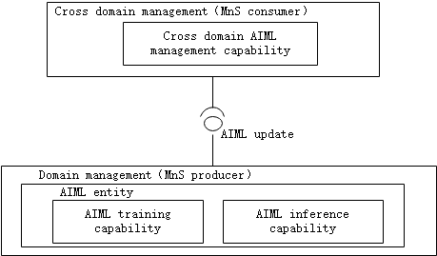

5.X.2.2 AI/ML entities updating initiated by producer
The AI/ML entity updating may be initiated by the AI/ML MnS producer. In order to keep the model at a requested level, the AI/ML MnS producer may periodically conduct AI/ML retraining with new available training data. Once a new version AI/ML entity is obtained after the training is finished, it can be used to update the current AI/ML entity with this new version. In another condition, the AI/ML MnS producer may initiate AI/ML entity updating based on the running model performance. For example, if the performance of the running AI/ML model is decreased under a predefined threshold, the AI/ML MnS producer may decide to start ratraining and then update the AI/ML entity to a new version which performs better.
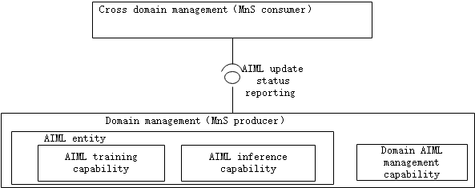

5.X.3 Potential requirements
Requirement label | Description | Related use case(s)
REQ-AIML_UPD-CON-1 | The AI/ML MnS producer should have a capability to allow the authorized consumer to request AI/ML entities updating. | AI/ML entities updating initiated by consumer (clause 5.X.2.1)
REQ-AIML_UPD-CON-2 | The AI/ML MnS producer should have a capability to allow the authorized consumer to specify the AI/ML entities version to be updated. | AI/ML entities updating initiated by consumer (clause 5.X.2.1)
REQ-AIML_UPD-CON-3 | The AI/ML MnS producer should have a capability to update the AI/ML entities and inform an authorized consumer about the update status. | AI/ML entities updating initiated by producer (clause 5.X.2.2)

5.X.4 Possible solutions
TBD

End of modified section

