3GPP TSG-SA5 Meeting #143-e S5-223625

e-meeting, 09 - 17 May 2022

Source: Ericsson, Deutsche Telekom, Telefónica

Title: Add procedure for consumption of exposed MnS after service order completed

Document for: Approval
Agenda Item: 6.5.22.3

1 Decision/action requested
The group is asked to agree the detailed proposal.

2 References
[1] 3GPP TS 28.533 Management and orchestration; Architecture framework
[2] 3GPP TS 23.501 System architecture for the 5G System (5GS)
[3] 3GPP TS 23.502 Procedures for the 5G System (5GS)
[4] 3GPP TS 23.222 Common API Framework for 3GPP Northbound APIs
[5] 3GPP TS 23.434 Service Enabler Architecture Layer for Verticals (SEAL); Functional architecture and information flows
[6] 3GPP TS 33.122 Security aspects of Common API Framework (CAPIF) for 3GPP northbound APIs
[7] 3GPP TS 33.501 Security architecture and procedures for 5G System
[8] 3GPP TS 28.530 Management and orchestration; Concepts, use cases and requirements

3 Rationale
The procedures described in clause 4.1.4 show the interaction between an NSC and an NSP when NSC orders a product/service and the NSP accepts and completes the order. After the product order and service order have been completed, the ordered service may be consumed by the NSC using the CAPIF (Common API Framework).
There is no description in the study what happens after the service order is completed nor how CAPIF may be used.
It is proposed to add a concept description in clause 4 and a solution description in clause 7.

4 Detailed proposal

1st Change

2 References
The following documents contain provisions which, through reference in this text, constitute provisions of the present document.
- References are either specific (identified by date of publication, edition number, version number, etc.) or non-specific.
- For a specific reference, subsequent revisions do not apply.
- For a non-specific reference, the latest version applies. In the case of a reference to a 3GPP document (including a GSM document), a non-specific reference implicitly refers to the latest version of that document in the same Release as the present document.
[1] 3GPP TR 21.905: "Vocabulary for 3GPP Specifications".
[2] TM Forum TMF622 Product Order API REST Specification
[3] TM Forum TMF641 Service Ordering API
[4] TM Forum TMF652 Resource Order Management API
[5] 3GPP TS 28.531: "Management and orchestration; Concepts, use cases and requirements"
[6] 3GPP TS 28.202: "Charging management; Network slice management charging in the 5G System (5GS); Stage 2"
[7] 3GPP TR23.700-99 “Study on Network Slice Capability Exposure for Application Layer Enablement (NSCALE)”

[8] 3GPP TS23.434 “Service Enabler Architecture Layer for Verticals (SEAL); Functional architecture and information flows.”
[9] 3GPP TS 28.541: "Management and orchestration; 5G Network Resource Model (NRM); Stage 2 and stage 3"
[10] 3GPP TS 28.537: "Management and orchestration; Management capabilities"
[11] 3GPP TS 28.533: "Management and orchestration; Architecture framework"
[12] TM Forum TMF633 Service Catalogue Management API
[13] TM Forum TMF620 Product Catalogue Management API
[14] 3GPP TS 23.222: "Functional architecture and information flows to support Common API Framework for 3GPP Northbound APIs; Stage 2"
[15] 3GPP TS 28.532: "Management and orchestration; Generic Management Service"
[16] 3GPP TS 28.623: "Telecommunication management; Generic Network Resource Model (NRM) Integration Reference Point (IRP); Solution Set (SS) definitions"
[17] 3GPP TS 28.622: " Telecommunication management; Generic Network Resource Model (NRM) Integration Reference Point (IRP) Information Service (IS)"
[18] 3GPP TS 28.201: "Charging management; Network slice performance and analytics charging in the 5G System (5GS); Stage 2"
[x] CAMARA: https://github.com/camaraproject

2nd Change

4.1.4.X Procedure for consumption of exposed MnS after service order is completed
The procedure for consumption of an exposed MnS after the product and service order are completed is shown in figure 4.1.4.X.1. The MnS is produced by the MnS producer located in the OSS of the NSP.
An MnS may already be produced before CAPIF 1 service is requested. The CAPIF 2/2e service is a filtered, enriched and/or converted version of the MnS. The transformation, filtering, enrichment, or conversion of MnS APIs into service APIs is optional. The details of how this transformation, filtering and/or enrichment is to be done is out of scope of SA5.
Editor’s Note: There exist initiatives such as CAMARA [x] which are working in this translation.
Filtering is removing of information elements (attributes and classes), enrichment is adding information elements from other MnS or other sources outside OAM, converting is changing information elements through for example combining or mapping information elements. The CAPIF 2/2e service is provided by the API_Provider_domain_function and consumed by the NSC_Application. The API_Provider_domain_function uses the MnS(s) produced to provide the CAPIF 2/2e service.

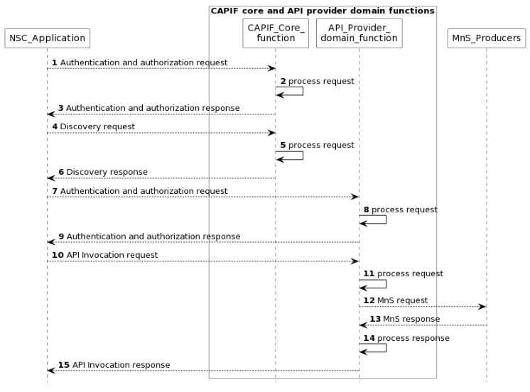
Figure 4.1.4.X.1 Procedure for consumption of exposed MnS after service order is completed
NOTE1: For simplicity reasons the CAPIF Core function and API Provider domain function defined in TS 23.222 [14] are combined and any communication between them is also not included.
NOTE2: The procedure is only applicable to “Exposure via CAPIF alternative 1” described in clause 7.9.1.

1) The CAPIF_Core_function receives an authenticating and authorization request from the NSC_Application based on the identity and other information required for authentication and authorization of the NSC_Application.
2) The CAPIF_Core_function processes the authentication and authorization request.
3) The CAPIF_Core_function provides the response with the result of the authentication and authorization to the NSC_Application.
4) The CAPIF_Core_function receives a request for the discovery of service APIs information.
5) The CAPIF_Core_function processes the discovery request.
6) The CAPIF_Core_function provides the appropriate response to the NSC_Application.
7) The API_Provider_domain_function receives an authentication and authorization request from the NSC_Application based on the identity and other information required for authorization of the NSC_Application.
8) The API_Provider_domain_function processes the authorization request.
9) The API_Provider_domain_function provides the response with the result of the authentication and authorization to the NSC_Application
10) The API_Provider_domain_function receives a request for the invocation of the service API(s) from the NSC_Application.
11) The API_Provider_domain_function processes (and optionally may enrich and/or convert) the invocation request.
12) The MnS_Producers receive requests from the API_Provider_domain_function for MnS.
13) The MnS_Producers provide the appropriate responses to the API_Provider_domain_function.
14) The API_Provider_domain_function processes (and optionally may filter, enrich and/or convert) the response from the OSS
15) The API_Provider_domain_function provides the appropriate response to the NSC_Application.
NOTE: Each response in the steps does not always need to trigger the next request.
3rd Change

7.X Potential solution for consumption of exposed MnS after service order completed
This clause describes a solution for the procedure for consumption of exposed MnS after service order completed described which is described in clause 4.1.4.X. For each step in the procedure Table 7.X.1 identifies the following:
- if an interface is:
- Internal to the NSP,
- External between a NSC and NSP,
- None, for internal processes within a function.
- which operation or notification is used by that step, and
- which specification describes the interface (stage 2 and stage 3).

Step | Description in step | Interface | Reference | Description in reference
1 | Authentication and authorization request | Internal | 3GPP TS 23.222[14], clause 6.4.2 | CAPIF-1
2 |  | None | - | -
3 | Authentication and authorization response | Internal | 3GPP TS 23.222[14], clause 6.4.2 | CAPIF 1
4 | Discovery request | Internal | 3GPP TS 23.222[14], clause 6.4.2 | CAPIF-1
5 |  | None | - | -
6 | Discovery response | Internal | 3GPP TS 23.222[14], clause 6.4.2 | CAPIF-1
7 | Authentication and authorization request | Internal | 3GPP TS 23.222[14], clause 6.4.4 | CAPIF-2
8 |  | None
9 | Authentication and authorization response | Internal | 3GPP TS 23.222[14], clause 6.4.4 | CAPIF-2
10 | API invocation request | Internal | 3GPP TS 23.222[14], clause 6.4.4 | CAPIF-2
11 |  | None
12 | MnS request | Internal | 3GPP TS 28.532 | MnS
13 | MnS response | Internal | 3GPP TS 28.532 | MnS
14 |  | None
15 | API invocation response | Internal | 3GPP TS 23.222[14], clause 6.4.4 | CAPIF 2
Table 7.X.1 Solution for consumption of exposed MnS within the operator trusted domain (NSC_Application is inside operator trusted domain)

Step | Description in step | Interface | Reference | Description in reference
1 | Authentication and authgorizationrequest | External | 3GPP TS 23.222[4], clause 6.4.3 | CAPIF-1e
2 |  | None | - | -
3 | Authentication and authorization response | External | 3GPP TS 23.222[4], clause 6.4.3 | CAPIF 1e
4 | Discovery request | External | 3GPP TS 23.222[4], clause 6.4.3 | CAPIF-1e
5 |  | None | - | -
6 | Discovery response | External | 3GPP TS 23.222[4], clause 6.4.3 | CAPIF-1e
7 | Authentication and authorization request | External | 3GPP TS 23.222[14], clause 6.4.5 | CAPIF-2e
8 |  | None
9 | Authentication and authorization response | External | 3GPP TS 23.222[14], clause 6.4.5 | CAPIF-2e
10 | API invocation request | External | 3GPP TS 23.222[4], clause 6.4.5 | CAPIF-2e
11 |  | None
12 | MnS request | Internal | 3GPP TS 28.532 | MnS/
13 | MnS response | Internal | 3GPP TS 28.532 | MnS/
14 |  | None
15 | API invocation response | External | 3GPP TS 23.222[4], clause 6.4.5 | CAPIF 2e
Table 7.X.2 Solution for consumption of exposed MnS outside operator trusted domain (NSC_Application is outside operator trusted domain)

4rd Change

Annex A UML code of the diagrams

A.x Figure: Procedure for consumption of exposed MnS after service order is completed
@startuml
skinparam sequence {
ArrowColor Black
ActorBorderColor Black
ActorBackgroundColor White
ParticipantBorderColor Black
ParticipantBackgroundColor White
LifeLineBorderColor Black
}
skinparam NoteBackgroundColor White
skinparam NoteBorderColor White
skinparam NoteColor White
skinparam shadowing false
hide footbox
autonumber
participant NSC_Application
box "CAPIF core and API provider domain functions" #white
participant "CAPIF_Core_\nfunction" as CAPIF_Core
participant "API_Provider_\ndomain_function" as API_Provider
end box
participant MnS_Producers

NSC_Application --> CAPIF_Core : Authentication and authorization request
CAPIF_Core -> CAPIF_Core: process request
NSC_Application <-- CAPIF_Core : Authentication and authorization response

NSC_Application --> CAPIF_Core : Discovery request
CAPIF_Core -> CAPIF_Core: process request
NSC_Application <-- CAPIF_Core : Discovery response

NSC_Application --> API_Provider : Authentication and authorization request
API_Provider -> API_Provider: process request
NSC_Application <-- API_Provider : Authentication and authorization response

NSC_Application --> API_Provider : API Invocation request
API_Provider -> API_Provider: process request
API_Provider --> MnS_Producers: MnS request
API_Provider <-- MnS_Producers: MnS response
API_Provider -> API_Provider: process response
NSC_Application <-- API_Provider : API Invocation response

@enduml

End of Changes

