3GPP TSG-SA5 Meeting #143-e S5-223622d4

e-meeting, 9 - 17 May 2022

Source: Alibaba group, AsiaInfo

Title: pCR 28.824 Update to solution regarding CAPIF based management capability exposure

Document for: Approval
Agenda Item: 6.5.22

1 Decision/action requested
For approval

2 References
[1] 3GPP TR 28.824 V0.5.0 Study on network slice management capability exposure

3 Rationale
This contribution proposes the enhancement of CAPIF interface considering network slice management capability exposure.

4 Detailed proposal
This contribution proposes to make the following changes in [1].

1st change

7.9 Potential solutions for network slice management capability exposure via CAPIF

7.9.1 Exposure via CAPIF alternative 1
This clause describes a potential solution where network slice management capability is exposed via the Common API Framework for 3GPP Northbound APIs, see TS 23.222 [14].
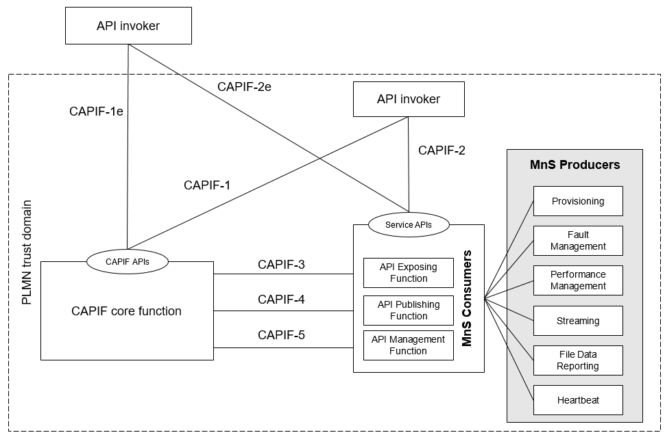
Figure 7.9.1-1: Exposure via CAPIF alternative 1
In this alternative, network slice management capability exposure provides faultMnS, fileDataReportingMnS, heartbeatNtf, perfMnS, provMnS, and streamingDataMnS as specified in in TS 28.532 [15].
Editor’s note: Whether network slice management capability exposure is affected by transforming the management service API to another service API is FFS.

7.9.2 Exposure via CAPIF alternative 2
This clause describes a potential solution where network slice management capability exposure is used in conjunction with a CAPIF core function (see TS 23.222 [14]) to expose management services to MnS consumers.

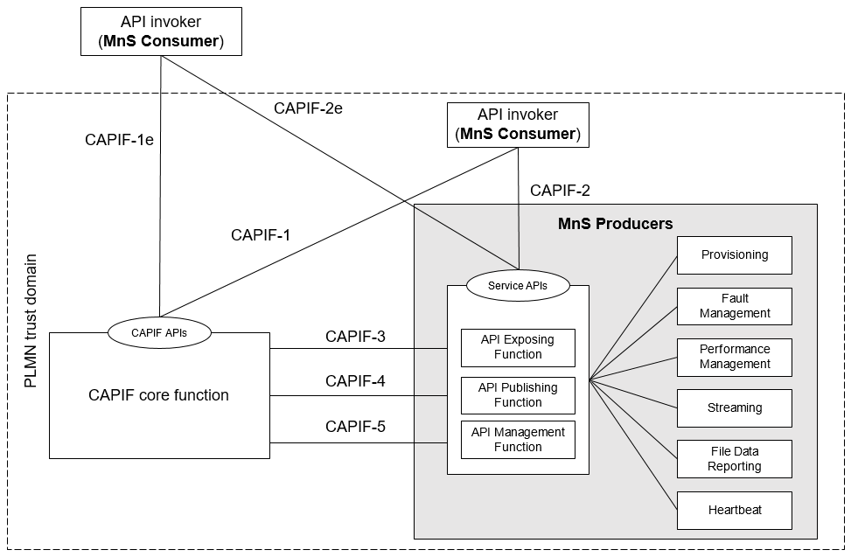
Figure 7.9.2-1: Exposure via CAPIF alternative 2
In this alternative, network slice management capability exposure consumes the interfaces at reference points CAPIF-3, CAPIF-4, and CAPIF-5 as defined in TS 23.222 [14]. It may be necessary to extend CAPIF-3/4/5 as defined in TS 23.222 [14] to support exposure of network slice management services.
Editor’s note: Whether it is necessary to extend CAPIF-3/4/5 for alternative 2 is FFS.
In this alternative, network slice management capability exposure provides the interfaces at reference point CAPIF-2/2e. It may be necessary to extend CAPIF-2/2e as defined in TS 23.222 [14] to support network slice management capability exposure and authentication of MnS consumers.
In this alternative, MnS Consumers utilize the interfaces at reference point CAPIF-1/1e. It may be necessary to extend CAPIF-1/1e as defined in TS 23.222 [14] to support network slice management capability exposure and authorization/authentication of MnS consumers.
Editor’s note: Whether network slice management capability exposure is affected by transforming the management service API to another service API is FFS.
Table7.9.2-1 shows the CAPIF interface and the potential MnS that can be implemented within the interface for alternative 2. In addition, extension of CAPIF interface may be needed to achieve certain functionalities in the context of network slice management capability expousre.
Table 7.9.2-1 Interface description
Interface | Related MnS | Gap analysis
CAPIF 1/1e | - Discovery of MnS(s) from MnS registry using ProvMnS  Specified in TS 28.622 [17], TS 28.623 [16], and TS 28.532 [15] | - The ServiceAPIDescription for CAPIF_Discover_Service_API needs to be extended in the context of network slice management capability exposure. The MnS address within the MnS data can indicate a dedicated producer for exposing exposed MnS after authentication and authorization. The mnsAddress within MnS is specified in table 7.9.2-3.  - Management of MnS consumers includes the management of MnS consumer type and identity. The management of MnS consumer type and identity is for differentiating different access permission for different MnS consumer. The MnS consumer management information is specified in table 7.9.2-4.
CAPIF 2/2e | - Authentication and authorization of MnS consumers is specified in TS 28.533 [11] clause 4.9.  - Service APIs (MnS): faultMnS, fileDataReportingMnS, heartbeatNtf, perfMnS, provMnS, and streamingDataMnS  Specified in in TS 28.532 [15]
CAPIF 3 | - Nchf_ConvergedCharging  Specified in TS 28.201 [18] and TS 28.202 [6] | Editor’s note: Access control for an MnS consumer, which is enforced by MnS producers is FFS.  - Routing information in CAPIF needs to be extended in the context of network slice management capability exposure. A dedicated producer obtains all the routing information of MnS producers, the routing information contains the address of MnS producers that produce the proper MnS (e.g. faultMnS, PerfMnS, etc). Detailed routing information is specified in table 7.9.2-2.
CAPIF 4 | - MnS Registry  Specified in TS 28.622 [17] and TS 28.623 [16]. | - The ServiceAPIDescription for CAPIF_Publish_Service_API needs to be extended in the context of network slice management capability exposure. The MnS address within the MnS data can indicate a dedicated producer for exposing exposed MnS after authentication and authorization. The mnsAddress within MnS is specified in table 7.9.2-3.
CAPIF 5 | - Auditing of the MnS producer is not specified

Editor’s note: Whether the extension of CAPIF-3 regarding routing information is needed for alternative 2 is FFS.
Editor’s note: Whether the extension of CAPIF-4 regarding ServiceAPIDescription is needed for alternative 2 is FFS.

7.9.3 Exposure via CAPIF alternative 3
This clause describes a potential solution where network slice management capability exposure implements a Common API Framework for 3GPP Northbound APIs (see TS 23.222 [14]) to expose management services to MnS consumers.

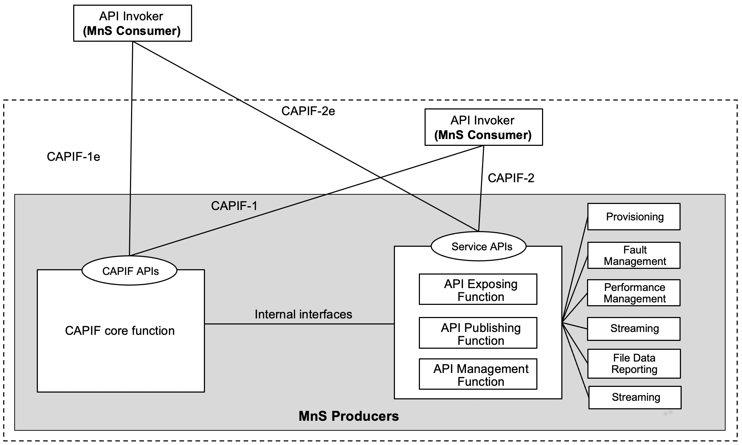
Figure 7.9.3-1: Exposure via CAPIF alternative 3
In this alternative, network slice management capability exposure may internally implement the internal interfaces using reference points CAPIF-3, CAPIF-4, and CAPIF-5 as defined in TS 23.222 [14] or may use non-standardized interfaces.
Editor’s note: Whether it is necessary to extend CAPIF-3/4/5 for alternative 3 is FFS.
In this alternative, network slice management capability exposure provides the interfaces at reference point CAPIF-1/1e. It may be necessary to extend CAPIF-1/1e as defined in TS 23.222 [14] to support authorization/authentication of MnS consumers and discovery of MnS producers.
In this alternative, network slice management capability exposure provides the interfaces at reference point CAPIF-2/2e. It may be necessary to extend CAPIF-2/2e as defined in TS 23.222 [14] to support network slice management capability exposure and authentication of MnS consumers.
Editor’s note: Whether network slice management capability exposure is affected by transforming the management service API to another service API is FFS.
Table7.9.3-1 shows the CAPIF interface and the potential MnS that can be implemented within the interface for alternative 2. In addition, extension of CAPIF interface may be needed to achieve certain functionalities in the context of network slice management capability exposure. Note that in CAPF alternative 3, 4, 5 in alternative 3 are internal interface. However, since external interface may bring impacts on the internal interface. The gap analysis for these interfaces is needed.
Table 7.9.3-1 Interface description
Interface | Related MnS | Gap analysis
CAPIF 1/1e | - Discovery of MnS(s) from MnS registry using ProvMnS  Specified in TS 28.622 [17], TS 28.623 [16], and TS 28.532 [15] | - The ServiceAPIDescription for CAPIF_Discover_Service_API needs to be extended in the context of network slice management capability exposure. The MnS address within the MnS data can indicate a dedicated producer for exposing exposed MnS after authentication and authorization. The mnsAddress within MnS is specified in table 7.9.1-3.  - Management of MnS consumers includes the the management of MnS consumer type and identity. The management of MnS consumer type and identity is for differentiating different access permission for different MnS consumer. The MnS consumer management information is specified in table 7.9.3-2.
CAPIF 2/2e | - Authentication and authorization of MnS consumers is specified in TS 28.533 [11] clause 4.9  - Service APIs (MnS): faultMnS, fileDataReportingMnS, heartbeatNtf, perfMnS, provMnS, and streamingDataMnS  Specified in in TS 28.532 [15]
CAPIF 3 | - Nchf_ConvergedCharging  Specified in TS 28.201 [18] and TS 28.202 [6] | Editor’s note: Access control for an MnS consumer, which is enforced by MnS producers is FFS.  - Routing information in CAPIF needs to be extended in the context of network slice management capability exposure. A dedicated producer obtains all the routing information of MnS producers, the routing information contains the address of MnS producers that produce the proper MnS (e.g. faultMnS, PerfMnS, etc). Detailed routing information is specified in table 7.9.3-3.
CAPIF 4 | - MnS Registry  Specified in TS 28.622 [17] and TS 28.623 [16] | - The ServiceAPIDescription for CAPIF_Publish_Service_API in CAPIF-4 needs to be extended in the context of network slice management capability exposure. The MnS address within the MnS data can indicate a dedicated producer for exposing exposed MnS after authentication and authorization. The mnsAddress within MnS is specified in table 7.9.1-3.
CAPIF 5 | - Auditing of the MnS producer is not specified

Editor’s note: Whether the extension of CAPIF-3 regarding routing information is needed for alternative 3 is FFS.
Editor’s note: Whether the extension of CAPIF-4 regarding ServiceAPIDescription is needed for alternative 3 is FFS.

End of changes

