3GPP TSG-SA5 Meeting #143-e S5-223437rev1

e-meeting, 9 - 17 May 2022

Source: Microsoft

Title: Discussion paper on deployment of cloud-native VNFs

Document for: Discussion
Agenda Item: 6.5.12 FS_MCVNF

1 Decision/action requested
Agree on high level requirements for management of cloud native network functions.

2 References
[1] 3GPP TS 28.526: "Telecommunication management: LCM for mobile networks that include VNFs; Procedures"
[2] ETSI GS NFV-IFA 013 V3.4.1: "NFV Release 3; Management and Orchestration; Os-Ma-nfvo reference point – Interface and Information Model Specification"
[3] 3GPP TS 28.531: "Management and orchestration; Provisioning"

3 Rationale
This paper studies the applicability of the existing management services for deployment of cloud-native virtual network functions as an example use case and proposes high level requirements to be considered for deployment of cloud-native network functions.

4 Detailed proposal

4.1 Management of cloud-native virtualized network functions in distributed cloud environments
Distributed cloud deployments benefit from flexibility and portability of containerized solutions for deployment of network functions across different locations in the cloud infrastructure. Figure 1 depicts an example of cloud-native virtualized network functions (cloud-native VNFs) deployed across a distributed cloud infrastructure, consisting of central cloud, edge and far edge clouds which may be data centres of different sizes and different capabilities at global, regional or access locations.
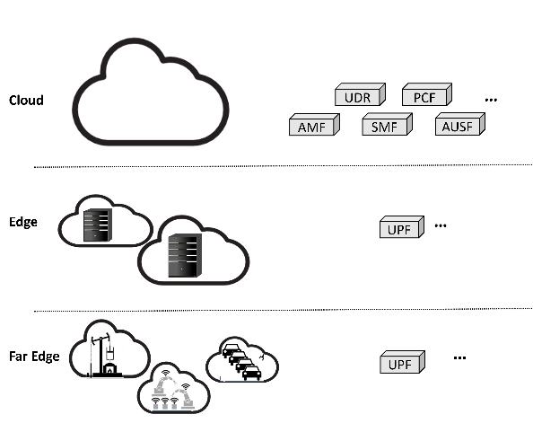
Figure 1. Example NF deployment across a distributed cloud infrastructure

Dynamic and automated deployments over such distributed cloud infrastructures rely on a central orchestration and management functionality, which is in charge of 1) management of the distributed cloud infrastructure and resources and 2) management of NF deployments (including transport) across the cloud infrastructure.
The focus of this discussion paper is management of NF deployments across the cloud infrastructure. This discussion paper does not consider the management of the cloud infrastructure i.e., data centres.
To manage the NF deployments across the distributed cloud infrastructure, the management system should be aware of the network topology and available resources at different parts of the cloud and be able to dynamically deploy and update cloud-native VNFs at cloud, edge, or far edge locations.
While the standardization activities to provide a full management solution for cloud-native applications are on-going in 3GPP and ETSI, today’s deployments rely on existing de-facto standards such as Kubernetes/Docker, etc. To avoid fragmentation in the ecosystem and expedite the uptake of the market, it is critical that the standardization efforts by SA5 allow use of the de-facto standards. Moreover, it would be beneficial for the market to avoid requiring complex and high-overhead interfaces and to develop solutions that allow flexibility in deployment by providing seamless integration with existing de-facto standards as well as other standardized solutions.

4.2 Example use case: deployment of cloud native virtualized network functions
In this paper we study deployment of cloud-native virtualized network functions as an example use case and highlight the issues that were identified in the process of enabling this use case based on the relevant SA5 specifications. We then derive, based on the studied use case, the high-level requirements that would, in our view, address the gap in enabling cloud-native deployments and hence higher adoption of the specifications in the market.
Deployment of a cloud-native virtualized network function includes the following three management operations:
- Onboarding of the cloud-native VNF (cloud-native VNF) Package
- Instantiation of the cloud-native VNF
- Configuration of the cloud-native VNF
Onboarding of the cloud-native VNF package to the management system in charge of cloud infrastructure needs to have been completed prior to instantiation of the NF. In this operation the cloud-native VNF Package is uploaded and enabled for use; however, it is not yet in use.
Issues related to cloud-native VNF Package onboarding:
- There are the following issues with the existing VNF Package procedures in [1]:
  - VNF package onboarding in Clause 4.3.1 is limited to uploading of VNF package to the NFVO. However, in order to support various existing de-facto standards for management of the cloud-native VNFs, use of de-facto standards, such as Kubernetes/Docker, Helm Charts, etc., in addition to ETSI NFV-MANO should be allowed. It is recommended that the SA5 solutions support integration and interoperability with the de-facto standards as well as NFV-MANO.
  - The triggering of onboarding of the packages is not necessarily with NM. It is recommended that the consumer of the onboarding service be generalized. In fact, from SA5 point of view the requirement is visibility into whether cloud-native VNF Package is onboarded to the management system in charge of cloud infrastructure and its operational status; the onboarding process does not need to be limited to a specific procedure.
  - [1] specifies the VNF package enabling procedure with a reference to Clause 7.7.3 in [2] which is void. Clause 4.3.2 in [1] should be removed/updated accordingly.
Instantiation of an NF is part of LCM and results in creation of a particular instance of NF using the onboarded cloud-native VNF Package and creation of an MOI for the created NF instance. The instantiation of a cloud-native VNF is initiated by an NF management service (NFMS) consumer for a specific geographical serving area. For the NFMS consumer to request the instantiation of the NF in a location best suited to service a specific serving area, the management system in charge of the LCM of cloud-native VNFs need to have the information regarding the available locations, i.e., data centres, or sites as well as their characteristics, i.e., capability, capacity, serving area, etc.
Issues related to cloud-native VNF Instantiation:
- There are the following issues with the existing NF Instance creation procedure in Clause 7.10 of [3]:
  - In study of this use case we considered a scenario in which NSSMF receives a request to create an NSSI, and needs to initiate the creation of an NF as part of provisioning of an NSS. In process of enabling this use case based on the procedures in the specification, we mapped the management roles in Figure 7.10-1 in [3] to NSSMF, NFMF, and ETSI MANO. The result is shown in Figure 2.
In this case NFMS_C is the NSS provisioning service management function in the NSSMF. At the same time, in an example deployment model where NSSMF is the entity that maintains the inventory of different NFs and their mapping to NSSI, it is in charge of deriving the requirements for the VNF instance. The 7.10-1 in [3], however, shows that NFMS_P derives the requirements for the VNF instance. Hence, in this scenario, NSSMF takes both NFMS_C and NFMS_P roles. Moreover, it needs to interact with NFMF (NFMS_P in the ManagedFunction). For this interaction the NSS Provisioning service takes the role of consumer for the NFMS in NFMF. Figure 2 illustrates the discussed mapping of consumer and producer roles to management functions for this example scenario in which NSSMF initiates the NF creation. This example illustrates that the mapping of the roles to network functions can easily get quite complicated and raises the need for some example mappings and additional descriptions to be provided in the specification.
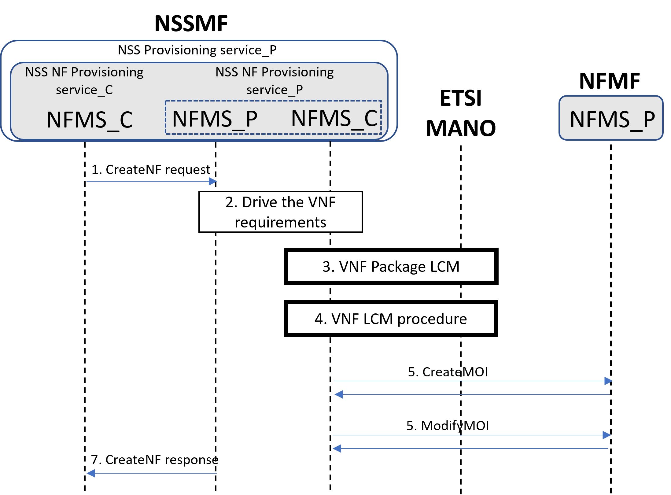
Figure 2. Figure 7.10-1 in [3] with roles mapped to management functions in an example that NSSMF triggers the NF creation.
  - Step 4 in Figure 7.10-1 in [3], i.e., VNF LCM procedure, refers to Clause 4.2.2.2 in [1] which specifies VNF LCM via Os-MA-nfvo interface of NFV-MANO as opposed to 4.2.2.1 that specifies VNF LCM via EM (NFMF).
    - This confirms that the NFMS_P is NSSMF in the scenario discussed above (as depicted in Figure 2) and not NFMF (EM).
    - This is against the requirement mentioned above for allowing seamless integration with the de-facto standards as well as NFV-MANO deployment for cloud-native VNF LCM.
Configuration of an NF allows for updating the attributes in an MOI and maintaining its operational state.
Issues related to cloud-native VNF Instantiation:
- The issues identified with the existing NF Instance modification procedure in Clause 7.11 of [3] are similar to the issues related to instantiation:
  - In a scenario that NSSMF receives a request to modify an NSSI, it may need to initiate the modification of an NF MOI, in this scenario:
    - Alternative 1: it will take the role of NFMS_P also for steps 2 (checking whether VNF instance needs to be scaled) and 3 (VNF instance scaling procedure) of Figure 7.11-1 in [3], and then takes NFMS_C role for step 4 (configuring MOI of the NF instance) when communicating with NFMS_P in NFMF,
    - Alternative 2: it will send the request to NFMF which takes the role of NFMS_P for all three steps, i.e., steps 2, 3, and 4, and is simply informed of the updated MOI via step 5 (ModifyNF response).
      - In this alternative NSSMF would not necessarily become aware of scaling.
    - Step 3 in Figure 7.11-1 in [3], i.e., VNF instance scaling procedure, refers to Clause 4.2.3 in [1] which specifies scaling procedures via interactions with NFV-MANO. This is against the requirement mentioned above for allowing seamless integration with the de-facto standards as well as NFV-MANO deployment for cloud-native VNF LCM.

4.3 Proposed Requirements
Below is the list of proposed high-level requirements, derived from the use case discussion above, for consideration as part of FS_MCVNF study item.
- Management system in charge of LCM of cloud-native VNFs shall have the capability allowing NM to request instantiation of a cloud-native virtualized network function.
- Management system in charge of LCM of cloud-native VNFs shall have the capability allowing NM to configure a cloud-native virtualized network function.
- Management solution for cloud-native VNFs should interoperate and integrate seamlessly with either ETSI NFV-MANO, if deployed, or the existing de-facto standards.
- Management system in charge of LCM of cloud-native VNFs should have the capability allowing NM to request information on the availability of the CNF Packages and their status, i.e., onboarded, enabled, etc.
- Management system in charge of LCM of cloud-native VNFs should have the capability allowing NM to request information on the available deployment sites including their characteristics and status.
- Management system in charge of LCM of cloud-native VNFs should have the capability to select a specific deployment site based on the NF serving area and NF requirements.

