3GPP TSG-SA5 Meeting #143-e S5-223414

e-meeting, 9- 17May 2022

Source: CMCC, Huawei

Title: pCR TR 28.830 Add description of key issue performance degradation

Document for: Approval
Agenda Item: 6.5.7.2

1 Decision/action requested
The group is asked to discuss and approve the proposal.

2 References
[1] SP-220153: "New SID on Fault Supervision Evolution"
[2] S5-222733: "draft TR 28.830 Fault supervision evolution"; v0.1.0

3 Rationale
5G networks provide high rates and low latency for services, but also result in high sensitivity and low tolerance of services to performance degradation. On the live network, a certain cell in a cell cluster is faulty. As a result, multiple cells generate a large number of alarms at the same time. This is because UEs in the faulty cell are handed over to different neighboring cells at the same time, causing congestion alarms and performance deterioration in multiple cells. Different types of alarms may be generated due to different fault symptoms in different cells. In the current fault management system, multiple work orders may be generated for O&M personnel to handle. In fact, only alarms of faulty cells need to be processed by work orders, which wastes human resources and takes a long time to rectify faults.

It is proposed to add description of key issue performance degradation in draft TR 28.830.

4 Detailed proposal
This document proposes the following changes in TR 28.830.

1st Change

5 Key Issues and potential solutions

5.X Key Issue #2: Performance degradation

5.X.1 Description
Editor’s note: This clause provides a description of the key issue.
5G networks provide high data rates and low latency services, it is high sensitive and low tolerance of performance degradation for some services. As depicted in Figure X, if the service becomes unavailable in an access cell A1 due to a kind of fault, the users in cell A1 need to be handed over to a neighboring cell (for example, A2, A3, and B2). When the traffic load of the cell cluster is too high, alarms related to performance degradation are reported, such as:
1) Alarm1: Cell A1 is unavailable.
2) Alarm2: Cell A2 (or cell A3, B1, and B2) cannot be accessed.
3) Performance alarm 1: Cell cluster service access degradation;
4) Performance alarm 2: Cell cluster service congestion and degradation.
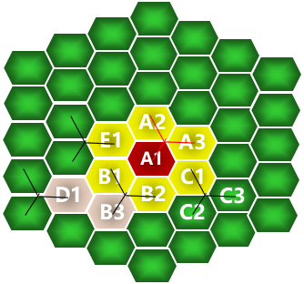
Figure X
The preceding types of alarms are generated. However, only the Alarm1 needs to be handled. Lack of root cause analysis results in waste of resources and time-consuming rectification.
The anomaly event MnS producer in fault supervision evolution should provide the capability to resolve the preceding kinds of alarms, and analyze root causes, recommend corresponding solutions and implement the recovery actions in more efficient means. For example, the anomaly event MnS producer obtains alarm, performance, and configuration information or anomaly event information from other anomaly event MnS producer and performs multi-data source correlation analysis, e.g., top N degraded cell identification, KPI trend analysis etc. For example, the performance degradation anomaly event is reported. Then it demarcates and analyzes the root causes of performance degradation anomaly event, and provides corresponding solutions for recovery. Therefore, only a single anomaly event name indicating the cell A1 failure is reported by the anomay event MnS producer, based on the alarms and performance measurements received from existing FM and PM data etc.
FSEV_REQ X1: The 3GPP management system should provide the capability to report performance degradation anomaly event related information.
FSEV_REQ X2: The 3GPP management system should provide the capability of querying performance degradation anomaly event related information.

End of change

