3GPP TSG-SA5 Meeting #143e S5- 223392rev3

e-meeting, 09 - 17 May 2022

Source: CMCC，Lenovo, Motorola Mobility

Title: pCR - 28.819 Proposed overall process

Document for: Approval,
Agenda Item: 6.5.14.1

1 Decision/action requested
The group is asked to discuss and approve.

2 References
[1] 3GPP SA5 TR 28.819 v0.5.0（2022-02）: ” Technical Specification Group Services and System Aspects; Management and Orchestration; Study on continuous integration continuous delivery support for 3GPP NFs”

3 Rationale
Add process based on the scenarios and solutions approved.

4 Detailed proposal
It proposes to make the following changes to TR 28.819[1].
Start of changes

7. Potential Process for Multi-Vendor CI-CD
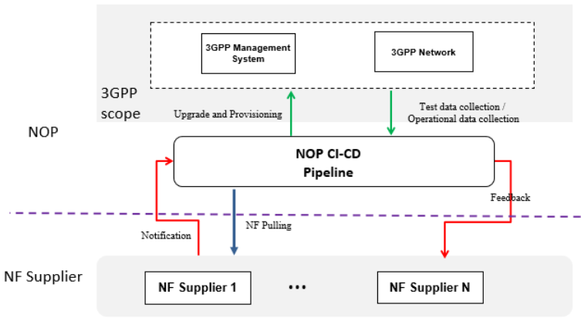
Figure 7.1-1 Example of High level Muti-vendor NF CICD process
The above figure describes one example of the high level muti-vendor NF CICD process between NOP and the NF supplier. High level process is to give the baseline of CICD procedures, not to open the detailed process in the pipeline and internal the 3GPP, but focusing on the interaction between the pipeline and the 3GPP. There may include the following stages and process:
-The new NF software is notified from the NF supplier to the NOP.
- The NOP CI-CD Pipeline pulls the new NF software.
-The NOP CI-CD Pipeline informs 3GPP management system to do upgrade and provisioning.
-The 3GPP system executes the upgrade and provisioning, the interaction with orchestration to complete the upgrade is not shown in this diagram.
- The NOP CI-CD Pipeline subscribes CICD related datas which can be monitored and collected by the 3GPP managenment system using existing 3GPP MnSs. During data collection process, CICD pipeline may need to do operational tests and collect testing data which directly work on 3GPP Network with test function, this interaction is not the 3GPP standardization scope.
- The NOP CI-CD Pipeline gives a feedback to NF supplier about the result of NF software upgrade and provisioning after necessary data handling.
In above high level processes, only upgrade and provisioning, monitoring and data collection (two green lines) processes have requirements and related potential normative works to 3GPP system.

End of changes

