3GPP TSG SA WG5 Meeting #143e S5-223390rev1

e-meeting, 9-17 May 2022

Source: Samsung, EUTC, BMWK, Vodafone

Title: pCR TR 28.829 Business use case - MNO provides performance info

Type: pCR

Document for: Approval, Information, Discussion
Agenda Item: 6.5.19 (FS_NSOEU: Study on Network and Service Operations for Energy Utilities)

1 Decision/action requested
SA5 is asked to approve this pCR.

2 References
None

3 Rationale
This pCR provides an overview of the problem domain that the study will address.

4 Detailed proposal
In this pCR general problem and current practice surrounding energy outage coordination and handling is presented as a use case.
BEGIN CHANGE

6 Business use cases and potential requirements

6.B Business use case: DSO obtains network performance and outage information, current practice

6.1.1 Description
Motivation
When there is an electrical outage, the electrical service operator strives to restore service as quickly as possible. There are several reasons for the need for rapid recovery from an interruption of electrical service:
- In some countries, regulations require rapid recovery and penalize an energy service provider for any time in which services does not operate. For example, at the least, in many countries customers do not have to pay for electrical service when it is not available.
- Interruptions in electrical service can be expensive, as businesses often require electricity for operations, manufacturing and to properly store valuable products. Thus, electrical outages can translate directly into business losses (of productivity or inventory.)
- Power outages for hospitals and care facilities can result in harm or even death to patients.
NOTE: Regulations identify 'critical' electricity customers which are obliged to install and maintain secure sources (e.g. local generators.) Public mobile network operators in some cases are not covered by these regulations. Further, public mobile network operators are generally not considered 'critical' electricity customers by regulation, so Energy Utility service providers cannot prioritize service to these customers.
- Electrical service outages affect many customers, so failure of service is not comparable in terms of business consequences to outages of mobile telecommunication service to a single customer.

For this reason, there are regulations that make energy service availability the highest priority. In order to achieve this, Smart Energy services such as protection, SCADA and Distribution Automation are used to monitor and adjust distribution equipment to avoid incidents that would reduce energy service availability.
As a point of comparison, a fiber optic access has an avialiability of at least 99.999%. Telecommunication systems may not achieve this level of service availability. Since telecommunications offers an alternative to fixed fiber optic access, additional means to achieve high degrees of availability are essential to the DSO.
Background
To achieve extreme telecommunication serivce availability, it is currently not feasible to rely on a single telecommunication network. Instead, DSOs networks employ communication access equipment that have multiple USIMs. If one telecommunication service provider is not available, the second can be used. However, this arrangement ('failover') is insufficient, as it requires in practice 2 minutes or more to bring up a secondary USIM and register with a back up network.
To prevent an outage that will last an hour or more, Distribution Automation must be used to intervene in the first minutes, ideally in the first seconds, in which an outage occurs. The following examples show two outages and can be considered characteristic of the prospects of resolution in most situations.
In Figure 1, an incident affecting an underground MV line eliminated service to 4223 customers. The existence of DA in secondary substations along the line allowed the fault to be isolated quickly and then resolved. This dramatically reduced the service outage duration for a substantial number of customers. A few customers that were along a line without DA access required local operation that took more than one hour. (The time scale on the X axis is not to scale.)

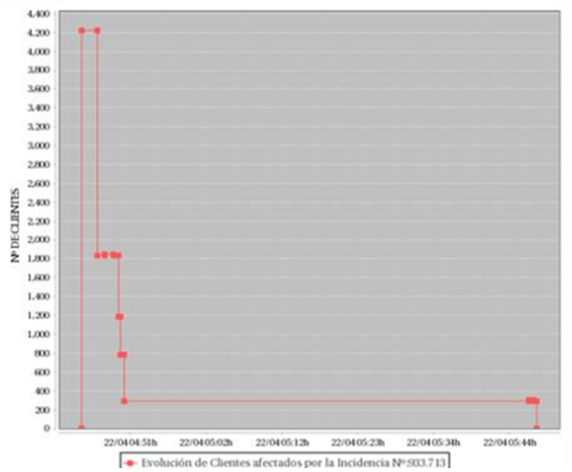
Figure 1: Incident Example
Over 50% of the customers could have their service restored in 3 minutes. Another 40% of the customers had their service restored in under 10 minutes. The remaining roughly 10% of the customers required manual intervention in order to have their service restored. The rapid service restoration saved EUR 1000s in saved penalties as well as needing only one service truck to roll.
In Figure 2, another example, another MV line was damaged, again showing a complication of a line that did not offer the possibility of DA intervention.
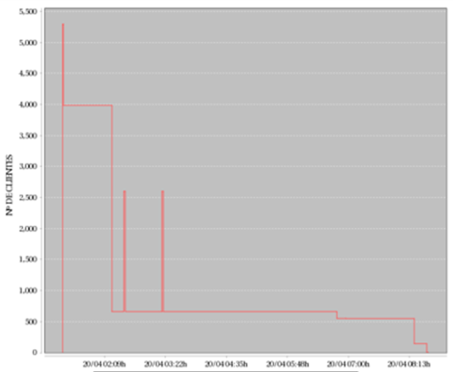
Figure 2: Incident Example featuring a time consuming recovery for a minority of customers
This incident affected 5292 customers. The outage lasted 7 hours but it can be observed that most of the customers could have their service restored within the first minutes due to remote access to primary and secondary substations and intervention using DA. In this incident, EUR 10000s could be saved.
Considering the importance of rapid response during a power outage, it is important that the communication facility is available at the time of an outage. If communication failure only is ascertained during an incident, the outage duration can be extended significantly for most of the affected customers.
In order to improve availability, some DSOs use dual USIM UE deployments. In practice, it takes on the order of 2 minutes to bring up service on an alternate mobile network. These minutes, if they coincide with an outage, are expensive both in terms of penalties and in terms of problems faced by customers during the outage. This also uses up roughly half of the ‘downtime budget’ of 99.999% availability (5 minutes per year unscheduled downtime maximum.)
Communication links are tested, e.g. every minute by means of ping messages end to end, to identify availability and latency. The effective availability of 3GPP telecommunications networks observed in practice can be more like 98.5% (where availability means ability to achieve communication with the expectations of performance according to the service level agreement. While this is far below the levels we expect from 5G and that we cite in stage 1 requirements, the fact is that observations of performance of past generations indicate that in order to achieve the target availability, information is needed.
NOTE: The actual availability of mobile network services is not exposed to energy utility service provider (customers), nor is the cause of the availability limit, e.g. limited capacity, radio quality issues, etc. This makes it difficult for energy utilities to perform risk assessment and network planning for communication services to carry their smart energy services.
Communication performance failure, based on extensive field experience, can be correlated with network performance events. Network performance can be compared to historic information indicating failures. In this case when communication with a ‘primary’ PLMN shows signs of declining performance, an ‘alternate’ communication channel can be employed, e.g. registration with another PLMN for a multi-USIM device. This action can be performed proactively, so that in the event that the ‘primary’ communication session does fail to deliver required performance, recovery can occur quickly (within seconds) to the ‘alternative’ communication session.

6.1.2 Details
There is currently no mechanism to convey network or services status from the MNO to the DSO. While the DSO can access real information from their CPEs (radio module or connectivity state, e.g.), no information comes from the MNO. Thus, in case service failure is happening in an area, the utility can just infer this situation through a qualified guess.
Utilities have alternative telecommunication connectivity possibilities in any given site. This connectivity can be provided by private networks (different to the MNOs’), or can be provided via alternative MNOs (another CPE in the same site; several SIM cards in the same CPE; etc.). Many of the sites where utilities need connectivity are mission critical; this means that the service must be highly available. If the utility is forced to use a standard MNO service, with no specific availability target, and no mechanism to know that service may be failing in an area, the utility will not rely in MNO services and will develop alternative telecommunications infrastructure that will eventually make MNOs’ services unnecessary.
The MNO has information on the state of its infrastructure. From the Core to the Radio Access Network, and through the different intelligent elements that make the 3GPP standards-based MNO network provide their services, the MNO can tell which network or service parts may be showing a degraded performance or potential unavailability. This information will enhance the MNO service visibility for specific user groups that may benefit from this, while making sure that some of them do not develop alternative solutions they can fully control.
Between the complete lack of information today, and the total control that MNO have of their network infrastructure, and that eventually may reach all the services provided to their customers, there is room to find added value service status information for specific user groups.
Use case actors
DSO network operations center engineer: The DSO operations engineer is responsible for deploying monitoring and control mechanisms in the network. The DSO operations center engineer determines how to control and configure the network for resiliency, e.g. when and how to switch between different accesses to maximize availability.
DSO electrical system operations center engineer: This actor is responsible for maintaining availability, efficiency and safety of the energy system.
Use case service flow
0. The energy system is monitored and managed by the electrical system engineer. It relies upon the network.
1. The DSO network operations center engineer deploys monitoring and control mechanisms to determine when a telecommunications network is not available.
2. There is no standard way to obtain network availability or performance information, so the DSO network operations center engineer must rely upon 'over the top' monitoring processes. In order to ensure that these monitoring processes do not use a significant amount of the communications capacity, the monitoring relies on periodic probes, e.g. ICMP messages ('pings') every minute. This is a very 'coarse grain' monitoring process, since a failure or performance degradation may take a significant amount of time to detect.
3a. The DSO network operations center engineer may manually trigger or set up a configuration that will automatically trigger a switch between one telecommunication network to a back-up communication access.
3b. The DSO network operations are not successful because insufficient information was available to the network operations center so the network fails before fail-over can occur, i.e. for more than 2 minutes. This means that the fail-over occurs during a time in which no communication is possible. This results in a network failure visible to the energy system engineer who requires communication for smart energy services. If a fault or protection problem for example occurs in that time the failure can cause damage to the energy system, inefficiencies and even outages. Especially if control is needed (e.g. critical SCADA) during this time frame, a serious energy system outage could occur.
Service flow result
Since the information that the DSO operations center engineer relies upon is of coarse granularity, there is a high likelihood that performance degradation or failure will be detected after several seconds from the point when they occurred. This extends the period of time in which communication service will be inadequate or unavailable before a secondary communication access can be made available. This reduces the availability of the energy system because, should an energy outage or instability occur during the time in which there is no communication possible, or inadequate performing communication this will lead to an energy service outage as described above.

6.1.3 Potential requirements
TBD.

END OF CHANGE

