3GPP TSG SA WG5 Meeting #143e S5-223389

e-meeting, 9-17 May 2022

Source: Samsung, EUTC, BMWK, Vodafone, Ericsson

Title: pCR TR 28.829 Business use case - Utility provides performance and failure info

Type: pCR

Document for: Approval
Agenda Item: 6.5.19 (FS_NSOEU: Study on Network and Service Operations for Energy Utilities)

1 Decision/action requested
SA5 is asked to approve this pCR.

2 References

[C] 3GPP TR 22.867: "Study on 5G smart energy and infrastructure".

3 Rationale
This pCR provides a use case to clarify existing practice and the gap that exists as there is no standard way to report incident or outage information from an energy utility service provider to a MNO. This use case essentially provides the motivation for the second objective in the SID:
ii. Study how Energy Utility customers of MNOs can provide standardized reports of network performance problems to MNOs.
Motivation: This information will enable MNOs to leverage extensive performance information known to the customer in their own processes. It will potentially improve response time to resolve a communication system performance incident, as currently this information is not delivered in any standard manner.
.

4 Detailed proposal
This document is a pCR intending to add an initial use case for existing practice for network performance problem reporting from a DSO to a MNO.
BEGIN CHANGE

6 Business use cases and potential requirements

6.A Business use case: DSO reporting to MNO to resolve problems and incidents, current practice

6.A.1 Description
Annex A of this document describes two processes, Problem Management and Incident Management. In current practice, these processes require interaction between the DSO and MNO, but the interaction is specialized, entirely depending on the processes of each individual MNO.
Problems, generally an observed decline or lack of expected service in certain scenarios over a period of time, need to be addressed or they will likely lead to incidents (where service fails completely or degrades so that service levels do not meet agreed key performance indicator objectives). Problem management allows interaction between a service provider and service customer to address longer term issues - such as capacity planning, disaster recovery or, most relevant, analysis of problems to identify their root cause. If the observed problem in the energy utility operator's network is decisively not the MNO's service and network, this will greatly help the energy utility operator to diagnose and resolve the problem. If, on the other hand, it is the result of the MNO's service and network, this realization can lead to more rapid response.
Incidents, a service failure, are resolved by means of specific procedures defined by service providers. The goal of the customer and service provider is to resolve incidents as quickly as possible.
It is acknowledged that the specifics of the IT processes for Problem Management and Incident Management are out of scope of 3GPP standards. It is however possible that the diversity of interfaces used to report information and the format of those reports can be standardized in 3GPP.
Since an energy utility operator has to work with many MNOs, especially if the energy utility operates across national borders, the lack of standards in this area for providing information regarding a problem or incident brings complexity and can delay the resolution process.

Energy utilities have vast deployments of communicating devices in hundreds or thousands of static sites. The communciation status of each of these devices is constantly monitored, especially their availability, but also latency and other performance metrics. This data, currently collected by energy utility service providers to identify problems and incidents in their own networks, could potentially be very useful to mobile network operators. This information is currently not shared by energy utilities with network operators.
Energy Utility operator are several stakeholders and have a specific role in the power grid.
Below picture gives an overview of stakeholders in the grid in Nordic countries. In principle the worldwide view is the same, with minor deviation.

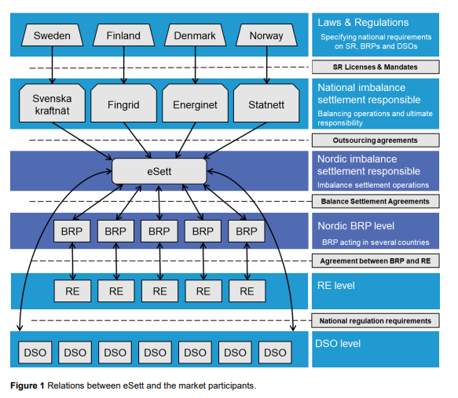

6.A.2 Details
Use case I: Network Problem Report
Problem Management processes, by which the DSO works with the MNO to address such issues as observed erratic or declining performance occurs very infrequently today, with resolution and improvements for processes such as capacity planning and adjustments to service level agreements taking months or years. The opportunities to analyze problems that emerge from time to time in energy utility networks essentially have to be analyzed by the energy utilities independently, without cooperation with the MNOs to ascertain the root cause of failure. This network problem discovery, trend analysis and identification of root causes of problems is very labor intensive for energy utility operators.
Use case actors:
DSO operations center engineer: The DSO operations center engineer analyzes collected information, creates and operates network monitoring tools including alarms, and seeks to identify areas of potential improvement in service delivery.
MNO technical service / account manager: The MNO operations center service representative responds to queries from the energy utility when needed. Such questions may arise when problems emerge, e.g. as network performance or avaialbility appears to decline in the customer's network.
Use case service flow:
1) Using the DSO operational tools, the DSO operations center engineer gathers and analyzes data, seeking to identify trends that appear threatening to the proper function of the energy utility network.
2) When such trends are identified, the DSO operations center engineer uses tools to study the details of the potential problem.
3) The 'root cause' of the problem may need to be investigated before identifying a potential remedy is possible, or determining how high a priority the mitigation has. It is possible at that time that the DSO operations center engineer contacts the MNO technical service representative with particular questions. The communication between the two organizations is not based on any standard data model - it requires ad hoc consultation which is labor intensive for both the MNO technical service and DSO operations engineers.
Service flow result:
The DSO learns about performance problems in their network. With consultation, it is possible to ascertain whether the issues are also present in the mobile network. This consultation is complicated by the lack of standard ways to exchange management information regarding network problems. The MNO does not benefit from information acertained by the DSO about network performance issues except through these consultations.
Use case II: Network Incident Report
Incident management is triggered when there is a performance incident - either a service is delivered below the service level agreement parameters or there is a service outage. In order to qualify as an 'incident' some parameters may apply (how long it is sustained, how frequently it occurs, etc.) according to the service level agreement, the details of which are out of scope of 3GPP.
When an incident occurs, this triggers processes to end the service performance failure or service outage as quickly as possible. The DSO needs to diagnose the root cause of the incident and take the necessary steps to recover service. To the extent that the service failure is attributed to the mobile network, or the root cause is unknown and could be due to service problems in the mobile network, the DSO works together with the MNO to diagnose the incident and resolve it.
The term 'service desk' represents the service provider contact that is available when incidents occur. The service desk can take many forms and interactions and interfaces are not standardized in current practice.
While resolution is needed on the order of seconds or minutes, communication and collaboration between the DSO and MNO can take much longer, sometimes hours even days. A significant amount of time is needed to describe the incident in terms that enables the MNO to take action. The lack of standards in this area means that the DSO has to identify the reporting formats of each MNO separately, which is labor intensive especially for DSOs that operate across national borders and therefore have large numbers of subscriptions with each operator in each country they operate.

Use case actors:
DSO operations center engineer: The DSO operations center engineer analyzes collected information, creates and operates network monitoring tools including alarms, and seeks to identify areas of potential improvement in service delivery.
MNO technical service desk engineer: The MNO is represented by this actor, whose role is to capture the incident information, analyze the MNO's management system to find corresponding relevant information and to work with the customer who reports the incident and MNO operational staff to resolve the incident if it is indeed an issue in the mobile network.
Use case service flow:
1) The DSO operational management system indicates a service outage in the DSO network. The DSO operations center engineer analyzes the alarm.
2) The root cause of the service outage is not clear. The DSO operations center engineer initiates a service desk procedure with the MNO providing service for the network that has a service outage.
3) The MNO technical service desk engineer gathers information from the DSO operations center engineer, partly through tools provided by the MNO service desk (e.g. web based reporting tools), partly through other forms of communication (phone, messages, etc.)
4) The MNO technical service desk engineer works with the MNO's operational staff and management tools to identify the corresponding network status.
a) Sure enough, there is a service outage in the mobile network corresponding to the service desk 'ticket' initiated by the DSO.
5a) The MNO technical service desk engineer informs the DSO operations center engineer of the incident and the expected time until resolution.
6a) The DSO operations center engineer initiates recovery procedures using a back up access system, if possible, or otherwise works to mitigate the impact of the outage.
b) Alternatively, the MNO network is functioning as expected - there is no service outage in the mobile network corresponding to the service desk 'ticket' initiated by the DSO.
5b) The MNO technical service desk engineer informs the DSO operations center engineer that the incident is not related to MNO network performance degradation or service failure.
6b) The DSO operations engineer continues to work to identify the root cause of the failure, excluding the mobile network as the cause.
6c) Eventually the source of the failure is identified and remedied.
Service flow result:
The DSO and MNO work to identify the root cause of the service failure or performance failure incident. If the incident's cause is in the MNO network, MNO operational staff and tools resolve the problem. If the incident's cause is in the DSO network, the DSO's operational staff and tools resolve the problem. Since there is no standard means for communicating the nature of the incident, the 'reporting' process may be complex and varies from operator to operator. This may result in extended resolution times for incidents.

6.A.3 Potential requirements
Currently, there is no interface between DSO and MNOs. This means that both systems work based on their own premisses. Through the use of non-standard, MNO-specific interactions, the DSO can report problems and incidents and work with the MNO to resolve these.
There are however synergies and potential improvement for building an interface. More investigation and analysis are needed to find appropriate use cases, see 3GPP TR 22.867 [C] and put possible requirements from them.
END OF CHANGE

