3GPP TSG-SA5 Meeting #143-e S5-222258rev2

e-meeting, 9 - 17 May 2022

Source: Huawei

Title: Add concept of service profile and slice profile

Document for: Approval
Agenda Item: 6.5.4

Decision/action requested
This tdoc is for approval.

2 Rational
This document is to add the concept of service profile, slice profile, introduce the existing solution of those when create a network slice. This document is also to add the analysis that the use of intent may impact the requirements expressed in service profile.

3 Proposed changes

The start of the change

2 References
The following documents contain provisions which, through reference in this text, constitute provisions of the present document.
- References are either specific (identified by date of publication, edition number, version number, etc.) or non-specific.
- For a specific reference, subsequent revisions do not apply.
- For a non-specific reference, the latest version applies. In the case of a reference to a 3GPP document (including a GSM document), a non-specific reference implicitly refers to the latest version of that document in the same Release as the present document.
[1] 3GPP TR 21.905: "Vocabulary for 3GPP Specifications".
[2] 3GPP TS 28.530: "Management and orchestration; Concepts, use cases and requirements"
[3] 3GPP TS 28.531: "Management and orchestration; Provisioning"
[y] 3GPP TS 28.541: "Management and orchestration; 5G Network Resource Model (NRM); Stage 2 and stage 3"

Second change

4 Concepts and Overview

4.1 General
Network slicing is one of the key 5G features. The lifecycle of a Network Slice instance can be described by the following: commissioning, operation and decommissioning. Before a NetworkSlice instance can be created there is a preparation phase. The different phases are described in more detail in TS 28.530 [2].
The attribtes in ServiceProfile represent the network slice related requirements, and the attributes in SliceProfile represent network slice subnet related requirements. The uses of ServiceProfile and SliceProfile are described in TS 28.531 [3] and TS 28.541 [y].
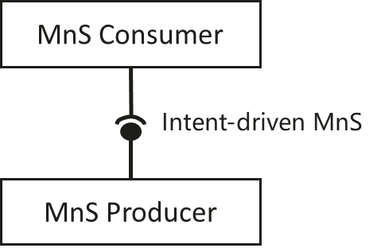
Figure 4.1-1: Intent-driven MnS
In Intent-driven management, the MnS consumer provides its intent to the MnS producer. The producer of an Intent-driven MnS shall allow the consumer to manage the service and / or network resources through the use of intents.

The end of the change

