3GPP TSG-SA5 Meeting #143-e S5-223231

e-meeting, 09 -17 May 2022

Source: Ericsson, Telefónica

Title: Filtering, enrichment and converting of management information

Document for: Discussion
Agenda Item: 6.5.22.1

1 Decision/action requested
Discuss and agree the recommendation in section 4.4.

2 References
[1] 3GPP TR 28.824: "Management and orchestration; Study on network slice management capability exposure"

3 Rationale
In the discussion on exposure of management capability a number of alternatives have been identified using CAPIF. This is documented in clause x in the TR 28.824, see reference [1]. Questions were raised regarding the use of translation in alternative 1. Translation effectively means the following, filtering, enrichment and/or conversion of an API.
The reason for doing the translation is to be able to provide an API that fulfils the following market requirement for it to be user friendly meaning that APIs shall hide telco complexity and make them easy to use to 3rd parties with no telco expertise/background. This may also mean that they need to be adapted for a specific type of 3rd party whose business expertise and jargon lies outside 3GPP (e.g. manufacturing and agriculture).

4 Detailed proposal

4.1 Architecture
The architecture in figure 4.1.1 is based on the solution for exposure via CAPIF alternative 1 described in clause 7.9.1 of TR 28.824, see reference [1]. The translation which was discussed during #142e meeting has been added to the architecture and is shown in figure 4.1.1 as “Filtering, enrichment, conversion”.. Filtering is hiding of information elements (attributes and classes), enrichment is adding information from other MnS or other sources outside OAM, converting is changing information elements through for example combing information elements or mapping information elements.
Figure 4.1.1 Location of translation using the CAPIF framework for exposing management APIs.

MnS Consumers
MnS Producers
API Invoker
CAPIF-1e
CAPIF-1
CAPIF-2e
CAPIF-2
CAPIF-3
CAPIF-4
CAPIF-5
Provisioning
Performance Management
Streaming
File Data Reporting
Heartbeat
Fault
Management
API Invoker
CAPIF core function
CAPIF APIs
ServiceAPIs
API Exposing Function
API Publishing Function
API Management Function
PLMN trust domain
Filtering, enrichment, conversion

4.2 Procedure

4.2.1 description of procedure
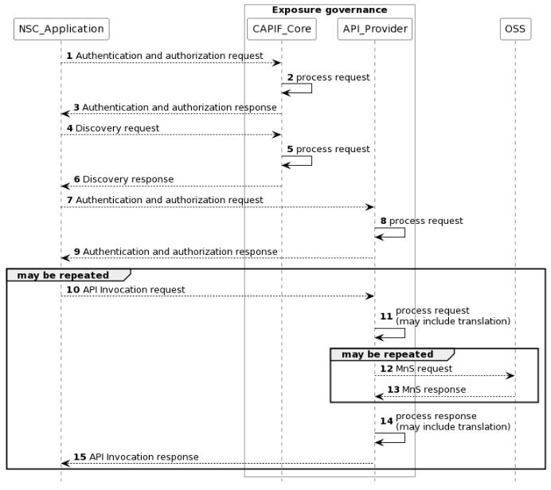
Figure 4.2.1.1 Procedure for consumption of exposed MnS after service order is completed
NOTE: For simplicity reasons the CAPIF Core Function and API Provider defined in TS 23.222 are combined into Exposure governance and any communication between them is also not included.
1) The CAPIF_Core receives an authenticating and authorization request from the NSC_Application based on the identity and other information required for authentication and authorization of the NSC_Application.
2) The CAPIF_Core processes the authentication and authorization request.
3) The CAPIF_Core provides the appropriate response to the NSC_Application.
4) The CAPIF_Core receives a request for the discovery of service APIs information.
5) The CAPIF_Core processes the discovery.request.
6) The CAPIF_Core provides the appropriate response to the NSC_Application.
7) The API_Provider receives an authorization request from the NSC_Application based on the identity and other information required for authorization of the NSC_Application.
8) The API_Provider processes the authorization request.
9) The API_Provider provides the appropriate response to the NSC_Application
10) The API_Provider receives a request for the invocation of the service API(s) from the NSC_Application.
11) The API_Provider processes (and optionally may filter, enrich and/or convert) the invocation request.
12) The OSS receives request from API_Provider for MnS.
13) The OSS provides the appropriate response to the API_Provider.
14) The API_Provider processes (and optionally may filter, enrich and/or convert) the response from the OSS
15) The API_Provider provides the appropriate response to the NSC_Application.

4.2.2 Detailed description of step 10-15
Once the NSC_Application has been authenticated and authorizated the NSC_Application can start to send API_Invocation requests (step 10). Each request is processed by the API_Provider where the API_Provider may optionally translate into several MnS requests (step 11). Translation means filtering, enrichment and/or conversion of the request to MnS request(s) (step 12). As part of the processing of the request the API_Provider may also invoke other services e.g. charging.
When all MnS reponses have been received (step 13 and step 14) the API_Provider may optionally translate this into a single API_Invocation reponse (step 15).

4.3 Observations
The procedure described in 4.2 would allow for handling of the exposed APIs to be completely separated from the MnS(s) and be more adaptable to the NSC Application needs
The procedure described in 4.2 would also allow for invocation of other services than MnS(s) that may be required to fulfil the need of the NSC Application.
NOTE: The procedure is only applicable to alternative 1 described in TR 28.824 [1]
NOTE: Filtering, enrichment and converting represents an optional translation of MnS APIs into service APIs, for the case where 3rd party consumption requires them. The decision on whether this translation is needed, and how to apply it (translation internals) is out of scope of SA5. Initiatives such as a CAMARA are working on this translation

4.4 Recommendations
The architecture described in 4.1 and the procedure described in 4.2 should be a recommended solution for exposure of management services in SA5 specifications.
NOTE: The recommendation is only applicable to alternative 1 described in TR 28.824 [1]

Annex A UML code: Procedure for consumption of exposed MnS after service order is completed
@startuml
skinparam sequence {
ArrowColor Black
ActorBorderColor Black
ActorBackgroundColor White
ParticipantBorderColor Black
ParticipantBackgroundColor White
LifeLineBorderColor Black
}
skinparam NoteBackgroundColor White
skinparam NoteBorderColor White
skinparam NoteColor White
skinparam shadowing false
hide footbox
autonumber
participant NSC_Application
box "Exposure governance" #white
participant CAPIF_Core
participant API_Provider
end box
participant OSS

NSC_Application --> CAPIF_Core : Authentication and authorization request
CAPIF_Core -> CAPIF_Core: process request
NSC_Application <-- CAPIF_Core : Authentication and authorization response

NSC_Application --> CAPIF_Core : Discovery request
CAPIF_Core -> CAPIF_Core: process request
NSC_Application <-- CAPIF_Core : Discovery response

NSC_Application --> API_Provider : Authentication and authorization request
API_Provider -> API_Provider: process request
NSC_Application <-- API_Provider : Authentication and authorization response

group may be repeated
NSC_Application --> API_Provider : API Invocation request
API_Provider -> API_Provider: process request\n(may include translation)
group may be repeated
API_Provider --> OSS: MnS request
API_Provider <-- OSS: MnS response
end
API_Provider -> API_Provider: process response\n(may include translation)
NSC_Application <-- API_Provider : API Invocation response
end
@enduml

