3GPP TSG-SA5 Meeting #143-e S5-223229

e-meeting, 09 - 17 May 2022

Source: Ericsson, Deutsche Telekom, TEF

Title: Add procedure for consumption of exposed MnS after service order completed

Document for: Approval
Agenda Item: 6.5.22.3

1 Decision/action requested
The group is asked to agree the detailed propsal.

2 References
[1] 3GPP TS 28.533 Management and orchestration; Architecture framework
[2] 3GPP TS 23.501 System architecture for the 5G System (5GS)
[3] 3GPP TS 23.502 Procedures for the 5G System (5GS)
[4] 3GPP TS 23.222 Common API Framework for 3GPP Northbound APIs
[5] 3GPP TS 23.434 Service Enabler Architecture Layer for Verticals (SEAL); Functional architecture and information flows
[6] 3GPP TS 33.122 Security aspects of Common API Framework (CAPIF) for 3GPP northbound APIs
[7] 3GPP TS 33.501 Security architecture and procedures for 5G System
[8] 3GPP TS 28.530 Management and orchestration; Concepts, use cases and requirements

3 Rationale
The procedures described in clause 4.1.4 show the interaction between an NSC and an NSP when NSC orders a product/service and the NSP accepts and completes the order. After the product order and service order have been completed, the ordered service may be consumed by the NSC using the CAPIF (Common API Framework).
There is no description in the study what happens after the service order is completed nor how CAPIF may be used.
It is proposed to add a concept description in clause 4 and a solution description in clause 7.

4 Detailed proposal

1st Change

4.1.4.X Procedure for consumption of exposed MnS after service order is completed
The procedure for consumption of an exposed MnS after the product and service order are completed is shown in figure 4.1.4.X.1. The MnS is produced by the MnS producer located in the OSS of the NSP, depending on deployment scenario the MnS provider resides in OSS_SML or OSS_NML. An MnS may already be produced before CAPIF 1 service is requested. The CAPIF 2/2e service is a filtered, enriched and/or converted version of the MnS. The transformation, filtering, enrichment or conversion of MnS APIs into service APIs is optional and, executed within the API provider. The details of how this transformation, filtering and/or enrichment is to be done is out of scope of SA5. Initiatives such as CAMARA are working out these details. . The CAPIF 2/2e service is provided by the API_Provider and consumed by the NSC_Application. The API_Provider uses the MnS(s) produced to provide the CAPIF 2/2e service.

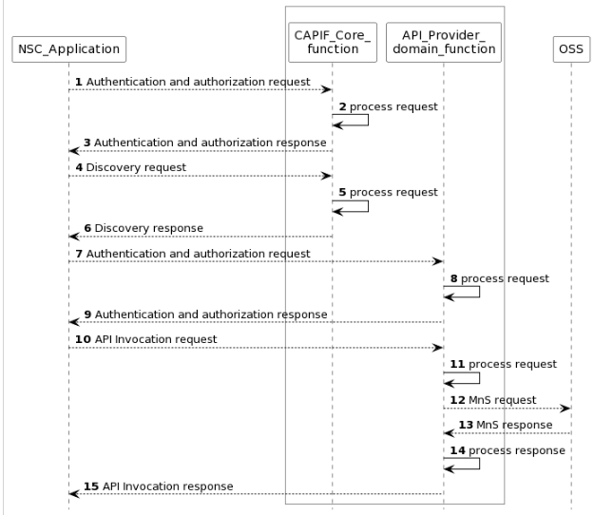
Figure 4.1.4.X.1 Procedure for consumption of exposed MnS after service order is completed
NOTE1: For simplicity reasons the CAPIF Core function and API Provider domain function defined in TS 23.222 are combined and any communication between them is also not included.
NOTE2: The procedure is only applicable to “Exposure via CAPIF alternative 1” described in clause 7.9.1.

1) The CAPIF_Core receives an authenticating and authorization request from the NSC_Application based on the identity and other information required for authentication and authorization of the NSC_Application.
2) The CAPIF_Core processes the authentication and authorization request.
3) The CAPIF_Core provides the appropriate response to the NSC_Application.
4) The CAPIF_Core receives a request for the discovery of service APIs information.
5) The CAPIF_Core processes the discovery.request.
6) The CAPIF_Core provides the appropriate response to the NSC_Application.
7) The API_Provider receives an authorization request from the NSC_Application based on the identity and other information required for authorization of the NSC_Application.
8) The API_Provider processes the authorization request.
9) The API_Provider provides the appropriate response to the NSC_Application
10) The API_Provider receives a request for the invocation of the service API(s) from the NSC_Application.
11) The API_Provider processes (and optionally may filter, enrich and/or convert) the invocation request.
12) The OSS receives request from API_Provider for MnS.
13) The OSS provides the appropriate response to the API_Provider.
14) The API_Provider processes (and optionally may filter, enrich and/or convert) the response from the OSS
15) The API_Provider the provides the appropriate response to the NSC_Application.

2nd Change

7.X Potential solution for consumption of exposed MnS after service order completed
This clause describes a solution for the procedure for consumption of exposed MnS after service order completed described which is described in clause 4.1.4.X. For each step in the procedure Table 7.X.1 identifies the following:
- if an interface is Internal to an operator, i.e. internal to the NSP or External between a NSC and NSP, or None in case the step is an internal process and there is no interface requirement,
- which operation or notification is used by that step, and
- which specification describes the interface (stage 2 and stage 3).

Step | Description in step | Interface | Reference | Description in reference
1 | Authentication and authorization request | Internal | 3GPP TS 23.222[14], clause 6.4.2 | CAPIF-1
2 |  | None | - | -
3 | Authentication and authorization response | Internal | 3GPP TS 23.222[14], clause 6.4.2 | CAPIF 1
4 | Discovery request | Internal | 3GPP TS 23.222[14], clause 6.4.2 | CAPIF-1
5 |  | None | - | -
6 | Discovery response | Internal | 3GPP TS 23.222[14], clause 6.4.2 | CAPIF-1
7 | Authentication and authorization request |  |  | CAPIF-2
8 |  | None
9 | Authentication and authorization response |  |  | CAPIF-2
10 | API invocation request | Internal | 3GPP TS 23.222[14], clause 6.4.2 | CAPIF-2
11 |  | None
12 | MnS request | Internal | 3GPP TS 28.532 | MnS
13 | MnS response | Internal | 3GPP TS 28.532 | MnS
14 |  | None
15 | API invocation response | Internal | 3GPP TS 23.222[14], clause 6.4.2 | CAPIF 2
Table 7.X.1 Solution for consumption of exposed MnS within the operator trusted domain (NSC_Application is inside operator trusted domain)

Step | Description in step | Interface | Reference | Description in reference
1 | Authentication and authgorizationrequest | External | 3GPP TS 23.222[4], clause 6.4.2 | CAPIF-1e
2 |  | None | - | -
3 | Authentication and authorization response | External | 3GPP TS 23.222[4], clause 6.4.2 | CAPIF 1e
4 | Discovery reqeust | External | 3GPP TS 23.222[4], clause 6.4.2 | CAPIF-1e
5 |  | None | - | -
6 | Discovery response | External | 3GPP TS 23.222[4], clause 6.4.2 | CAPIF-1e
7 | Authentication and authorization request |  |  | CAPIF-2e
8 |  | None
9 | Authentication and authorization response |  |  | CAPIF-2e
10 | API invocation request | External | 3GPP TS 23.222[4], clause 6.4.2 | CAPIF-2e
11 |  | None
12 | MnS request | Internal | 3GPP TS 28.532 | MnS/
13 | MnS response | Internal | 3GPP TS 28.532 | MnS/
14 |  | None
15 | API invocation response | External | 3GPP TS 23.222[4], clause 6.4.2 | CAPIF 2e
Table 7.X.2 Solution for consumption of exposed MnS outside operator trusted domain (NSC_Application is outside operator trusted domain)

3rd Change

Annex A UML code of the diagrams

A.x Figure: Procedure for consumption of exposed MnS after service order is completed
@startuml
skinparam sequence {
ArrowColor Black
ActorBorderColor Black
ActorBackgroundColor White
ParticipantBorderColor Black
ParticipantBackgroundColor White
LifeLineBorderColor Black
}
skinparam NoteBackgroundColor White
skinparam NoteBorderColor White
skinparam NoteColor White
skinparam shadowing false
hide footbox
autonumber
participant NSC_Application
box #white
participant "CAPIF_Core_\nfunction" as CAPIF_Core
participant "API_Provider_\ndomain_function" as API_Provider

end box
participant OSS

NSC_Application --> CAPIF_Core : Authentication and authorization request
CAPIF_Core -> CAPIF_Core: process request
NSC_Application <-- CAPIF_Core : Authentication and authorization response

NSC_Application --> CAPIF_Core : Discovery request
CAPIF_Core -> CAPIF_Core: process request
NSC_Application <-- CAPIF_Core : Discovery response

NSC_Application --> API_Provider : Authentication and authorization request
API_Provider -> API_Provider: process request
NSC_Application <-- API_Provider : Authentication and authorization response

NSC_Application --> API_Provider : API Invocation request
API_Provider -> API_Provider: process request
API_Provider --> OSS: MnS request
API_Provider <-- OSS: MnS response
API_Provider -> API_Provider: process response
NSC_Application <-- API_Provider : API Invocation response

@enduml

End of Changes

