3GPP TSG-SA5 Meeting #143-e S5-223225rev2

e-meeting, 9 - 17 May 2022

Source: MATRIXX Software

Title: pCR TR 32.847 Add new solution for Key issue#8

Document for: Approval
Agenda Item: 7.5.3

1 Decision/action requested
This pCR is to introduce a new solution for Key issue#8

2 References
[1] 3GPP TR 32.847 "Study on Charging Aspects for Network Slicing Phase 2"

3 Rationale
This pCR is to introduce a new solution for Key issue#8

4 Detailed proposal
The following changes are proposed to be incorporated into TR 32.847 [1]
First change

5 Potential charging requirements
REQ-NSCH-01 The 5G charging framework should support converged charging per S-NSSAI.
REQ-NSCH-02 The 5G charging framework should support converged charging per S-NSSAI, based on "number of UEs".
REQ-NSCH-03 The 5G charging framework should support converged charging per S-NSSAI, based on "number of PDU sessions".
REQ-NSCH-04 The 5G charging framework should support converged charging per S-NSSAI, based on "number of UEs", exempting Emergency Registered UEs
REQ-NSCH-05 The 5G charging framework should support converged charging per S-NSSAI, based on "number of PDU sessions", exempting Emergency services, Multimedia Priority Service, and Mission Critical Service.
REQ-NSCH-06 The 5G charging framework should support converged charging per S-NSSAI, based on "number of UEs", including UEs connected in the EPS.
REQ-NSCH-07 The 5G charging framework should support converged charging per S-NSSAI, based on "number of PDU sessions", including PDN connections in the EPS.
REQ-NSCH-08 The 5G charging framework should support converged charging per tenant based on assigned group of S-NSSAI(s).
REQ-NSCH-09 The 5G charging framework should support converged charging per S-NSSAI, based on "aggregated PDU sessions volume".
REQ-NSCH-10 The 5G charging framework should support converged charging per S-NSSAI, based on "PDU session maximum duration".
REQ-NSCH-11 The 5G charging framework should support individual UE converged charging based on Network Slice usage charging criteria.
REQ-NSCH-12 The 5G charging framework should support converged charging per S-NSSAI for the time an S-NSSAI is used.
REQ-NSCH-13 The 5G charging framework should support converged charging for UE Network Slice-specific Authentication and Authorization (NSSAA) invocation invocation towards a 3rd party for network slice access.

Next change

6.8.1 General Description
This key issue is for investigating how to support UE Network Slice-specific Authentication and Authorization (NSSAA) network slice access converged charging.
NSSAA functionality specified in clause 5.15.10 3GPP TS 23.501 [7] is an additional AAA-S EAP based authorization for UE to access a network slice, after the primary authorization was granted by the PLMN under the list of allowed S-NSSAI(s). This capability can be offered and monetized by Operators (PLMN) to 3rd party enterprises owning AAA-S.
The use case for this key issue is:
A UE has a subscription with the MNO. The MNO is the owner of NSSAF and AAA-P.
The MNO has a business relationship with the 3rd party MNO for access to network slice(s) by MNO UEs requiring Slice-Specific Authentication and Authorisation by the 3rd party. The 3rd pary is the owner of AAA-S.
The MNO to 3rd party charging could be based number of invocations by MNO UEs for this additional Authentication and Authorization towards the 3rd party:
This investigation covers the following:
- determination of which entity/entities in the 5G system is suitable to provide charging information for usage of NSSAA by UE;
- determination of the main interactions required to obtain charging information for usage of NSSAA.
- identification of the main charging information to be collected;

Next change

6.8.2.1 General description
This solution addresses the Key Issue#8 for REQ-NSCH-13 and is based on use of Nchf converged charging service by 5GS Network Functions involved in UE NSSAA procedures.
AMF interacts with CHF during NSSAA procedure with the Network Slice-Specific Authentication and Authorization Function (NSSAAF) for a given UE and S-NSSAI for CHF to produce appropriate CDR.
NSSAAF interacts with CHF during NSSAA procedure for a given UE and S-NSSAI for CHF to produce appropriate CDR.
The solution applies for NSSAA, AAA Server triggered Network Slice-Specific Re-authentication and Re-authorization procedure and AAA Server triggered Slice-Specific Authorization Revocation.
The AMF Charging characteristics (Annex A of 3GPP TS 32.256[10]) is extended to include NSSAA related configuration.
NSSAAF Charging characteristics pre-configured in NSSAAF includes NSSAA related information.

Next change

6.8.2.3 Flow description
The figure 6.8.2.3-1 below describe the high level charging procedure for Converged Charging in PEC mode for Network Slice-Specific Authentication and Authorization (NSSAA) procedure based on figure 4.2.9.2-1 3GPP TS 23.502 [11]:

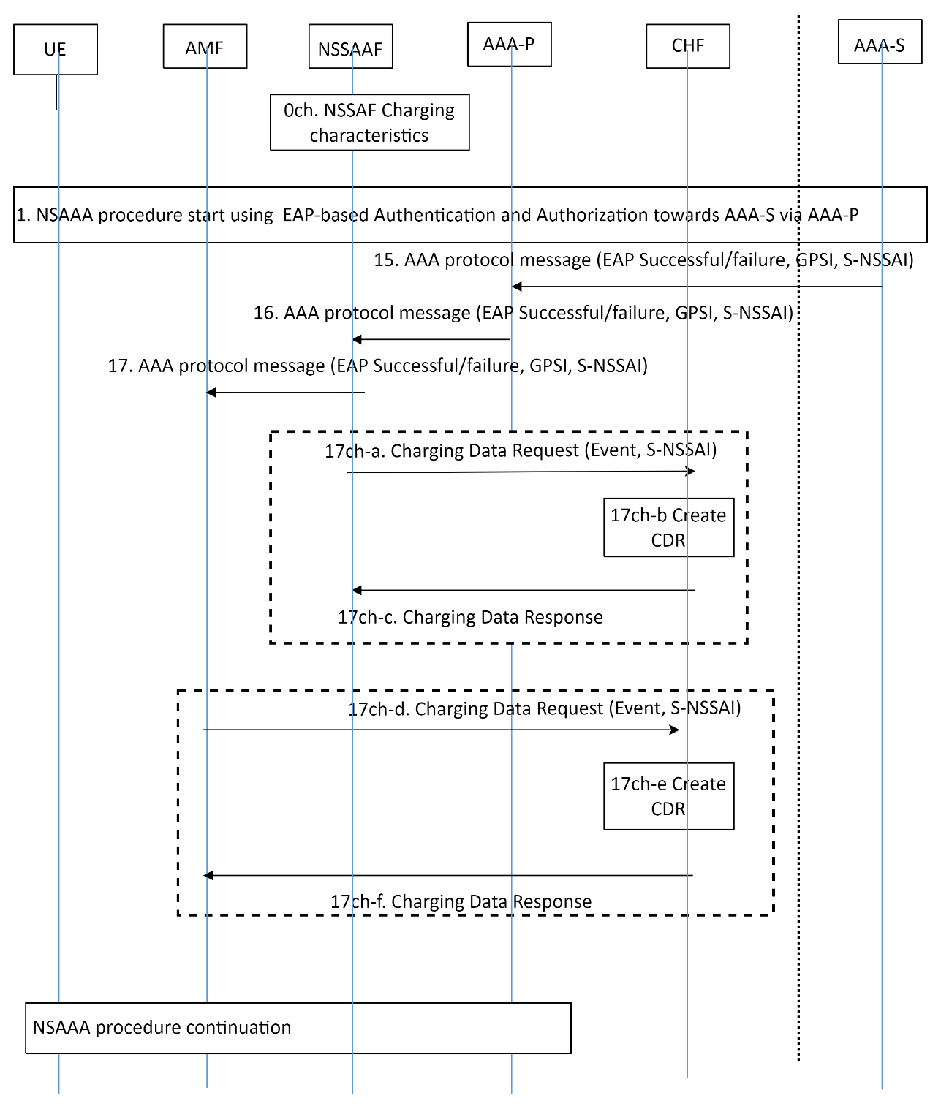
Figure 6.8.2.3-1: Converged Charging for NSSAA - PEC
Steps are based on steps of figure 4.2.9.2-1 3GPP TS 23.502 [11], with the following additions:
0ch. NSSAAF Charging characteristics is pre-configured in NSSAAF indicating: Charging active (Yes/No) for NS authentication/auth, re-authentication/re-auth, revocation per S-NSSAI.

17ch-a to c: Charging active in NSSAAF: Charging Data Request [Event] is sent to CHF with the result of NSSAA Authentication (EAP-Success/Failure, S-NSSAI, GPSI) for CHF NSSAAF CDR generation
17ch-d to e: Charging active in AMF: Charging Data Request [Event] is sent to CHF by AMF with the result of NSSAA Authentication (EAP-Success/Failure, S-NSSAI, GPSI) for CHF AMF CDR generation

The solution for Converged Charging AAA Server triggered Network Slice-Specific Re-authentication and Re-authorization procedure are based on figure 4.2.9.3-1 3GPP TS 23.502 [11] with additional interactions with CHF from NSSAAF and AMF on Nnssaaf_NSSAA_Re-AuthNotification.
The solution for Converged Charging AAA Server triggered Slice-Specific Authorization Revocation procedure are based on figure 4.2.9.4-11 3GPP TS 23.502 [11] with additional interactions with CHF from NSSAAF and AMF on Nnssaaf_NSSAA_RevocationNotification.

Next change

6.8.x Solution#8.x Converged Charging for NSSAA from AAA-P

6.8.x.1 General description
This solution addresses the Key Issue#8 for REQ-NSCH-13 and is based on use of Nchf converged charging service by AAA-P involved in UE NSSAA procedures towards a AAA-S belonging to a third party.
AAA-P interacts with CHF during NSSAA procedure for a given UE and S-NSSAI for CHF to produce appropriate CDR for charging for "requesting (re-)authentication/authorization" between the owner of the NSSAAF and the owner of the AAA-S.
The solution applies for AAA Server triggered Network Slice-Specific Re-authentication and Re-authorization procedure and AAA Server triggered Slice-Specific Authorization Revocation.
AAA-P Charging characteristics pre-configured in AAA-P includes NSSAA related configuration.

6.8.x.2 Architecture description

Figure 6.8.x.2-1: AAA-P converged charging architecture

6.6.x.3 Flow description
The figure 6.8.x.3-1 below describes the high level charging procedure for Converged Charging in PEC mode for Network Slice-Specific Authentication and Authorization (NSSAA) procedure based on figure 4.2.9.2-1 3GPP TS 23.502 [11]:

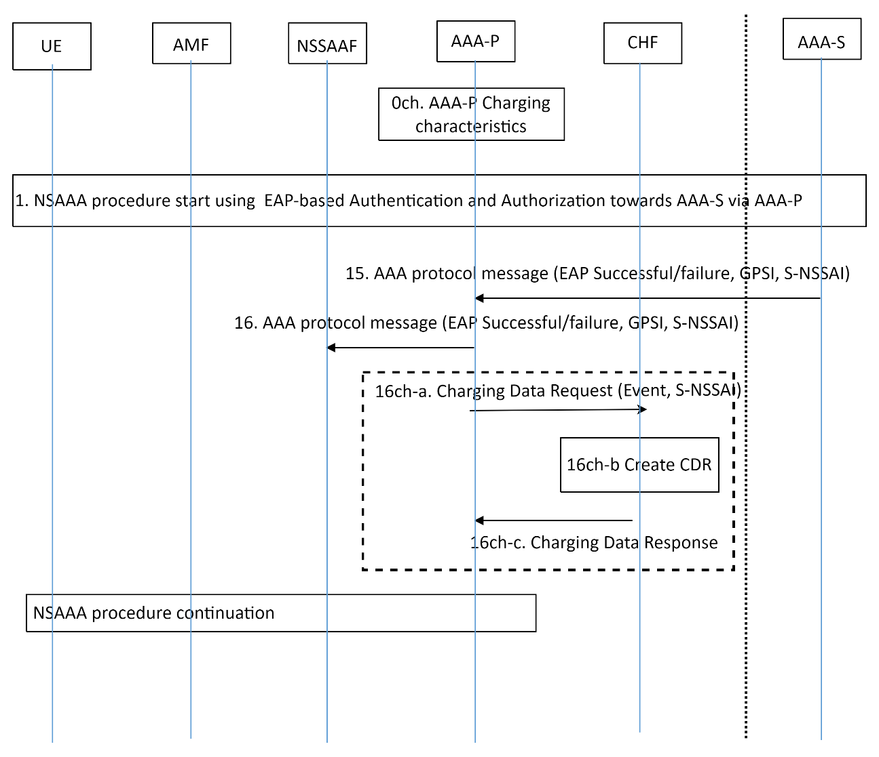
Figure 6.8.x.3-1: Converged Charging for NSSAA from AAA-P - PEC
Steps are based on steps of figure 4.2.9.2-1 3GPP TS 23.502 [11], with the following additions:
0ch. AAA-P Charging characteristics is pre-configured in AAA-P indicating: Charging active (Yes/No) for NS authentication/auth, re-authentication/re-auth, revocation per S-NSSAI.

16ch-a to c: Charging active in AAA-P: Charging Data Request [Event] is sent to CHF with the result of NSSAA Authentication (EAP-Success/Failure, S-NSSAI, GPSI) for CHF CDR generation
The solution for Converged Charging AAA Server triggered Network Slice-Specific Re-authentication and Re-authorization procedure are based on figure 4.2.9.3-1 3GPP TS 23.502 [11] with additional interactions with CHF from AAA-P on AAA Protocol Re-Auth Response.
The solution for Converged Charging AAA Server triggered Slice-Specific Authorization Revocation procedure are based on figure 4.2.9.4-11 3GPP TS 23.502 [11] with additional interactions with CHF from AAA-P on AAA Protocol Revocation Re-Auth Response.

End of changes

