3GPP TSG-SA5 Meeting #143-e S5-223123rev1

e-meeting, 9 - 17 May 2022

Source: Alibaba group

Title: pCR 28.824 Update to solution regarding CAPIF based management capability exposure

Document for: Approval
Agenda Item: 6.5.22

1 Decision/action requested
For approval

2 References
[1] 3GPP TR 28.824 V0.5.0 Study on network slice management capability exposure

3 Rationale
This contribution proposes the enhancement of CAPIF interface considering network slice management capability exposure.

4 Detailed proposal
This contribution proposes to make the following changes in [1].

1st change

7.9 Potential solutions for network slice management capability exposure via CAPIF

7.9.1 Exposure via CAPIF alternative 1
This clause describes a potential solution where network slice management capability is exposed via the Common API Framework for 3GPP Northbound APIs, see TS 23.222 [14].
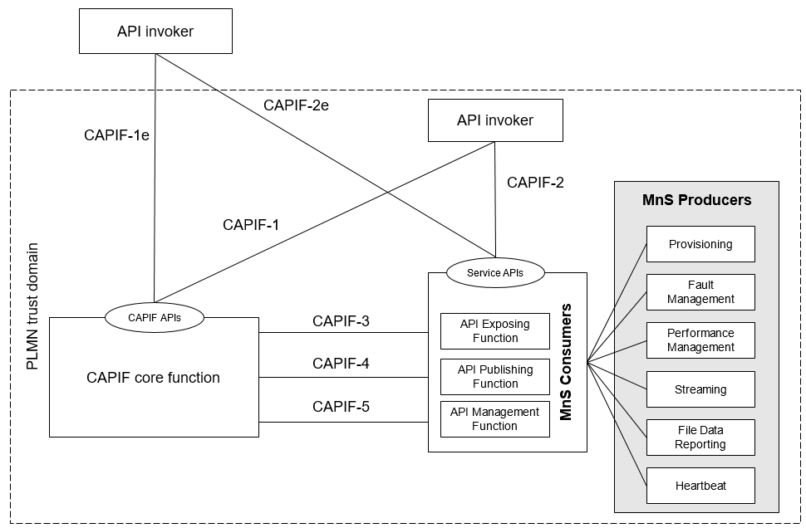
Figure 7.9.1-1: Exposure via CAPIF alternative 1
In this alternative, network slice management capability exposure provides faultMnS, fileDataReportingMnS, heartbeatNtf, perfMnS, provMnS, and streamingDataMnS as specified in in TS 28.532 [15].
Editor’s note: Whether network slice management capability exposure is affected by transforming the management service API to another service API is FFS.

7.9.2 Exposure via CAPIF alternative 2
This clause describes a potential solution where network slice management capability exposure is used in conjunction with a CAPIF core function (see TS 23.222 [14]) to expose management services to MnS consumers.

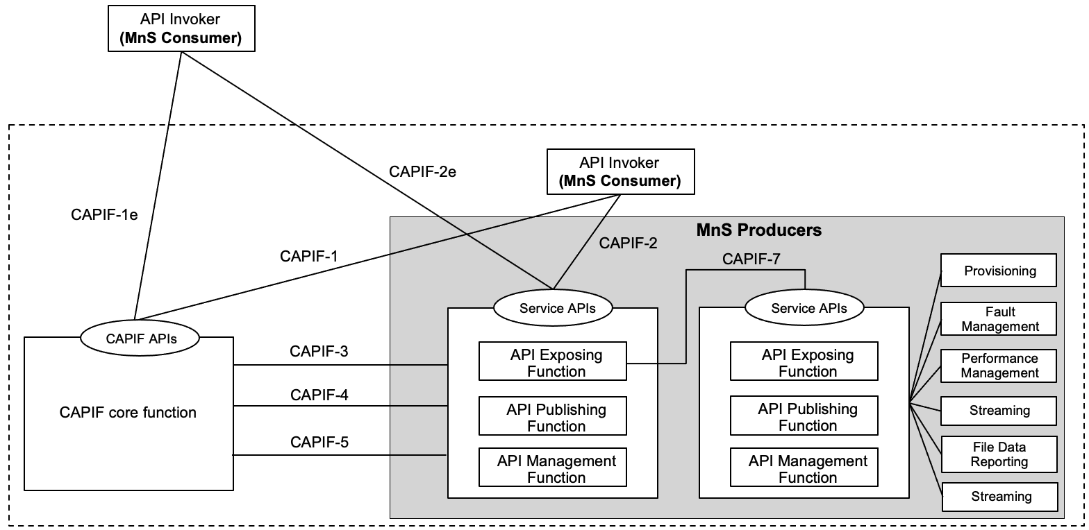
Figure 7.9.2-1: Exposure via CAPIF alternative 2
In this alternative, network slice management capability exposure consumes the interfaces at reference points CAPIF-3, CAPIF-4, and CAPIF-5 as defined in TS 23.222 [14]. It may be necessary to extend CAPIF-3/4/5 as defined in TS 23.222 [14] to support exposure of network slice management services.
Editor’s note: Whether it is necessary to extend CAPIF-3/4/5 is FFS.
In this alternative, network slice management capability exposure provides the interfaces at reference point CAPIF-2/2e. It may be necessary to extend CAPIF-2/2e as defined in TS 23.222 [14] to support network slice management capability exposure and authentication of MnS consumers.
In this alternative, MnS Consumers utilize the interfaces at reference point CAPIF-1/1e. It may be necessary to extend CAPIF-1/1e as defined in TS 23.222 [14] to support network slice management capability exposure and authorization/authentication of MnS consumers.
Editor’s note: Whether network slice management capability exposure is affected by transforming the management service API to another service API is FFS.
Table7.9.2-1 shows the exposed services proviced by CAPIF and the potential MnS that can be implemented within the exposed services for alternative 2. In addition, extension of CAPIF interface may be needed to achieve certain functionalities in the context of network slice management capability expousre.
Table 7.9.2-1 Interface description
Interface | Exposed services | Supported by MnS
CAPIF 2/2e | - AEF_Security_API  Specified in TS 29.222 [11]  - Service APIs: (Fault management, File data reporting, Heartbeat, Performance management, Povisioning, Streaming) | - Authentication and authorization of MnS consumers is specified in TS 28.533 [11] clause 4.9.  - Service APIs (MnS): faultMnS, fileDataReportingMnS, heartbeatNtf, perfMnS, provMnS, and streamingDataMnS  Specified in in TS 28.532 [15]
CAPIF 3 | - CAPIF_Events_API  - CAPIF_Security_API  - CAPIF_Logging_API_Invocation_API  - CAPIF_Access_Control_Policy_API  Specified in TS 29.222 [11]  - Nchf_ConvergedCharging  Specified in TS 32.254 [13] | - Nchf_ConvergedCharging  Specified in TS 28.201 [18] and TS 28.202 [6]  Editor’s note: Access control for an MnS consumer, which is enforced by MnS producers is FFS.
CAPIF 4 | - CAPIF_Events_API  - CAPIF_Publish_Service_API  Specified in TS 29.222 [11] | - MnS Registry  Specified in TS 28.622 [17] and TS 28.623 [16].  - The ServiceAPIDescription for CAPIF_Publish_Service_API needs to be extended in the context of network slice management capability exposure. MnS data for expsoure contains mnsLabel, mnsType, mnsVersion and mnsAddress, MnS address can indicate a dedicated producer for exposing exposed MnS after authentication and authorization. The mnsAddress within MnS is specified in table 7.9.1-3.
CAPIF 5 | - CAPIF_Events_API  - CAPIF_Monitoring_API  - CAPIF_Auditing_API  - CAPIF_API_Provider_Management_API  Specified in TS 29.222 [11] | - The ServiceAPIDescription for CAPF_Events_API and CAPIF_Monitoring_API needs to be extended in the context of network slice management capability exposure. Management of MnS consumers includes the management of MnS consumer type and identity. The management of MnS consumer type and identity is for differentiate different access permission for different MnS consumer. The MnS consumer management information is specified in table 7.9.2-4.  - Auditing of the MnS producer is not specified
CAPIF 7 | - CAPIF_Routing_Info_API | - Routing information in CAPIF needs to be extended in the context of network slice management capability exposure. A dedicated producer obtains all the routing information of MnS producers, the routing information contains the address of MnS producers that produce the proper MnS (e.g. faultMnS, PerfMnS, etc). Detailed routing information is specified in table 7.9.3-3.

The routing information can be described as below:
Table 7.9.2-2 routing information
Attributes | Support | Cardinality | Description
Exposure routing information | O | 1…N | The routing information contains the address of MnS producers that produce the proper MnS (e.g. faultMnS, PerfMnS, etc).

The mnsAddress within MnsInfo can be described as below:
Table 7.9.2-3 mnsaddress information within MnsInfo
Attributes | Support | Cardinality | Description
mnsAddress | M | 1 | The MnS address for external MnS consumer indicates a dedicated producer for exposing exposed MnS after authentication and authorization. The dedicated producer obtains the MnS from corresponding MnS producer based on the routing information and exposes the MnS to the MnS consumer.

The MnS consumer management information can be described as below:
Table 7.9.2-4 MnS consumer management information
Attributes | Support | Cardinality | Description
MnSConsumerType | O | 1…N | It indicates the type of MnS consumer that requests for the exposure of the MnSs provided by MnS producer. The type of MnS consumer can be the external depending on the location of MnS consumer.  allowedValue: EXTERNAL,  INTERNAL
MnSConsumerID | O | 1…N | It indicates the Identifier of the MnS consumer that requests MnSs from the MnS producer.  The identifier of the MnS consumer canbe linked to certain catergory such as CAT1, CAT2, CAT3. each of the catergory can represents a set of MnSs that are allowed to be exposed to MnS exposure service consumer.  The format of the MnS exposure service consumer ID can use FQDN (See TS 21.003 clause 19.4.2.1).

7.9.3 Exposure via CAPIF alternative 3
This clause describes a potential solution where network slice management capability exposure implements a Common API Framework for 3GPP Northbound APIs (see TS 23.222 [14]) to expose management services to MnS consumers.

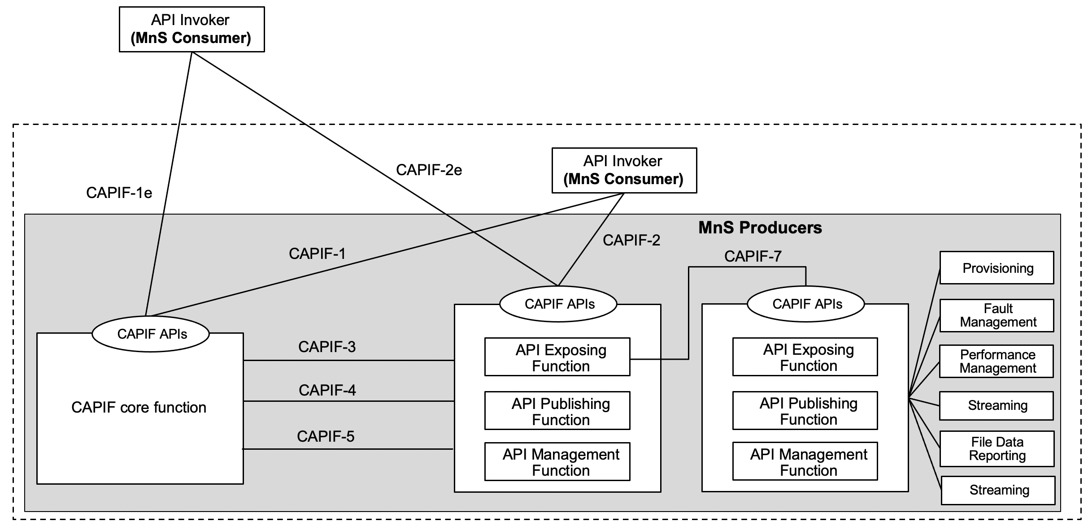
Figure 7.9.3-1: Exposure via CAPIF alternative 3
In this alternative, network slice management capability exposure may internally implement the interfaces at reference points CAPIF-3, CAPIF-4, and CAPIF-5 as defined in TS 23.222 [14] or may use non-standardized interfaces.
In this alternative, network slice management capability exposure provides the interfaces at reference point CAPIF-1/1e. It may be necessary to extend CAPIF-1/1e as defined in TS 23.222 [14] to support authorization/authentication of MnS consumers and discovery of MnS producers.
In this alternative, network slice management capability exposure provides the interfaces at reference point CAPIF-2/2e. It may be necessary to extend CAPIF-2/2e as defined in TS 23.222 [14] to support network slice management capability exposure and authentication of MnS consumers.
Editor’s note: Whether network slice management capability exposure is affected by transforming the management service API to another service API is FFS.
Table7.9.3-1 shows the exposed services proviced by CAPIF and the potential MnS that can be implemented within the exposed services for alternative 2. In addition, extension of CAPIF interface may be needed to achieve certain functionalities in the context of network slice management capability expousre.
Table 7.9.3-1 Interface description
Interface | Exposed services | Supported by MnS
CAPIF 1/1e | - CAPIF_Discover_Service_API  - CAPIF_Events_API  - CAPIF_API_Invoker_Management_API  - CAPIF_Security_API  Specified in TS 29.222 [11] | - Discovery of MnS(s) from MnS registry using ProvMnS  Specified in TS 28.622 [17], TS 28.623 [16], and TS 28.532 [15]  - The ServiceAPIDescription for CAPIF_Discover_Service_API needs to be extended in the context of network slice management capability exposure. MnS data for exposure contains mnsLabel, mnsType, mnsVersion and mnsAddress, MnS address can indicate a dedicated producer for exposing exposed MnS after authentication and authorization. The mnsAddress within MnS is specified in table 7.9.1-3.  - Management of MnS consumers includes the the management of MnS consumer type and identity. The management of MnS consumer type and identity is for differentiating different access permission for different MnS consumer. The MnS consumer management information is specified in table 7.9.3-2.
CAPIF 2/2e | - AEF_Security_API  Specified in TS 29.222 [11]  - Service APIs: (Fault management, File data reporting, Heartbeat, Performance management, Povisioning, Streaming) | - Authentication and authorization of MnS consumers is specified in TS 28.533 [11] clause 4.9  - Service APIs (MnS): faultMnS, fileDataReportingMnS, heartbeatNtf, perfMnS, provMnS, and streamingDataMnS  Specified in in TS 28.532 [15]
CAPIF 3 | - CAPIF_Events_API  - CAPIF_Security_API  - CAPIF_Logging_API_Invocation_API  - CAPIF_Access_Control_Policy_API  Specified in TS 29.222 [11]  - Nchf_ConvergedCharging  Specified in TS 32.254 [13] | - Nchf_ConvergedCharging  Specified in TS 28.201 [18] and TS 28.202 [6]  Editor’s note: Access control for an MnS consumer, which is enforced by MnS producers is FFS.
CAPIF 4 | - CAPIF_Events_API  - CAPIF_Publish_Service_API  Specified in TS 29.222 [11] | - MnS Registry  Specified in TS 28.622 [17] and TS 28.623 [16]
CAPIF 5 | - CAPIF_Events_API  - CAPIF_Monitoring_API  - CAPIF_Auditing_API  - CAPIF_API_Provider_Management_API  Specified in TS 29.222 [11] | - The ServiceAPIDescription for CAPF_Events_API and CAPIF_Monitoring_API needs to be extended in the context of network slice management capability exposure. Management of MnS consumers includes the the management of MnS consumer type and identity. The management of MnS consumer type and identity is for differentiate different access permission for different MnS consumer. The MnS consumer management information is specified in table 7.9.3-2.  - Auditing of the MnS producer is not specified
CAPIF 7 | - CAPIF_Routing_Info_API | - Routing information in CAPIF needs to be extended in the context of network slice management capability exposure. A dedicated producer obtains all the routing information of MnS producers, the routing information contains the address of MnS producers that produce the proper MnS (e.g. faultMnS, PerfMnS, etc). Detailed routing information is specified in table 7.9.3-3.

The mnsAddress within MnsInfo can be described as below:
Table 7.9.3-1 mnsaddress information within MnsInfo
Attributes | Support | Cardinality | Description
mnsAddress | M | 1 | The MnS address for external MnS consumer indicates a dedicated producer for exposing exposed MnS after authentication and authorization. The dedicated producer obtains the MnS from corresponding MnS producer based on the routing information and exposes the MnS to the MnS consumer.

The MnS consumer management information can be described as below:
Table 7.9.3-2 MnS consumer management information
Attributes | Support | Cardinality | Description
MnSConsumerType | O | 1…N | It indicates the type of MnS consumer that requests for the exposure of the MnSs provided by MnS producer. The type of MnS consumer can be the external depending on the location of MnS consumer.  allowedValue: EXTERNAL,  INTERNAL
MnSConsumerID | O | 1…N | It indicates the identifier of the MnS consumer that requests MnSs from the MnS producer. The identifier of the MnS consumer canbe linked to certain catergory such as CAT1, CAT2, CAT3. each of the catergory can represents a set of MnSs that are allowed to be exposed to MnS exposure service consumer.  The format of the MnS exposure service consumer ID can use FQDN (See TS 21.003 clause 19.4.2.1).

The routing information can be described as below:
Table 7.9.3-3 routing information
Attributes | Support | Cardinality | Description
Exposure routing information | O | 1…N | The routing information contains the address of MnS producers that produce the proper MnS (e.g. faultMnS, PerfMnS, etc).

End of changes

