3GPP TSG-SA5 Meeting #142-e S5-222534

e-meeting, 4 - 12 April 2022
CR-Form-v12.1
CHANGE REQUEST
 | 28.531 | CR | DraftCR | rev | - | Current version: | 17.3.0
For HELP on using this form: comprehensive instructions can be found at
http://www.3gpp.org/Change-Requests.

Proposed change affects: | UICC apps |  | ME |  | Radio Access Network | X | Core Network | X

Title: | Add asynchronous network slicing provisioning procedures
Source to WG: | Ericsson
Source to TSG: | S5
Work item code: | eNETSLICE_PRO |  |  |  |  |  | Date: |  |  | 2022-03-25
Category: | B |  |  |  |  |  | Release: |  |  | Rel-17
 | Use one of the following categories:  F (correction)  A (mirror corresponding to a change in an earlier release)  B (addition of feature),  C (functional modification of feature)  D (editorial modification)  Detailed explanations of the above categories can  be found in 3GPP TR 21.900. |  |  |  |  |  |  |  | Use one of the following releases:  Rel-8 (Release 8)  Rel-9 (Release 9)  Rel-10 (Release 10)  Rel-11 (Release 11)  …  Rel-15 (Release 15)  Rel-16 (Release 16)  Rel-17 (Release 17)  Rel-18 (Release 18)
Reason for change: |  | The current procedures for network slicing are based on synchronous operations. In reality the procedures may take longer and the consumer has no information about the progress and status of the operation. A solution needs to be defined based on an asynchronous pattern.  For further background see also WID as well as discussion paper S5-222531.
Summary of change: |  | The procedures in clause 7 for allocation, deallocation and modification on both slice and slice subnet level are updated to use a common asynchronous pattern based on Job IOCs managed by generic provisioning operations from TS 28.532.  The main steps of each procedure (see ‘Background process’ block in each diagram) are not meant to be changed by this CR and only have some minor editorial updates.  Due to change to asynchronous pattern, the slicing-specific operations in clause 6 and corresponding stage 3 solutions in clause 9 are no longer used by any procedure and are therefore removed.
Consequences if not approved: |  | No asynchronous option is available for the network slicing provisioning procedures
Clauses affected: |  | 6.5.1, 6.5.2, 6.5.3, 6.5.4, 7.2, 7.3, 7.4, 7.5, 7.6, 7.7, 9,1, 9.2
 |  | Y | N
Other specs |  |  | X | Other core specifications |  |  |  | TS/TR ... CR ...
affected: |  |  | X | Test specifications |  |  |  | TS/TR ... CR ...
(show related CRs) |  |  | X | O&M Specifications |  |  |  | TS/TR ... CR ...
Other comments: |  | This draft CR covers only a specific set of procedures and is not meant to preclude addition of asynchronous solutions for other provisioning procedures by separate CRs.
This CR's revision history:

First Change

6.5. Operations of provisioning

6.5.1 Void

6.5.2 Void

6.5.3 Void

6.5.4 Void

6.5.5 AllocateNetwork operation

6.5.5.1 Description
This operation is invoked by allocateNetwork operation service consumer to request the provider to satisfy the network related requirements.

6.5.5.2 Input parameters
Parameter Name | Support Qualifier | Information Type / Legal Values | Comment
attributeListIn | M | LIST OF SEQUENCE< attribute name, attribute value> | This parameter specifies the network related requirements defined in ServiceProfile in Clause 6.3.3 in TS 28.541 [6].

6.5.5.3 Output parameters
Parameter name | Support Qualifier | Matching Information / Legal Values | Comment
serviceProfileId | M | String | A unique identifier of the network related requirements which have been supported by the allocated network.
status | M | ENUM (OperationSucceeded, OperationFailed) | An operation may fail because of a specified or unspecified reason.

Second Change

7 Provisioning procedures of networks and network slicing

7.1 General
The procedures of provisioning of 5G networks are listed in this following subclauses.

7.2 Procedure of Network Slice Instance Allocation
The Figure 7.2-1 illustrates the procedure of creating a new NSI or using an existing NSI to satisfy the required network slice related requirements.

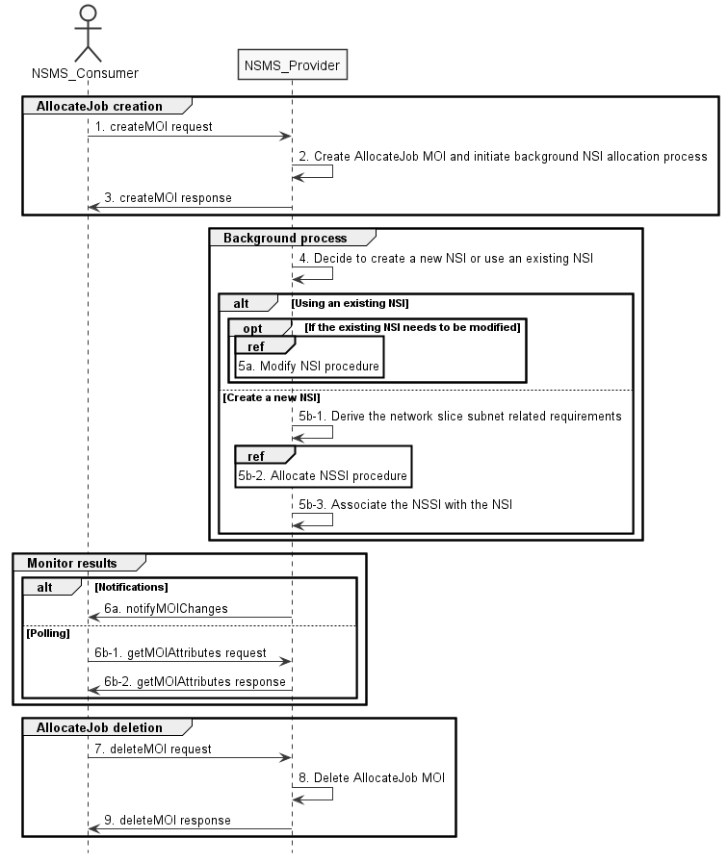
Figure 7.2-1: Network Slice Instance Allocation Request procedure
1) The Network Slice Management Service Provider (NSMS_Provider) receives an AllocateJob creation request (see createMOI operation defined in clause 11.1.1.1 in TS 28.532 [8]) from the Network Slice Management Service Consumer (NSMS_Consumer) with network slice related requirements (the network slice related requirements are defined as the writable attributes in the ServiceProfile see clause 6.3.3 in TS 28.541 [6]).
2) The NSMS_Provider creates an AllocateJob instance and initiates execution of a background NSI allocation process.
3) The NSMS_Provider sends an AllocateJob creation response (see createMOI operation defined in clause 11.1.1.1 in TS 28.532 [8]).
4) Based on the network slice related requirements and the knowledge of the capabilities of existing deployed network slices, the NSMS_Provider compare/match the provided requirements against all the candidate NetworkSlice instances, and then decides whether to use an existing NSI or create a new NSI. If the network slice related requirements allow the requested NSI to be shared and if an existing suitable NSI can be reused, the NSMS_Provider may decide to use the existing NSI.
5a) If using an existing NSI and the existing NSI needs to be modified to satisfy the network slice related requirements, the NSMS_Provider invokes the procedure to modify the existing NSI as described in clause 7.6.
5b-1) If creating a new NSI, the NSMS_Provider derives the network slice subnet related requirements from the received network slice related requirements. Before NSMS_Provider derives the network slice subnet related requirements, NSMS_Provider may invoke corresponding network slice subnet capability information querying procedure as described in clause 7.8.
5b-2) The NSMS_Provider invokes the NSSI allocation procedure as described in clause 7.3.
5b-3) The NSMS_Provider creates the MOI for NetworkSlice and configures the MOI with the DN of MOI for the NetworkSliceSubnet, other configuration information may be configured for the created MOI.
Note: The detailed configuration information is described in network slice NRM (see NetworkSlice IOC defined in clause 6.3.1 in TS 28.541 [6]).
6a) If the NSMS_Consumer has subscribed to MOI change notifications, the NSMS_Provider sends the NSI allocation result via notification (see notifyMOIChanges defined in clause 11.1.1.11 in TS 28.532 [8]) to the NSMS_Consumer. The notification will include updated AllocateJob attribute values that cover process status and if successful also additional outputs:
- DN of an existing or newly created NSI that has been selected to satisfy the network slice related requirements (see NetworkSlice IOC defined in clause 6.3.1 in TS 28.541 [6])

- ServiceProfile which has been allocated and the actual value assigned to each profile attribute, including serviceProfileId.
Otherwise the result may include the reason of failure, for example, the required latency or user number cannot be satisfied, or the physical resource is not enough.
Note: The NSMS_Producer may also update certain status attributes while the procedure is still in progress. Such updates would also trigger MOI change notifications to be sent in case a matching subscription has been configured.
6b-1) If the NSMS_Consumer has not subscribed to MOI change notifications, it may instead poll at regular intervals the status of the procedure as well as other MOI attributes of interest using a getMOIAttributes request (see clause 11.1.1.2 in TS 28.532 [8]).
6b-2) The NSMS_Producer will send a getMOIAttributes response including current values of the requested attributes (see clause 11.1.1.2 in TS 28.532 [8]).
7) When the NSMS_Consumer decides to delete the AllocateJob instance (e.g. after obtaining the allocation result), the NSMS_Consumer sends a job deletion request (see deleteMOI operation defined in clause 11.1.1.4 in TS 28.532 [8]) to the NSMS_Provider for the specific AllocateJob instance.
8) The NSMS_Provider deletes the specified AllocateJob instance.
9) The NSMS_Provider sends an AllocateJob deletion response (see deleteMOI operation defined in clause 11.1.1.4 in TS 28.532 [8]).

7.3 Procedure of Network Slice Subnet Instance Allocation
The Figure 7.3-1 illustrates the procedure of creating a new network slice subnet instance or using an existing network slice subnet instance to satisfy the required network slice subnet related requirements.

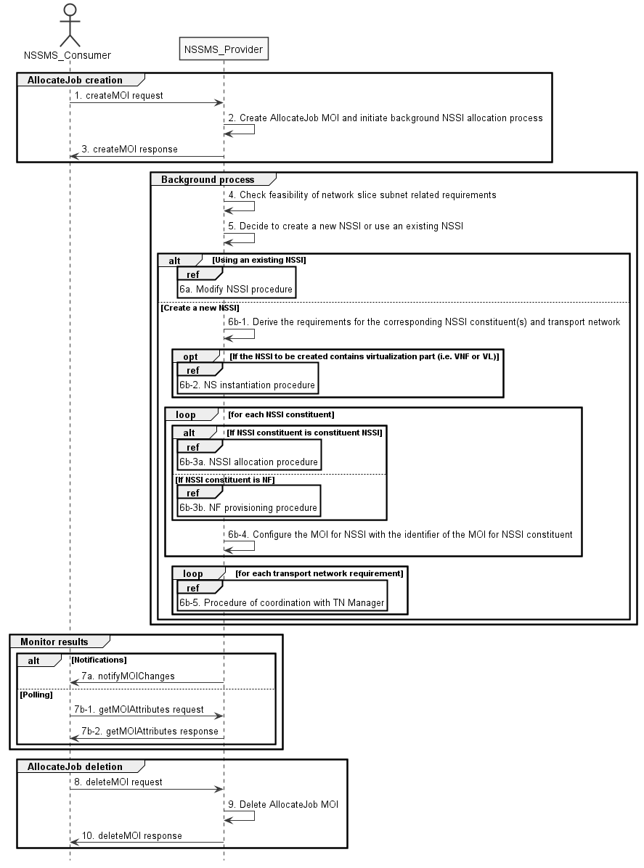
Figure 7.3-1: Network Slice Subnet Instance Allocation Request procedure
1) The Network Slice Subnet Management Service Provider (NSSMS_P) receives an AllocateJob creation request (see createMOI operation defined in clause 11.1.1.1 in TS 28.532 [8]) from the Network Slice Subnet Management Service Consumer (NSSMS_C) with network slice subnet related requirements (network slice subnet related requirements defined as the writable attributes in the SliceProfile see clause 6.3.4 in TS 28.541 [6]).
2) The NSSMS_Provider creates an AllocateJob instance and initiates execution of a background NSSI allocation process.
3) The NSSMS_Provider sends an AllocateJob creation response (see createMOI operation defined in clause 11.1.1.1 in TS 28.532 [8]).
4) The NSSMS_Provider checks the feasibility of network slice subnet related requirements. If the network slice subnet related requirements can be satisfied, the following steps 5) and 6) are needed, else go to step 7).
5) Based on the network slice subnet related requirements and the existing NSSI capabilities, the NSSMS_Provider decides whether to use an existing NSSI or create a new NSSI. If the network slice subnet related requirements allow the requested NSSI to be shared and if an existing suitable NSSI can be reused, the NSSMS_Provider decides to use the existing NSSI.
6a) If using an existing NSSI and the existing NSSI needs to be modified to satisfy the network slice subnet related requirements, the NSSMS_Provider invokes the procedure to modify the existing NSSI as described in clause 7.7.
6b-1) If creating a new NSSI, the NSSMS_Provider creates the NetworkSliceSubnet MOI. The NSSMS_Provider derives the corresponding network slice subnet constituent (i.e. NF, constituent NSS) related requirements and transport network related requirements (e.g. 3GPP endpoint information, latency requirements, bandwidth requirements and isolation requirements) from the received network slice subnet related requirements. Part of these requirements may be referenced by attribute "epTransportRef" as defined in clause 6.3.2.2 in TS 28.541[6]. Before NSSMS_Provider derives the constituent network slice subnet related requirements, NSMS_Provider may invoke corresponding network slice subnet capability information querying procedure as described in clause 7.8.2.
6b-2) If the NSSI to be created contains virtualisation part (i.e. VNF or VL), the NSSMS_Provider derives the NS instance instantiation information (the NS instance instantiation information is described in clause 7.3.2.2 and clause 7.3.3.2 [3]) based on network slice subnet related requirements. The NSSMS_Provider determines new VNF instance(s) that need to be deployed and the existing VNF instance(s) that need to be reused according to the necessary network function(s) and then derives the profile of virtual link(s) according to the connection requirements between the network functions. The NSSMS_Provider chooses a proper NSD deployment flavour and creates data concerning the SAPs of the NS instance. The NSSMS_Provider invokes the NS instantiation procedures to create a NS instance. The NSSMS_Provider configures the NSS MOI with the NS instance identifier.
Note: NS instantiation procedure is described in TS 28.526 [7].
For each required NSSI constituent, the following steps 6b-3a), 6b-3b) and 6b-4) are needed:
6b-3a) If the required NSSI constituent is constituent NSSI, the NSSMS_Provider invokes NSSI Allocation Procedure.
6b-3b) If the required NSSI constituent is NF instance, the NSSMS_Provider invokes NF Creation Procedure as described in clause 7.10 or NF Modification Procedure as described in clause 7.11.
6b-4) The NSSMS_Provider configures the NetworkSliceSubnet MOI with the DN of the MOI for NSSI constituent (i.e. ManagedFunction MOI, NetworkSliceSubnet MOI).
6b-5) For each required transport network related requirements, the NSSMS_Provider invokes corresponding procedure of coordination with relevant TN Manager to handle the TN part as described in clause 7.9.
7a) If the NSSMS_Consumer has subscribed to MOI change notifications, the NSSMS_Provider sends the NSSI allocation result via notification (see notifyMOIChanges defined in clause 11.1.1.11 in TS 28.532 [8]) to the NSSMS_Consumer. The notification will include updated AllocateJob attribute values that cover process status and if successful also additional outputs:
- DN of an existing or newly created NSSI that has been selected to satisfy the network slice subnet related requirements (see NetworkSliceSubnet IOC defined in clause 6.3.2 in TS 28.541 [6])
- SliceProfile which has been allocated and the actual value assigned to each profile attribute, including sliceProfileId.

Otherwise the result may include the reason of failure, for example, the required latency or user Number cannot be satisfied, or the physical resouce is not enough.
Note: The NSSMS_Producer may also update certain status attributes while the procedure is still in progress. Such updates would also trigger MOI change notifications to be sent in case a matching subscription has been configured.
7b-1) If the NSSMS_Consumer has not subscribed to MOI change notifications, it may instead poll at regular intervals the status of the procedure as well as other MOI attributes of interest using a getMOIAttributes request (see clause 11.1.1.2 in TS 28.532 [8]).
7b-2) The NSSMS_Producer will send a getMOIAttributes response including current values of the requested attributes (see clause 11.1.1.2 in TS 28.532 [8]).
8) When the NSSMS_Consumer decides to delete the AllocateJob instance (e.g. after obtaining the allocation result), the NSSMS_Consumer sends a job deletion request (see deleteMOI operation defined in clause 11.1.1.4 in TS 28.532 [8]) to the NSSMS_Provider for the specific AllocateJob instance.
9) The NSSMS_Provider deletes the specified AllocateJob instance.
10) The NSSMS_Provider sends an AllocateJob deletion response (see deleteMOI operation defined in clause 11.1.1.4 in TS 28.532 [8]).

7.4 Procedure of Network Slice Instance Deallocation
Figure 7.4-1 depicts the procedure of deallocating a network slice instance by the network slice management service provider to satisfy the NSI deallocation request received from an authorized consumer.

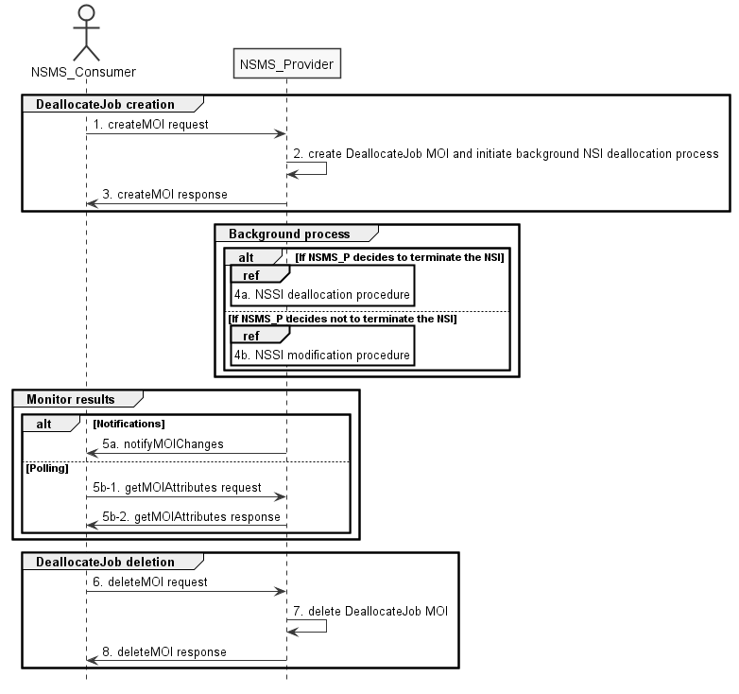
Figure 7.4-1: Network slice instance deallocation procedure
1) The Network Slice Management Service Provider (NSMS_Provider) receives a DeallocateJob creation request (see createMOI operation defined in clause 11.1.1.1 in TS 28.532 [8]) from the Network Slice Management Service Consumer (NSMS_Consumer) indicating that the NetworkSlice MOI is no longer needed for the given requirements i.e ServiceProfile.

2) The NSMS_Provider creates a DeallocateJob instance and initiates execution of a background NSI deallocation process.
3) The NSMS_Provider sends a DeallocateJob creation response (see createMOI operation defined in clause 11.1.1.1 in TS 28.532 [8]).
4a) The NSMS_Provider may decide to terminate the NSI, then it invokes the NSSI deallocation procedure as described in clause 7.5.
4b) The NSMS_Provider may decide not to terminate the NSI but to modify the NSI, then it invokes the NSI modification procedure as described in clause 7.6.
5a) If the NSMS_Consumer has subscribed to MOI change notifications, the NSMS_Provider sends the NSI deallocation result via notification (see notifyMOIChanges defined in clause 11.1.1.11 in TS 28.532 [8]) to the NSMS_Consumer.
Note: The NSMS_Producer may also update certain status attributes while the procedure is still in progress. Such updates would also trigger MOI change notifications to be sent in case a matching subscription has been configured.
5b-1) If the NSMS_Consumer has not subscribed to MOI change notifications, it may instead poll at regular intervals the status of the procedure as well as other MOI attributes of interest using a getMOIAttributes request (see clause 11.1.1.2 in TS 28.532 [8]).
5b-2) The NSMS_Producer will send a getMOIAttributes response including current values of the requested attributes (see clause 11.1.1.2 in TS 28.532 [8]).
6) When the NSMS_Consumer decides to delete the DeallocateJob instance (e.g. after obtaining the deallocation result), the NSMS_Consumer sends a job deletion request (see deleteMOI operation defined in clause 11.1.1.4 in TS 28.532 [8]) to the NSMS_Provider for the specific DeallocateJob instance.
7) The NSMS_Provider deletes the specified DeallocateJob instance.
8) The NSMS_Provider sends a DeallocateJob deletion response (see deleteMOI operation defined in clause 11.1.1.4 in TS 28.532 [8]).

7.5 Procedure of network slice subnet instance deallocation
Figure 7.5-1 depicts the procedure of deallocating a network slice subnet instance by the network slice subnet management service provider to satisfy the NSSI deallocation request received from an authorized consumer.

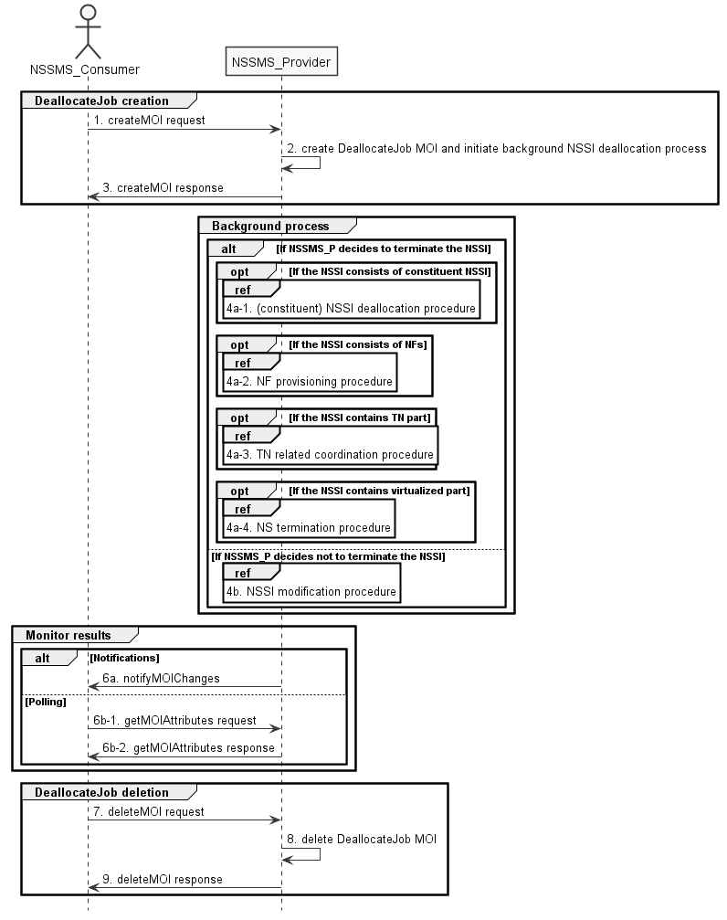
Figure 7.5-1: Network slice subnet instance deallocation procedure
1) The Network Slice Subnet Management Service Provider (NSSMS_Provider) receives a DellocationJob creation request (see createMOI operation defined in clause 11.1.1.1 in TS 28.532 [8]) from the Network Slice Subnet Management Service Consumer (NSSMS_Consumer) indicating that the NetworkSliceSubnet MOI is no longer needed for the given requirements i.e SliceProfile.

2) The NSSMS_Provider creates a DeallocateJob instance and initiates execution of a background NSSI deallocation process.
3) The NSSMS_Provider sends a DeallocateJob creation response (see createMOI operation defined in clause 11.1.1.1 in TS 28.532 [8]).
4a-1) The NSSMS_Provider may decide to terminate the NSSI, it invokes (constituent) NSSI deallocation procedure as described in clause 7.5 if the NSSI consists of constituent NSSI.
4a-2) The NSSMS_Provider invokes NF deletion procedure as described in clause 7.12 only if the NF is dedicated for this NSSI and not being used by any other NSSI in the network, otherwise, the NSSMS_Provider invokes NF modification procedure as described in clause 7.11.
4a-3) The NSSMS_Provider invokes TN related coordination procedure with responsible manager as described in clause 7.9 if the NSSI consists of TN part.
4a-4) The NSSMS_Provider invokes NS termination procedure if the NSSI contains virtualized part.
Note: NS termination procedure is described in TS 28.526 [7].
4b) The NSSMS_Provider may decide not to terminate the NSSI, it invokes NSSI modification procedure as described in clause 7.7.
5a) If the NSSMS_Consumer has subscribed to MOI change notifications, the NSSMS_Provider sends the NSSI deallocation result via notification (see notifyMOIChanges defined in clause 11.1.1.11 in TS 28.532 [8]) to the NSSMS_Consumer.
Note: The NSSMS_Producer may also update certain status attributes while the procedure is still in progress. Such updates would also trigger MOI change notifications to be sent in case a matching subscription has been configured.
5b-1) If the NSSMS_Consumer has not subscribed to MOI change notifications, it may instead poll at regular intervals the status of the procedure as well as other MOI attributes of interest using a getMOIAttributes request (see clause 11.1.1.2 in TS 28.532 [8]).
5b-2) The NSSMS_Producer will send a getMOIAttributes response including current values of the requested attributes (see clause 11.1.1.2 in TS 28.532 [8]).
6) When the NSSMS_Consumer decides to delete the DeallocateJob instance (e.g. after obtaining the deallocation result), the NSSMS_Consumer sends a job deletion request (see deleteMOI operation defined in clause 11.1.1.4 in TS 28.532 [8]) to the NSSMS_Provider for the specific DeallocateJob instance.
7) The NSSMS_Provider deletes the specified DeallocateJob instance.
8) The NSSMS_Provider sends a DeallocateJob deletion response (see deleteMOI operation defined in clause 11.1.1.4 in TS 28.532 [8]).

7.6 Procedure of Network Slice Instance Modification
The Figure 7.6-1 illustrates the procedure of modifying an existing NSI.

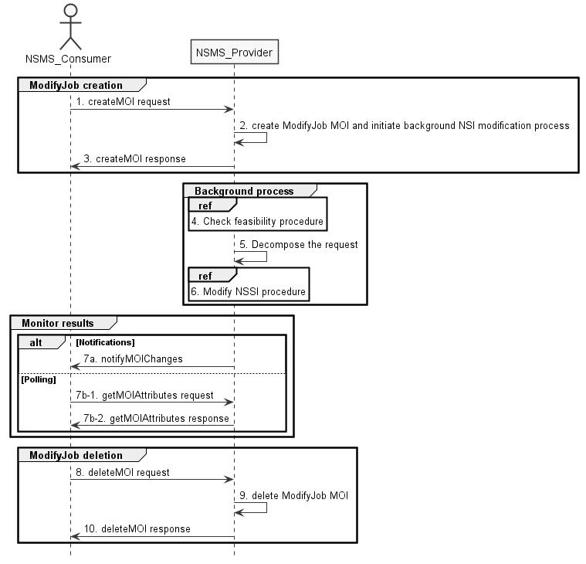
Figure 7.6-1: Network Slice Instance Modification Request procedure
1) The Network Slice Management Service Provider (NSMS_Provider) receives a ModifyJob creation request (see createMOI operation defined in clause 11.1.1.1 in TS 28.532 [8]) from the Network Slice Management Service Consumer (NSMS_Consumer) with the DN of NetworkSlice MOI and the new network slice related requirements (see ServiceProfile defined in clause 6.3.3 in TS 28.541[6]).
2) The NSMS_Provider creates a ModifyJob instance and initiates execution of a background NSI modification process.
3) The NSMS_Provider sends a ModifyJob creation response (see createMOI operation defined in clause 11.1.1.1 in TS 28.532 [8]).
4) Based on the new network slice related requirements, the NSMS_Provider invokes the feasibility check procedure. If the modification requirements can be satisfied, go to step 5), else go to step 7).
5) The NSMS_Provider decomposes the NetworkSlice MOI modification request into NSSI modification request(s), i.e., generating the new network slice subnet related requirements for each NSSI if needed.
6) The NSMS_Provider, as the role of Network Slice Subnet Management Service Consumer (NSSMS_Consumer), invokes the NSSI modification procedure.
7a) If the NSMS_Consumer has subscribed to MOI change notifications, the NSMS_Provider sends the NSI modification result via notification (see notifyMOIChanges defined in clause 11.1.1.11 in TS 28.532 [8]) to the NSMS_Consumer.
Note: The NSMS_Producer may also update certain status attributes while the procedure is still in progress. Such updates would also trigger MOI change notifications to be sent in case a matching subscription has been configured.
7b-1) If the NSMS_Consumer has not subscribed to MOI change notifications, it may instead poll at regular intervals the status of the procedure as well as other MOI attributes of interest using a getMOIAttributes request (see clause 11.1.1.2 in TS 28.532 [8]).
7b-2) The NSMS_Producer will send a getMOIAttributes response including current values of the requested attributes (see clause 11.1.1.2 in TS 28.532 [8]).
8) When the NSMS_Consumer decides to delete the ModifyJob instance (e.g. after obtaining the modification result), the NSMS_Consumer sends a job deletion request (see deleteMOI operation defined in clause 11.1.1.4 in TS 28.532 [8]) to the NSMS_Provider for the specific ModifyJob instance.
9) The NSMS_Provider deletes the specified ModifyJob instance.
10) The NSMS_Provider sends a ModifyJob deletion response (see deleteMOI operation defined in clause 11.1.1.4 in TS 28.532 [8]).

7.7 Procedure of Network Slice Subnet Instance Modification
The Figure 7.7-1 illustrates the procedure of modifying an existing NSSI.

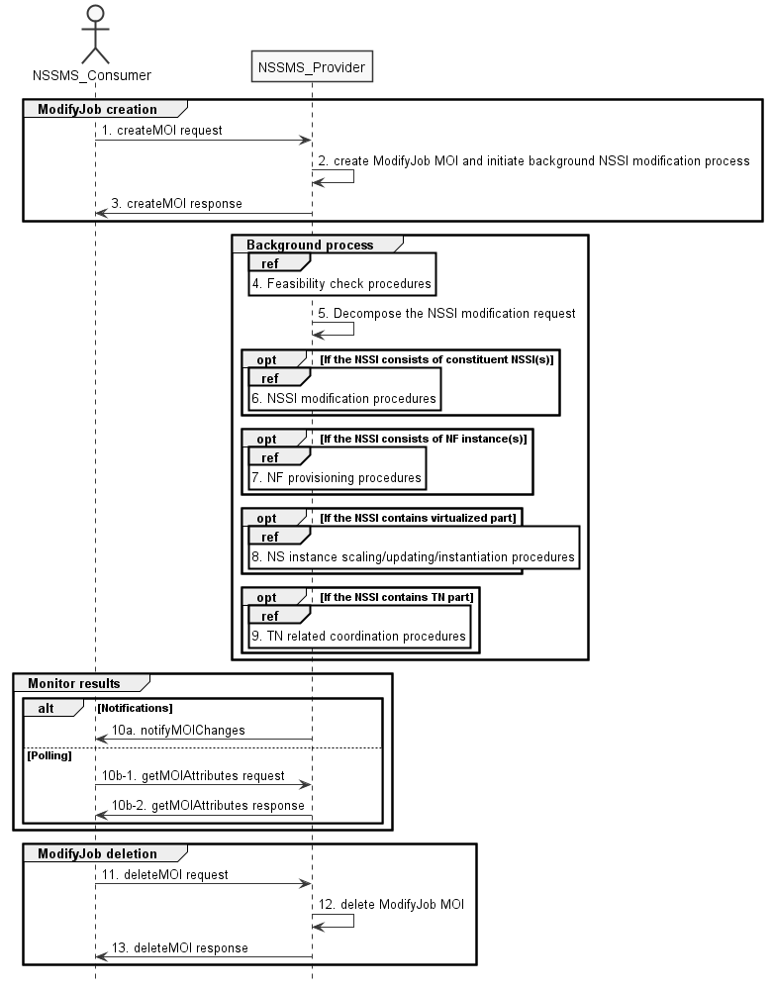
Figure 7.7-1: Network Slice Subnet Instance Modification Request procedure
1) The Network Slice Subnet Management Service Provider (NSSMS_Provider) receives a ModifyJob creation request (see createMOI operation defined in clause 11.1.1.1 in TS 28.532 [8]) from the Network Slice Subnet Management Service Consumer (NSSMS_Consumer) with the DN of NetworkSliceSubnet MOI and the new network slice subnet related requirements (see SliceProfile defined in clause 6.3.3 in TS 28.541[6]).
2) The NSSMS_Provider creates a ModifyJob instance and initiates execution of a background NSSI modification process.
3) The NSSMS_Provider sends a ModifyJob creation response (see createMOI operation defined in clause 11.1.1.1 in TS 28.532 [8]).
4) Based on the new network slice subnet related requirements, the NSSMS_Provider invokes the feasibility check procedure. If the modification requirements can be satisfied, go to step 5), else go to step 10).
5) The NSSMS_Provider decomposes the NetworkSliceSubnet MOI modification request into modification requests for each NSSI constituent.
6) If the requested NSSI constituent is constituent NSSI, the NSSMS_Provider invokes NSSI modification procedure as described in clause 7.7.
7) If the requested NSSI constituent is NF instance, the NSSMS_Provider invokes NF creation procedure as described in clause 7.10 or NF modification procedure as described in clause 7.11.
8) If the NSSI contains the virtualized part, the NSSMS_Provider invokes the NS instance scaling and/or NS instance updating and/or NS instance instantiation procedure as described in TS 28.526 [7].
9) If the NSSI contains the TN part, the NSSMS_Provider invokes the TN related coordination procedure as described in clause 7.9.
10a) If the NSSMS_Consumer has subscribed to MOI change notifications, the NSSMS_Provider sends the NSSI modification result via notification (see notifyMOIChanges defined in clause 11.1.1.11 in TS 28.532 [8]) to the NSSMS_Consumer.
Note: The NSSMS_Producer may also update certain status attributes while the procedure is still in progress. Such updates would also trigger MOI change notifications to be sent in case a matching subscription has been configured.
10b-1) If the NSSMS_Consumer has not subscribed to MOI change notifications, it may instead poll at regular intervals the status of the procedure as well as other MOI attributes of interest using a getMOIAttributes request (see clause 11.1.1.2 in TS 28.532 [8]).
10b-2) The NSSMS_Producer will send a getMOIAttributes response including current values of the requested attributes (see clause 11.1.1.2 in TS 28.532 [8]).
11) When the NSSMS_Consumer decides to delete the ModifyJob instance (e.g. after obtaining the modification result), the NSSMS_Consumer sends a job deletion request (see deleteMOI operation defined in clause 11.1.1.4 in TS 28.532 [8]) to the NSSMS_Provider for the specific ModifyJob instance.
12) The NSSMS_Provider deletes the specified ModifyJob instance.
13) The NSSMS_Provider sends a ModifyJob deletion response (see deleteMOI operation defined in clause 11.1.1.4 in TS 28.532 [8]).

7.8 Procedure of Obtaining Network Slice Subnet Capability

7.8.1 Introduction
The clause illustrates possible procedures of obtaining network slice subnet capability information (e.g. supported maximum latency, supported capacity (e.g. maximum user number)) of network slice subnet instance(s) which can be provided by network slice subnet management service provider.

7.8.2 Querying Network Slice Subnet Capability Information
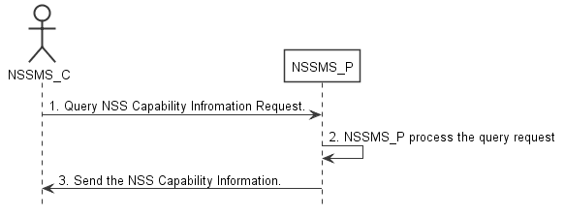
Figure 7.8-2: Procedure of querying network slice subnet capability information
1) Network Slice Subnet Management Service Consumer (NSSMS_C) wants to query the NSS capability information of the NSSI(s) which can be provided by corresponding Network Slice Subnet Management Service Consumer (NSSMS_P), NSSMS_C sends NSS capability querying request (see getMOIAttributes operation defined in TS 28.532 [8]) to NSSMS_P to obtain the NSS capability information of the NSSI(s) which can be provided by corresponding NSSMS_P.
2) NSSMS_P processes the NSS capability information querying request.
3) NSSMS_P sends the NSS capability information (e.g. supported maximum latency, supported capacity (e.g. user number)) of NSSI(s) that can be provided by itself (see getMOIAttributes operation defined in TS 28.532 [8]) to NSSMS_C.

7.8.3 Void

7.9 Procedure of TN coordination supporting network slicing

7.9.1 Introduction
This clause describes procedures of coordination with TN Manager to handle TN part supporting network slicing.
NOTE: The present document: addresses interactions with NFVO as TN manager,. interactions with other types of TN Manager (e.g. Optical, IP bearer transport network, etc.) have not been addressed.

7.9.2 Interaction with NFVO as TN Manager
This clause considers the procedure of interaction between the 3GPP management system and the NFVO, which behaves as TN Manager, to satisfy the TN related requirements for the virtual links used in NSSI. The procedure is applicable to creation and modification of the NSSI.
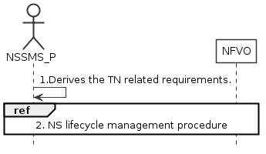
Figure 7.9.2-1: Interaction with NFVO as TN manager to support network slicing
1) Network Slice Subnet Management Service Provider (NSSMS_P) derives the TN related requirements (e.g. 3GPP endpoint information, latency requirements, bandwidth requirements, isolation requirements) for the TN part to be used in the NSSI.
2) To satisfy the TN related requirements NSSMS_P invokes the corresponding NS instance lifecycle management procedures as described in TS 28.526 [7].
3) After the NFVO executes the requested operation, it sends the corresponding notification to the NSSMS_P as described in TS 28.526 [7].

7.10 Procedure of NF instance creation
The Figure 7.10-1 illustrates the procedure of creating a new network function instance to satisfy the required network function related requirements.
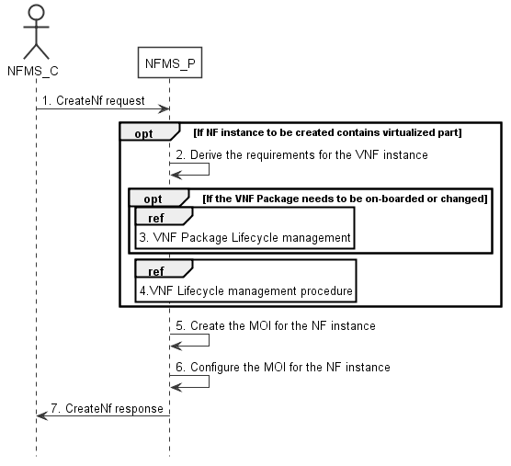
Figure 7.10-1: Network Function Instance Creation procedure
1) Network Function Management Service Provider (NFMS_P) receives a createMOI, for ManagedFunction IOC, request from Network Function Management Service Consumer (NFMS_C) with network function related requirements.
Note: The network function related requirements see information model definition for NR NRM in clause 4 and information model definition for 5GC NRM in clause 5 in TS 28.541[6] .
2) If NF instance to be created contains virtualized part, NFMS_P derives the requirements for VNF instance based on the network function related requirements.
3) If corresponding VNF Package needs to be on-boarded or changed, the NFMS_P invoke corresponding VNF Package management procedure as described in clause 4.3 in TS 28.526 [7].
4) The NFMS_P invokes VNF lifecycle management with requirements for VNF instance as descried in clause 4.2.2.2 in TS 28.526 [7].
5) The NFMS_P creates the MOI for the ManagedFunction to be created. If the ManagedFunction contains virtualized part, the NFMS_P may send the request of creating the MOI to the NFMS_P in the ManagedFunction.
6) The NFMS_P configures the new created MOI with corresponding configuration information (see information model definition for NR NRM in clause 4 and information model definition for 5GC NRM in clause 5 in TS 28.541[6]).
7) The NFMS_P sends the response to NFMS_C with DN of MOI and with identifier of NFMS_P which actually maintains the MOI for ManagedFunction.

7.11 Procedure of NF instance modification
The Figure 7.11-1 illustrates the procedure of modify NF instance.
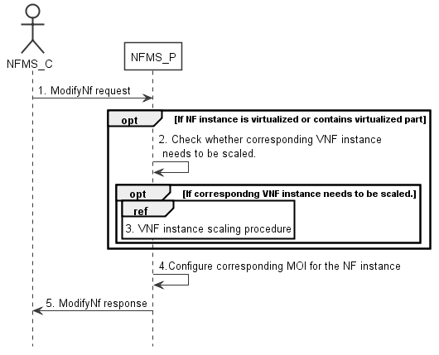
Figure 7.11-1: Network Function Instance Modify procedure
1) Network Function Management Service Provider (NFMS_P) receives a modifyMOIAttributes operation defined in TS 28.532 [8]from Network Function Management Service Consumer (NFMS_C) with DN of MOI for ManagedFunction and network function related requirements.
Note: The network funcation related requirements see information model definition for NR NRM in clause 4 and information model definition for 5GC NRM in clause 5 in TS 28.541[6].
2) If ManagedFunction instance contains virtualized part, NFMS_P checks whether corresponding VNF instance needs to be scaled to satisfy the network function related requirements.
3) If corresponding VNF instance needs to be scaled, NFMS_P invokes corresponding VNF instance scaling procedure as described in clause 4.2.3 in TS 28.526 [7].
4) NFMS_P reconfigures corresponding ManagedFunction MOI.
5) The NFMS_P sends the response (see modifyMOIAttributes operation defined in TS 28.532 [8]) to NFMS_C.

7.12 Procedure of NF instance deletion
The Figure 7.12-1 illustrates the procedure of deleting NF instance.
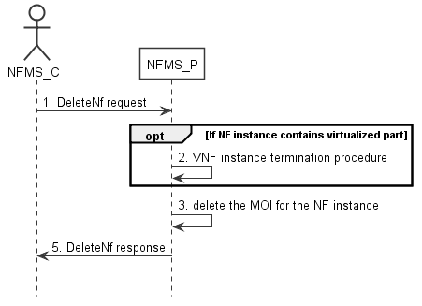
Figure 7.12-1: Network Function Instance Deletion procedure
1) Network Function Management Service Provider (NFMS_P) receives deletetMOI from Network Function Management Service Consumer (NFMS_C) with DN of ManagedFunction MOI.
2) If the ManagedFunction instance contains virtualized part, NFMS_P invokes VNF instance termination procedure as described in clause 4.2.4 in TS 28.526 [7].
3) NFMS_P deletes the ManagedFunction MOI.
4) NFMS_P sends the response (see deleteMOI operation defined in TS 28.532 [8]) to NFMS_C.

7.13 Procedure of reservation and checking feasibility of NSI
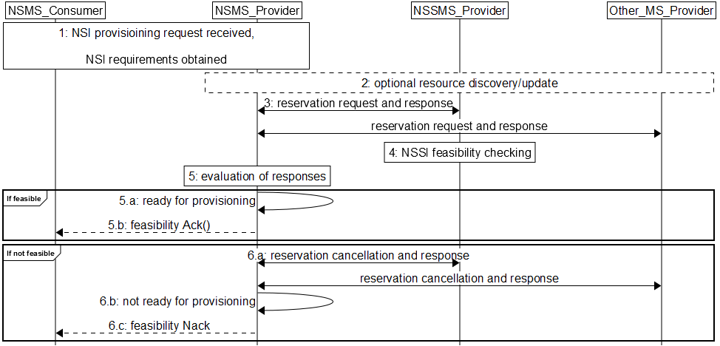
Figure 7.13-1 Network slice feasibility check procedure
1) Network Slice Management Service Provider (NSMS_Provider) receives a provisioning NSI request (e.g., AllocateNsi request (see AllocateNsi operation defined in clause 6.5.1), ModifyNsi request (see modifyMOIAttributes operation defined in TS 28.532 [8])) from Network Slice Management Service Consumer (NSMS_Consumer) with network slice related requirements (e.g. Area information, User Number, traffic demand, QoS Quality, whether the requested network slice instance could be shared).
2) [Optional] NSMS_Provider may request information and updates from NSSMS_Provider and Other_MS_Provider regarding the resources.
3) NSMS_Provider sends reservation requests to Network Slice Subnet Management Service Provider (NSSMS_Provider) and (if needed) Other Management Service Providers (Other_MS_Provider), e.g., MANO, TN manager. NSMS_Provider receives responses with information regarding allocated resources, e.g., their availability, identification information of reserved resources and so on.
4) A reservation request to NSSMS_Provider can trigger NSSI feasibility checking.
5) NSMS_Provider evaluates the responses to determine if the network slice requirements can be satisfied.
6) If feasible,
6.a) NSMS_Provider is ready for provisioning.
6.b) [Optional] Acknowledgement regarding reservation check results can be sent to NSMS_Customer.
7) If not feasible,
7.a) NSMS_Provider cancels reservations, optionally may receive acknowledgement.
7.b) NSMS_Provider is not ready for provisioning.
7.c) NSMS_Provider may send negative acknowledgement regarding results of reservation check to NSMS_Customer.

7.14 Procedure of reservation and checking feasibility of network slice subnet
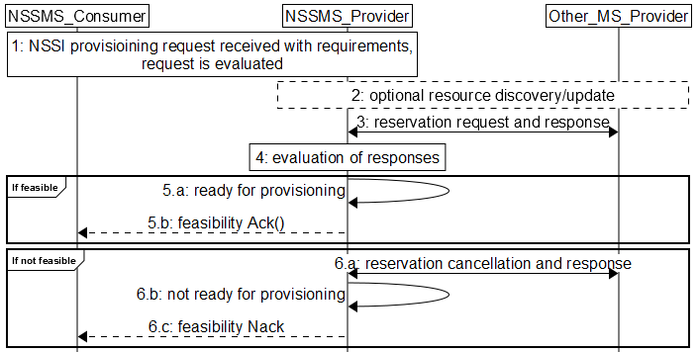
Figure 7.14-2 Network slice subnet feasibility check procedure
1) Network Slice Subnet Management Service Provider (NSSMS_Provider) receives a provisioning NSSI request (e.g., AllocateNssi request (see AllocateNssi operation defined in clause 6.5.2), ModifyNssi request (see modifyMOIAttributes operation defined in TS 28.532 [8])) from Network Slice Subnet Management Service Consumer (NSSMS_Consumer) with network slice subnet related requirements (e.g. Area information, User Number, traffic demand, QoS Quality, whether the requested network slice instance could be shared). The request is evaluated and initial resources to be allocated are identified.
2) [Optional] NSSMS_Provider may request information and updates from NSSMS_Provider and Other_MS_Provider regarding the resources.
3) NSSMS_Provider sends reservation requests to Other Management Service Providers (Other_MS_Provider), e.g., MANO, TN manager. NSSMS_Provider receives responses with information regarding reserved resources, e.g., their availability, identification information of reserved resources and so on.
4) NSSMS_Provider evaluates the responses to determine if the network slice subnet requirements can be satisfied.
5) If feasible:
5.a) NSSMS_Provider is ready for provisioning.
5.b) [Optional] Acknowledgement regarding reservation check results can be sent to NSSMS_Customer.
6) If not feasible,
6.a) NSSMS_Provider cancels reservations, optionally may receive acknowledgement.
6.b) NSSMS_Provider is not ready for provisioning.
6.c) NSSMS_Provider may send negative acknowledgement regarding results of reservation check to NSSMS_Customer.

7.15 Void

7.16 Procedure of allocating network with or without slicing for communication services
The Figure 7.16-1 illustrates the procedure of allocating network with or without slicing for communication services.
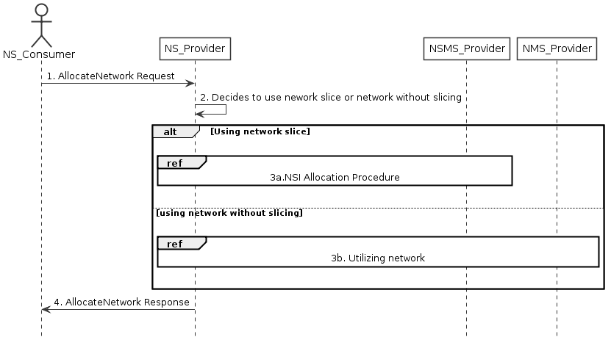
Figure 7.16-1 Allocating network with or without slicing for communication services
1) Network Service Provider (NS_Provider) receives AllocateNetwork request (see AllocateNetwork operation defined in clause 6.5.5) from Network Service Consumer (NS_Consumer). The received request includes network related service requirements (e.g. isolation, latency, coverage).
2) NS_Provider decides to use the network with or without slicing depending on these network related service requirements based on some internal admission control.
3) Based on the decision by NS_Provider:
3a) If NS_Provider decides to use a network with slicing, network slice instance allocation procedures in clause 7.2 follows. These procedures may result a new network slice to be created, or use an existing network slice with modification.
3b) If NS_Provider decides to use network without slicing, the network without slicing is utilized to satisfy the network related service requirements, there may be modification of the existing network or creation of a new network.
4) NS_Provider sends the AllocateNetwork response (see AllocateNetwork operation defined in clause 6.5.5) to NS_Consumer.

Third Change

9 RESTful HTTP-based solution set of provisioning

9.1 Void

9.2 Void

End of Changes

