3GPP TSG-SA5 Meeting #142-e S5-222464

e-meeting, 4 - 12 April 2022

Source: Huawei

Title: pCR TR 28.908 Add Key Issue of Model deployment for MDA

Document for: Approval
Agenda Item: 6.5.5

1 Decision/action requested
In this box give a very clear / short /concise statement of what is wanted.

References
[1] SP-211443 New Study on AI/ ML management
[2] 3GPP TS 28.104 Management and orchestration; Management Data Analytics (MDA)
[3] 3GPP TS 28.105 Management and orchestration; Artificial Intelligence / Machine Learning (AI/ML) management
[4] 3GPP TR 28.908 Study on Artificial Intelligence / Machine Learning (AI/ML) management

3 Rationale
The approved new SI [1] proposed to study the AI/ML management capabilities and management services to support/coordinate AI/ML in 5GS (3GPP management system, 5GC and NG-RAN). One of the AI/ML management capabilities is the deployment of AI/ML model, and Management Data Analytics (MDA) [2] is a typical AI/ML-enabled functions in 3GPP management system. This contribution proposes to add a key issue of model deployment for MDA.

4 Detailed proposal
It is proposed to add the following chapter in TR 28.908 [4].
1st modified section

X.Y Key Issue #XX: Model deployment for MDA

X.Y.1 Description
Management Data Analytics (MDA), as a key enabler of automation and intelligence, is considered a foundational capability for mobile networks and services management and orchestration. The MDA provides a capability of processing and analysing data related to network and service events and status. There is a possibility for MDA to be used in conjunction with AI/ML technologies. That is to say, the MDA can utilize historical management data and AI/ML model to generate analysis result as illustrated in Figure X.Y.1-1. To use the AI/ML technologies, the AI/ML model needs to be deployed in MDA.
This key issue studies how the AI/ML model is deployed to support MDA. The basic problem related to this key issue is where the AI/ML model comes from.
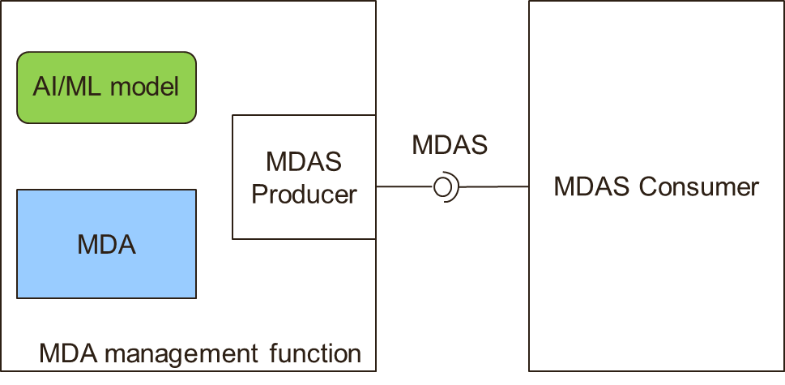
Figure X.Y.1-1: MDA with AI/ML utilization

End of modified section

