3GPP TSG-SA5 Meeting #142-e S5-222276rev1

e-meeting, 4 - 12 April 2022

Source: Huawei

Title: Update use case Exposure of network slice as a service

Document for: Approval
Agenda Item: 6.5.22

1 Decision/action requested
For approval

2 References
[1] 3GPP TR 28.824 V0.5.0 Study on network slice management capability exposure

3 Rationale
It is proposed to add a sub use case describing the exposure of network slice subnet as a service in clause 5.6. The new sub use case describes the scenario that the NSC can directly send eMnS consumption requests to NOP OSS/NML based on the service orders sent from NSC to NSP. In addition, it is proposed to remove the box with placeholder ‘EGMF’ in the Figure 5.6.1.1-1 and 5.6.1.1-2 as it is supposed to be shown in the corresponding solutions for use case 5.6.

4 Detailed proposal
This contribution proposes to make the following changes in [1].

1st change

5.6 Exposure of network slice as a service

5.6.1 Description
This use case involves the following roles:
- NSP: Network Slice Provider
- NSC: Network Slice Customer
- NOP: Network Operator
- CSC: Communication Service Customer
- CSP: Communication Service Provider
, and the following systems:
- BSS: Business Support System
- OSS: Operations Support System, made up of the two following sub-systems:
- SML: Service Management Layer
- NML: Network Management Layer (for sake of simplicity, network management and network element / function management are both in the NML).

5.6.1.1 Sub-use case 1: NSP and NOP play by the same organization
In this scenario, the following organizations play aforementioned roles as follows:
- Company-V, which has a contract with Company-A for the exposure directly via OSS, plays the role of NSC
- Company-A plays the role of NSP and NOP
- As NSP, it has:
- a BSS, e.g. to manage its customers, products, contracts, and
- a SML, to manage the services that support its products,
- As NOP, it has:
- its own 5G network (RAN + core). In this sub-use case, Company-A owns the whole set of network resources used by the service that can potentially support the service required by Company-V
- a NML, to manage the network resources used by services
NOTE: NSC may have connection with Company-A BSS for the product-level interaction. If not, the OSS/SML may have an embedded BSS functionalities for the product-level interaction.

5.6.1.1.1 Exposure via OSS/SML

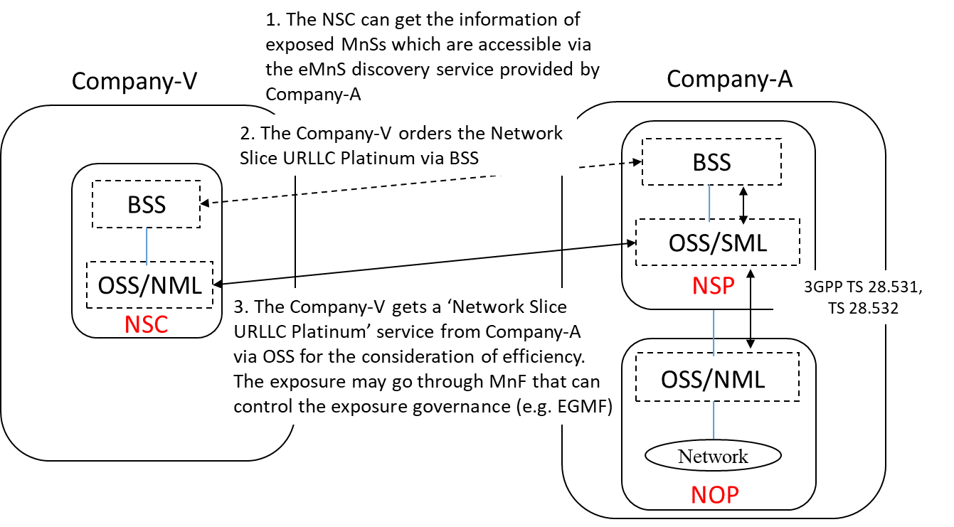
Figure 5.6.1.1.1 Sub-use case – NSP and NOP played by the same organization-exposure via OSS/SML

Company-A proposes the following product offering together with the exposure capability:
- Network Slice eMBB with the exposure capability of related KPI monitoring and alarm notification, etc.
In this sub-use case 1:
1. Company-V (as the NSC) gets the information regarding eMnSs that are available via the eMnS discovery service from the Company-A.
2. Company-V sends a request to Company-A (as the NSP) for the access to exposed MnS set ‘Network Slice eMBB’, which contains the exposure capabilities such as related KPI monitoring and alarm notification, etc. To achieve this, a candidate API is the interface with the MnF that controls the exposure governance (e.g. EGMF).
2.1 Company-A SML determines which service supports the exposed MnS being requested by Company-V.
2.2 Company-A OSS / SML sents a response, including the authentication materials (e.g. key, token) for access to the chosen exposed MnS.
3. The company-V can direct consume the exposed MnS (e.g. KPI monitoring and alarm notification) from SML of the Company-A’s 3GPP management system.

5.6.1.1.2 Exposure via OSS/NML
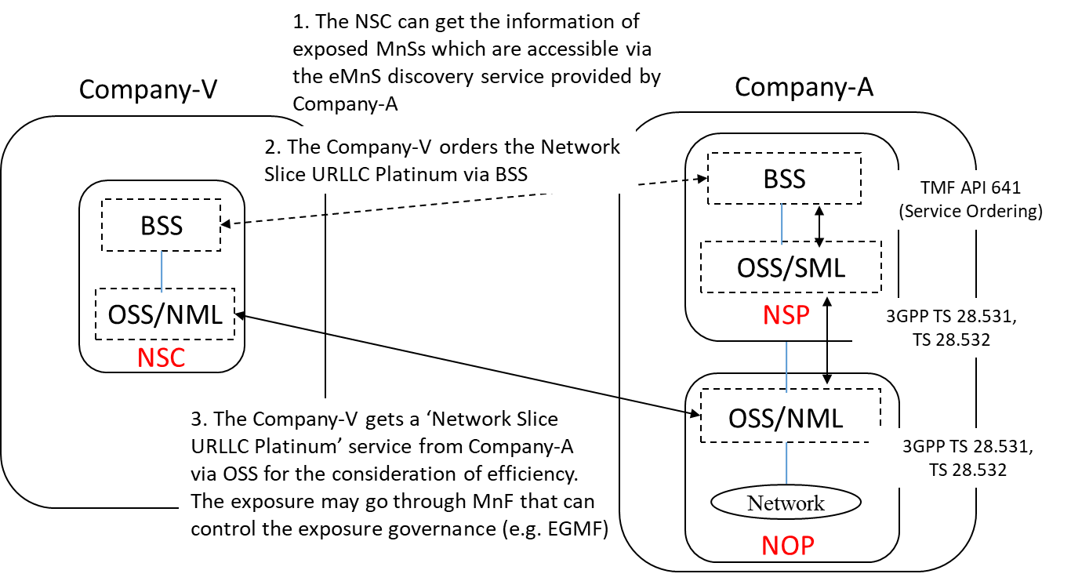
Figure 5.6.1.1.2 Sub-use case – NSP and NOP played by the same organization-exposure via OSS/NML
Company-A proposes the following product offering together with the exposure capability:
- Network Slice eMBB with the exposure capability of related KPI monitoring and alarm notification, etc.
In this sub-use case 1:
1. Company-V (as the NSC) gets the information regarding eMnSs that are available via the eMnS discovery service from the Company-A.
2. Company-V sends a request to Company-A (as the NSP) for the access to exposed MnS set ‘Network Slice eMBB’, which contains the exposure capabilities such as related KPI monitoring and alarm notification, etc. To achieve this, a candidate API is the interface with the MnF that controls the exposure governance (e.g. EGMF).
2.1 Company-A SML determines which service supports the exposed MnS being requested by Company-V.
2.2 Company-A OSS/SML transfers the request for accessing to the service that determined in step 2.1 to company-A OSS/NML.
2.3 Company-A OSS / NML sents a response, including the authentication materials (e.g. key, token) for access to the chosen exposed MnS.
3. The company-V can direct consume the exposed MnS (e.g. KPI monitoring and alarm notification) from NML of the Company-A’s 3GPP management system.
End of changes

