3GPP TSG-SA5 Meeting #142-e S5-222171

e-meeting, 4 - 12 April 2022
CR-Form-v12.1
CHANGE REQUEST
 | 28.622 | CR | DraftCR | rev | - | Current version: | 17.1.1
For HELP on using this form: comprehensive instructions can be found at
http://www.3gpp.org/Change-Requests.

Proposed change affects: | UICC apps |  | ME |  | Radio Access Network | X | Core Network | X

Title: | Rel-17 Input to DraftCR 28.622 Add data discovery NRM fragment
Source to WG: | Nokia, Nokia Shanghai Bell
Source to TSG: | S5
Work item code: | MADCOL |  |  |  |  |  | Date: |  |  | 2022-03-25
Category: | F |  |  |  |  |  | Release: |  |  | Rel-17
 | Use one of the following categories:  F (correction)  A (mirror corresponding to a change in an earlier release)  B (addition of feature),  C (functional modification of feature)  D (editorial modification)  Detailed explanations of the above categories can  be found in 3GPP TR 21.900. |  |  |  |  |  |  |  | Use one of the following releases:  Rel-8 (Release 8)  Rel-9 (Release 9)  Rel-10 (Release 10)  Rel-11 (Release 11)  …  Rel-15 (Release 15)  Rel-16 (Release 16)  Rel-17 (Release 17)  Rel-18 (Release 18)
Reason for change: |  | Requirements for data discovery are specified in TS 28.537. The stage 2 solution is still missing
Summary of change: |  | The stage 2 solution for data discovery is added.
Consequences if not approved: |  | The stage 2 solution for data discovery would be missing.
Clauses affected:
 |  | Y | N
Other specs |  |  | X | Other core specifications |  |  |  | TS/TR ... CR ...
affected: |  |  | X | Test specifications |  |  |  | TS/TR ... CR ...
(show related CRs) |  |  | X | O&M Specifications |  |  |  | TS/TR ... CR ...
Other comments:
This CR's revision history:

First modification

4.2.1 Relationships
This clause depicts the set of classes (e.g. IOCs) that encapsulates the information relevant for this IRP. This clause provides the overview of the relationships of relevant classes in UML. Subsequent clauses provide more detailed specification of various aspects of these classes.
The following figure shows the containment/naming hierarchy and the associations of the classes defined in the present document. See Annex A of a class diagram that combines this figure with Figure 1 of [2], the class diagram of UIM.
NOTE 1: ManagedElement may be contained either
- in a SubNetwork (since SubNetwork inherits from Domain_ and ManagedElement inherits from ManagedElement_ and Domain_ name-contained ManagedElement_ as observed in the figure of Annex A) or
- in a MeContext instance as observed by the above figure or in the figure of Annex A.
This either-or relation cannot be shown by using an {xor} constraint in the above figure.
ManagedElement may also have no parent instance at all.
NOTE 2: Void
NOTE 3: If the configuration contains several instances of SubNetwork, exactly one SubNetwork instance shall directly or indirectly contain all the other SubNetwork instances.
NOTE 4: The SubNetwork instance not contained in any other instance of SubNetwork is referred to as "the root SubNetwork instance".
NOTE 5: ManagementNode shall be contained in the root SubNetwork instance.
NOTE 6: If contained in a SubNetwork instance, MnsAgent shall be contained in the root SubNetwork instance.
NOTE 7: For a clarification on the choice of containment of the IRPAgent (since it has three possible parents), see the definition of MnsAgent.
NOTE 8: The MnsAgent shall be replaced by the IRPAgent in deployments using the IRP framework as defined in TS 32.102 [2].

Figure 4.2.1-1: NRM fragment
Each Managed Object is identified with a Distinguished Name (DN) according to 3GPP TS 32.300 [13] that expresses its containment hierarchy. As an example, the DN of a ManagedElement instance could have a format like:
SubNetwork=Sweden,MeContext=MEC-Gbg-1,ManagedElement=RNC-Gbg-1.

NOTE 8: Void
NOTE 9: Void
Figure 4.2.1-2: Vendor specific data container NRM fragment

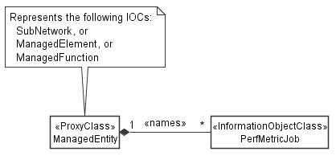

Figure 4.2.1-3: PM control NRM fragment

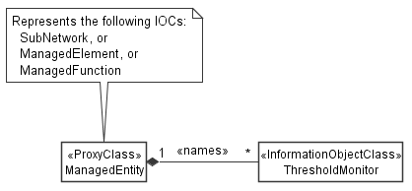

Figure 4.2.1-4: Threshold monitoring control NRM fragment

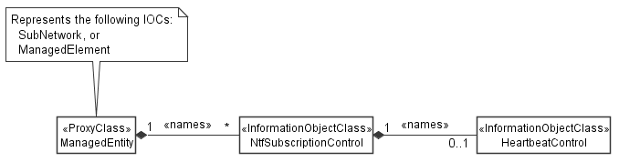

Figure 4.2.1-5: Notification subscription and heartbeat notification control NRM fragment

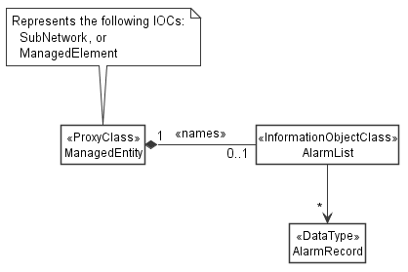

Figure 4.2.1-6: FM control NRM fragment

Figure 4.2.1-7: Trace control NRM fragment
Figure 4.2.1-8: MnS Registry NRM fragment

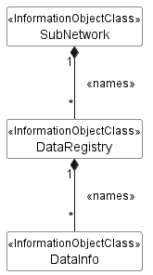
Figure 4.2.1-x: Data discovery NRM fragment

Next modification

4.2.2 Inheritance

This clause depicts the inheritance relationships.

Figure 4.2.2-1: NRM fragment

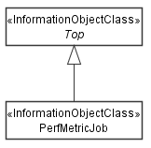

Figure 4.2.2-2: PM control NRM fragment

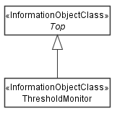

Figure 4.2.2-3: Threshold monitoring control NRM fragment

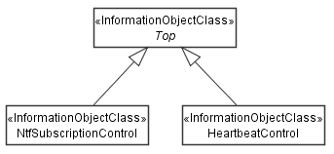

Figure 4.2.2-4: Notification subscription and heartbeat notification control NRM fragment

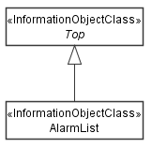
Figure 4.2.2-5: FM control NRM fragment

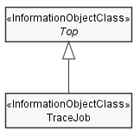
Figure 4.2.2-6: Trace control NRM fragment
Figure 4.2.2-7: MnS Registry NRM fragment

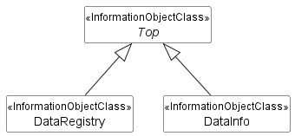
Figure 4.2.2-x: Data discovery NRM fragment

Next modification

4.3.X DataRegistry

4.3.X.1 Definition
This IOC represents all data types that can be produced by the Network Functions and Management Functions represented by the "SubNetwork" name-containing the "DataRegistry".

4.3.X.2 Attributes
The "DataRegistry" IOC includes the attributes inherited from Top IOC (defined in clause 4.3.29) and the following attributes.
Attribute name | S | isReadable | isWritable | isInvariant | isNotifyable

4.3.Y DataInfo

4.3.X.1 Definition
This IOC represents information related to a specific data type. A data type is identified with its "dataId".

4.3.X.2 Attributes
The "DataInfo" IOC includes the attributes inherited from "Top" IOC (defined in clause 4.3.29) and the following attributes.
Attribute name | S | isReadable | isWritable | isInvariant | isNotifyable
dataId | M | T | F | F | T
dataCategory | M | T | F | F | T
dataPurpose | O | T | F | F | T
dataIdSpecificInfo | M | T | F | T | F
relatedEntity | M | T | F | F | T
mnsProfileRefs | M | T | F | F | T

Editor's note: The following attribute definitions are provided for better readability not as part of the big attribute definitions table in clause 4.4.1. When approved, the rapporteur will move them to clause 4.4.1
Attribute Name | Documentation and Allowed Values | Properties
dataId | Data identifier  They are standardized or vendor/customer specific  Example:  For measurements defined in TS 28.552 the dataId is constructed as follows:  - "family.measurementName.subcounter" for measurement types with subcounters  - "family.measurementName" for measurement types without subcounters  - "family" for measurement families  For KPIs defined in TS 28.554 [28] the dataId is defined in the KPI definitions template as the component designated with e).  For trace metrics (including trace messages, MDT measurements (immediate MDT, logged MDT and logged MBSFN MDT), RLF reports, RCEF reports) the data identifier is defined in clause X in TS 32.422 [30]. Examples are:  - trace.amf.n1  - immediateMdt.nr.m2  - rlfReport  Editor's note: Data identifiers for trace metrics are introduced in the companion contribution S5-222208.  Editor's note: Data identifiers for Analytics need to be added once defined.  AllowedValues: N/A | type: String  multiplicity: 1  isOrdered: N/A  isUnique: N/A  defaultValue: None  isNullable: False
dataCategory | Data category. Each piece of data identified by its “dataId” belongs to a certain data category.  AllowedValues:  - PERFORMANCE_MEASUREMENT  - KPI  - MDT  - TRACE  - ANALYTICS | type: String  multiplicity: 1  isOrdered: N/A  isUnique: N/A  defaultValue: None  isNullable: False
dataPurpose | Data purpose. The data purpose indicates for which use case the data may provide value, such as mobility load balancing optimisation or throughput analysis.  AllowedValues: N/A | type: String  multiplicity: *  isOrdered: False  isUnique: True  defaultValue: None  isNullable: False
dataIdSpecificInfo | Info that is specific for each data category. For example, for performance measurements, this are the supported granularity periods.  Editor's note: The data types for each kind of data are ffs.  AllowedValues: N/A | type: CHOICE  multiplicity: 1  isOrdered: N/A  isUnique: N/A  defaultValue: None  isNullable: False
relatedEntity | Entity related to the data, such as a measured network function, a cell or a UE.  Editor's note: add some examples  AllowedValues: N/A | type: Dn  multiplicity: 1  isOrdered: N/A  isUnique: N/A  defaultValue: None  isNullable: False
mnsProfileRefs | References to “MnsInfo” instances, that allow to manage the collection of the data.  AllowedValues: N/A | type: Dn  multiplicity: *  isOrdered: False  isUnique: True  defaultValue: None  isNullable: False

End of modification

