3GPP TSG-SA5 Meeting #142-e S5-222130

e-meeting, 4 - 12 April 2022

Source: China Mobile

Title: pCR 28.312 Update procedures for intent management

Document for: Approval
Agenda Item: 6.6.3

1 Decision/action requested
The group is asked to discuss and approval.

2 References
[1] 3GPP draft TS 28.312: “Management and orchestration; Intent driven management services for mobile networks v1.0.0”.

3 Rationale
This contribution proposes to update clause 6.3 of TS 28.312[1], to resolve existing conflicts about intent feasibility in intent creation and modification procedures, and to add some clarification about method and enabling policy of feasibility check to improve the readability.

4 Detailed proposal
It proposes to make the following changes to TS 28.312[1].
1st Change

6.3 Procedures for intent management

6.3.1 Introduction
This clause describes the procedures for intent management.

6.3.2 Create an intent
The Figure 6.3.2-1 illustrates the procedure for create a new intent.

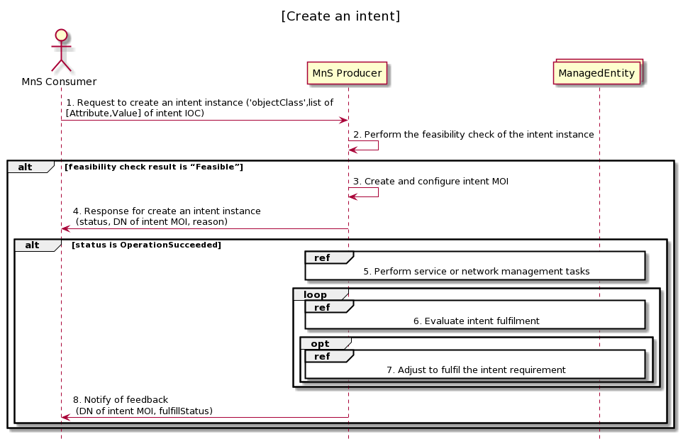

Figure 6.3.2-1 Procedure for create an intent
1. MnS Consumer sends a request to create an intent instance to MnS Producer with ‘objectClass’ and list of [Attribute,Value] for the new intent to be created. The detailed [Attribute,Value] see the concrete intent IOC defined in clause 6.2. ‘objectClass’ is the name for the concrete intent IOC.
2. MnS Producer perform the feasibility check of the intent instance. MnS Producer can perform the feasibility check and get the results based on latest statistics of network or service performance metrics, historical experience (e.g. experience based feasible value range or threshold of performance gain), current operating status including network resource utilization and availability, prediction results based on network simulation system, and predefined checking rules or policies.
Note: Whether to perform the feasibility check can be determined according to the feasibility check enabling policy (e.g. enforce to perform feasibility check in any case, enforce to perform feasibility check in specific cases, not to perform feasibility check in specific cases, not to perform feasibility check in any case). And the feasibility check enabling policy can be predefined/configured in the MnS Producer or sent with the intent creation request from the MnS Consumer.
If the feasibility check result is ‘feasible’,
3. Based on the request, the MnS Producer creates the concrete intent MOI (i.e. instance of intent IOC) with value for attribute ‘objectInstance’ allocated, and configure the new created intent MOI with the received list of [Attribute, Value]. ‘objectInstance’ is the identifier (DN) for the concrete intent MOI.
4. MnS Producer sends a response to the MnS Consumer with status (OperationSucceeded or OperationFailed) and ‘objectInstance’ of the created intent MOI. The response information may also include the possible reasons for the unsuccessful executions (e.g., conflicting with existing intents).
5. Based on the intent, MnS Producer identifies the MOI for managed entities (e.g. ManagedElement, ManagedFunction) and derives one or more executable management tasks (including deployment and configuration requirements) for these managed entities, then MnS producer deploys or configures corresponding managed entities to satisfy the intent.
6. During the execution of the intent, MnS Producer continuously monitors intent fulfilment status.
7. MnS Producer analyses and adjusts the managed entities to ensure the intent is continuously satisfied.
8. MnS Producer may notify MnS Consumer about the intent fulfilment information, including DN of intent MOI, and fulfillStatus.
If the feasibility check result is ‘infeasible’, MnS Producer does not create an intent MOI and feedback the feasibility check result information to MnS Consumer.

6.3.3 Modify an intent
The Figure 6.3.3-1 illustrates the procedure for modify an existing intent.

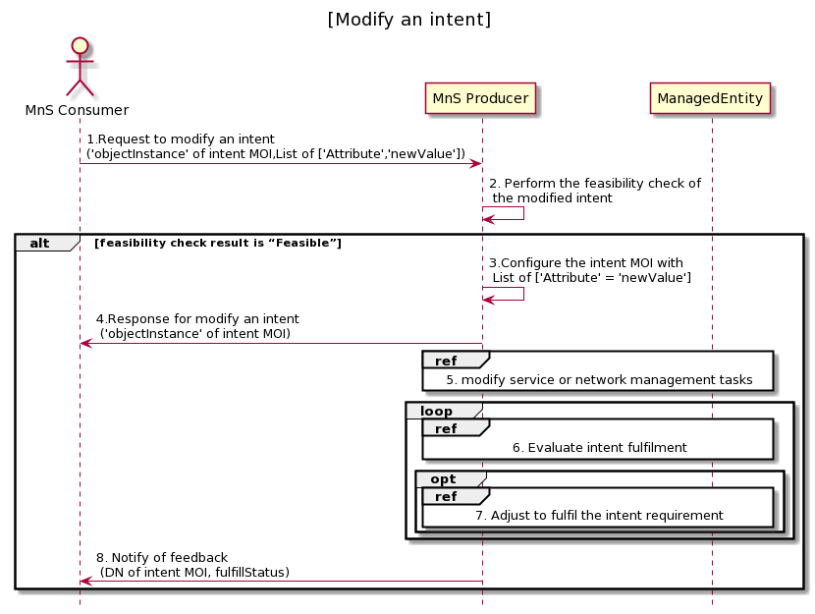
Figure 6.3.3-1: Procedure for modify an intent
1. MnS Consumer sends a request to modify an intent intsnace to MnS Producer with ‘objectInstance’ of the intent MOI and List of [‘Attrribute’, ‘newValue’] to be modified. The detailed [Attribute,Value] see the concrete intent IOC defined in clause 6.2.
2. MnS Producer perform the feasibility check of the modified intent instance. Whether to perform the feasibility check can be determined according to the feasibility check enabling policy.
If the feasibility check result is ‘feasible’,
3. Based on the request, MnS Producer configure the intent MOI with list of ‘Attribute’ = ’newValue’ which is required to be modified.
4. MnS Producer sends a response to the MnS consumer with status (OperationSucceeded or OperationFailed), and‘objectInstance’ of the modified intent MOI, and list of [‘Attribute’, ‘newValue’] which is modified. The response information may also include possible reasons for the unsuccessful executions (e.g., conflicting with other intents).
- MnS Producer derives one or more executable management tasks for these managed entities, then MnS producer deploys or configures corresponding managed entities to satisfy the intent.
- During the execution of the intent, MnS producer continuously tracks intent fulfilment status.
- MnS producer analyses and adjusts the managed entities to ensure the intent is continuously satisfied.
- MnS Producer may notify MnS Consumer about the intent fulfilment information, including DN of intent MOI, and fulfillStatus via notification or intent reporting.

If the feasibility check result is ‘infeasible’, MnS Producer does not modify the intent MOI and feedback the feasibility check result information to MnS Consumer.

End of Changes

