3GPP TSG-SA5 Meeting #140-e S5-216382

e-meeting, 15 - 24 November 2021

Source: Ericsson, Deutsche Telekom

Title: Add text to procedures related to management capability exposure

Document for: Approval
Agenda Item: 6.5.4

1 Decision/action requested
The group is asked to agree the text in detailed proposal.

2 References
Not applicable

3 Rationale
This contribution proposes update the procedures by adding descriptive text for the steps shown in the procedures. The following procedures are described by a sequence diagram:
- Procedure invoking internal service order after receiving product order from NSC
- Procedure invoking external product order after receiving product order from NSC
- Procedure invoking external service order after receiving product order from NSC
For each procedure an Editor’s Note states the following “The details and the description of the steps in the sequence diagram as well as the actual names of requests and responses are FFS”.
The following figures have been updated as follows:
- Figure 4.1.4.2.1 has been updated to include numbering of the steps in the procedure
- Figure 4.1.4.3.1 has been updated to include numbering of the steps in the procedure
- Figure 4.1.4.4.1 has been updated to include missing steps (step 2 and step 9) and renumbering of the steps in the procedure

4 Detailed proposal

First change

2 References
The following documents contain provisions which, through reference in this text, constitute provisions of the present document.
- References are either specific (identified by date of publication, edition number, version number, etc.) or non-specific.
- For a specific reference, subsequent revisions do not apply.
- For a non-specific reference, the latest version applies. In the case of a reference to a 3GPP document (including a GSM document), a non-specific reference implicitly refers to the latest version of that document in the same Release as the present document.
[1] 3GPP TR 21.905: "Vocabulary for 3GPP Specifications".
[2] TM Forum TMF622 Product Order API REST Specification
[3] TM Forum TMF641 Service Ordering API
[4] TM Forum TMF652 Resource Order Management API
[5] 3GPP TS 28.531: "Management and orchestration; Concepts, use cases and requirements"
[6] 3GPP TS 28.202: "Charging management; Network slice management charging in the 5G System (5GS); Stage 2"
[x] 3GPP TS 28.541: "Management and orchestration; 5G Network Resource Model (NRM); Stage 2 and stage 3"

Second change

4.1.4 Procedures related to consumption of exposed network management capabilities

4.1.4.1 Introduction
When an NSP receives an order from an NSC for a network slice enabled product, the order is decomposed by the NSP’s BSS. Depending if the NSP employs services from 3rd party CSP’s different procedures may apply for the same order. The different procedures applicable to the same order may be invoked asynchronously and treated as independent procedures, however it may not result in loss of traceability between the original order and the orders that are created as result of decomposition. The following procedures have been identified:
- Procedure invoking internal service order after receiving product order from NSC
- Procedure invoking external product order after receiving product order from NSC
- Procedure invoking external service order after receiving product order from NSC

4.1.4.2 Procedure invoking internal service order after receiving product order from NSC
The procedure for invoking a service order internal to the NSP after receiving a product order from an NSC is shown in 4.1.4.2.1. The interface through which the NSC can order a product from the NSP is on BSS level. The steps as shown in Figure 4.1.4.2.1 are described in the subsequent paragraphs.
Editor’s Note: The specific operations in the TM Forum specification and applicable use cases for resource order are FFS

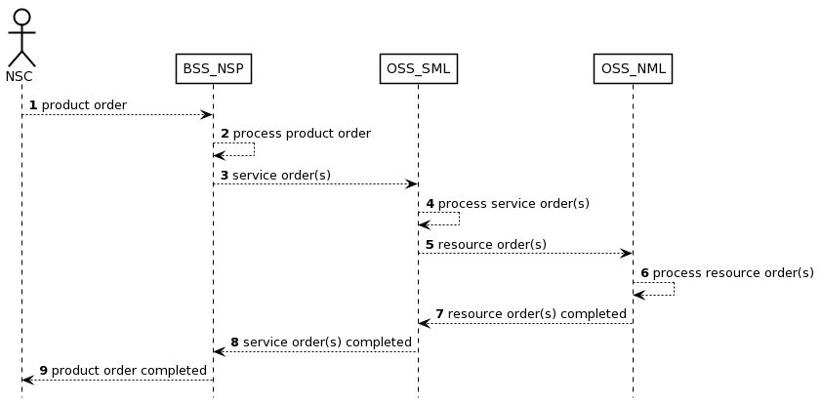
Figure 4.1.4.2.1 Procedure invoking internal service order after receiving product order from NSC

1) The NSP receives a product order from the NSC through the interface to BSS. The interface used towards the BSS is specified by TM Forum specifications [2].
2) The BSS processes the product order and when applicable converts it to appropriate service order(s) for the OSS Service Management Layer. This is internal to BSS and there are no interface requirements.
3) The OSS Service Management Layer receives a service order from the BSS. The interface used is specified by TM Forum specifications [3]
4) The MnS producer on the OSS Service Management Layer processes the service order and when applicable converts it to appropriate request(s) for the OSS Network Management Layer as requests for management and orchestration of resources. This is internal to the MnS producer on the OSS Service Management Layer and there are no interface requirements.
5) The OSS Network Management Layer receives a request from the MnS producer on the OSS Service Management Layer.

Editor’s Note: The interface to be used in step 5 is specified by TM Forum [4] and by 3GPP TS 28.531 [5], which one to use in which scenario is FFS.
6) The MnS producer on OSS Network Management Layer processes the request and when applicable converts it to appropriate request(s) for the network. An interface that may be used is specified by 3GPP TS 28.531 [5] and TS 28.541 [x].
7) The MnS producer on OSS Network Management Layer notifies the MnS producer on the OSS Service Management Layer that the resource order(s) have been completed.
Editor’s Note: The interface to be used in step 5 is specified by TM Forum [4] and by 3GPP TS 28.531 [5], which one to use in which scenario is FFS.
8) The MnS producer on OSS Service Management Layer notifies the BSS that the service order has been completed. The interface used is specified by TM Forum specifications [3]
9) The BSS notifies the NSC that the product order has been completed. The NSC may start using the services included in the product order. The interface used the interface towards the BSS is specified by TM Forum specifications [2].

4.1.4.3 Procedure invoking external product order after receiving product order from NSC
The procedure for invoking a product order external to the NSP after receiving a product order from an NSC is shown in 4.1.4.3.1. The interface through which the NSC can order a product from the NSP is on BSS level. The steps as shown in Figure 4.1.4.3.1 are described in the subsequent paragraphs.

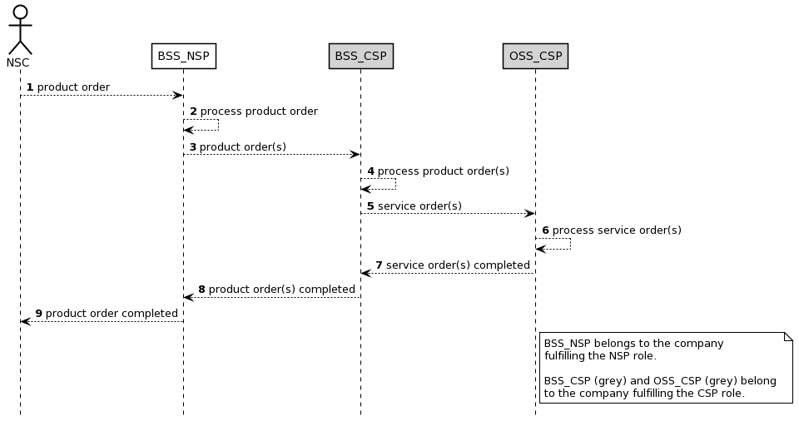
Figure 4.1.4.3.1 Procedure invoking external product order after receiving product order from NSC

1) The NSP receives a product order from the NSC through the interface to BSS. The interface used is specified by TM Forum specifications [2].
2) The NSP BSS processes the product order and when applicable converts it to appropriate product order(s) towards a 3rd party CSP BSS. This is internal to BSS and there are no interface requirements.
NOTE: When the BSS_NSP receives a product order the BSS_NSP splits the product order into service orders. A service order that can be fulfilled by the NSP will be processed by the NSP_OSS_SML (see also Figure 4.1.4.2.1) while a service order that cannot be fulfilled by NSP will be ordered from the CSP through a product order.

3) The CSP BSS receives a product order from the NSP BSS consumer. The interface used is specified by TM Forum specifications [2]
4) The CSP BSS processes the product order and when applicable converts it to appropriate service order(s) for the CSP OSS. This is internal to the BSS and there are no interface requirements.
5) The CSP OSS producer receives a service order from the CSP BSS. The interface used is specified by TM Forum specifications [3]
6) The CSP OSS producer processes the service order until the service order is completed.
7) The CSP OSS notifies the CSP BSS that the service order has been completed. The interface used is specified by TM Forum [3].
8) The CSP BSS notifies the NSP BSS that the product order has been completed. The interface used is specified by TM Forum [2].
9) The BSS notifies the NSC that the product order has been completed. The NSC may start using the services included in the product order.

4.1.4.4 Procedure invoking external service order after receiving product order from NSC
The procedure for invoking a service order external to the NSP after receiving a product order from an NSC is shown in 4.1.4.4.1. The interface through which the NSC can order a product from the NSP is on BSS level. The steps as shown in Figure 4.1.4.4.1 are described in the subsequent paragraphs.

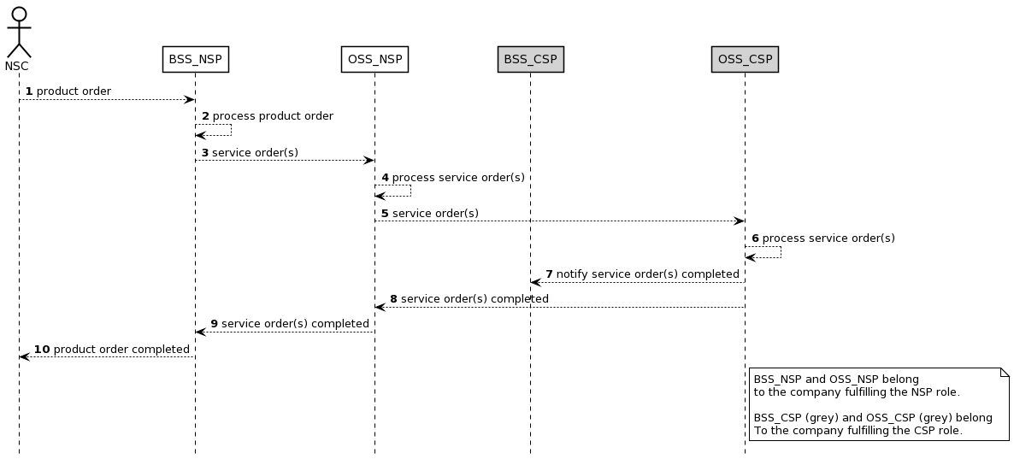
Figure 4.1.4.4.1 Procedure invoking external service order after receiving product order from NSC

1) The NSP receives a product order from the NSC through the interface to BSS. The interface used is specified by TM Forum specifications [2].
2) The NSP BSS processes the product order and when applicable converts it to appropriate service order(s) for the OSS producer. This is internal to BSS producer and there are no interface requirements.
3) The NSP OSS producer receives a service order from the NSP BSS. The interface used is specified by TM Forum specifications [3]
4) The OSS producer processes the service order and when applicable converts it to appropriate service order(s) for a 3rd party CSP OSS. This is internal to the OSS producer and there are no interface requirements.
5) The CSP OSS producer receives a service order from the NSP OSS producer. The interface used is specified by TM Forum specifications [3]
6) The CSP OSS producer processes the service order until the service order is completed. This is internal to the OSS producer and there are no interface requirements
7) The CSP OSS notifies the CSP BSS that the service order has been completed. The interface used is specified by 3GPP [6].
8) The CSP OSS notifies the NSP OSS producer (may occur at the same time as or before step 7) that the service order has been completed. The interface used is specified by 3GPP [3].
9) The NSP BSS notifies the NSC that the product order has been completed. The NSC may start using the services included in the product order.

Second change

Annex A (informative):
Appendix with UML code of the sequence diagrams

A.1 UML code for Figure 4.1.4.2.1
@startuml
skinparam sequence {
ArrowColor Black
ActorBorderColor Black
ActorBackgroundColor White
ParticipantBorderColor Black
ParticipantBackgroundColor White
LifeLineBorderColor Black
BackGroundColor <<BSS_Prov>> Black
}
skinparam NoteBackgroundColor White
skinparam NoteBorderColor Black
skinparam shadowing false
hide footbox
autonumber

actor NSC
participant BSS_NSP
participant OSS_SML
participant OSS_NML

NSC --> BSS_NSP : product order
BSS_NSP --> BSS_NSP : process product order
BSS_NSP --> OSS_SML : service order(s)
OSS_SML --> OSS_SML : process service order(s)
OSS_SML --> OSS_NML : resource order(s)
OSS_NML --> OSS_NML : process resource order(s)

OSS_SML <-- OSS_NML : resource order(s) completed
BSS_NSP <-- OSS_SML : service order(s) completed
NSC <-- BSS_NSP : product order completed
@enduml

A.2 UML code for Figure 4.1.4.3.1
@startuml
skinparam sequence {
ArrowColor Black
ActorBorderColor Black
ActorBackgroundColor White
ParticipantBorderColor Black
ParticipantBackgroundColor White
LifeLineBorderColor Black
BackGroundColor <<BSS_Prov>> Black
}
skinparam NoteBackgroundColor White
skinparam NoteBorderColor Black
skinparam shadowing false
hide footbox
autonumber

actor NSC
participant BSS_NSP
participant BSS_CSP #lightgrey
participant OSS_CSP #lightgrey

NSC --> BSS_NSP : product order

BSS_NSP --> BSS_NSP : process product order
BSS_NSP --> BSS_CSP : product order(s)
BSS_CSP --> BSS_CSP : process product order(s)
BSS_CSP --> OSS_CSP : service order(s)
OSS_CSP --> OSS_CSP : process service order(s)
BSS_CSP <-- OSS_CSP : service order(s) completed
BSS_NSP <-- BSS_CSP : product order(s) completed

NSC <-- BSS_NSP : product order completed

note right of OSS_CSP
BSS_NSP belongs to the company
fulfilling the NSP role.

BSS_CSP (grey) and OSS_CSP (grey) belong
to the company fulfilling the CSP role.
end note
@enduml

A.3 UML code for Figure 4.1.4.4.1
@startuml
skinparam sequence {
ArrowColor Black
ActorBorderColor Black
ActorBackgroundColor White
ParticipantBorderColor Black
ParticipantBackgroundColor White
LifeLineBorderColor Black
BackGroundColor <<BSS_Prov>> Black
}
skinparam NoteBackgroundColor White
skinparam NoteBorderColor Black
skinparam shadowing false
hide footbox
autonumber
actor NSC
participant BSS_NSP
participant OSS_NSP
participant BSS_CSP #lightgrey
participant OSS_CSP #lightgrey
NSC --> BSS_NSP : product order
BSS_NSP --> BSS_NSP : process product order
BSS_NSP --> OSS_NSP : service order(s)
OSS_NSP --> OSS_NSP : process service order(s)
OSS_NSP --> OSS_CSP : service order(s)
OSS_CSP --> OSS_CSP : process service order(s)
OSS_CSP --> BSS_CSP : notify service order(s) completed
OSS_NSP <-- OSS_CSP : service order(s) completed
BSS_NSP <-- OSS_NSP : service order(s) completed
NSC <-- BSS_NSP : product order completed

note right of OSS_CSP
BSS_NSP and OSS_NSP belong
to the company fulfilling the NSP role.

BSS_CSP (grey) and OSS_CSP (grey) belong
To the company fulfilling the CSP role.
end note
@enduml

End of changes

