3GPP TSG-SA5 Meeting #139-e S5-216331

e-meeting, 15 - 24 November 2021
CR-Form-v12.1
CHANGE REQUEST
 | 32.422 | CR | 0380 | rev | 1 | Current version: | 16.7.0
For HELP on using this form: comprehensive instructions can be found at
http://www.3gpp.org/Change-Requests.

Proposed change affects: | UICC apps |  | ME |  | Radio Access Network | x | Core Network

Title: | Update to include Trace Failure admin messages.
Source to WG: | S5
Source to TSG: | Ericsson
Work item code: | 5GMDT |  |  |  |  |  | Date: |  |  | 2021-11-03
Category: | F |  |  |  |  |  | Release: |  |  | Rel-16
 | Use one of the following categories:  F (correction)  A (mirror corresponding to a change in an earlier release)  B (addition of feature),  C (functional modification of feature)  D (editorial modification)  Detailed explanations of the above categories can  be found in 3GPP TR 21.900. |  |  |  |  |  |  |  | Use one of the following releases:  Rel-8 (Release 8)  Rel-9 (Release 9)  Rel-10 (Release 10)  Rel-11 (Release 11)  …  Rel-15 (Release 15)  Rel-16 (Release 16)  Rel-17 (Release 17)  Rel-18 (Release 18)
Reason for change: |  | Trace failure notifications for 5GS can be done via file or administrative messages. At present only the file method is mentioned in the trace procedures.
Summary of change: |  | Add the administrative messages for trace failures to relevant procedures.
Consequences if not approved: |  | Trace failure administrative messages are defined, but it is unclear when to use them.
Clauses affected: |  | 4.1.1.1.2,4.1.2.1.2
 |  | Y | N
Other specs |  |  | X | Other core specifications |  |  |  | TS/TR ... CR ...
affected: |  |  | X | Test specifications |  |  |  | TS/TR ... CR ...
(show related CRs) |  |  | X | O&M Specifications |  |  |  | TS/TR ... CR ...
Other comments:
This CR's revision history:

1st change

4.1.1.1.2 General management activation mechanisms for 5GS
In 5GS the management trace activation utilizes the Services Based Management Architecture (SBMA) defined in TS 28.533 [48]. The NE is configured with Trace Control and Configuration parameters via interaction between Provisioning MnS (see definitions in TS 28.532 [47]) consumer and Provisioning MnS producer. Figure 4.1.1.1.2-1 below illustrates the 5GS management activation where the role of a Provisioning MnS producer is played by the NE and the role of a Provisioning MnS consumer is played by the Management System. The configured NE shall not propagate the received Trace Control and Configuration parameters to any other NE's - whether or not it is involved in the actual recording of the call.
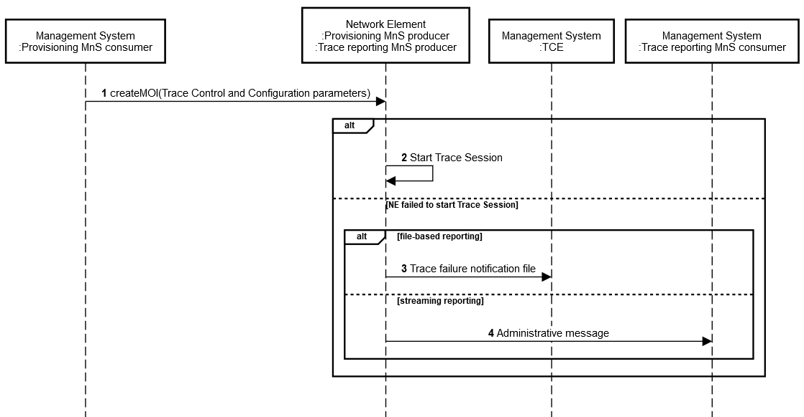
Figure 4.1.1.1.2-1: Overview of management activation for 5GS
Once configured with Trace Control and Configuration parameters, the NE shall activate the Trace Session. If the NE failed to activate the Trace Session in a file-based reporting case, a Trace failure notification shall be sent to the TCE. XML based encoding of the Trace failure notification file is defined in Annex A. Administrative messages can also be used if the NE failed to activate a Trace Session, or if there are errors for an ongoing session, and are included in the trace data. An example of an administrative message is the Trace File Abnormal Closed administrative message (see 3GPP TS 32.423 [3]).

2nd change

4.1.2.1.2 General signalling activation mechanisms for 5GS
In 5GS the signaling trace activation utilizes the Services Based Management Architecture (SBMA) defined in TS 28.533 [48]. A 5GC NE is configured with Trace Control and Configuration parameters via interaction between Provisioning MnS (see definitions in TS 28.532 [47]) consumer and Provisioning MnS producer. Figure 4.1.2.1.2-1 below illustrates the 5GS signaling activation where the role of a Provisioning MnS producer is played by the 5GC NE and the role of a Provisioning MnS consumer is played by the Management System.
In case of home subscriber trace (i.e. in the HPLMN), the Trace Session activation shall go to the 5GC NE which played as the Provisioning MnS producer, such as UDM, AMF and SMF. Instances where the home subscriber is roaming in a VPLMN, the Provisioning MnS producer may initiate a trace in that VPLMN. The VPLMN may reject such requests.
In case of foreign subscriber trace (i.e. the HPLMN operator wishes to trace foreign subscribers roaming in his PLMN), the Trace Session activation shall go to the 5GC NE located in the PLMN operator (i.e. the 5GC NE belongs to VPLMN as described in clause 4.2.4 of TS 23.501 [40], such as AMF/SMF).
Depending on the Trace Control and Configuration parameters received, the configured 5GC NE shall propagate the activation to selected NE's in the entire network – RAN and Core Network.
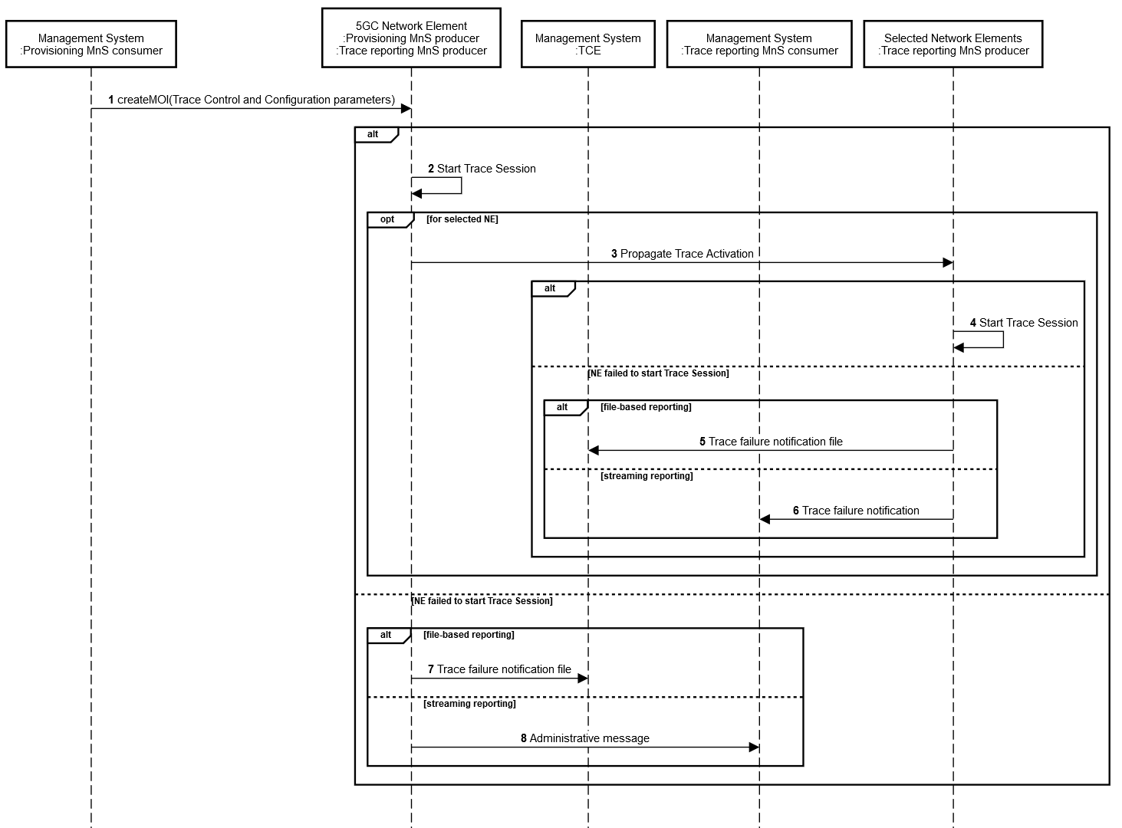
Figure 4.1.2.1.2-1: Overview of signaling activation for 5GS
If the NE failed to activate the Trace Session in a file-based reporting case, a Trace failure notification shall be sent to the TCE. XML based encoding of the Trace failure notification shall follow the Trace failure notification file XML schema defined in Annex A. Administrative messages can also be used if the NE failed to activate a Trace Session, or if there are errors for an ongoing session, and are included in the trace data. An example of an administrative message is the Trace File Abnormal Closed administrative message (see 3GPP TS 32.423 [3]).

