3GPP TSG-SA5 Meeting #140-e S5-216291rev1

Online, , 15th Nov 2021 - 24th Nov 2021
CR-Form-v12.1
CHANGE REQUEST
 | 28.622 | CR | Draft CR | rev | - | Current version: | 16.9.0
For HELP on using this form: comprehensive instructions can be found at
http://www.3gpp.org/Change-Requests.

Proposed change affects: | UICC apps |  | ME |  | Radio Access Network | X | Core Network | X

Title: | Rel-17 Input to DraftCR 28.622 Add file download NRM fragment
Source to WG: | Nokia, Nokia Shanghai Bell
Source to TSG: | SA5
Work item code: | FIMA |  |  |  |  |  | Date: |  |  | 2021-11-05
Category: | B |  |  |  |  |  | Release: |  |  | 17
 | Use one of the following categories:  F (correction)  A (mirror corresponding to a change in an earlier release)  B (addition of feature),  C (functional modification of feature)  D (editorial modification)  Detailed explanations of the above categories can  be found in 3GPP TR 21.900. |  |  |  |  |  |  |  | Use one of the following releases:  Rel-8 (Release 8)  Rel-9 (Release 9)  Rel-10 (Release 10)  Rel-11 (Release 11)  …  Rel-15 (Release 15)  Rel-16 (Release 16)  Rel-17 (Release 17)  Rel-18 (Release 18)
Reason for change: |  | Requirements for file download were agreed at SA5#138. This contribution proposes the corresponding file download control NRM fragment.
Summary of change:
Consequences if not approved: |  | The WI FIMA cannot progress.
Clauses affected:
 |  | Y | N
Other specs |  |  | X | Other core specifications |  |  |  | TS/TR ... CR ...
affected: |  |  | X | Test specifications |  |  |  | TS/TR ... CR ...
(show related CRs) |  |  | X | O&M Specifications |  |  |  | TS/TR ... CR ...
Other comments: |  | Baseline DraftCR for FIMA: S5-214758
This CR's revision history:

First modification

4.2 Class diagrams

4.2.1 Relationships
This clause depicts the set of classes (e.g. IOCs) that encapsulates the information relevant for this IRP. This clause provides the overview of the relationships of relevant classes in UML. Subsequent clauses provide more detailed specification of various aspects of these classes.
The following figure shows the containment/naming hierarchy and the associations of the classes defined in the present document. See Annex A of a class diagram that combines this figure with Figure 1 of [2], the class diagram of UIM.
NOTE 1: ManagedElement may be contained either
- in a SubNetwork (since SubNetwork inherits from Domain_ and ManagedElement inherits from ManagedElement_ and Domain_ name-contained ManagedElement_ as observed in the figure of Annex A) or
- in a MeContext instance as observed by the above figure or in the figure of Annex A.
This either-or relation cannot be shown by using an {xor} constraint in the above figure.
ManagedElement may also have no parent instance at all.
NOTE 2: Void
NOTE 3: If the configuration contains several instances of SubNetwork, exactly one SubNetwork instance shall directly or indirectly contain all the other SubNetwork instances.
NOTE 4: The SubNetwork instance not contained in any other instance of SubNetwork is referred to as "the root SubNetwork instance".
NOTE 5: ManagementNode shall be contained in the root SubNetwork instance.
NOTE 6: If contained in a SubNetwork instance, MnsAgent shall be contained in the root SubNetwork instance.
NOTE 7: For a clarification on the choice of containment of the IRPAgent (since it has three possible parents), see the definition of MnsAgent.
NOTE 8: The MnsAgent shall be replaced by the IRPAgent in deployments using the IRP framework as defined in TS 32.102 [2].

Figure 4.2.1-1: NRM fragment
Each Managed Object is identified with a Distinguished Name (DN) according to 3GPP TS 32.300 [13] that expresses its containment hierarchy. As an example, the DN of a ManagedElement instance could have a format like:
SubNetwork=Sweden,MeContext=MEC-Gbg-1,ManagedElement=RNC-Gbg-1.

NOTE 8: Void
NOTE 9: Void
Figure 4.2.1-2: Vendor specific data container NRM fragment

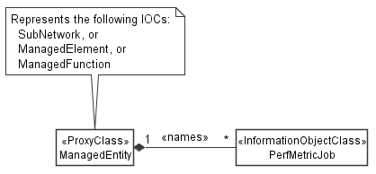

Figure 4.2.1-3: PM control NRM fragment

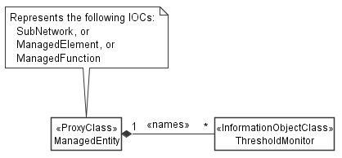
Figure 4.2.1-4: Threshold monitoring control NRM fragment

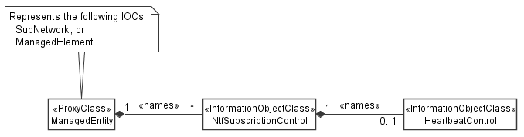
Figure 4.2.1-5: Notification subscription and heartbeat notification control NRM fragment

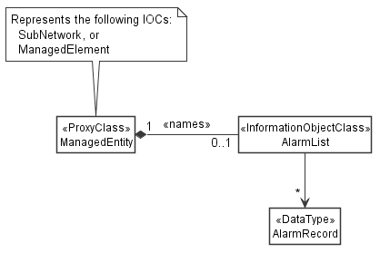
Figure 4.2.1-6: FM control NRM fragment

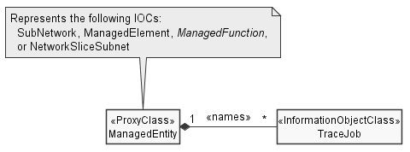
Figure 4.2.1-7: Trace control NRM fragment

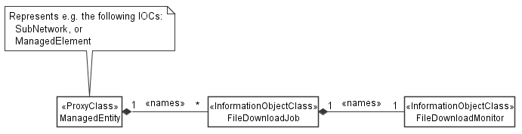
Figure 4.2.1-9: File download NRM fragment

4.2.2 Inheritance

This clause depicts the inheritance relationships.

Figure 4.2.2-1: NRM fragment

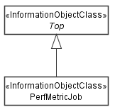

Figure 4.2.2-2: PM control NRM fragment

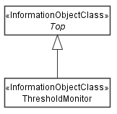

Figure 4.2.2-3: Threshold monitoring control NRM fragment

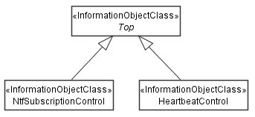

Figure 4.2.2-4: Notification subscription and heartbeat notification control NRM fragment

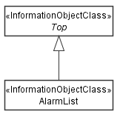
Figure 4.2.2-5: FM control NRM fragment

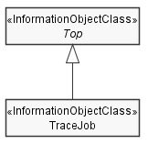
Figure 4.2.2-6: Trace control NRM fragment

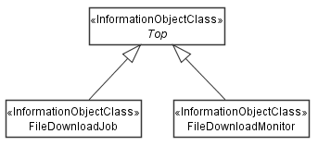
Figure 4.2.2-8: File download NRM fragment

Next modification

4.3.A FileDownloadJob

4.3.A.1 Definition
The "FileDownloadJob" represents a job on a MnS producer that downloads a file from a MnS consumer. It can be name-contained by "ManagedElement" or "SubNetwork".
A "FileDownloadJob" is created by a MnS consumer on a MnS producer. The creation requests the MnS producer to download a file from the MnS consumer to the MnS producer. Upon completion of the file download, the MnS consumer shall delete the "FileDownloadJob".
The creation request contains the information required by the MnS producer to download the file, namely the attribute "fileLocation", and the file properties "fileCompression" and "fileSize".
The creation request may contain in addition a "notificationRecipientAddress". If present, this attribute instructs the MnS producer to create, on behalf of the MnS consumer, a subscription for attribute value change notifications of the new "FileDownloadMonitor". The "notificationRecipientAddress" attribute of the created "NtfSubscriptionControl" object shall be set to the value of the "notificationRecipientAddress" in the "FileDownloadJob" creation request (implicit notification subscription).
To cancel a file download, the MnS consumer shall set the " cancellationRequested "attribute to "TRUE". Cancellation is possible in the "NOT_STARTED" and "ONGOING" state.
The attribute "_linkToFileDownloadMonitor" allows a MnS consumer to create simple notification subscriptions related to the "FileDownloadMonitor". The subscription scope is the object identified by "_linkToFileDownloadMonitor".
In addition, the attribute "_linkToFileDownloadMonitor" allows for deployments not relying on notifications for reporting the file download status, where the MnS consumer just polls the object identified by "_linkToFileDownloadMonitor".

4.3.A.2 Attributes
Attribute name | S | isReadable | isWritable | isInvariant | isNotifyable
operationalState | M | T | F | F | T
administrativeState | M | T | T | F | T
fileLocation | M | T | T | T | F
fileCompression | M | T | T | T | F
fileSize | O | T | T | T | F
notificationRecipientAddress | O | T | T | T | F
cancellationRequested | O | T | T | F | T
_linkToFileDownloadMonitor | O | T | T | T | F

4.3.A.2a Attribute definitions
Attribute Name | Documentation and Allowed Values | Properties
operationalState | See definition in clause 3a.2.2.1  Editor's note: Clause above not approved yet | N/A
administrativeState | See definition in clause 3a.2.2.2  Editor's note: Clause above not approved yet | N/A
fileLocation | See definition in clause 4.3.Y.2a  Editor's note: Clause above not approved yet | N/A
fileCompression | See definition in clause 4.3.Y.2a  Editor's note: Clause above not approved yet | N/A
fileSize | See definition in clause 4.3.Y.2a  Editor's note: Clause above not approved yet | N/A
notificationRecipientAddress | Notification recipient address for implicit notification subscription.  AllowedValues: N/A | Type: String  multiplicity: 1  isOrdered: N/A  isUnique: N/A  defaultValue: FALSE  isNullable: False
cancellationRequested | Setting this attribute to TRUE cancels an onging file download process. Cancellation is possible in the "NOT_STARTED" and "ONGOING" state. Setting the value to FALSE has no observable result.  AllowedValues: TRUE, FALSE | Type: ENUM  multiplicity: 1  isOrdered: N/A  isUnique: N/A  defaultValue: None  isNullable: False
_linkToFileDownloadMonitor

4.3.A.3 Attribute constraints
None.

4.3.A.4 Notifications
The common notifications defined in clause 4.5 are valid for this IOC, without exceptions or additions.

4.3.B FileDownloadMonitor

4.3.B.1 Definition
A "FileDownloadMonitor" represents the status of a file download job in a general manner independent from details of the file transer protocol. It is name-contained by the "FileDownloadJob" whose status is represented by the monitor.
A "FileDownloadMonitor" is created by the MnS producer together with the associated "FileDownloadJob" upon receiving a "FileDownloadJob" creation request. Its attributes are populated and updated by the MnS producer as the file download progresses. The MnS producer shall delete the monitor shortly after the file download terminted and the "status" attribute is either "SUCCESS, "FAILURE" or "CANCELLED".
The attributes "status", "progress", "startTime" and "endTimePredicted" are provided for monitoring the status of the file download progress. In case the file download fails for some reason, the "status" attribute shall be set the "Failed" and the "errorReason" attribute shall indicate the error reason.
Editor's note: It is ffs is this IOC should be merged with "FileDownloadJob". In case merged, a spoecial data type me be defined for all attributes of "FileDownloadMinitor" to group the status information into a single attribute.

4.3.B.2 Attributes
Attribute name | S | isReadable | isWritable | isInvariant | isNotifyable
status | M | T | F | F | T
errorReason | M | T | F | F | T
progress | M | T | F | F | T
startTime | O | T | F | F | T
endTimePredicted | O | T | F | F | T

4.3.B.2a Attribute definitions
Attribute Name | Documentation and Allowed Values | Properties
status | Status of the file download process.  allowedValues:  - NOT_STARTED  - ONGOING  - SUCCESS  - FAILURE  - CANCELLED | Type: ENUM  multiplicity: 1  isOrdered: N/A  isUnique: N/A  defaultValue: None  isNullable: False
errorReason | Error reason, present when the file download failed and "status"="FAILURE". Otherwise, the attribute shall be absent or carry the "NULL" value.  allowedValues:  - NULL  - UNKNOWN  - NO_STORAGE  - LOW_MEMROY  - NO_CONNECTION_TO_REMOTE_SERVER  - FILE_NOT_AVAILABLE  - DNS_CANNOT_BE_RESOLVED  - OTHER | Type: ENUM  multiplicity: 1  isOrdered: N/A  isUnique: N/A  defaultValue: None  isNullable: True
progress | Indicates how much of the file is already downloaded.  Unit is percent.  Allowed values:  integer between 0 and 100 with increments of 5 | Type: Integer  multiplicity: 1  isOrdered: N/A  isUnique: N/A  defaultValue: None  isNullable: False
startTime | Start time of the file download process.  allowedValues: N/A | Type: DateTime  multiplicity: 1  isOrdered: N/A  isUnique: N/A  defaultValue: None  isNullable: False
endTimePredicted | Predicted end time of the file download process.  allowedValues: N/A | Type: DateTime  multiplicity: 1  isOrdered: N/A  isUnique: N/A  defaultValue: None  isNullable: False

4.3.B.4 Notifications
The common notifications defined in clause W4.5 are not valid for this IOC. The set of notifications defined in the following table is valid.
Name | S | Notes
notifyMOICreation | M
notifyMOIDeletion | M
notifyMOIAttributeValueChanges | M
notifyMOIChanges | M

Editor's note: This contribution does not follow the agreed NRM template in 3GPP TS 32.156. It is based instead on an alternative for NRM fragments that is currently under discussion. Based on the outcome of this discussion this contribution needs to be updated.
End of modifications

