3GPP TSG-SA5 Meeting #140-e S5-216196rev4

e-meeting, 15 - 24 November 2021
CR-Form-v11.4
CHANGE REQUEST
 | 28.541 | CR | 0618 | rev | - | Current version: | 17.4.0
For HELP on using this form: comprehensive instructions can be found at
http://www.3gpp.org/Change-Requests.

Proposed change affects: | UICC apps |  | ME |  | Radio Access Network | X | Core Network

Title: | Rel-17 CR 28.541 Add C-SON CCO NRM model
Source to WG: | Huawei
Source to TSG: | S5
Work item code: | eSON_5G |  |  |  |  |  | Date: |  |  | 2021-11-05
Category: | B |  |  |  |  |  | Release: |  |  | Rel-17
 | Use one of the following categories:  F (correction)  A (mirror corresponding to a change in an earlier release)  B (addition of feature),  C (functional modification of feature)  D (editorial modification)  Detailed explanations of the above categories can  be found in 3GPP TR 21.900. |  |  |  |  |  |  |  | Use one of the following releases:  Rel-8 (Release 8)  Rel-9 (Release 9)  Rel-10 (Release 10)  Rel-11 (Release 11)  Rel-12 (Release 12)  Rel-13 (Release 13)  Rel-14 (Release 14)  Rel-15 (Release 15)  Rel-16 (Release 16)
Reason for change: |  | To support CCO use case in TS 28.313 [57], this contribution proposes to add CCOFunction.
Summary of change: |  | Add NRM fragment for CCO Management and Inheritance Hierarchy.  Add CCOFunction and related data type including CCOPolicy, CCOPolicyAction, and ParameterInfo
Consequences if not approved: |  | Cannot support CCO use case in TS 28.313 [57].
Clauses affected: |  | 4.2.1.1, 4.2.1.2, 4.3.X (new), 4.3.Y (new), 4.4.1
 |  | Y | N
Other specs |  |  | X | Other core specifications |  |  |  | TS/TR ... CR ...
affected: |  |  | X | Test specifications |  |  |  | TS/TR ... CR ...
(show related CRs) |  | X |  | O&M Specifications |  |  |  | TS/TR 28.313 CR 0040
Other comments:

1st Change

4.2.1.1 Relationships
This clause depicts the set of classes (e.g. IOCs) that encapsulates the information relevant for this gNB and en-gNB. For the UML semantics, see 3GPP TS 32.156 [43]. Subsequent clauses provide more detailed specification of various aspects of these classes.
The model fragments are for management representation of gNB and en-gNB for all NG-RAN deployment scenario as listed below.
- Non-split NG-RAN deployment scenario, represents the gNB defined in TS 38.401[4]. In this scenario, a gNB is represented by a combination of a GNBCUCPFunction, one or more GNBCUUPFunctions and one or more GNBDUFunctions.
- 2-split NG-RAN deployment scenario, represents the gNB consist of gNB-CU and gNB-DU defined in TS 38.401[4] clause 6.1.1. In this scenario, a gNB-CU is represented by a combination of a GNBCUCPFunction and one or more GNBCUUPFunctions, whereas a gNB-DU is represented by a GNBDUFunction.
- 3-split NG-RAN deployment scenario, represents the gNB consist of gNB-CU-CP, gNB-CU-UP and gNB-DU defined in TS 38.401[4] clause 6.1.2. In this scenario, a gNB-CU-CP is represented by a GNBCUCPFunction, a gNB-CU-UP is represented by a GNBCUUPFunction, and a gNB-DU is represented by a GNBDUFunction.
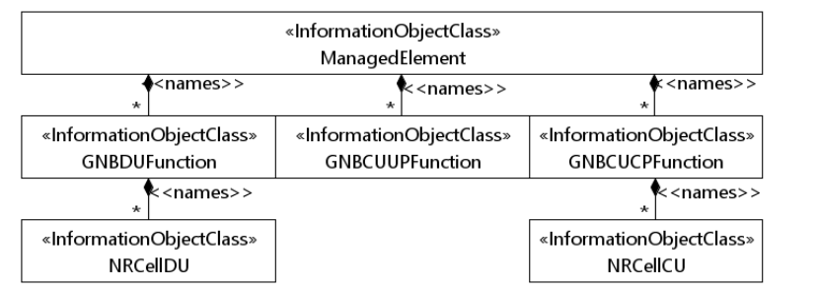
Figure 4.2.1.1-1: NRM for all deployment scenarios
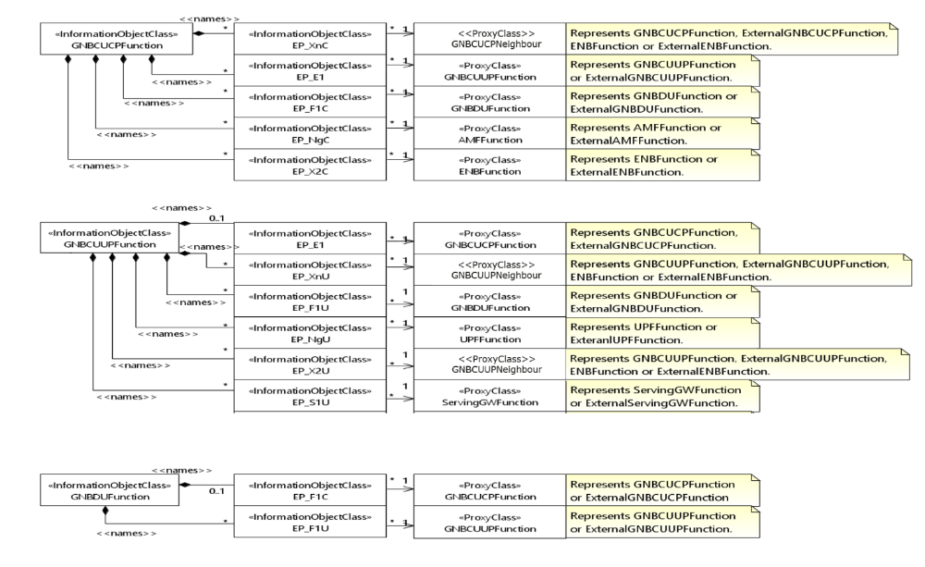
Figure 4.2.1.1-2: NRM for EPs for all deployment scenarios
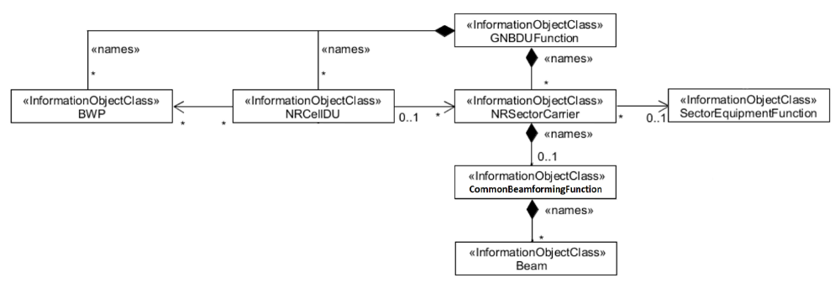
Figure 4.2.1.1-3: NRM for <<IOC>>NRSectorCarrier and <<IOC>>BWP for all deployment scenarios
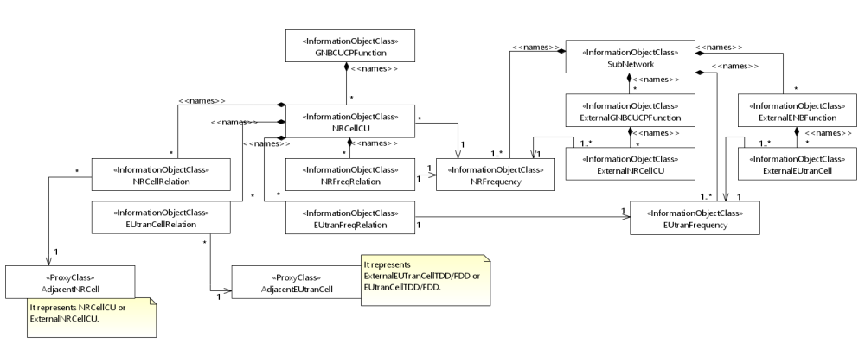
Figure 4.2.1.1-4: Cell Relation view for all deployment scenarios
NOTE 1: The above NRM fragment uses SubNetwork to hold both NR and LTE external entities and frequencies.
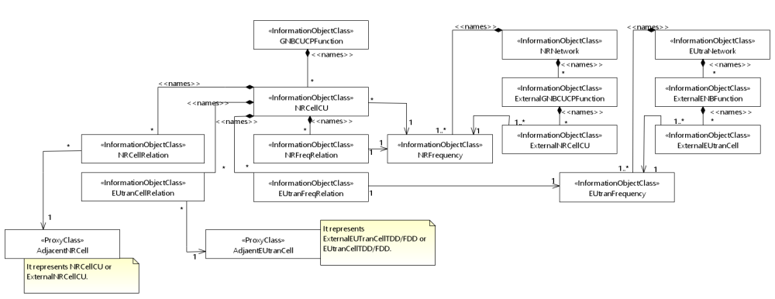
Figure 4.2.1.1-5: Cell Relation view for all deployment scenarios
NOTE 2: The above NRM fragment uses NRNetwork to hold NR external entities and frequency and using EUtraNetwork to hold LTE external entities and frequency. The NRNetwork and EUtraNetwork are subclasses of SubNetwork (defined in TS 28.622 [30]) with no additional attributes. The reason using NRNetwork and EUtraNetwork is for a clean separation of NR external entities and frequency and LTE external entities and frequency.
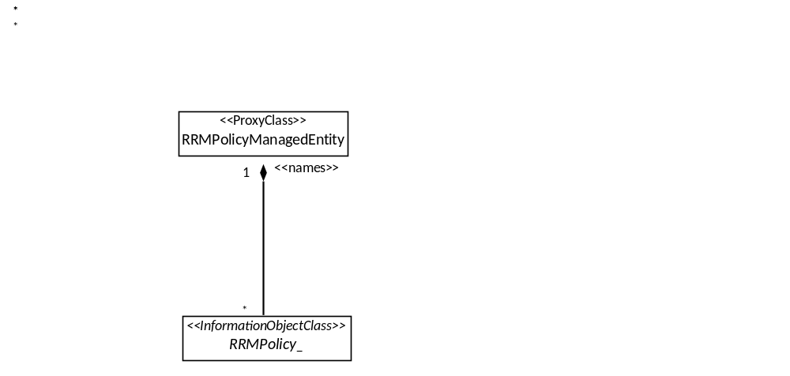
Figure 4.2.1.1-6: NRM fragment for RRM Policies
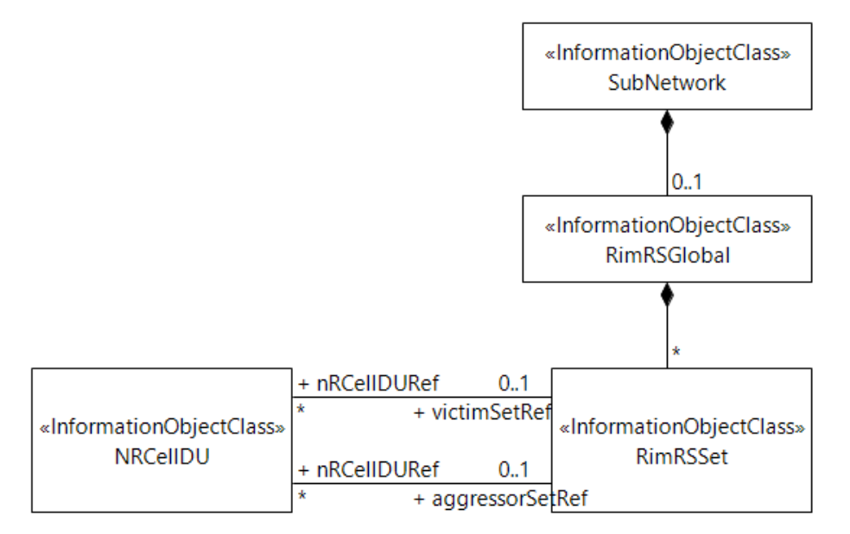
Figure 4.2.1.1-7: NRM fragment to support RIM
The Figure 4.2.1.1-8 shows the NRM fragment for pre-configured 5QIs in NG-RAN.
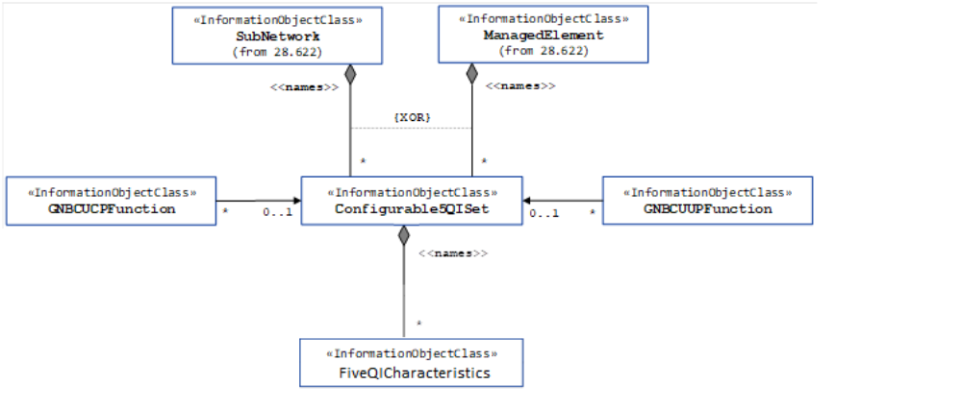
Figure 4.2.1.1-8: NRM fragment for pre-configured 5QIs in NG-RAN
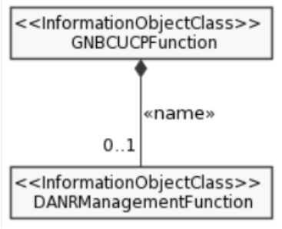
Figure 4.2.1.1-9: NRM fragment for DANR Management
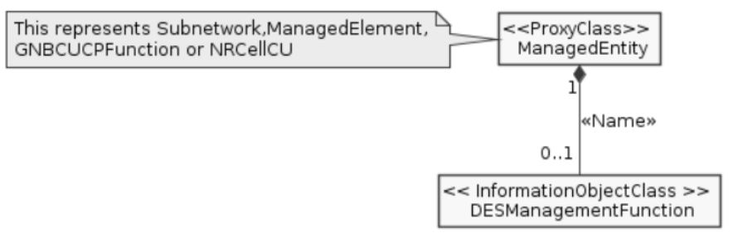
Figure 4.2.1.1-10: NRM fragment for DES Management
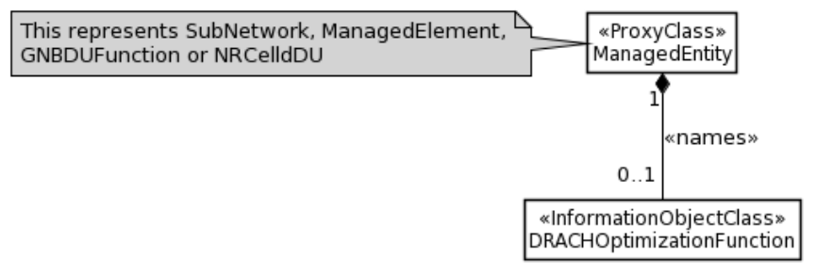
Figure 4.2.1.1-11: NRM fragment for DRACH Management
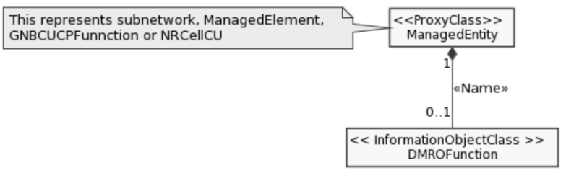
Figure 4.2.1.1-12: NRM fragment for DMRO Management
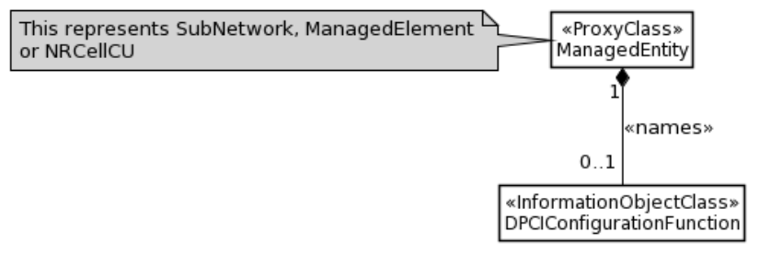
Figure 4.2.1.1-13: NRM fragment for DPCI Management
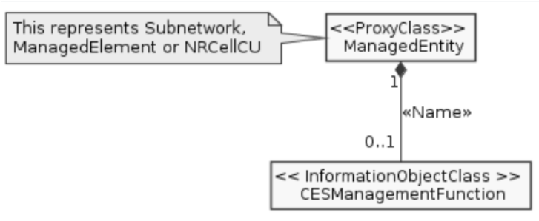
Figure 4.2.1.1-14: NRM fragment for CES Management
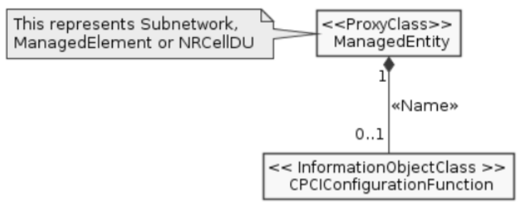
Figure 4.2.1.1-15: NRM fragment for CPCI Management
The Figure 4.2.1.1-16 shows the NRM fragment for dynamic 5QIs in NG-RAN.
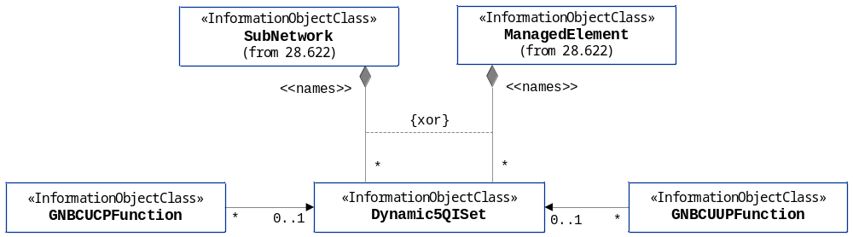
Figure 4.2.1.1-16: NRM fragment for dynamically assigned 5QIs in NG-RAN

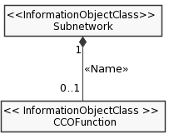
Figure 4.2.1.1-X: NRM fragment for CCO Management

2nd Change

4.2.1.2 Inheritance
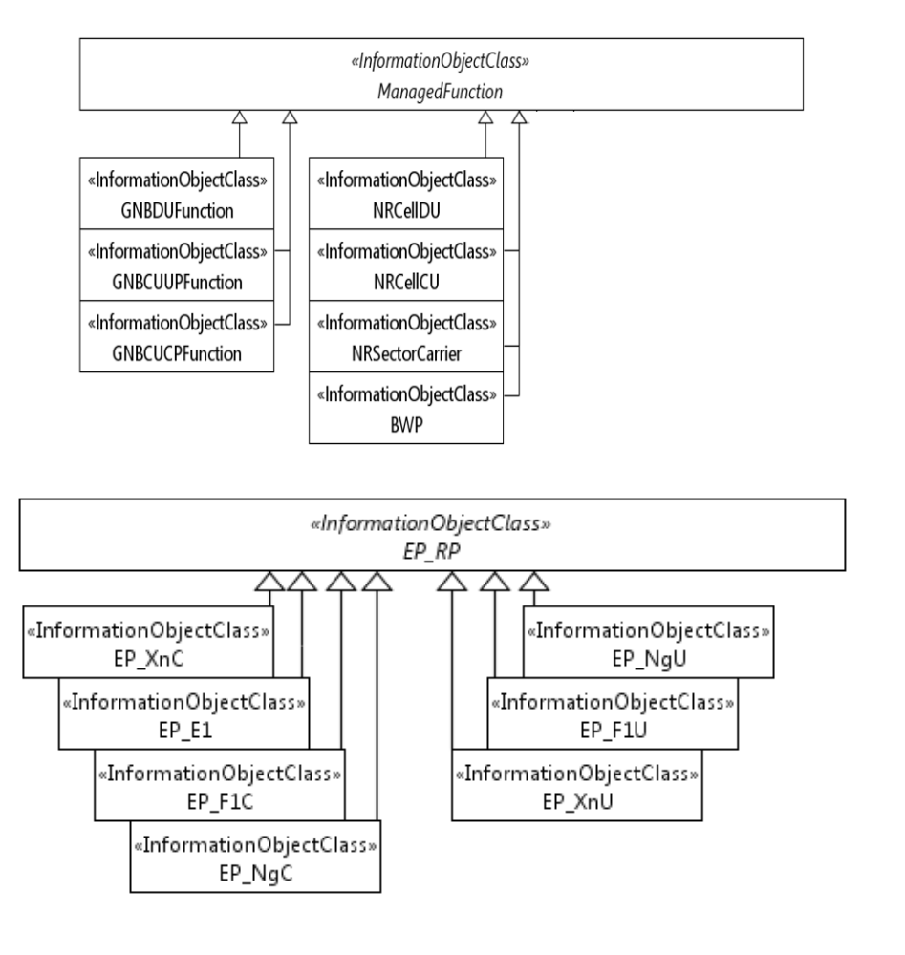

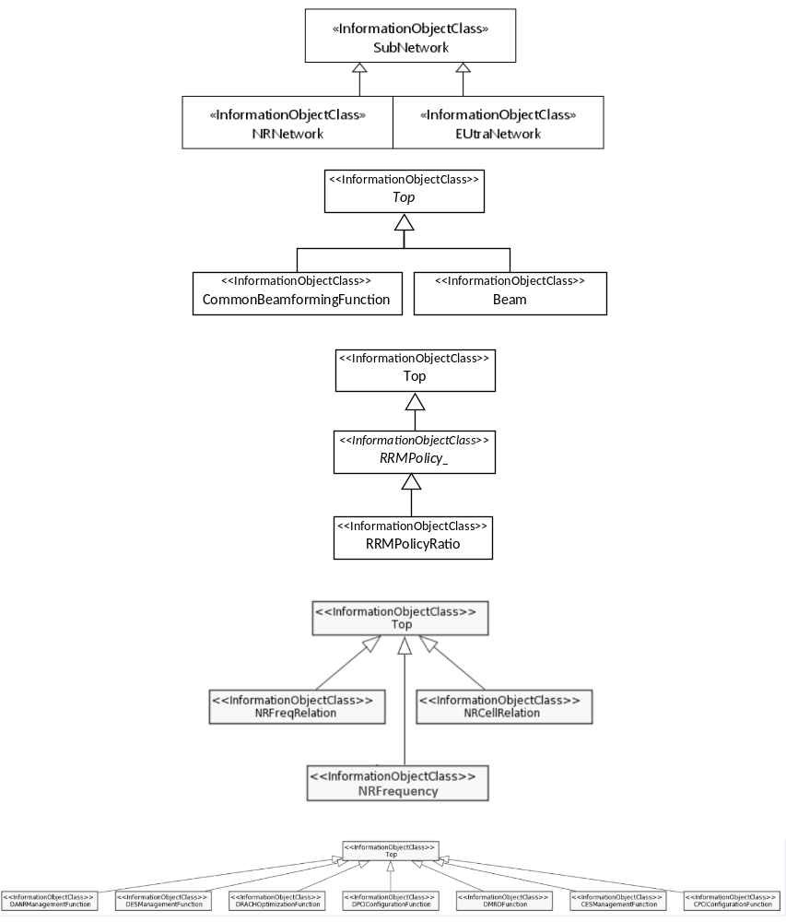
Figure 4.2.1.2-1: Inheritance Hierarchy
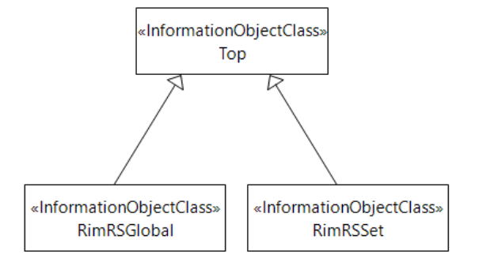
Figure 4.2.1.2-2: Inheritance Hierarchy
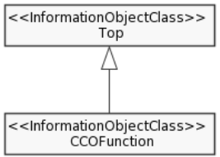
Figure 4.2.1.2-x: Inheritance Hierarchy

3rd Change

4.3.X CCOFunction

4.3.X.1 Definition
This IOC contains attributes to support the C-SON function of Capacity and Coverage optimization (See clause 7.2.3 in TS 28.313 [57]).
NOTE: in the case where multiple CCOFunction MOIs exist at different levels of the containment tree, the CCOFunction MOI at the lower level overrides the CCOFunction MOIs at higher level(s) of the same containment tree.

4.3.X.2 Attributes
The CCOFunction IOC includes attributes inherited from Top IOC (defined in TS 28.622[30]) and the following attributes:
Attribute Name | Support Qualifier | isReadable | isWritable | isInvariant | isNotifyable
cCOPolicies | M | T | T | F | T
cCOSwitch | M | T | T | F | T

4.3.X.3 Attribute constraints
None.

4.3.X.4 Notifications
The common notifications defined in sub clause 4.5 are valid for this IOC, without exceptions or additions.

4.3.Y CCOPolicy <<dataType>>

4.3.Y.1 Definition
This data type represents the attributes of radio coverage policy content. It consists of condition and the corresponding actions applied for C-SON function of radio Capacity and Coverage optimization.

4.3.Y.2 Attributes
Attribute Name | Support Qualifier | isReadable | isWritable | isInvariant | isNotifyable
cCOPolicyCondition | M | T | T | F | T
downlinkTransmitPowerInfo | O | T | T | F | T
antennaTiltInfo | O | T | T | F | T
antennaAzimuthInfo | O | T | T | F | T
digitalTiltInfo | O | T | T | F | T
digitalAzimuthInfo | O | T | T | F | T
coverageShapeList | O | T | T | F | T

4.3.Y.3 Attribute constraints
None.

4.3.Y.4 Notifications
The subclause 4.5 of the <<IOC>> using this <<dataType>> as one of its attributes, shall be applicable.

4th Change

4.4 Attribute definitions

4.4.1 Attribute properties
Attribute Name | Documentation and Allowed Values | Properties
administrativeState | It indicates the administrative state of the NRCellDU. It describes the permission to use or prohibition against using the cell, imposed through the OAM services.  allowedValues: LOCKED, SHUTTING DOWN, UNLOCKED.  The meaning of these values is as defined in ITU-T Recommendation X.731 [18].  See Annex A for Relation between the "Pre-operation state of the gNB-DU Cell" and administrative state relevant in case of 2-split and 3-split deployment scenarios. | type: ENUM  multiplicity: 1  isOrdered: N/A  isUnique: N/A  defaultValue: LOCKED  isNullable: False
operationalState | It indicates the operational state of the NRCellDU instance. It describes whether the resource is installed and partially or fully operable (Enabled) or the resource is not installed or not operable (Disabled).  allowedValues: ENABLED, DISABLED. | type: ENUM  multiplicity: 1  isOrdered: N/A  isUnique: N/A  defaultValue: None  isNullable: False
cellState | It indicates the usage state of the NRCellDU instance. It describes whether the cell is not currently in use (Idle), or currently in use but not configured to carry traffic (Inactive) or is currently in use and is configured to carry traffic (Active).  The Inactive and Active definitions are in accordance with TS 38.401 [4]:  "Inactive: the cell is known by both the gNB-DU and the gNB-CU. The cell shall not serve UEs;  Active: the cell is known by both the gNB-DU and the gNB-CU. The cell should be able to serve UEs."  "allowedValues: IDLE, INACTIVE, ACTIVE. | type: ENUM  multiplicity: 1  isOrdered: N/A  isUnique: N/A  defaultValue: None  isNullable: False
arfcnDL | NR Absolute Radio Frequency Channel Number (NR-ARFCN) for downlink  allowedValues:  See TS 38.104 [12] subclause 5.4.2. Note that allowed values of NR-ARFCN are specified for each band in subclause 5.4.2.3. | type: Integer  multiplicity: 1  isOrdered: N/A  isUnique: N/A  defaultValue: None  isNullable: False
arfcnUL | NR Absolute Radio Frequency Channel Number (NR-ARFCN) for uplink  allowedValues:  See TS 38.104 [12] subclause 5.4.2. Note that allowed values of NR-ARFCN are specified for each band in subclause 5.4.2.3. | type: Integer  multiplicity: 1  isOrdered: N/A  isUnique: N/A  defaultValue: None  isNullable: False
arfcnSUL | NR Absolute Radio Frequency Channel Number (NR-ARFCN) for supplementary uplink  allowedValues:  See TS 38.104 [12] subclause 5.4.2. Note that allowed values of NR-ARFCN are specified for each band in subclause 5.4.2.3. | type: Integer  multiplicity: 1  isOrdered: N/A  isUnique: N/A  defaultValue: None  isNullable: False
beamAzimuth | The azimuth of a beam transmission, which means the horizontal beamforming pointing angle (beam peak direction) in the (Phi) φ-axis in 1/10th degree resolution. See subclauses 3.2 in TS 38.104 [12] and 7.3 in TS 38.901 [53] as well as TS 28.662 [11]. The pointing angle is the direction equal to the geometric centre of the half-power contour of the beam relative to the reference plane. Zero degree implies explicit antenna bearing (boresight). Positive angle implies clockwise from the antenna bearing.  allowedValues: [-1800 ..1800] 0.1 degree | type: Integer  multiplicity: 1  isOrdered: N/A  isUnique: N/A  defaultValue: Null  isNullable: True
beamHorizWidth | The Horizontal beamWidth of a beam transmission, which means the horizontal beamforming half-power (3dB down) beamwidth in the (Phi) φ-axis in 1/10th degree resolution. See subclauses 3.2 in TS 38.104 [12] and 7.3 in TS 38.901 [53].  allowedValues: [0..3599] 0.1 degree | type: Integer  multiplicity: 1  isOrdered: N/A  isUnique: N/A  defaultValue: Null  isNullable: True
beamIndex | Index of the beam.  For example, please see subclause 6.6.2 of TS 38.331 [54] where the ssb-Index in the rsIndexResults element of MeasResultNR is defined. | type: Integer  multiplicity: 1  isOrdered: N/A  isUnique: N/A  defaultValue: Null  isNullable: True
beamTilt | The tilt of a beam transmission, which means the vertical beamforming pointing angle (beam peak direction) in the (Theta) θ-axis in 1/10th degree resolution. See subclauses 3.2 in TS 38.104 [12] and 7.3 in TS 38.901 [53] as well as TS 28.662 [11]. The pointing angle is the direction equal to the geometric centre of the half-power contour of the beam relative to the reference plane. Positive value implies downtilt.  allowedValues: [-900..900] 0.1 degree | type: Integer  multiplicity: 1  isOrdered: N/A  isUnique: N/A  defaultValue: Null  isNullable: True
beamType | The type of the beam.  allowedValues: "SSB-BEAM" | type: string  multiplicity: 0..1  isOrdered: N/A  isUnique: N/A  defaultValue: Null  isNullable: True
beamVertWidth | The Vertical beamWidth of a beam transmission, which means the vertical beamforming half-power (3dB down) beamwidth in the (Theta) θ-axis in 1/10th degree resolution. See subclauses 3.2 in TS 38.104 [12] and 7.3 in TS 38.901 [53].  allowedValues: [0...1800] 0.1 degree | type: Integer  multiplicity: 1  isOrdered: N/A  isUnique: N/A  defaultValue: Null  isNullable: True
bSChannelBwDL | BS Channel BW in MHz. for downlink  allowedValues:  See BS Channel BW in TS 38.104 [12], subclause 5.3.​ | type: Integer  multiplicity: 1  isOrdered: N/A  isUnique: N/A  defaultValue: None  isNullable: False
bSChannelBwUL | BS Channel BW in MHz.for uplink  allowedValues:  See BS Channel BW in TS 38.104 [12], subclause 5.3.​ | type: Integer  multiplicity: 1  isOrdered: N/A  isUnique: N/A  defaultValue: None  isNullable: False
bSChannelBwSUL | BS Channel BW in MHz.for supplementary uplink  allowedValues:  See BS Channel BW in TS 38.104 [12], subclause 5.3.​ | type: Integer  multiplicity: 1  isOrdered: N/A  isUnique: N/A  defaultValue: None  isNullable: False
configuredMaxTxPower | This is the maximum transmission power in milliwatts (mW) at the antenna port for all downlink channels, used simultaneously in a cell, added together.  allowedValues: N/A | type: Integer  multiplicity: 1  isOrdered: N/A  isUnique: N/A  defaultValue: None  isNullable: False
configuredMaxTxEIRP | This is the maximum emitted isotroptic radiated power (EIRP) in dBm for all downlink channels, used simultaneously in a cell, added together [12].  allowedValues: N/A | type: Integer  multiplicity: 1  isOrdered: N/A  isUnique: N/A  defaultValue: None  isNullable: False
coverageShape | Identifies the sector carrier coverage shape described by the envelope of the contained SSB beams. The coverage shape is implementation dependent.  allowedValues: 0 : 65535 | type: Integer  multiplicity: 1  isOrdered: N/A  isUnique: N/A  defaultValue: None  isNullable: False
digitalTilt | Digitally-controlled tilt through beamforming. It represents the vertical pointing direction of the antenna relative to the antenna bore sight, representing the total non-mechanical vertical tilt of the selected coverageShape. Positive value gives downwards tilt and negative value gives upwards tilt.  allowedValues: [-900..900] 0.1 degree | type: Integer  multiplicity: 1  isOrdered: N/A  isUnique: N/A  defaultValue: None  isNullable: False
digitalAzimuth | Digitally-controlled azimuth through beamforming. It represents the horizontal pointing direction of the antenna relative to the antenna bore sight, representing the total non-mechanical horizontal pan of the selected coverageShape. Positive value gives azimuth to the right and negative value gives an azimuth to the left.  allowedValues: [-1800 ..1800] 0.1 degree | type: Integer  multiplicity: 1  isOrdered: N/A  isUnique: N/A  defaultValue: None  isNullable: False
cyclicPrefix | Cyclic prefix as defined in TS 38.211 [32], subclause 4.2.  allowedValues:  NORMAL, EXTENDED. | type: ENUM  multiplicity: 1  isOrdered: N/A  isUnique: N/A  defaultValue: None  isNullable: False
localAddress | This parameter specifies the localAddress used for initialization of the underlying transport.  The AddressWithVlan <dataType> is defined in clause 4.3.64. | type: AddressWithVlan  multiplicity: 1  isOrdered: False  isUnique: N/A  defaultValue: None  isNullable: False
AddressWithVlan.iPaddress | This parameter specifies the IP address used for initialization of the underlying transport.  IP address can be an IPv4 address (See RFC 791 [37]) or an IPv6 address (See RFC 2373 [38]). | type: String  multiplicity: 1  isOrdered: N/A  isUnique: N/A  defaultValue: None  isNullable: False
AddressWithVlan. vlanId | This parameter specifies the local VLAN Id (See IEEE 802.1Q [39]) used for initialization of the underlying transport. | type: String  multiplicity: 1  isOrdered: N/A  isUnique: N/A  defaultValue: None  isNullable: False
remoteAddress | Remote address including IP address used for initialization of the underlying transport.  IP address can be an IPv4 address (See RFC 791 [37]) or an IPv6 address (See RFC 2373 [38]). | type: String  multiplicity: 1  isOrdered: N/A  isUnique: N/A  defaultValue: None  isNullable: False
gNBId | It identifies a gNB within a PLMN. The gNB ID is part of the NR Cell Identifier (NCI) of the gNB cells.  See "gNB Identifier (gNB ID)" of subclause 8.2 of TS 38.300 [3]. See "Global gNB ID" in subclause 9.3.1.6 of TS 38.413 [5].  allowedValues: 0..4294967295 | type: Integer  multiplicity: 1  isOrdered: N/A  isUnique: N/A  defaultValue: None  isNullable: False
gNBIdLength | This indicates the number of bits for encoding the gNB ID. See "Global gNB ID" in subclause 9.3.1.6 of TS 38.413 [5].  allowedValues: 22 .. 32. | type: Integer  multiplicity: 1  isOrdered: N/A  isUnique: N/A  defaultValue: None  isNullable: False
gNBDUId | It uniquely identifies the DU at least within a gNB-CU. See 'gNB-DU ID' in subclause 9.3.1.9 of 3GPP TS 38.473 [8].  allowedValues: 0..2³⁶-1 | type: Integer  multiplicity: 1  isOrdered: N/A  isUnique: N/A  defaultValue: None  isNullable: False
gNBCUUPId | It uniquely identifies the gNB-CU-UP at least within a gNB-CU-CP. See 'gNB-CU-UP ID' in subclause 9.3.1.15 of 3GPP TS 38.463 [48].  allowedValues: 0..2³⁶-1 | type: Integer  multiplicity: 1  isOrdered: N/A  isUnique: N/A  defaultValue: None  isNullable: False
gNBCUName | It identifies the Central Entity of a NR node, see subclause 9.2.1.4 of 3GPP TS 38.473 [8].  allowedValues: Not applicable | type: String  multiplicity: 1  isOrdered: N/A  isUnique: N/A  defaultValue: None  isNullable: False
gNBDUName | It identifies the Distributed Entity of a NR node, see subclause 9.2.1.5 of 3GPP TS 38.473 [8].  allowedValues: Not applicable | type: String  multiplicity: 1  isOrdered: N/A  isUnique: N/A  defaultValue: None  isNullable: False
cellLocalId | It identifies a NR cell of a gNB.  It, together with the gNB Identifier (using gNBId of the parent GNBCUCPFunction or GNBDUFunction or ExternalCUCPFunction), identifies a NR cell within a PLMN. This is the NR Cell Identity (NCI). See subclause 8.2 of TS 38.300 [3].  The NCI can be constructed by encoding the gNB Identifier using gNBId (of the parent GNBCUCPFunction or GNBDUFunction or ExternalCUCPFunction) and cellLocalId where the gNB Identifier field is of length specified by gNBIdLength (of the parent GNBCUCPFunction or GNBDUFunction or ExternalCUCPFunction). See "Global gNB ID" in subclause 9.3.1.6 of TS 38.413 [5].  The NR Cell Global identifier (NCGI) is constructed from the PLMN identity the cell belongs to and the NR Cell Identifier (NCI) of the cell.  See relation between NCI and NCGI subclause 8.2 of TS 38.300 [3].  allowedValues: Not applicable | type: Integer  multiplicity: 1  isOrdered: N/A  isUnique: True  defaultValue: None  isNullable: False
cAGIdList | It identifies a CAG list containing up to 12 CAG-identifiers per PLMN Identity, see TS 38.331 [54].  CAG is used for the PNI-NPNs to prevent UE(s), which are not allowed to access the NPN via the associated cell(s), from automatically selecting and accessing the associated CAG cell(s).  CAG ID is used to combine with PLMN ID to identify a PNI-NPN.  allowedValues: BIT STRING (SIZE (32)). | type: String  multiplicity: 1  isOrdered: N/A  isUnique: True  defaultValue: None  isNullable: False
nIDList | It identifies a list of NIDs containing up to 12 NIDs per PLMN Identity, see TS 38.331 [54].  NID is used to combine with PLMN ID to identify an SNPN.  allowedValues: BIT STRING (SIZE (44)). | type: String  multiplicity: 1  isOrdered: N/A  isUnique: True  defaultValue: None  isNullable: False
nRPCI | This holds the Physical Cell Identity (PCI) of the NR cell.  allowedValues:  See 3GPP TS 36.211 subclause 6.11 for legal values of pci. | type: Integer  multiplicity: 1  isOrdered: N/A  isUnique: N/A  defaultValue: None  isNullable: False
nRTAC | This holds the identity of the common Tracking Area Code for the PLMNs.  allowedValues:  a) It is the TAC or Extended-TAC.  b) A cell can only broadcast one TAC or Extended-TAC. See TS 36.300, subclause 10.1.7 (PLMNID and TAC relation).  c) TAC is defined in subclause 19.4.2.3 of 3GPP TS 23.003  [13] and Extended-TAC is defined in subclause 9.3.1.29 of 3GPP TS 38.473 [8].  d) For a 5G SA (Stand Alone), it has a non-null value. | type: Integer  multiplicity: 1  isOrdered: N/A  isUnique: N/A  defaultValue: NULL  isNullable: True
GNBCUCPFunction.pLMNId | It specifies the PLMN identifier to be used as part of the global RAN node identity.  allowedValues: Not applicable. | Type: PLMNId  multiplicity: 1  isOrdered: N/A  isUnique: N/A  defaultValue: None  isNullable: False
GNBCUUPFunction.pLMNIdList | This is a list of PLMN identifiers. It defines from which set of PLMNs an UE must have as its serving PLMN to be allowed to use the GNB-CU-UP.  allowedValues: Not applicable. | type: PLMNId  multiplicity: 1..12  isOrdered: N/A  isUnique: True  defaultValue: None  isNullable: False
NRCellCU.pLMNInfoList | It defines which PLMNs that can be served by the NR cell, and which S-NSSAIs can be supported by the NR cell for corresponding PLMN in case of network slicing feature is supported  allowedValues: Not applicable. | type: PLMNInfo  multiplicity: 1..*  isOrdered: N/A  isUnique: True  defaultValue: None  isNullable: False
NRCellDU.pLMNInfoList | It defines which PLMNs that can be served by the NR cell, and which S-NSSAs can be supported by the NR cell for corresponding PLMN in case of network slicing feature is supported. The pLMNId of the first entry of the list is the PLMNId used to construct the nCGI for the NR cell.  allowedValues: Not applicable. | type: PLMNInfo  multiplicity: 1..*  isOrdered: True  isUnique: True  defaultValue: None  isNullable: False
nPNIdentityList | It defines which NPNs that can be served by the NR cell, and which CAG IDs or NIDs can be supported by the NR cell for corresponding PNI-NPN or SNPN in case of the cell is NPN-only cell.  (nPNIdentity referring to TS 38.331 [54])  allowedValues: Not applicable. | type: NPNIdentity  multiplicity: 1..*  isOrdered: True  isUnique: True  defaultValue: None  isNullable: False
ExternalNRCellCU.pLMNIdList | It defines which PLMNs that are assumed to be served by the NR Cell in another gNB-CU-CP. This list is either updated by the managed element itself (e.g. due to ANR, signalling over Xn etc) or by consumer over the standard interface.  allowedValues: Not applicable. | Type: PLMNId  multiplicity: 1..12  isOrdered: N/A  isUnique: True  defaultValue: None  isNullable: False
rRMPolicyMemberList | It represents the list of RRMPolicyMember (s) that the managed object is supporting. A RRMPolicyMember <<dataType>> include the PLMNId <<dataType>> and S-NSSAI <<dataType>>.  allowedValues: N/A | type: RRMPolicyMember  multiplicity: 1..*  isOrdered: N/A  isUnique: True  defaultValue: None  isNullable: False
resourceType | The resource type of interest for an RRM Policy.  allowedValues:  PRB, PRB UL, PRB DL (for NRCellDU, GNBDUFunction)  RRC connected users (for NRCellCU, GNBCUCPFunction)  DRB (for GNBCUUPFunction)  See NOTE 2and NOTE 4 | type: ENUM  multiplicity: 1  isOrdered: N/A  isUnique: N/A  defaultValue: None  isNullable: False
sNSSAIList | It represents the list of S-NSSAI the managed object is supporting. The S-NSSAI is defined in 3GPP TS 23.003 [13].  allowedValues: See 3GPP TS 23.003 [13] | type: S-NSSAI  multiplicity: *  isOrdered: N/A  isUnique: N/A  defaultValue: None  allowedValues: N/A  isNullable: False
sST | This attribute specifies the Slice/Service type (SST) of the network slice.  See clause 5.15.2 of 3GPP TS 23.501 [2]. | type: Integer  multiplicity: 1  isOrdered: N/A  isUnique: N/A  defaultValue: None  allowedValues: N/A  isNullable: False
sD | This attribute specifies the Slice Differentiator (SD), which is optional information that complements the slice/service type(s) to differentiate amongst multiple Network Slices.  See clause 5.15.2 of 3GPP TS 23.501 [2]. | type: String  multiplicity: 1  isOrdered: N/A  isUnique: N/A  defaultValue: None  allowedValues: N/A  isNullable: False
rRMPolicyMaxRatio | This attribute specifies the maximum percentage of radio resources that can be used by the associated rRMPolicyMemberList. The maximum percentage of radio resources include at least one of the shared resources, prioritized resources and dedicated resources.  The sum of the ‘rRMPolicyMaxRatio’ values assigned to all RRMPolicyRatio(s) name-contained by same MangedEntity can be greater than 100.  Default value: 100  allowedValues:  0 : 100 | type: Integer  multiplicity: 1  isOrdered: N/A  isUnique: N/A  defaultValue: True  allowedValues: N/A  isNullable: False
rRMPolicyMinRatio | This attribute specifies the minimum percentage of radio resources that can be used by the associated rRMPolicyMemberList. The minimum percentage of radio resources including at least one of prioritized resources and dedicated resources.  The sum of the ‘rRMPolicyMinRatio’ values assigned to all RRMPolicyRatio(s) name-contained by same MangedEntity shall be less or equal 100.  Default value: 0  allowedValues:  0 : 100  NOTE: Void. | type: Integer  multiplicity: 1  isOrdered: N/A  isUnique: N/A  defaultValue: True  allowedValues: N/A  isNullable: False
rRMPolicyDedicatedRatio | This attribute specifies the percentage of radio resource that dedicatedly used by the associated rRMPolicyMemberList.  The sum of the ‘rRMPolicyDedicatedRatio’ values assigned to all RRMPolicyRatio(s) name-contained by same MangedEntity shall be less or equal 100.  Default value: 0  allowedValues:0 : 100 | type: Integer  multiplicity: 1  isOrdered: N/A  isUnique: N/A  defaultValue: TRUE  allowedValues: N/A  isNullable: False
subCarrierSpacing | Subcarrier spacing configuration for a BWP. See subclause 5 in TS 38.104 [12].  AllowedValues: [15, 30, 60, 120] depending on the frequency range FR1 or FR2. | type: Integer  multiplicity: 1  isOrdered: N/A  isUnique: N/A  defaultValue: None  isNullable: False
txDirection | Indicates if the transmission direction is downlink (DL), uplink (UL) or both downlink and uplink (DL and UL).  allowedValues:  DL, UL, DL and UL | type: ENUM  multiplicity: 1  isOrdered: N/A  isUnique: N/A  defaultValue: None  isNullable: False
bwpContext | It identifies whether the object is used for downlink, uplink or supplementary uplink.  allowedValues:  DL, UL, SUL | type: ENUM  multiplicity: 1  isOrdered: N/A  isUnique: N/A  defaultValue: None  isNullable: False
isInitialBwp | It identifies whether the object is used for initial or other BWP.  allowedValues:  INITIAL, OTHER | type: ENUM  multiplicity: 1  isOrdered: N/A  isUnique: N/A  defaultValue: None  isNullable: False
startRB | Offset in common resource blocks to common resource block 0 for the applicable subcarrier spacing for a BWP. This corresponds to N_BWP_start, see subclause 4.4.5 in TS 38.211 [32].  allowedValues:  0 to N_grid_size – 1, where N_grid_size equals the number of resource blocks for the BS channel bandwidth, given the subcarrier spacing of the BWP. | type: Integer  multiplicity: 1  isOrdered: N/A  isUnique: N/A  defaultValue: None  isNullable: False
numberOfRBs | Number of physical resource blocks for a BWP. This corresponds to N_BWP_size, see subclause 4.4.5 in TS 38.211 [32].  allowedValues:  1 to N_grid_size – startRB of the BWP. Se startRB for definition of N_grid_size. | type: Integer  multiplicity: 1  isOrdered: N/A  isUnique: N/A  defaultValue: None  isNullable: False
nRTCI | This is the Target NR Cell Identifier. It consists of NR Cell Identifier (NCI) and Physical Cell Identifier of the target NR cell (nRPCI).  The NRRelation.nRTCI identifies the target cell from the perspective of the NRCell, the name-containing instance of the subject NRCellCU instance.  allowedValues: Not applicable. | type: Integer  multiplicity: 1  isOrdered: N/A  isUnique: N/A  defaultValue: None  isNullable: False
adjacentCellRef | This attribute contains the DN of an adjacentNRCell (NRCellCU or ExternalNRCellCU)  allowedValues: Not applicable. | type: DN  multiplicity: 1  isOrdered: N/A  isUnique: True  defaultValue: None  isNullable: False
ssbFrequency | Indicates cell defining SSB frequency domain position  Frequency of the cell defining SSB transmission. The frequency provided in this attribute identifies the position of resource element RE=#0 (subcarrier #0) of resource block RB#10 of the SS block. The frequency must be positioned on the NR global frequency raster, as defined in TS 38.101-1 [42] subclause 5.4.2. and within bSChannelBwDL.  allowedValues: 0..3279165 | type: Integer  multiplicity: 1  isOrdered: N/A  isUnique: N/A  defaultValue: None  isNullable: False
nRFrequencyRef | This attribute contains the DN of the referenced NRFrequency.  allowedValues: Not applicable. | type: DN  multiplicity: 1  isOrdered: N/A  isUnique: True  defaultValue: None  isNullable: False
nRSectorCarrierRef | This attribute contains the DN of the referenced NRSectorCarrier.  allowedValues: Not applicable. | type: DN  multiplicity: 1  isOrdered: N/A  isUnique: True  defaultValue: None  isNullable: False
bWPRef | This attribute contains the DN of the referenced BWP.  allowedValues: Not applicable. | type: DN  multiplicity: 1  isOrdered: N/A  isUnique: True  defaultValue: None  isNullable: False
sectorEquipmentFunctionRef | This attribute contains the DN of the referenced NSectorEquipmentFunction.  allowedValues: Not applicable. | type: DN  multiplicity: 1  isOrdered: N/A  isUnique: True  defaultValue: None  isNullable: False
offsetMO | It is a list of offset values applicable to all measured cells with reference signal(s) indicated in this MeasObjectNR. See offsetMO of subclause 5.5.4 of TS 38.331 [54].  allowedValues: Not applicable. | type: QOffsetRangeList  multiplicity: 1  isOrdered: N/A  isUnique: N/A  defaultValue: N/A  isNullable: False
cellIndividualOffset | It is a list of offset values for the neighbour cell. Used when UE is in connected mode. The unit is 1dB. It is defined for rsrpOffsetSSB, rsrqOffsetSSB, sinrOffsetSSB, rsrpOffsetCSI-RS, rsrqOffsetCSI-RS and sinrOffsetCSI-RS. See TS 38.331 [54].  allowedValues: Not applicable. | type: Integer  multiplicity: 6  isOrdered: True  isUnique: N/A  defaultValue: 0  isNullable: False
blockListEntry | It specifies a list of PCI (physical cell identity) that are blocklisted in EUTRAN measurements as described in 3GPP TS 38.331 [54].  allowedValues: { 0…1007 } | type: Integer  multiplicity: *  isOrdered: N/A  isUnique: N/A  defaultValue: None  isNullable: False
blockListEntryIdleMode | It specifies a list of PCI (physical cell identity) that are blocklisted in SIB4 and SIB5.  allowedValues: { 0…1007 } | type: Integer  multiplicity: 1  isOrdered: N/A  isUnique: N/A  defaultValue: None  isNullable: False
cellReselectionPriority | It is the absolute priority of the carrier frequency used by the cell reselection procedure. See CellReselectionPriority IE in TS 38.331 [54].  It corresponds to the parameter priority in 3GPP TS 38.304 [49].  Value 0 means lowest priority. The UE behaviour when no value is entered is specified in subclause 5.2.4.1 of 3GPP TS 38.304 [49].  The value must not already used by other RAT, i.e. equal priorities between RATs are not supported.  allowedValues: N/A | type: Integer  multiplicity: 1  isOrdered: N/A  isUnique: N/A  defaultValue: 0None  isNullable: False
cellReselectionSubPriority | It indicates a fractional value to be added to the value of cellReselectionPriority to obtain the absolute priority of the concerned carrier frequency for E-UTRA and NR. See CellReselectionSubPriority IE in TS 38.331 [54].  allowedValues: { 0.2, 0.4, 0.6, 0.8 }. | type: Real  multiplicity: 1  isOrdered: N/A  isUnique: N/A  defaultValue: None  isNullable: False
pMax | It calculates the parameter Pcompensation (defined in 3GPP TS 38.304 [49]), at cell reselection to an Cell. Its unit is 1 dBm. It corresponds to parameter PEMAX in 3GPP TS 38.101-1 [42].  allowedValues: { -30..33 }. | type: Integer  multiplicity: 1  isOrdered: N/A  isUnique: N/A  defaultValue: None  isNullable: False
qOffsetFreq | It is the frequency specific offset applied when evaluating candidates for cell reselection. See TS 38.331 [49]. Its unit is 1 dB.  allowedValues:  { -24, -22, -20, -18, -16, -14, -12, -10, -8, -6, -5, -4, -3, -2, -1, 0, 1, 2, 3, 4, 5, 6, 8, 10, 12, 14, 16, 20, 22, 24 } | type: Integer  multiplicity: 1  isOrdered: N/A  isUnique: N/A  defaultValue: 0  isNullable: False
qOffsetRangeList | It is used to indicate a cell, beam or measurement object specific offset to be applied when evaluating candidates for cell re-selection or when evaluating triggering conditions for measurement reporting. The value in dB. Value dB-24 corresponds to -24 dB, dB-22 corresponds to -22 dB and so on.  This is a list of enum values representing, in sequence: rsrpOffsetSSB, rsrqOffsetSSB, sinrOffsetSSB, rsrpOffsetCSI-RS, srqOffsetCSI-RS, sinrOffsetCSI-RS.  See Q-OffsetRangeList in subclause of subclause 6.3.1 of TS 38.331 [54].  allowedValues:  { -24, -22, -20, -18, -16, -14, -12, -10, -8, -6, -5, -4, -3, -2, -1, 0, 1, 2, 3, 4, 5, 6, 8, 10, 12, 14, 16, 18, 20, 22, 24 } | type: ENUM  multiplicity: 6  isOrdered: True  isUnique: N/A  defaultValue: 0  isNullable: False
qQualMin | It indicates the minimum required quality level in the cell (dB). See qQualMin in TS 38.304 [49]. Unit is 1 dB.  Value 0 means that it is not sent and UE applies in such case the (default) value of negative infinity for Qqualmin. Sent in SIB3 or SIB5.  allowedValues: { -34..-3, 0 } | type: Integer  multiplicity: 1  isOrdered: N/A  isUnique: N/A  defaultValue: None  isNullable: False
qRxLevMin | It indicates the required minimum received Reference Symbol Received Power (RSRP) level in the (E-UTRA) frequency for cell reselection. It corresponds to Qrxlevmin defined in 3GPP TS 38.304 [49]. It is broadcast in SIB3 or SIB5, depending on whether the related frequency is intra- or inter-frequency. Its unit is 1 dBm and resolution is 2.  allowedValues: { -140..-44 }. | type: Integer  multiplicity: 1  isOrdered: N/A  isUnique: N/A  defaultValue: None  isNullable: False
threshXHighP | This specifies the Srxlev threshold (in dB) used by the UE when reselecting towards a higher priority RAT/ frequency than the current serving frequency. Each frequency of NR and E-UTRAN might have a specific threshold. It corresponds to the Thresh_{X, HighP} in 3GPP TS 38.304 [49]. Its unit is 1 dB and resolution is 2.  allowedValues: { 0..62 } | type: Integer  multiplicity: 1  isOrdered: N/A  isUnique: N/A  defaultValue: None  isNullable: False
threshXHighQ | This specifies the Squal threshold (in dB) used by the UE when reselecting towards a higher priority RAT/ frequency than the current serving frequency. Each frequency of NR and E-UTRAN might have a specific threshold. It corresponds to the ThreshX, HighQ in TS 38.304 [49]. Its unit is 1 dB.  allowedValues: { 0..31 } | type: Integer  multiplicity: 1  isOrdered: N/A  isUnique: N/A  defaultValue: None  isNullable: False
threshXLowP | This specifies the Srxlev threshold (in dB) used by the UE when reselecting towards a lower priority RAT/ frequency than the current serving frequency. Each frequency of NR might have a specific threshold. It corresponds to ThreshX,LowP in 3GPP TS 38.304 [49]. Its unit is 1 dB. Its resolution is 2.  allowedValues: { 0..62 } | type: Integer  multiplicity: 1  isOrdered: N/A  isUnique: N/A  defaultValue: None  isNullable: False
threshXLowQ | This specifies the Squal threshold (in dB) used by the UE when reselecting towards a lower priority RAT/ frequency than the current serving frequency. Each frequency of NR might have a specific threshold. It corresponds to ThreshX,Low in TS 38.304 [49]. Its unit is 1 dB.  allowedValues: {0..31}. | type: Integer  multiplicity: 1  isOrdered: N/A  isUnique: N/A  defaultValue: None  isNullable: False
tReselectionNr | It is the cell reselection timer and corresponds to parameter TreselectionRAT for NR defined in 38.331 [54]. Its unit is in seconds.  allowedValues: {0..7}. | type: Integer  multiplicity: 1  isOrdered: N/A  isUnique: N/A  defaultValue: None  isNullable: False
tReselectionNRSfHigh | The attribute t-ReselectionNr (a parameter Treselection_{NR} in TS 38.304 [49]) is multiplied with this factor if the UE is in high mobility state. It corresponds to the parameter Speed dependent ScalingFactor for TreselectionNr for medium high state in 3GPP TS 38.304 [49]. The unit is one %.  Value mapping:  25 = 0.25  50 = 0.5  75 = 0.75  100 = 1.0  allowedValues: {25, 50, 75, 100}. | type: Integer  multiplicity: 1  isOrdered: N/A  isUnique: N/A  defaultValue: None  isNullable: False
tReselectionNRSfMedium | The attribute t-ReselectionNR (a parameter "Treselection_{NR} in TS 38.304 [49]”) is multiplied with this factor if the UE is in medium mobility state. It corresponds to the parameter Speed dependent ScalingFactor for TreselectionNr for medium mobility state in 3GPP TS 38.304 [49]. Its unit is one %.  Value mapping:  25 = 0.25  50 = 0.5  75 = 0.75  100 = 1.0  allowedValues: {25, 50, 75, 100}. | type: Integer  multiplicity: 1  isOrdered: N/A  isUnique: N/A  defaultValue: None  isNullable: False
absoluteFrequencySSB | The absolute frequency applicable for a downlink NR carrier frequency associated with the SSB.  allowedValues: {0.. 3279165}. | type: Integer  multiplicity: 1  isOrdered: N/A  isUnique: N/A  defaultValue: None  isNullable: False
sSBSubCarrierSpacing | This SSB is used for for synchronization. See subclause 5 in TS 38.104 [12]. Its units are in kHz.  allowedValues: {15, 30, 120, 240}.  Note that the allowed values of SSB used for representing data, by e.g. a BWP, are: 15, 30, 60 and 120 in units of kHz. | type: Integer  multiplicity: 1  isOrdered: N/A  isUnique: N/A  defaultValue: None  isNullable: False
multiFrequencyBandListNR | It is a list of additional frequency bands the frequency belongs to. The list is automatically set by the gNB.  allowedValues: {1..256 } | type: Integer  multiplicity: 1  isOrdered: N/A  isUnique: N/A  defaultValue: None  isNullable: False
ssbPeriodicity | Indicates cell defined SSB periodicity in number of subframes (ms).  The SSB periodicity in msec is used for the rate matching purpose.  allowedValues: 5, 10, 20, 40, 80, 160. | type: Integer  multiplicity: 1  isOrdered: N/A  isUnique: N/A  defaultValue: None  isNullable: False
ssbOffset | Indicates cell defining SSB time domain position. Defined as the offset of the measurement window, in number of subframes (ms), in which to receive SS/PBCH blocks, where allowed values depend on the ssbPeriodicity.  allowedValues:  ssbPeriodicity5 ms 0..4,  ssbPeriodicity10 ms 0..9,  ssbPeriodicity20 ms 0..19,  ssbPeriodicity40 ms 0..39,  ssbPeriodicity80 ms 0..79,  ssbPeriodicity160 ms 0..159. | type: Integer  multiplicity: 1  isOrdered: N/A  isUnique: N/A  defaultValue: None  isNullable: False
ssbDuration | Duration of the measurement window in which to receive SS/PBCH blocks. It is given in number of subframes (ms) (see 38.213 [41], subclause 4.1.  allowedValues: 1, 2, 3, 4, 5. | type: Integer  multiplicity: 1  isOrdered: N/A  isUnique: N/A  defaultValue: None  isNullable: False
rimRSMonitoringStartTime | This field configures the UTC time when the gNB attempts to start RIM-RS monitoring.  allowedValues: containing the information same with xsd: dateTime. | type: String  multiplicity: 1  isOrdered: N/A  isUnique: N/A  defaultValue: None  isNullable: False
rimRSMonitoringStopTime | This field configures the UTC time when the gNB stops RIM-RS monitoring.  allowedValues: containing the information same with xsd: dateTime. | type: String  multiplicity: 1  isOrdered: N/A  isUnique: N/A  defaultValue: None  isNullable: False
mappingSetIDBackhaulAddressList | The attribute specifies a list of mappingSetIDBackhaulAddress which is defined as a datatype (see clause 4.3.47). Which is used to retrieve the backhaul address of the victim set.  allowedValues: Not applicable | type: MappingSetIDBackhaulAddress  multiplicity: 1..*  isOrdered: N/A  isUnique: N/A  defaultValue: None  isNullable: False
backhaulAddress | The attribute specifies backhaulAddress which is defined as a datatype (see clause 4.3.48).  allowedValues: Not applicable | type: BackhaulAddress  multiplicity: 1  isOrdered: N/A  isUnique: N/A  defaultValue: None  isNullable: False
setID | This specifies the set ID of a victim Set (RIM-RS1 Set) or aggressor Set (RIM-RS2 set). (See subclause 7.4.1.6 in TS 38.211 [32]).  allowedValues:  The bit length of the set ID is maximum 22bit.  See NOTE 10. | type: Integer  multiplicity: 1  isOrdered: N/A  isUnique: N/A  defaultValue: None  isNullable: False
tAI | Indicates the TAI (see subclause 9.3.3.11 in TS 38.413[5]), including pLMNId ID and nRTAC. allowedValues: Not applicable | type: TAI  multiplicity: 1  isOrdered: N/A  isUnique: N/A  defaultValue: None  isNullable: False
isRemoveAllowed | This indicates if the subject NRCellRelation can be removed (deleted) or not.  If TRUE, the subject NRCellRelation instance can be removed (deleted).  If FALSE, the subject NRCellRelation instance shall not be removed (deleted) by any entity but an MnS consumer.  allowedValues: TRUE,FALSE | type: Boolean  multiplicity: 1  isOrdered: N/A  isUnique: N/A  defaultValue: None  isNullable: False
isHOAllowed | This indicates if HO is allowed or prohibited.  If TRUE, handover is allowed from source cell to target cell. The source cell is identified by the name-containing NRCellCU of the NRCellRelation that contains the isHOAllowed. The target cell is referenced by the NRCellRelation that contains this isHOAllowed.  If FALSE, handover shall not be allowed.  allowedValues: TRUE,FALSE | type: Boolean  multiplicity: 1  isOrdered: N/A  isUnique: N/A  defaultValue: None  isNullable: False
intrasystemANRManagementSwitch | This attribute determines whether the intra-system ANR function is activated or deactivated.  If “TRUE”, the intra-system ANR function may add or remove intra NG-RAN Neighbour Relations, i.e. add or remove NRCellRelation instances from NRCellCU of this GNBCUCPFunction.  If “FALSE”, the intra-system ANR Function must not add or remove Neighbour Relations, i.e. add or remove NRCellRelation instances from NRCellCU of this GNBCUCPFunction.  allowedValues: TRUE,FALSE | type: Boolean  multiplicity: 1  isOrdered: N/A  isUnique: N/A  defaultValue: None  isNullable: False
intersystemANRManagementSwitch | This attribute determines whether the inter-system ANR function is activated or deactivated.  If “TRUE”, the inter-system ANR function may add or remove inter-system Neighbour Relations, i.e. add or remove EUtranRelation instances from NRCellCU of this GNBCUCPFunction.  If “FALSE”, the inter-system ANR Function must not add or remove inter-system Neighbour Relations, i.e. add or remove EUtranRelation instances from NRCellCU of this GNBCUCPFunction.  allowedValues: TRUE,FALSE | type: Boolean  multiplicity: 1  isOrdered: N/A  isUnique: N/A  defaultValue: None  isNullable: False
desSwitch | This attribute determines whether the Distributed SON energy saving function is enabled or disabled.  allowedValues: TRUE,FALSE | type: Boolean  multiplicity: 1  isOrdered: N/A  isUnique: N/A  defaultValue: None  isNullable: False
cesSwitch | This attribute determines whether the Centralized SON energy saving function is enabled or disabled.  allowedValues: TRUE,FALSE | type: Boolean  multiplicity: 1  isOrdered: N/A  isUnique: N/A  defaultValue: None  isNullable: False
energySavingControl | This attribute allows the Centralized SON energy saving function to initiate energy saving activation or deactivation.  allowedValues: toBeEnergySaving, toBeNotEnergySaving | type: enumeration  multiplicity: 1  isOrdered: N/A  isUnique: N/A  defaultValue: None  isNullable: True
energySavingState | Specifies the status regarding the energy saving in the cell.  If the value of energySavingControl is toBeEnergySaving, then it shall be tried to achieve the value isEnergySaving for the energySavingState.  If the value of energySavingControl is toBeNotEnergySaving, then it shall be tried to achieve the value isNotEnergySaving for the energySavingState.  allowedValues: isNotEnergySaving, isEnergySaving. | type: enumeration  multiplicity: 1  isOrdered: N/A  isUnique: N/A  defaultValue: None  isNullable: True
intraRatEsActivationOriginalCellLoadParameters | This attributes is relevant, if the cell acts as an original cell.  This attribute indicates the traffic load threshold and the time duration, which are used by distributed ES algorithms to allow a cell to enter the energySaving state. The time duration indicates how long the load needs to have been below the threshold.  allowedValues:  Threshold: Integer 0..100 (Percentage of PRB usage, see 3GPP TS 36.314 [13])  TimeDuration: Integer (in unit of seconds) | type: data type  multiplicity: 1  isOrdered: N/A  isUnique: N/A  defaultValue: None  isNullable: True
intraRatEsActivationCandidateCellsLoadParameters | This attributes is relevant, if the cell acts as a candidate cell.  This attribute indicates the traffic load threshold and the time duration, which are used by distributed ES algorithms level to allow a n ‘original’ cell to enter the energySaving state. Threshold and duration are applied to the candidate cell(s) which will provides coverage backup of an original cell when it is in the energySaving state. The threshold applies in the same way for a candidate cell, no matter for which original cell it will provide backup coverage.  The time duration indicates how long the traffic in the candidate cell needs to have been below the threshold before any original cells which will be provided backup coverage by the candidate cell enters energy saving state.  allowedValues: Threshold: Integer 0..100 (Percentage of PRB usage (see 3GPP TS 36.314 [13]) )  TimeDuration: Integer (in unit of seconds) | type: data type  multiplicity: 1  isOrdered: N/A  isUnique: N/A  defaultValue: None  isNullable: True
intraRatEsDeactivationCandidateCellsLoadParameters | This attributes is relevant, if the cell acts as a candidate cell.  This attribute indicates the traffic load threshold and the time duration which is used by distributed ES algorithms to allow a cell to leave the energySaving state. Threshold and time duration are applied to the candidate cell when it which provides coverage backup for the cell in energySaving state. The threshold applies in the same way for a candidate cell, no matter for which original cell it provides backup coverage.  The time duration indicates how long the traffic in the candidate cell needs to have been above the threshold to wake up one or more original cells which have been provided backup coverage by the candidate cell.  allowedValues: Threshold: Integer 0..100 (Percentage of PRB usage (see 3GPP TS 36.314 [13]) )  TimeDuration: Integer (in unit of seconds) | type: data type  multiplicity: 1  isOrdered: N/A  isUnique: N/A  defaultValue: None  isNullable: True
esNotAllowedTimePeriod | This attribute can be used to prevent a cell entering energySaving state.  This attribute indicates a list of time periods during which inter-RAT energy saving is not allowed.  Time period is valid on the specified day and time of every week.  allowedValues: The legal values are as follows:  startTime and endTime:  All values that indicate valid UTC time. endTime should be later than startTime.  periodOfDay: structure of startTime and endTime.  daysOfWeekList: list of weekday.  weekday: Monday, Tuesday, … Sunday.  List of time periods:  {{ daysOfWeek daysOfWeekList,  periodOfDay dailyPeriod}} | type: data type  multiplicity: 0..*  isOrdered: N/A  isUnique: N/A  defaultValue: None  isNullable: True
interRatEsActivationOriginalCellParameters | This attribute is relevant, if the cell acts as an original cell.  This attribute indicates the traffic load threshold and the time duration, which are used by distributed inter-RAT ES algorithms to allow an original cell to enter the energySaving state. The time duration indicates how long the traffic load (both for UL and DL) needs to have been below the threshold.  In case the original cell is an EUTRAN cell, the load information refers to Composite Available Capacity Group IE (see 3GPP TS 36.413 [12] Annex B.1.5) and the following applies:  Load = (100 - ‘Capacity Value’ ) * ‘Cell Capacity Class Value’, where ‘Capacity Value’ and ‘Cell Capacity Class Value’ are defined in 3GPP TS 36.423 [7].  In case the original cell is a UTRAN cell, the load information refers to Cell Load Information Group IE (see 3GPP TS 36.413 [12] Annex B.1.5) and the following applies:  Load= ‘Load Value’ * ‘Cell Capacity Class Value’, where ‘Load Value’ and ‘Cell Capacity Class Value’ are defined in 3GPP TS 25.413 [19].  If the ‘Cell Capacity Class Value’ is not known, then ‘Cell Capacity Class Value’ should be set to 1 when calculating the load, and the load threshold should be set in range of 0..100.  allowedValues:  LoadThreshold: Integer 0..10000  TimeDuration: Integer 0..900 (in unit of seconds) | type: data type  multiplicity: 1  isOrdered: N/A  isUnique: N/A  defaultValue: None  isNullable: True
interRatEsActivationCandidateCellParameters | This attribute is relevant, if the cell acts as a candidate cell.  This attribute indicates the traffic load threshold and the time duration, which are used by distributed inter-RAT ES algorithms to allow an original cell to enter the energySaving state. Threshold and time duration are applied to the candidate cell(s) which will provides coverage backup of an original cell when it is in the energySaving state.  The time duration indicates how long the traffic load (both for UL and DL) in the candidate cell needs to have been below the threshold before any original cells which will be provided backup coverage by the candidate cell enters energySaving state.  In case the candidate cell is a UTRAN or GERAN cell, the load information refers to Cell Load Information Group IE(see 3GPP TS 36.413 [12] Annex B.1.5) and the following applies:  Load= ‘Load Value’ * ‘Cell Capacity Class Value’, where ‘Load Value’ and ‘Cell Capacity Class Value’ are defined in 3GPP TS 25.413 [19] (for UTRAN) / TS 48.008 [20] (for GERAN).  If the ‘Cell Capacity Class Value’ is not known, then ‘Cell Capacity Class Value’ should be set to 1 when calculating the load, and the load threshold should be set in range of 0..100.  allowedValues:  LoadThreshold: Integer 0..10000  TimeDuration: Integer 0..900 (in unit of seconds) | type: data type  multiplicity: 1  isOrdered: N/A  isUnique: N/A  defaultValue: None  isNullable: True
interRatEsDeactivationCandidateCellParameters | This attribute is relevant, if the cell acts as a candidate cell.  This attribute indicates the traffic load threshold and the time duration which is used by distributed inter-RAT ES algorithms to allow an original cell to leave the energySaving state. Threshold and time duration are applied to the candidate cell which provides coverage backup for the cell in energySaving state.  The time duration indicates how long the traffic load (either for UL or DL) in the candidate cell needs to have been above the threshold to wake up one or more original cells which have been provided backup coverage by the candidate cell.  For the load see the definition of interRatEsActivationCandidateCellParameters.  allowedValues:  LoadThreshold: Integer 0..10000  TimeDuration: Integer 0..900 (in unit of seconds) | type: data type  multiplicity: 1  isOrdered: N/A  isUnique: N/A  defaultValue: None  isNullable: True
isProbingCapable | This attribute indicates whether this cell is capable of performing the ES probing procedure. During this procedure the eNB owning the cell indicates its presence to UEs for measurement purposes, but prevents idle mode UEs from camping on the cell and prevents incoming handovers to the same cell.  If this parameter is absent, then probing is not done.  allowedValues: yes, no | type: enumeration  multiplicity: 1  isOrdered: N/A  isUnique: N/A  defaultValue: None  isNullable: True
dmroControl | This attribute determines whether the MRO function is enabled or disabled.  allowedValues: TRUE,FALSE | type: Boolean  multiplicity: 1  isOrdered: N/A  isUnique: N/A  defaultValue: None  isNullable: False
cSonPciList | This holds a list of physical cell identities that can be assigned to the pci attribute by gNB. The assignment algorithm is not specified.  This attribute shall be supported if and only if the C-SON PCI configuration is supported. See TS 28.313, ref [57] subclause 7.1.3.  allowedValues: See TS 38.211 [32] subclause 7.4.2.1 for legal values of pci. The number of pci in the list is 1 to 100X. | type: Integer  multiplicity: 1..*  isOrdered: N/A  isUnique: N/A  defaultValue: None  isNullable: False
ueAccProbilityDist | This is a list of target Access Probability (AP_{n}) for the RACH optimization function.  Each instance AP_{n} of the list is the probability that the UE gets access on the RACH channel per cell within n number of preambles sent over an unspecified sampling period.  This target is suitable for RACH optimization.  allowedValues: Each element of the list, AP_{n,} is a pair (a, n) where a is the targetProbability (in %) and n is the number of preambles sent.  The legal values for a are 25, 50, 75, 90.  The legal values for n are 1 to 200.  The number of elements specified is 4. The number of elements supported is vendor specific. The choice of supported values for a and n is vendor-specific. | type: data type  multiplicity: 0..*  isOrdered: N/A  isUnique: N/A  defaultValue: None  isNullable: True
ueAccDelayProbilityDist | This is a list of target Access Delay probability (AD_{P}) for the RACH optimization function.  Each instance AD_{P} of the list is the target time before the UE gets access on the RACH channel per cell, for the P percent of the successful RACH Access attempts with lowest access delay, over an unspecified sampling period.  This target is suitable for RACH optimization.  allowedValues: Each element of the list, AD_{p,} is a pair (p, d) where p is the targetProbability (in %) and d is the access delay (in milliseconds).  The legal values for p are 25, 50, 75, 90.  The legal values for d are 10 to 560.  The number of elements specified is 4. The number of elements supported is vendor specific. The choice of supported values for a and b is vendor-specific. | type: data type  multiplicity: 0..*  isOrdered: N/A  isUnique: N/A  defaultValue: None  isNullable: True
drachOptimizationControl | This attribute determines whether the RACH Optimization function is enabled or disabled.  allowedValues: TRUE,FALSE | type: Boolean  multiplicity: 1  isOrdered: N/A  isUnique: N/A  defaultValue: None  isNullable: False
nRPciList | This holds a list of physical cell identities that can be assigned to the NR cells.  This attribute shall be supported if D-SON PCI configuration function is supported. See subclause 8.2.3, 8.3.1 in TS 28.313 [57].  allowedValues: See TS 38.211 [32] subclause 7.4.2 for legal values of pci. The number of pci in the list is 0 to 1007. | type: Integer  multiplicity: 1..*  isOrdered: N/A  isUnique: N/A  defaultValue: None  isNullable: False
dPciConfigurationControl | This attribute determines whether the Distributed SON PCI configuration Function is enabled or disabled.  allowedValues: TRUE,FALSE | type: Boolean  multiplicity: 1  isOrdered: N/A  isUnique: N/A  defaultValue: None  isNullable: False
cPciConfigurationControl | This attribute determines whether the Centralized SON PCI configuration function is enabled or disabled.  allowedValues: TRUE,FALSE | type: Boolean  multiplicity: 1  isOrdered: N/A  isUnique: N/A  defaultValue: None  isNullable: False
maximumDeviationHoTrigger | This parameter defines the maximum allowed absolute deviation of the Handover Trigger, from the default point of operation (see clause 15.5.2.5 in TS 38.300 [3] and clause 9.2.2.61 in TS 38.423 [58]).  allowedValues: -20..20  Unit: 0.5 dB | type: Integer  multiplicity: 1  isOrdered: N/A  isUnique: N/A  defaultValue: None  isNullable: True
minimumTimeBetweenHoTriggerChange | This parameter defines the minimum allowed time interval between two Handover Trigger change performed by MRO. This is used to control the stability and convergence of the algorithm (see clause 15.5.2.5 in TS 38.300 [3]).  allowedValues: 0..604800  Unit: Seconds | type: Integer  multiplicity: 1  isOrdered: N/A  isUnique: N/A  defaultValue: None  isNullable: True
tstoreUEcntxt | The timer used for detection of too early HO, too late HO and HO to wrong cell. Corresponds to Tstore_UE_cntxt timer described in clause 15.5.2.5 in TS 38.300 [3].  This attribute is used for Mobility Robustness Optimization.  allowedValues: 0..1023  Unit: 100 milliseconds | type: Integer  multiplicity: 1  isOrdered: N/A  isUnique: N/A  defaultValue: None  isNullable: True
configurable5QISetRef | This is the DN of Configurable5QISet.  The detailed definition for Configurable5QISet see clause 5.3.75.  allowedValues: DN of the Configurable5QISet MOI. | type: String  multiplicity: 0..1  isOrdered: False  isUnique: True  defaultValue: None  isNullable: True
dynamic5QISetRef | This is the DN of Dynamic5QISet.  The detailed definition for Dynamic5QISet see clause 5.3.94.  allowedValues: DN of the Dynamic5QISet MOI. | type: String  multiplicity: 0..1  isOrdered: False  isUnique: True  defaultValue: None  isNullable: True
frequencyDomainPara | This attribute defines configuration parameters of frequency domain resource to support RIM RS.  allowedValues: Not applicable. | type: FrequencyDomainPara  multiplicity: 1  isOrdered: N/A  isUnique: N/A  defaultValue: None  isNullable: False
sequenceDomainPara | This attribute defines configuration parameters of sequence domain resource to support RIM RS.  allowedValues: Not applicable. | type: SequenceDomainPara  multiplicity: 1  isOrdered: N/A  isUnique: N/A  defaultValue: None  isNullable: False
timeDomainPara | This attribute defines configuration parameters of time domain resource to support RIM RS.  allowedValues: Not applicable. | type: TimeDomainPara  multiplicity: 1  isOrdered: N/A  isUnique: N/A  defaultValue: None  isNullable: False
rimRSSubcarrierSpacing | It is the subcarrier spacing configuration () for the RIM-RS. Subcarrier spacing (see 38.211 [32], subclause 5.3.3).  allowedValues: 0, 1 | type: Integer  multiplicity: 1  isOrdered: N/A  isUnique: N/A  defaultValue: None  isNullable: False
rIMRSBandwidth | It is the bandwidth of the RIM-RS in resource blocks (see 38.211 [32], subclause 5.3.3).  For carrier bandwidth larger than 20MHz, this attributer should be  96 if subcarrier spacing is15kHz;  48 or 96 if subcarrier spacing is 30kHz;  For carrier bandwidth smaller than or equal to 20MHz, this attributer should be  Minimum of {96 , bandwidth of downlink carrier in number of PRBs} if subcarrier spacing is15kHz;  Minimum of {48, bandwidth of downlink carrier in number of PRBs } if subcarrier spacing is 30kHz;  allowedValues: 1,2..96 | type: Integer  multiplicity: 1  isOrdered: N/A  isUnique: N/A  defaultValue: None  isNullable: False
nrofGlobalRIMRSFrequencyCandidates | It is the number of candidate frequency resources in the whole network () (see 38.211 [32], subclause 7.4.1.6).  allowedValues: 1,2,4 | type: Integer  multiplicity: 1  isOrdered: N/A  isUnique: N/A  defaultValue: None  isNullable: False
rimRSStartingFrequencyOffsetIdList | It is a list of configured frequency offsets in units of resource blocks, where each element is the frequency offset relative to a configured reference point for RIM-RS. The size of the list is nrofGlobalRIMRSFrequencyCandidates and the resulting frequency resource blocks of RIM-RS corresponding to different configured frequency offset have no overlapping bandwidth. (see 38.211 [32], subclause 7.4.1.6).  .  allowedValues: 0..maxNrofPhysicalResourceBlocks-1 where maxNrofPhysicalResourceBlocks = 550 | type: Integer  multiplicity: 1, 2, 4  isOrdered: N/A  isUnique: N/A  defaultValue: None  isNullable: False
nrofRIMRSSequenceCandidatesofRS1 | It is the number of candidate sequences assigned for RIM RS-1 () (see 38.211 [32], subclause 7.4.1.6). It should be even when enableEnoughNotEnoughIndication for RS-1 is ON  allowedValues: 1,2..8  see NOTE 10 | type: Integer  multiplicity: 1  isOrdered: N/A  isUnique: N/A  defaultValue: None  isNullable: False
rimRSScrambleIdListofRS1 | It is a list of configured scrambling identities for RIM RS-1 (see 38.211 [32], subclause 7.4.1.6). The size of the list is nrofRIMRSSequenceCandidatesofRS1.  allowedValues: 0..2^10-1 | type: Integer  multiplicity: 1, 2..8  isOrdered: N/A  isUnique: N/A  defaultValue: None  isNullable: False
nrofRIMRSSequenceCandidatesofRS2 | It is the number of candidate sequences assigned for RIM RS-2 () (see 38.211 [32], subclause 7.4.1.6).  allowedValues: 1,2..8  See NOTE 10. | type: Integer  multiplicity: 1  isOrdered: N/A  isUnique: N/A  defaultValue: None  isNullable: False
rimRSScrambleIdListofRS2 | It is a list of configured scrambling identities for RIM RS-2 (see 38.211 [32], subclause 7.4.1.6).. The size of the list is nrofRIMRSSequenceCandidatesofRS2.  allowedValues: 0..2^10-1 | type: Integer  multiplicity: 1, 2..8  isOrdered: N/A  isUnique: N/A  defaultValue: None  isNullable: False
enableEnoughNotEnoughIndication | It is indication of whether “Enough” / “Not enough” indication functionality is enabled for RIM RS-1 (see 38.211 [32], subclause 7.4.1.6).  If the indication is "enable",  the first half of nrofRIMRSSequenceCandidatesofRS1 sequences indicates "Not enough mitigation", and the second half indicates "Enough mitigation", where,  "Enough mitigation" indicates that IoT going back to certain level at victim side and/or no further interference mitigation actions are needed at aggressor side  "Not enough mitigation" indicates that IoT exceeding certain level at victim side and/or further interference mitigation actions are needed at aggressor side  enableEnoughNotEnoughIndication is equivalent to EnoughIndication (see 38.211 [32], subclause 7.4.1.6)  allowedValues: "ENABLE", "DISABLE"  see NOTE 8 | type: Enum  multiplicity: 1  isOrdered: N/A  isUnique: N/A  defaultValue: DISABLE  isNullable: False
RIMRSScrambleTimerMultiplier | It is parameter multiplier factor for initialization seed of the pseudo-random sequence (see 38.211 [32], subclause 7.4.1.6.2).  allowedValues: 0,1,….2^31-1 | type: Integer  multiplicity: 1  isOrdered: N/A  isUnique: N/A  defaultValue: None  isNullable: False
RIMRSScrambleTimerOffset | It is parameter offset for initialization seed of the pseudo-random sequence (see 38.211 [32], subclause 7.4.1.6.2).  allowedValues: 0,1,….2^31-1 | type: Integer  multiplicity: 1  isOrdered: N/A  isUnique: N/A  defaultValue: None  isNullable: False
dlULSwitchingPeriod1 | This attribute is used to configure the first uplink-downlink switching period (P1) for RIM RS transmission in the network, where one RIM RS is configured in one uplink-downlink switching period. (see 38.211 [32], subclause 7.4.1.6).  When only one TDD-UL-DL-Pattern is configured, only dl-UL-SwitchingPeriod1 is configured, where P1 equals to the transmission periodicity of the TDD-UL-DL-Pattern.  When two concatenated TDD-UL-DL-Patterns are configured, and RIM-RS resources is configured only in one of the TDD patterns, only dl-UL-SwitchingPeriod1 is configured, where P1 equals to the addition of the concatenated transmission periodicity of the two TDD-UL-DL-Patterns.  When two concatenated TDD-UL-DL-Patterns are configured, and RIM-RS resources are configured in both TDD patterns, both dl-UL-SwitchingPeriod1 and dl-UL-SwitchingPeriod2 are configured, where P1 equals to the transmission periodicity of the first TDD-UL-DL-Pattern.  P1 is equivalent to (see 38.211 [32], subclause 7.4.1.6).  See NOTE 6  allowedValues:  MS0P5, MS0P625, MS1, MS1P25, MS2, MS2P5, MS4, MS5, MS10, MS20, if a single uplink-downlink period is configured for RIM-RS purposes;  MS0P5, MS0P625, MS1, MS1P25, MS2, MS2P5, MS3, MS4, MS5, MS10, MS20, if two uplink-downlink periods are configured for RIM-RS purposes.  see NOTE 9 | type: Enum  multiplicity: 1  isOrdered: N/A  isUnique: N/A  defaultValue: None  isNullable: False
symbolOffsetOfReferencePoint1 | This attribute is used to configure the reference point in the first uplink-downlink switching period, which is the symbols offset of the reference point after the starting boundary of the first uplink-downlink switching period. It’s Configured together with dl-UL-SwitchingPeriod1 (see 38.211 [32], subclause 7.4.1.6).  When only one TDD-UL-DL-Pattern is configured, the reference point configured for the first uplink-downlink switching period is the DL transmission boundary of the TDD-UL-DL-Pattern.  When two concatenated TDD-UL-DL-Patterns are configured, and RIM-RS resources is configured only in one of the TDD patterns, the reference point configured for the first uplink-downlink switching period is the DL transmission boundary of the TDD-UL-DL-Pattern where the RIM-RS resource is configured.  When two concatenated TDD-UL-DL-Patterns are configured, and RIM-RS resources are configured in both TDD patterns, the reference points configured for first uplink-downlink switching period is the DL transmission boundary of the first TDD-UL-DL-Pattern.  allowedValues: 2, 3..20*2*maxNrofSymbols-1, where maxNrofSymbols=14 | type: Integer  multiplicity: 1  isOrdered: N/A  isUnique: N/A  defaultValue: None  isNullable: False
dlULSwitchingPeriod2 | This attribute is used to configure the second uplink-downlink switching period (P2) for RIM RS transmission in the network, where one RIM RS is configured in one uplink-downlink switching period (see 38.211 [32], subclause 7.4.1.6).  When two concatenated TDD-UL-DL-Patterns are configured, and RIM-RS resources are configured in both TDD patterns, both dl-UL-SwitchingPeriod1 and dl-UL-SwitchingPeriod2 are configured, where P2 equals to the transmission periodicity of the second TDD-UL-DL-Pattern, and where (P1 + P2) divides 20 ms.  allowedValues: MS0P5, MS0P625, MS1, MS1P25, MS2, MS2P5, MS3, MS4, MS5, MS10  P2 is equivalent to (see 38.211 [32], subclause 7.4.1.6)  See NOTE 9 | type: Enum  multiplicity: 1  isOrdered: N/A  isUnique: N/A  defaultValue: None  isNullable: False
symbolOffsetOfReferencePoint2 | This attribute is used to configure the reference point in the second uplink-downlink switching period, which is the symbol offset of the reference point after starting boundary of the second uplink-downlink switching period. Configured together with dl-UL-SwitchingPeriod2 (see 38.211 [32], subclause 7.4.1.6).  When two concatenated TDD-UL-DL-Patterns are configured, and RIM-RS resources are configured in both TDD patterns, the reference points configured for second uplink-downlink switching period is the DL transmission boundary of the second TDD-UL-DL-Pattern.  allowedValues: 2, 3..20*2*maxNrofSymbols-1, where maxNrofSymbols=14 | type: Integer  multiplicity: 1  isOrdered: N/A  isUnique: N/A  defaultValue: None  isNullable: False
totalnrofSetIdofRS1 | It is the total number of set IDs for RIM RS-1 () (see 38.211 [32], subclause 7.4.1.6).  allowedValues: 0,1...2^22-1 | type: Integer  multiplicity: 1  isOrdered: N/A  isUnique: N/A  defaultValue: None  isNullable: False
totalnrofSetIdofRS2 | It is the total number of set IDs for RIM RS-2 () (see 38.211 [32], subclause 7.4.1.6).  allowedValues: 0,1...2^22 | type: Integer  multiplicity: 1  isOrdered: N/A  isUnique: N/A  defaultValue: None  isNullable: False
nrofConsecutiveRIMRS1 | It is the number of consecutive uplink-downlink switching periods for RS-1 (R1) for repetition/near-far indication:. (see 38.211 [32], subclause 7.4.1.6).  allowedValues: 1,2,4,8  see NOTE 7 | type: Integer  multiplicity: 1  isOrdered: N/A  isUnique: N/A  defaultValue: None  isNullable: False
nrofConsecutiveRIMRS2 | It is the number of consecutive uplink-downlink switching periods for RS-2 (R2) for repetition/near-far indication. (see 38.211 [32], subclause 7.4.1.6).  allowedValues: 1,2,4,8  see NOTE 7 | type: Integer  multiplicity: 1  isOrdered: N/A  isUnique: N/A  defaultValue: None  isNullable: False
consecutiveRIMRS1List | It is used to configure the OFDM symbol position(s) of RIM RS-1 within the uplink-downlink switching period. It is a list of symbol offset of RIM RS-1 () before the reference point. The size of the list is nrofConsecutiveRIMRS1 (see 38.211 [32], subclause 7.4.1.6).  The resulting RIM RS-1 symbols and its reference point shall belong to the same 10ms frame.  .  allowedValues: 2,3..20*2*maxNrofSymbols-1, where maxNrofSymbols=14 | type: Integer  multiplicity: *  isOrdered: N/A  isUnique: N/A  defaultValue: None  isNullable: False
consecutiveRIMRS2List | It is used to configure the OFDM symbol position(s) of RIM RS-2 within the uplink-downlink switching period. It is a list of symbol offset of RIM RS-2 () before the reference point. The size of the list is nrofConsecutiveRIMRS2 (see 38.211 [32], subclause 7.4.1.6).  The resulting RIM RS-2 symbols and its reference point shall belong to the same 10ms frame.  .  allowedValues: 2,3..20*2*maxNrofSymbols-1, where maxNrofSymbols=14 | type: Integer  multiplicity: *  isOrdered: N/A  isUnique: N/A  defaultValue: None  isNullable: False
enablenearfarIndicationRS1 | It is indication of whether near-far functionality is enabled for RIM RS1.  If the indication is “enable”,  the first half of nrofConsecutiveRIMRS1 (R1) consecutive uplink-downlink switching period is for "Near" indication with R1/2 repetitions,  the second half of R1 consecutive uplink-downlink switching period is for "Far" indication with R1/2 repetitions.  allowedValues: "ENABLE", "DISABLE"  see NOTE 10. | type: ENUM  multiplicity: 1  isOrdered: N/A  isUnique: N/A  defaultValue: DISABLE  isNullable: False
enablenearfarIndicationRS2 | It is indication of whether near-far functionality is enabled for RIM RS2.  If the indication is “enable”,  the first half of nrofConsecutiveRIMRS2 (R2) consecutive uplink-downlink switching period is for "Near" indication with R2/2 repetitions,  the second half of R2 consecutive uplink-downlink switching period is for "Far" indication with R2/2 repetitions.  allowedValues: "ENABLE", "DISABLE"  see NOTE 10. | type: ENUM  multiplicity: 1  isOrdered: N/A  isUnique: N/A  defaultValue: DISABLE  isNullable: False
rimRSReportConf | It is used to configure gNBs to report the all necessary information derived from the detected RIM-RS to OAM.  allowedValues: Not applicable | type: RimRSReportConf  multiplicity: 1  isOrdered: N/A  isUnique: N/A  defaultValue: N/A  isNullable: False
reportIndicator | It is used to enable or disable the RS report on a gNB.  If the indication is “enable”, the gNB starts to periodically report necessary information derived from the detected RIM-RS to OAM.  If the indication is “disable”, the gNB stops reporting.  allowedValues: ENABLE, DISABLE | type: ENUM  multiplicity: 1  isOrdered: N/A  isUnique: N/A  defaultValue: DISABLE  isNullable: False
reportInterval | It is used to define reporting interval of a gNB in ms.  allowedValues: Not applicable | type: Integer  multiplicity: 1  isOrdered: N/A  isUnique: N/A  defaultValue: None  isNullable: False
nrofRIMRSReportInfo | It is used to define the maximum number of RIMRSReportInfo in a single report.  allowedValues: Not applicable | type: Integer  multiplicity: 1  isOrdered: N/A  isUnique: N/A  defaultValue: None  isNullable: False
maxPropagationDelay | It is used to define the maximum reported OFDM symbol number for the propagation delay of the detected RIM-RS in each RIMRSReportInfo.  allowedValues: 0, 1..20*2*maxNrofSymbols-1, where maxNrofSymbols=14. | type: Integer  multiplicity: 1  isOrdered: N/A  isUnique: N/A  defaultValue: None  isNullable: False
rimRSReportInfoList | It represents a list (the length of the list is nrofRIMRSReportInfo) of necessary information derived from the detected RIM-RS.  allowedValues:  Not applicable | type: RimRSReportInfo  multiplicity: *  isOrdered: N/A  isUnique: N/A  defaultValue: N/A  isNullable: False
detectedSetID | This attributer indicates the Set ID of the detected RIM-RS.  allowedValues: 0,1...max{totalnrofSetIdofRS1, totalnrofSetIdofRS2}. | type: Integer  multiplicity: 1  isOrdered: N/A  isUnique: N/A  defaultValue: None  isNullable: False
propagationDelay | This attributer indicates the propagation delay of the detected RIM-RS, in number of OFDM symbol.  allowedValues: 0, 1.. maxPropagationDelay. | type: Integer  multiplicity: 1  isOrdered: N/A  isUnique: N/A  defaultValue: None  isNullable: False
functionalityOfRIMRS | This attributer indicates the functionality of the detected RIM-RS.  If the indication of enableEnoughNotEnoughIndication is “enable”, valid values are {RS2, RS1forEnoughMitigation, RS1forNotEnoughMitigation};  If the indication of enableEnoughNotEnoughIndication is “disable”, valid values are {RS1, RS2}.  RS1forEnoughMitigation means RIM-RS type 1 is used to indicate 'enough mitigation' functionality.  RS1forNotEnoughMitigation means RIM-RS type 1 is used to indicate 'Not enough mitigation' functionality.  allowedValues: RS1, RS2, RS1forEnoughMitigation, RS1forNotEnoughMitigation | type: Enum  multiplicity: 1  isOrdered: N/A  isUnique: N/A  defaultValue: None  isNullable: False
rimRSMonitoringWindowDuration | This attributer configures a duration of the monitoring window in which gNB monitors the RIM-RS, in unit of , where is the RIM-RS transmission periodicity in units of uplink-downlink switching period (see 38.211 [32], subclause 7.4.1.6).  This field is configured together with rimRSMonitoringInterval, rimRSMonitoringWindowStartingOffset, rimRSMonitoringOccasionInterval and rimRSMonitoringOccasionStartingOffset.  The duration of the monitoring window is expected to be larger than or equal to , where is the interval between adjacent monitoring occasions within the monitoring window (configured by rimRSMonitoringInterval).  The absolute duration of the monitoring window is not expected to be larger than the periodicity of the monitoring window (configured by rimRSMonitoringWindowPeriodicity).  Only the earliest consecutive detection durations in each RIM-RS transmission periodicity () in the monitoring window are taken as valid time for monitoring potential interference, and they are consecutively monitored in the monitoring window, while the residual part of each RIM-RS transmission periodicity is not used for discovering potential interference, where, a consecutive detection duration spans (if only is configured) or (if both and are configured), where,  is the number of consecutive uplink-downlinkswitching periods for RS-1 (configured by nrofConsecutiveRIMRS1),  is the first uplink-downlinkswitching period (configured by dlULSwitchingPeriod1),  is the second uplink-downlink switching period (configured by dlULSwitchingPeriod2), and  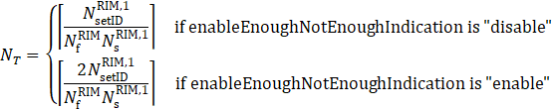  is the total number of set IDs for RIM RS-1 (configured by totalnrofSetIdofRS1),  is the number of candidate frequency resources in the whole network (configured by nrofGlobalRIMRSFrequencyCandidates), and  is the number of candidate sequences assigned for RIM RS-1 (configured by nrofRIMRSSequenceCandidatesofRS1).  allowedValues: 1,2,..2^14 | type: Integer  multiplicity: 1  isOrdered: N/A  isUnique: N/A  defaultValue: None  isNullable: False
rimRSMonitoringWindowPeriodicity | This attributer configures the periodicity of the monitoring window, in unit of hours.  allowedValues: 1, 2, 3, 4, 6, 8, 12, 24 | type: Integer  multiplicity: 1  isOrdered: N/A  isUnique: N/A  defaultValue: None  isNullable: False
rimRSMonitoringWindowStartingOffset | This attributer configures the start offset of the first monitoring window within one day, in unit of hours.  allowedValues: 0,1,2..23 | type: Integer  multiplicity: 1  isOrdered: N/A  isUnique: N/A  defaultValue: None  isNullable: False
rimRSMonitoringOccasionInterval | This attributer configures the interval between adjacent monitoring occasions (M) within the monitoring window, in unit of consecutive detection duration.  M is expected to be prime to , where is given in above attribute rimRSMonitoringWindowDuration.  allowedValues: 1,2..-1. | type: Integer  multiplicity: 1  isOrdered: N/A  isUnique: N/A  defaultValue: None  isNullable: False
rimRSMonitoringOccasionStartingOffset | This attributer configures the start offset of the first monitoring occasions within the monitoring window (), in unit of consecutive detection duration.  gNB starts monitoring potential interference from the -th consecutive detection duration in the first complete RIM-RS transmission periodicity () within the monitoring window.  allowedValues: 0,1,2..M-1  where M is the the interval between adjacent monitoring occasions within the monitoring window (configured by rimRSMonitoringOccasionInterval) | Integer  multiplicity: 1  isOrdered: N/A  isUnique: N/A  defaultValue: None  isNullable: False
victimSetRef | This attribute contains the DN of a victim Set (RimRSSet)  allowedValues: Not applicable. | type: DN  multiplicity: 1  isOrdered: N/A  isUnique: True  defaultValue: None  isNullable: False
aggressorSetRef | This attribute contains the DN of an aggressor Set (RimRSSet)  allowedValues: Not applicable. | type: DN  multiplicity: 1  isOrdered: N/A  isUnique: True  defaultValue: None  isNullable: False
setType | The attribute specifies type of a RIM-RS Set . RIM RS1 is generated and transmitted by victim to indicate its suffering remote interference, and RIM RS2 is generated and transmitted by aggressor to measure if Remote Interference still exist  If the attribute value is “RS1”, the RIM-RS Set is victim set.  If the attribute value is “RS2”, the RIM-RS Set is aggressor set.  allowedValues:  RS1, RS2. | type: ENUM  multiplicity: 1  isOrdered: N/A  isUnique: N/A  defaultValue: None  isNullable: False
nRCellDURef | This attribute contains the DN of a NR Cell (NRCellDU)  allowedValues: Not applicable. | type: DN  multiplicity: *  isOrdered: N/A  isUnique: True  defaultValue: None  isNullable: False
isENDCAllowed | This indicates if EN-DC is allowed or prohibited.  If TRUE, the target cell is allowed to be used for EN-DC. The target cell is referenced by the NRCellRelation that contains this isENDCAllowed.  If FALSE, EN-DC shall not be allowed.  allowedValues: TRUE,FALSE | type: Boolean  multiplicity: 1  isOrdered: N/A  isUnique: N/A  defaultValue: None  isNullable: False
x2BlockList | This is a list of GeNBIds. If the target node GeNBId is a member of the source node’s NRCellCU.x2BlockList, the source node is:  1) prohibited from sending X2 connection requests to the target node;  2) forced to tear down an established X2 connection to the target node;  3) not allowed to accept incoming X2 connection requests from the target node.  The same GeNBId may appear here and in NRCellCU.x2AllowList. In such case, the GeNBId in x2AllowList shall be treated as if it is absent.  allowedValues: See NOTE 5. | type: String  multiplicity: 0..*  isOrdered: False  isUnique: True  defaultValue: None  isNullable: False
xnBlockList | This is a list of GgNBIds. If the target node GgNBId is a member of the source node’s NRCellCU.xnBlockList, the source node is:  1) prohibited from sending Xn connection requests to the target node;  2) forced to tear down an established Xn connection to the target node;  3) not allowed to accept incoming Xn connection requests from the target node.  The same GgNBId may appear here and in NRCellCU.xnAllowList. In such case, the GgNBId in xnAllowList shall be treated as if it is absent.  allowedValues: See NOTE 5. | type: String  multiplicity: 0..*  isOrdered: False  isUnique: True  defaultValue: None  isNullable: False
x2AllowList | This is a list of GeNBIds. If the target node GeNBId is a member of the source node’s NRCellCU.x2AllowList, the source node is:  1) allowed to request the establishment of an X2 connection to the target node;  2) not allowed to initiate the tear down of an established X2 connection to the target node  The same GeNBId may appear here and in NRCellCU.x2BlockList. In such case, the GeNBId here shall be treated as if it is absent.  allowedValues: See NOTE 5. | type: String  multiplicity: 0..*  isOrdered: False  isUnique: True  defaultValue: None  isNullable: False
xnAllowList | This is a list of GgNBIds. If the target node GgNBId is a member of the source node’s NRCellCU.xnAllowList, the source node is:  1) allowed to request the establishment of Xn connection with the target node;  2) not allowed to initiate the tear down of an established Xn connection to the target node  The same GgNBId may appear here and in NRCellCU.xnBlockList. In such case, the GgNBId here shall be treated as if it is absent.  allowedValues: See NOTE 5. | type: String  multiplicity: 0..*  isOrdered: False  isUnique: True  defaultValue: None  isNullable: False
xnHOBlockList | This is a list of GgNBIds. For all the entries in NRCellCU.xnHOBlockList, the subject NRCellCU is prohibited to use the Xn interface for HOs even if an Xn interface exists to the target cell.  allowedValues: See NOTE 5. | type: String  multiplicity: 0..*  isOrdered: False  isUnique: True  defaultValue: None  isNullable: False
x2HOBlockList | This is a list of GeNBIds. For all the entries in NRCellCU.x2HOBlockList, the subject NRCellCU is prohibited to use the X2 interface for HOs even if an X2 interface exists to the target cell.  allowedValues: See NOTE 5. | type: String  multiplicity: 0..*  isOrdered: False  isUnique: True  defaultValue: None  isNullable: False
tceIDMappingInfoList | This attribute includes a list of TCE ID, PLMN where TCE resides and the corresponding TCE IP address. It is used in Logged MDT case to provide the information to the gNodeB or GNBCUCPFunction to get the corresponding TCE IP address when there is an MDT log received from the UE.  allowedValues: Not applicable | type: tceIDMappingInfo  multiplicity: 1..*  isOrdered: N/A  isUnique: N/A  defaultValue: None  isNullable: False
tceIPAddress | This attribute indicates IP address of TCE. (See subclause 4.1.1.9.2 in TS 32.422[68]) | type: String  multiplicity: 1  isOrdered: N/A  isUnique: N/A  defaultValue: None  isNullable: False
tceID | This attribute indicates TCE Id. (See subclause 4.1.1.9.2 in TS 32.422[68]) | type: Integer  multiplicity: 1  isOrdered: N/A  isUnique: N/A  defaultValue: None  isNullable: False
pLMNTarget | This attribute indicates PLMN where TCE resides. (See subclauses 4.1.1.9.2 and 4.9.2 in TS 32.422 [68]) | Type: PLMNId  multiplicity: 1  isOrdered: N/A  isUnique: N/A  defaultValue: None  isNullable: False
isMLBAllowed | This indicates if mobility load balancing is allowed or prohibited from source cell to target cell.  If TRUE, load balancing is allowed from source cell to target cell. The source cell is identified by the name-containing NRCellCU of the NRCellRelation that contains the isMLBAllowed. The target cell is referenced by the NRCellRelation that contains this isLBAllowed. In case of isHOAllowed is FALSE, mobility load balancing is prohibited by handover from source cell to target cell.  If FALSE, load balancing shall be prohibited from source cell to target cell.  allowedValues: TRUE,FALSE | type: Boolean  multiplicity: 1  isOrdered: N/A  isUnique: N/A  defaultValue: None  isNullable: False
cCOPolicies | It indicates condition and the corresponding actions applied for the C-SON function of radio Capacity and Coverage optimization.  allowedValues: N/A | type: CCOPolicy  multiplicity: 1..*  isOrdered: N/A  isUnique: N/A  defaultValue: None  isNullable: False
cCOPolicyCondition | It indicates the condition which will trigger the actions to optimize radio coverage.  allowedValues: “weak coverage”, “pilot pollution”, “overshoot coverage”. | type: String  multiplicity: 1  isOrdered: N/A  isUnique: N/A  defaultValue: None  isNullable: False
downlinkTransmitPowerInfo | It indicates adjustment range (including maximum value, minimum value) of downlinkTransmitPower to optimize radio coverage.  allowedValues: [1..100] | type: Integer  multiplicity: 1  isOrdered: N/A  isUnique: N/A  defaultValue: None  isNullable: False
antennaTiltInfo | It indicates adjustment range (including maximum value, minimum value) of antennaTilt to optimize radio coverage.  allowedValues: [-900..900] 0.1 degree | type: Integer  multiplicity: 1  isOrdered: N/A  isUnique: N/A  defaultValue: None  isNullable: False
antennaAzimuthInfo | It indicates adjustment range (including maximum value, minimum value) of antennaAzimuth to optimize radio coverage.  allowedValues: [-1800..1800] 0.1 degree | type: Integer  multiplicity: 1  isOrdered: N/A  isUnique: N/A  defaultValue: None  isNullable: False
digitalTiltInfo | It indicates adjustment range (including maximum value, minimum value) of digitalTilt to optimize radio coverage.  allowedValues: [-900..900] 0.1 degree | type: Integer  multiplicity: 1  isOrdered: N/A  isUnique: N/A  defaultValue: None  isNullable: False
digitalAzimuthInfo | It indicates adjustment range (including maximum value, minimum value) of digitalAzimuth to optimize radio coverage.  allowedValues: [-1800..1800] 0.1 degree | type: Integer  multiplicity: 1  isOrdered: N/A  isUnique: N/A  defaultValue: None  isNullable: False
coverageShapeList | It indicates the coverageShape which can be selected to optimize radio coverage.  allowedValues: 0 : 65535 | type: Integer  multiplicity: 1..*  isOrdered: N/A  isUnique: True  defaultValue: None  isNullable: False
cCOSwitch | This attribute determines whether the centralized SON CCO Function is enabled or disabled.  allowedValues: TRUE,FALSE | type: Boolean  multiplicity: 1  isOrdered: N/A  isUnique: N/A  defaultValue: None  isNullable: False
NOTE 1: Void
NOTE 2: The radio resource can be signaling resources (e.g. RRC connected users) or user plane resources (e.g. PRB, PRB UL, PRB DL, DRB). Different RRM Policy maybe applied for different types of radio resource. E.g. RRMPolicyRatio is used for PRB resource. When the resource type is PRB the policy applies for both uplink and downlink, and ‘PRB UL’ and ‘PRB DL’ are not used.
NOTE 3: Void
NOTE 4: A RRM Policy can make use of the defined policy (e.g. RRMPolicyRatio) or a vendor specific RRM Policy.
NOTE 5: For Global gNB Identifiers, the entries are formatted according to the pattern <mcc><mnc>-<gNBIdLength>-<gNBId>, where <mcc> is three digits, <mnc> two or three digits, <gNBIdLength> is a string containing a number n as digits, in the range 22 to 32, and <gNBId> is a string containing digits for the number 0 to 2^{n}-1. For Global eNB Identifiers, the entries are formatted according to the pattern <mcc><mnc>-<eNBIdLength>-<eNBId>, where <mcc> is three digits, <mnc> two or three digits, <gNBIdLength> is a string containing a number m as digits, m being one of 18, 20, 21 or 22, and <eNBId> is a string containing digits for the number 0 to 2^{m}-1.
NOTE 6: The maximum number of total RIM RS sequence within 10ms is 32 regardless single or two uplink-downlink period are configured in the 10ms..
NOTE 7:
1. The maximum number of consecutive uplink-downlink switching periods for repetition/near-far-functionality is 8 (the number can be either 2, 4, or 8) with near-far functionality and with repetition.
2. The maximum number of consecutive uplink-downlink switching periods for repetition is 4 (the number can be either 1, 2, or 4) without near-far functionality and with repetition only.
3. The maximum number of consecutive uplink-downlink switching periods is 2 with near-far functionality only and without repetition.
NOTE 8 (for information): “Not enough mitigation” means aggressor gNB needs to increase the interference mitigation level (i.e., further interference mitigation actions) (e.g., further reducing the DL transmission power on DL symbols at aggressor side), while “Enough mitigation” means aggressor gNB keeping the current interference mitigation level unchanged (i.e., no further interference mitigation actions) (e.g., remaining the DL transmission power on DL symbols unchanged at aggressor side).
NOTE 9: Value MS0P5 corresponds to 0.5 ms, MS0P625 corresponds to 0.625 ms, MS1 corresponds to 1 ms, MS1P25 corresponds to 1.25 ms, and so on.
NOTE 10: RIM RS-1, RIM-RS1，RIM RS1 is equivalent to RIM-RS type 1 (see 38.211 [32], clause 7.4.1.6)
RIM RS-2, RIM-RS2，RIM RS2 is equivalent to RIM-RS type 2 (see 38.211 [32], clause 7.4.1.6).

5th Change

D.4.3 OpenAPI document "nrNrm.yaml"

openapi: 3.0.1
info:
title: NR NRM
version: 17.4.0
description: >-
OAS 3.0.1 specification of the NR NRM
© 2020, 3GPP Organizational Partners (ARIB, ATIS, CCSA, ETSI, TSDSI, TTA, TTC).
All rights reserved.
externalDocs:
description: 3GPP TS 28.541; 5G NRM, NR NRM
url: http://www.3gpp.org/ftp/Specs/archive/28_series/28.541/
paths: {}
components:
schemas:

#-------- Definition of types-----------------------------------------------------

GnbId:
type: string
GnbIdLength:
type: integer
minimum: 22
maximum: 32
GnbName:
type: string
maxLength: 150
GnbDuId:
type: number
minimum: 0
maximum: 68719476735
GnbCuUpId:
type: number
minimum: 0
maximum: 68719476735

Sst:
type: integer
maximum: 255
Snssai:
type: object
properties:
sst:
$ref: '#/components/schemas/Sst'
sd:
type: string
SnssaiList:
type: array
items:
$ref: '#/components/schemas/Snssai'

Mnc:
type: string
pattern: '[0-9]{3}|[0-9]{2}'
PlmnId:
type: object
properties:
mcc:
$ref: 'genericNrm.yaml#/components/schemas/Mcc'
mnc:
$ref: '#/components/schemas/Mnc'
PlmnIdList:
type: array
items:
$ref: '#/components/schemas/PlmnId'
PlmnInfo:
type: object
properties:
plmnId":
$ref: '#/components/schemas/PlmnId'
snssai:
$ref: '#/components/schemas/Snssai'
PlmnInfoList:
type: array
items:
$ref: '#/components/schemas/PlmnInfo'
cagId:
type: string
nid:
type: string
NpnIdentity:
type: object
properties:
plmnId":
$ref: '#/components/schemas/PlmnId'
cagidList:
$ref: '#/components/schemas/cagId'
nidList:
$ref: '#/components/schemas/nid'
NpnIdentityList:
type: array
items:
$ref: '#/components/schemas/NpnIdentity'
GGnbId:
type: string
pattern: '^[0-9]{3}[0-9]{2,3}-(22|23|24|25|26|27|28|29|30|31|32)-[0-9]{1,10}'
GEnbId:
type: string
pattern: '^[0-9]{3}[0-9]{2,3}-(18|20|21|22)-[0-9]{1,7}'

GGnbIdList:
type: array
items:
$ref: '#/components/schemas/GGnbId'

GEnbIdList:
type: array
items:
$ref: '#/components/schemas/GEnbId'

NrPci:
type: integer
maximum: 503
NrTac:
type: integer
maximum: 16777215
Tai:
type: object
properties:
plmnId:
$ref: '#/components/schemas/PlmnId'
nrTac:
$ref: '#/components/schemas/NrTac'

BackhaulAddress:
type: object
properties:
gnbId:
$ref: '#/components/schemas/GnbId'
tai:
$ref: "#/components/schemas/Tai"
MappingSetIDBackhaulAddress:
type: object
properties:
setID:
type: integer
backhaulAddress:
$ref: '#/components/schemas/BackhaulAddress'
IntraRatEsActivationOriginalCellLoadParameters:
type: object
properties:
loadThreshold:
type: integer
timeDuration:
type: integer
IntraRatEsActivationCandidateCellsLoadParameters:
type: object
properties:
loadThreshold:
type: integer
timeDuration:
type: integer
IntraRatEsDeactivationCandidateCellsLoadParameters:
type: object
properties:
loadThreshold:
type: integer
timeDuration:
type: integer
EsNotAllowedTimePeriod:
type: object
properties:
startTimeandendTime:
type: string
periodOfDay:
type: string
daysOfWeekList:
type: string
listoftimeperiods:
type: string
InterRatEsActivationOriginalCellParameters:
type: object
properties:
loadThreshold:
type: integer
timeDuration:
type: integer
InterRatEsActivationCandidateCellParameters:
type: object
properties:
loadThreshold:
type: integer
timeDuration:
type: integer
InterRatEsDeactivationCandidateCellParameters:
type: object
properties:
loadThreshold:
type: integer
timeDuration:
type: integer

UeAccProbilityDist:
type: object
properties:
targetProbability:
type: integer
numberofpreamblessent:
type: integer

UeAccDelayProbilityDist:
type: object
properties:
targetProbability:
type: integer
accessdelay:
type: integer

NRPciList:
type: object
properties:
NRPci:
type: integer

CSonPciList:
type: object
properties:
NRPci:
type: integer

MaximumDeviationHoTrigger:
type: integer
minimum: -20
maximum: 20

MinimumTimeBetweenHoTriggerChange:
type: integer
minimum: 0
maximum: 604800

TstoreUEcntxt:
type: integer
minimum: 0
maximum: 1023

CellState:
type: string
enum:
- IDLE
- INACTIVE
- ACTIVE
CyclicPrefix:
type: string
enum:
- '15'
- '30'
- '60'
- '120'
TxDirection:
type: string
enum:
- DL
- UL
- DL and UL
BwpContext:
type: string
enum:
- DL
- UL
- SUL
IsInitialBwp:
type: string
enum:
- INITIAL
- OTHER
- SUL
QuotaType:
type: string
enum:
- STRICT
- FLOAT
IsESCoveredBy:
type: string
enum:
- NO
- PARTIAL
- FULL
RrmPolicyMember:
type: object
properties:
plmnId:
$ref: '#/components/schemas/PlmnId'
snssai:
$ref: '#/components/schemas/Snssai'
RrmPolicyMemberList:
type: array
items:
$ref: '#/components/schemas/RrmPolicyMember'
AddressWithVlan:
type: object
properties:
ipv4Address:
$ref: 'genericNrm.yaml#/components/schemas/Ipv4Addr'
ipv6Address:
$ref: 'genericNrm.yaml#/components/schemas/Ipv6Addr'
vlanId:
type: integer
minimum: 0
maximum: 4096
LocalAddress:
type: object
properties:
addressWithVlan:
$ref: '#/components/schemas/AddressWithVlan'
port:
type: integer
minimum: 0
maximum: 65535
RemoteAddress:
type: object
properties:
ipv4Address:
$ref: 'genericNrm.yaml#/components/schemas/Ipv4Addr'
ipv6Address:
$ref: 'genericNrm.yaml#/components/schemas/Ipv6Addr'

CellIndividualOffset:
type: object
properties:
rsrpOffsetSSB:
type: integer
rsrqOffsetSSB:
type: integer
sinrOffsetSSB:
type: integer
rsrpOffsetCSI-RS:
type: integer
rsrqOffsetCSI-RS:
type: integer
sinrOffsetCSI-RS:
type: integer
QOffsetRange:
type: integer
enum:
- -24
- -22
- -20
- -18
- -16
- -14
- -12
- -10
- -8
- -6
- -5
- -4
- -3
- -2
- -1
- 0
- 24
- 22
- 20
- 18
- 16
- 14
- 12
- 10
- 8
- 6
- 5
- 4
- 3
- 2
- 1
QOffsetRangeList:
type: object
properties:
rsrpOffsetSSB:
$ref: '#/components/schemas/QOffsetRange'
rsrqOffsetSSB:
$ref: '#/components/schemas/QOffsetRange'
sinrOffsetSSB:
$ref: '#/components/schemas/QOffsetRange'
rsrpOffsetCSI-RS:
$ref: '#/components/schemas/QOffsetRange'
rsrqOffsetCSI-RS:
$ref: '#/components/schemas/QOffsetRange'
sinrOffsetCSI-RS:
$ref: '#/components/schemas/QOffsetRange'
QOffsetFreq:
type: number
TReselectionNRSf:
type: integer
enum:
- 25
- 50
- 75
- 100
SsbPeriodicity:
type: integer
enum:
- 5
- 10
- 20
- 40
- 80
- 160
SsbDuration:
type: integer
enum:
- 1
- 2
- 3
- 4
- 5
SsbSubCarrierSpacing:
type: integer
enum:
- 15
- 30
- 120
- 240
CoverageShape:
type: integer
maximum: 65535
DigitalTilt:
type: integer
minimum: -900
maximum: 900
DigitalAzimuth:
type: integer
minimum: -1800
maximum: 1800

RSSetId:
type: integer
maximum: 4194303

RSSetType:
type: string
enum:
- RS1
- RS2

FrequencyDomainPara:
type: object
properties:
rimRSSubcarrierSpacing:
type: integer
rIMRSBandwidth:
type: integer
nrofGlobalRIMRSFrequencyCandidates:
type: integer
rimRSCommonCarrierReferencePoint:
type: integer
rimRSStartingFrequencyOffsetIdList:
type: array
items:
type: integer

SequenceDomainPara:
type: object
properties:
nrofRIMRSSequenceCandidatesofRS1:
type: integer
rimRSScrambleIdListofRS1:
type: array
items:
type: integer
nrofRIMRSSequenceCandidatesofRS2:
type: integer
rimRSScrambleIdListofRS2:
type: array
items:
type: integer
enableEnoughNotEnoughIndication:
type: string
enum:
- ENABLE
- DISABLE
RIMRSScrambleTimerMultiplier:
type: integer
RIMRSScrambleTimerOffset:
type: integer

TimeDomainPara:
type: object
properties:
dlULSwitchingPeriod1:
type: string
enum:
- MS0P5
- MS0P625
- MS1
- MS1P25
- MS2
- MS2P5
- MS3
- MS4
- MS5
- MS10
- MS20
symbolOffsetOfReferencePoint1:
type: integer
dlULSwitchingPeriod2:
type: string
enum:
- MS0P5
- MS0P625
- MS1
- MS1P25
- MS2
- MS2P5
- MS3
- MS4
- MS5
- MS10
- MS20
symbolOffsetOfReferencePoint2:
type: integer
totalnrofSetIdofRS1:
type: integer
totalnrofSetIdofRS2:
type: integer
nrofConsecutiveRIMRS1:
type: integer
nrofConsecutiveRIMRS2:
type: integer
consecutiveRIMRS1List:
type: array
items:
type: integer
consecutiveRIMRS2List:
type: array
items:
type: integer
enablenearfarIndicationRS1:
type: string
enum:
- ENABLE
- DISABLE
enablenearfarIndicationRS2:
type: string
enum:
- ENABLE
- DISABLE

RimRSReportInfo:
type: object
properties:
detectedSetID:
type: integer
propagationDelay:
type: integer
functionalityOfRIMRS:
type: string
enum:
- RS1
- RS2
- RS1forEnoughMitigation
- RS1forNotEnoughMitigation

RimRSReportConf:
type: object
properties:
reportIndicator:
type: string
enum:
- ENABLE
- DISABLE
reportInterval:
type: integer
nrofRIMRSReportInfo:
type: integer
maxPropagationDelay:
type: integer
rimRSReportInfoList:
type: array
items:
$ref: '#/components/schemas/RimRSReportInfo'
TceMappingInfo:
type: object
properties:
TceIPAddress:
oneOf:
- $ref: 'genericNrm.yaml#/components/schemas/Ipv4Addr'
- $ref: 'genericNrm.yaml#/components/schemas/Ipv6Addr'
TceID:
type: integer
PlmnTarget:
$ref: '#/components/schemas/PlmnId'
TceMappingInfoList:
type: array
items:
$ref: '#/components/schemas/TceMappingInfo'

CCOPolicy:
type: object
properties:
CCOPolicyCondition:
type: string
CCOPolicyAction:
$ref: '#/components/schemas/CCOPolicyAction'

CCOPolicyAction:
type: object
properties:
coverageShapeList:
type: integer
downlinkTransmitPowerInfo:
type: integer
antennaTiltInfo:
type: integer
antennaAzimuthInfo:
type: integer
digitalTiltInfo:
type: integer
digitalAzimuthInfo:
type: integer

#-------- Definition of abstract IOCs --------------------------------------------

RrmPolicy_-Attr:
type: object
properties:
resourceType:
type: string
rRMPolicyMemberList:
$ref: '#/components/schemas/RrmPolicyMemberList'

#-------- Definition of concrete IOCs --------------------------------------------

SubNetwork-Single:
allOf:
- $ref: 'genericNrm.yaml#/components/schemas/Top'
- type: object
properties:
attributes:
$ref: 'genericNrm.yaml#/components/schemas/SubNetwork-Attr'
- $ref: 'genericNrm.yaml#/components/schemas/SubNetwork-ncO'
- type: object
properties:
SubNetwork:
$ref: '#/components/schemas/SubNetwork-Multiple'
ManagedElement:
$ref: '#/components/schemas/ManagedElement-Multiple'
NRFrequency:
$ref: '#/components/schemas/NRFrequency-Multiple'
ExternalGnbCuCpFunction:
$ref: '#/components/schemas/ExternalGnbCuCpFunction-Multiple'
ExternalENBFunction:
$ref: '#/components/schemas/ExternalENBFunction-Multiple'
EUtranFrequency:
$ref: '#/components/schemas/EUtranFrequency-Multiple'
DESManagementFunction:
$ref: '#/components/schemas/DESManagementFunction-Single'
DRACHOptimizationFunction:
$ref: '#/components/schemas/DRACHOptimizationFunction-Single'
DMROFunction:
$ref: '#/components/schemas/DMROFunction-Single'
DPCIConfigurationFunction:
$ref: '#/components/schemas/DPCIConfigurationFunction-Single'
CPCIConfigurationFunction:
$ref: '#/components/schemas/CPCIConfigurationFunction-Single'
CESManagementFunction:
$ref: '#/components/schemas/CESManagementFunction-Single'
Configurable5QISet:
$ref: '5gcNrm.yaml#/components/schemas/Configurable5QISet-Multiple'
RimRSGlobal:
$ref: '#/components/schemas/RimRSGlobal-Single'
Dynamic5QISet:
$ref: '5gcNrm.yaml#/components/schemas/Dynamic5QISet-Multiple'

CCOFunction-Single:
$ref: '#/components/schemas/ CCOFunction-Single'

ManagedElement-Single:
allOf:
- $ref: 'genericNrm.yaml#/components/schemas/Top'
- type: object
properties:
attributes:
$ref: 'genericNrm.yaml#/components/schemas/ManagedElement-Attr'
- $ref: 'genericNrm.yaml#/components/schemas/ManagedElement-ncO'
- type: object
properties:
GnbDuFunction:
$ref: '#/components/schemas/GnbDuFunction-Multiple'
GnbCuUpFunction:
$ref: '#/components/schemas/GnbCuUpFunction-Multiple'
GnbCuCpFunction:
$ref: '#/components/schemas/GnbCuCpFunction-Multiple'
DESManagementFunction:
$ref: '#/components/schemas/DESManagementFunction-Single'
DRACHOptimizationFunction:
$ref: '#/components/schemas/DRACHOptimizationFunction-Single'
DMROFunction:
$ref: '#/components/schemas/DMROFunction-Single'
DPCIConfigurationFunction:
$ref: '#/components/schemas/DPCIConfigurationFunction-Single'
CPCIConfigurationFunction:
$ref: '#/components/schemas/CPCIConfigurationFunction-Single'
CESManagementFunction:
$ref: '#/components/schemas/CESManagementFunction-Single'
Configurable5QISet:
$ref: '5gcNrm.yaml#/components/schemas/Configurable5QISet-Multiple'
Dynamic5QISet:
$ref: '5gcNrm.yaml#/components/schemas/Dynamic5QISet-Multiple'

GnbDuFunction-Single:
allOf:
- $ref: 'genericNrm.yaml#/components/schemas/Top'
- type: object
properties:
attributes:
allOf:
- $ref: 'genericNrm.yaml#/components/schemas/ManagedFunction-Attr'
- type: object
properties:
gnbDuId:
$ref: '#/components/schemas/GnbDuId'
gnbDuName:
$ref: '#/components/schemas/GnbName'
gnbId:
$ref: '#/components/schemas/GnbId'
gnbIdLength:
$ref: '#/components/schemas/GnbIdLength'
rimRSReportConf:
$ref: '#/components/schemas/RimRSReportConf'
- $ref: 'genericNrm.yaml#/components/schemas/ManagedFunction-ncO'
- type: object
properties:
RRMPolicyRatio:
$ref: '#/components/schemas/RRMPolicyRatio-Multiple'
NrCellDu:
$ref: '#/components/schemas/NrCellDu-Multiple'
Bwp-Multiple:
$ref: '#/components/schemas/Bwp-Multiple'
NrSectorCarrier-Multiple:
$ref: '#/components/schemas/NrSectorCarrier-Multiple'
EP_F1C:
$ref: '#/components/schemas/EP_F1C-Single'
EP_F1U:
$ref: '#/components/schemas/EP_F1U-Multiple'
DRACHOptimizationFunction:
$ref: '#/components/schemas/DRACHOptimizationFunction-Single'
GnbCuUpFunction-Single:
allOf:
- $ref: 'genericNrm.yaml#/components/schemas/Top'
- type: object
properties:
attributes:
allOf:
- $ref: 'genericNrm.yaml#/components/schemas/ManagedFunction-Attr'
- type: object
properties:
gnbId:
$ref: '#/components/schemas/GnbId'
gnbIdLength:
$ref: '#/components/schemas/GnbIdLength'
gnbCuUpId:
$ref: '#/components/schemas/GnbCuUpId'
plmnInfoList:
$ref: '#/components/schemas/PlmnInfoList'
configurable5QISetRef:
$ref: 'genericNrm.yaml#/components/schemas/Dn'
dynamic5QISetRef:
$ref: 'genericNrm.yaml#/components/schemas/Dn'
- $ref: 'genericNrm.yaml#/components/schemas/ManagedFunction-ncO'
- type: object
properties:
RRMPolicyRatio:
$ref: '#/components/schemas/RRMPolicyRatio-Multiple'
EP_E1:
$ref: '#/components/schemas/EP_E1-Single'
EP_XnU:
$ref: '#/components/schemas/EP_XnU-Multiple'
EP_F1U:
$ref: '#/components/schemas/EP_F1U-Multiple'
EP_NgU:
$ref: '#/components/schemas/EP_NgU-Multiple'
EP_X2U:
$ref: '#/components/schemas/EP_X2U-Multiple'
EP_S1U:
$ref: '#/components/schemas/EP_S1U-Multiple'
GnbCuCpFunction-Single:
allOf:
- $ref: 'genericNrm.yaml#/components/schemas/Top'
- type: object
properties:
attributes:
allOf:
- $ref: 'genericNrm.yaml#/components/schemas/ManagedFunction-Attr'
- type: object
properties:
gnbId:
$ref: '#/components/schemas/GnbId'
gnbIdLength:
$ref: '#/components/schemas/GnbIdLength'
gnbCuName:
$ref: '#/components/schemas/GnbName'
plmnId:
$ref: '#/components/schemas/PlmnId'
x2BlackList:
$ref: '#/components/schemas/GGnbIdList'
xnBlackList:
$ref: '#/components/schemas/GGnbIdList'
x2WhiteList:
$ref: '#/components/schemas/GGnbIdList'
xnWhiteList:
$ref: '#/components/schemas/GGnbIdList'
x2XnHOBlackList:
$ref: '#/components/schemas/GEnbIdList'
mappingSetIDBackhaulAddress:
$ref: '#/components/schemas/MappingSetIDBackhaulAddress'
tceMappingInfoList:
$ref: '#/components/schemas/TceMappingInfoList'
configurable5QISetRef:
$ref: 'genericNrm.yaml#/components/schemas/Dn'
dynamic5QISetRef:
$ref: 'genericNrm.yaml#/components/schemas/Dn'
- $ref: 'genericNrm.yaml#/components/schemas/ManagedFunction-ncO'
- type: object
properties:
RRMPolicyRatio:
$ref: '#/components/schemas/RRMPolicyRatio-Multiple'
NrCellCu:
$ref: '#/components/schemas/NrCellCu-Multiple'
EP_XnC:
$ref: '#/components/schemas/EP_XnC-Multiple'
EP_E1:
$ref: '#/components/schemas/EP_E1-Multiple'
EP_F1C:
$ref: '#/components/schemas/EP_F1C-Multiple'
EP_NgC:
$ref: '#/components/schemas/EP_NgC-Multiple'
EP_X2C:
$ref: '#/components/schemas/EP_X2C-Multiple'
DANRManagementFunction:
$ref: '#/components/schemas/DANRManagementFunction-Single'
DESManagementFunction:
$ref: '#/components/schemas/DESManagementFunction-Single'
DMROFunction:
$ref: '#/components/schemas/DMROFunction-Single'

NrCellCu-Single:
allOf:
- $ref: 'genericNrm.yaml#/components/schemas/Top'
- type: object
properties:
attributes:
allOf:
- $ref: 'genericNrm.yaml#/components/schemas/ManagedFunction-Attr'
- type: object
properties:
cellLocalId:
type: integer
plmnInfoList:
$ref: '#/components/schemas/PlmnInfoList'
nRFrequencyRef:
$ref: 'genericNrm.yaml#/components/schemas/Dn'
- $ref: 'genericNrm.yaml#/components/schemas/ManagedFunction-ncO'
- type: object
properties:
RRMPolicyRatio:
$ref: '#/components/schemas/RRMPolicyRatio-Multiple'
NRCellRelation:
$ref: '#/components/schemas/NRCellRelation-Multiple'
EUtranCellRelation:
$ref: '#/components/schemas/EUtranCellRelation-Multiple'
NRFreqRelation:
$ref: '#/components/schemas/NRFreqRelation-Multiple'
EUtranFreqRelation:
$ref: '#/components/schemas/EUtranFreqRelation-Multiple'
DESManagementFunction:
$ref: '#/components/schemas/DESManagementFunction-Single'
DMROFunction:
$ref: '#/components/schemas/DMROFunction-Single'
CESManagementFunction:
$ref: '#/components/schemas/CESManagementFunction-Single'
DPCIConfigurationFunction:
$ref: '#/components/schemas/DPCIConfigurationFunction-Single'

NrCellDu-Single:
allOf:
- $ref: 'genericNrm.yaml#/components/schemas/Top'
- type: object
properties:
attributes:
allOf:
- $ref: 'genericNrm.yaml#/components/schemas/ManagedFunction-Attr'
- type: object
properties:
administrativeState:
$ref: 'genericNrm.yaml#/components/schemas/AdministrativeState'
operationalState:
$ref: 'genericNrm.yaml#/components/schemas/OperationalState'
cellLocalId:
type: integer
cellState:
$ref: '#/components/schemas/CellState'
plmnInfoList:
$ref: '#/components/schemas/PlmnInfoList'
npnIdentityList:
$ref: '#/components/schemas/NpnIdentityList'
nrPci:
$ref: '#/components/schemas/NrPci'
nrTac:
$ref: '#/components/schemas/NrTac'
arfcnDL:
type: integer
arfcnUL:
type: integer
arfcnSUL:
type: integer
bSChannelBwDL:
type: integer
bSChannelBwUL:
type: integer
bSChannelBwSUL:
type: integer
ssbFrequency:
type: integer
minimum: 0
maximum: 3279165
ssbPeriodicity:
$ref: '#/components/schemas/SsbPeriodicity'
ssbSubCarrierSpacing:
$ref: '#/components/schemas/SsbSubCarrierSpacing'
ssbOffset:
type: integer
minimum: 0
maximum: 159
ssbDuration:
$ref: '#/components/schemas/SsbDuration'
nrSectorCarrierRef:
type: array
items:
$ref: 'genericNrm.yaml#/components/schemas/Dn'
bwpRef:
type: array
items:
$ref: 'genericNrm.yaml#/components/schemas/Dn'
rimRSMonitoringStartTime:
type: string
rimRSMonitoringStopTime:
type: string
rimRSMonitoringWindowDuration:
type: integer
rimRSMonitoringWindowStartingOffset:
type: integer
rimRSMonitoringWindowPeriodicity:
type: integer
rimRSMonitoringOccasionInterval:
type: integer
rimRSMonitoringOccasionStartingOffset:
type: integer
nRFrequencyRef:
$ref: 'genericNrm.yaml#/components/schemas/Dn'
victimSetRef:
$ref: 'genericNrm.yaml#/components/schemas/Dn'
aggressorSetRef:
$ref: 'genericNrm.yaml#/components/schemas/Dn'
- $ref: 'genericNrm.yaml#/components/schemas/ManagedFunction-ncO'
- type: object
properties:
RRMPolicyRatio:
$ref: '#/components/schemas/RRMPolicyRatio-Multiple'
CPCIConfigurationFunction:
$ref: '#/components/schemas/CPCIConfigurationFunction-Single'
DRACHOptimizationFunction:
$ref: '#/components/schemas/DRACHOptimizationFunction-Single'

NRFrequency-Single:
allOf:
- $ref: 'genericNrm.yaml#/components/schemas/Top'
- type: object
properties:
attributes:
type: object
properties:
absoluteFrequencySSB:
type: integer
minimum: 0
maximum: 3279165
ssbSubCarrierSpacing:
$ref: '#/components/schemas/SsbSubCarrierSpacing'
multiFrequencyBandListNR:
type: integer
minimum: 1
maximum: 256
EUtranFrequency-Single:
allOf:
- $ref: 'genericNrm.yaml#/components/schemas/Top'
- type: object
properties:
attributes:
type: object
properties:
earfcnDL:
type: integer
minimum: 0
maximum: 262143
multiBandInfoListEutra:
type: integer
minimum: 1
maximum: 256

NrSectorCarrier-Single:
allOf:
- $ref: 'genericNrm.yaml#/components/schemas/Top'
- type: object
properties:
attributes:
allOf:
- $ref: 'genericNrm.yaml#/components/schemas/ManagedFunction-Attr'
- type: object
properties:
txDirection:
$ref: '#/components/schemas/TxDirection'
configuredMaxTxPower:
type: integer
arfcnDL:
type: integer
arfcnUL:
type: integer
bSChannelBwDL:
type: integer
bSChannelBwUL:
type: integer
sectorEquipmentFunctionRef:
$ref: 'genericNrm.yaml#/components/schemas/Dn'
- $ref: 'genericNrm.yaml#/components/schemas/ManagedFunction-ncO'
- type: object
properties:
CommonBeamformingFunction:
$ref: '#/components/schemas/CommonBeamformingFunction-Single'
Bwp-Single:
allOf:
- $ref: 'genericNrm.yaml#/components/schemas/Top'
- type: object
properties:
attributes:
allOf:
- $ref: 'genericNrm.yaml#/components/schemas/ManagedFunction-Attr'
- type: object
properties:
bwpContext:
$ref: '#/components/schemas/BwpContext'
isInitialBwp:
$ref: '#/components/schemas/IsInitialBwp'
subCarrierSpacing:
type: integer
cyclicPrefix:
$ref: '#/components/schemas/CyclicPrefix'
startRB:
type: integer
numberOfRBs:
type: integer
- $ref: 'genericNrm.yaml#/components/schemas/ManagedFunction-ncO'
CommonBeamformingFunction-Single:
allOf:
- $ref: 'genericNrm.yaml#/components/schemas/Top'
- type: object
properties:
attributes:
allOf:
- type: object
properties:
coverageShape:
$ref: '#/components/schemas/CoverageShape'
digitalAzimuth:
$ref: '#/components/schemas/DigitalAzimuth'
digitalTilt:
$ref: '#/components/schemas/DigitalTilt'
- type: object
properties:
Beam:
$ref: '#/components/schemas/Beam-Multiple'
Beam-Single:
allOf:
- $ref: 'genericNrm.yaml#/components/schemas/Top'
- type: object
properties:
attributes:
allOf:
- type: object
properties:
beamIndex:
type: integer
beamType:
type: string
enum:
- SSB-BEAM
beamAzimuth:
type: integer
minimum: -1800
maximum: 1800
beamTilt:
type: integer
minimum: -900
maximum: 900
beamHorizWidth:
type: integer
minimum: 0
maximum: 3599
beamVertWidth:
type: integer
minimum: 0
maximum: 1800
RRMPolicyRatio-Single:
allOf:
- $ref: 'genericNrm.yaml#/components/schemas/Top'
- type: object
properties:
attributes:
allOf:
- $ref: '#/components/schemas/RrmPolicy_-Attr'
- type: object
properties:
rRMPolicyMaxRatio:
type: integer
rRMPolicyMinRatio:
type: integer
rRMPolicyDedicatedRatio:
type: integer

NRCellRelation-Single:
allOf:
- $ref: 'genericNrm.yaml#/components/schemas/Top'
- type: object
properties:
attributes:
type: object
properties:
nRTCI:
type: integer
cellIndividualOffset:
$ref: '#/components/schemas/CellIndividualOffset'
adjacentNRCellRef:
$ref: 'genericNrm.yaml#/components/schemas/Dn'
nRFrequencyRef:
$ref: 'genericNrm.yaml#/components/schemas/Dn'
isRemoveAllowed:
type: boolean
isHOAllowed:
type: boolean
isESCoveredBy:
$ref: '#/components/schemas/IsESCoveredBy'
isENDCAllowed:
type: boolean
isMLBAllowed:
type: boolean
EUtranCellRelation-Single:
allOf:
- $ref: 'genericNrm.yaml#/components/schemas/Top'
- type: object
properties:
attributes:
allOf:
- $ref: 'genericNrm.yaml#/components/schemas/ManagedFunction-Attr'
- type: object
properties:
adjacentEUtranCellRef:
$ref: 'genericNrm.yaml#/components/schemas/Dn'
- $ref: 'genericNrm.yaml#/components/schemas/ManagedFunction-ncO'
NRFreqRelation-Single:
allOf:
- $ref: 'genericNrm.yaml#/components/schemas/Top'
- type: object
properties:
attributes:
type: object
properties:
offsetMO:
$ref: '#/components/schemas/QOffsetRangeList'
blackListEntry:
type: array
items:
type: integer
minimum: 0
maximum: 1007
blackListEntryIdleMode:
type: integer
cellReselectionPriority:
type: integer
cellReselectionSubPriority:
type: number
minimum: 0.2
maximum: 0.8
multipleOf: 0.2
pMax:
type: integer
minimum: -30
maximum: 33
qOffsetFreq:
$ref: '#/components/schemas/QOffsetFreq'
qQualMin:
type: number
qRxLevMin:
type: integer
minimum: -140
maximum: -44
threshXHighP:
type: integer
minimum: 0
maximum: 62
threshXHighQ:
type: integer
minimum: 0
maximum: 31
threshXLowP:
type: integer
minimum: 0
maximum: 62
threshXLowQ:
type: integer
minimum: 0
maximum: 31
tReselectionNr:
type: integer
minimum: 0
maximum: 7
tReselectionNRSfHigh:
$ref: '#/components/schemas/TReselectionNRSf'
tReselectionNRSfMedium:
$ref: '#/components/schemas/TReselectionNRSf'
nRFrequencyRef:
$ref: 'genericNrm.yaml#/components/schemas/Dn'
EUtranFreqRelation-Single:
allOf:
- $ref: 'genericNrm.yaml#/components/schemas/Top'
- type: object
properties:
attributes:
type: object
properties:
cellIndividualOffset:
$ref: '#/components/schemas/CellIndividualOffset'
blackListEntry:
type: array
items:
type: integer
minimum: 0
maximum: 1007
blackListEntryIdleMode:
type: integer
cellReselectionPriority:
type: integer
cellReselectionSubPriority:
type: number
minimum: 0.2
maximum: 0.8
multipleOf: 0.2
pMax:
type: integer
minimum: -30
maximum: 33
qOffsetFreq:
$ref: '#/components/schemas/QOffsetFreq'
qQualMin:
type: number
qRxLevMin:
type: integer
minimum: -140
maximum: -44
threshXHighP:
type: integer
minimum: 0
maximum: 62
threshXHighQ:
type: integer
minimum: 0
maximum: 31
threshXLowP:
type: integer
minimum: 0
maximum: 62
threshXLowQ:
type: integer
minimum: 0
maximum: 31
tReselectionEutran:
type: integer
minimum: 0
maximum: 7
tReselectionNRSfHigh:
$ref: '#/components/schemas/TReselectionNRSf'
tReselectionNRSfMedium:
$ref: '#/components/schemas/TReselectionNRSf'
eUTranFrequencyRef:
$ref: 'genericNrm.yaml#/components/schemas/Dn'
DANRManagementFunction-Single:
allOf:
- $ref: 'genericNrm.yaml#/components/schemas/Top'
- type: object
properties:
attributes:
type: object
properties:
intrasystemANRManagementSwitch:
type: boolean
intersystemANRManagementSwitch:
type: boolean

DESManagementFunction-Single:
allOf:
- $ref: 'genericNrm.yaml#/components/schemas/Top'
- type: object
properties:
attributes:
type: object
properties:
desSwitch:
type: boolean
intraRatEsActivationOriginalCellLoadParameters:
$ref: "#/components/schemas/IntraRatEsActivationOriginalCellLoadParameters"
intraRatEsActivationCandidateCellsLoadParameters:
$ref: "#/components/schemas/IntraRatEsActivationCandidateCellsLoadParameters"
intraRatEsDeactivationCandidateCellsLoadParameters:
$ref: "#/components/schemas/IntraRatEsDeactivationCandidateCellsLoadParameters"
esNotAllowedTimePeriod:
$ref: "#/components/schemas/EsNotAllowedTimePeriod"
interRatEsActivationOriginalCellParameters:
$ref: "#/components/schemas/IntraRatEsActivationOriginalCellLoadParameters"
interRatEsActivationCandidateCellParameters:
$ref: "#/components/schemas/IntraRatEsActivationOriginalCellLoadParameters"
interRatEsDeactivationCandidateCellParameters:
$ref: "#/components/schemas/IntraRatEsActivationOriginalCellLoadParameters"
isProbingCapable:
type: string
enum:
- yes
- no
energySavingState:
type: string
enum:
- isNotEnergySaving
- isEnergySaving

DRACHOptimizationFunction-Single:
allOf:
- $ref: 'genericNrm.yaml#/components/schemas/Top'
- type: object
properties:
attributes:
type: object
properties:
drachOptimizationControl:
type: boolean
ueAccProbilityDist:
$ref: "#/components/schemas/UeAccProbilityDist"
ueAccDelayProbilityDist:
$ref: "#/components/schemas/UeAccDelayProbilityDist"
- $ref: 'genericNrm.yaml#/components/schemas/ManagedFunction-ncO'

DMROFunction-Single:
allOf:
- $ref: 'genericNrm.yaml#/components/schemas/Top'
- type: object
properties:
attributes:
type: object
properties:
dmroControl:
type: boolean
maximumDeviationHoTrigger:
$ref: '#/components/schemas/MaximumDeviationHoTrigger'
minimumTimeBetweenHoTriggerChange:
$ref: '#/components/schemas/MinimumTimeBetweenHoTriggerChange'
tstoreUEcntxt:
$ref: '#/components/schemas/TstoreUEcntxt'

DPCIConfigurationFunction-Single:
allOf:
- $ref: 'genericNrm.yaml#/components/schemas/Top'
- type: object
properties:
attributes:
type: object
properties:
dPciConfigurationControl:
type: boolean
nRPciList:
$ref: "#/components/schemas/NRPciList"

CPCIConfigurationFunction-Single:
allOf:
- $ref: 'genericNrm.yaml#/components/schemas/Top'
- type: object
properties:
attributes:
type: object
properties:
cPciConfigurationControl:
type: boolean
cSonPciList:
$ref: "#/components/schemas/CSonPciList"

CESManagementFunction-Single:
allOf:
- $ref: 'genericNrm.yaml#/components/schemas/Top'
- type: object
properties:
attributes:
type: object
properties:
cesSwitch:
type: boolean
intraRatEsActivationOriginalCellLoadParameters:
$ref: "#/components/schemas/IntraRatEsActivationOriginalCellLoadParameters"
intraRatEsActivationCandidateCellsLoadParameters:
$ref: "#/components/schemas/IntraRatEsActivationCandidateCellsLoadParameters"
intraRatEsDeactivationCandidateCellsLoadParameters:
$ref: "#/components/schemas/IntraRatEsDeactivationCandidateCellsLoadParameters"
esNotAllowedTimePeriod:
$ref: "#/components/schemas/EsNotAllowedTimePeriod"
interRatEsActivationOriginalCellParameters:
$ref: "#/components/schemas/IntraRatEsActivationOriginalCellLoadParameters"
interRatEsActivationCandidateCellParameters:
$ref: "#/components/schemas/IntraRatEsActivationOriginalCellLoadParameters"
interRatEsDeactivationCandidateCellParameters:
$ref: "#/components/schemas/IntraRatEsActivationOriginalCellLoadParameters"
energySavingControl:
type: string
enum:
- toBeEnergySaving
- toBeNotEnergySaving
energySavingState:
type: string
enum:
- isNotEnergySaving
- isEnergySaving

RimRSGlobal-Single:
allOf:
- $ref: 'genericNrm.yaml#/components/schemas/Top'
- type: object
properties:
attributes:
type: object
properties:
frequencyDomainPara:
$ref: '#/components/schemas/FrequencyDomainPara'
sequenceDomainPara:
$ref: '#/components/schemas/SequenceDomainPara'
timeDomainPara:
$ref: '#/components/schemas/TimeDomainPara'
RimRSSet:
$ref: '#/components/schemas/RimRSSet-Multiple'

RimRSSet-Single:
allOf:
- $ref: 'genericNrm.yaml#/components/schemas/Top'
- type: object
properties:
attributes:
type: object
properties:
setId:
$ref: '#/components/schemas/RSSetId'
setType:
$ref: '#/components/schemas/RSSetType'
nRCellDURefs:
$ref: 'genericNrm.yaml#/components/schemas/DnList'

ExternalGnbDuFunction-Single:
allOf:
- $ref: 'genericNrm.yaml#/components/schemas/Top'
- type: object
properties:
attributes:
allOf:
- $ref: 'genericNrm.yaml#/components/schemas/ManagedFunction-Attr'
- type: object
properties:
gnbId:
$ref: '#/components/schemas/GnbId'
gnbIdLength:
$ref: '#/components/schemas/GnbIdLength'
- $ref: 'genericNrm.yaml#/components/schemas/ManagedFunction-ncO'
- type: object
properties:
EP_F1C:
$ref: '#/components/schemas/EP_F1C-Multiple'
EP_F1U:
$ref: '#/components/schemas/EP_F1U-Multiple'
ExternalGnbCuUpFunction-Single:
allOf:
- $ref: 'genericNrm.yaml#/components/schemas/Top'
- type: object
properties:
attributes:
allOf:
- $ref: 'genericNrm.yaml#/components/schemas/ManagedFunction-Attr'
- type: object
properties:
gnbId:
$ref: '#/components/schemas/GnbId'
gnbIdLength:
$ref: '#/components/schemas/GnbIdLength'
- $ref: 'genericNrm.yaml#/components/schemas/ManagedFunction-ncO'
- type: object
properties:
EP_E1:
$ref: '#/components/schemas/EP_E1-Multiple'
EP_F1U:
$ref: '#/components/schemas/EP_F1U-Multiple'
EP_XnU:
$ref: '#/components/schemas/EP_XnU-Multiple'
ExternalGnbCuCpFunction-Single:
allOf:
- $ref: 'genericNrm.yaml#/components/schemas/Top'
- type: object
properties:
attributes:
allOf:
- $ref: >-
genericNrm.yaml#/components/schemas/ManagedFunction-Attr
- type: object
properties:
gnbId:
$ref: '#/components/schemas/GnbId'
gnbIdLength:
$ref: '#/components/schemas/GnbIdLength'
plmnId:
$ref: '#/components/schemas/PlmnId'
- $ref: 'genericNrm.yaml#/components/schemas/ManagedFunction-ncO'
- type: object
properties:
ExternalNrCellCu:
$ref: '#/components/schemas/ExternalNrCellCu-Multiple'
EP_XnC:
$ref: '#/components/schemas/EP_XnC-Multiple'
EP_E1:
$ref: '#/components/schemas/EP_E1-Multiple'
EP_F1C:
$ref: '#/components/schemas/EP_F1C-Multiple'
ExternalNrCellCu-Single:
allOf:
- $ref: 'genericNrm.yaml#/components/schemas/Top'
- type: object
properties:
attributes:
allOf:
- $ref: 'genericNrm.yaml#/components/schemas/ManagedFunction-Attr'
- type: object
properties:
cellLocalId:
type: integer
nrPci:
$ref: '#/components/schemas/NrPci'
plmnIdList:
$ref: '#/components/schemas/PlmnIdList'
nRFrequencyRef:
$ref: 'genericNrm.yaml#/components/schemas/Dn'
- $ref: 'genericNrm.yaml#/components/schemas/ManagedFunction-ncO'
ExternalENBFunction-Single:
allOf:
- $ref: 'genericNrm.yaml#/components/schemas/Top'
- type: object
properties:
attributes:
allOf:
- $ref: 'genericNrm.yaml#/components/schemas/ManagedFunction-Attr'
- type: object
properties:
eNBId:
type: integer
- $ref: 'genericNrm.yaml#/components/schemas/ManagedFunction-ncO'
- type: object
properties:
ExternalEUTranCell:
$ref: '#/components/schemas/ExternalEUTranCell-Multiple'
ExternalEUTranCell-Single:
allOf:
- $ref: 'genericNrm.yaml#/components/schemas/Top'
- type: object
properties:
attributes:
allOf:
- $ref: 'genericNrm.yaml#/components/schemas/ManagedFunction-Attr'
- type: object
properties:
EUtranFrequencyRef:
$ref: 'genericNrm.yaml#/components/schemas/Dn'
- $ref: 'genericNrm.yaml#/components/schemas/ManagedFunction-ncO'

EP_XnC-Single:
allOf:
- $ref: 'genericNrm.yaml#/components/schemas/Top'
- type: object
properties:
attributes:
allOf:
- $ref: 'genericNrm.yaml#/components/schemas/EP_RP-Attr'
- type: object
properties:
localAddress:
$ref: '#/components/schemas/LocalAddress'
remoteAddress:
$ref: '#/components/schemas/RemoteAddress'
EP_E1-Single:
allOf:
- $ref: 'genericNrm.yaml#/components/schemas/Top'
- type: object
properties:
attributes:
allOf:
- $ref: 'genericNrm.yaml#/components/schemas/EP_RP-Attr'
- type: object
properties:
localAddress:
$ref: '#/components/schemas/LocalAddress'
remoteAddress:
$ref: '#/components/schemas/RemoteAddress'
EP_F1C-Single:
allOf:
- $ref: 'genericNrm.yaml#/components/schemas/Top'
- type: object
properties:
attributes:
allOf:
- $ref: 'genericNrm.yaml#/components/schemas/EP_RP-Attr'
- type: object
properties:
localAddress:
$ref: '#/components/schemas/LocalAddress'
remoteAddress:
$ref: '#/components/schemas/RemoteAddress'
EP_NgC-Single:
allOf:
- $ref: 'genericNrm.yaml#/components/schemas/Top'
- type: object
properties:
attributes:
allOf:
- $ref: 'genericNrm.yaml#/components/schemas/EP_RP-Attr'
- type: object
properties:
localAddress:
$ref: '#/components/schemas/LocalAddress'
remoteAddress:
$ref: '#/components/schemas/RemoteAddress'
EP_X2C-Single:
allOf:
- $ref: 'genericNrm.yaml#/components/schemas/Top'
- type: object
properties:
attributes:
allOf:
- $ref: 'genericNrm.yaml#/components/schemas/EP_RP-Attr'
- type: object
properties:
localAddress:
$ref: '#/components/schemas/LocalAddress'
remoteAddress:
$ref: '#/components/schemas/RemoteAddress'
EP_XnU-Single:
allOf:
- $ref: 'genericNrm.yaml#/components/schemas/Top'
- type: object
properties:
attributes:
allOf:
- $ref: 'genericNrm.yaml#/components/schemas/EP_RP-Attr'
- type: object
properties:
localAddress:
$ref: '#/components/schemas/LocalAddress'
remoteAddress:
$ref: '#/components/schemas/RemoteAddress'
EP_F1U-Single:
allOf:
- $ref: 'genericNrm.yaml#/components/schemas/Top'
- type: object
properties:
attributes:
allOf:
- $ref: 'genericNrm.yaml#/components/schemas/EP_RP-Attr'
- type: object
properties:
localAddress:
$ref: '#/components/schemas/LocalAddress'
remoteAddress:
$ref: '#/components/schemas/RemoteAddress'
epTransportRefs:
$ref: 'genericNrm.yaml#/components/schemas/DnList'

EP_NgU-Single:
allOf:
- $ref: 'genericNrm.yaml#/components/schemas/Top'
- type: object
properties:
attributes:
allOf:
- $ref: 'genericNrm.yaml#/components/schemas/EP_RP-Attr'
- type: object
properties:
localAddress:
$ref: '#/components/schemas/LocalAddress'
remoteAddress:
$ref: '#/components/schemas/RemoteAddress'
epTransportRefs:
$ref: 'genericNrm.yaml#/components/schemas/DnList'

EP_X2U-Single:
allOf:
- $ref: 'genericNrm.yaml#/components/schemas/Top'
- type: object
properties:
attributes:
allOf:
- $ref: 'genericNrm.yaml#/components/schemas/EP_RP-Attr'
- type: object
properties:
localAddress:
$ref: '#/components/schemas/LocalAddress'
remoteAddress:
$ref: '#/components/schemas/RemoteAddress'
EP_S1U-Single:
allOf:
- $ref: 'genericNrm.yaml#/components/schemas/Top'
- type: object
properties:
attributes:
allOf:
- $ref: 'genericNrm.yaml#/components/schemas/EP_RP-Attr'
- type: object
properties:
localAddress:
$ref: '#/components/schemas/LocalAddress'
remoteAddress:
$ref: '#/components/schemas/RemoteAddress'

CCOFunction-Single:
allOf:
- $ref: 'genericNrm.yaml#/components/schemas/Top-Attr'
- type: object
properties:
attributes:
type: object
properties:
CCOSwitch:
type: boolean
CCOPolicy:
$ref: "#/components/schemas/CCOPolicy"

#-------- Definition of JSON arrays for name-contained IOCs ----------------------

SubNetwork-Multiple:
type: array
items:
$ref: '#/components/schemas/SubNetwork-Single'
ManagedElement-Multiple:
type: array
items:
$ref: '#/components/schemas/ManagedElement-Single'
GnbDuFunction-Multiple:
type: array
items:
$ref: '#/components/schemas/GnbDuFunction-Single'
GnbCuUpFunction-Multiple:
type: array
items:
$ref: '#/components/schemas/GnbCuUpFunction-Single'
GnbCuCpFunction-Multiple:
type: array
items:
$ref: '#/components/schemas/GnbCuCpFunction-Single'

NrCellDu-Multiple:
type: array
items:
$ref: '#/components/schemas/NrCellDu-Single'
NrCellCu-Multiple:
type: array
items:
$ref: '#/components/schemas/NrCellCu-Single'

NRFrequency-Multiple:
type: array
minItems: 1
items:
$ref: '#/components/schemas/NRFrequency-Single'
EUtranFrequency-Multiple:
type: array
minItems: 1
items:
$ref: '#/components/schemas/EUtranFrequency-Single'

NrSectorCarrier-Multiple:
type: array
items:
$ref: '#/components/schemas/NrSectorCarrier-Single'
Bwp-Multiple:
type: array
items:
$ref: '#/components/schemas/Bwp-Single'
Beam-Multiple:
type: array
items:
$ref: '#/components/schemas/Beam-Single'
RRMPolicyRatio-Multiple:
type: array
items:
$ref: '#/components/schemas/RRMPolicyRatio-Single'

NRCellRelation-Multiple:
type: array
items:
$ref: '#/components/schemas/NRCellRelation-Single'
EUtranCellRelation-Multiple:
type: array
items:
$ref: '#/components/schemas/EUtranCellRelation-Single'
NRFreqRelation-Multiple:
type: array
items:
$ref: '#/components/schemas/NRFreqRelation-Single'
EUtranFreqRelation-Multiple:
type: array
items:
$ref: '#/components/schemas/EUtranFreqRelation-Single'

RimRSSet-Multiple:
type: array
items:
$ref: '#/components/schemas/RimRSSet-Single'

ExternalGnbDuFunction-Multiple:
type: array
items:
$ref: '#/components/schemas/ExternalGnbDuFunction-Single'
ExternalGnbCuUpFunction-Multiple:
type: array
items:
$ref: '#/components/schemas/ExternalGnbCuUpFunction-Single'
ExternalGnbCuCpFunction-Multiple:
type: array
items:
$ref: '#/components/schemas/ExternalGnbCuCpFunction-Single'
ExternalNrCellCu-Multiple:
type: array
items:
$ref: '#/components/schemas/ExternalNrCellCu-Single'

ExternalENBFunction-Multiple:
type: array
items:
$ref: '#/components/schemas/ExternalENBFunction-Single'
ExternalEUTranCell-Multiple:
type: array
items:
$ref: '#/components/schemas/ExternalEUTranCell-Single'

EP_E1-Multiple:
type: array
items:
$ref: '#/components/schemas/EP_E1-Single'
EP_XnC-Multiple:
type: array
items:
$ref: '#/components/schemas/EP_XnC-Single'
EP_F1C-Multiple:
type: array
items:
$ref: '#/components/schemas/EP_F1C-Single'
EP_NgC-Multiple:
type: array
items:
$ref: '#/components/schemas/EP_NgC-Single'
EP_X2C-Multiple:
type: array
items:
$ref: '#/components/schemas/EP_X2C-Single'
EP_XnU-Multiple:
type: array
items:
$ref: '#/components/schemas/EP_XnU-Single'
EP_F1U-Multiple:
type: array
items:
$ref: '#/components/schemas/EP_F1U-Single'
EP_NgU-Multiple:
type: array
items:
$ref: '#/components/schemas/EP_NgU-Single'
EP_X2U-Multiple:
type: array
items:
$ref: '#/components/schemas/EP_X2U-Single'
EP_S1U-Multiple:
type: array
items:
$ref: '#/components/schemas/EP_S1U-Single'

#-------- Definitions in TS 28.541 for TS 28.532 ---------------------------------

resources-nrNrm:
oneOf:
- $ref: '#/components/schemas/SubNetwork-Single'
- $ref: '#/components/schemas/ManagedElement-Single'

- $ref: '#/components/schemas/GnbDuFunction-Single'
- $ref: '#/components/schemas/GnbCuUpFunction-Single'
- $ref: '#/components/schemas/GnbCuCpFunction-Single'

- $ref: '#/components/schemas/NrCellCu-Single'
- $ref: '#/components/schemas/NrCellDu-Single'

- $ref: '#/components/schemas/NRFrequency-Single'
- $ref: '#/components/schemas/EUtranFrequency-Single'

- $ref: '#/components/schemas/NrSectorCarrier-Single'
- $ref: '#/components/schemas/Bwp-Single'
- $ref: '#/components/schemas/CommonBeamformingFunction-Single'
- $ref: '#/components/schemas/Beam-Single'
- $ref: '#/components/schemas/RRMPolicyRatio-Single'

- $ref: '#/components/schemas/NRCellRelation-Single'
- $ref: '#/components/schemas/EUtranCellRelation-Single'
- $ref: '#/components/schemas/NRFreqRelation-Single'
- $ref: '#/components/schemas/EUtranFreqRelation-Single'

- $ref: '#/components/schemas/DANRManagementFunction-Single'
- $ref: '#/components/schemas/DESManagementFunction-Single'
- $ref: '#/components/schemas/DRACHOptimizationFunction-Single'
- $ref: '#/components/schemas/DMROFunction-Single'
- $ref: '#/components/schemas/DPCIConfigurationFunction-Single'
- $ref: '#/components/schemas/CPCIConfigurationFunction-Single'
- $ref: '#/components/schemas/CESManagementFunction-Single'

- $ref: '#/components/schemas/RimRSGlobal-Single'
- $ref: '#/components/schemas/RimRSSet-Single'

- $ref: '#/components/schemas/ExternalGnbDuFunction-Single'
- $ref: '#/components/schemas/ExternalGnbCuUpFunction-Single'
- $ref: '#/components/schemas/ExternalGnbCuCpFunction-Single'
- $ref: '#/components/schemas/ExternalNrCellCu-Single'
- $ref: '#/components/schemas/ExternalENBFunction-Single'
- $ref: '#/components/schemas/ExternalEUTranCell-Single'

- $ref: '#/components/schemas/EP_XnC-Single'
- $ref: '#/components/schemas/EP_E1-Single'
- $ref: '#/components/schemas/EP_F1C-Single'
- $ref: '#/components/schemas/EP_NgC-Single'
- $ref: '#/components/schemas/EP_X2C-Single'
- $ref: '#/components/schemas/EP_XnU-Single'
- $ref: '#/components/schemas/EP_F1U-Single'
- $ref: '#/components/schemas/EP_NgU-Single'
- $ref: '#/components/schemas/EP_X2U-Single'
- $ref: '#/components/schemas/EP_S1U-Single'
- $ref: '#/components/schemas/CCOFunction-Single'

End of changes

