3GPP TSG-SA5 Meeting #140e S5-216043

e-meeting 15th - 24th November 2021

Source: Nokia, Nokia Shanghai Bell, Huawei Asiainfo

Title: Extend Attributes of the Intent IOC

Document for: Approval
Agenda Item: 6.4.10

1 Decision/action requested
The group is asked to discuss and approval.

2 References
[1] 3GPP draft TS 28.312: “Management and orchestration; Intent driven management services for mobile networks v0.5.0”.

3 Rationale

This contribution proposes to Extend attributes of the Intent IOC for an Intent-driven Management Service
.

4 Detailed proposal
It proposes to make the following changes to TS 28.312[1].
1st Change

6.2 Information model definition for Intent (MnS component typeB)

6.2.1 Information model definition for Intent

6.2.1.1 Class diagram

6.2.1.1.1 Relationship

@startuml TS 28.541 figure 6.2.1-2 (as of MArch 2021)
' UML diagram for 3GPP TS 28.541 clause 6
skinparam ClassStereotypeFontStyle normal
skinparam ClassBackgroundColor White
skinparam shadowing false
skinparam monochrome true
hide members
hide circle
'skinparam maxMessageSize 250

class ManagedEntity <<ProxyClass>>
class Intent <<InformationObjectClass>>
class intentExpectation <<dataType>>
class intentTarget <<dataType>>
class context<<dataType>>
class IntentReport <<DataType>>

ManagedEntity "1" *-- "*" Intent: <<names>>
ManagedEntity "1" *-- "*" IntentReport
Intent "1" *-r- "*" intentExpectation
Intent "1" *-d- "*" context
intentExpectation "1" *-r- "*" intentTarget
intentExpectation "1" *-d- "*" context

'ManagedEntity -d- IntentReport: <<FFS>>
Intent -l-> IntentReport

intentTarget "1" *-d- "*" context

note top of ManagedEntity
Represents the following IOCs:
Subnetwork or
Other ICs are FFS
end note

note "{xor}" as N1
(Intent, context) .. N1
N1 .. (intentTarget, context)
N1 .. (intentExpectation, context)

@enduml
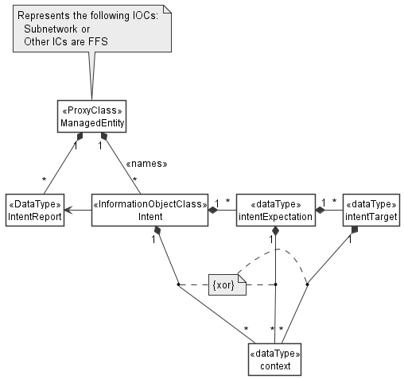

Figure 6.2.1.1.1-1 Relationship UML diagram for intent . Note: Above XOR means an instance of Context can only be name contained by either the Intent, IntentExpectation or IntentTarget.
Editor’s Note: The detailed model for Intent, IntentReport and IntentExpectation objects (e.g. is it <<IOC>>, <<DataType>>, or string) is FFS as their relationship needs to be decided later based on the content of these three objects
Editor’s Note: whether using the context or constraint is FFS, which needs to discuss together with intent definition.”
“Editor’s Note: the relationship related to context in above figure need further study

6.2.1.1.2 Inheritance
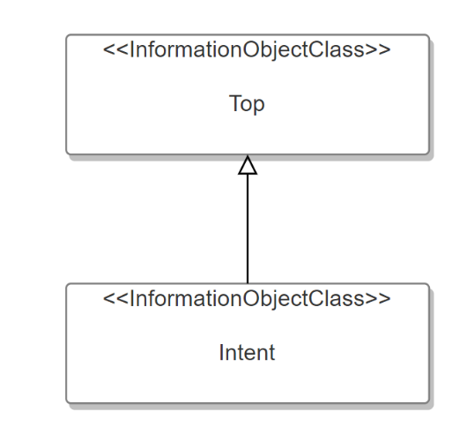
@startuml TS 28.541 figure 6.2.1-2 (as of MArch 2021)
' UML diagram for 3GPP TS 28.541 clause 6
skinparam ClassStereotypeFontStyle normal
skinparam ClassBackgroundColor White
skinparam shadowing false
skinparam monochrome true
hide members
hide circle

class Top <<InformationObjectClass>>
class Intent <<InformationObjectClass>>
'class intentExpectation <<dataType>>
'class Context <<dataType>>
'class IntentTarget <<dataType>>

Top <|-- Intent
'Top <|-- intentExpectation

@enduml
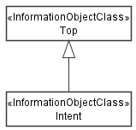

Figure 6.2.1.1.2-1 Inheritance UML diagram for generic intent

6.2.1.2 Class definition

6.2.1.2.1 Intent <<IOC>>

6.2.1.2.1.1 Definition
This IOC represents the properties of an Intent. The Intent IOC contains one or multiple intentExpectation(s) which includes MnS consumer’s requirements, goals and constraints given to a 3GPP system.
The Intent IOC includes the attribute objectClass and objectInstance from the TOP IOC. The value of attribute objectClass is “Intent” and the value of attribute objectInstance is the DN of the instance of Intent IOC.

6.2.1.2.1.2 Attributes
The Intent includes attributes inherited from TOP IOC (defined in TS 28.622) and the following attributes:
Attribute Name | Support Qualifier | isReadable | isWritable | isInvariant | isNotifyable
intentExpectations | M | T | T | F | T
userLabel | M | T | T | F | T
IntentContexts | O | T | T | F | T
intentFulfilStatus | M | T | F | F | T

Editor’s Note: whether other the attributes are needed for the Intent IOC needs further discussion.

6.2.1.2.1.3 Attribute constraints
None

6.2.1.2.2 IntentExpectation
IntentExpectation class represent MnS consumer’s requirements, goals and constraints given to a 3GPP system.
Editor’s Note: more description for IntentExpectation will be added later based on the further discussion.

6.2.1.2.2.1 Definition
IntentExpectation class represent MnS consumer’s requirements, goals and constraints given to a 3GPP system.

6.2.1.2.2.2 Attributes

The IntentExpectation includes the following attributes:
Attribute Name | Support Qualifier | isReadable | isWritable | isInvariant | isNotifyable
ExpectationId | M | T | T | T | T
ExpectationObject | M | T | T | F | T
ExpectationObjectContexts | M | T | T | F | T
ExpetationTargets | M | T | T | F | T
ExpetationContexts | O | T | T | F | T

Editor’s Note: whether other the attributes are needed for the IntentExpectation IOC needs further discussion.
Editor’s Note: The naming of the terms may need further discussion.
Editor’s Note: whether both expectionObjectContexts and ExpetationTargets are mandatory is FFS.

6.2.1.2.2.3 Attribute constraints
None

6.2.1.2.3 IntentReport

6.2.1.2.3.1 Definition
IntentReport class represent intent fulfilment feedback information that MnS consumer can obtained from a 3gpp system.
Editor’s Note: more description for IntentReport will be added later based on the further discussion.

6.2.1.2.3.2 Attributes
TBD

6.2.1.2.3.3 Attribute constraints
TBD

6.2.1.3 DataType definition

6.2.1.3.1 expectationTarget <<dataType>>

6.2.1.3.1.1 Definition
This <<dataType>> represents the Targets of the IntentExpectation that are required to be achieved .

6.2.1.3.1.2 Attributes
The expectationTarget includes the following attributes:
Attribute Name | Support Qualifier | isReadable | isWritable | isInvariant | isNotifyable
targetName | M | T | T | T | T
targetCondition | M | T | T | F | T
targetValueRange | M | T | T | F | T
targetContexts | O | T | T | F | T

6.2.1.3.1.3 Attribute constraints
None

6.2.1.3.2 context << dataType >>

6.2.1.3.2.1 Definition
This IOC represents the properties of a context. A context describes the list of constraints and conditions that should evaluate to True when the targets are fulfilled but are themselves not to be enforced. The context may apply to the intent, the intent expectation, the intent targets or to the object as filter information used to identify the manged objects to which the targets are intended.

6.2.1.3.2.2 Attributes
The context includes the following attributes:
Attribute Name | Support Qualifier | isReadable | isWritable | isInvariant | isNotifyable
contextAttribute | M | T | F | T | T
contextCondition | M | T | T | F | T
contextValueRange | M | T | T | F | T

6.2.1.3.2.3 Attribute constraints
None

6.2.1.4 Attribute definition

Attribute Name | Documentation and Allowed Values | Properties
userLabel | A user-friendly (and user assignable) name of the intent.  allowedValues: Not Applicable | type: String  multiplicity: 1  isOrdered: F  isUnique: F  defaultValue: None  isNullable: False
intentExpectation | It indicates the expectations including requirements, goals and context(including constraints and filter information) given to a 3GPP system. It states the list of specific outcomes desired to be realized for a specific type of object | type: FFS  multiplicity: *  isOrdered: F  isUnique: F  defaultValue: None  isNullable: False
intentFulfilStatus | It describes the status of the intent fulfilment result, which is configured by MnS producer and can be read by MnS consumer.  allowedValues: "FULFILLED", “NOT_FULFILLED  Editor’s Note: whether other allowed values should be supported is FFS, and the name for the attribute intentFulfilStatus is FFS. | type: ENUM  multiplicity: 1  isOrdered: N/A  isUnique: N/A  defaultValue: None  isNullable: False
intentContext | It describes the list of constraints and conditions that should apply for the entire intent even if there may be specific constraints and conditions defined for specific parts of the intent.  allowedValues: triple of (attribute, condition, value range) | type: Context  multiplicity: 1  isOrdered: False  isUnique: False  defaultValue: None  isNullable: False
intentExpectationId | A user-friendly (and user assignable) name of the intentExpectation.  allowedValues: Not Applicable | type: String  multiplicity: 1  isOrdered: False  isUnique: False  defaultValue: None  isNullable: False
expectionoObject | expectation carries requirements (expectations, goals and constrains) on an expectationObject.  expectionObject refers to an object (e.g. instance of managed object) to which the intentExpectation should apply. This means, which object the requirements specified by the expectation are meant for. expectionObject is mandatory. expectationObject is mandatory. expectationObject may be known and may be unknown. If expectationObject is known, its Identity may be will be specified. if Object is unknown, the consumer may provide a description which the system uses to identify the object  It may be used together with the ExpectionObjectContext to identify the specific entity to which the intentExpectation should apply. E.g. the intentExpectation may be stated for a slice (type of Object) with identitier IIOT_Atomotive_2021 (identifier as context). Alternatively, the intentExpectation may be stated for a slice (type of Object in context 1) serving IIoT users (slice/service type context 2) .  allowedValues: NA | type: string  multiplicity: 1  isOrdered: False  isUnique: False  defaultValue: None  isNullable: False
expectionobjectContext | It describes the list of constraints and conditions to be used as filter information to identify the specific object to which a given intentExpectation should apply. Note there may be other constraints and conditions defined either for the entire intent , for the specific intentExpectation or for the expectationTarget of the considered intentExpectation.  E.g. the intentExpectation may be stated for a slice (type of Object) with identitier IIOT_Atomotive_2021 (identifier as context). Alternatively, the intentExpectation may be stated for a slice (type of Object) serving IIoT users (context 1) with slice profile supporting automotive connectivity (context 2).  expectationObjectContext may also be used to select a specific instance of Object, i.e., given the type of object in "ExpectionObject", the object instance is identified using the identifier of the object instance under Object context e.g. to refer to cell instance number 234, we state the Object context as {cell_id, "=", 234}. The object identifier is in that case the context  allowedValues: depends on Object in the IntentExpectation | type: Context  multiplicity: 1  isOrdered: False  isUnique: False  defaultValue: None  isNullable: False
expectionTargets | It describes the list of specific outcomes on metrics and observables related to the Object (e.g. the metrics that characterize the performance of the object(s) or some abstract index that expresses the behavior of the object(s)) that are desired to be realized for a given intentExpectation.  allowedValues: depends on Object in the IntentExpectation | type: expectationTarget  multiplicity: 1  isOrdered: False  isUnique: False  defaultValue: None  isNullable: False
expectationContext | It describes the list of constraints and conditions that should apply for a specific intentExpectation. Note there may be other constraints and conditions defined for the entire intent or for specific parts of the intentExpectation.  allowedValues: depends on Object in the IntentExpectation | type: Context  multiplicity: 1  isOrdered: False  isUnique: False  defaultValue: None  isNullable: False
targetName | It describes a specific attribute of the object on which the outcomes are stated, either a configuration or observable of that object. The attributes may be a parameter, gauge, counter, KPI, weighted metric, etc. related to that object  allowedValues: depends on Object in the IntentExpectation | type: string  multiplicity: 1  isOrdered: False  isUnique: False  defaultValue: Null  isNullable: True
targetCondition | It expresses the limits within which the targetNameis allowed/supposed to be  allowedValues: is equal to; is less than; is greater than;  Note: Others conditions like "is within the range" or "is outside the range" can be expressed in terms of these basic conditions | type: enum  multiplicity: upto 2  isOrdered: False  isUnique: False  defaultValue: "is equal to"  isNullable: False
targetValueRange | It describes the range of values that applicable to the targetName and the TargetCondition. | type: FFS  multiplicity: upto 2  isOrdered: False  isUnique: False  defaultValue: Null  isNullable: True
targetContext | It describes the list of constraints and conditions that should apply for a specific expectationTarget. Note there may be other constraints and conditions defined for the entire intent or the intentExpectation.  allowedValues: triple of (attribute, condition, value range) | type: Context  multiplicity: 1  isOrdered: False  isUnique: False  defaultValue: None  isNullable: False
contextAttribute | It describes a specific attribute of or related to the object or to characteristics thereof (e.g. its control parameter, gauge, counter, KPI, weighted metric,, etc) to which the expection should apply or an attribute related to the operating conditions of the object (such as weather conditions, load conditions, etc). | type: DN  multiplicity: 1  isOrdered: False  isUnique: False  defaultValue: Null  isNullable: True
contextCondition | It expresses the limits within which the ContextAttribute is allowed/supposed to be  allowedValues: is equal to; is less than; is greater than;  Note: Others conditions like "is within the range" or "is outside the range" can be expressed in terms of these basic conditions | type: enum  multiplicity: upto 2  isOrdered: False  isUnique: False  defaultValue: "is equal to"  isNullable: False
contextValueRange | It describes the range of values that explicatable to the ContextAttribute and the ContextCondition. | type: FFS  multiplicity: upto 2  isOrdered: False  isUnique: False  defaultValue: Null  isNullable: True

2nd Change

Annex <A> (informative):
Mapping the 3GPP and the TM Forum intentExpectation Models
The TM forum defines the structure of an intent as a list of expectations with each expectation containing the requirements goals and constraints to be achieved. The expectation is defined to contain 2 attributes - the imm:target and the imm:params. On the hand, the intentExpectation defined in 3GPP (see clause 6.2.1.2.2) contain more attributes some of which (the expectionObject, expectionObjectContexts, expectationTargets and expectationContexts)can be mapped to the TM Forum model.

Following the table to illustrate the attributes mapping between 3GPP Intent Expectation and TM Forum IntentExpectation
3GPP Intent Expectation | TM Forum Intent Expectation
Class Property | Attribute
expectionObject | imm:target
expectionObjectContexts | imm:params
expectationTargets
expectationContexts

End of changes

