3GPP TSG-SA5 Meeting #139-e S5-215421

e-meeting, 11 - 19 October 2021

Source: Ericsson, Deutsche Telekom, Orange

Title: Types of interfaces for the exposure of network slice

Document for: Approval
Agenda Item: 6.5.4

1 Decision/action requested
In this box give a very clear / short /concise statement of what is wanted.

2 References
[1] TS 28.530: "Management and orchestration; Concepts, use cases and requirements"

3 Rationale
Clause 4.1.1.3 describes scenarios for exposure to BSS. In these scenarios external and internal interfaces are identified. An external interface is an interface between two companies (legally separated entities) and an internal interface is internal to a company for example between two departments inside the same company.
The interface between a BSS of one company and a BSS of another company is an external interface. The interface between the BSS and Service Manager of the same company is an internal interface. The interface between a Vertical (company) and an CSP (company) is via the BSS of the CSP.
In scenario 1 and scenario 2 the service management layer is missing.
It is proposed to update the figures accordingly.

4 Detailed proposal
1st change

4.1.1.2 Exposure of Management Services
Exposure of management services indicates the case that an external MnS consumer which is outside 3GPP management system can indirectly access management capabilities offered by an MnS producer within a 3GPP management system. In order to enable the exposure of eMnS, an external customer, which has external MnS consumer, has to sign a contract, which contains the agreement on what eMnS optionally under what condition can be exposed, with an MNO. The signing of the contract may need the interaction with BSS. The condition can be certain constraint of eMnS access based on the contract e.g., the access quota of certain eMnS, the access frequency of certain eMnS, etc.

4.1.1.3 Exposure via BSS

4.1.1.3.1 General
Exposure of service data to companies that are external to the operator are regulated by contracts. Different customers may have access to different management capabilities. It may differ on what attributes/policies/intents are allowed to be changed, in which value ranges changes are allowed and which performance metrics are allowed to be exposed.
The slice data with the ServiceProfile is located in the network manager.
Even if the external interface always goes via BSS, there are different scenarios for how a customer e.g., a vertical, can influence the ServiceProfile.
The capabilities required from a Vertical have to be the same on the interface between NOP Network manager and CSP Service manager. The external interface is external to the administrative domain of the operator, while the internal interface is inside the administrative domain of the operator.

4.1.1.3.2 Types of interface for the exposure of network slice

4.1.1.3.2.1 Introduction
Different types of interfaces may be used during the whole lifecycle of network slice, including ordering, provisioning, operation phases. These interfaces can be categorized as:
- Inter-organization interfaces (represented East-West):
- Between the organizational entity playing the Network Slice Customer (NSC) role, named Company V here, and the organizational entity playing the Network Slice Provider (NSP) role, named Company A here:
- Interface Type-A to:
- create a product (network slice) order,
- retrieve information concerning a product (network slice) order,
- update a product (network slice) order,
- delete a product (network slice) order;
Candidate APIs for Interface Type-A include, but are not limited to, TMF API 622 (Product ordering).
Interface Type-A is not in the scope of 3GPP.
- Between the organizational entity playing the Network Slice Provider (NSP) role, named Company A here, and the two organizational entities playing the Communication Service Provider (CSP) role, acting as ‘partners’ and named Company X and Company Y respectively here (the role of Company A towards the ‘partners’ is that of Communication Service Customer (CSC))
- Interface Type-X to:
- create a product order,
- retrieve information concerning a product order,
- update a product order,
- delete a product order;
Candidate APIs for Interface Type-X include, but are not limited to, TMF API 622 (Product ordering).
Interface Type-X is not in the scope of 3GPP.

- Intra-organization interfaces (represented North-South), internal to the organizational entity playing the Network Slice Provider (NSP) role:
- Between its BSS and its OSS/SML
- Interface Type-1 to:
- create a service order,
- retrieve information concerning a service order,
- update a service order,
- delete a service order;
Candidate APIs for Interface Type-1 include, but are not limited to, TMF API 641 (Service ordering).
Interface Type-1 is not in the scope of 3GPP.
- Between its OSS/SML and its OSS/NML
- Interface Type-2 to:
- create a network slice / network slice subnet,
- retrieve information concerning a network slice / network slice subnet,
- update a network slice / network slice subnet,
- delete a network slice / network slice subnet,
- collect PM and FM date concerning a network slice / network slice subnet;
Candidate APIs for Interface Type-2 include, but are not limited to, 3GPP TS 28.531, TS 28.532, TS 28.545, TS 28.550.
Interface Type-2 is in the scope of SA5.
The following clauses describe use cases may be not exhaustive.
In case of additional use cases, new types of interfaces may be needed.

4.1.1.3.2.2 Use case No.1: simple case
In this use case, Company-V (as the NSC) chooses a product from Company-A product offerings and sends a request to Company-A to order the product which is a network slice via Interface Type-A.
As Company-A can satisfy Company-V’s requirements by itself, it doesn’t have to count on partners.
In this use case, Interface Type-A, Type-1 and Type-2 are involved.
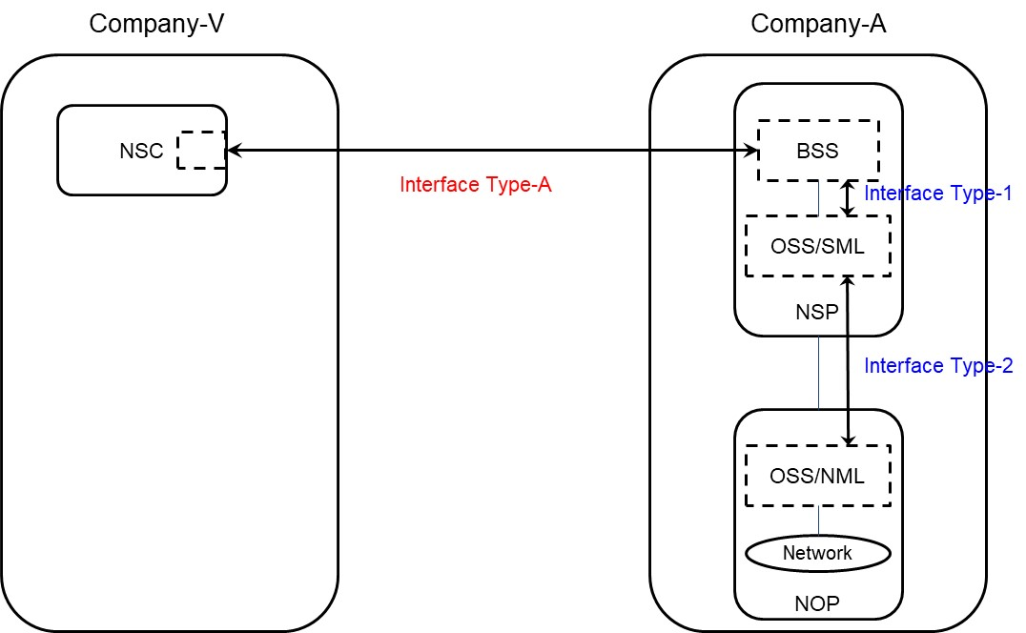
Figure 4.1.1.3.2.2.1 Use case 1 - Type-A between two companies

4.1.1.3.2.3 Use case No.2: partners involved
In this use case, Company-V (as the NSC) chooses a product from Company-A product offerings and sends a request to Company-A to order the product which is a network slice via Interface Type-A.
As Company-A can’t satisfy Company-V’s requirements by itself, it has to count on partners (Company-X and Company-Y), e.g. to provide RAN coverage in their respective countries.
In this use case, Interface Type-A, Type-1, Type-2 and Type-X are involved.

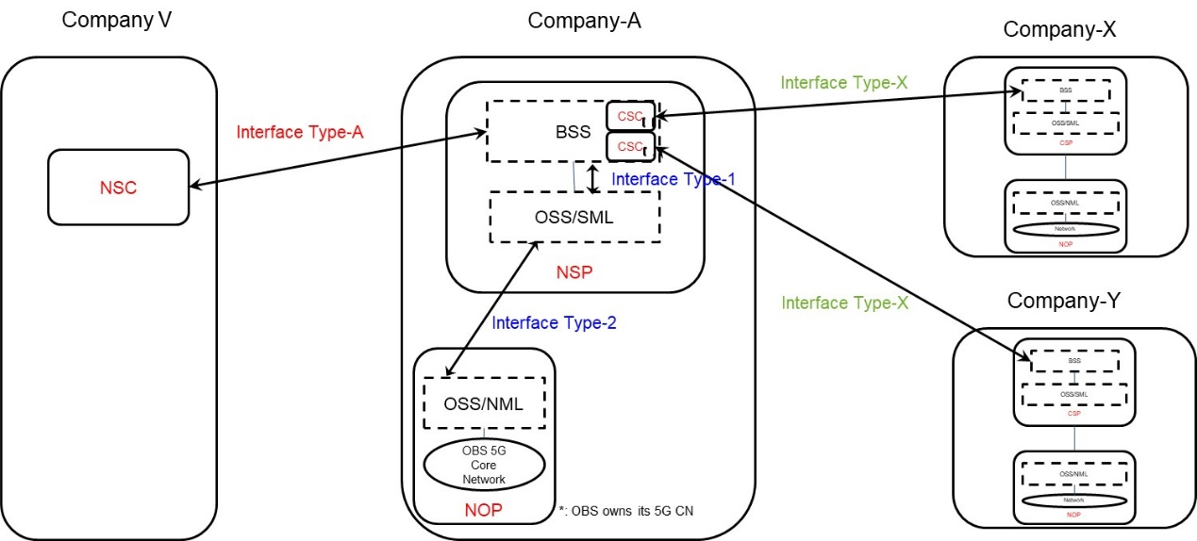
Figure 4.1.1.3.2.3.1 Use case 2 - Type-A and Type-X between companies

End of changes

