3GPP TSG-SA5 Meeting #138-e S5-215365rev2

Online, , 23rd Aug 2021 - 31st Aug 2021
CR-Form-v12.1
CHANGE REQUEST
 | 28.622 | CR | Draft CR | rev | - | Current version: | 16.9.0
For HELP on using this form: comprehensive instructions can be found at
http://www.3gpp.org/Change-Requests.

Proposed change affects: | UICC apps |  | ME |  | Radio Access Network | X | Core Network | X

Title: | Rel-17 Input to DraftCR 28.622 Add solution for reporting and storing data
Source to WG: | Nokia, Nokia Shanghai Bell
Source to TSG: | SA5
Work item code: | MADCOL |  |  |  |  |  | Date: |  |  | 2021-10-01
Category: | B |  |  |  |  |  | Release: |  |  | 17
 | Use one of the following categories:  F (correction)  A (mirror corresponding to a change in an earlier release)  B (addition of feature),  C (functional modification of feature)  D (editorial modification)  Detailed explanations of the above categories can  be found in 3GPP TR 21.900. |  |  |  |  |  |  |  | Use one of the following releases:  Rel-8 (Release 8)  Rel-9 (Release 9)  Rel-10 (Release 10)  Rel-11 (Release 11)  …  Rel-15 (Release 15)  Rel-16 (Release 16)  Rel-17 (Release 17)  Rel-18 (Release 18)
Reason for change: |  | Requirements for reporting and storing are agreed. This contribution proposes the corresponding data NRM fragment.
Summary of change:
Consequences if not approved: |  | The WI MADCOL cannot progress.
Clauses affected:
 |  | Y | N
Other specs |  |  | X | Other core specifications |  |  |  | TS/TR ... CR ...
affected: |  |  | X | Test specifications |  |  |  | TS/TR ... CR ...
(show related CRs) |  |  | X | O&M Specifications |  |  |  | TS/TR ... CR ...
Other comments: |  | Baseline DraftCR for MADCOL: None.
This CR's revision history:

First modification

4.2 Class diagrams

4.2.1 Relationships
This clause depicts the set of classes (e.g. IOCs) that encapsulates the information relevant for this IRP. This clause provides the overview of the relationships of relevant classes in UML. Subsequent clauses provide more detailed specification of various aspects of these classes.
The following figure shows the containment/naming hierarchy and the associations of the classes defined in the present document. See Annex A of a class diagram that combines this figure with Figure 1 of [2], the class diagram of UIM.
NOTE 1: ManagedElement may be contained either
- in a SubNetwork (since SubNetwork inherits from Domain_ and ManagedElement inherits from ManagedElement_ and Domain_ name-contained ManagedElement_ as observed in the figure of Annex A) or
- in a MeContext instance as observed by the above figure or in the figure of Annex A.
This either-or relation cannot be shown by using an {xor} constraint in the above figure.
ManagedElement may also have no parent instance at all.
NOTE 2: Void
NOTE 3: If the configuration contains several instances of SubNetwork, exactly one SubNetwork instance shall directly or indirectly contain all the other SubNetwork instances.
NOTE 4: The SubNetwork instance not contained in any other instance of SubNetwork is referred to as "the root SubNetwork instance".
NOTE 5: ManagementNode shall be contained in the root SubNetwork instance.
NOTE 6: If contained in a SubNetwork instance, MnsAgent shall be contained in the root SubNetwork instance.
NOTE 7: For a clarification on the choice of containment of the IRPAgent (since it has three possible parents), see the definition of MnsAgent.
NOTE 8: The MnsAgent shall be replaced by the IRPAgent in deployments using the IRP framework as defined in TS 32.102 [2].

Figure 4.2.1-1: NRM fragment
Each Managed Object is identified with a Distinguished Name (DN) according to 3GPP TS 32.300 [13] that expresses its containment hierarchy. As an example, the DN of a ManagedElement instance could have a format like:
SubNetwork=Sweden,MeContext=MEC-Gbg-1,ManagedElement=RNC-Gbg-1.

NOTE 8: Void
NOTE 9: Void
Figure 4.2.1-2: Vendor specific data container NRM fragment

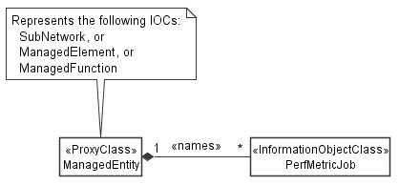

Figure 4.2.1-3: PM control NRM fragment

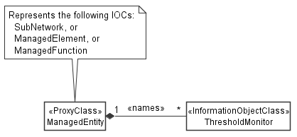
Figure 4.2.1-4: Threshold monitoring control NRM fragment

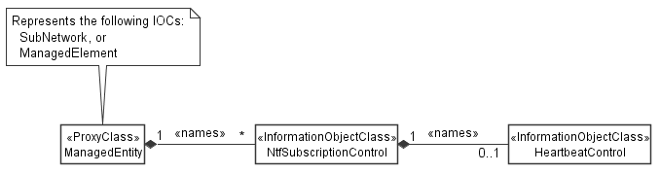
Figure 4.2.1-5: Notification subscription and heartbeat notification control NRM fragment

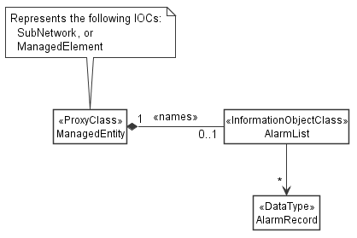
Figure 4.2.1-6: FM control NRM fragment

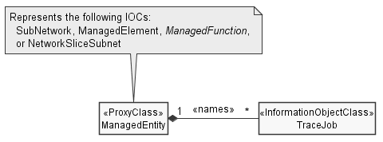
Figure 4.2.1-7: Trace control NRM fragment

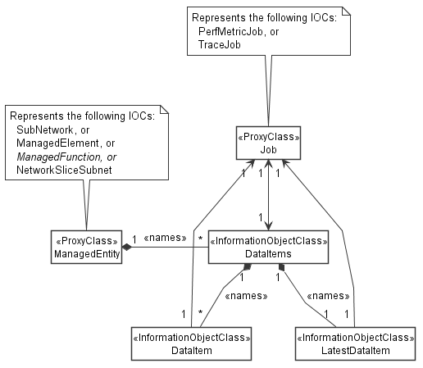
Figure 4.2.1-10: Data NRM fragment

4.2.2 Inheritance

This clause depicts the inheritance relationships.

Figure 4.2.2-1: NRM fragment

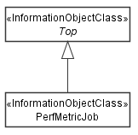

Figure 4.2.2-2: PM control NRM fragment

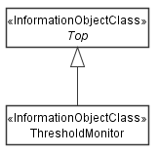

Figure 4.2.2-3: Threshold monitoring control NRM fragment

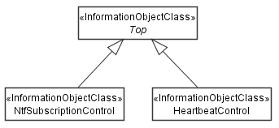

Figure 4.2.2-4: Notification subscription and heartbeat notification control NRM fragment

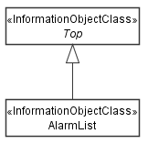
Figure 4.2.2-5: FM control NRM fragment

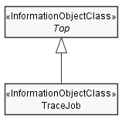
Figure 4.2.2-6: Trace control NRM fragment

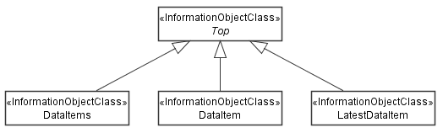
Figure 4.2.2-9: Data NRM fragment

Next modification

4.3.X DataItems

4.3.X.1 Definition
This IOC represents a collection of data items. It contains meta data about the management data stored in the collection, but not the actual data. The actual data is represented by the name-contained "DataItem" instances.
"DataItems" can be name-contained by "ManagedElement", "ManagedFunction" or "SubNetwork". In addtion, it can be name-contained by "NetworkSliceSubnet" (3GPP TS 28.541 [c]). The name-containment links "DataItems" to the object that the data relates to. For example, data collected on or related to a network element of type XYZ shall be name-contained under the "XyzFunction" that represents the network element in the management system.
Editor's note: It is ffs if the statement that "NetworkSliceSubnet" may contain "DataItems" should be put here or in 28.541, where "NetworkSliceSubnet" is defined.
More specifically, the parent object for performance measurements is defined by item f) of the measurement specification template (3GPP TS 32.404 [y], clause 3.3) and by item d) of the KPI specification template (3GPP TS 28.554 [x], clause 5).
Editor's note: The parent object for Trace/MDT is ffs.
In the present 3GPP release "DataItems" shall not be supported, when the root object of the information model exposed by a MnS producer is "ManagedElement".
Editor's note: The sentence above is a way to say: Don't use this NRM fragment on a NF as an alternative for file or stream-based reporting of performance metrics and trace/MDT data. Use it only for re-exposing collected data. It is ffs if the technique to convey this message by specifying the class of the root object is appropriate, or if better ways exist.
"DataItems" instances are created, updated and deleted by the MnS producer. They cannot be created nor updated nor deleted by MnS consumers.
The attributes of "DataItems" contain meta data about the collection. They specify the management data type ("dataType"), the total size of the data collection ("size"), the time window when the data was collected ("startTime", "endTime") and the time when the data will be deleted ("deletionTime"). The MnS producer shall update the meta data attributes when data items are added to or deleted from the collection, or when existing data items are changed, for example, when new data is added.
The data NRM fragment is provided for two different deployments and purposes:
- For making data collected by data collection jobs available to MnS consumers. The data NRM fragment is used in this case by a collection job for publishing the collected data.
- For re-exposing collected data. The data NRM fragment is used without collection jobs. This is the case when a Management Function consumes data collected by jobs and re-expses them to other data consumers such as SON or analytics applications.
When the data NRM fragment is used by data collection jobs ("PerfMetricJob" or "TraceJob") for making collected data available to MnS consumers the following provisions shall apply:
- The "DataItems" object shall be created at the same time as the object representing the data collection job.
- The attributes "jobRef" and "jobId" shall be supported and present in a "DataItems" instance. They shall identify the job that the data items in the data item collection relate to.
- A "DataItems" instance shall contain data items related to one and only one job.
- The data items produced by one job shall be contained in one and only one "DataItems" instance.
- The job object shall support an attribute with a link to the created "DataItems" instance ("_linkToCreatedDataItems").
- The attribute "_linkToCreatedDataItems" shall be returned in the job creation response.
Editor's note: "_linkToCreatedDataItems" still needs to be added to "PerfMetricJob"
Editor's note: The reporting control of "PerfMetricJob" and "TraceJob" needs to be enhanced to allow also the selection of reporting with the data NRM fragment, in addition to file-based and stream-based reporting.
When the data NRM fragment is used for re-exposing collected data the following provisions shall apply:
- The attributes "jobRef" and "jobId" shall not be supported and present in a "DataItems" instance.

4.3.X.2 Attributes
Attribute name | S | isReadable | isWritable | isInvariant | isNotifyable
dataType | M | T | F | F | F
size | M | T | F | F | F
startTime | M | T | F | F | F
endTime | M | T | F | F | F
deletionTime | M | T | F | F | T
Attributes related to roles
jobRef | CM | T | F | T | F
jobId | CM | T | F | T | F

4.3.X.2a Attribute definitions
Attribute Name | Documentation and Allowed Values | Properties
dataType | Management data types stored in the collection.  allowedValues:  - PERFORMANCE_MANAGEMENT  - KPI  - TRACE  - MDT  - ANALYTICS  Editor's note: ENUM needs to be aligned across all SA5 TS, could be an item for common definitions. | Type: ENUM  multiplicity: 1  isOrdered: N/A  isUnique: N/A  defaultValue: None  isNullable: False
size | Size of all "DataItem" instances in the collection. Unit is byte.  allowedValues: non-negative integers | Type: Integer  multiplicity: 1  isOrdered: N/A  isUnique: N/A  defaultValue: None  isNullable: False
startTime | Start time of the data, i.e. the time stamp of the first data element of the first "DataItem" in "DataItems". This attribute is set once only and is never updated.  allowedValues: N/A | Type: DateTime  multiplicity: 1  isOrdered: N/A  isUnique: N/A  defaultValue: None  isNullable: False
endTime | End time of the data, i.e. the time stamp of the last data element of the last "DataItem" in "DataItems". This attribute is updated always by the MnS producer when a new "DataItem" is added or an existing "DataItem" is modified.  allowedValues: N/A | Type: DateTime  multiplicity: 1  isOrdered: N/A  isUnique: N/A  defaultValue: None  isNullable: False
deletionTime | Time when the MnS producer will delete the data collection.  allowedValues: N/A | Type: DateTime  multiplicity: 1  isOrdered: N/A  isUnique: N/A  defaultValue: None  isNullable: False

4.3.B.3 Attribute constraints
Name | Definition
jobRef  Support Qualifier | Condition: This attribute shall be supported when "PerfMetricJob" or "TraceJob" are supported.
jobId  Support Qualifier | Condition: This attribute shall be supported when "PerfMetricJob" or "TraceJob" are supported.

4.3.B.4 Notifications
The common notifications defined in clause W4.5 are not valid for this IOC. The set of notifications defined in the following table is valid.
Name | S | Notes
notifyMOIObjectCreation | M
notifyMOIObjectDeletion | M
notifyMOIAttributeValueChanges | O
notifyMOIChanges | O

4.3.Y DataItem

4.3.Y.1 Definition
A "DataItem" contains collected management data. A "DataItems" instance name-contains one or more "DataItem" instances.
"DataItem" instances are created, updated and deleted by the MnS producer. They cannot be created nor updated nor deleted by a MnS consumer. The MnS producer shall advertise the deletion time of a "DataItem" instance by the "deletionTime" attribute.
Note that by always deleting the last item only the MnS producer can maintan a set of "DataItem" instances representing the data that was collected over a sliding time window. This allows to control the size of the stored data allowing for diverse deployment scenarios of the data NRM fragment. For example, for reporting collected data, one or two "DataItem" instances are sufficient. For data store functions re-exposing collected data, the number of "DataItem" instances may become very large.
The MnS producer shall emit to subscribed MnS consumers an object creation notification as defined in 3GPP TS 28.532 ("notifyMOICreation") with the complete object representation. Data consumers wishing to receive collected data need to subscribe to this notification. Alternatively, data consumers can read the latest "DataItem" object contained in "DataItems".
When the data NRM fragment is used by data collection jobs ("PerfMetricJob" or "TraceJob") for making collected data available to MnS consumers the following provisions shall apply:
- The attributes "jobRef" and "jobId" shall be supported and present. They shall identify the job the data in a "DataItem" instance is related to.
- The "id" of the "DataItem" created last shall be set to "latest".
- Data consumers wishing to receive newly collected data need to subscribe to object creation notifications of "DataItem". The presence of the "jobRef" and "jobId" attributes in "DataItem" allows to set notification filters in subscriptions in such a way that only notifications are sent to subscribed MnS consumers if the "DataItem" represents data related to jobs that the subscribed MnS consumer created or is interested in.
- Alternatively, data consumers may choose to not subscribe to notifications and retrieve the latest "DataItem" object contained in "DataItems" instead. They do so by specifying a query that selects the "DataItem" instance whose "id" attribute has a value of "latest".
In addition, when the data NRM fragment is used by data collection jobs, that use a reporting period for making collected data available to MnS consumers ("PerfMetricJob"), the following provisions shall apply:
- When a reporting period expires, a new "DataItem" instance shall be created that represents the data collected during the elapsed reporting period.
Editor's note: Provisions for Trace/MDT are ffs.
When data reporting involves no reporting period, the MnS producer decides based on other considerations when to open and close "DataItem" instances.
When the data NRM fragment is used for re-exposing collected data the following provisions shall apply:
- The attributes "jobRef" and "jobId" shall not be supported.
- The MnS producer decides based on own considerations how to structure data into "DataItem" instances.
The "data" attribute represents the actual data.
Editor's note: The data type of "data" is ffs. For performance measurements it includes time and the measurement name/value pair. Trace/MDT is ffs.

4.3.Y.2 Attributes
Attribute name | S | isReadable | isWritable | isInvariant | isNotifyable
managementDataType | M | T | F | F | T
size | M | T | F | F | T
startTime | M | T | F | F | T
endTime | M | T | F | F | T
deletionTime | M | T | F | F | T
data | M | T | F | F | T
Attributes related to roles
jobRef | CM | T | F | T | F
jobId | CM | T | F | T | F

4.3.Y.2a Attribute definitions
Attribute Name | Documentation and Allowed Values | Properties
managementDataType | Management data types stored in the "DataItem".  allowedValues:  - PERFORMANCE_MANAGEMENT  - KPI  - TRACE  - MDT  - ANALYTICS | Type: ENUM  multiplicity: 1  isOrdered: N/A  isUnique: N/A  defaultValue: None  isNullable: False
size | Size of the "DataItem". Unit is byte.  allowedValues: non-negative integers | Type: Integer  multiplicity: 1  isOrdered: N/A  isUnique: N/A  defaultValue: None  isNullable: False
startTime | Start time of the data, i.e. the time stamp of the first data element in the "DataItem". This attribute is set once only and is never updated.  allowedValues: N/A | Type: DateTime  multiplicity: 1  isOrdered: N/A  isUnique: N/A  defaultValue: None  isNullable: False
endTime | End time of the data, i.e. the time stamp of the last data element in the "DataItem".  allowedValues: N/A | Type: DateTime  multiplicity: 1  isOrdered: N/A  isUnique: N/A  defaultValue: None  isNullable: False
deletionTime | Time when the MnS producer will delete the "DataItem".  allowedValues: N/A | Type: DateTime  multiplicity: 1  isOrdered: N/A  isUnique: N/A  defaultValue: None  isNullable: False
data | Data that is represented by the "DataItem".  Editor's note: The data format is ffs. | Type: tbc  multiplicity: 1  isOrdered: N/A  isUnique: N/A  defaultValue: None  isNullable: False

4.3.Y.3 Attribute constraints
Name | Definition
jobRef  Support Qualifier | Condition: This attribute shall be supported when "PerfMetricJob" or "TraceJob" are supported.
jobId  Support Qualifier | Condition: This attribute shall be supported when "PerfMetricJob" or "TraceJob" are supported.

4.3.Y.4 Notifications
The common notifications defined in clause W4.5 are not valid for this IOC. The set of notifications defined in the following table is valid.
Name | S | Notes
notifyMOIObjectCreation | M
notifyMOIObjectDeletion | M
notifyMOIAttributeValueChanges | O
notifyMOIChanges | O

4.3.Z LatestDataItem

4.3.Z.1 Definition
The "LatestDataItem" should be supported, when the data NRM fragment is used by data collection jobs for making the collected data available to MnS consumers. It contains a copy of the latest "DataItem" in a collection. The latest "DataItem" is the instance whose "id" is equal to "latest". The "LatestDataItem" instance is name-contained under the same "DataItems" instance as the corresponding "DataItem" instance. Instances of "LatestDataItem" are created by the MnS producer.
The "id" of this object shall be set to "1".
The purpose of this object is to allow for easy retrieval of the latest data in a collection. The MnS consumer can always use the same Read request that returns the same object instance. No scoping or filtering is required.
This object does not support any notifications.

4.3.Z.2 Attributes
Same as for "DataItem", except for that "isNotifyable" is false ("F") for all attributes.

4.3.Z.2a Attribute definitions
Same as for "DataItem".

4.3.Z.3 Attribute constraints
Same as for "DataItem".

4.3.Z.4 Notifications
There is no notification defined.

End of modifications

