3GPP TSG-SA5 Meeting #139-e S5-215252rev1

e-meeting, 11 - 20 October 2021
CR-Form-v12.1
CHANGE REQUEST
 | 28.541 | CR | 0587 | rev |  | Current version: | 17.4.0
For HELP on using this form: comprehensive instructions can be found at
http://www.3gpp.org/Change-Requests.

Proposed change affects: | UICC apps |  | ME |  | Radio Access Network | x | Core Network | x

Title: | Update relationship between GST and Network Slice NRM fragment
Source to WG: | Telefónica S.A.
Source to TSG: | S5
Work item code: | EMA5SLA |  |  |  |  |  | Date: |  |  | 2021-10-01
Category: | F |  |  |  |  |  | Release: |  |  | Rel-17
 | Use one of the following categories:  F (correction)  A (mirror corresponding to a change in an earlier release)  B (addition of feature),  C (functional modification of feature)  D (editorial modification)  Detailed explanations of the above categories can  be found in 3GPP TR 21.900. |  |  |  |  |  |  |  | Use one of the following releases:  Rel-8 (Release 8)  Rel-9 (Release 9)  Rel-10 (Release 10)  Rel-11 (Release 11)  …  Rel-15 (Release 15)  Rel-16 (Release 16)  Rel-17 (Release 17)  Rel-18 (Release 18)
Reason for change: |  | - The concepts of Top SliceSubnet, 5GC SliceProfile and NG-RAN SliceProfile are not defined in TS 28.541. They need to be replaced by TopSliceSubnetProfile, CNSliceSubnetProfile and RANSliceSubnetProfile constructions.  - The concepts of parameter and attribute are wrongly used in Table L.21. GST is composed of parameters, while ServiceProfile/SliceProfile constructions consist of attributes.
Summary of change: |  | - Replace {Top SliceSubnet, 5GC SliceProfile, NG-RAN SliceProfile} with {TopSliceSubnetProfile, CNSliceSubnetProfile, RANSliceSubnetProfile} throughout the entire annex.  - Update Figure L.2.1 to capture the two above changes.  - Update Figure L.2.1 to clarify which SDO/fora is responsible to manage which information.  - Correct the use of parameter/attribute wording in Table L.2.1.
Consequences if not approved: |  | May lead to wrong implementations, since workflow makes reference to concepts that are not defined in TS 28.541.
Clauses affected: |  | L.1, L.2
 |  | Y | N
Other specs |  |  | x | Other core specifications |  |  |  | TS/TR ... CR ...
affected: |  |  | x | Test specifications |  |  |  | TS/TR ... CR ...
(show related CRs) |  |  | x | O&M Specifications |  |  |  | TS/TR ... CR ...
Other comments:
This CR's revision history:

1st modified section

Annex L (normative):
Relation of GSMA GST, ServiceProfile and SliceProfile

L.1 General
This annex describes the relation between GSMA GST [50] and the ServiceProfile and SliceProfile captured in the network slice NRM fragment (c.f. clause 6)

2nd modified section

L.2 GSMA GST, ServiceProfile and sliceProfile
The GSMA GST is used as the SLA information for the communication between the NSC (e.g., vertical industry) and the NSP. The SLA requirements can be fulfilled from management aspect and control aspect in a coordinated way. The SLS includes ServiceProfile information model.
As shown in figure L.2.1, the GST parameters [50] are used as input to define the ServiceProfile. The ServiceProfile, which defines the service requirements associated to the NSC, is translated into the SliceProfile. In particular, the attributes captured in the ServiceProfile are mapped to TopSliceSubnetProfile attributes. Based on the TopSliceSubnetProfile attributes, the corresponding requirements for the dedicated domain specific network slice subnets are defined. For example, the CNSliceSubnetProfile attributes are used to carry 5GC domain requirements, the RANSliceSubnetProfile attributes are used to carry NG-RAN domain requirements, and the TN requirements are derived and provide input to the TN domain. As shown in figure L.2.1, the elicitation of TN requirements out of TopSliceSubnetProfile is out of the scope of 3GPP.

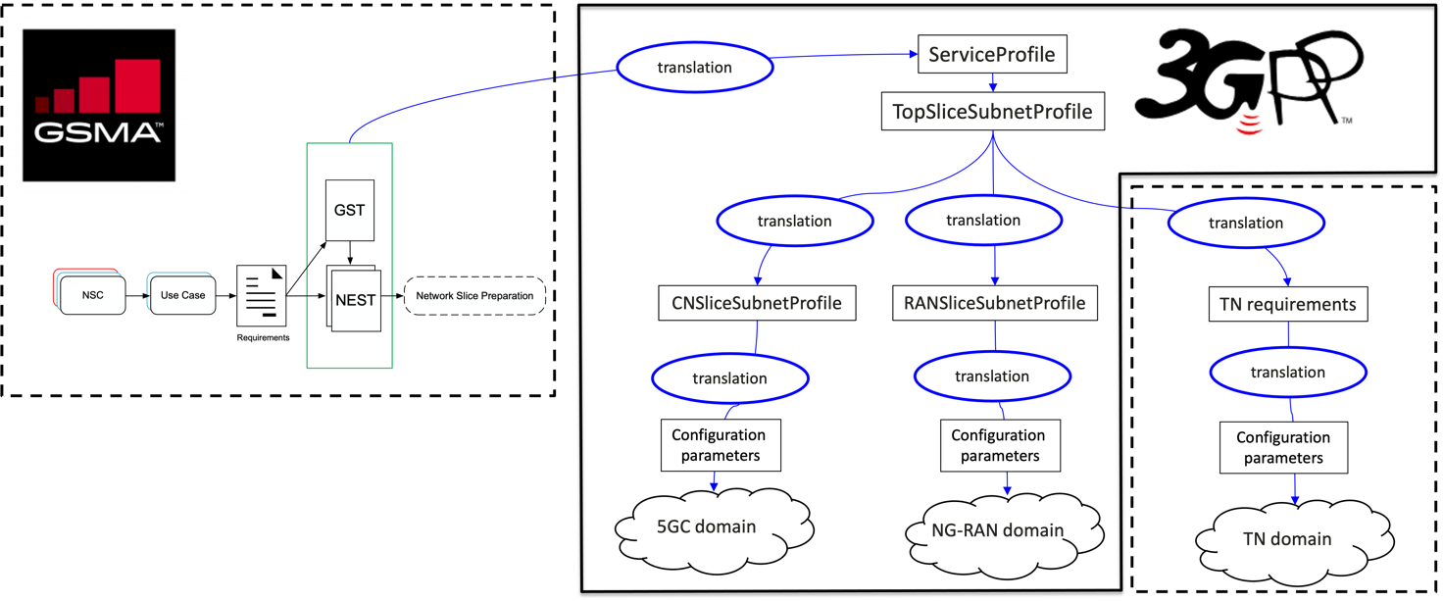
Figure L.2.1 Relation between GSMA GST, ServiceProfile and SliceProfile

As shown in Table L.2.1 some of the attributes in CNSliceSubnetProfile and RANSliceSubnetProfile parameters can be translated to configurable parameters related to network function behaviour to satisfy SLS of the service in the control plane. While other information (e.g delay tolerance, determistic communication support) in CNSliceSubnetProfile and RANSliceSubnetProfile are kept at OAM domain and is used to determine the overall behaviour of the network slice.
The following table show the translation of GST attributes.
Table L.2.1: GST translation
GST parameters | ServiceProfile attributes | TopSliceSubnetProfile  attributes | RANSliceSubnetProfile attrbutes | CNSliceSubnetProfile attributes | Configuration parameters
Maximu  m number of UEs | maxNumberofUE  s | maxNumberofUE | maxNumberofUEs | maxNumberofUEs | attributes in NSACF
Maximu  m number of PDU sessions | maxNumberofCo  nns | maxNumberofPDUSes  sions | N/A | maxNumberofPDUSes  sions | TBD
Downlink maximu  m throughp  ut per UE | dLThptPerUE | dLThptPerUE | dLThptPerUEPerSu  bnet | dLThptPerUEPerSubn  et | TBD
Uplink maximu  m throughp  ut per UE | uLThptPerUE | uLThptPerUE | uLThptPerUEPerSu  bnet | uLThptPerUEPerSubn  et | TBD

Editor's note: The list of exact configurable parameters is to be revisited depending on the requirements from SA2 and RAN WGs.
NOTE: Void.

End of modified section

