3GPP TSG-SA5 Meeting #139-e S5-215088

e-meeting, 11 - 20 October 2021
CR-Form-v12.1
CHANGE REQUEST
 | 28.531 | CR | 0070 | rev | 1 | Current version: | 17.1.0
For HELP on using this form: comprehensive instructions can be found at
http://www.3gpp.org/Change-Requests.

Proposed change affects: | UICC apps |  | ME |  | Radio Access Network | X | Core Network | X

Title: | Rel-17 CR TS 28.531 Update procedure of reservation and checking feasibility of network slice subnet
Source to WG: | S5
Source to TSG: | Huawei,China Unicom, Deutsche Telekom,China Mobile
Work item code: | adNRM |  |  |  |  |  | Date: |  |  | 2021-07-28
Category: | B |  |  |  |  |  | Release: |  |  | Rel-17
 | Use one of the following categories:  F (correction)  A (mirror corresponding to a change in an earlier release)  B (addition of feature),  C (functional modification of feature)  D (editorial modification)  Detailed explanations of the above categories can  be found in 3GPP TR 21.900. |  |  |  |  |  |  |  | Use one of the following releases:  Rel-8 (Release 8)  Rel-9 (Release 9)  Rel-10 (Release 10)  Rel-11 (Release 11)  …  Rel-15 (Release 15)  Rel-16 (Release 16)  Rel-17 (Release 17)  Rel-18 (Release 18)
Reason for change: |  | The procedure of reservation and checking feasibility of network slice subnet defined in TS 28.531 are not aligned with Network Slice Subnet feasibility check use case is described in clause 5.1.21 in TS 28.531. Also it is not clear for how to implement the network slice subnet feasibility check procedure.
Summary of change: |  | Update the procedure of reservation and checking feasibility of network slice subnet.
Consequences if not approved:
Clauses affected: |  | 7.2, 7.14
 |  | Y | N
Other specs |  |  | X | Other core specifications |  |  |  | TS/TR ... CR ...
affected: |  |  | X | Test specifications |  |  |  | TS/TR ... CR ...
(show related CRs) |  |  | X | O&M Specifications |  |  |  | TS/TR ... CR ...
Other comments:
This CR's revision history: |  | S5-215088 is the revision of S5-214202

1st Change

7.14 Procedure of reservation and checking feasibility of network slice subnet

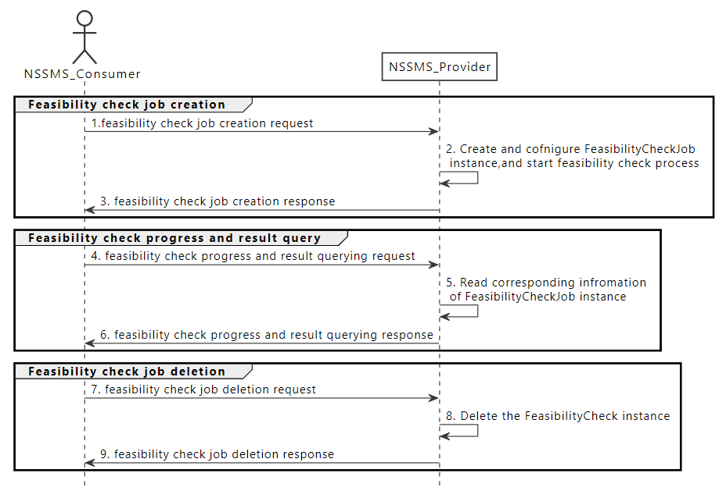
Figure 7.14-2 Network slice subnet feasibility check procedure
1) Network Slice Subnet Management Service Provider (NSSMS_Provider) receives a feasibility check job creation request (see createMOI operation defined in TS 28.532 [8]) from Network Slice Subnet Management Service Consumer (NSSMS_Consumer) with feasibility check requirements (see FeasibilityCheckJob IOC defined in TS 28.541[6]). The request is to check whether the network slice subnet related requirements (i.e. SliceProfile) can be satisfied.
2) NSSMS_Provider create the FeasibilityCheckJob instance and configure the attribute "SliceProfile" and "targetTime". NSSMS_Provider start the executing the feasibility check process. NSSMS_Provider may request other MnS producer to check the feasibility for the network slice subnet constituent.
3) NSSMS_Provider sends the feasibility check job creation response (see createMOI operation defined in TS 28.532 [8]) requests to NSSMS_Consumer with the value of "objectClass" and "objectInstance".
4) During the feasibility check process execution time, the NSSMS_Provider receives a feasibility check job progress and result query request (see getMOIAttributes defined in TS 28.532 [8]) from NSSMS_Consumer to query the value for attribute "progress" and "feasibilityResult" with the value of "objectClass" and "objectInstance" for the FeasibilityCheckJob instance specified.
5) NSSMS_Provider read the value of the attribute "progress" and "feasibilityResult" for the specified FeasibilityCheckJob instance.
6) NSSMS_Provider sends feasibility check job progress and result query response (see getMOIAttributes operation defined in TS 28.532 [8]) to NSSMS_Consumer with the values of the attribute “progress” and “feasibilityResult” for the specified FeasibilityCheckJob instance.
7) When NSSMS_Consumer decides to delete the feasibility check job (e.g. obtained the feasibility check result), the NSSMS_Provider receives a feasibility check job deletion request (sees deleteMOI operation defined in TS 28.532 [8]) with the value of "objectClass" and "objectInstance" for the FeasibilityCheckJob instance specified.
8) NSSMS_Provider delete the specified FeasibilityCheckJob instance.
9) NSSMS_Provider sends a feasibility check job deletion response (sees deleteMOI operation defined in TS 28.532 [8]) with "objectInstance" of the deleted FeasibilityCheckJob instance.

2nd Change

7.2 Procedure of Network Slice Instance Allocation
The Figure 7.2-1 illustrates the procedure of creating a new NSI or using an existing NSI to satisfy the required network slice related requirements.
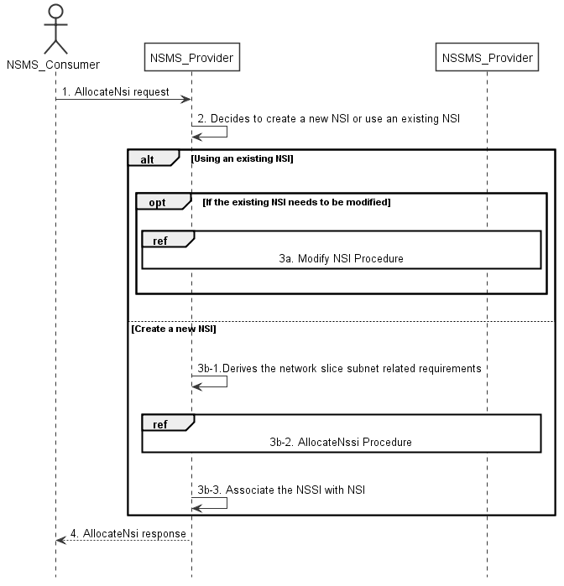
Figure 7.2-1: Network Slice Instance Allocation Request procedure
1) Network Slice Management Service Provider (NSMS_Provider) receives an AllocateNsi request (see AllocateNsi operation defined in clause 6.5.1) from Network Slice Management Service Consumer (NSMS_Consumer) with network slice related requirements (the network slice related requirements are defined as the attributes in the ServiceProfile see clause 6.3.3 in TS 28.541 [6]).
2) Based on the network slice related requiremen and the knowledge of the capabilities of existing deployed network slices, the NSMS_Provider compare/match the provided requirements against all the candidate NetworkSlice instances, and then decides whether to use an existing NSI or create a new NSI. If the network slice related requirements allow the requested NSI to be shared and if an existing suitable NSI can be reused, the NSMS_Provider may decide to use the existing NSI.
3a) If using an existing NSI and the existing NSI needs to be modified to satisfy the network slice related requirements, the NSMS_Provider invokes the procedure to modify the existing NSI as described in clause 7.6.
3b-1) If creating a new NSI, the NSMS_Provider derives the network slice subnet related requirements from the received network slice related requirements. Before NSMS_Provider derives the network slice subnet related requirements, NSMS_Provider may invoke corresponding network slice subnet capability information querying procedure as described in clause 7.8.
3b-2) The NSMS_Provider invokes the NSSI allocation procedure as described in clause 7.3. Before NSMS_Provider invokes the NSSI allocation procedure, NSMS_Provider may invoke corresponding network slice subnet feasibility check procedure as described in clause 7.14.
3b-3) The NSMS_Provider creates the MOI for NSI and configures the MOI with the DN of MOI for the NSSI, other configuration information may be configured for the created MOI.
Note: The detailed configuration information is described in network slice NRM (see NetworkSlice IOC defined in clause 6.3.1 in TS 28.541 [6]).
4) The NSMS_Provider sends NSI allocation result (see AllocateNsi operation defined in clause 6.5.1) to the NSMS_Consumer. If an existing NSI is modified or a new NSI is created successfully to satisfy the network slice related requirements, the result includes the relevant network slice instance information (see NetworkSlice IOC defined in clause 6.3.1 in TS 28.541 [6]):
- DN of the MOI for NSI.
Otherwise the result may include the reason of failure, for example, the required latency or user number cannot be satisfied, or the physical resource is not enough.

3rd Change

7.6 Procedure of Network Slice Instance Modification
The Figure 7.6-1 illustrates the procedure of modifying an existing NSI.
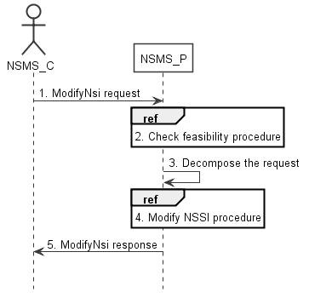
Figure 7.6-1: Network Slice Instance Modification Request procedure
1) Network Slice Management Service Provider (NSMS_P) receives a ModifyNsi request (see modifyMOIAttributes operation defined in TS 28.532 [8]) from Network Slice Management Service Consumer (NSMS_C) with the management identifier of NSI and the new network slice related requirements (see ServiceProfile defined in clause 6.3.3 in TS 28.541[6]).
2) Based on the new network slice related requirements, NSMS_P invokes the feasibility check procedure. If the modification requirements can be satisfied, go to step 3), else go to step 5).
3) NSMS_P decomposes the NSI modification request into NSSI modification request(s), i.e., generating the new network slice subnet related requirements for each NSSI if needed.
4) NSMS_P, as the role of Network Slice Subnet Management Service Consumer (NSSMS_C), invokes the NSSI modification procedure. Before NSMS_P invokes the NSSI modification procedure, NSMS_Provider may invoke corresponding network slice subnet feasibility check procedure as described in clause 7.14.

5) NSMS_P sends NSI modification result (see modifyMOIAttributes operation defined in TS 28.532 [8]) to NSMS_C.

End of Change

