3GPP TSG SA WG5 Meeting 136-e S5-212214

electronic meeting, online, 1-9 March 2021

Source: ZTE, China Unicom

Title: Discussion on NG-RAN network sharing with multiple CellId

Document for: Discussion and Approval
Agenda Item: 6.4.17

1 Decision/action requested
The group is asked to discuss and approve the proposals.

2 References
[1] 3GPP TS 23.501: “System architecture for the 5G System (5GS)”
[2] 3GPP TS 38.331: “NR; Radio Resource Control (RRC); Protocol specification”
[3] 3GPP TS 38.401: “NG-RAN; Architecture description”

3 Discussion
In TS 23.501, it is mentioned that “5G MOCN supports NG-RAN Sharing with or without multiple Cell Identity broadcast as described in TS 38.300 [27].”
In TS 38.331, multiple Cell Identity broadcast is reflected in the definition of SIB1/PLMN-IdentityInfoList. The figure below is an example of the mapping from the PLMN-IdentityInfoLists in the SIB1 broadcast to the NCGIs.
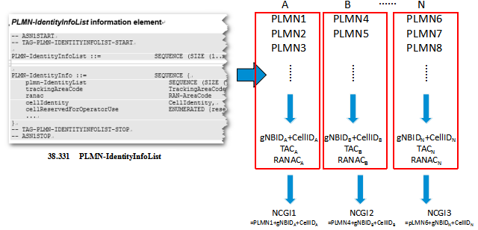

When the NG-RAN is not shared, there is only one PLMN-Identity and one cellIdentity in the SIB1 broadcast, which only maps to one NCGI and supports one PLMN. The figure below depicts a deployment example for this scenario.
Note: In the following figures, the definitions of the entities (e.g. gNB, gNB-CU, gNB-DU) and the relationship of the entities can be found in TS 38.401[3]
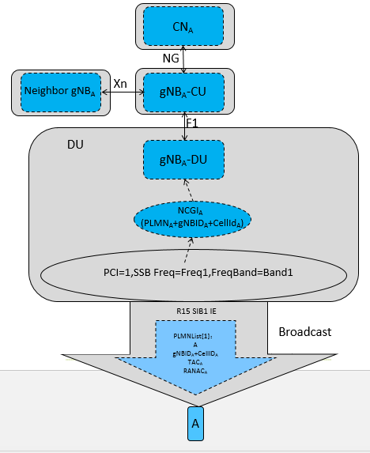
In the 5G MOCN NG-RAN sharing without multiple Cell Identity broadcast scenario, there is only one PLMN-IdentityInfo in the SIB1 broadcast, which only maps to one NCGI. The figure below depicts a deployment example for this scenario. In this scenario, the logical node gNB-CU and its associated resources, the logical node gNB-DU and its associated resources are all shared.
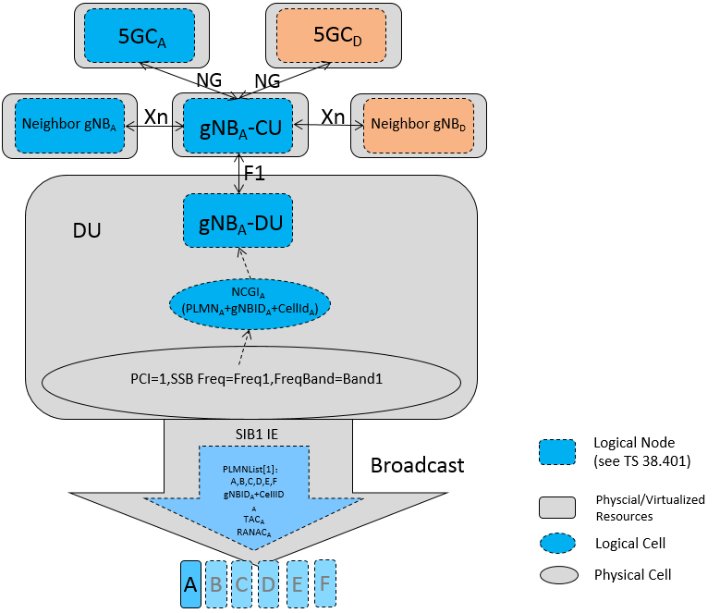

In the 5G MOCN NG-RAN sharing with multiple Cell Identity broadcast scenario, there are more than one PLMN-IdentityInfo in the SIB1 broadcast, which maps to more than one NCGIs. The figure below depicts a deployment example for the scenario NG-RAN sharing with multiple Cell Identity broadcast based on per-PLMN signalling (see 8.11, TS 38.401 [z]). In this scenario, only the pure resources for the gNB-DU is shared.
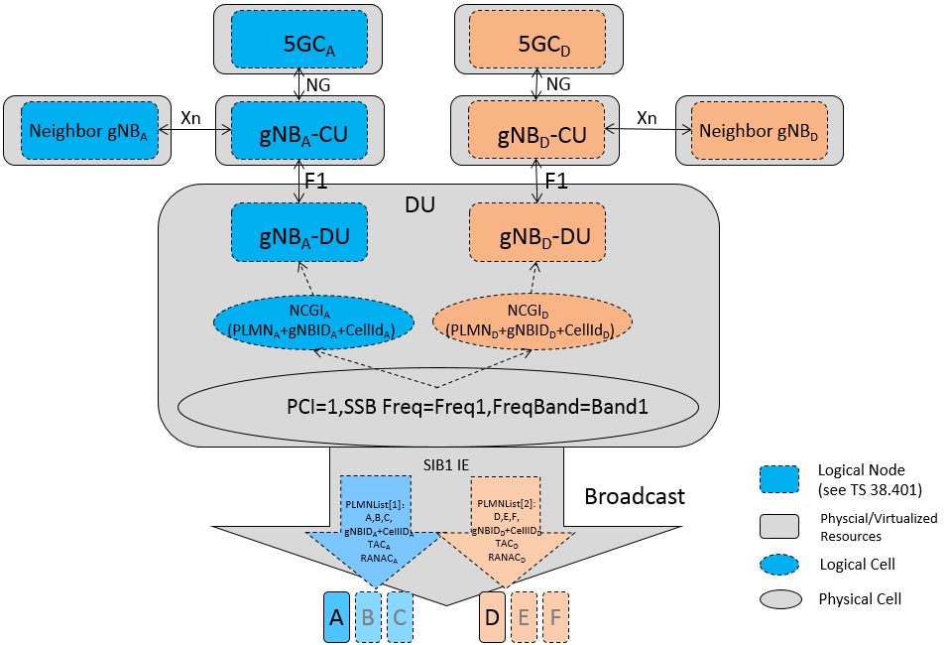

In this deployment scenario, with the support of multiple Cell Identities, one physical gNB-DU can be mapped to different logical gNB-DUs. This provides the possibility of the real E2E isolation between different logical networks (i.e. different operators or network slices).
Meanwhile, this deployment scenario aligns with the definition of gNB, gNB Identity and NCGI in RAN specifications.

And for this deployment scenario, from the management aspect point of view, the NRM of gNB-DU or gNB-DU cell needs to be enhanced to support the separation of logical part and physical part, because the attributes of the logical part can be managed separately by different operators, but the physical part related attributes (e.g. ssbFrequency) cannot be configured by different operators simultaneously, otherwise the information redundance and operation conflict will be caused.

4 Detailed proposal
It is proposed to agree with the following actions:

- Add the above mentioned NG-RAN network sharing with multiple Cell Identities deployment scenario into TS 32.130 as an annex.
- Enhance the NRM definitions to support 5G MOCN NG-RAN sharing with multiple Cell Identity broadcast.

