3GPP TSG SA WG5 Meeting 136-e Tdoc S5-212193
electronic meeting, online, 1-9 March 2021

Title: LS on network sharing with multiple SSBs in a carrier
Response to: -
Release: Rel-17
Work Item: Management Aspects of 5G Network Sharing, MANS

Source: SA5#136-e
To: RAN2, RAN3
Cc:

Contact person: zhu.weihong@zte.com.cn

Send any reply LS to: 3GPP Liaisons Coordinator, mailto:3GPPLiaison@etsi.org

Attachments:

1 Overall description
SA5 is working on the Rel-17 WI “Management Aspects of 5G Network Sharing (MANS)”. During the discussion, the companies have different opinions on whether the feature multiple SSBs in a carrier can be used to support NG-RAN sharing. SA5 notices that the feature multiple SSBs in a carrier is described in TS 38.300, clause 5.2.4 and Annex B.2, however, no description is provided as to whether this feature can be used to support NG-RAN sharing or not.
SA5 would like to ask RAN2 and RAN3 to clarify the following questions.
- Is there any constraint for the feature multiple SSBs in a carrier to support NG-RAN sharing (i.e. the cell associated to different SSBs can be used by different operators)?
- Is the NG-RAN sharing deployment example depicted in the figure below a valid application of multiple SSBs in a carrier feature?
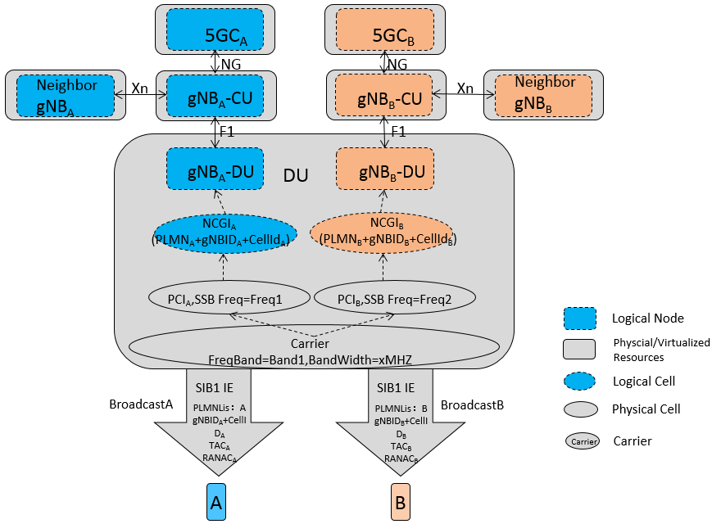

Note: In the figure, gNB_{A}-DU and gNB_{B}-DU represent the logical DUs which share one physical DU.

2 Actions
To RAN2, RAN3:
ACTION: SA5 would like to ask RAN2 and RAN3 to clarify the abovementioned questions.

3 Dates of next TSG SA WG 5 meetings
SA5#136-e 1st March 2021 - 10th March 2021 electronic meeting
SA5#137-e 10th - 19th May 2021 electronic meeting

