3GPP TSG SA WG5 Meeting 136-e S5-212106

electronic meeting, online, 1st – 9th March 2021

Source: Nokia, NEC

Title: Enahancing analytics request and reporting use case

Document for: Approval
Agenda Item: 6.5.4

1 Decision/action requested
Enhance the analytics request and reporting use case in section 6.99.2

2 References
The following documents contain provisions which, through reference in this text, constitute provisions of the present document.
- References are either specific (identified by date of publication, edition number, version number, etc.) or non-specific.
- For a specific reference, subsequent revisions do not apply.
- For a non-specific reference, the latest version applies. In the case of a reference to a 3GPP document (including a GSM document), a non-specific reference implicitly refers to the latest version of that document in the same Release as the present document.
[1] 3GPP TR 21.905: "Vocabulary for 3GPP Specifications".
[2] 3GPP TS 28.550: "Management and orchestration; Performance assurance".
[3] 3GPP TS 28.533: "Management and orchestration; Architecture framework".
[4] 3GPP TS 28.530: "Management and orchestration; Concepts, use cases and requirements".
[5] 3GPP TR 28.861: "Study on the Self-Organizing Networks (SON) for 5G networks".
[6] 3GPP TR 28.805: "Study on management aspects of communication services".
[7] 3GPP TS 28.554: "5G end to end Key Performance Indicators (KPI)".
[8] 3GPP TS 28.552: "Management and orchestration; 5G performance measurements".
[9] 3GPP TS 22.101: "service aspects; service principles".
[10] 3GPP TS 32.500: "Telecommunication management; Self-Organizing Networks (SON); Concepts and requirements".
[11] 3GPP TS 37.816: "Study on RAN-centric data collection and utilization for LTE and NR".
[12] 3GPP TS 37.320: "Radio measurement collection for Minimization of Drive Tests (MDT); Overall description".
[13] 3GPP TS 23.501: "System Architecture for the 5G System (5GS); Stage 2".
[14] 3GPP TS 28.310: "Energy efficiency of 5G".
[15] 3GPP TR 21.866: "Study on Energy Efficiency Aspects of 3GPP Standards".
[16] 3GPP TS 26.247: "Transparent end-to-end Packet-switched Streaming Service (PSS); Progressive Download and Dynamic Adaptive Streaming over HTTP (3GP-DASH)".
[17] 3GPP TS 26.114: "IP Multimedia Subsystem (IMS); Multimedia Telephony; Media handling and interaction".
[18] 3GPP TS 23.288: "Architecture enhancements for 5G System (5GS) to support network data analytics services".
[19] 3GPP TS 28.313: "Self-Organizing Networks (SON) for 5G networks".
[20] 3GPP TS 28.541: "Management and orchestration; 5G Network Resource Model (NRM); Stage 2 and stage 3".
[21] 3GPP TS 38.304 NR: "User Equipment (UE) procedures in idle mode and in RRC Inactive state".
[22] 3GPP TS 28.545: "Management and orchestration; Fault Supervision (FS)".
[23] 3GPP TS 28.813: "Study on new aspects of Energy Efficiency (EE) for 5G".
[24] 3GPP TS 28.406: "Telecommunication management; Quality of Experience (QoE) measurement collection; Information definition and transport".
[25] 3GPP TS 32.422: "Telecommunication management; Subscriber and equipment trace; Trace control and configuration management".
[26] 3GPP TS 32.425: "Telecommunication management; Performance Management (PM); Performance measurements Evolved Universal Terrestrial Radio Access Network (E-UTRAN)".
[27] 3GPP TS 23.273: "5G System (5GS) Location Services (LCS); Stage 2".
[28] 3GPP TS 28.532: "Management and orchestration; Generic management services".
[29] 3GPP TS 26.247: "Transparent end-to-end Packet-switched Streaming Service (PSS); Progressive Download and Dynamic Adaptive Streaming over HTTP (3GP-DASH)".
[30] 3GPP TS 26.114: "IP Multimedia Subsystem (IMS); Multimedia Telephony; Media handling and interaction".
[31] 3GPP TS 28.405: "Telecommunication management, Quality of Experience (QoE) measurement collection; Control and configuration".
[32] GSMA NG.116: "Generic Network Slice Template".
[33] 3GPP TS 28.531: "Management and orchestration; Provisioning".
[34] 3GPP TS 28.628: "Telecommunication management; Self-Organizing Networks (SON) Policy Network Resource Model (NRM) Integration Reference Point (IRP); Information Service (IS)".

3 Rationale
This contribution enahnces the MDA management aspects in section 6.99.2 related to requesting MDA reports.
It generalizes the MDA reporting request and illustrates the three different options of reporting including file based, streaming and notification reporting.

4 Detailed proposal

First Change

6.99.2 Requesting and reporting of Management Data Analytics Reports

6.99.2.1 Use case
A MDAS Producer may provide several management data analysis reports. Multiple consumers may wish to receive a selection of these reports.
The consumer submits a request to MDAS producer to request MDA reports. This request may include a filter to specify the scope of MDA reports (e.g., type of analytics report such as coverage issue analysis, resource utilization analysis, the managed objects to be analysed, etc.). The MDAS producer activates the data collection if it is not already active. In the request, the consumer may indicate the method that the MDA reports are to be reported.
For all reports, the MDAS producer collects data, analyses the data, and generates the analytics report.
The MDAS producer provides the MDA reports based on the reporting method designated by the consumer.
The consumer may send a request to MDAS producer to terminate the MDA reporting request.

6.99.2.2 Potential requirements
REQ-MDA_SUB-1 The MDAS producer should have a capability to allow an MDAS consumer to request an analytics report. The reporting request should optionally allow the MDAS consumer to filter the scope of data in the analytics report.
REQ-MDA_SUB-2 The MDAS producer should have a capability to provide the analytics report to the requesting consumers.
REQ-MDA_SUB-3 The MDAS producer should have a capability to allow an MDAS consumer to terminate an analytics reporting request.

6.99.2.3 Possible solutions
The MDAS consumer sends the MDA reporting requestto MDAS producer, with the following information included:
- identifier of the reporting request;
- reporting method, i.e., file reporting or streaming data reporting or notification based reporting;
- streaming target if the reporting method is designated to streaming data reporting;
- file information (e.g., file location, ready time, expiration time, size, compression and format) if the reporting method is designated to file reporting;
- notification target if the reporting method is designated to provide notification based reporting;
- filter for the scope of the MDA report (e.g., type of analytics report, managed objects to be analysed, etc.)
The MDA reporting request may be modelled as an IOC and managed via provisioning related operations (such as CreateMOI, ModifyMOI, DeleteMOI).
The MDAS producers provides a response indicating the status of the request.
For the MDA reporting request designating the reporting method of file-based reporting and streaming-based reporting are already defined in TS 28.532 [28] while notification based reporting will need to be further investigated during the normative phase. Figure 6.99.2.3-1 shows MDA reporting with the multiple reporting options.

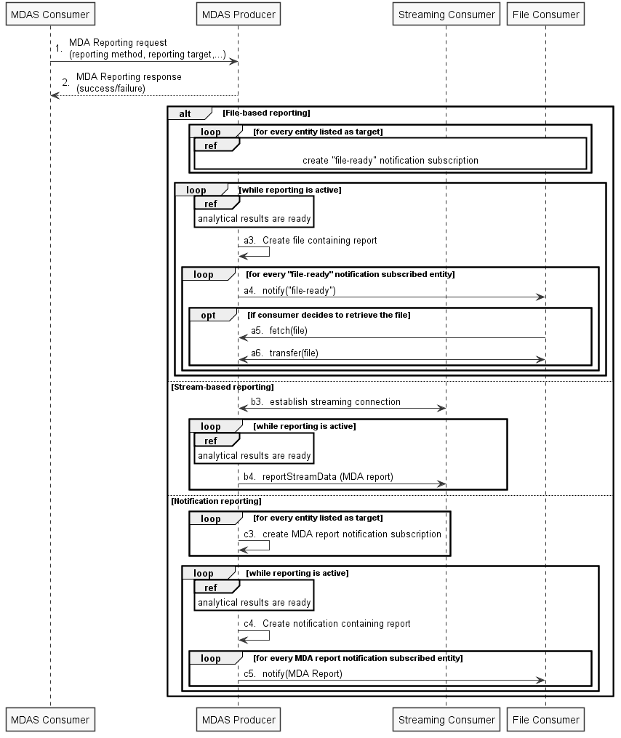
Figure 6.99.2.3-1: MDA report with multiple reporting options
Note: The file server where MDA report is fetched from in steps a5 and a6 can be deployed separately from the MDAS producer.

6.99.2.4 Evaluation
The solution described in clause 6.99.2.3 include multiple reporting options:
- the generic streaming data reporting service and file reporting service as defined in TS 28.532 [28] and can be reused for MDA data reporting
- notification based reporting, for which the detailed solution can befurther inverstigated and determined during the normative phase. It is possible that notification based reporting can be supported by either defining a new mechanism for notification based data reporting in SA5 or reusing existing notification based solution for NWDAF reporting from SA2/CT4.

Therefore, this solution is a feasible candidate for MDA reporting request and reporting.

End of Change

